Maze-Navigating Robot Agent
ACI – Assignment1- PS10
GROUP 264 - Details:
S.NO | NAME | BITS ID | CONTRIBUTION %
1 | Nalla Manoj Kumar | 2024AC05141 | 100 %
2 | D Mallikarjuna Reddy | 2024AC05653 | 100 %
3 | Sajjala Ashok Reddy | 2024AC05829 | 100 %
4 | Adurti Sai Venkatesh | 2024AC05968 | 100 %
5 | M Satish Kumar | 2024AD05320 | 100 %

PEAS

Component | Description
Performance Measure | - Minimize total path cost from Start to Finish  - Avoid unnecessary East moves to reduce sunlight penalty  - Reach goal in shortest safe path
Environment | - Grid-based maze with static obstacles (walls) and size 6x7(full observable)  - Movement allowed in 4 directions: N, S, E, W, no change in defined walls(static)  - Sunlight intensity affects East direction (adds cost), no uncertain moves, limited (countable) steps to reach goal  - Static/Fully observable/ Discrete/ Deterministic/Single Agent
Actuators | - Motors/wheels to move the robot in 4 directions (N, S, E, W)  - Mechanism to execute transition functions between adjacent cells
Sensors | - Vision or proximity sensors to detect walls/obstacles  - Light sensors to detect East direction exposure (sunlight penalty)  - current cell(position), maze configuration map, internal memory to store cost details, queue

Justification of Algoritham Choice:

- A* Search is used due to its optimal and complete properties when using admissible heuristics.
- Manhattan Distance is appropriate for 4-direction grid-based movement.
- The weighted heuristic allows fine-tuning the influence of estimated cost (W > 1 leads to more greedy behavior).
- Cost structure:
- Base move cost = 3
- Additional East penalty = 5 (total of 8 for East moves)

Comparison chart (from IPYNB):

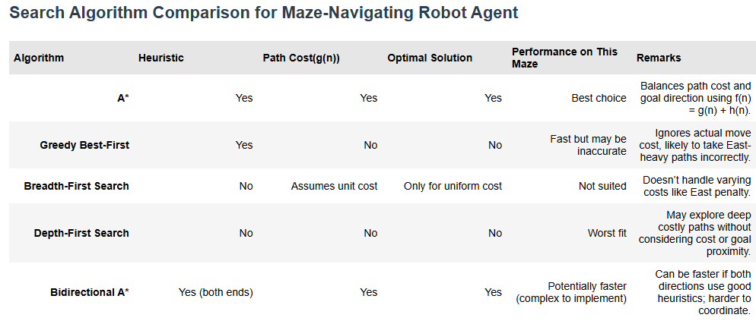

Complexity and Data structures:

- Time Complexity: O(E), where E is the number of expanded nodes depending on heuristic efficiency.
- Data Structures:
- `heapq` (priority queue) for open list (min-heap based on f(n))
- Dictionary for `g_score`, `came_from` mapping
- Set for `closed_set` to avoid re-expanding.

Complexity details (from IPYNB):
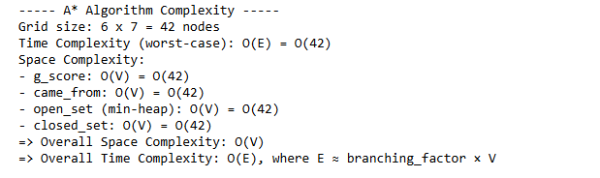

Fringe Design:

- Each fringe entry holds: (f(n), cell coordinates).
- At each step, the lowest f(n) node is selected and expanded.
- Neighboring cells are evaluated and added if they improve the path cost (g(n)).

Execution Flow Explanation:
- Each step corresponds to expanding the node with the lowest f(n) in the open list.
- g(n) accumulates cost: +3 for each move, +5 additional for any Eastward move.
- h(n) = Manhattan distance to the goal.
- f(n) = g(n) + W * h(n), where W = 1.0 or 2.5

Method-2: (With Dynamic Inputs):[from IPYNB]

Inputs:

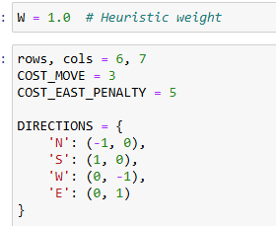
- initial weight set to 1.0 or 2.5 for scenario-2
- cost move +3, additional cost for East move +5 defined
- Directions – based on give compass from cell (i,j)
  - (i-1,j) -> North
  - (i+1,j) -> South
  - (i,j-1) -> West
  - (i,j+1) -> East

Defining functions:

Manhattan distance:
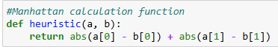

Manhattan distance of (x1,y1) & (x2,y2) is = |x1-x2|+|y1-y2|

  - Pseudocode: A* Maze Pathfinding Algorithm [For Actual code in IPYNB]

FUNCTION A_STAR_MAZE(maze, start, goal, W, rows, cols):

Initialize open_set as a priority queue (min-heap) with (f=0, start)
Initialize g_score dictionary with g(start) = 0
Initialize came_from as an empty map
Initialize closed_set as an empty set
Initialize step_costs as an empty list
Initialize step_num = 1

WHILE open_set is not empty:
Pop node with lowest f(n) from open_set → current
IF current is already in closed_set:
CONTINUE

Add current to closed_set

Calculate:
g = g_score[current]
h = Manhattan heuristic from current to goal
f = g + W × h
PRINT step number, current, g(n), h(n), f(n)

IF current == goal:
Reconstruct path from came_from
FOR each (prev → current) in reverse path:
Identify movement direction (N, S, E, W)
Add cost: base cost + east penalty (if applicable)
Append move and cost to step_costs
RETURN path (reversed), step_costs, total_cost, g_score

FOR each possible direction (N, S, E, W):
IF that direction is open from current:
Calculate neighbor coordinates
IF neighbor is within bounds:
Compute move_cost:
= base move cost + penalty (if direction is East)
Compute tentative_g = g_score[current] + move_cost

IF tentative_g < g_score[neighbor] (or neighbor not in g_score):
Update came_from[neighbor] = current
Update g_score[neighbor] = tentative_g
Calculate f_neighbor = tentative_g + W × heuristic(neighbor, goal)
Push (f_neighbor, neighbor) into open_set

RETURN None (no path found), empty step_costs, ∞, g_score

Detailed Explanation of A* function:

- Start with the beginning cell and add it to a priority queue based on its cost.
- Track the cost from the start to each cell using a dictionary (g score).
- Use a set (closed set) to keep track of already visited cells.
- While there are still cells to explore, pick the one with the lowest total cost f(n) = g(n) + W × h(n).
- If that cell is already visited, skip it.
- If it’s the goal, reconstruct the path taken and calculate the total cost.
- For each direction (N, S, E, W) from the current cell, check if it's open.
- If the neighbouring cell is within bounds, calculate the cost to reach it.
- If this path is cheaper than any previous one, update the path and re-add the neighbour to the queue.
- If the goal is unreachable, return failure with no path and infinite cost.

Calling the A* Function:

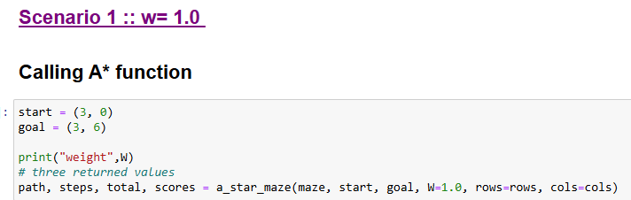

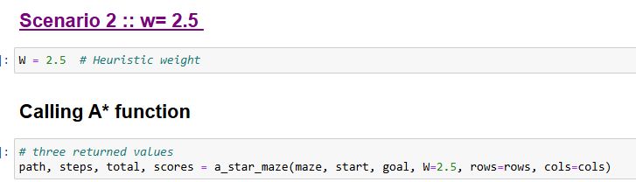

Output: [from IPYNB]
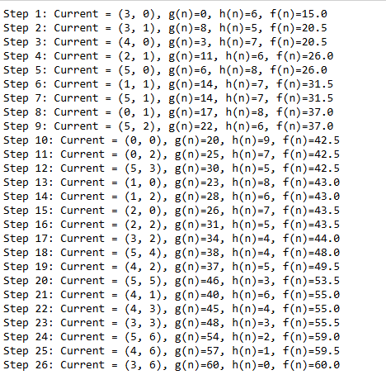

At each step, we chose the least f(n) node from the queue, the details can be seen in the above step.

Displaying Optimal Path details:
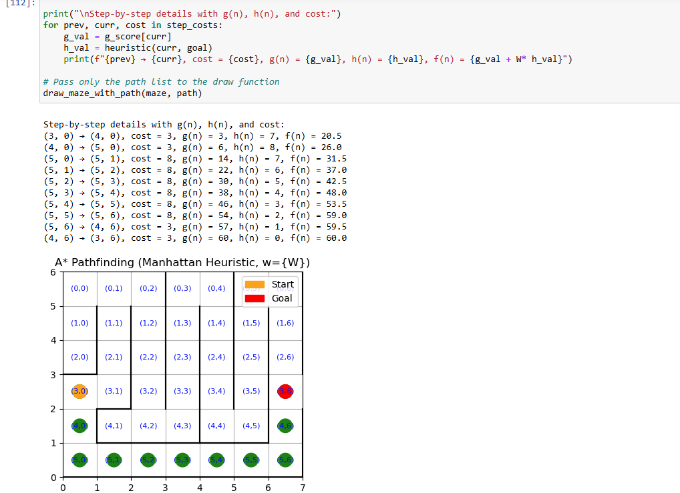

Optimal path is highlighted from start to goal in green color.

-------------------------------------END---------------------------------------------

