CCZG506 | API-DRIVEN CLOUD NATIVE SOLUTIONS
API-Driven Chest X-Ray
Analysis and Explanation Assistant
Assignment II - Integrated Computer Vision, Grounded NLP, FastAPI, Streamlit and LLMOps
DOMAIN  Healthcare / Medical Imaging | AI CATEGORIES  Computer Vision + NLP | GROUP  Group 89

Educational-use boundary: This prototype supports research and educational demonstration. It is not a diagnostic system and does not replace review by a qualified healthcare professional.

BITS Pilani Work Integrated Learning Programmes

0. Group Details and Contribution
The contribution allocation is balanced across five core workstreams. Each member is assigned a distinct Assignment II responsibility while the integrated deliverable remains a collective group outcome.
# | BITS ID | Name | Assignment II contribution | Weight
1 | 2024ac05968@wilp.bits-pilani.ac.in | ADURTI SAI VENKATESH | ChestMNIST dataset acquisition and integrity validation, multilabel exploratory analysis, preprocessing design, class-imbalance analysis, and data-engineering evidence. | 20%
2 | 2024ac05284@wilp.bits-pilani.ac.in | ANKITA TOMAR | ResNet-18 multilabel model development, training-strategy review, checkpoint analysis, finding-specific threshold calibration, and model-development evidence. | 20%
3 | 2024ac05653@wilp.bits-pilani.ac.in | D MALLIKARJUNA REDDY | FastAPI contract and service integration, Streamlit HTTP-client workflow, end-to-end interface orchestration, packaging coordination, and deployment validation. | 20%
4 | 2024ad05005@wilp.bits-pilani.ac.in | KSHIRSAGAR RUTUJA VILAS | Isolated test evaluation, multilabel error analysis, Grad-CAM explainability validation, representative evidence review, and interpretation of model limitations. | 20%
5 | 2024aa05099@wilp.bits-pilani.ac.in | MISHRA SUDHAKAR RAMNAWAL LALIT | Grounded-language task design, prompt and guardrail review, language evaluation, LLMOps and MLflow evidence, documentation checks, and demonstration support. | 20%

Contribution total: 5 members x 20% = 100% of the Assignment II work allocation.

Table of Contents
- 1. Executive Summary
- 2. Assignment Alignment and Unified Objective
- 3. Architecture and End-to-End Workflow
- 4. Development Method and Notebook Traceability
- 5. Platform Readiness and Reproducibility
- 6. Dataset Engineering and Exploratory Analysis
- 7. Computer-Vision Model Development
- 8. Isolated Test Evaluation and Error Analysis
- 9. Visual Explainability with Grad-CAM
- 10. Grounded Language Model and Guardrails
- 11. FastAPI Service and OpenAPI Contract
- 12. Streamlit Interface and Live Demonstration
- 13. LLMOps, Testing and Operational Evidence
- 14. Packaging and Deployment
- 15. Safety, Limitations and Responsible Use
- 16. Assignment Compliance Matrix
- 17. Conclusions and Future Work
- Appendix A. Endpoint Catalogue
- Appendix B. Notebook and Artifact Traceability
- References

1. Executive Summary
This project designs and implements an interactive, API-driven educational assistant for chest X-ray analysis. It combines a fine-tuned multilabel computer-vision model, finding-specific Grad-CAM attribution, a fine-tuned grounded language model, deterministic safety guardrails, a versioned FastAPI service, and a Streamlit demonstration interface. The unifying principle is that every language response must be derived from structured computer-vision evidence rather than independent image interpretation.
The computer-vision component fine-tunes ImageNet-pretrained ResNet-18 on ChestMNIST at 224 x 224 resolution. It produces fourteen independent probabilities and applies frozen, finding-specific thresholds selected on validation data. The isolated test set contains 22,433 images. Final test performance includes macro ROC-AUC 0.8175, micro ROC-AUC 0.8226, macro F1 0.2816, micro F1 0.3391 and Hamming loss 0.0988.
The natural-language component performs full sequence-to-sequence fine-tuning of FLAN-T5-small on 4,800 grounded records spanning structured reports, plain-language explanations, question answering and educational follow-up. Held-out evaluation on 600 records produced ROUGE-L F1 0.8489 and smoothed BLEU-4 0.7393. A deterministic guardrail processed all generations and achieved complete post-guardrail contract compliance, including a zero unsupported-finding rate.
Result: The final readiness gate passed all 20 checks, with 49 checksum-registered artifacts, 23 passing API tests, 5 passing HTTP-client tests, 5 passing UI state tests, and an operational live workflow.

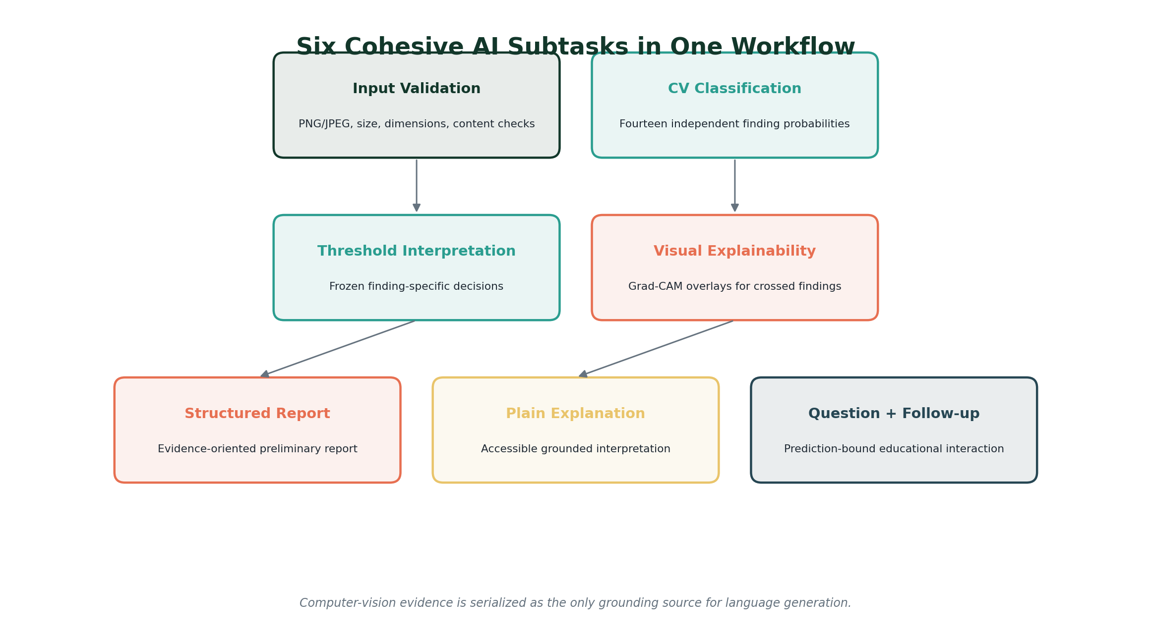
Figure 1. The six cohesive AI subtasks and their shared evidence flow. Source: Project design synthesized from Notebooks 2-8.

2. Assignment Alignment and Unified Objective
The selected domain is healthcare and medical imaging. The chosen AI categories are Computer Vision and Natural Language Processing. Six cohesive subtasks are delivered, exceeding the minimum requirement of five. They are integrated through a single evidence contract and exposed as an interactive API-based application.
Category | Subtask | Model/service | Integrated output
Computer Vision | Multilabel image classification | ResNet-18 | Fourteen finding probabilities and frozen decisions
Computer Vision | Visual explainability | LayerGradCam | Finding-specific overlays and attribution heatmaps
NLP | Structured report generation | FLAN-T5-small | Evidence-oriented preliminary report
NLP | Plain-language explanation | FLAN-T5-small | Accessible grounded explanation
NLP | Grounded question answering | FLAN-T5-small + guardrail | Prediction-bound answer
NLP | Educational follow-up | FLAN-T5-small + guardrail | Controlled next-step guidance

Cohesion is enforced technically. The vision service emits a strict finding-evidence schema containing label identity, probability, calibrated threshold, threshold decision, confidence category and approved description. The language serializer consumes this schema and the guardrail prohibits unsupported finding names, ungrounded numeric claims, diagnostic language and omission of required limitations.
Ground truth: Ground truth refers to the reference labels supplied by ChestMNIST for training and evaluation. It is not the application's prediction and is not equivalent to a new clinical diagnosis.

3. Architecture and End-to-End Workflow
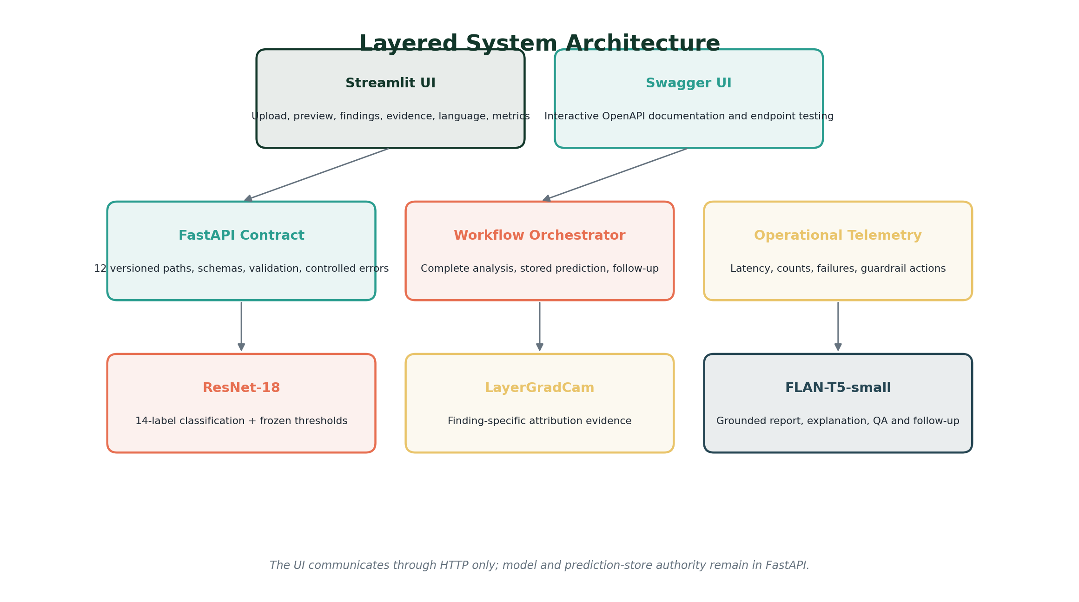
Figure 2. Layered architecture separating interface, API orchestration, model services and persisted evidence.
The Streamlit interface is intentionally thin. It validates only the immediate user-experience contract, such as accepted file extensions and preview availability. Authoritative validation, model loading, inference, threshold application, Grad-CAM generation, language generation, guardrail auditing and prediction persistence occur in FastAPI services.
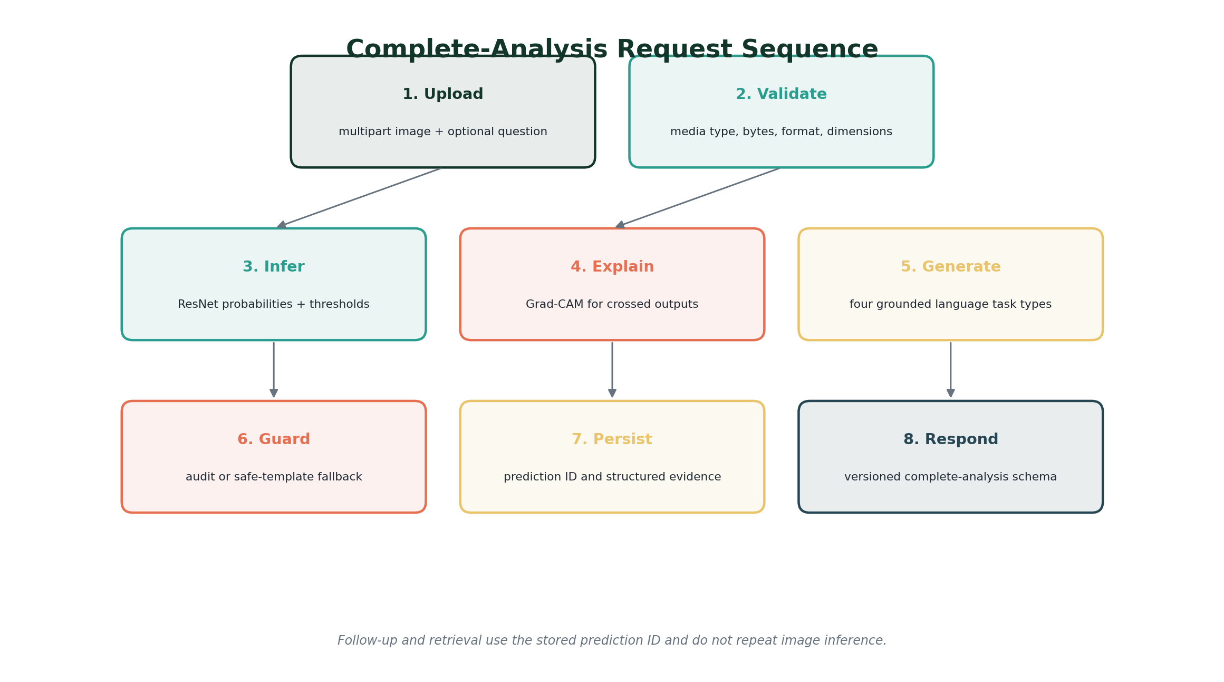
Figure 3. Complete-analysis sequence and prediction reuse.
A single POST request to /api/v1/analyze-complete triggers the full workflow. The response contains request and prediction identifiers, image metadata, all fourteen findings, explainability metadata, optional visual evidence, multiple language outputs, versions, warnings and latency. Follow-up endpoints receive only the prediction identifier and question; the client cannot supply or modify grounding evidence.

4. Development Method and Notebook Traceability
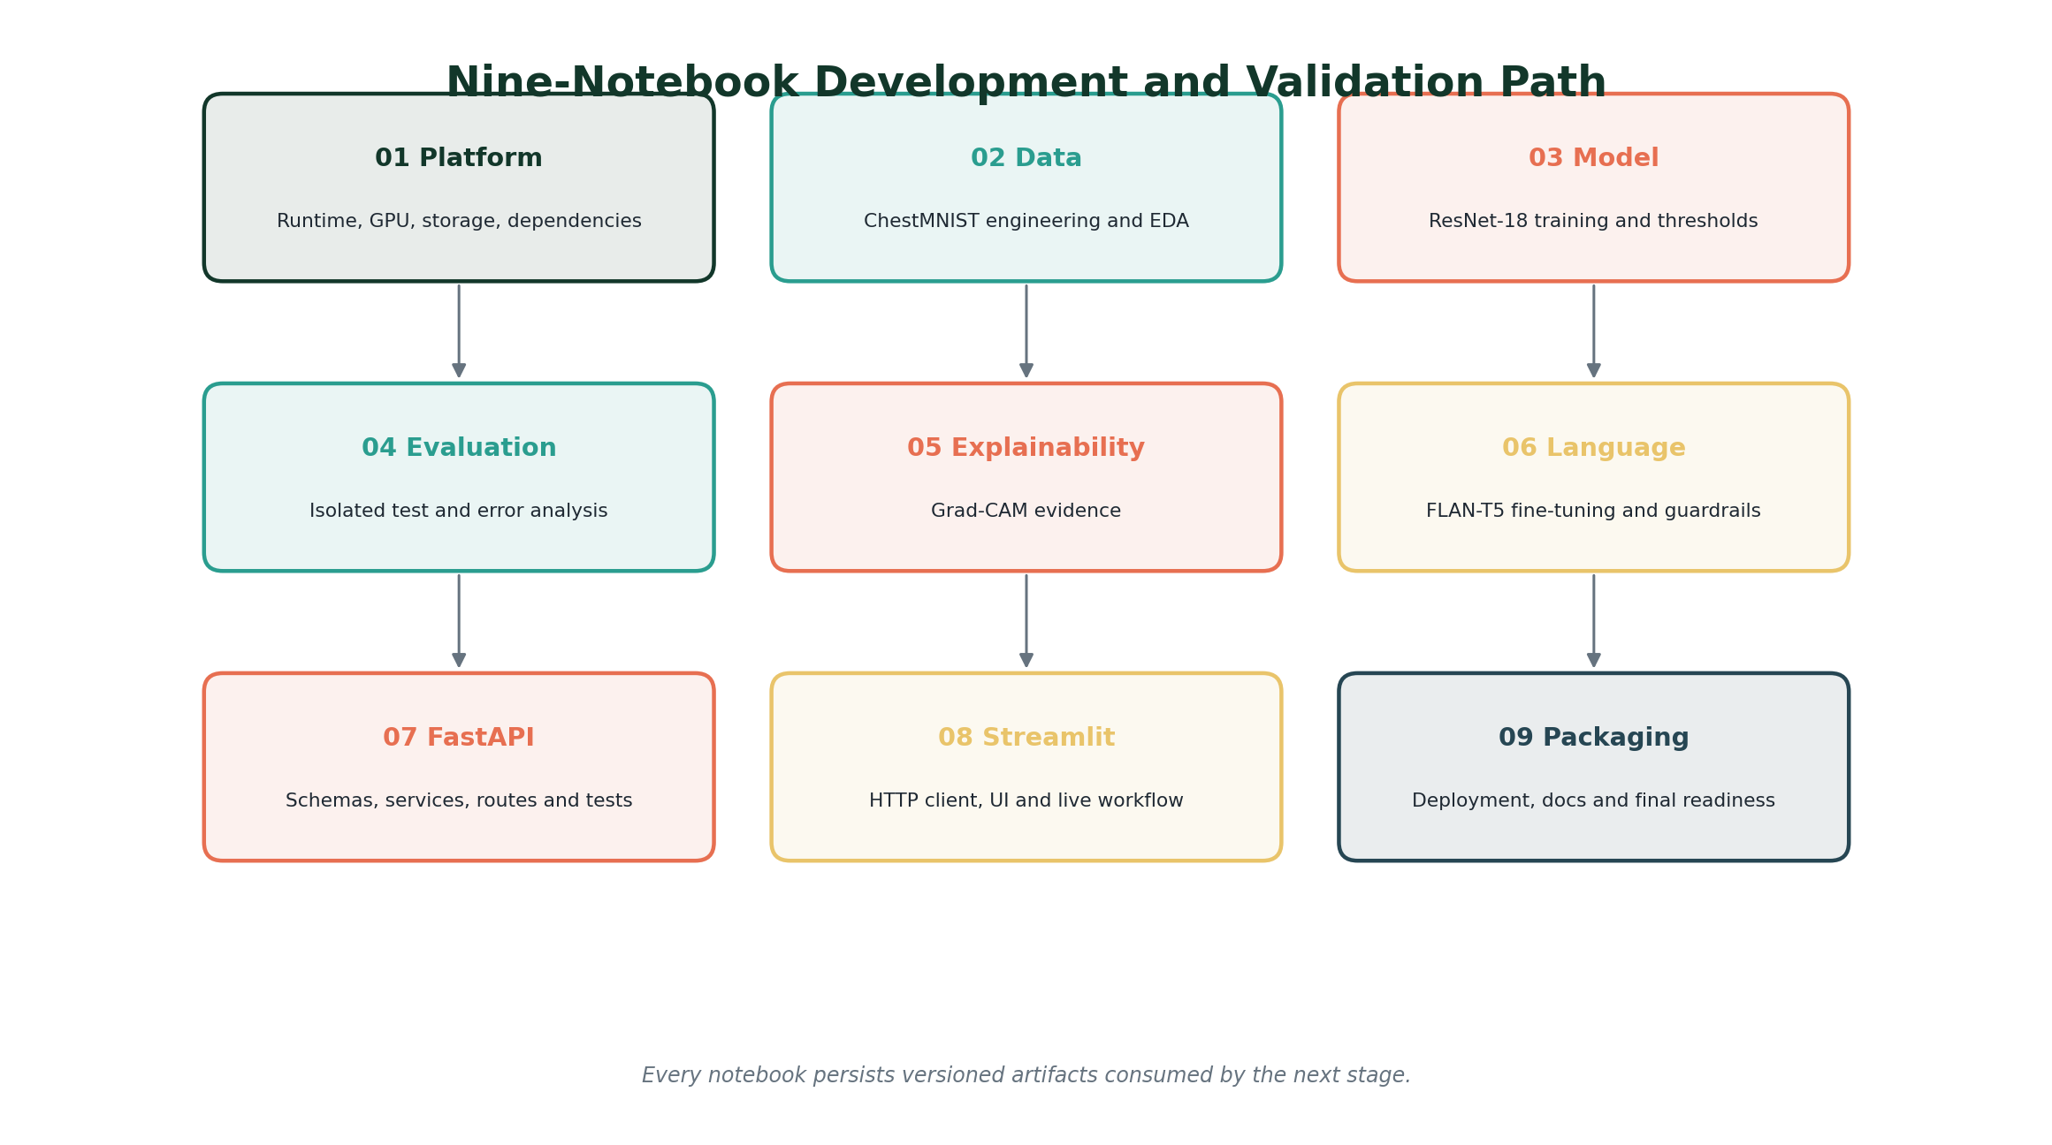
Figure 4. Nine-notebook progression from platform validation to packaging readiness.
Notebook | Focus | Primary work | Gate/output
01 | Platform readiness | Runtime, GPU, storage, dependencies and paths | Environment readiness
02 | Data engineering | Integrity, EDA, transformations and class weights | Data readiness
03 | Model development | ResNet-18 training, checkpointing and thresholds | Model bundle
04 | Evaluation | Isolated test inference, metrics and errors | Frozen test evidence
05 | Explainability | LayerGradCam and representative cases | Visual evidence registry
06 | Grounded language | FLAN-T5 fine-tuning, evaluation and guardrail | Language bundle
07 | FastAPI | Schemas, services, routes and tests | 12-path API
08 | Streamlit | HTTP client, state, rendering and live validation | Demonstration UI
09 | Packaging | Containers, Compose, documentation and audit | Final readiness

5. Platform Readiness and Reproducibility
Notebook 1 validates a Kubeflow/Jupyter runtime with Python 3.11, an NVIDIA A100-SXM4-80GB GPU, CUDA 12.1 and PyTorch 2.5.1+cu121. It separates lightweight solution source code from datasets, checkpoints, model bundles, Hugging Face caches, MLflow runs and generated outputs stored on the dedicated data volume.
Control | Implementation | Evidence
GPU | NVIDIA A100-SXM4-80GB | Available and CUDA-enabled
Precision | FP16/BF16 functional checks | Passed
Path registry | configs/paths.yaml | Created and reused
Experiment tracking | File-based MLflow URI | Routed to persistent volume
Storage reserve | 4.00 GiB protected | 8.71 GiB free at final audit
Final gate | Environment readiness | Ready for data engineering

Centralized configuration prevents later notebooks from silently diverging on label ordering, image resolution, storage locations or model versions. Cache routing also avoids exhausting the root filesystem during model retrieval and full-model fine-tuning.

6. Dataset Engineering and Exploratory Analysis
ChestMNIST is a standardized multilabel chest X-ray dataset with fourteen binary findings. The project uses the 224 x 224 archive and preserves the official train, validation and test partitions. Every image can have zero, one or multiple positive labels; therefore the target is a fourteen-element binary vector rather than a single softmax class.
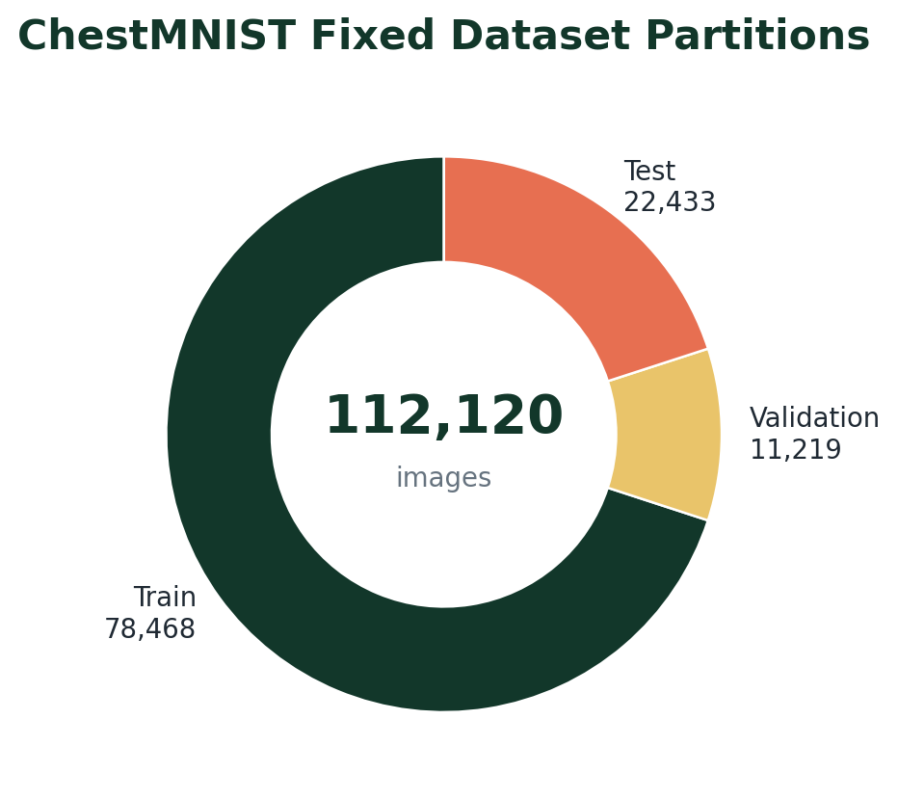
Figure 5. Fixed ChestMNIST train, validation and isolated-test partitions. Source: Notebook 2.
Label ID | Finding
0 | Atelectasis
1 | Cardiomegaly
2 | Effusion
3 | Infiltration
4 | Mass
5 | Nodule
6 | Pneumonia
7 | Pneumothorax
8 | Consolidation
9 | Edema
10 | Emphysema
11 | Fibrosis
12 | Pleural abnormality
13 | Hernia

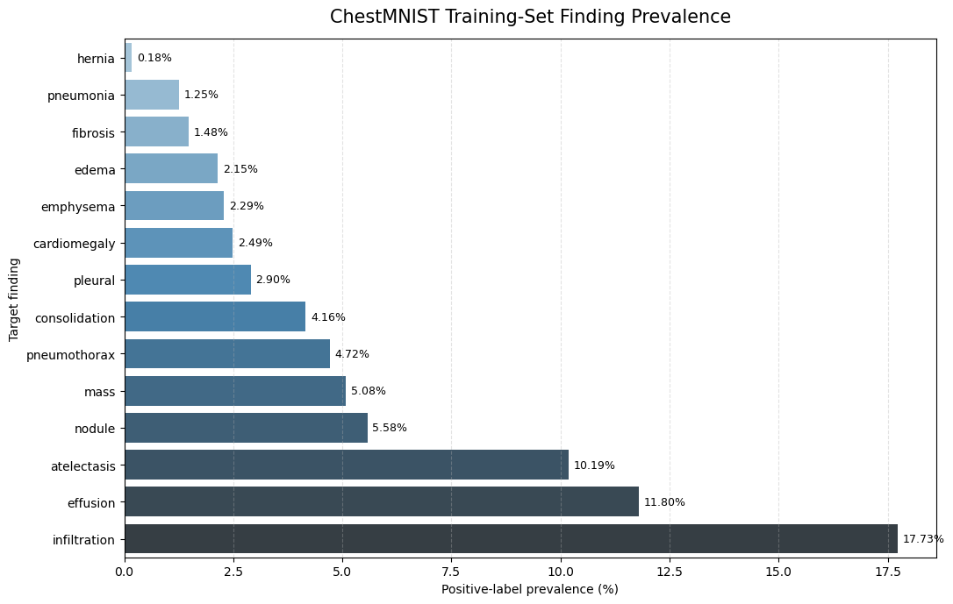
Figure 6. Training-set prevalence across the fourteen supported findings. Source: Notebook 2 embedded output.
The prevalence plot demonstrates strong class imbalance. Infiltration is the most frequent training finding at 17.73%, followed by effusion at 11.80% and atelectasis at 10.19%. Hernia is extremely rare at 0.18%. Positive-class weights therefore range from 4.64 for infiltration to a raw 543.92 for hernia; the hernia weight is capped at 100 to control optimization instability.
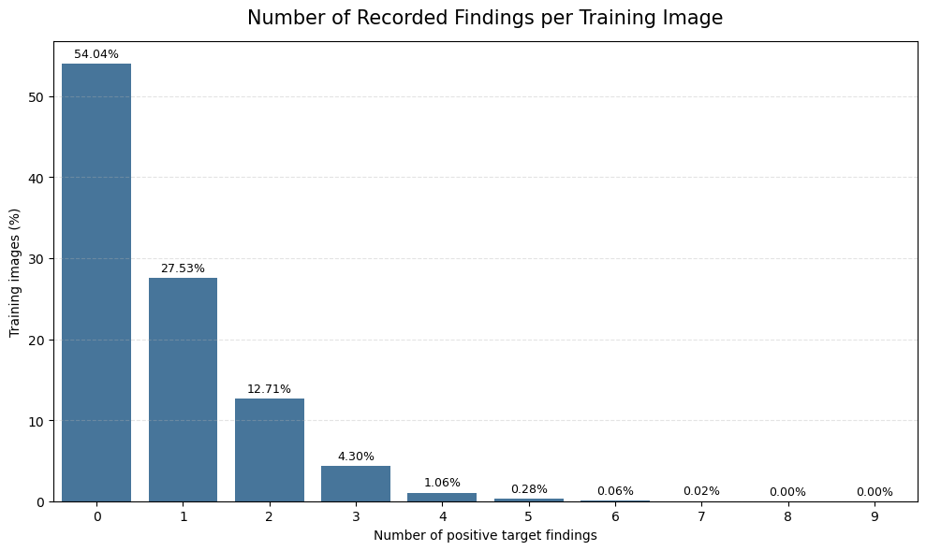
Figure 7. Distribution of no-target, single-finding and multiple-finding records. Source: Notebook 2 embedded output.
Within the training split, 54.04% of images have no target finding, 27.53% have exactly one finding and 18.43% contain multiple findings. The mean label cardinality is 0.720, confirming that both sparse positive labels and co-occurring findings must be handled explicitly.
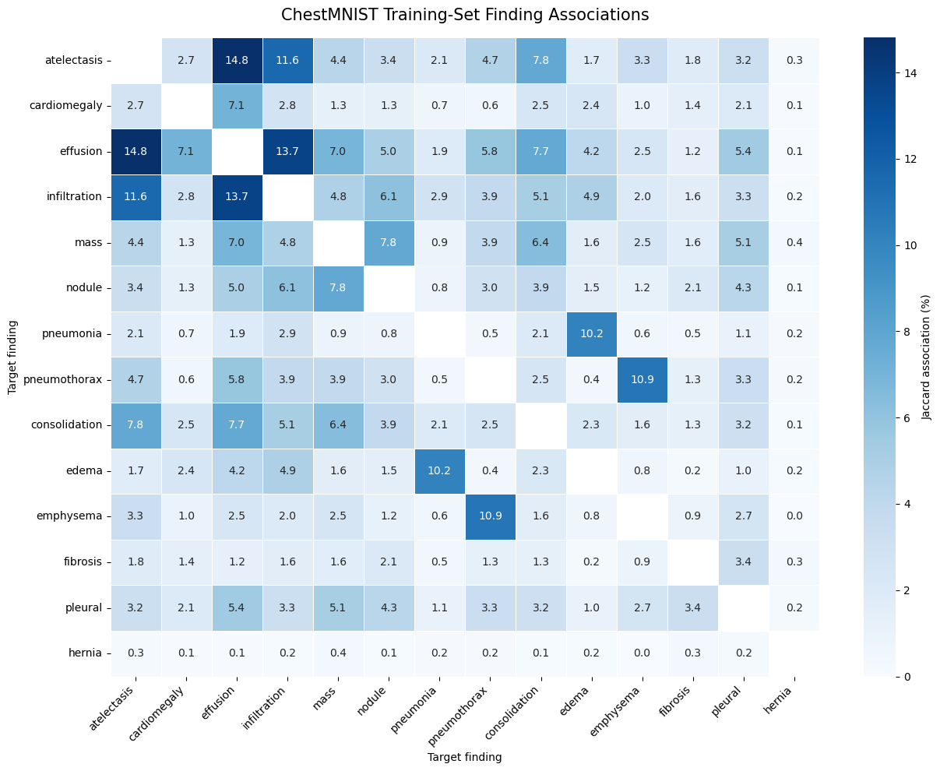
Figure 8. Finding co-occurrence counts and Jaccard association heatmap. Source: Notebook 2 embedded output.
The strongest observed pairs include atelectasis-effusion, effusion-infiltration and atelectasis-infiltration. Association analysis supports multilabel modeling because the findings are not mutually exclusive. It also motivates representative-case evaluation instead of relying only on one aggregate score.
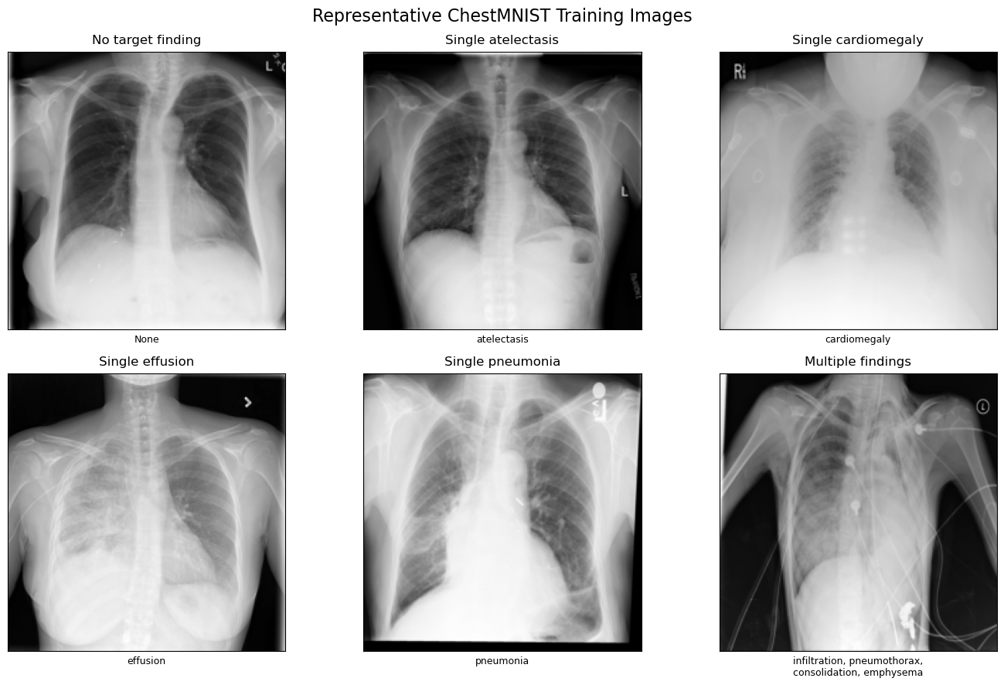
Figure 9. Representative ChestMNIST images covering no-target, single-finding and multiple-finding cases. Source: Notebook 2 embedded output.
Training augmentation is deliberately conservative for radiographs: random affine transformations are limited to +/-5 degrees, 2% translation and 0.95-1.05 scaling, while brightness and contrast jitter are limited to 0.9-1.1. All inputs are converted to three channels and normalized with ImageNet statistics to match the pretrained ResNet-18 contract.

7. Computer-Vision Model Development
The classifier starts from ImageNet-pretrained ResNet-18 and replaces the final classification layer with fourteen independent logits. Sigmoid converts each logit to a probability. BCEWithLogitsLoss receives the positive-class weights produced by Notebook 2 so rare findings contribute meaningfully during training.
Model-development element | Persisted value
Backbone | ResNet-18 pretrained on ImageNet
Output | 14 independent logits / sigmoid probabilities
Training records | 78,468
Validation records | 11,219
Precision | BF16 mixed precision on A100
Epochs | 5 completed; epoch 2 selected
Best validation macro ROC-AUC | 0.8210
Elapsed training duration | 7.34 minutes
Tracking | MLflow experiment chestmnist-resnet18-development

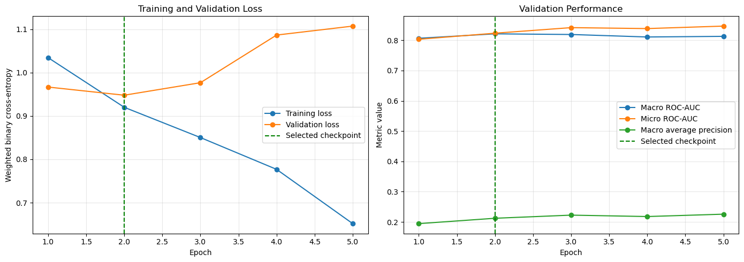
Figure 10. ResNet-18 training loss and validation macro ROC-AUC across five epochs. Source: Notebook 3 embedded output.
Training loss decreases consistently, while validation loss reaches its minimum and macro ROC-AUC reaches its maximum at epoch 2. Subsequent training improves the fit to training data but reduces the selected validation objective, so the versioned checkpoint remains epoch 2. This is evidence of validation-based model selection rather than selection on the isolated test set.
Finding-specific thresholds are calibrated on validation data before test evaluation. Examples include 0.6758 for effusion, 0.8281 for pneumothorax, 0.8750 for emphysema and 0.6992 for hernia. Threshold calibration raises validation macro F1 from 0.2024 at a uniform 0.50 decision boundary to 0.2947, while Hamming loss improves from 0.2841 to 0.0949.
Frozen inference contract: Model weights, label order, preprocessing, thresholds and version metadata are exported together as resnet18-chestmnist-v1 before isolated-test evaluation.

8. Isolated Test Evaluation and Error Analysis
Notebook 4 restores the versioned model bundle and applies it to 22,433 isolated test images without modifying weights or thresholds. The evaluation deliberately reports both ranking metrics and threshold-dependent decision metrics because class imbalance can make any single number incomplete.
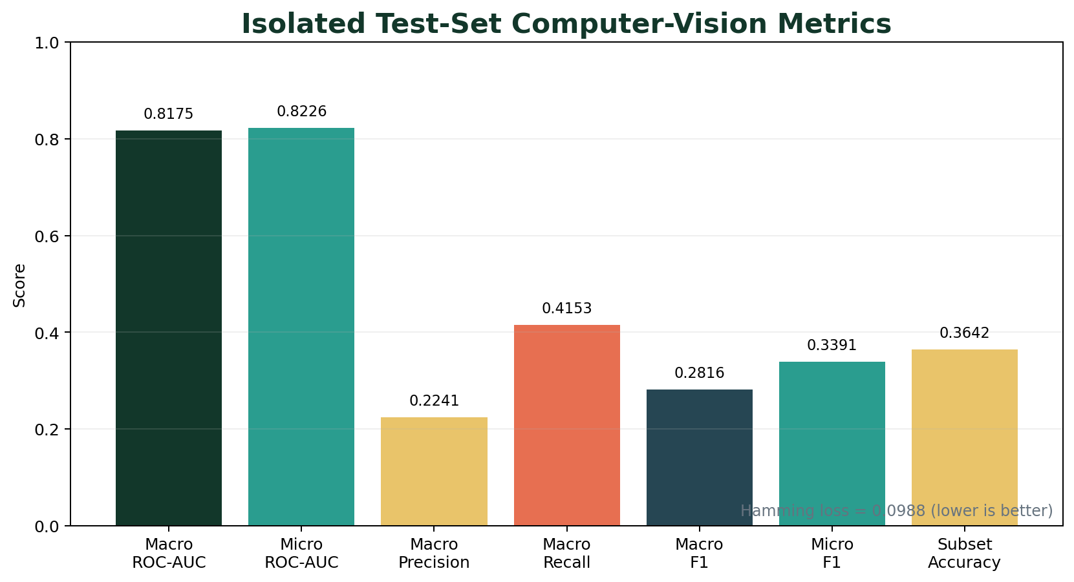
Figure 11. Overall isolated test-set performance. Source: Notebook 4.
Metric | Value | Interpretation
Macro ROC-AUC | 0.8175 | Equal weight to each finding's ranking quality
Micro ROC-AUC | 0.8226 | Aggregate ranking across all label decisions
Macro average precision | 0.2216 | Imbalance-sensitive precision-recall summary
Macro precision | 0.2241 | Average positive predictive precision
Macro recall | 0.4153 | Average sensitivity across findings
Macro F1 | 0.2816 | Harmonic balance of macro precision and recall
Micro F1 | 0.3391 | Global label-level precision/recall balance
Hamming loss | 0.0988 | Fraction of incorrect individual label decisions
Subset accuracy | 0.3642 | Exact match across all fourteen labels

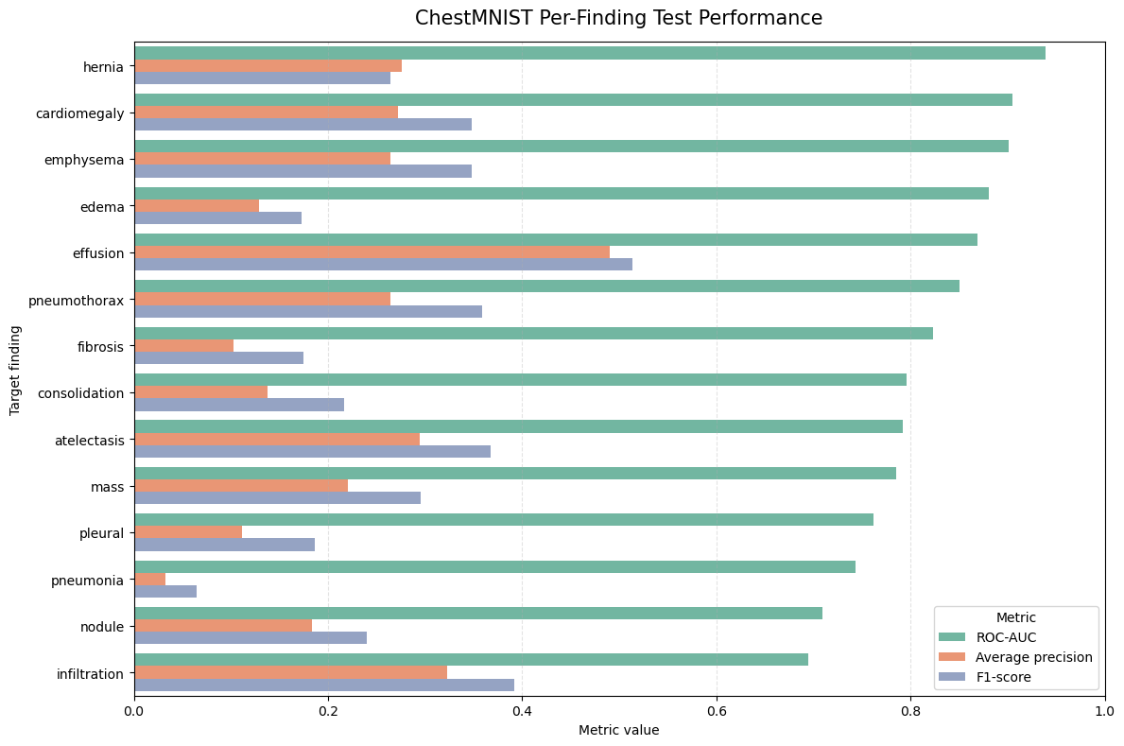
Figure 12. Per-finding ROC-AUC, average precision and F1 comparison. Source: Notebook 4 embedded output.
Per-finding discrimination is strongest for hernia (ROC-AUC 0.9385), cardiomegaly (0.9046), emphysema (0.9011), edema (0.8799) and effusion (0.8687). Infiltration has the lowest ROC-AUC at 0.6944. Average precision is substantially lower for rare labels, demonstrating why prevalence-aware interpretation is required.
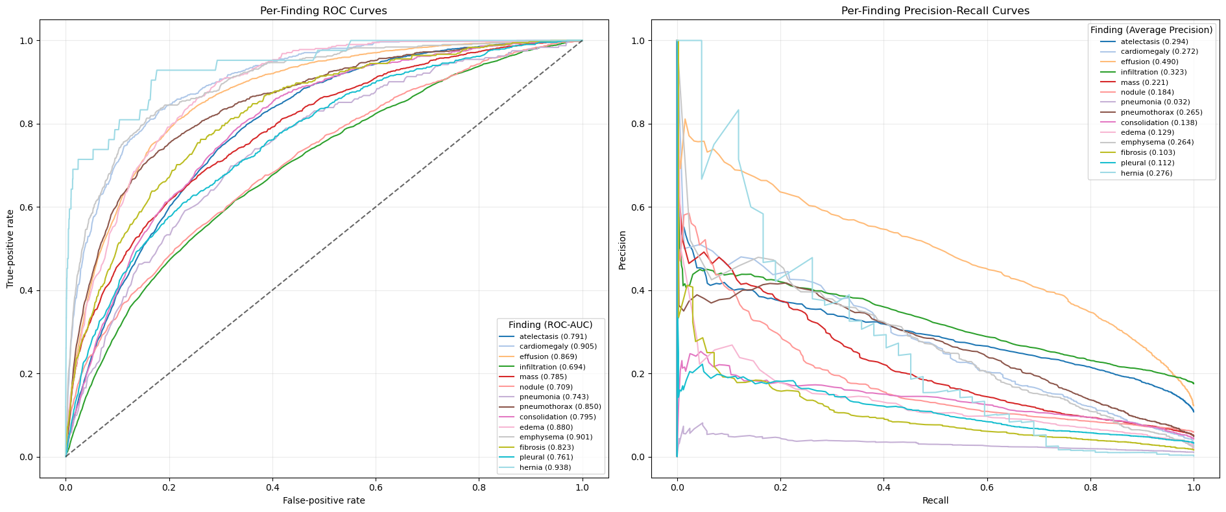
Figure 13. ROC and precision-recall curves for all fourteen findings. Source: Notebook 4 embedded output.
ROC curves show ranking performance across thresholds, whereas precision-recall curves expose the practical difficulty of rare positive findings. The divergence between ROC-AUC and average precision for several findings is expected under severe class imbalance and prevents overstating performance.
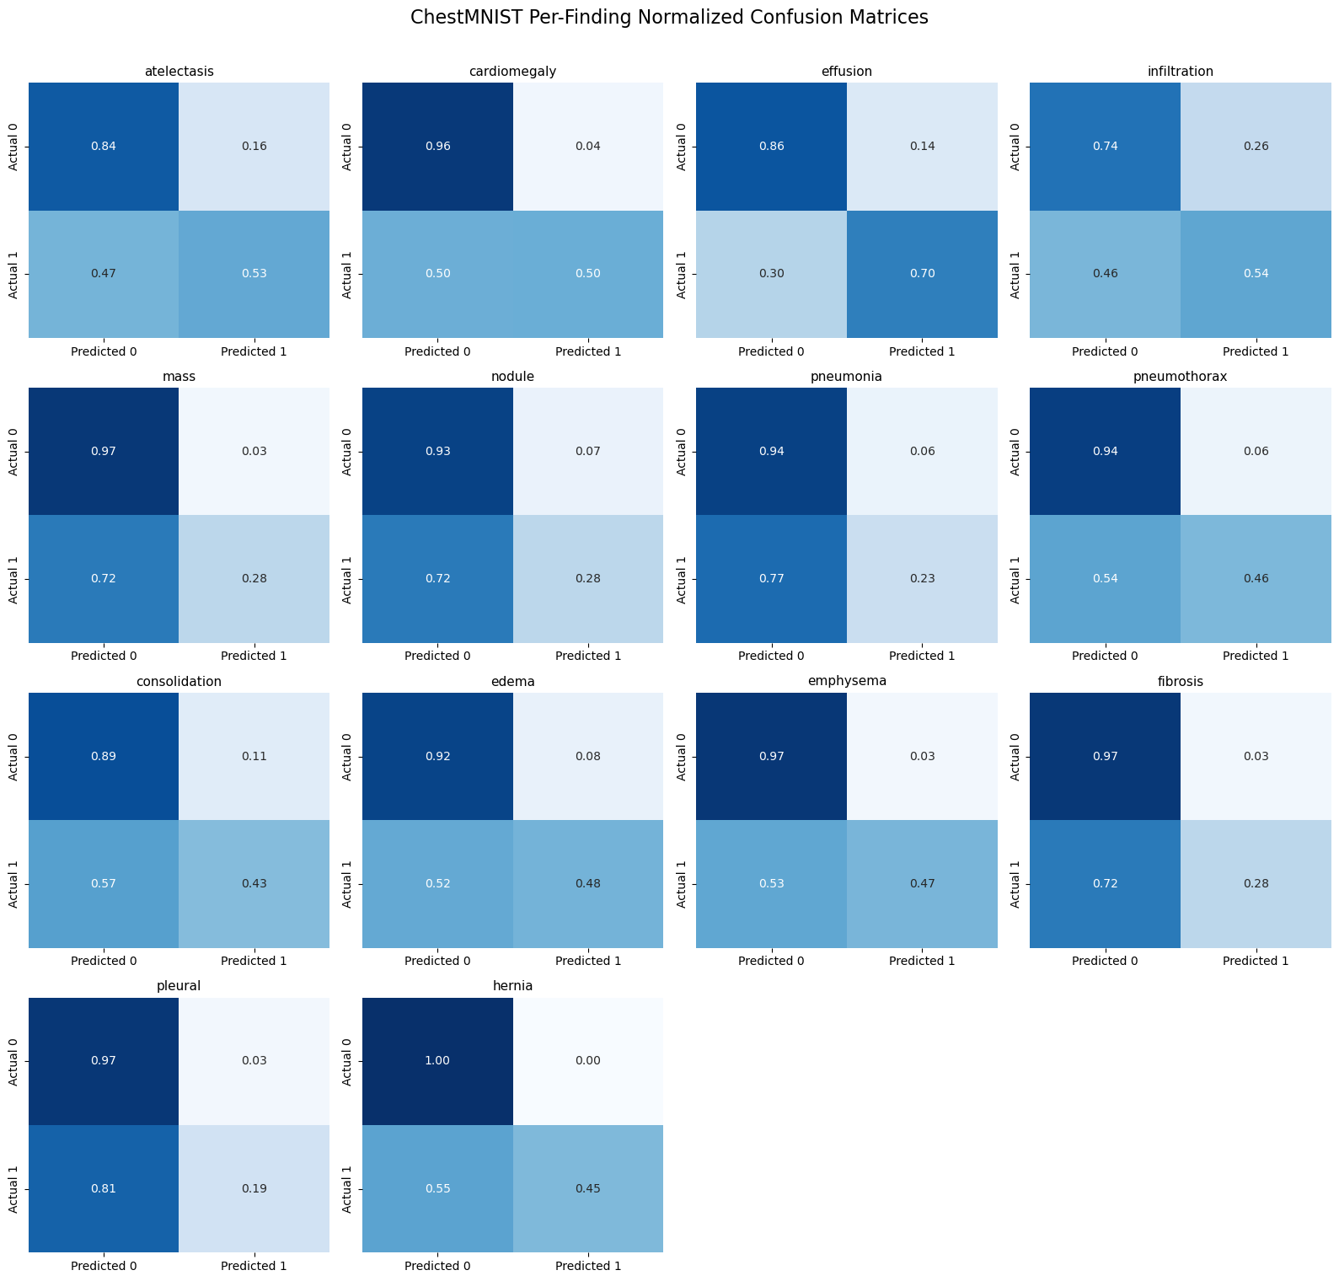
Figure 14. Finding-specific confusion matrices under frozen calibrated thresholds. Source: Notebook 4 embedded output.
The confusion matrices make operating-point trade-offs explicit. For example, effusion achieves 1,920 true positives and 2,806 false positives, while pneumonia achieves only 55 true positives against 1,407 false positives because it is rare and difficult. These results are reported transparently rather than hidden behind aggregate metrics.
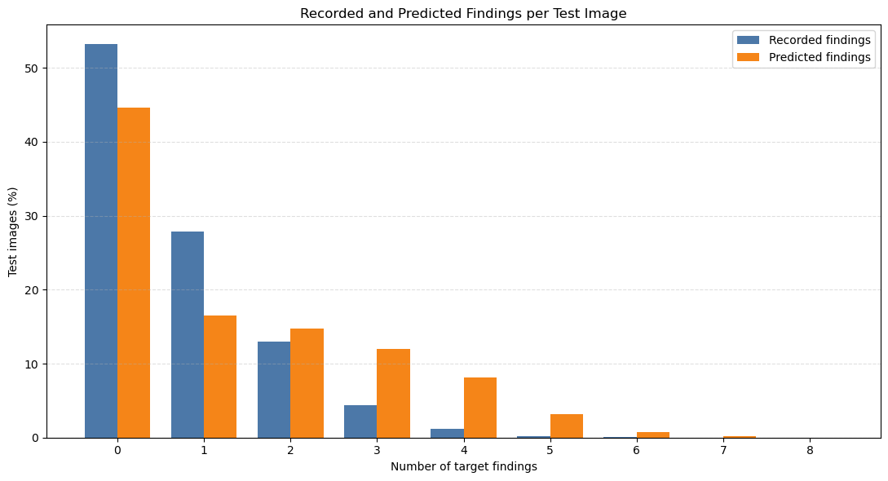
Figure 15. Recorded versus predicted finding-cardinality distribution. Source: Notebook 4 embedded output.
The classifier predicts no finding for 44.59% of test images versus 53.17% in the reference labels, and predicts two or more findings more frequently than recorded. Exact fourteen-label agreement is 36.42%; 37.27% of reference no-finding images receive at least one model alert. This error profile reinforces the educational-use limitation and the need for qualified review.

9. Visual Explainability with Grad-CAM
Notebook 5 uses Captum LayerGradCam on the final convolutional layer, layer4[-1].conv2. The attribution target is finding-specific: gradients are computed for one selected output logit rather than for a generic image-level decision. Positive attributions are normalized and rendered as heatmaps and overlays.
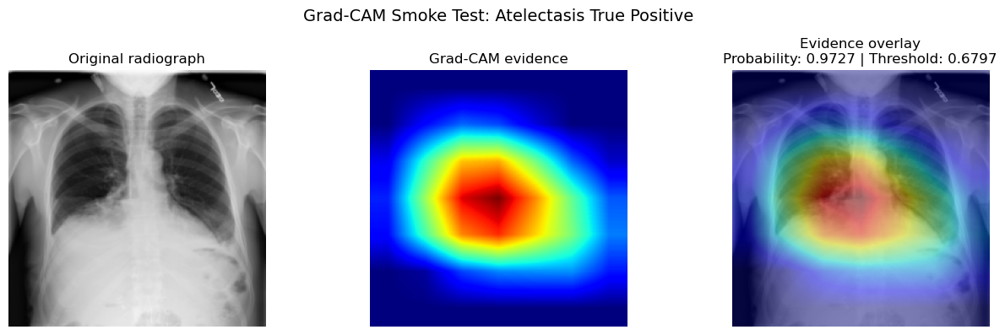
Figure 16. Attribution integrity smoke test showing source image, heatmap and overlay. Source: Notebook 5 embedded output.
Integrity checks verify output dimensions, finite attribution values, normalization bounds and preservation of the frozen inference contract. The visual is interpreted only as evidence of regions that influenced the model output.
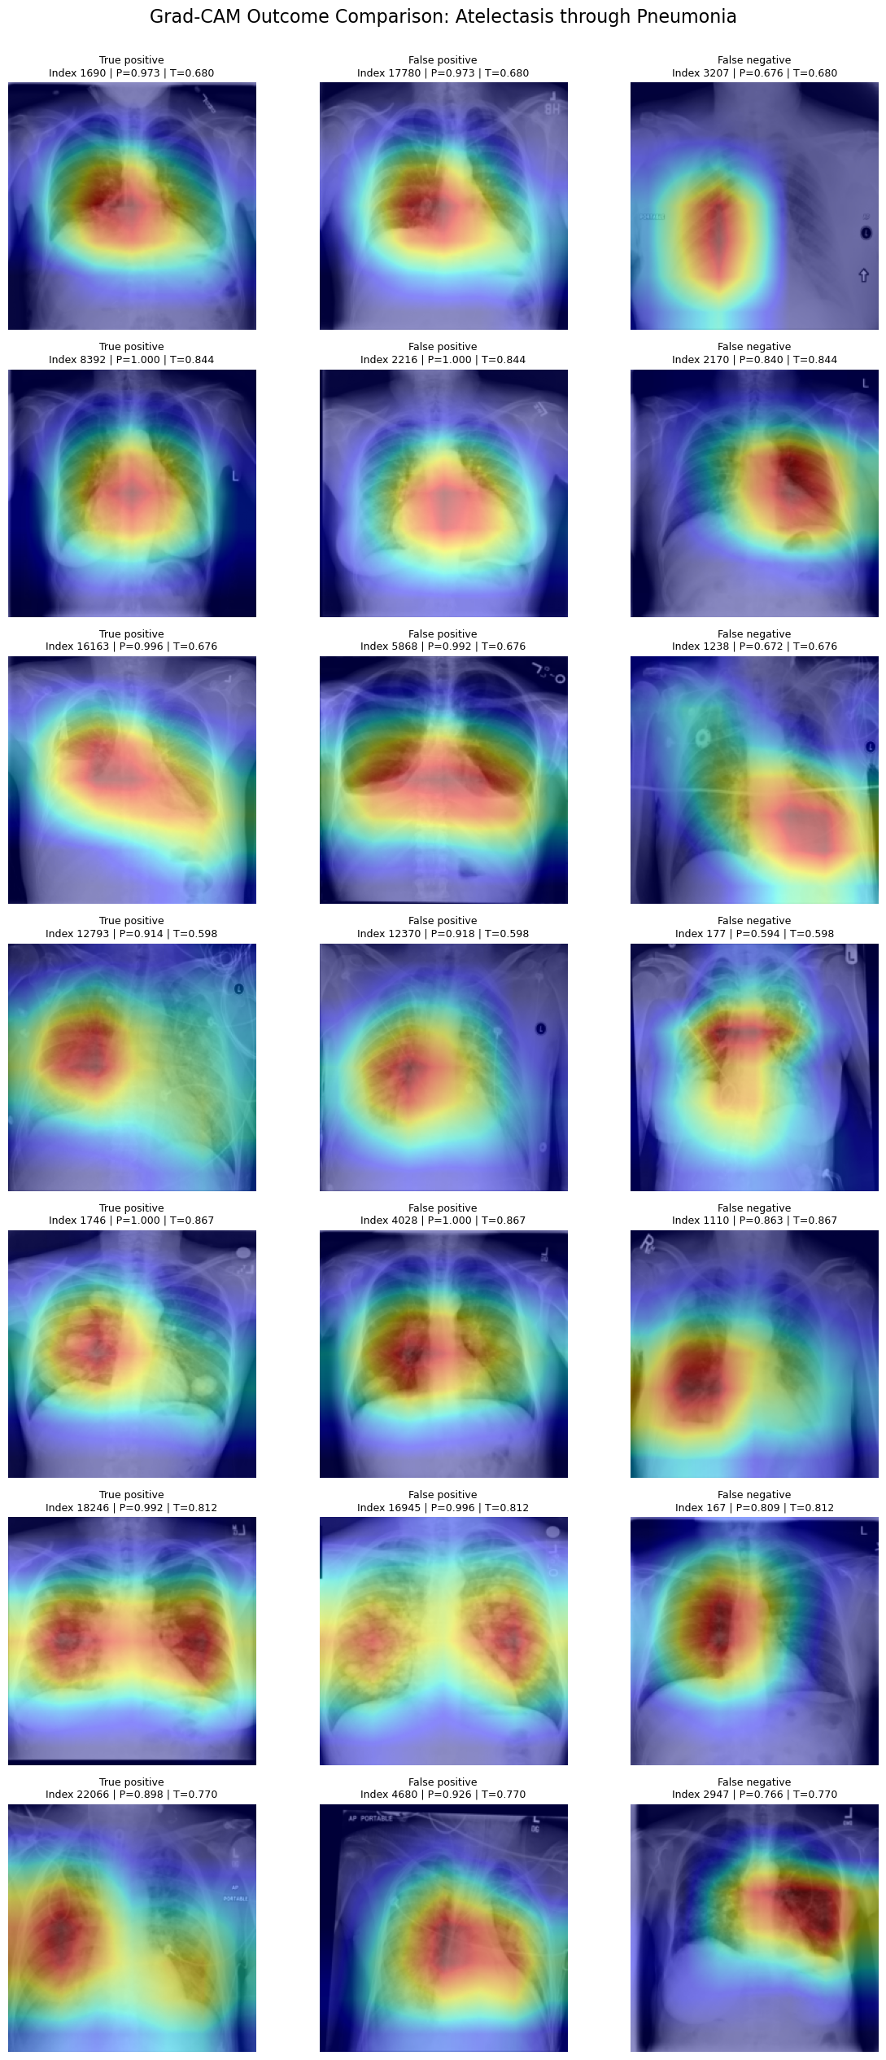 | 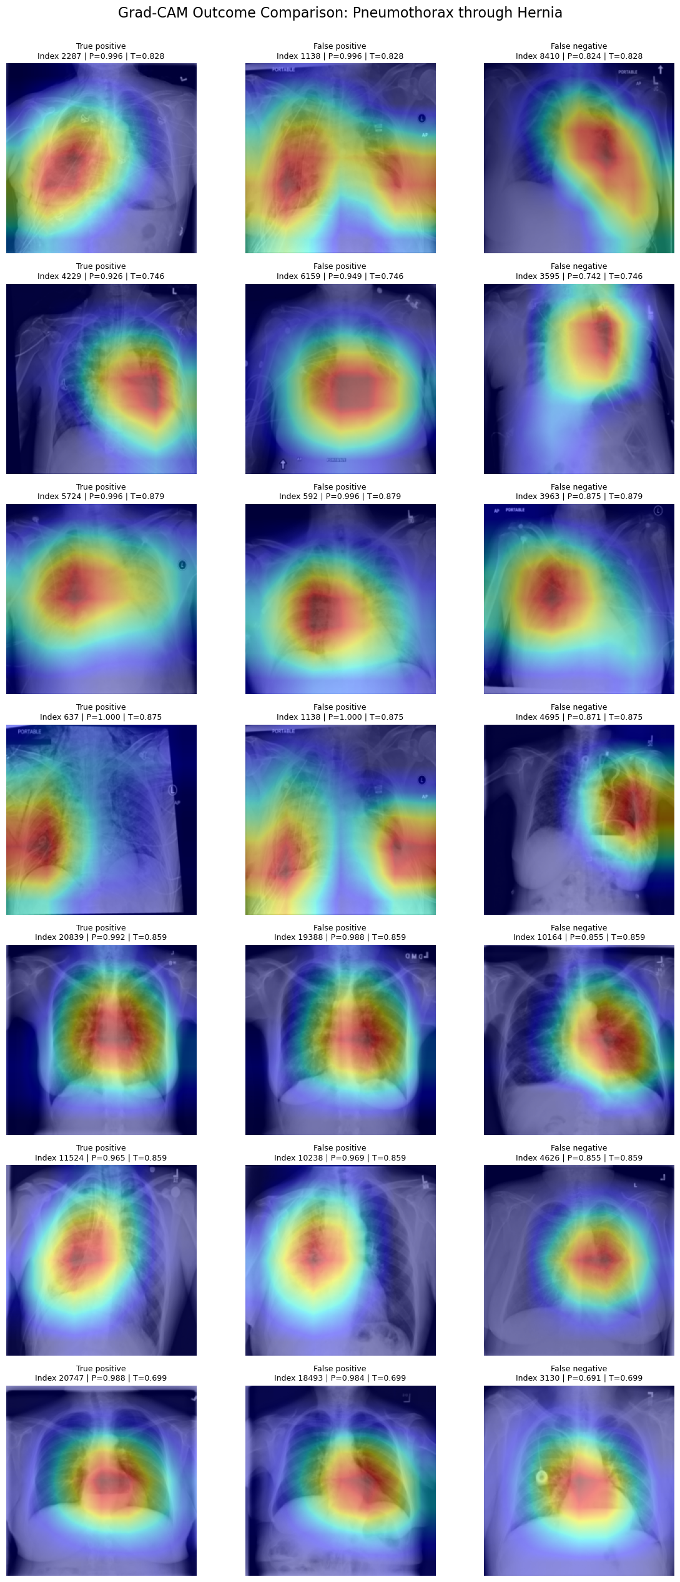
Figure 17. Complete cross-outcome Grad-CAM galleries covering representative true-positive, false-positive and false-negative evidence for all fourteen findings. Source: Notebook 5 persisted outputs.
Interpretation boundary: Grad-CAM does not segment a lesion, confirm an anatomical abnormality, establish causality or provide a clinical diagnosis. It explains model influence, not medical truth.

10. Grounded Language Model and Guardrails
Notebook 6 defines a versioned ontology, prompt registry and four language tasks. A leakage-resistant dataset of 4,800 records is split into 3,600 training, 600 validation and 600 held-out test records. FLAN-T5-small is fully fine-tuned for five epochs; the best validation loss is 0.1574.
Task | Evaluation records | Contract objective
Structured report | 150 held-out | Ordered finding evidence and limitations
Plain-language explanation | 150 held-out | Accessible description of thresholds and meaning
Grounded question answering | 150 held-out | Question answered only from stored prediction evidence
Educational follow-up | 150 held-out | Controlled professional-review guidance

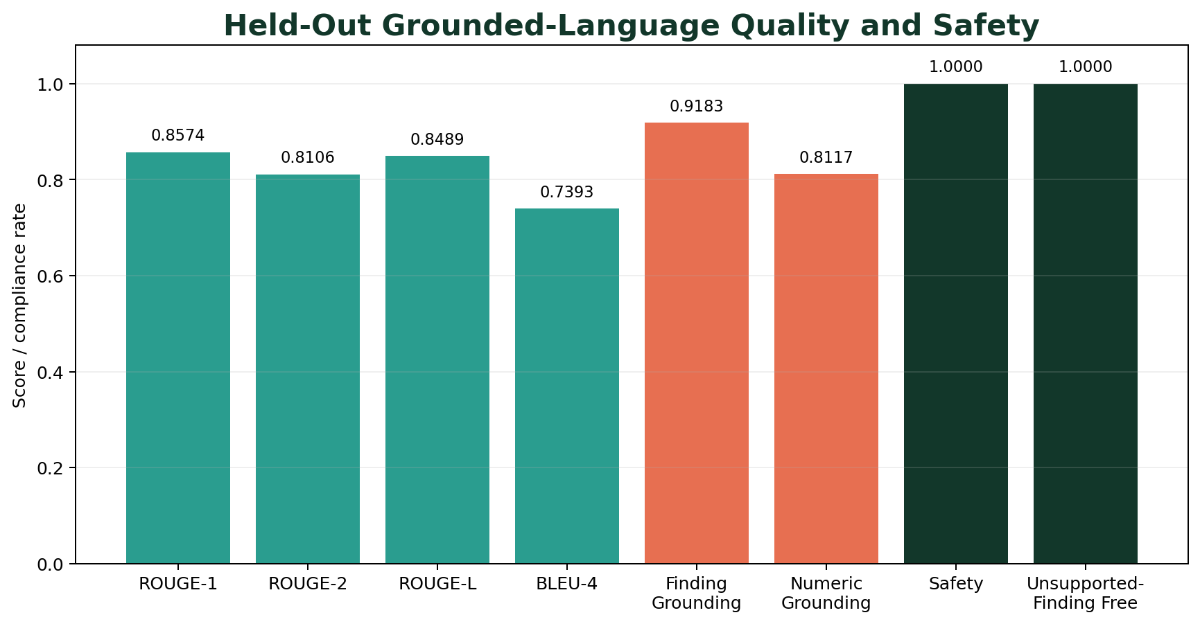
Figure 18. Held-out language quality, grounding and safety metrics. Source: Notebook 6.
Text-overlap quality is high across the controlled reference contract: ROUGE-1 F1 is 0.8574, ROUGE-2 F1 is 0.8106, ROUGE-L F1 is 0.8489 and smoothed BLEU-4 is 0.7393. Exact match is zero because the task permits valid wording variation. More importantly, the unsupported-finding rate is zero, safety-boundary compliance is 1.0000 and forbidden-claim-free rate is 1.0000.
Raw generation still exposes contract weaknesses: finding-grounding compliance is 0.9183 and numeric-grounding compliance is 0.8117. Error analysis identifies 164 of 600 generations with at least one issue, dominated by numeric-grounding issues (113 records) and missing-required-finding issues (49 records).
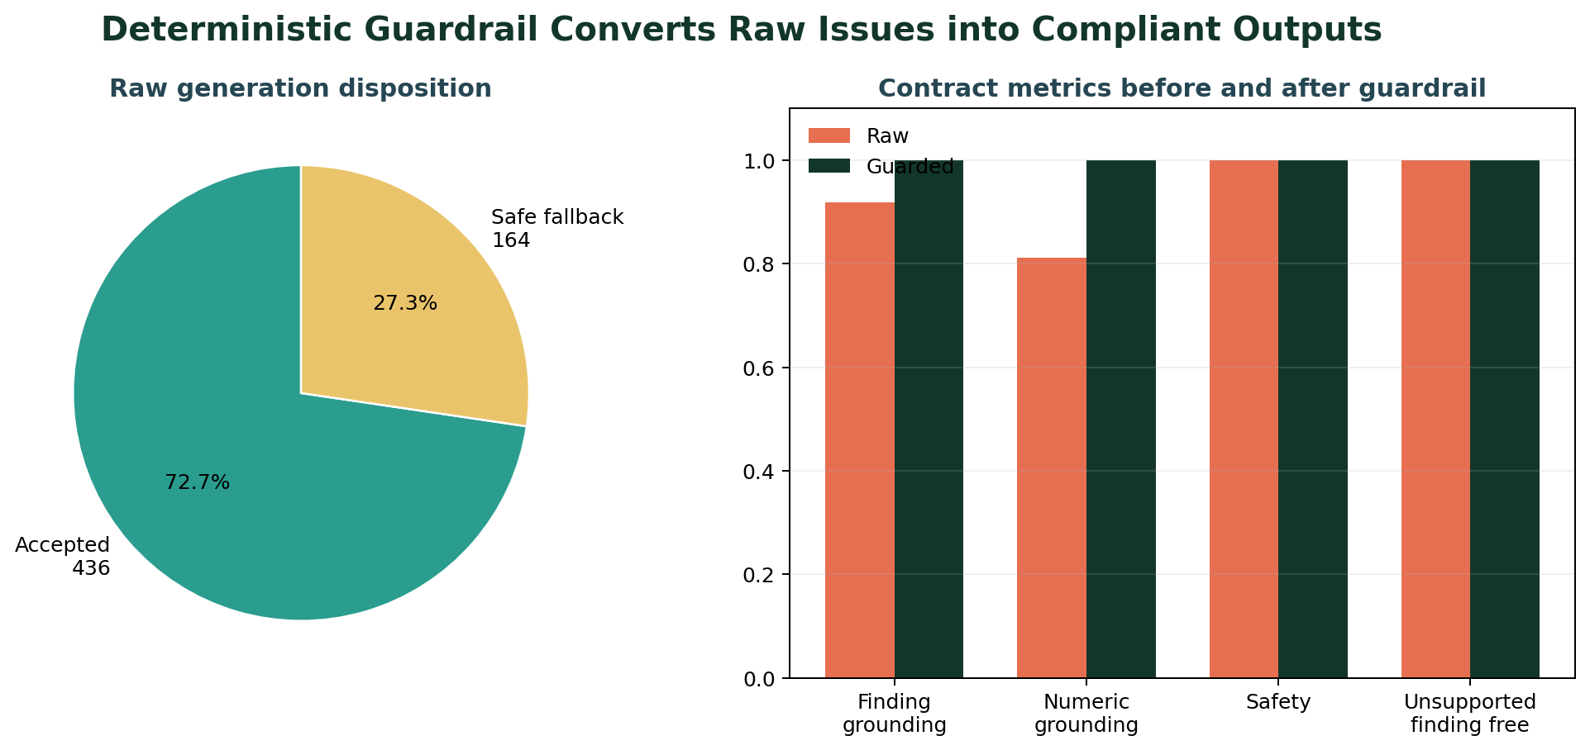
Figure 19. Guardrail disposition and contract compliance before and after deterministic control. Source: Notebook 6.
The deterministic guardrail accepts 436 raw generations and replaces 164 with task-specific safe templates. Post-guardrail evaluation reaches 1.0000 for task routing, section order, required findings, unsupported-finding freedom, numeric grounding, safety limitations, no-target boundaries, controlled refusals, Grad-CAM limitations and forbidden-claim avoidance. The original raw generations are retained for auditability.

11. FastAPI Service and OpenAPI Contract
Notebook 7 converts the model and language artifacts into a reusable service architecture. Pydantic schemas enforce strict request and response contracts; controlled exceptions avoid leaking internal paths; bounded upload reading and format verification protect image endpoints; locks protect inference, Grad-CAM and the in-memory prediction store; middleware records latency and request outcomes.
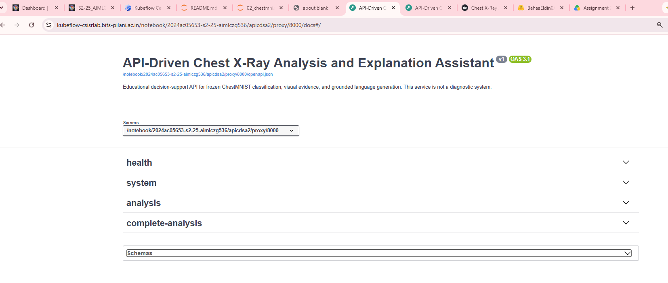
Figure 20. Swagger UI title, OpenAPI 3.1 contract and proxy-aware server configuration. Source: Live FastAPI application.
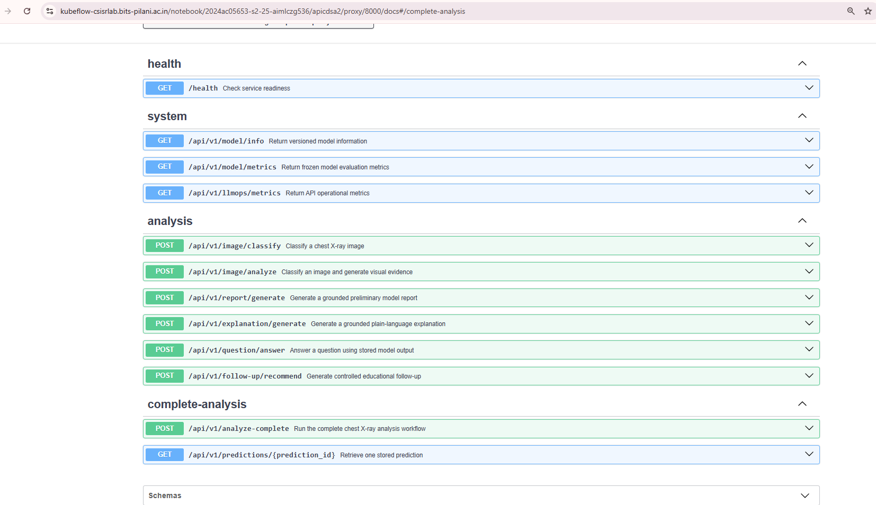
Figure 21. Swagger endpoint catalogue showing all twelve health, system, analysis and complete-analysis operations. Source: Live FastAPI application.
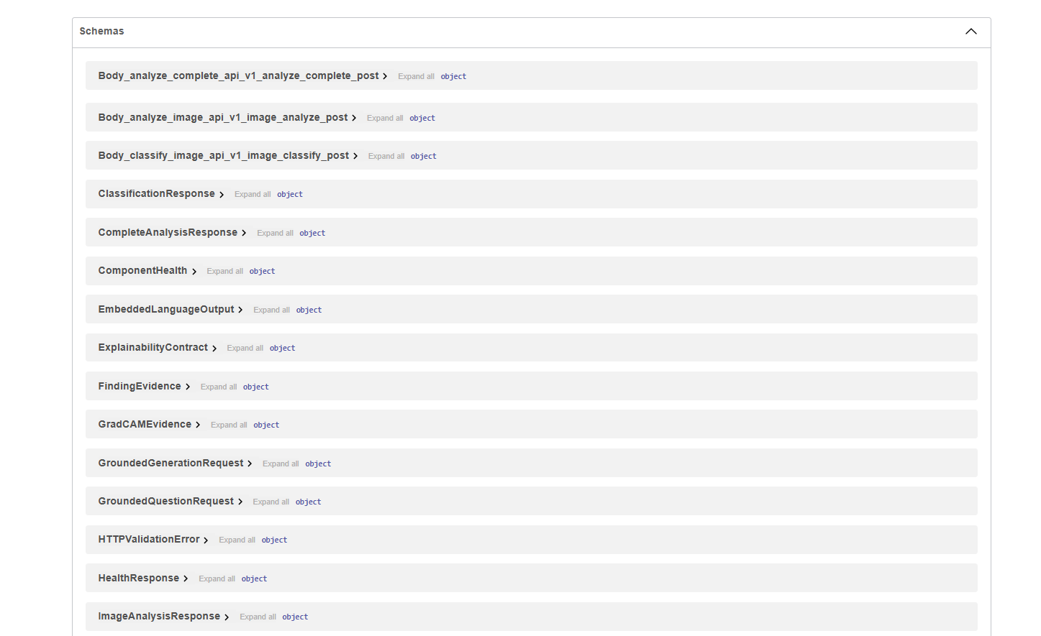
Figure 22. Representative OpenAPI component schemas generated from strict Pydantic contracts. Source: Live FastAPI application.
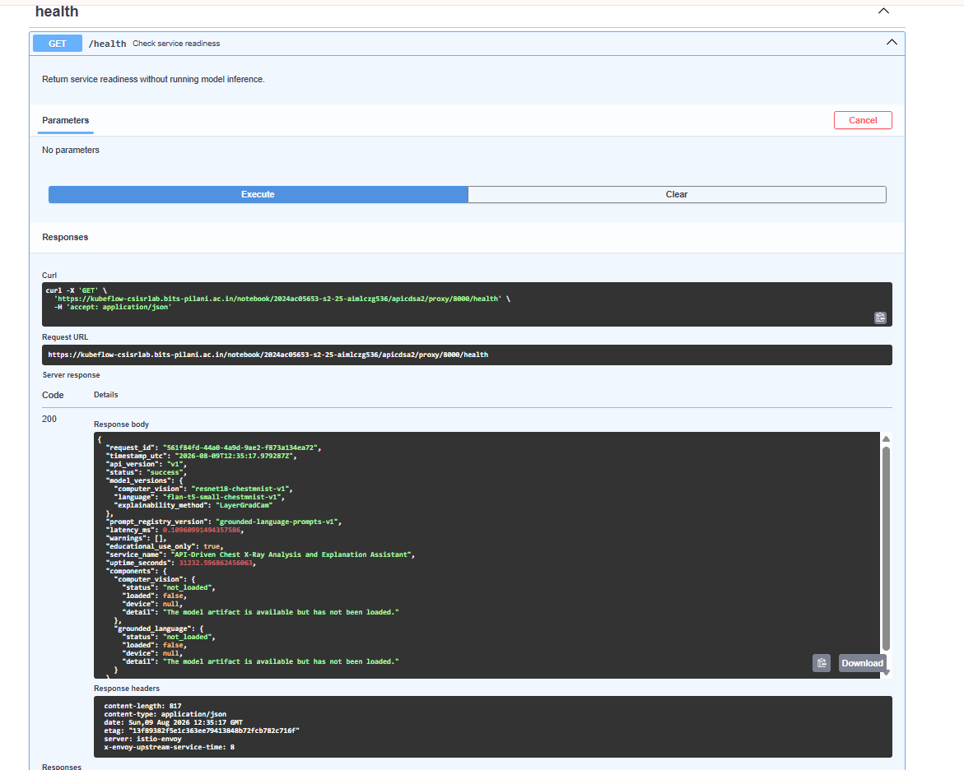
Figure 23. Executed GET /health request with HTTP 200, version lineage, uptime and lazy-load component state. Source: Live FastAPI application.
The health endpoint intentionally returns readiness without loading models. The screenshot therefore shows HTTP 200 and service success while model components remain not_loaded until an inference endpoint requires them. This lazy-load design separates lightweight availability checks from expensive GPU initialization.
API assurance | Evidence
OpenAPI paths | 12 / 12
OpenAPI operations | 12 / 12
Reusable API tests | 23 passed, 0 failed
Standalone Uvicorn | Verified without traceback
Controlled errors | 400, 404, 413, 415, 422 and 500 contracts
Artifact registry | 45 API files with checksums at Notebook 7 gate

12. Streamlit Interface and Live Demonstration
Notebook 8 builds an HTTP-only Streamlit client. The UI never imports the model, Grad-CAM service or prediction store. It supports PNG/JPEG uploads up to 10 MiB, previews the selected image, sends one complete-analysis request, persists the response in session state, renders structured evidence, submits grounded questions and retrieves stored predictions without repeated inference.
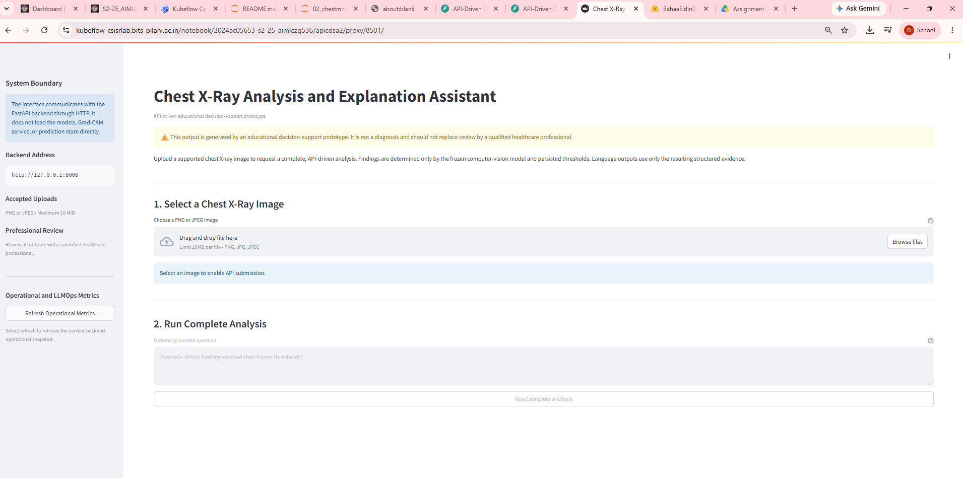
Figure 24. Streamlit landing interface with safety notice, upload contract and HTTP-only system boundary. Source: Live Streamlit application.
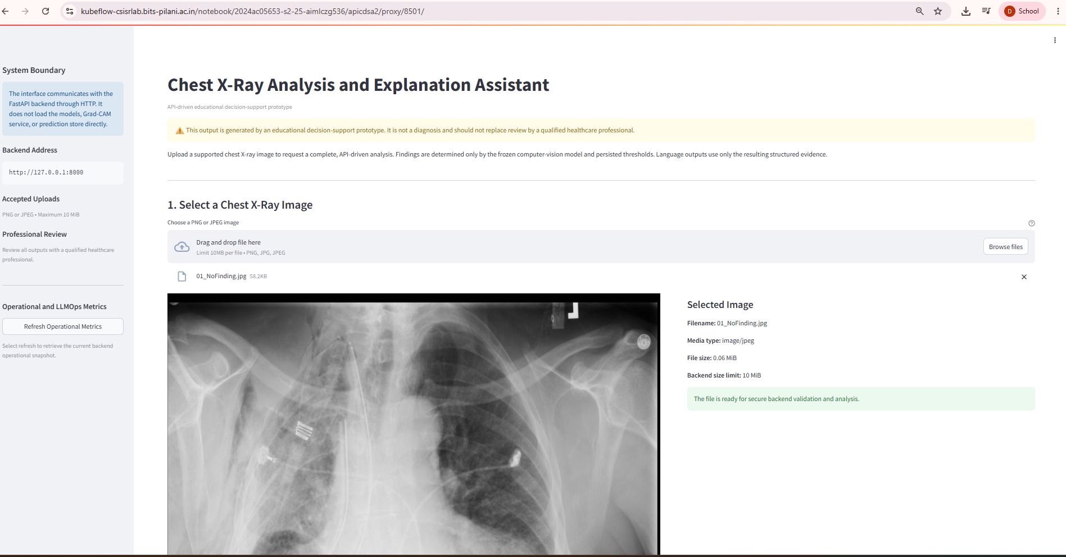
Figure 25. Selected chest X-ray preview and backend-validation boundary before submission. Source: Live Streamlit application.
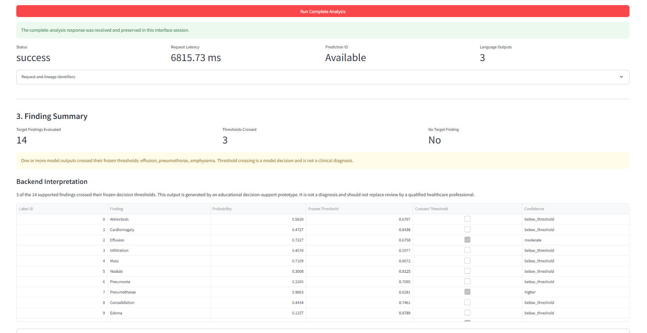
Figure 26. Successful complete-analysis response with 14 findings, three crossed thresholds and persisted prediction ID. Source: Live Streamlit application.
Live demonstration field | Observed application output
Request status | success
End-to-end latency | 6,815.73 ms
Findings evaluated | 14
Thresholds crossed | 3
Crossed model outputs | Effusion, pneumothorax, emphysema
Language outputs | 3 embedded tasks

Scope of interpretation: The report documents observed model outputs and workflow behavior. It does not claim that the crossed thresholds are clinically correct for the uploaded image.

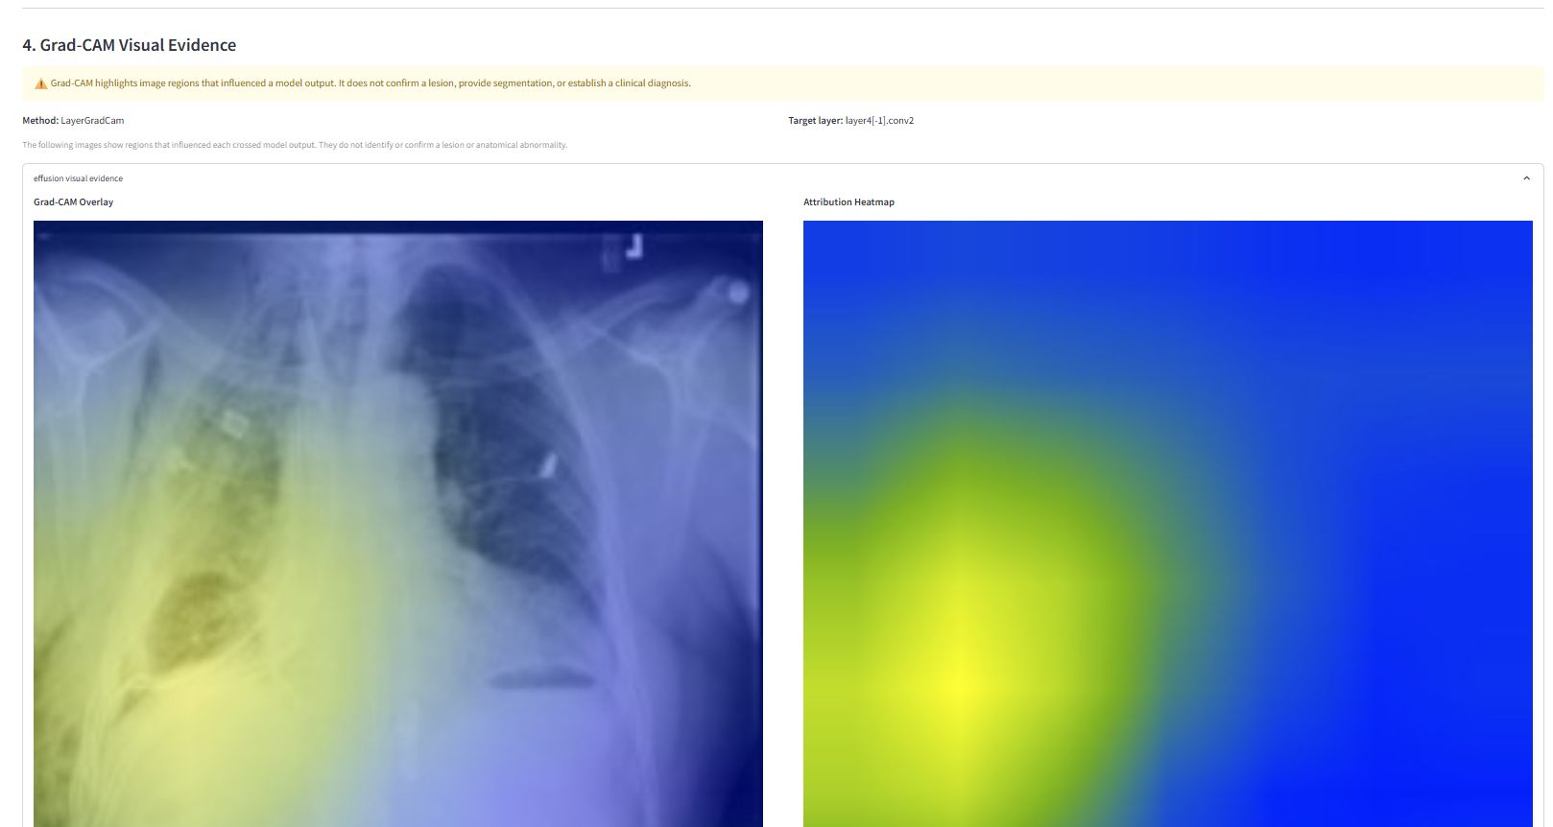
Figure 27. Live effusion Grad-CAM overlay and attribution heatmap with adjacent safety limitation. Source: Live Streamlit application.
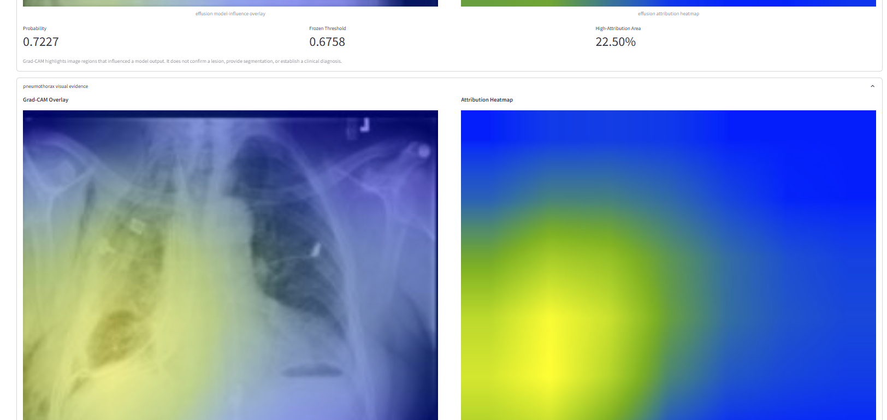
Figure 28. Live visual-evidence panels and evidence metadata for crossed model outputs. Source: Live Streamlit application.
The live application displays Grad-CAM only for crossed findings. Probability, frozen threshold and high-attribution-area percentage remain adjacent to the image evidence so the user can distinguish the decision value from the attribution visualization.
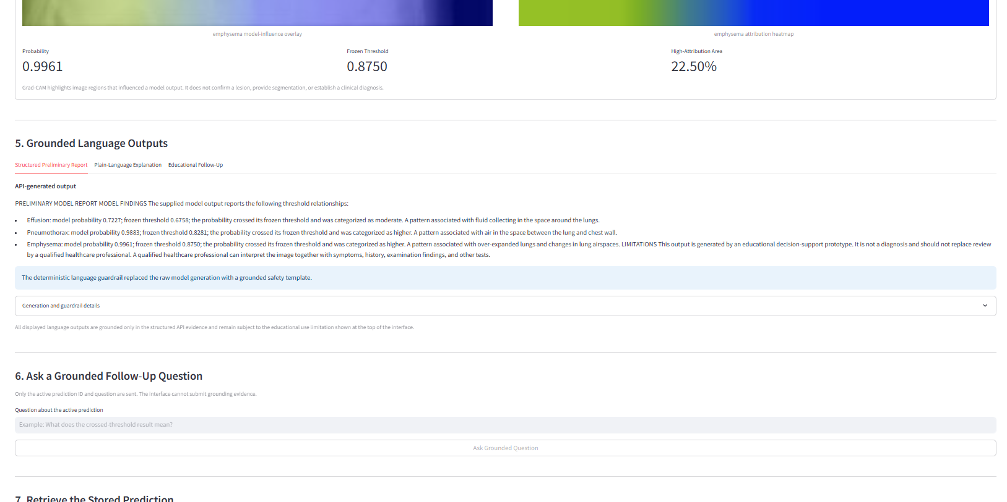
Figure 29. Grounded structured preliminary report and deterministic safety-template notice. Source: Live Streamlit application.
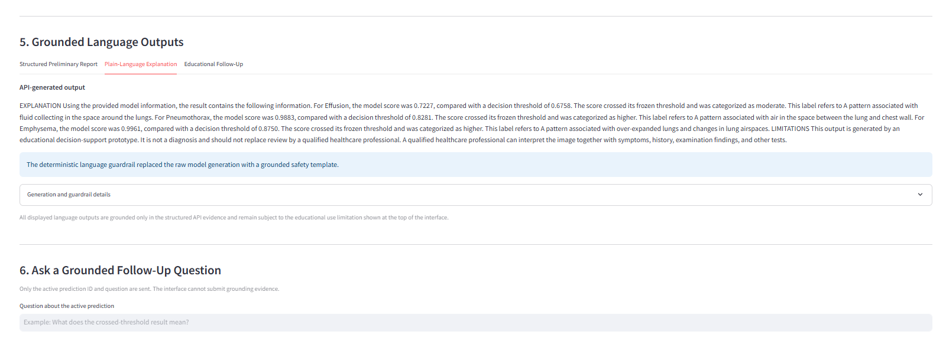
Figure 30. Plain-language explanation grounded in API-provided probabilities and thresholds. Source: Live Streamlit application.
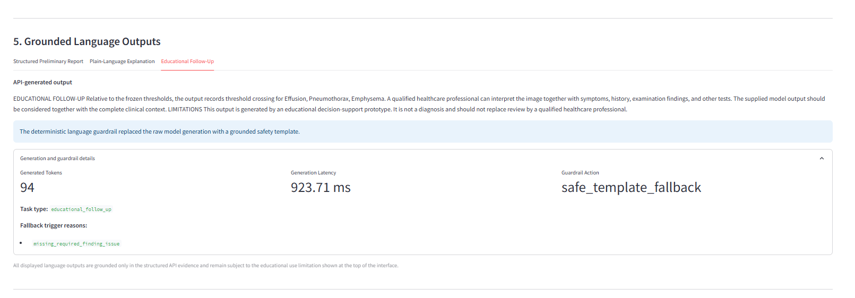
Figure 31. Educational follow-up output with guardrail action, latency and fallback reason. Source: Live Streamlit application.
The main demonstration shows safe_template_fallback for generated language. This is an intended control outcome, not a service failure: the deterministic guardrail detected a missing required finding and replaced the raw output with a grounded template while preserving the trigger reason for audit.
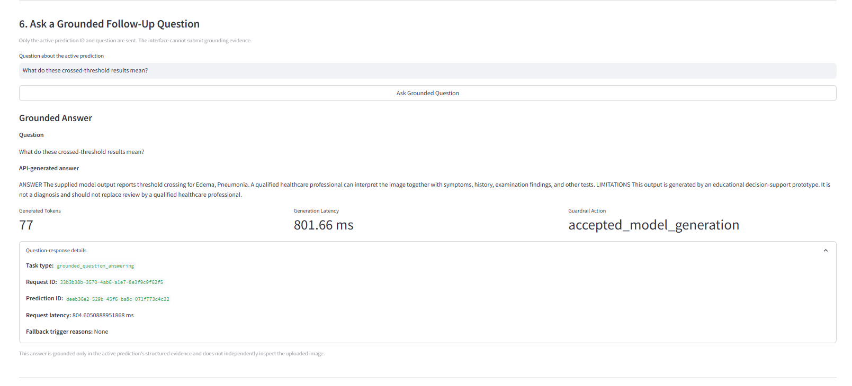
Figure 32. Separate grounded-question interaction showing accepted model generation, request lineage and no fallback. Source: Live Streamlit application.
The follow-up screenshot is treated as a separate prediction interaction because its active evidence differs from the primary demonstration screenshot. It nevertheless validates the same contract: only prediction ID and question are submitted, the answer remains grounded in stored evidence, and the response exposes guardrail action, generated tokens and latency.
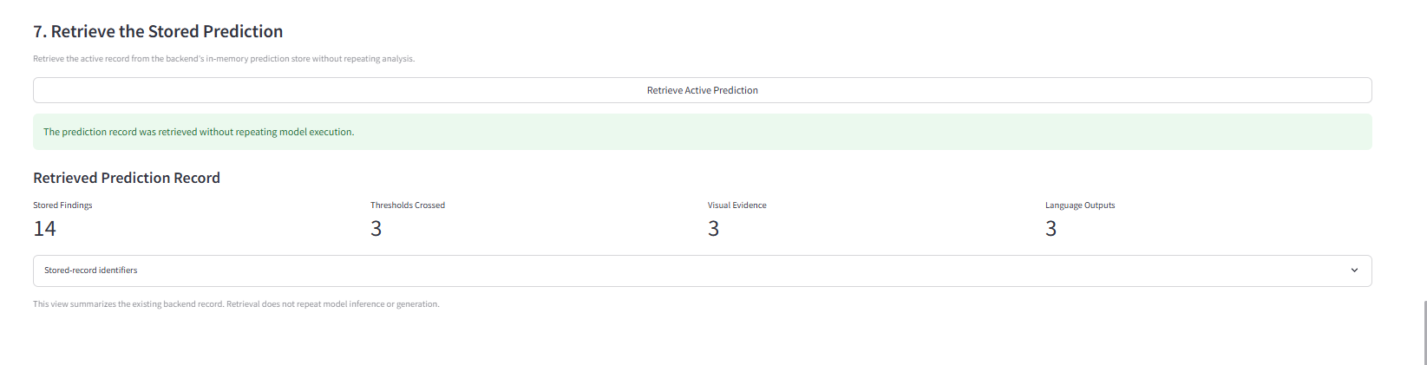
Figure 33. Stored prediction retrieved without repeating classification, Grad-CAM or language generation. Source: Live Streamlit application.
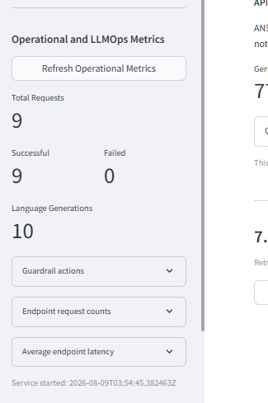
Figure 34. Operational and LLMOps summary showing nine successful requests, zero failures and ten language generations. Source: Live Streamlit application.
Language-generation count can exceed HTTP request count because one complete-analysis request may execute several language tasks. The operational panel therefore measures both request-level and internal language-operation activity.

13. LLMOps, Testing and Operational Evidence
LLMOps is implemented as an evidence chain rather than a single tracking screen. Model, dataset, prompt, schema and API versions are frozen and returned in responses. MLflow records training, evaluation, explainability, language, API, UI and packaging stages. Each stage exports machine-readable evidence and a checksum registry. Operational telemetry records endpoint counts, average latency, language-generation calls and guardrail actions.
LLMOps control | Implementation evidence
Model lineage | resnet18-chestmnist-v1; flan-t5-small-chestmnist-v1
Prompt lineage | grounded-language-prompts-v1
Finding contract | chestmnist-finding-contract-v1
MLflow | Training, evaluation, explainability, language, API, UI and packaging runs
Artifact integrity | SHA-256 checksum registries; 49 final registered files
Operational metrics | Counts, latency, failures, language calls and guardrail actions
Safety monitoring | Raw issues, fallback reasons and post-guardrail compliance
Storage governance | 4 GiB protected reserve; final reserve available

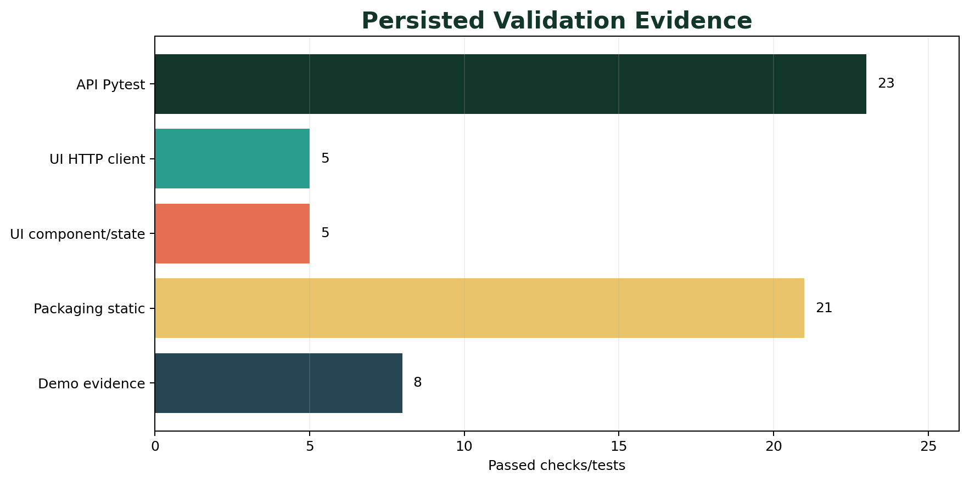
Figure 35. Persisted automated-test and readiness evidence across integration layers.
Validation layer | Passed | Failed | Coverage
API integration | 23 | 0 | System, image, language, complete workflow and controlled errors
UI HTTP client | 5 | 0 | Health, multipart, controlled errors, validation and timeout
UI component/state | 5 | 0 | Initial render, state transitions, table, base64 and HTTP boundary
Static packaging | 21 | 0 | Requirements, Dockerfiles, Compose, docs and launch contracts
Demonstration evidence | 8 | 0 | API/UI health, screenshots, workflow and artifacts
Final readiness | 20 | 0 | End-to-end solution-readiness conditions

14. Packaging and Deployment
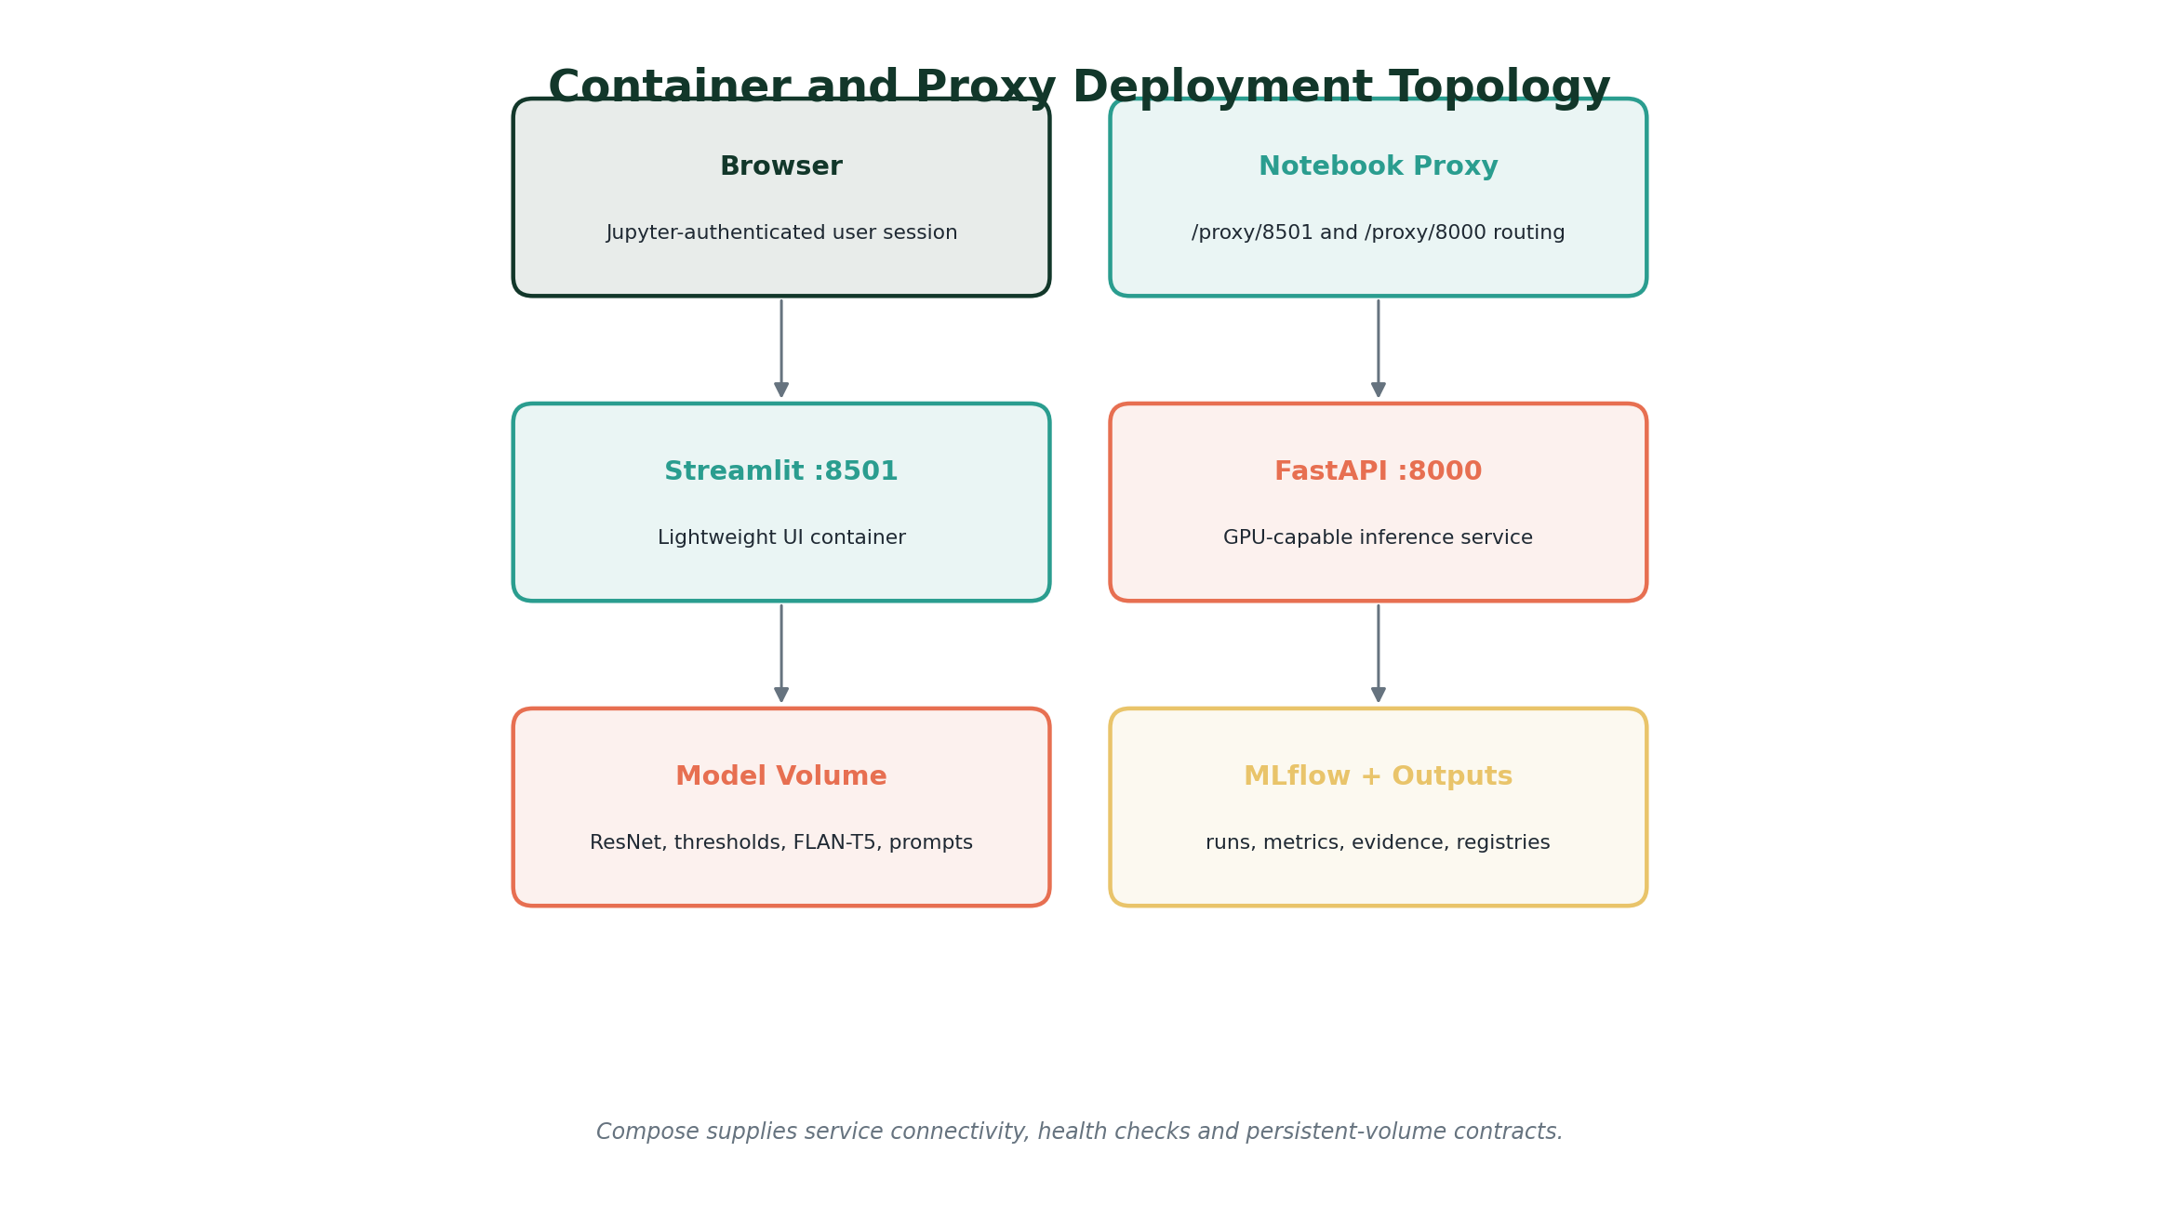
Figure 36. Independent FastAPI and Streamlit deployment topology with proxy routing and persistent volumes.
Notebook 9 defines pinned runtime requirements, separate launch scripts, a GPU-capable FastAPI container, a lightweight Streamlit container, Docker Compose connectivity, persistent model and MLflow volumes, and service-specific health checks. The project intentionally validates static packaging without forcing container builds inside the constrained notebook environment.
Packaging component | Validated contract
FastAPI container | GPU inference dependencies, Uvicorn launch and /health check
Streamlit container | UI-only dependencies and HTTP API base URL
Compose network | Service name resolution and backend-to-UI connectivity
Persistent volumes | Models, outputs, MLflow, caches and artifact registries
Environment contract | API base URL, ports, workers and path configuration
Documentation | README, architecture, usage, API examples, safety and testing
Final registry | 49 files with complete checksums
Final MLflow status | FINISHED

Final gate: 20 of 20 final solution-readiness checks passed; static packaging checks 21/21; demonstration checks 8/8; protected storage reserve preserved.

15. Safety, Limitations and Responsible Use
Medical imaging is a high-stakes domain. The project therefore presents the system as an educational decision-support prototype, displays the limitation before any output, propagates educational_use_only through API responses, and requires professional review in all generated language.
Boundary | Responsible interpretation
Dataset labels | ChestMNIST labels are reference labels for benchmark training/evaluation and may contain noise; they are not new clinical diagnoses.
Supported scope | Only fourteen contracted findings are modeled; absence of a crossed threshold does not establish clinical normality.
Threshold decisions | Crossing a frozen threshold is a model operating-point decision, not confirmation of disease.
Grad-CAM | Attribution indicates model influence and is not segmentation, lesion confirmation or causality.
Language | Outputs are grounded in structured evidence but may require safe-template fallback when raw generation violates the contract.
Prediction store | The demonstration store is in-memory and process-local; restarts clear active prediction identifiers.
Generalization | Results are limited to the training domain and were not validated for clinical deployment, demographics, acquisition shifts or external institutions.
Privacy | Demonstration images must remain de-identified; no patient-specific clinical recommendations are produced.

Required wording: Use 'model output', 'dataset reference label', 'crossed threshold' and 'attribution evidence'. Avoid 'diagnosis', 'confirmed lesion', 'normal X-ray' or 'disease detected'.

16. Assignment Compliance Matrix
Assignment requirement | Project evidence | Status
Select a domain | Healthcare / medical imaging | Satisfied
Choose two AI categories | Computer Vision and Natural Language Processing | Satisfied
At least five subtasks | Six integrated subtasks | Exceeded
Identify appropriate models | ResNet-18, LayerGradCam and FLAN-T5-small | Satisfied
Cohesive unified objective | Vision evidence grounds every language output | Satisfied
API-based interactive application | 12-path FastAPI service, Swagger UI and Streamlit | Satisfied
Apply LLMOps | MLflow, versioning, registries, monitoring and guardrails | Satisfied
At least five metrics | CV, language, grounding, safety and operational metrics | Exceeded
Fine-tune a model | ResNet-18 and FLAN-T5-small fine-tuned | Exceeded
Demonstrate fine-tuned model | Live complete-analysis workflow and screenshots | Satisfied
Screenshots with explanation | Notebook outputs, Swagger and Streamlit figures integrated throughout | Satisfied
Member contributions | Five Assignment II workstreams at 20% each | Satisfied

17. Conclusions and Future Work
The project demonstrates a complete API-driven AI solution rather than an isolated model notebook. It integrates two AI categories and six cohesive subtasks, fine-tunes both vision and language models, exposes strict versioned contracts, presents an interactive interface, preserves evidence and lineage, and validates packaging and operational behavior.
The results also show the value of transparent limitations. Ranking performance is materially stronger than exact multilabel agreement, rare-label precision remains difficult, and raw language generation requires deterministic control. The design makes those limitations visible through per-finding evaluation, error analysis, Grad-CAM boundaries, raw-versus-guarded metrics and professional-review notices.
Future work should evaluate external datasets, calibrate probabilities under acquisition shift, compare stronger vision backbones, add expert-reviewed labels, introduce persistent encrypted storage, perform concurrency and load testing, evaluate subgroup performance, add model-drift monitoring, and conduct clinician-centered usability studies before any consideration of real-world deployment.
Final status: Notebook 9 reports SOLUTION READY FOR REPRODUCIBLE PACKAGING AND DEPLOYMENT. This means the educational prototype and its documented contracts are ready for submission and demonstration; it does not imply clinical readiness.

Appendix A. Complete Endpoint Catalogue
Method | Path | Purpose
GET | /health | Backend health and readiness without model inference
GET | /api/v1/model/info | Model, prompt, explainability and limitation lineage
GET | /api/v1/model/metrics | Persisted vision, language and guardrail metrics
GET | /api/v1/llmops/metrics | Operational request, latency and guardrail metrics
POST | /api/v1/image/classify | Validate and classify one chest X-ray
POST | /api/v1/image/analyze | Classify and return finding-specific visual evidence
POST | /api/v1/report/generate | Generate a grounded preliminary report
POST | /api/v1/explanation/generate | Generate a grounded plain-language explanation
POST | /api/v1/question/answer | Answer a question using stored prediction evidence
POST | /api/v1/follow-up/recommend | Generate controlled educational follow-up
POST | /api/v1/analyze-complete | Execute the complete image-to-language workflow
GET | /api/v1/predictions/{prediction_id} | Retrieve a stored prediction without repeated inference

Appendix B. Key Version and Artifact Traceability
Artifact/contract | Version or evidence
Computer-vision model | resnet18-chestmnist-v1
Language model | flan-t5-small-chestmnist-v1
Prompt registry | grounded-language-prompts-v1
Finding contract | chestmnist-finding-contract-v1
API contract | api-contract-v1
Readiness contract | fastapi-integration-readiness-v1
UI version | streamlit-interface-v1
Final registered files | 49 checksum-validated artifacts
Final MLflow status | FINISHED
Final storage | 8.71 GiB free; 4.00 GiB reserve preserved

References
1. Yang, J. et al. MedMNIST v2 - A large-scale lightweight benchmark for 2D and 3D biomedical image classification. Scientific Data 10, 41 (2023). https://doi.org/10.1038/s41597-022-01721-8
2. He, K., Zhang, X., Ren, S., and Sun, J. Deep Residual Learning for Image Recognition. CVPR (2016). https://doi.org/10.1109/CVPR.2016.90
3. Selvaraju, R. R. et al. Grad-CAM: Visual Explanations from Deep Networks via Gradient-Based Localization. ICCV (2017). https://doi.org/10.1109/ICCV.2017.74
4. Chung, H. W. et al. Scaling Instruction-Finetuned Language Models. Journal of Machine Learning Research 25 (2024). https://arxiv.org/abs/2210.11416
5. PyTorch documentation. https://pytorch.org/docs/stable/
6. Captum model interpretability documentation. https://captum.ai/
7. Hugging Face Transformers documentation. https://huggingface.co/docs/transformers/
8. FastAPI documentation. https://fastapi.tiangolo.com/
9. Streamlit documentation. https://docs.streamlit.io/
10. MLflow documentation. https://mlflow.org/docs/latest/
11. Project evidence: Notebooks 01-09, persisted API/UI validation artifacts and live screenshots supplied by Group 89.

