SOFTWARE ENGINEERING FOR MACHINE LEARNING
Software-Engineered Chest X-Ray
Analysis and Explanation System
Assignment II — Engineering Implementation and Quality Assurance

Domain | Healthcare / medical imaging
Engineering focus | Modular ML software, automated QA and deployment controls
Group | Group 89

⁠0. Group Details & Contribution
Group No: 89
Implementation ownership was divided across requirements, data quality, ML pipeline construction, architecture, validation and report integration. Each contribution is tied to a concrete engineering responsibility within the delivered system.
# | BITS ID | Name | Contribution | Weight
1 | 2024ac05672@wilp.bits-pilani.ac.in | Ananda Vadivel D | Requirements formulation, GR4ML view preparation, quality requirement justification | 25%
2 | 2024ac05968@wilp.bits-pilani.ac.in | Adurti Sai Venkatesh | Dataset preparation, exploratory data analysis, visualization support, data quality validation | 25%
3 | 2024ac05653@wilp.bits-pilani.ac.in | D Mallikarjuna Reddy | ML pipeline implementation, model comparison, final evaluation, report integration | 25%
4 | 2024ac05055@wilp.bits-pilani.ac.in | Krupashankar Subramani | System architecture, architectural pattern mapping, model registry artifacts, inference and application validation | 25%

Engineering Requirements Traceability
The traceability table connects each implemented engineering capability to its concrete mechanism, verification evidence and detailed report location. It provides a compact system-level index without duplicating the technical analysis in later sections.
Engineering capability | Implemented mechanism | Verification evidence | Report location
Modular design | Separated data, model, workflow, inference and telemetry packages. | Topology and service-contract audits | Sections 3-4
Research-production parity | Notebook probability path paired with ComputerVisionService. | 10/10 contracts; parity at 1e-6 | Section 5
Operational logging | INFO, WARNING and ERROR events in three critical services. | Six structured-logging tests | Section 6
Static code quality | Pinned Black, isort and Ruff with transactional remediation. | Zero findings; compile and regression pass | Section 7
Typed inference API | Strict schemas, status codes, error contracts and versions. | 12 paths and 12 OpenAPI operations | Section 12; App. A
Multi-layer testing | Unit, data, model, security, API and deployment tests. | 81 repository-wide tests pass | Section 9
ML behavior contracts | Small-batch optimization and frozen inference parity. | Loss, shape, range and parity assertions | Sections 8.2, 11
Quality measurement | Data integrity plus ROC-AUC, AP and F1 metrics. | Versioned data/model metric artifacts | Sections 10-11
Production experiment | Deterministic 10% non-interfering shadow route. | Routing and isolation tests | Section 14
Security control | Media, signature, size, integrity and dimension validation. | Six adversarial upload tests | Section 13
Table 1. Engineering capability, implementation and verification traceability.

⁠Table of Contents
Engineering Requirements Traceability
1. Executive Summary
2. Engineering Context and System Scope
3. Architecture and Responsibility Boundaries
4. Modularity and Object-Oriented Contracts
5. Research-to-Production Refactoring
6. Exception Handling and Structured Logging
7. Code Quality and Static Analysis
8. Production Data and Training Components
9. Test Strategy and Regression Evidence
10. Data Quality and Drift Controls
11. Model Quality and Inference Integrity
12. FastAPI Contract and Application Integration
13. Security Engineering
14. Shadow Deployment Strategy
15. Packaging, Reproducibility and Deployment Readiness
16. Evidence Integrity and Final Readiness
17. Technical Limitations and Next Engineering Iterations
18. Conclusion
Appendix A. Endpoint Catalogue
Appendix B. Notebook and Artifact Traceability
Appendix C. Evidence Registry
Appendix D. Selected Implementation Excerpts
References

⁠1. Executive Summary
The Software-Engineered Chest X-Ray Analysis and Explanation System converts an interactive machine-learning workflow into a modular, testable and deployable software system. The implementation separates data access, model construction, image validation, classification, visual explanation, grounded language generation, prediction persistence, operational metrics, API schemas and user-interface integration into explicit components with validated contracts.
Engineering evidence was generated through static repository audits, public-symbol inspection, exception-path analysis, structured logging tests, deterministic data checks, frozen-model inference parity, upload-security tests, OpenAPI schema tests, shadow-deployment policy tests, packaging contracts and a repository-wide regression suite. All thirteen final readiness gates passed.
The implementation unifies modular service boundaries, research-to-production parity, structured logging, typed API contracts and automated quality gates. Model training and inference behavior, data integrity, security controls and deployment experimentation are verified through executable tests and versioned evidence artifacts.
45  Initial audited modules | 11,040  Initial source lines | 48 → 81  Expanded regression tests | 0  Final lint findings

Verified outcome
- The service layer exposes stable object-oriented boundaries without changing the fourteen-label inference contract.
- Research and production probability vectors match exactly within an absolute tolerance of 1 × 10⁻⁶.
- The frozen test partition contains 22,433 images; threshold recalibration and test inference reruns were explicitly excluded from the final evidence extraction.
- The deployment package defines API and UI services, health checks, pinned dependencies and external model/data mounts without embedding large runtime artifacts.
- A SHA-256 evidence manifest binds 52 evidence files and 80 repository files to the final readiness decision.
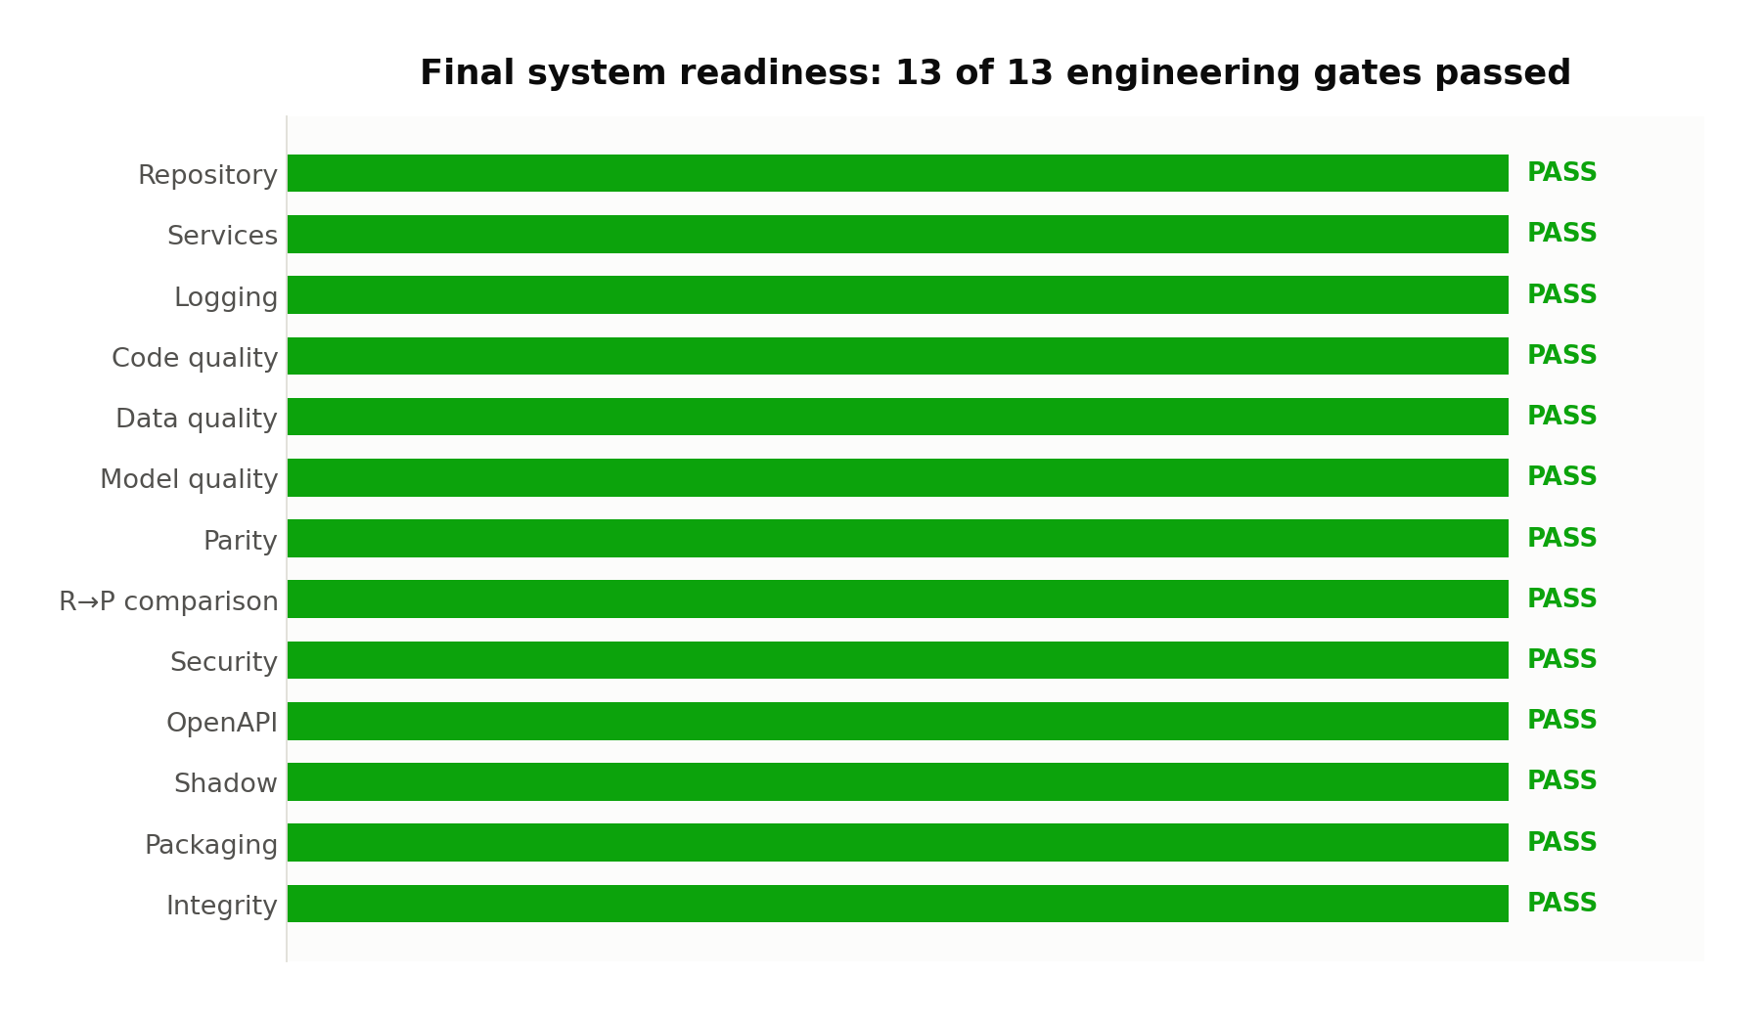
Figure 1. Final readiness gate summary generated from the validated evidence registry.

⁠2. Engineering Context and System Scope
The system accepts a chest X-ray image, validates its media and dimensional contract, produces fourteen ordered finding probabilities, identifies threshold crossings, generates Grad-CAM visual evidence, serializes grounded findings for language generation, applies deterministic output guardrails and exposes the result through typed API and UI workflows. The software scope includes both the ML execution path and the controls required to operate that path predictably.

2.1 Functional execution path
1. Validate the declared media type, decoded format, byte size, pixel dimensions and image integrity.
2. Normalize and preprocess the image under the frozen model input contract.
3. Execute ResNet-18 inference and preserve the configured fourteen-label order and per-label thresholds.
4. Generate visual evidence only for threshold-crossed findings using the configured Grad-CAM target layer.
5. Persist the prediction record and attach explainability and grounded-language outputs through controlled upserts.
6. Return strict response schemas with request metadata, component versions, latency and controlled errors.

2.2 Software-quality objectives
Each software-engineering practice below was selected because it maps to a specific quality risk in ML systems rather than to general application code: modularity keeps the data, model and serving concerns independently testable; observability and reproducibility let a prediction be traced back to the exact model version and input contract that produced it; and automated QA gives an objective, repeatable signal in place of ad-hoc notebook checks.
Quality attribute | Implemented control | Verification mechanism
Modularity | Service, workflow, schema and configuration boundaries | AST topology and public-contract audit
Correctness | Frozen label order, thresholds and tensor contracts | Inference parity and behavior tests
Observability | Structured lifecycle, validation, inference and guardrail events | Six behavior tests plus event inventory
Security | Content-aware upload validation and controlled error responses | Six adversarial upload tests
Reproducibility | Pinned dependencies, configuration artifacts and SHA-256 evidence | Packaging and integrity contracts
Deployability | Separate API/UI images, health checks and external artifact mounts | Eleven deployment contract tests

⁠3. Architecture and Responsibility Boundaries
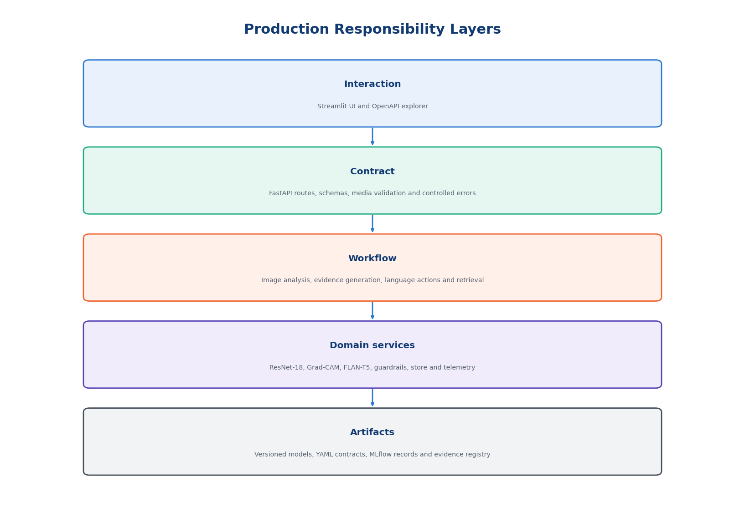
Figure 2. Layered production architecture and responsibility separation.
The architecture uses dependency injection through a ServiceContainer. Construction is isolated in the factory, request handlers depend on declared services, and workflow classes coordinate multiple services without owning model construction. This keeps HTTP concerns, ML execution, persistence, telemetry and schema serialization independently testable.

3.1 Runtime component map
Layer | Primary modules | Owned responsibility
Interaction | ui.app, ui.components, ui.api_client | Session state, upload workflow, evidence rendering, retrieval and metrics views
HTTP contract | api.main, api.routes.*, api.schemas.* | Routing, strict validation, response types, exception translation and OpenAPI
Orchestration | image_workflow, language_workflow, complete_workflow | Sequencing, metadata propagation, record updates and service invocation metrics
Domain services | image, computer_vision, gradcam, grounding, language, guardrail | Validation, inference, explanation, serialization and controlled generation
State and operations | prediction_store, operational_metrics | Bounded in-memory retention, thread-safe updates and operational snapshots
Configuration | configs/*.yaml, *.json | Finding order, thresholds, paths, prompts, limits and response templates

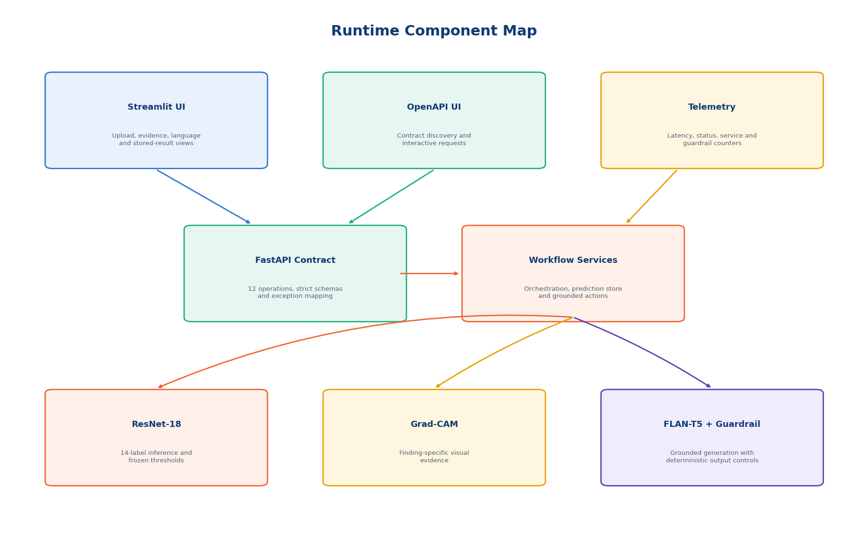
Figure 3. System component architecture as exercised by the application workflows.

⁠4. Modularity and Object-Oriented Contracts
A static AST audit parsed all 45 initial Python modules without syntax failure. The audited baseline contained 61 classes, 74 functions and 77 dependency references across 11,040 source lines. The service-contract audit then validated sixteen requested modules, twenty-seven classes, forty-two public methods and fourteen public functions with no missing or invalid module.
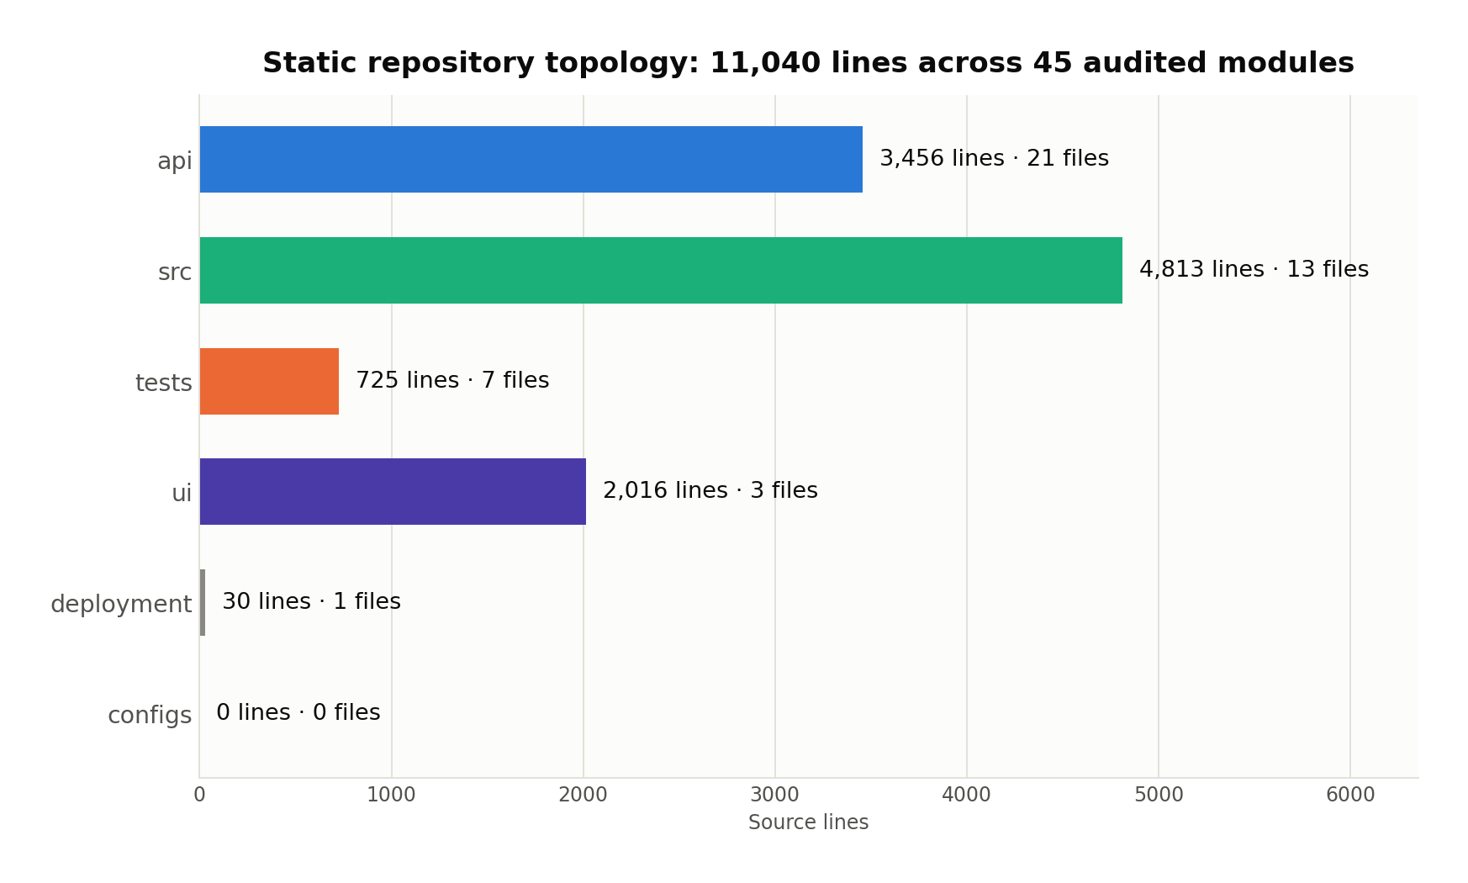
Figure 4. Audited repository topology before the additional QA modules were introduced.

4.1 Core service contracts
Component | State and synchronization | Public contract
ImageValidationService | Validated settings; no raw content retained | validate_and_decode → ValidatedImage
ComputerVisionService | Model, thresholds, device and inference lock | preprocess; predict; is_ready; confidence_category
GradCAMService | Target layer, device, dtype and generation lock | generate; generate_for_crossed_findings
GroundedInputSerializer | Model version, task prefixes and limitation contract | normalize_finding; serialize
GroundedLanguageModelService | Tokenizer, model, device and inference lock | generate; generate_many
DeterministicLanguageGuardrail | Required limitation and review strings | audit; apply; build_fallback
PredictionStoreService | Thread-safe bounded record store and retention | create; get; attach; upsert; snapshot
OperationalMetricsService | Thread-safe counters and bounded latency samples | record_*; snapshot

4.2 Design properties
- Encapsulation: model and tokenizer lifecycle state remains private to the service that owns it.
- Single-responsibility boundaries: validation, inference, explainability, serialization, guardrails and persistence are separate modules.
- Dependency inversion: workflow services receive collaborators and metadata builders through constructors.
- Concurrency control: inference, generation, metrics and record operations use explicit locks around shared mutable state.
- Schema stability: dataclass result objects and Pydantic response models preserve typed boundaries across layers.

5. Research-to-Production Refactoring
The production implementation preserves the trained model’s numerical behavior while relocating notebook-controlled state into reusable software components. The comparison uses a frozen reference probability path and validates both structural contracts and numerical parity.
Dimension | Research implementation | Production implementation
Execution boundary | Notebook-controlled execution state | Reusable ComputerVisionService instance
Model lifecycle | Construction and restoration in cells | Service-owned construction, restoration and readiness
Configuration | Notebook variables and metadata | Validated ServiceSettings dependency
Preprocessing | Transformation sequence executed directly | Reusable preprocess method with fixed tensor contract
Concurrency | Single interactive flow | Inference lock protects shared model state
Failure handling | Notebook exception propagation | ModelNotReadyError and ServiceExecutionError
Observability | Cell output and evaluation artifacts | Structured lifecycle and inference events
Output | Fourteen sigmoid probabilities | ClassificationResult with ordered finding evidence
Verification | Frozen reference probability path | Automated numerical parity and contract tests

10/10  Production contracts | 14  Ordered labels | 1×10⁻⁶  Absolute tolerance | 0.0000000000  Maximum difference
The zero observed difference demonstrates that the refactoring changed ownership and execution structure without changing the output vector. The test also verifies that the frozen checkpoint was not modified.

⁠6. Exception Handling and Structured Logging
Exception control begins with domain-specific ServiceError subclasses and ends with typed API error responses. Invalid images, unsupported media, excessive payloads, unavailable models, missing predictions, grounding-contract violations and service execution failures are translated without exposing internal exception text or sensitive request content.
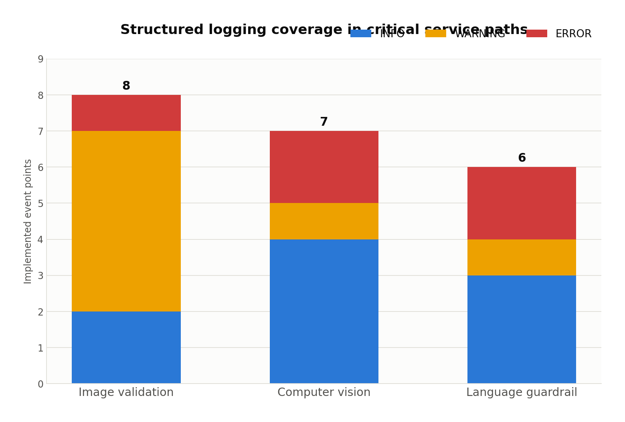
Figure 5. Implemented log-event points by severity and critical module.

6.1 Exception boundary
Failure class | Detection location | External behavior
UnsupportedMediaTypeError | Declared type and decoded format validation | Controlled 4xx response with supported-type details
InvalidImageError | Empty, corrupt or dimensionally invalid image | Controlled image-validation error
UploadTooLargeError | Maximum upload-byte boundary | Controlled size error without reading further workflow state
ModelNotReadyError | Model load or inference readiness check | Component readiness failure
PredictionNotFoundError | Prediction-store lookup | Controlled missing-record response
GroundingContractError | Finding serialization or generation precondition | Controlled grounded-language failure
ServiceExecutionError | Unexpected inference/generation execution | Sanitized service failure with request metadata

6.2 Sensitive-content exclusion
Logging behavior tests verify event semantics and exclusion boundaries. Logs do not contain raw image bytes, uploaded filenames, checkpoint paths, tensor values, probability arrays, generated text, user questions, serialized prompts or finding evidence. Six dedicated tests passed in 2.98 seconds.
The implemented log statements use stable event names and structured scalar metadata so that operational queries do not depend on free-form message parsing.

⁠7. Code Quality and Static Analysis
A pinned development toolchain was defined in requirements.dev.txt and pyproject.toml: pytest 8.3.5, Black 24.10.0, isort 5.13.2 and Ruff 0.9.10 targeting Python 3.11 across src, api, ui and tests. The baseline was captured without modifying source files, followed by transactional remediation with a snapshot and rollback boundary.
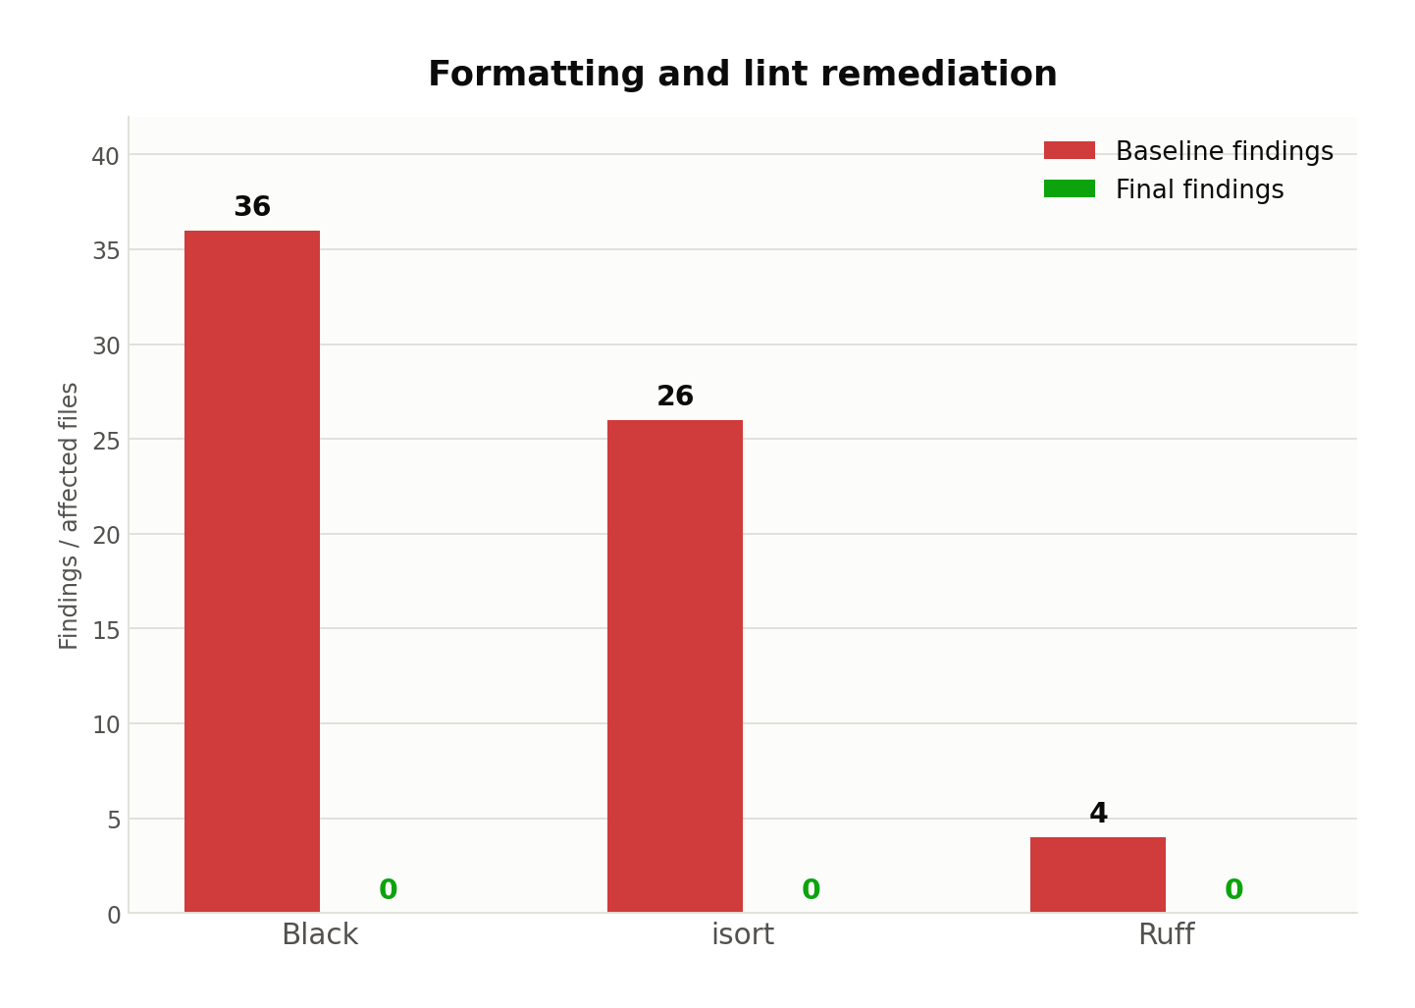
Figure 6. Baseline findings and final zero-finding state.

7.1 Transactional remediation
1. Snapshot all 45 in-scope Python files before mutation.
2. Run the complete pre-remediation regression suite and require a zero return code.
3. Apply Ruff fixes, isort import normalization and Black formatting in a deterministic order.
4. Compile the repository and re-audit public symbols to detect structural contract changes.
5. Run the post-remediation suite; restore the snapshot automatically on any gate failure.
Gate | Baseline | Final | State
Black | 36 affected files | 0 | PASS
isort | 26 affected files | 0 | PASS
Ruff | 4 findings | 0 | PASS
compileall | Not a finding count | Return code 0 | PASS
Public symbols | Captured | Unchanged | PASS

⁠8. Production Data and Training Components
Production data access uses NumPy memory mapping so the 5.36 GiB image corpus is validated without loading complete arrays into process memory. The reusable ChestMNIST dataset component enforces split names, shapes, data types and label width before exposing samples to training or validation code.
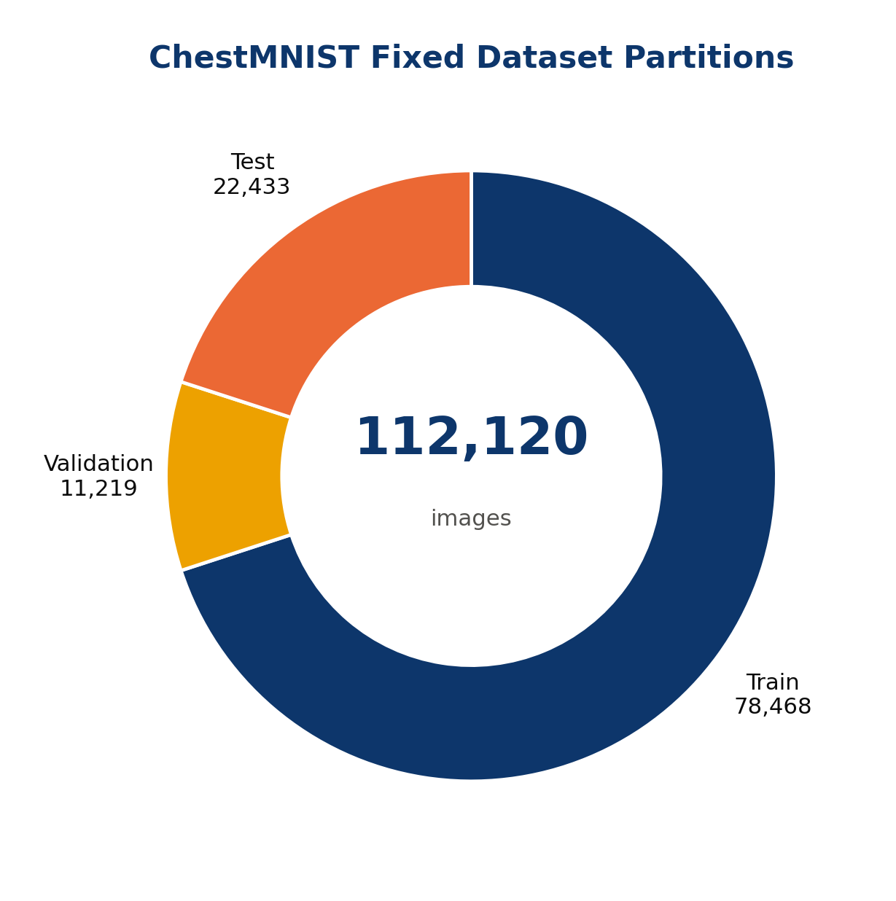
Figure 7. ChestMNIST split composition used by the data-access contract.
Split | Image shape | Label shape | Image dtype | Label dtype | Memmap
train | (78,468, 224, 224) | (78,468, 14) | uint8 | uint8 | True
val | (11,219, 224, 224) | (11,219, 14) | uint8 | uint8 | True
test | (22,433, 224, 224) | (22,433, 14) | uint8 | uint8 | True

8.1 Reusable model factory
src.models.resnet18_factory constructs a fourteen-output ResNet-18 under an explicit freezing policy. The small-batch trainer owns the optimizer-facing head parameters while leaving the backbone frozen. A two-sample smoke batch produced shape (2, 14) with 11,183,694 total parameters and 7,182 trainable parameters.

8.2 Training behavior test
8  Batch size | 20  Optimization steps | 0.7892 → 0.1132  Loss trajectory | 85.65%  Relative reduction
The CUDA test validates loss reduction, head updates, frozen backbone invariance and non-creation of a checkpoint. The observed behavior test passed in 9.47 seconds.

9. Test Strategy and Regression Evidence
The test strategy separates deterministic component behavior, ML-specific contracts, adversarial validation, API integration, experimentation policy and deployment packaging. Tests are designed around externally observable contracts rather than implementation line coverage alone.
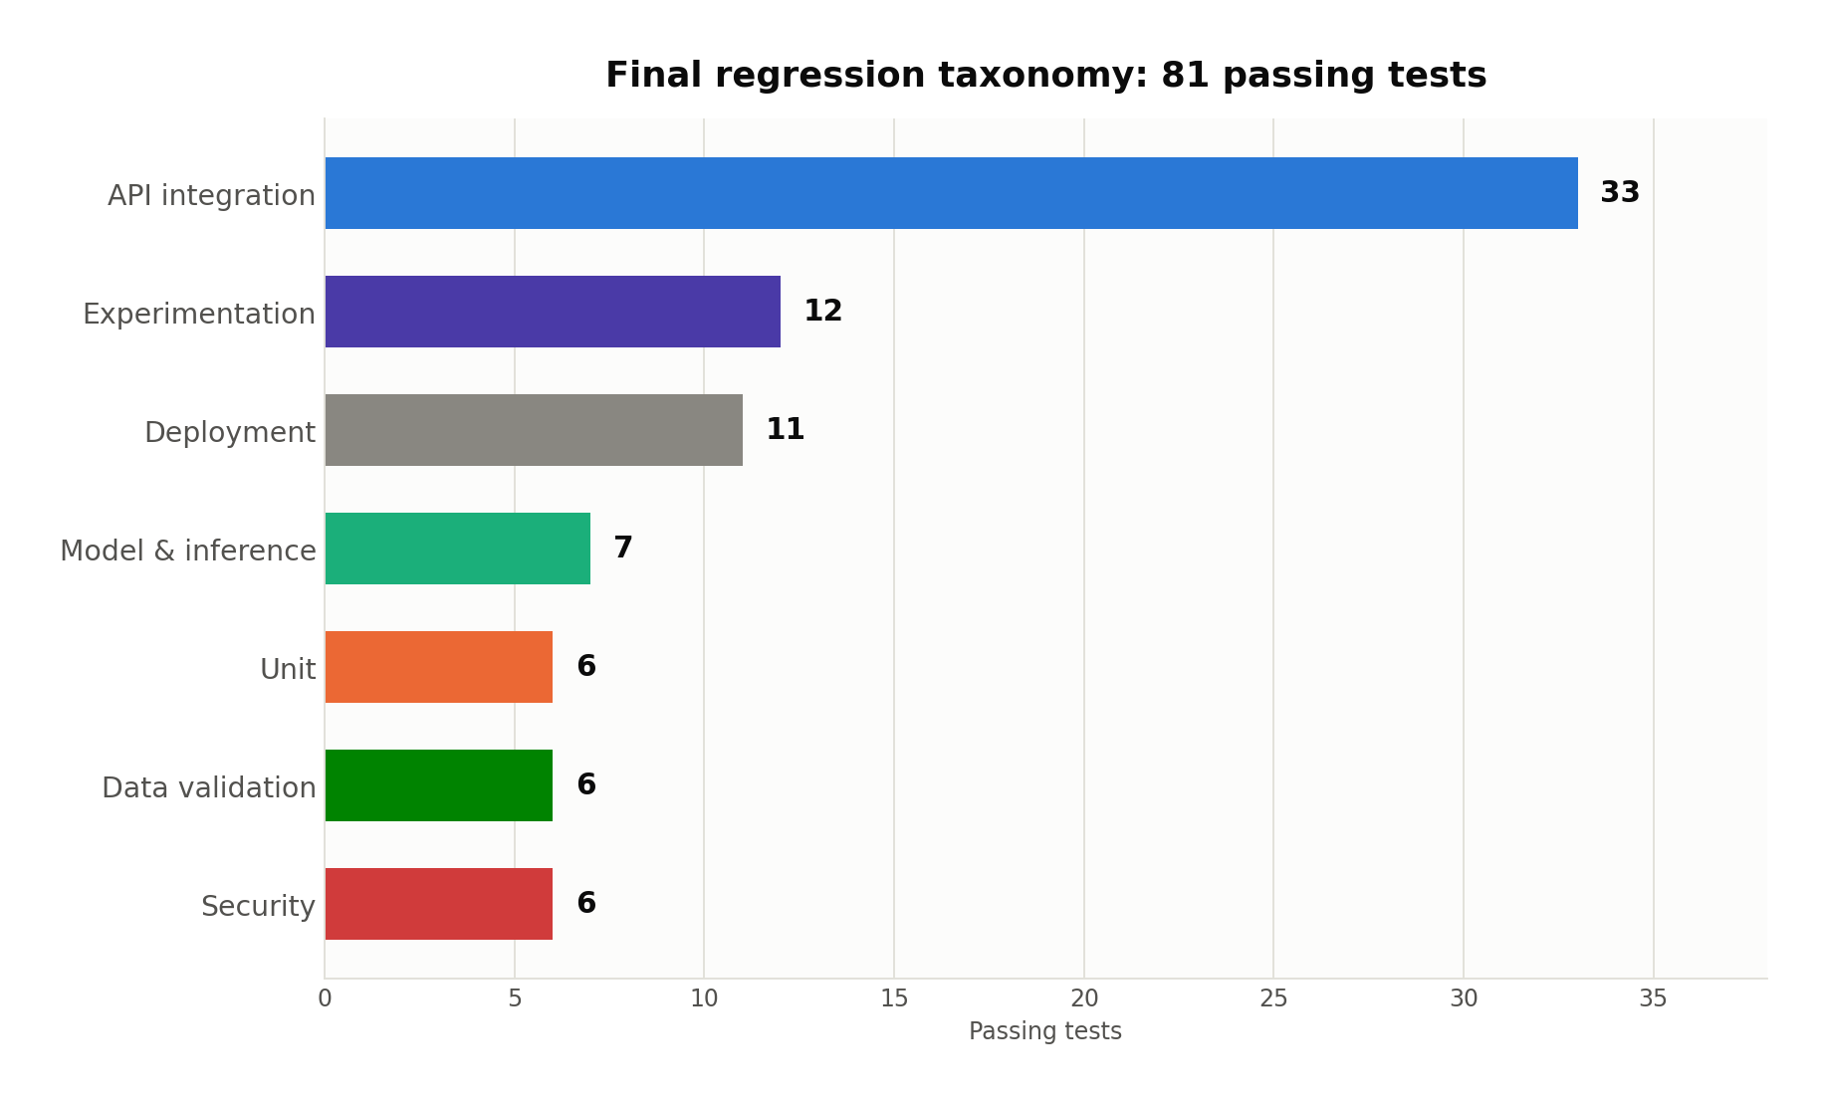
Figure 8. Final regression distribution by engineering concern.
Category | Validated behavior | Passing tests
Unit | Structured log events and sensitive-content exclusion | 6
Data validation | Schema, missingness, binary labels, isolation and drift | 6
Model and inference | Training loss, frozen backbone, shape, label order and parity | 7
Security | Content spoofing, corruption, size, dimensions and controlled errors | 6
API integration | Workflows, retrieval, system endpoints and OpenAPI schema | 33
Experimentation | Deterministic sampling, isolation, metrics and kill switch | 12
Deployment | Docker descriptors, health checks, dependencies and artifact boundaries | 11

9.1 Final repository-wide execution
81  Tests passed | 1  Warning | 71.64 s  Regression time | 0  Failures
Black, isort, Ruff and compileall also returned zero in the same final validation boundary. Services were not started and models were not loaded during the repository-wide gate; model behavior was exercised separately by dedicated tests.

10. Data Quality and Drift Controls
Data validation evaluates schema correctness, finite-value completeness, binary-label validity, split-artifact isolation and inter-split label-distribution stability. All measurements operate on the authoritative split artifacts and preserve the image-level multilabel interpretation contract.
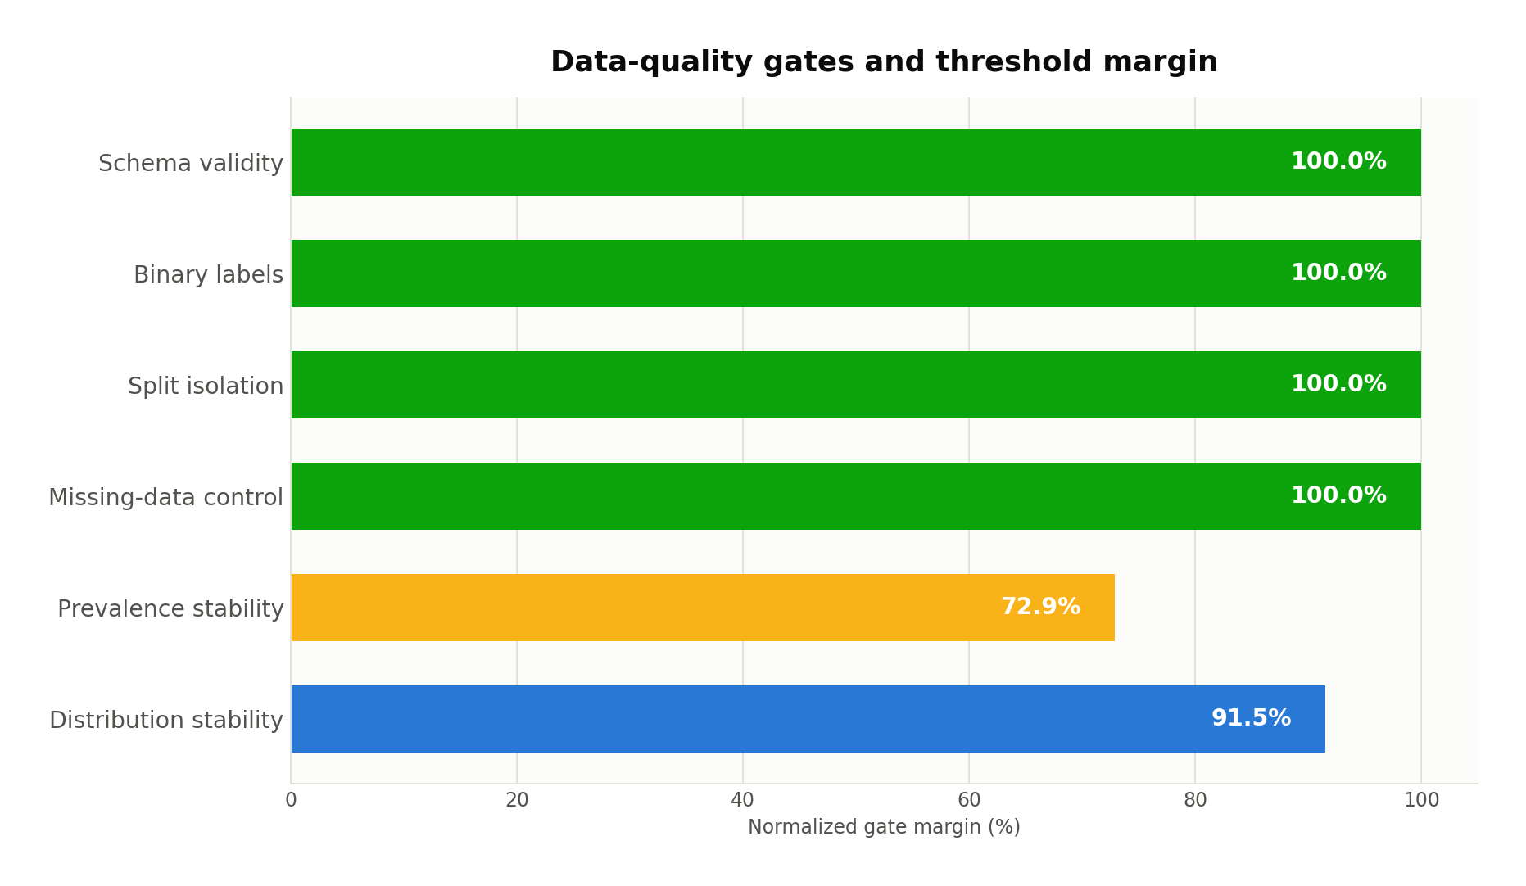
Figure 9. Normalized data-quality gate margins; higher values indicate greater threshold headroom.
Metric | Observed | Threshold | State
Schema-validity rate | 1.00000000 | >= 1.000000 | PASS
Missing / non-finite rate | 0.00000000 | <= 0.000000 | PASS
Binary-label-validity rate | 1.00000000 | >= 1.000000 | PASS
Split-artifact isolation rate | 1.00000000 | >= 1.000000 | PASS
Maximum prevalence shift | 0.00813528 | <= 0.030000 | PASS
Maximum Jensen–Shannon divergence | 0.00084628 | <= 0.010000 | PASS

The largest prevalence shift occurs for atelectasis between validation and test partitions. The maximum Jensen–Shannon divergence also occurs for validation versus test. Both remain materially inside their configured gates.

⁠11. Model Quality and Inference Integrity
Model-quality evidence is read from the frozen test-partition evaluation artifacts for resnet18-chestmnist-v1. The evidence covers 22,433 images and fourteen output labels. Threshold recalibration was not performed, the test inference was not rerun for this report, and the extracted values preserve parity with the recorded MLflow outputs.
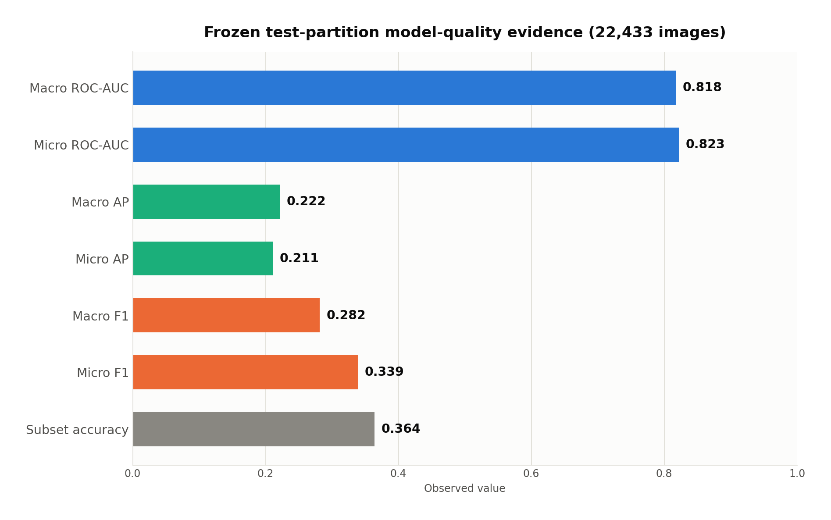
Figure 10. Selected frozen test-partition metrics.
Metric | Macro | Micro
ROC-AUC | 0.817548 | 0.822593
Average precision | 0.221623 | 0.211137
Precision | 0.224136 | 0.261507
Recall | 0.415256 | 0.482132
F1 | 0.281583 | 0.339091

Additional multilabel measures: Hamming loss = 0.098799; subset accuracy = 0.364151. ROC-AUC and ranking performance must be interpreted separately from threshold-dependent precision, recall and exact-subset measures.
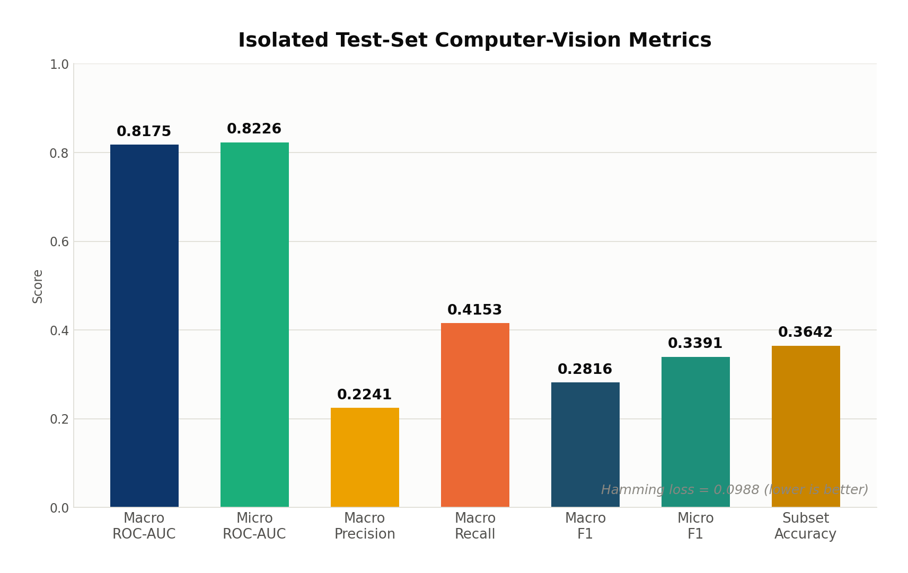
Figure 11. Recorded isolated-test evaluation summary for the frozen model.

11.1 Explainability contract
Grad-CAM is generated for findings whose probabilities cross configured thresholds. The output carries the target finding, heatmap/overlay payload, layer identity and a limitation string. Generation is serialized by a lock because gradient hooks and shared model state are not independently re-entrant.
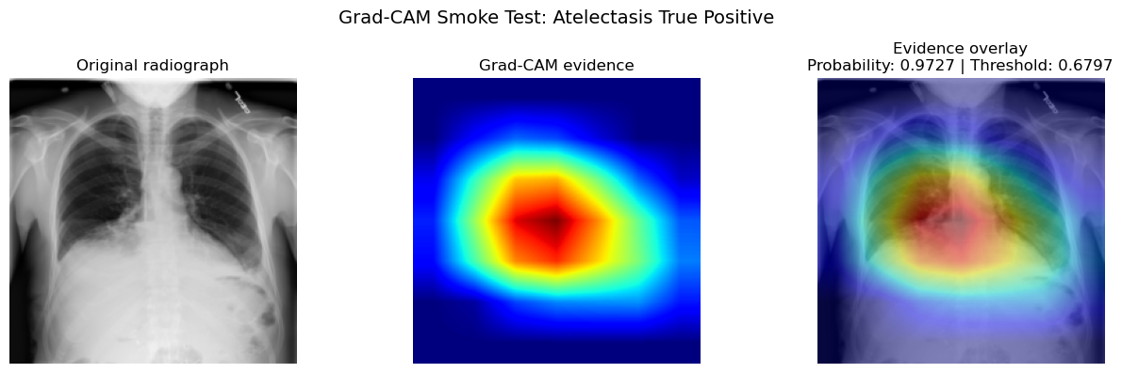
Figure 12. Grad-CAM smoke validation showing the raw radiograph, heatmap and overlay.

⁠12. FastAPI Contract and Application Integration
FastAPI provides the typed boundary around the domain services. Request models forbid unknown fields where appropriate, upload endpoints use content-aware validation, response schemas carry model versions and request metadata, and application-level exception handlers map domain failures to stable API error structures.
12  Registered paths | 12  Operations | 23  Component schemas | 3.1.0  OpenAPI version
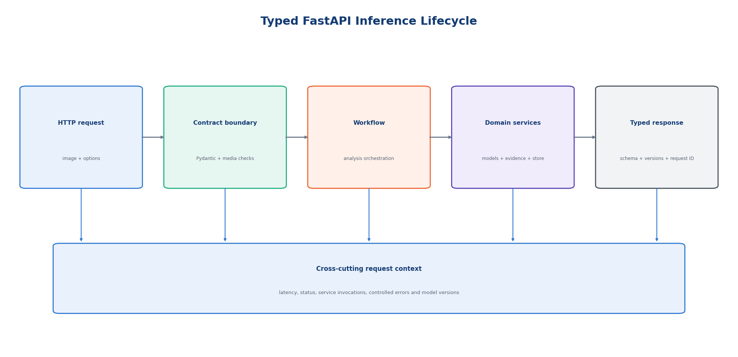
Figure 13. Typed inference lifecycle from request validation through workflow execution, domain services and telemetry.
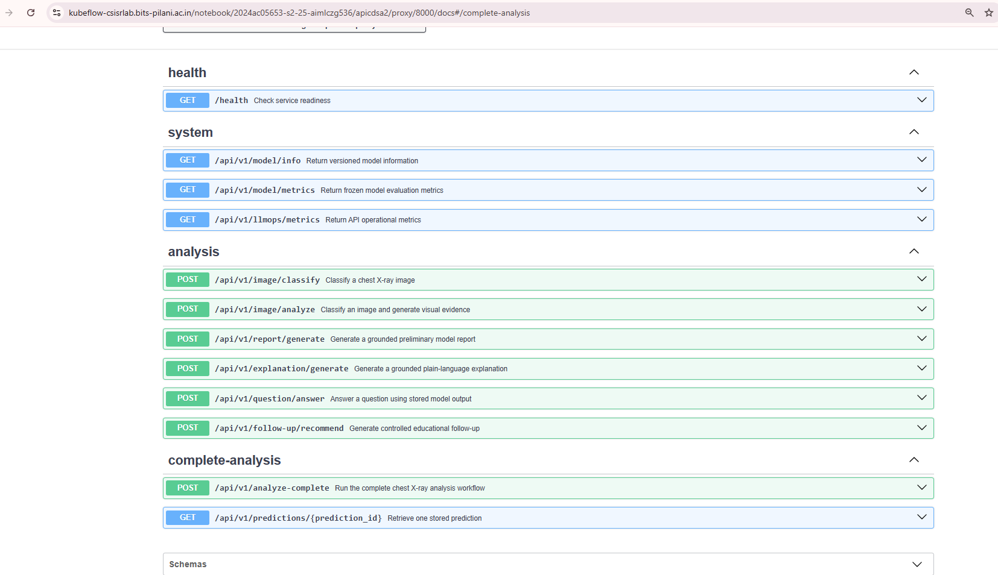
Figure 14. OpenAPI workflow and system endpoints exposed by the service.

12.1 Integration behavior
- Image workflows support classification-only and classification-plus-Grad-CAM execution.
- Language workflows retrieve an existing prediction, serialize its grounded evidence and persist guarded outputs by task type.
- The aggregate workflow executes image analysis, report generation, explanation, optional question answering and follow-up generation under one request context.
- System endpoints publish health, model metadata, model quality and operational metrics independently of prediction execution.
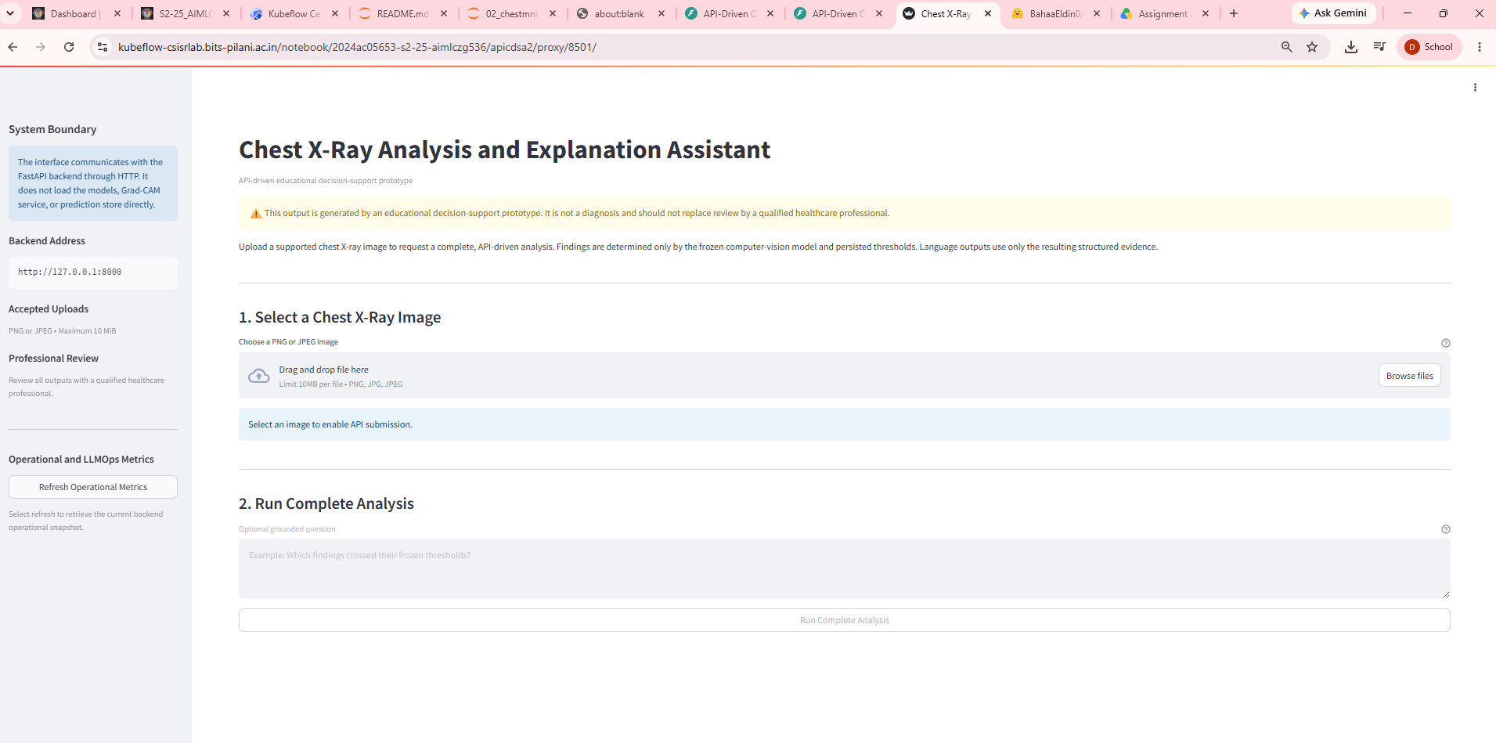
Figure 15. Application interface connected to the typed API client.
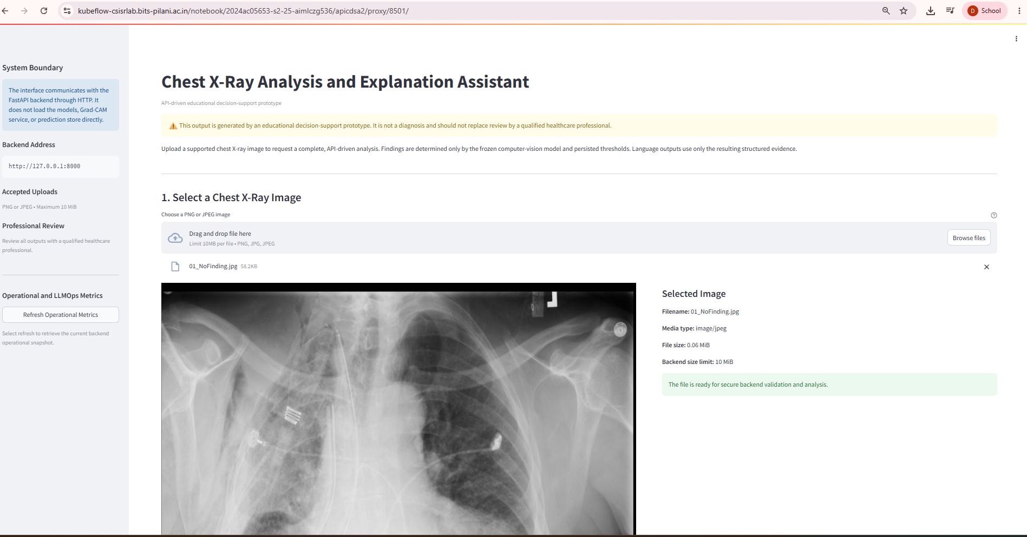
Figure 16. Integrated image-analysis response with ordered finding evidence.

⁠13. Security Engineering
The upload boundary distrusts both the filename and declared media type. Validation checks the accepted media-type allowlist, reads bounded content, rejects empty uploads, verifies image decoding and integrity, compares the decoded format with the declared type, and enforces maximum pixel dimensions before inference.
Threat / failure mode | Control | Verified result
Unsupported declared type | Allowlist before decoding | Rejected through typed service error
Empty upload | Non-zero content requirement | Rejected before preprocessing
Oversized payload | Maximum byte boundary | Rejected with received and maximum sizes
Corrupt image | Pillow decode and integrity verification | Rejected without inference
Media spoofing | Declared type versus decoded format comparison | Rejected as mismatch
Decompression / dimension abuse | Maximum width and height contract | Rejected before tensor creation

6  Security tests | 0.21 s  Execution time | 0  Failures | 0  Raw-content log events

13.1 Error-information control
Client details are sanitized before serialization. Unexpected exceptions receive a request identifier and controlled error code while internal stack traces remain server-side. Logging tests separately verify that user-supplied image content and grounded-language inputs are not emitted.

⁠14. Shadow Deployment Strategy
A deterministic policy selects a stable subset of requests for candidate inference while preserving the active model as the only client-visible decision path. The candidate runs asynchronously within the policy boundary, its errors are recorded as experiment outcomes, and neither its output nor its failure can change the active response.
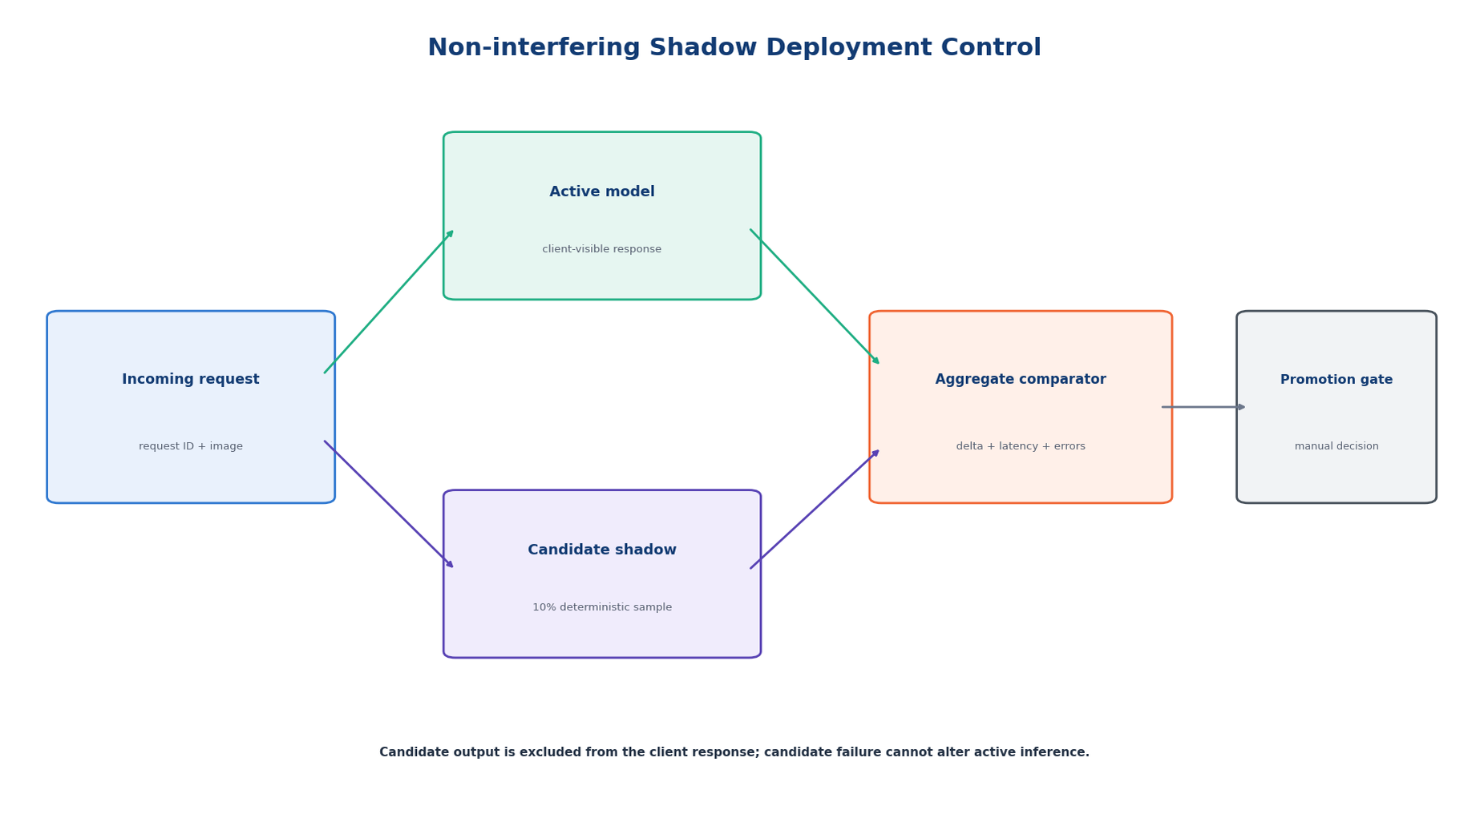
Figure 17. Shadow execution, aggregate comparison and manual promotion boundary.
Control | Configured value
Shadow enabled | True
Configured sampling rate | 10.00%
Observed routing experiment | 1,039 of 10,000 requests (10.39%)
Candidate output visible to client | False
Candidate failure affects response | False
Minimum comparison volume | 1,000 samples
Maximum candidate error rate | 0.5%
Maximum decision disagreement | 2.0%
Maximum mean probability delta | 3.0%
Maximum p95 latency overhead | 75 ms

Only aggregate comparison metrics are retained; raw images and generated text are excluded. Promotion remains a manual release decision and the policy exposes a kill switch for immediate deactivation.

⁠15. Packaging, Reproducibility and Deployment Readiness
Deployment descriptors separate the API and UI into independent images. Docker Compose provides both services, health checks and an explicit UI dependency on API readiness. Dataset and model artifacts remain external mounts, preventing large or licensed runtime assets from being embedded in the source package or container build context.
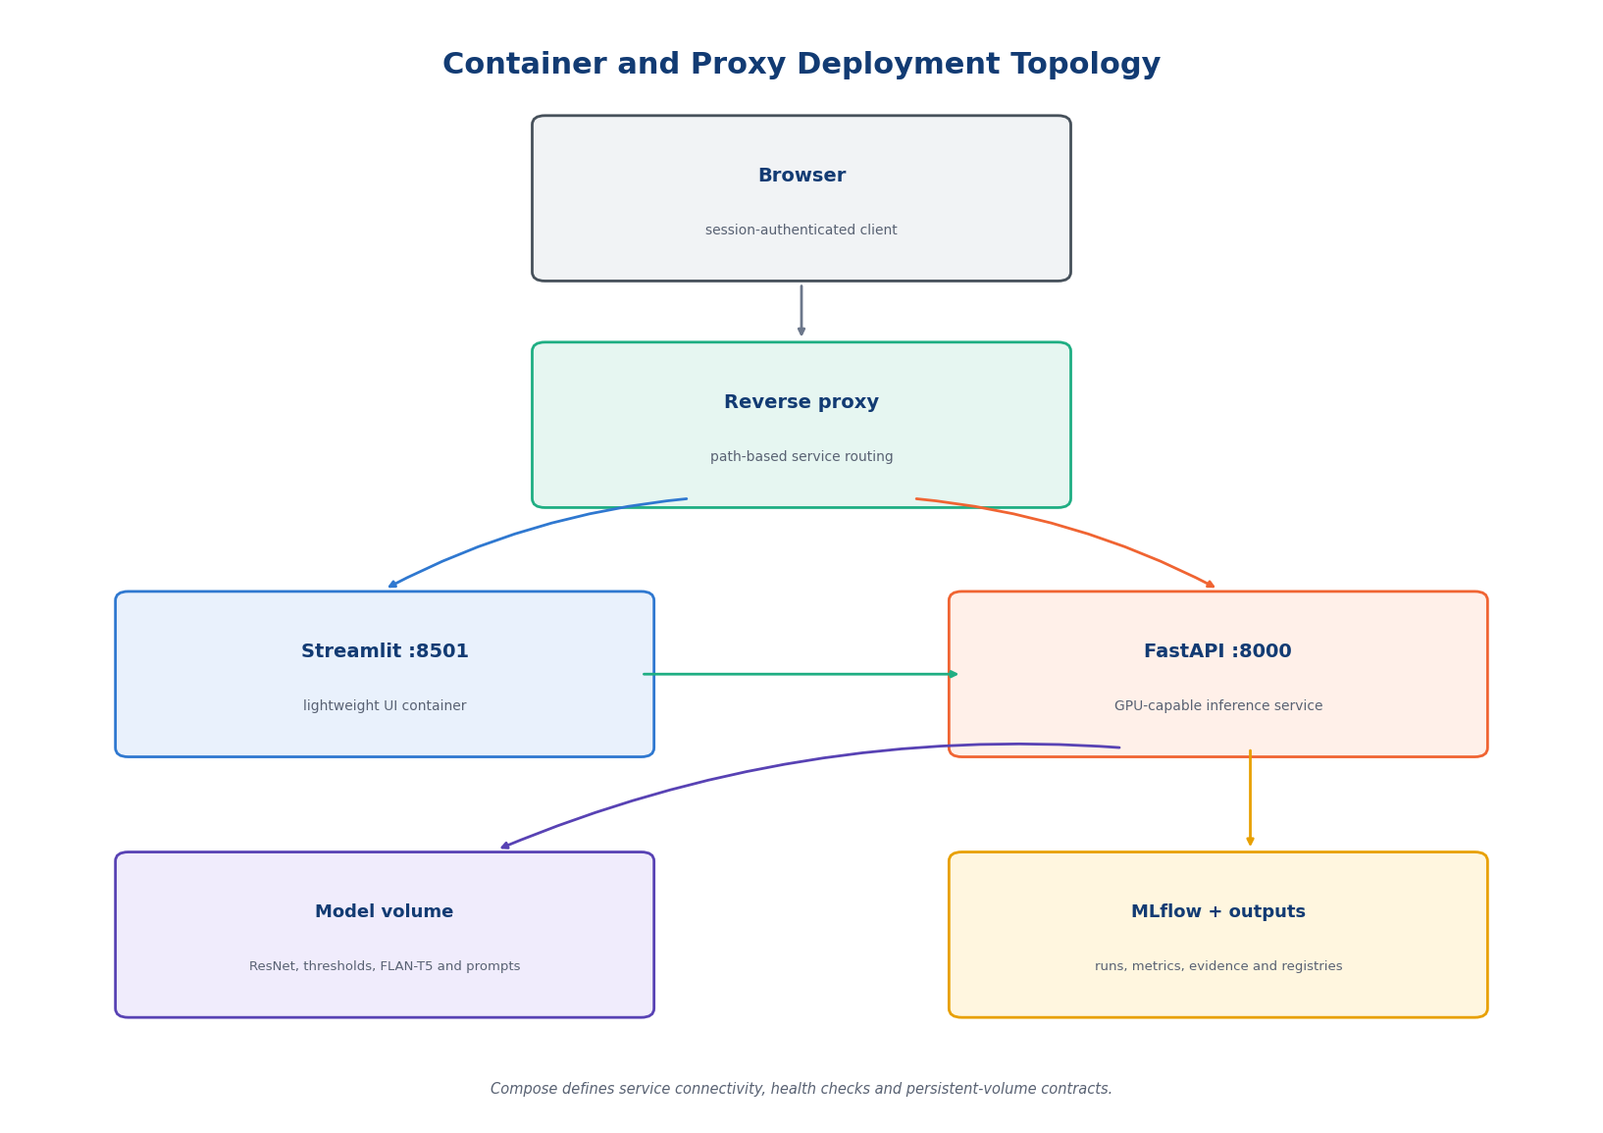
Figure 18. Container and reverse-proxy deployment topology.
Packaging contract | Observed state
Compose services | api, ui
API health check | Present
UI health check | Present
UI dependency on API | Present
API direct dependencies | 17 pinned entries
UI direct dependencies | 6 pinned entries
Large model/data embedded | No
Packaging contract tests | 11 passed
Persistent free space | 8.71 GiB
Protected reserve | 4.00 GiB

15.1 Reproducibility boundary
requirements.api.txt, requirements.ui.txt and requirements.dev.txt isolate runtime and development dependencies. YAML and JSON files version dataset labels, model thresholds, prompt task prefixes, API response templates, file-system paths and explainability contracts. The package can therefore be reconstructed without relying on notebook-global variables.
The Kubeflow environment did not expose the Docker Compose CLI, so image construction and service startup were intentionally not claimed. Deployment readiness is supported by static descriptor validation and eleven executable packaging-contract tests.

16. Evidence Integrity and Final Readiness
The evidence-integrity manifest establishes a verifiable chain from source files and generated QA artifacts to the final readiness decision. Required JSON artifacts are parsed structurally, text evidence is validated as non-empty, and every in-scope file receives a SHA-256 digest.
36/36  Required evidence | 52  Evidence files | 80  Repository hashes | SHA-256  Integrity algorithm
Final gate | State | Primary evidence
Repository modularity | PASS | repository_modularity_audit.json
Service-layer contracts | PASS | service_layer_contract_audit.json
Structured logging | PASS | logging_validation.json + logging_pytest.txt
Code quality | PASS | final_engineering_validation.json
Data quality | PASS | data_quality_metrics.json
Model quality | PASS | model_quality_metrics.json
Inference parity | PASS | research_production_parity.json
Research-production comparison | PASS | research_production_comparison.json
Security validation | PASS | security_test_results.json
OpenAPI contract | PASS | openapi_contract_validation.json
Shadow deployment | PASS | shadow_deployment_strategy.json
Packaging and deployment | PASS | packaging_deployment_validation.json
Evidence integrity | PASS | evidence_integrity_manifest.json

Manifest SHA-256: a9a626ea2b27fd39c2af252fd596e77bcd31339d3b39e4ceb5f4d0de9a212c15

⁠17. Technical Limitations and Next Engineering Iterations
The final readiness state demonstrates engineering completeness for the validated environment; it does not eliminate known operational and model boundaries. These limitations are expressed as concrete implementation constraints and measurable next-stage controls.
Current limitation | Engineering consequence | Next controlled iteration
In-memory prediction store | Records do not survive process restart and are local to one replica | Replace with a bounded persistent store using the existing repository contract
Container runtime unavailable in the notebook | Images and inter-service health were not executed in Kubeflow | Run the existing packaging suite plus live smoke tests in CI with Docker/Compose
Single frozen test distribution | Metrics do not establish transportability to new institutions | Introduce external validation and cohort-specific drift dashboards
Threshold-dependent multilabel output | Precision/recall trade-offs depend on the frozen operating points | Version threshold changes and require held-out calibration evidence
Grad-CAM localization is post-hoc | Heatmaps indicate model sensitivity, not causal or pixel-level ground truth | Add expert-reviewed localization evaluation and failure taxonomy
Grounded language depends on serialized findings | Generation quality is bounded by classifier evidence and prompt contracts | Measure groundedness, omission and contradiction on an expanded locked set
Shadow policy is simulated | Promotion gates are defined but not yet fed by production telemetry | Connect aggregate metrics to the release pipeline and retain manual approval

18. Conclusion
The completed system demonstrates a full research-to-production engineering path for a multimodal chest X-ray application. Notebook state was converted into explicit modules, configuration and service contracts; inference parity preserved the frozen model behavior; data, security and API boundaries were made executable; and packaging, experimentation and evidence integrity were validated independently.
The final repository contains 62 validated Python files and twelve test modules. Eighty-one tests pass, Black/isort/Ruff/compileall are clean, all twelve API operations satisfy the OpenAPI contract, and all thirteen final readiness gates pass. The resulting software is reproducible, traceable and structured for controlled deployment and subsequent engineering iteration.

Figure 19. Final engineering validation state: all controlled readiness gates passed.

⁠Appendix A. Endpoint Catalogue
Method | Path | Response schema | Responsibility
POST | /api/v1/analyze-complete | CompleteAnalysisResponse | End-to-end image and optional language workflow
POST | /api/v1/image/classify | ClassificationResponse | Validated image classification
POST | /api/v1/image/analyze | ImageAnalysisResponse | Classification plus visual evidence
POST | /api/v1/report/generate | LanguageGenerationResponse | Grounded report generation
POST | /api/v1/explanation/generate | LanguageGenerationResponse | Grounded explanation generation
POST | /api/v1/question/answer | LanguageGenerationResponse | Grounded question answering
POST | /api/v1/follow-up/recommend | LanguageGenerationResponse | Grounded follow-up generation
GET | /api/v1/predictions/{prediction_id} | StoredPredictionResponse | Prediction retrieval
GET | /api/v1/model/info | ModelInfoResponse | Model and finding contract metadata
GET | /api/v1/model/metrics | ModelMetricsResponse | Frozen quality metrics
GET | /api/v1/llmops/metrics | OperationalMetricsResponse | Request and language-action telemetry
GET | /health | HealthResponse | Component readiness

The OpenAPI schema contains twelve unique operation identifiers and twenty-three component schemas. Ten dedicated contract tests validate schema structure, operation uniqueness and response references.

A.1 HTTP response semantics
Status | Trigger | External contract
200 | Successful workflow or system query | Declared response_model schema
400 | Decoded content is not a valid image | INVALID_IMAGE
404 | Prediction identifier is not present | PREDICTION_NOT_FOUND
413 / 415 | Upload exceeds size limit or media type is unsupported | UPLOAD_TOO_LARGE / UNSUPPORTED_MEDIA_TYPE
422 | Request-schema validation fails | Controlled validation response
503 | Required model component is unavailable | MODEL_NOT_READY
500 | Grounding or service execution contract fails | Sanitized controlled error

⁠Appendix B. Notebook and Artifact Traceability
The implementation notebook is the executable engineering narrative; the report consolidates its validated outputs into architectural decisions, contract descriptions and evidence tables. Large datasets and frozen model files remain external to the notebook and report.
Engineering concern | Notebook evidence block | Repository / artifact anchor
Environment and topology | Kernel, filesystem and static AST diagnostics | repository_modularity_audit.json
OOP architecture | Service-layer contract inspection | service_layer_contract_audit.json
Logging | Three implementation audits and behavior tests | logs/*.json; logging_pytest.txt
Code quality | Toolchain, baseline, remediation and final gates | code_quality/before, after and final
Production data/model | Memmap module, model factory and trainer | src/data; src/models; src/training
ML QA | Data, training, inference and frozen model tests | data_quality; metrics; test_results
API/security | OpenAPI contract and upload-security tests | openapi_schema.json; security_test_results.json
Experimentation | Shadow routing and non-interference tests | shadow_deployment_strategy.json
Deployment | Packaging descriptors and tests | docker-compose.yaml; Dockerfiles; packaging evidence
Final readiness | Repository-wide validation and 13-gate decision | system_readiness_gate.json; integrity manifest

Notebook artifact: 89.ipynb · 58 final cells · 0 error-output cells · SHA-256 f0dae0c23ee5ac2fd434862b00ad5d3549e7d97f495c1193d4a339741b2c57dc

⁠Appendix C. Evidence Registry
Evidence family | Key artifacts | Validated property
Architecture | repository_modularity_audit.json; service_layer_contract_audit.json; openapi_schema.json | Topology, public contracts and API schema
Logging | image_validation_logging_implementation.json; computer_vision_logging_implementation.json; language_guardrail_logging_implementation.json | Event coverage and sensitive-content exclusion
Code quality | baseline_code_quality.json; remediation_registry.json; final_code_quality.json | Before/after findings and transactional remediation
Data quality | data_quality_metrics.json; data_validation_pytest.txt | Schema, missingness, label validity and drift
Model quality | model_quality_metrics.json; inference parity artifacts | Frozen metrics, output contract and numerical equivalence
Testing | test_taxonomy.json; full_test_results.json; final_full_pytest.txt | Test coverage and repository-wide regression
Security | security_test_results.json; security_pytest.txt | Adversarial upload boundary
Experimentation | shadow_deployment_strategy.json; shadow_deployment_pytest.txt | Sampling, non-interference and promotion gates
Deployment | packaging_deployment_validation.json; packaging_contract_pytest.txt | Container descriptors, dependencies and artifact isolation
Readiness | final_engineering_validation.json; system_readiness_gate.json; evidence_integrity_manifest.json | Final quality gates and file integrity

⁠Appendix D. Selected Implementation Excerpts
The excerpts below expose the executable boundaries behind the architecture, logging, API and ML-quality evidence. They are drawn from the validated repository and retain the same public contracts exercised by the automated tests.

D.1 Memory-mapped production data access
def open_split(self, split: str) -> tuple[np.ndarray, np.ndarray]:
paths = self.array_paths(split)
images = np.load(
paths.images, mmap_mode="r", allow_pickle=False
)
labels = np.load(
paths.labels, mmap_mode="r", allow_pickle=False
)
return images, labels
Production data access opens persisted arrays without loading the full image corpus into memory.

D.2 Structured validation event
logger.info(
"image_validation_started",
extra={
"component": "image_validation",
"event": "validation_started",
"media_type": media_type,
"received_bytes": len(content),
},
)
The event records scalar operational context while excluding filenames and image content.

D.3 Typed inference endpoint
@router.post(
"/image/classify",
response_model=ClassificationResponse,
summary="Classify a chest X-ray image",
)
async def classify_image(
image: UploadFile = File(...),
services: ServiceContainer = Depends(get_service_container),
) -> ClassificationResponse:
request_context = RequestContext()
validated_image = await _validate_upload(
upload=image,
services=services,
)
execution = await run_in_threadpool(
services.image_analysis_workflow.classify,
validated_image=validated_image,
request_context=request_context,
)
return execution.response
The route delegates validation and inference to injected services and returns a strict response schema.

D.4 Small-batch training assertion
trace = trainer.overfit_batch(
images,
targets,
steps=optimization_steps,
)
assert torch.isfinite(torch.tensor(trace.losses)).all()
assert trace.final_loss < trace.initial_loss
The behavioral test requires a finite optimization trace and an observed loss reduction.

References
1. MedMNIST v2. https://medmnist.com/
2. PyTorch documentation. https://pytorch.org/docs/stable/index.html
3. TorchVision ResNet models. https://pytorch.org/vision/stable/models/resnet.html
4. Grad-CAM: Visual Explanations from Deep Networks. https://arxiv.org/abs/1610.02391
5. FastAPI documentation. https://fastapi.tiangolo.com/
6. Pydantic documentation. https://docs.pydantic.dev/
7. pytest documentation. https://docs.pytest.org/
8. Black documentation. https://black.readthedocs.io/
9. Ruff documentation. https://docs.astral.sh/ruff/
10. Docker Compose specification. https://docs.docker.com/compose/compose-file/

