Assignment 1: MoveMint

Subject Code & Section: MAP524A
Assignment Number: 1
Teacher's Name: John Selmys
Due Date: February 27th, 2015
Date Submitted:
Student Name: Michael Allison
Stduent ID: 065-756-066
Executive Summary

When you are looking for a job in another province, the figure presented by the salary isn't the only factor to consider. Though they may be offering you a higher pay, what if the cost of living is higher? What if you must pay more taxes where you move? Suddenly that $80,000 that the out of province company is offering is more like a salary of $60,000 where you currently are.

MoveMint is an application that allows you to select a current location, a destination, and a salary. It will then calculate an equivalent salary in the destination location based on average household spending and taxation brackets. It will also generate a report to tell you exactly where your spending is likely to increase or decrease. If rent is higher in the destination location, it will show in red. If food is cheaper in the destination location, it will be displayed in green.

MoveMint is an application that allows you to determine the true value of any cross-province move that you make.

This application will be based on two data sets from the Government of Canada Open Data site.

Average household expenditure, by province:
http://open.canada.ca/data/en/dataset/df1435c8-a5b6-47f2-8d2f-172c50a88d05

Indexation Factors, Tax Brackets, and Tax Rates for the 2014 Individual Income Tax and Benefit Return:
http://open.canada.ca/data/en/dataset/41f5f794-591e-4827-b832-4141bd9dc5bf

Why Mobile?
Mobile is an excellent medium for this application, as it will be constructed with simplicity in mind. The user need's only enter three pieces of data – from province, to province and the salary in question for EITHER the destination or the origin. The application will then produce a very simple report comparing all the basic aspects of income that are likely to be affected, perfect for display on a mobile screen. Mobile is an excellent choice due to the lightweight nature of the application.

The mobility provided through Android will also be a benefit to this application. During the job hunting process, having an easy to use application wherever you happen to be searching can be an incredible tool. For example, if you are at a job fair and you find a position available outside of the province, you can quickly look up whether or not it will be financially worth your while. If your work asks you if you would consider the possibility of relocation, you can again quickly determine if it is a good move.

Userbase
This application is intended to be used by young professionals, in the age bracket of 20-35. These users are the most likely to consider a cross-province move for their career, as they are less likely to have things tethering them to their current location, such as families or purchased properties.

On a less common scale, this application may also be used by hiring managers to determine salaries for employees hired from a different province.

Features
The application will consist of the following basic features:
- Equivalent Salary Calculator
  - Allows you to enter an origin province, destination province, and salary offered in the current location or destination location
  - Application will calculate equivalent salary in the origin or destination, whichever is not entered. This information will tell you if the offer is worth the move, and if you will make more or less at the destination.
  - Allows you to change the destination easily, in case you want to compare multiple destination provinces.
- Taxation Calculator
  - Allows you to enter a salary and application will calculate taxes to be due in selected province
  - Summary page tells you flat amount of taxes for each province. You can select each province to get detailed information about the taxation brackets.
- Province Info
  - This page will give information at the provincial level, regardless of any salary or origin provinces
  - Gives user information about taxation brackets and a breakdown of average spending in dollars for each household spending item.
Use Cases
This section contains some of the more common uses of this application.

Use case 1 | User wants to determine what salary amount in a destination province would be equivalent to the salary they are currently making in the origin province.
Actor | Professional
Basic Flow | User opens up the app, then selects Provincial Salary Comparison button, which brings up the equivalent salary form. The user then enters their current salary into the current salary TextEdit field. They then select a province from the origin province dropdown, and select a destination province from the destination province dropdown. They then select the “Go!” button. Application brings up a report with a simple salary figure on top, then a breakdown report underneath.

Use case 2 | User wants to determine the amount of taxes they will owe based on their salary in a certain province.
Actor | Professional
Basic Flow | User opens up the app and selects the Taxation button, which brings up the taxation form. User enters a salary into the salary EditText field. They then select a province from the province dropdown, or they may also select “View All” from the dropdown (covered in another use case). Assuming the user selects an actual province, and they select the “Go!” button, the application will bring up a report of taxes owed, net salary, and then a tax bracket breakdown.

Use case 3 | User wants to view all relevant cost of living and taxation information for a province
Actor | Professional
Basic Flow | User selects the Province Info button, which brings up the “Select Province” spinner page. This page will also contain a fragment which will display information about the province, which will update each time a new value is selected from the spinner. Upon selecting a province, a report will be displayed to the user, the top of the report will contain basic summary information, then the bottom part of the report will contain more detailed information.
Mockups

Main page Comparison Selection Form
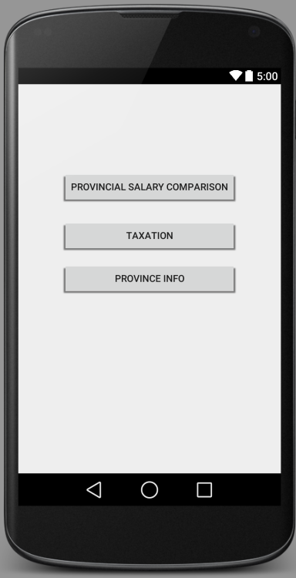
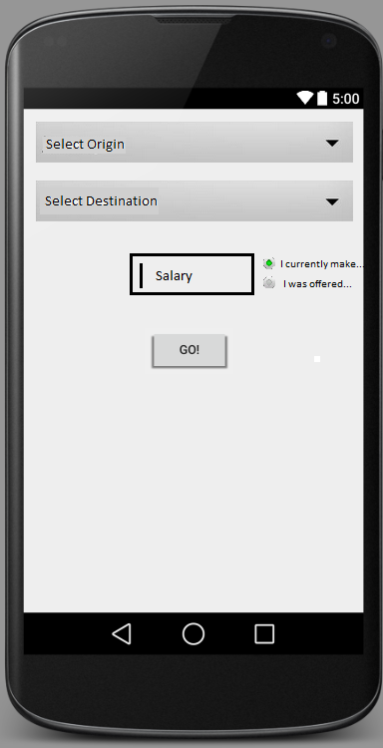

Mockups (Cont)

Final Comparison Report
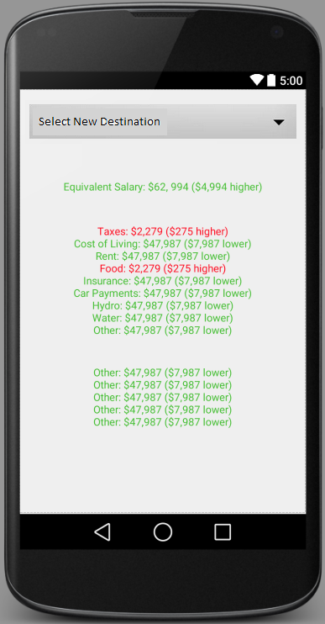

Timeline
March 6th | Application will successfully load both relevant data sets (taxation and household spending), and basic querying helper functions will be completed.
March 13th | Activities will be created and layouts will be modeled after mockups
March 20th | Provincial comparison module will be completed functional, allowing the user to compare salaries between provinces
March 27th | Taxation module will be completed, allowing user to determine how much taxes would be owed on a salary in a certain province
April 3rd | Provincial information module will be complete, allowing a user to pull up all relevant information about a province in regards to taxes and household spending information.  This date will mark the completion of the application, before testing. Testing will also begin on this date.
April 10th | All QA is completed on the application, and all bugs identified are fixed. The product is launched.

Conclusions
MoveMint is an application designed to solve a common issue among young professionals in a simple, straightforward manner. The focus in this application will be simplicity and ease of use, giving the user a rich source of information with minimal interaction on their part. With these goals in mind and keeping user experience as the key factor to strive for, this application could be a crucial factor in making a huge life decision.

