Assignment 2: MoveMint

Subject Code & Section: MAP524A
Assignment Number: 2
Teacher's Name: John Selmys
Due Date: April 10th, 2015
Date Submitted: April 10th, 2015
Student Name: Michael Allison
Stduent ID: 065-756-066
Executive Summary

When you are looking for a job in another province, the figure presented by the salary isn't the only factor to consider. Though they may be offering you a higher pay, what if the cost of living is higher? What if you must pay more taxes where you move? Suddenly that $80,000 that the out of province company is offering is more like a salary of $60,000 where you currently are.

MoveMint is an application that allows you to select a current location, a destination, and a salary. It will then calculate an equivalent salary in the destination location based on average household spending and taxation brackets. It will also generate a report to tell you exactly where your spending is likely to increase or decrease. If rent is higher in the destination location, it will show in red. If food is cheaper in the destination location, it will be displayed in green.

MoveMint is an application that allows you to determine the true value of any cross-province move that you make.

This application will be based on two data sets from the Government of Canada Open Data site.

Average household expenditure, by province:
http://open.canada.ca/data/en/dataset/df1435c8-a5b6-47f2-8d2f-172c50a88d05

Indexation Factors, Tax Brackets, and Tax Rates for the 2014 Individual Income Tax and Benefit Return:
http://open.canada.ca/data/en/dataset/41f5f794-591e-4827-b832-4141bd9dc5bf

The Final Product vs Project Plan

The final product is nearly identical to what was planned in the original planning document. Variation was kept to an absolute minimum and for the most part was unnecessary.

The only differences that can be found from the original plan is on pages that allow you to enter your salary, it was intended that you would be able to select whether or not this salary was to be for the destination location, or if it was for the present location. This feature was found to be redundant and did not add any value to the product for the amount of effort expended, therefore it was removed. The application now assumes that the user is entering in a salary from their origin province.

A second, very small difference can be found in the location of the “Select New Province” drop down item. On most pages that provide a report for the user, the user is given the option to select a new destination from the province list to easily and quickly compare to another province altogether. In the mockups, this feature was located at the top of the screen, but it was found to be more visually appealing, and less intrusive, to have it on the bottom.

While not technically a difference, it was never stated in the original plan how the data was intended to be imported into the application's data store. During the actual development phase, the decision was made to retrieve the data from the government of Canada via CSV format. The application then parses this data, converting it into SQL statements. These SQL statements are then executed against an integrated SQLite database for easy access throughout the application. These access methods are all found within a database handler class.

Completed Features

All features that were listed within the original planning document were completed. They were as follows:
- Provincial Comparison – The user is given the option to select two provinces, and enter in a salary. The user is then provided with an in depth report of how much that same dollar figure is worth in another province. This data is based on both provincial spending data, to determine how much money would be required to maintain their same quality of life, and also the taxation data, as some provinces charge significantly more taxes than others.
- Taxation Information – This page gives a breakdown of the taxation brackets that come into play for their entered salary. It provides the user with an estimate of the amount of provincial taxes that they would need to pay on their dollar figure, along with the rates that apply to each taxation bracket.
- Provincial Info – This page simply provides the user with a report detailing the average spending figures that were used in estimating equivalent salaries in other provinces.

Snapshots

To demonstrate the quality of the final working product, application snapshots have been included.

Figure 1: The Main Activity / Navigation Page Figure 2: Provincial Comparison Form

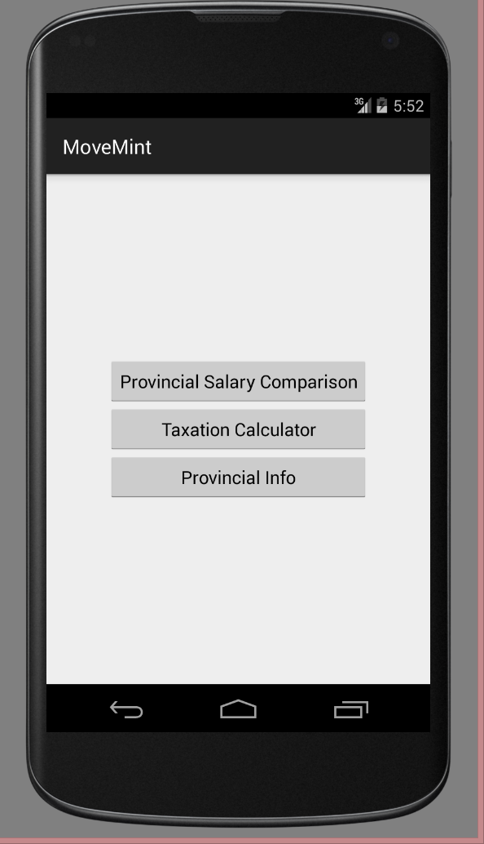
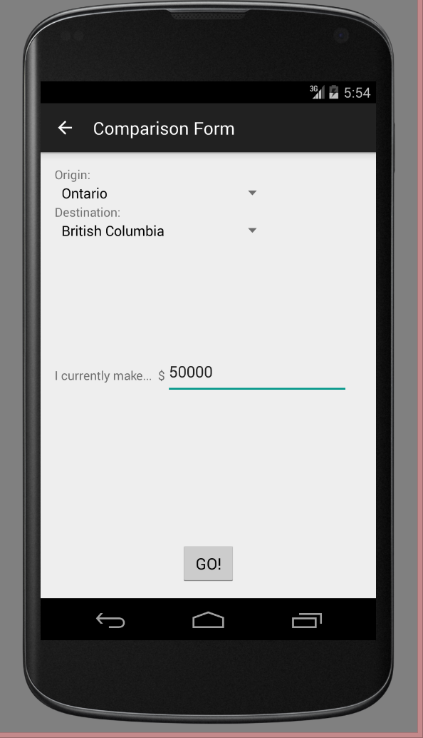

Snapshots Cont

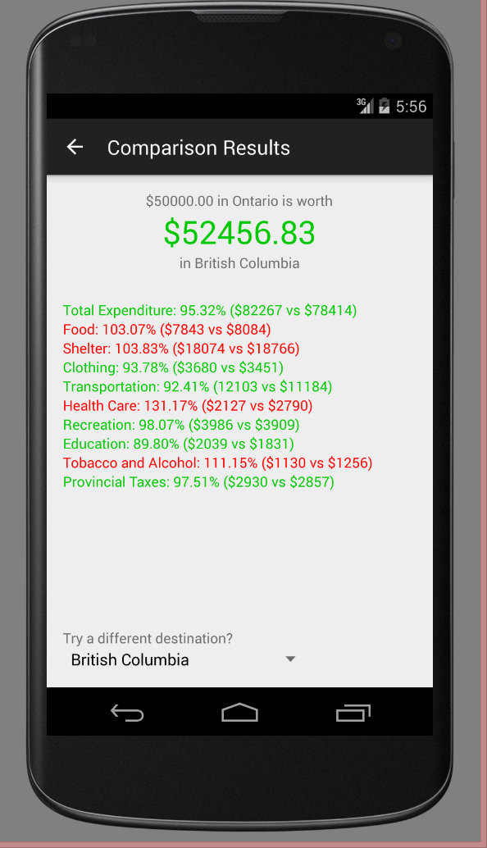
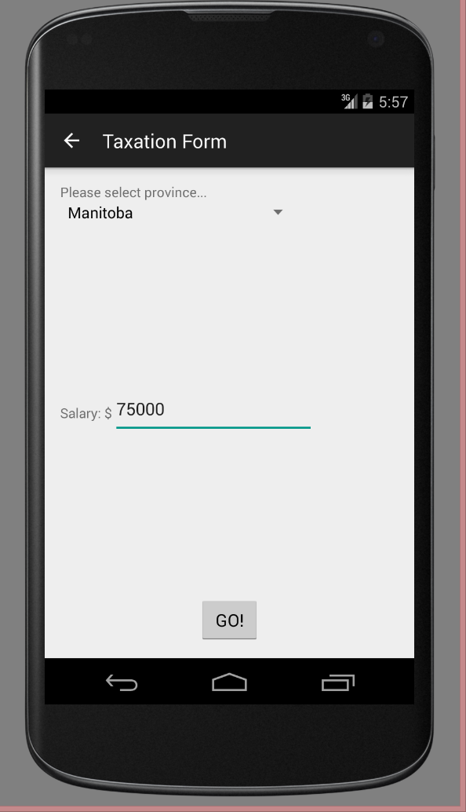
Figure 3: Provincial Comparison Report Figure 4: Taxation Calculation Form

Snapshots Cont
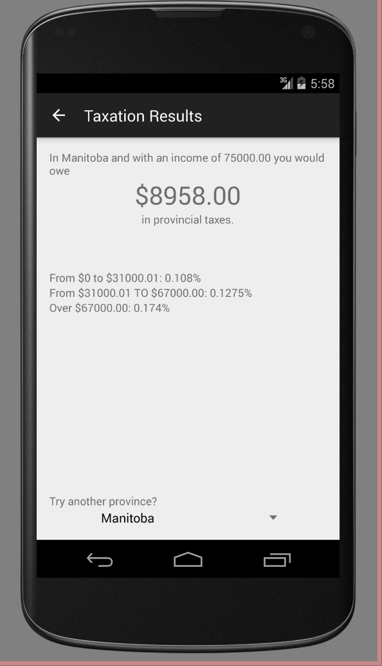

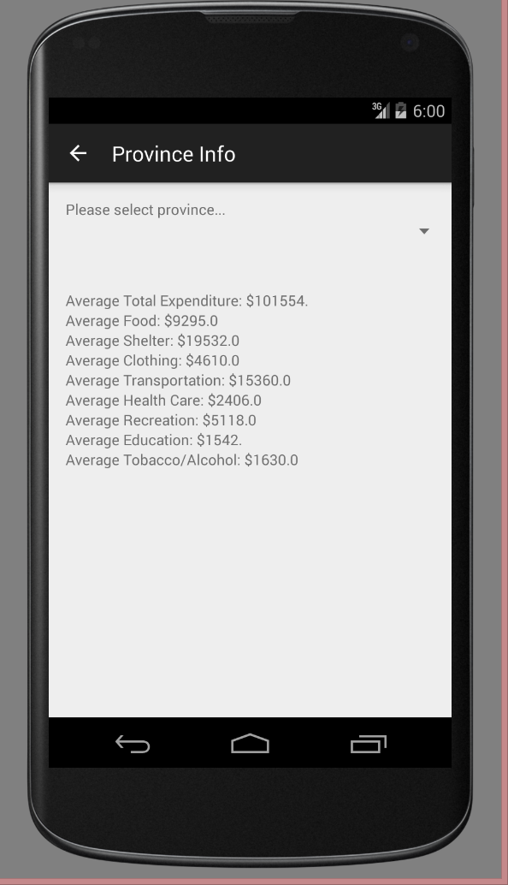
Figure 5: Taxation Report Figure 6: Provincial Info

Conclusions

Overall, the final product is of a quality that is consistent with what was described in the planning document – all features were completed, all testing was thorough and the application is found – so far – to be bug free.

While no features were excluded from the application, no new features were added, either. This is mostly due to the tight schedule and heavy workload associated with the final school term. If there were more time to work on the application, there are a few features that would have been great to add.

The most obvious and natural way to extend this application is to include other countries. The amount of work this would entail, however, would be immense – it would be necessary to have the application convert between currencies, which involves network capabilities to pull in the most recent conversion rates. It would require an extensive database of not only other countries, but the provinces/states within them, as well.

To further improve this application, more effort could be put into the aesthetics of the user interface. It was kept very basic due to the sole developer lacking any design background whatsoever, and it was not mandatory to allow the application to function correctly.

Overall Impression
The intention behind pursuing this particular application is that I wanted to create an application that I myself would actually use. As a new professional, I've found myself going out of my way to pursue the information that this application can provide. For someone who is willing to relocate to make the best out of their career, this application serves as an excellent tool to maximize your earning potential and simplify the weighing of pros and cons, when it can potentially come to a cross-country move.

