KOCAELİ ÜNİVERSİTESİ MÜHENDİSLİK FAKÜLTESİ

Smart Home Automation Based C#

C# ile Programlama

Burak Yeniaydın

Bölümü: Elektronik ve Haberleşme Mühendisliği

Danışman: Oğuzhan Karahan

KOCAELİ, 2021

PREFACE

In today, the impact of programming languages is quite high. Under favour of the languages used in computers, smart phones and other electronic devices, the control of the mentioned devices is provided. Therefore, programming languages are important for technological devices.

C#, which is a new generation programming language, brings innovations in programming. It was developed for use in the C# .NET environment developed by Microsoft. Anders Hejlberg pioneered the design of the language. This programming language, which has developed over time, is now used in most places, whether it is desktop or web applications.

I would like to thank my esteemed teacher Dr. Oğuzhan Karahan for his support for this study.

December 2021, KOCAELİ Burak Yeniaydın

CONTENT

PREFACE i
CONTENT ii
ŞEKİLLER DİZİNİ ii
1. HARDWARE 5
1.1 Hardware Components 5
1.1.1 Microcontroller 5
1.1.2 Electronic Component 5
1.1.3 Sensors and Actuators 7
2. SOFTWARE 9
SONUÇLAR ve ÖNERİLER 10
KAYNAKLAR 11
ÖZGEÇMİŞ 12

FIGURE

Figure 1 – Stm32 devKit 4
Figure 2 - BTA41 Triac 5
Figure 3 – Optocoupler 5
Figure 4 - IRF530N 6
Figure 5 - DHT11 6
Figure 6 - LDR sensor 7
Figure 7 - HC-06 Bluetooth Module 7
Figure 8 - 12V fan 8
Figure 9 – 4x1 Keypad 8

Smart Home Automation Based C#

Burak Yeniaydın

Keywords: C#, user interface, user controlled

Abstract: In this project, a user-controlled smart home application was developed.
For the hardware part, an ARM Cortex M4 based microcontroller and many electronic components were used. The bluetooth interface was used to send commands to this hardware and to receive data from this hardware. A user interface was created with the C# language. With this interface, the sensors were controlled.

HARDWARE

Hardware Components

Microcontroller

Low cost is important in IOT applications. For this reason, lower cost and smaller microprocessors are used in iot applications, not computer processors. In this project, stm32f407vg discovery card was used.
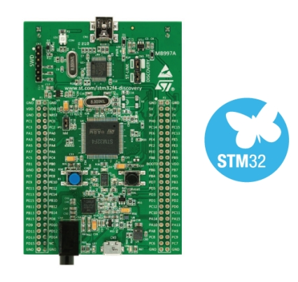
Figure 1 – Stm32 devKit

Electronic Component

The circuit consisting of triac, bridge diode and optocoupler was used to switch the 220V AC wave and drive the light bulb. Integral bounds will change as AC clips.

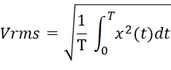

For this reason, the RMS voltage will decrease. The operating performance of the bulb will change as the RMS voltage changes.

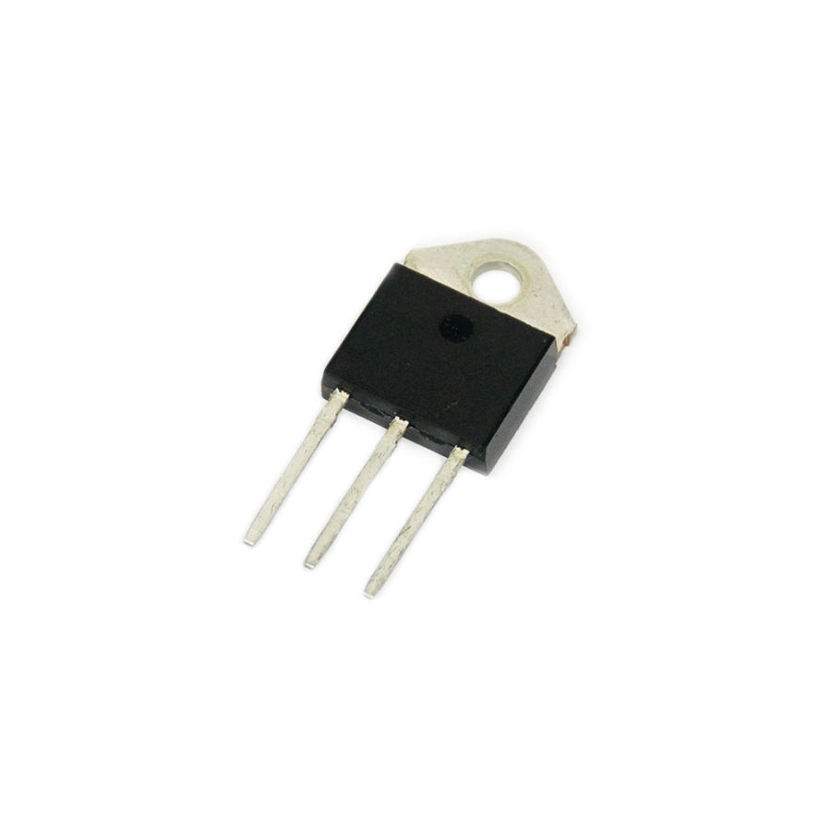
Figure 2 - BTA41 Triac

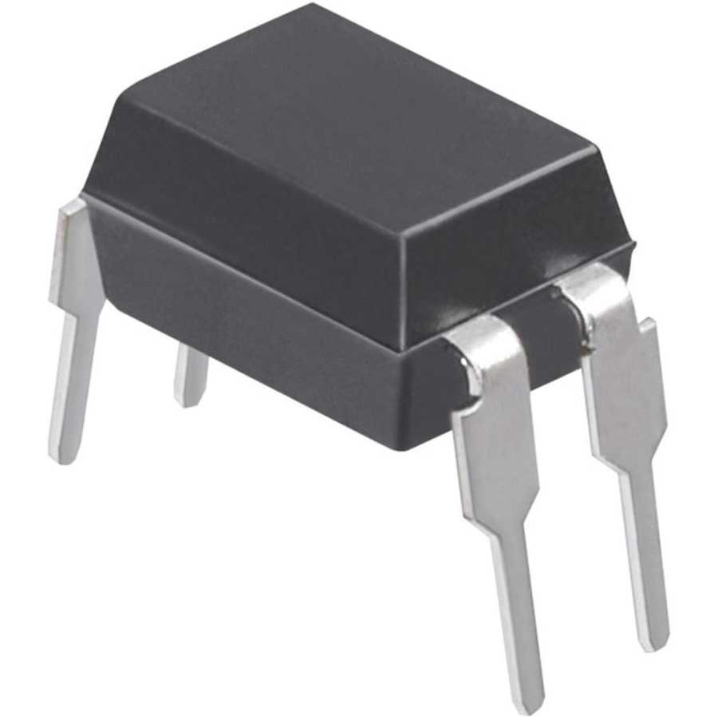
Figure 3 – Optocoupler

IRF530N transistor was used to drive the 12V fan and heater. This transistor can provide current up to 14 Amps at 25 degrees Celsius. The heater I use works with 50W power. That means it draws about 4 A of current.

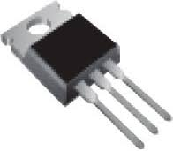
Figure 4 - IRF530N

We can not control 5V sensors with stm32. The reason for this is that 3.3V is given to the high voltage at the pin outputs of the stm32 microcontroller. For this, I used a logic level converter that converts from 3.3V to 5V.

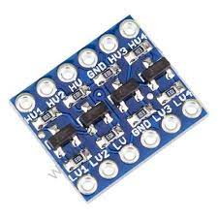
Figure 5 - Logic Level Convertor

Sensors and Actuators

DHT11 sensor was used to get temperature and humidity information. This sensor communicates with One-Wire protocol.

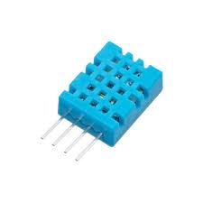
Figure 6 - DHT11

LDR sensor was used to get light information. ADC hardware in the microcontroller is used to receive data from this sensor.

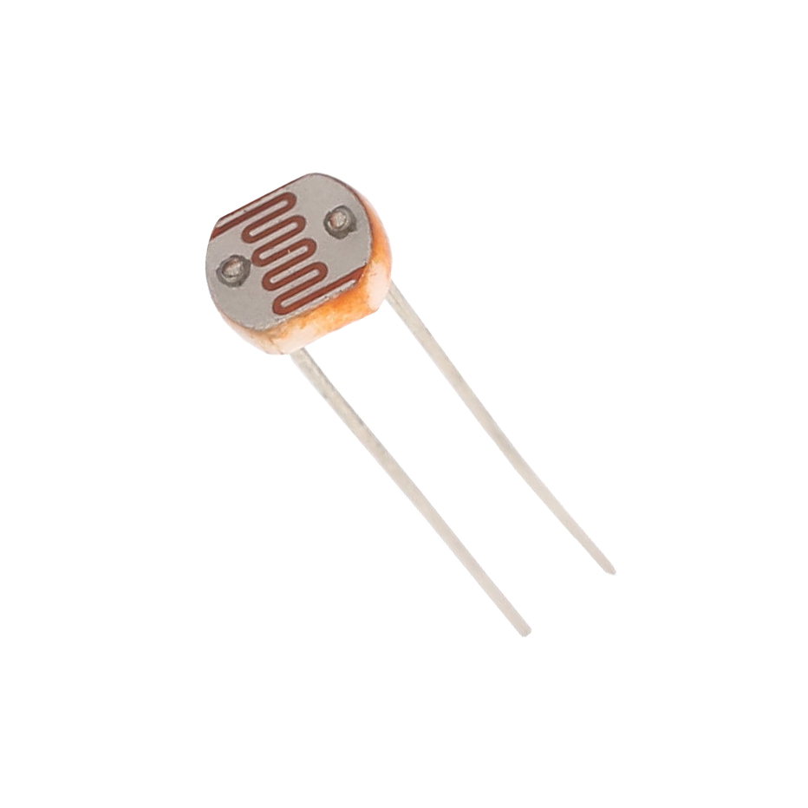
Figure 7 - LDR sensor

A bluetooth module was used to transmit/receive data remotely between the microprocessor and the computer.

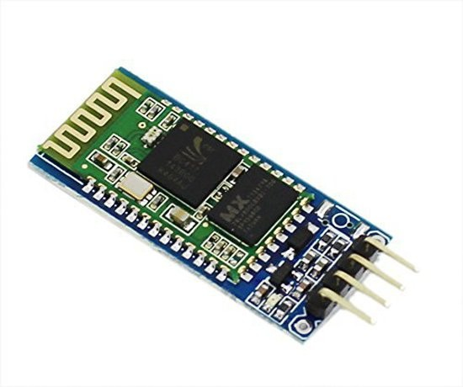
Figure 8 - HC-06 Bluetooth Module

The 12 V fan was used to cool the environment . The heater working with 12V was used to heat the environment.

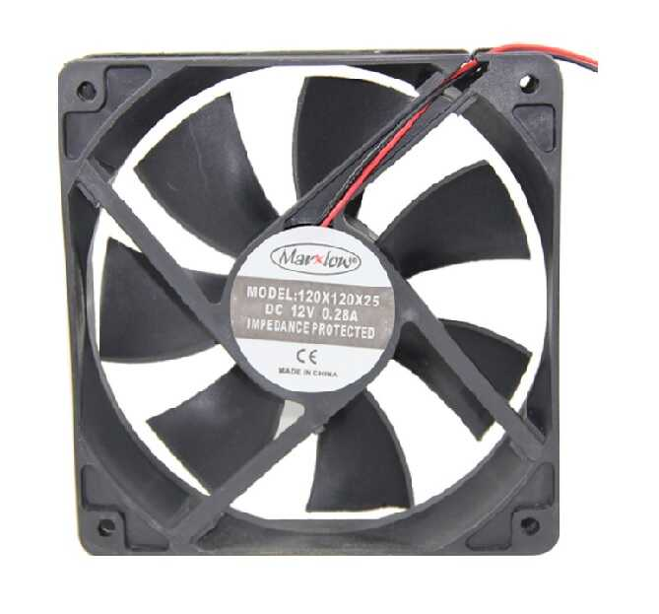
Figure 9 - 12V fan

The keypad was used to allow the user to enter a password.

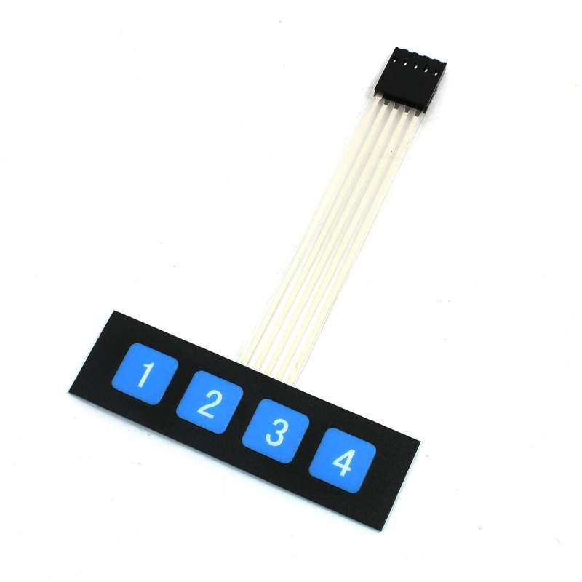
Figure 10 – 4x1 Keypad

SOFTWARE

Visual studio IDE was used for the project. In order to get information from the serial port and to create an interface, I created a Windows form application (.NET Framework) project.


Figure 11 - Visual Studio

First of all, in order to provide communication between the environment and the interface, the user must click on the “Connect Bluetooth” button. This command will provide the connection between the user interface and the Bluetooth module.

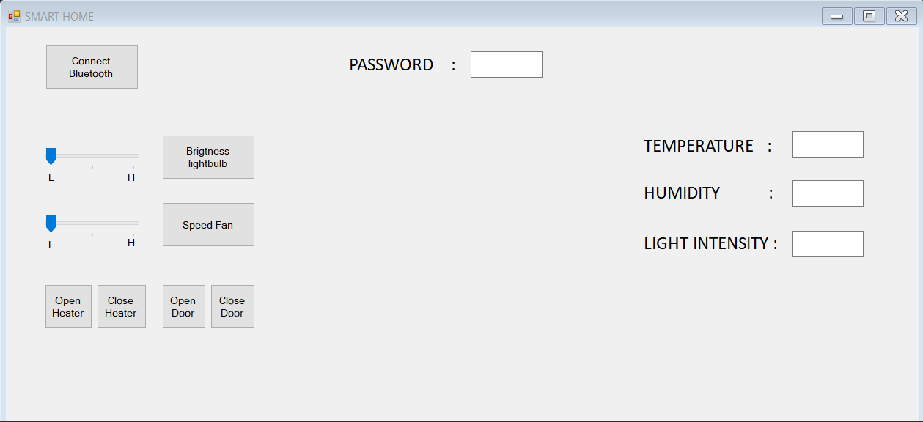
Figure 12 - User Interface

I used System.IO.Ports. Here are the classes where I will start serial communication and use serial communication.

I used a total of 7 buttons in the user interface. The first of these was used to create the serial connection. Other buttons sent commands to the microprocessor via the bluetooth module.

I used 2 trackbars to adjust the brightness of the bulb and to adjust the rotation speed of the fan. In this trackbar, the fan can be adjusted to operate at low, medium and high speeds. On the other trackbar, the brightness of the bulb can be adjusted as low brightness, medium brightness and high brightness.

I also added 4 textBoxes to the interface. One of them is typing the incoming password. Others write the value of temperature, humidity and luminosity.

When the Bluetooth connection is established, the interface asks the user to enter a password. If the user enters the wrong password, the message that the password is incorrect is displayed.

If no bluetooth connection is made, all other buttons are turned off. However, if the password is entered correctly, this lock is opened.

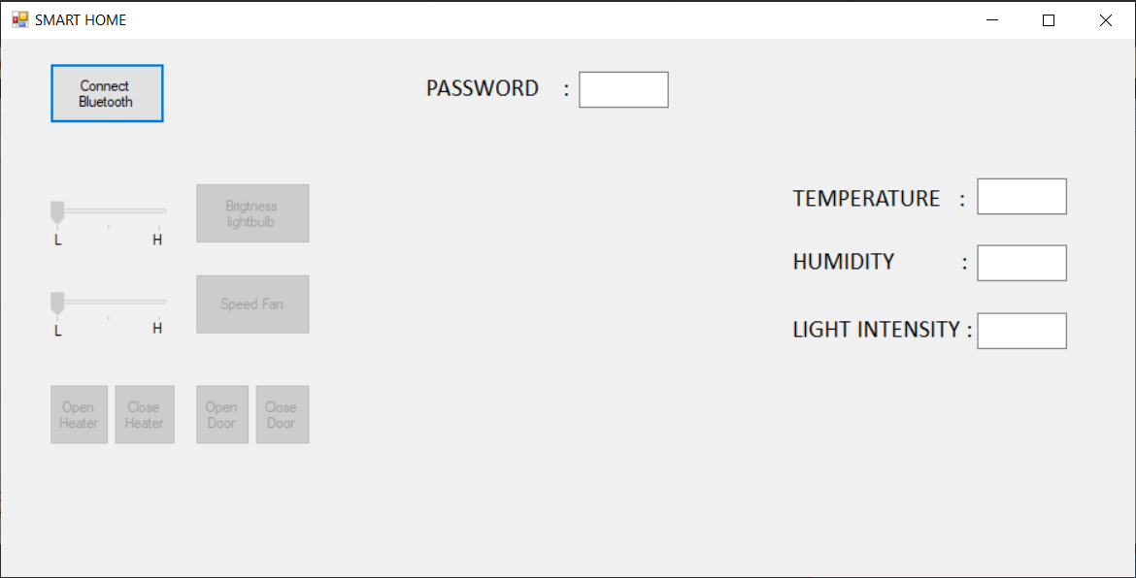
Figure 13 - Locked buttons

Conclusıon

I made a user-controlled smart home project, not an automatic control. The user interface was created with the C# programming language. An ARM Cortex M4 based microcontroller was used to process the data from the sensors and communicate with the user interface. In addition, this microcontroller was used to transfer the commands from the user interface to the actuators.

KAYNAKLAR

- https://www.microsoft.com/tr-tr/
- https://stackoverflow.com

