**Generic Elective (Semester –I)**

**Computer Science**

By: **Lucky Lao**

Course: **B.Sc. (Hons.) Mathematics**

College ID: **23BMAT019**

Q1. WAP to find the roots of a quadratic equation.

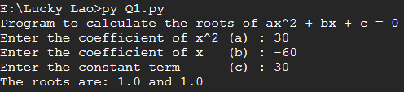

Q2. (This program may be done using functions)

WAP to accept a number ‘n’ and

1. Check if ’n’ is prime

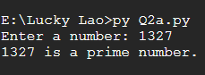

1. Generate all prime numbers till ‘n’

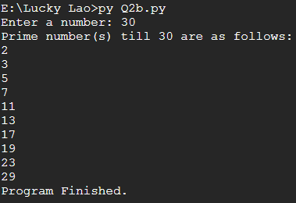

1. Generate first ‘n’ prime numbers

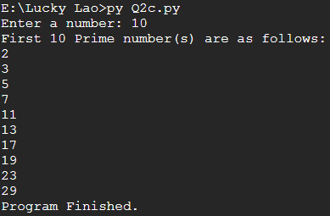

Q3. WAP to create a pyramid of the character ‘*’ and a reverse pyramid

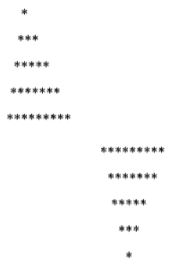



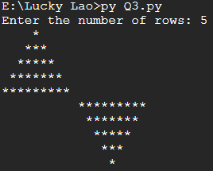

Q4. WAP that accepts a character and performs the following:

1. print whether the character is a letter or numeric digit or a special character



1. if the character is a letter, print whether the letter is uppercase or lowercase



1. if the character is a numeric digit, prints its name in text (e.g., if input is 9, output is NINE)



Q5WAP to perform the following operations on a string

1. Find the frequency of a character in a string.

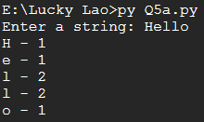

1. Replace a character by another character in a string.

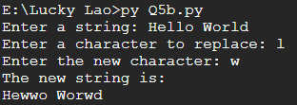

1. Remove the first occurrence of a character from a string.

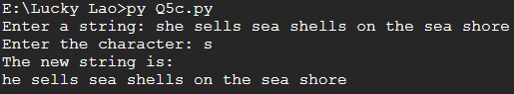

1. Remove all occurrences of a character from a string.

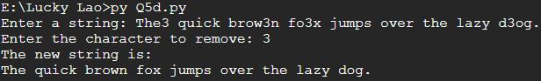

Q6. WAP to swap the first n characters of two strings.

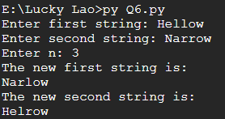

Q7. Write a function that accepts two strings and returns the indices of all the occurrences of the second string in the first string as a list. If the second string is not present in the first string then it should return -1.

****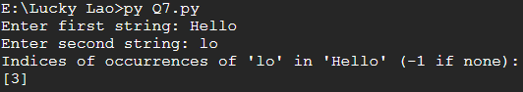

Q8. WAP to create a list of the cubes of only the even integers appearing in the input list (may have elements of other types also) using the following:

1. ‘for’ loop

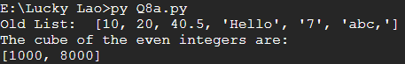

1. list comprehension

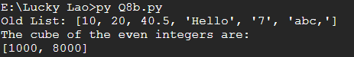

Q9. WAP to read a file and

1. Print the total number of characters, words and lines in the file.

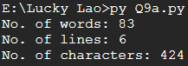

1. Calculate the frequency of each character in the file. Use a variable of dictionary type to maintain the count.

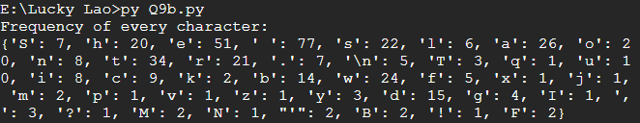

1. Print the words in reverse order.

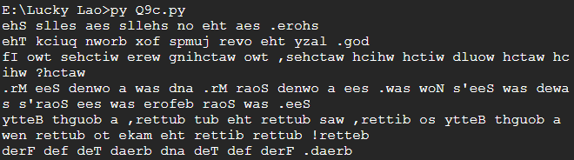

1. Copy even lines of the file to a file named ‘File1’ and odd lines to another file named ‘File2’.

(No Output in Terminal) Result: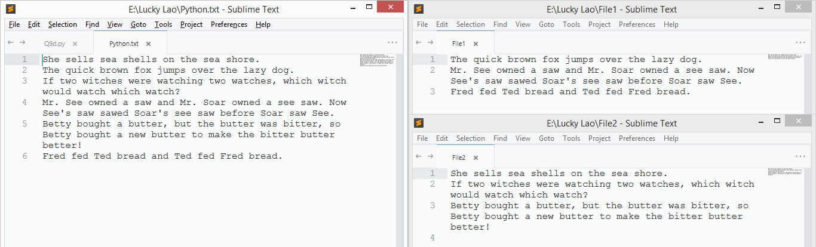

Q10. Write a function that prints a dictionary where the keys are numbers between 1 and 5 and the values are cubes of the keys.



Q11. Consider a tuple t1=(1, 2, 5, 7, 9, 2, 4, 6, 8, 10). WAP to perform following operations:

1. Print half the values of the tuple in one line and the other half in the next line.

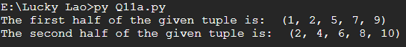

1. Print another tuple whose values are even numbers in the given tuple.



1. Concatenate a tuple t2=(11,13,15) with t1.



1. Return maximum and minimum value from this tuple



Q12. WAP to accept a name from a user. Raise and handle appropriate exception(s) if the text entered by the user contains digits and/or special characters.

