M AGNETIC resonance imaging (MRI) provides an excellent modality for distinguishing different tissues in the human body, which is essential for medical applications. When MRI is used for stereotactic treatment planning, its geometric accuracy is crucial. Previous studies have been conducted to correct the distortion caused by nonlinearity of the MRI scanner’s magnetic gradient fields by imaging a cubic phantom [1], [2] and defining distortion correction functions based on the distorted appearance its surfaces. Correct mathematical handling of the distortion correction function required that the cube was centered about the magnetic isocenter, which is defined as the common center of the three magnetic gradient fields and is not very accurately known. New 3Tesla MRI systems have a larger bore, making the previous phantom design impractically small for probing the field nonlinearity in the periphery of the bore, as the phantom cannot be scaled up due to constraints related to weight and cost of manufacturing. We are introducing a new phantom design using a different approach, which can be built to a larger size, improves accuracy of distortion characterization and reduces cost.
Phantom Design for Distortion Correction of MR Images
Ritchie Cai, Keith Schubert, Reinhard Schulte
- Design
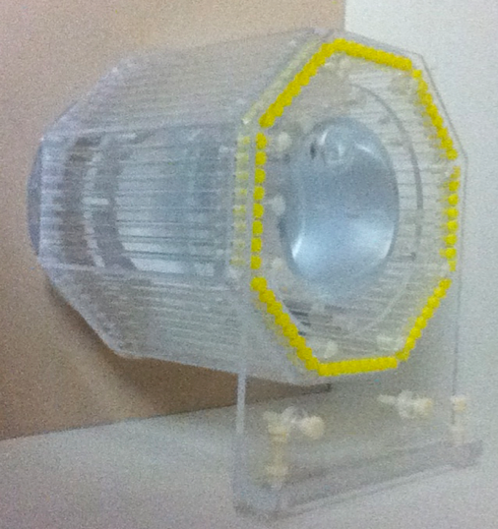
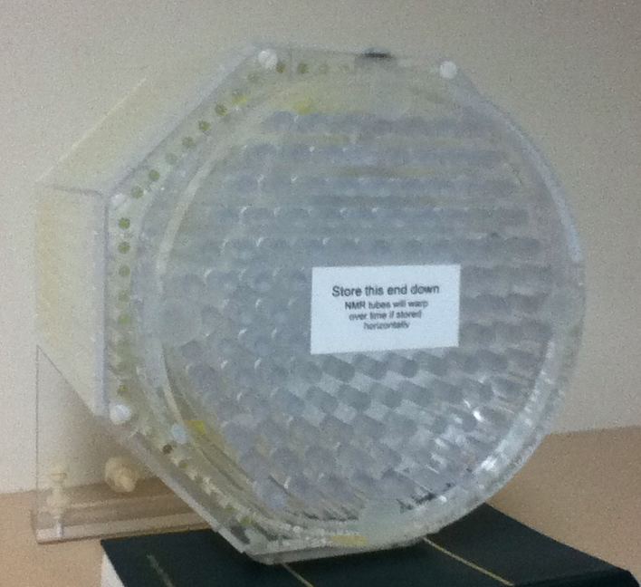
The phantom is shaped to be as large as possible, while still fitting in the head coil of the scanner, so as to achieve the maximum quality of signal and largest distortion. The phantom is an octagonal prism with 205mm between opposite sides. Each face of the octagonal prism is composed of 8 high precision NMR tubes that are 5mm in outer diameter and 205 mm in length. These tubes are filled with copper sulfate solution to generate a strong signal in an MRI scanner. The tubes are placed parallel to the magnetic field so they will cause less susceptibility distortion [3], and thus provide more accurate information on the gradient field. In the center of the phantom is a large water tank to help intensify the signals generated by the tubes. At one end of the phantom is a cylindrical tank filled with copper sulfate, with a number of small solid cylinders in a hexagonal pattern that are connecting the two surfaces of the tank. These cylinders are used to maintain the long-term accuracy of the two surfaces, making sure they won’t deform, and are also aligned to the field to minimize their effect on the field. The data generated from 64 tubes mounted on the sides are designed to give us x and y axis distortion information, and the end tank is designed to provide z-axis distortion data, allowing a complete 3-D distortion correction with a relatively small amount of data.
- initial experience
Our design allows us to obtain more precise data samples by measuring the surface of all 64 tubes and using this to find the center of each tube. Thus the amount of distortion information is larger than in the previous design with 6 cube surfaces This allows us to track distortions of the center of each tube along the main magnetic field axis to a very high degree of accuracy. In practice, we have been able to utilize this information to estimate the gradient isocenter of the magnetic field down to 0.03mm accuracy [4]. Additional results will be presented at the time of the conference.
- Conclusion
A new phantom for the measurement and correction of nonlinear gradient field distortion of MRI systems is presented. It is lighter, more economic, and allows for both more accurate measurement of field distortion and the location of the isocenter.
References
- S. Langlois, M. Desvignes, J.M. Constans, and M. Revenu, MRI Geometric Distortion: A Simple Approach to Correcting the Effects of Non-linear Gradient Fields, J. Magn. Reson. Imaging, vol. 9, pp. 821-831, 1999.
- T. Lee, K. Schubert, R. Schulte, Software-Based Algorithm for Modeling and Correction of Gradient Nonlinearity Distortions in Magnetic Resonance Imaging, IAENG Transactions on Electrical and Electronics Engineering, vol. I, 2008
- J. F. Schenck, “The Role of Magnetic Susceptibilty In Magnetic Resonance Imaging: MRI Magnetic Compatibility of the First And Second Kind”, Medical Physics, vol. 23, iss 6, 1996, pp. 815–850.
- R. Cai, K. Schubert, R. Schulte, Computational Algorithm for Estimating the Gradient Isocenter of an MRI Scanner. Proceedings of the International Conference on Scientific Computing, 2012, accepted for publication

 

