1. 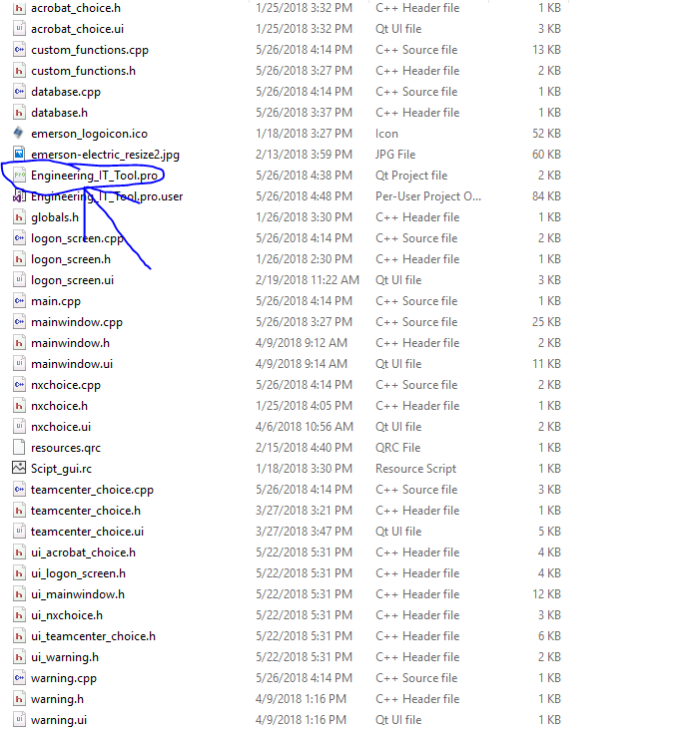 Click on the .pro file or open the .pro file with Qt
2. You should then get a screen like this inside Qt:

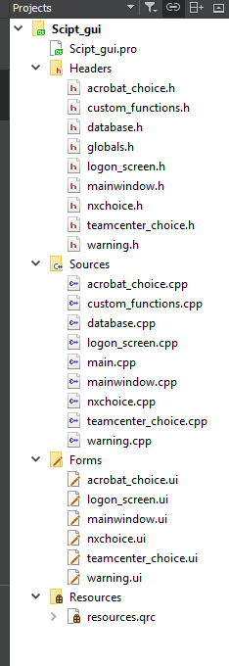

1. Once you compile the code you will get a directory the one highlighted below, place the sqlite file in this directory for testing.

