**Mallu Sravana Sandhya Assessment-2**

Create database database_name #used to create a database

Use database_name #used to make use of database created earlier

Create table table_name(col_name datatype,……) #to create a table

Insert into table_name values(val1,val2,………) #to insert records into the table

Select * from table_name #to fetch the records from table

Drop table table_name #to remove table from database

Delete table table_name #to delete the table

Create view viewname as subquery from table_name where condition #create a view of the table

Drop view view_name #removes view from database

SELECT table_name FROM INFORMATION_SCHEMA.TABLES WHERE table_type = 'BASE TABLE' #to get tables present in database

SELECT COLUMN_NAME FROM INFORMATION_SCHEMA.COLUMNS WHERE TABLE_NAME ='table_name'; #to get columns present in the table

Alter table table_name add col_name datatype #to add a column to table

Alter table table_name drop col_name #to remove column from table

Update table_name set col_name=newvalue where conditions #to update a value in table

CURRENT_TIMESTAMP #to get current date

Distinct #to elimate duplicate values

Order by #to arrange a column values in an order(alphabetical/ascending)

Delete table_name where condition #deletes the record in table which meets the condition

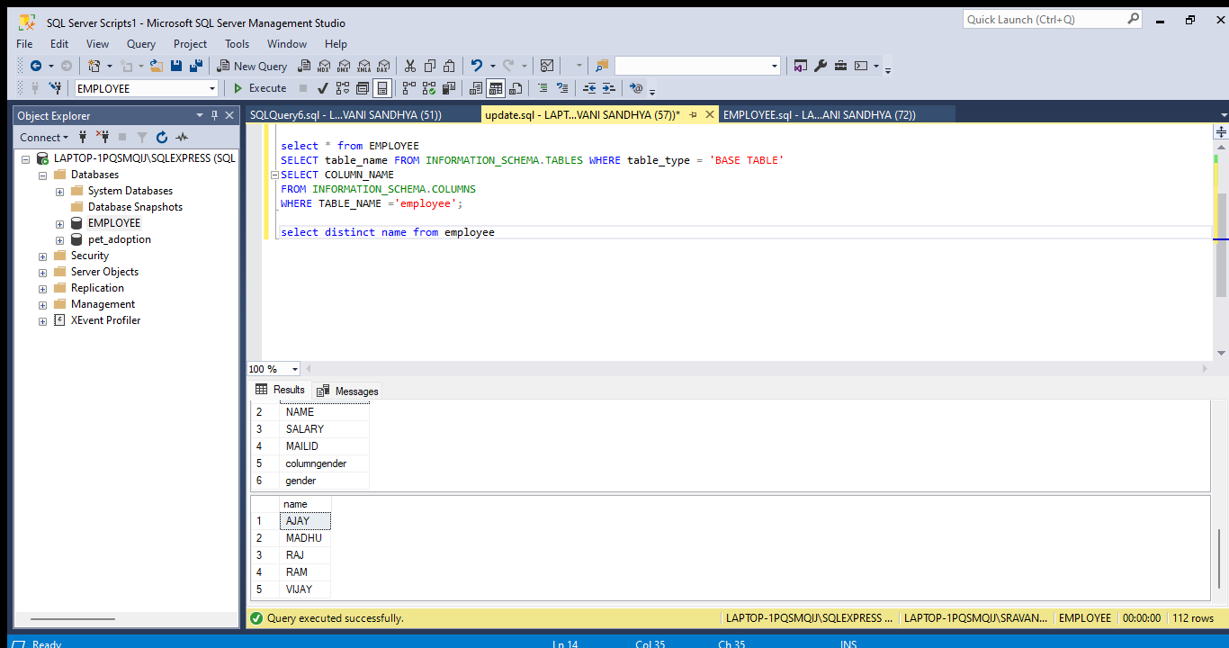Fetching column names from table and getting names in alphabetical order 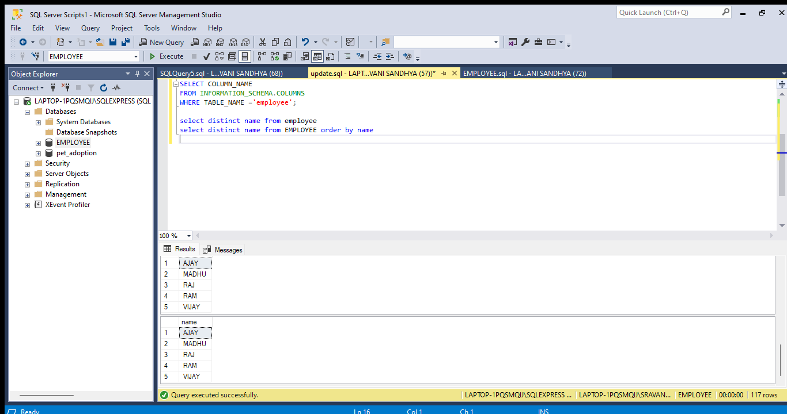removing duplicates in name column of employee table and sorting them 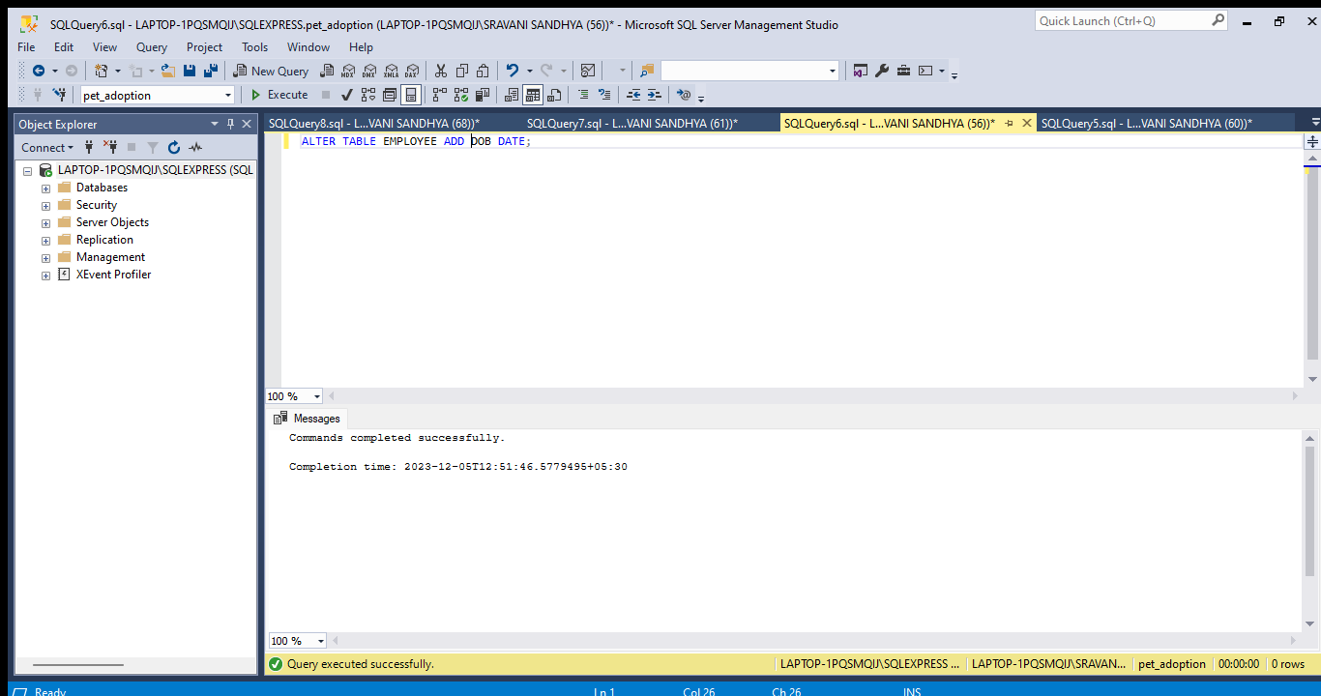adding doj column for employee table using alter command 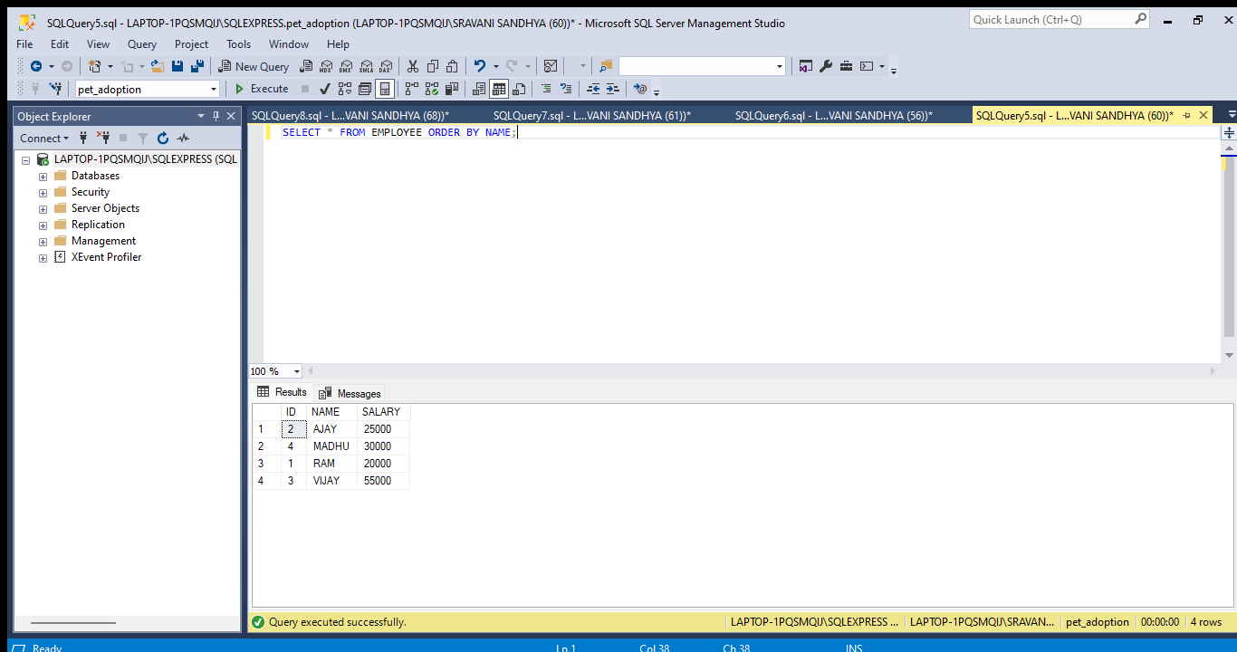fetching records from employee table using select query

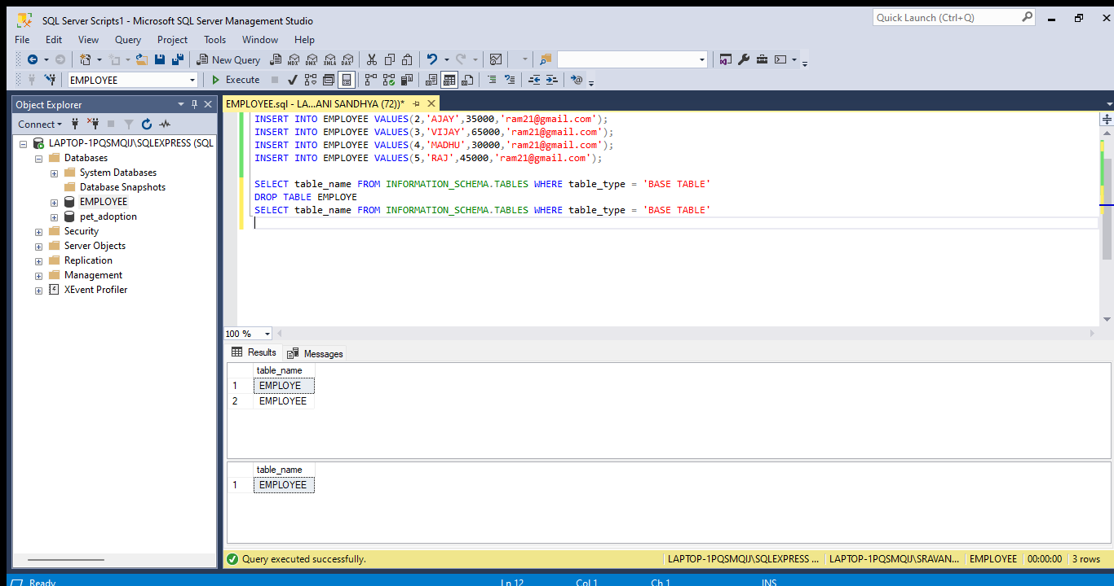feching tables present in employee database 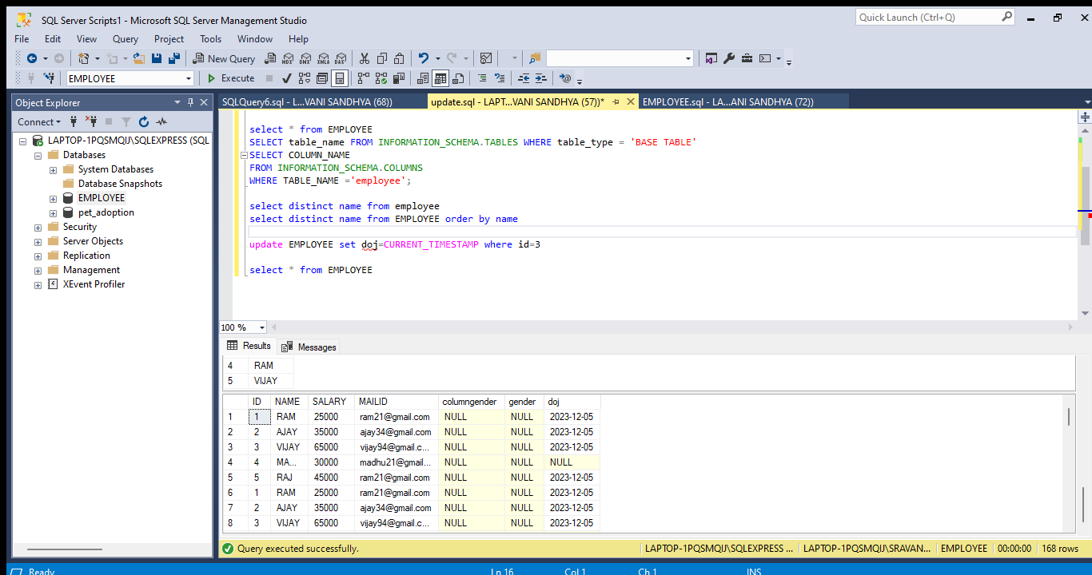getting updated employee table

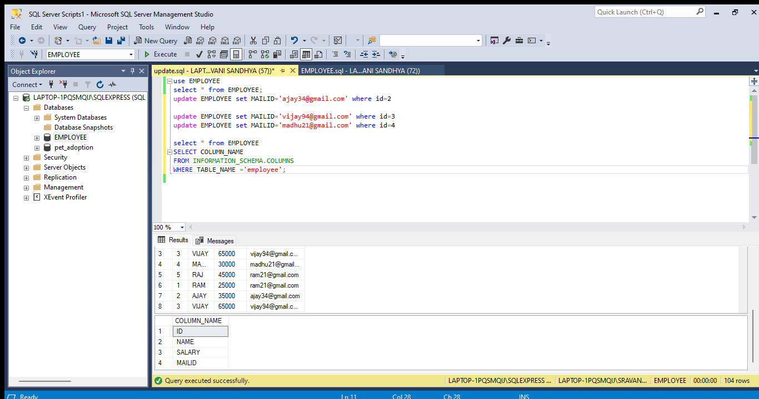getting column names in employee table