Mallu Sravana Sandhya Assessment-5 08/12/2023

JOINS-- using on /where which joins two tables with matching column in both the tables

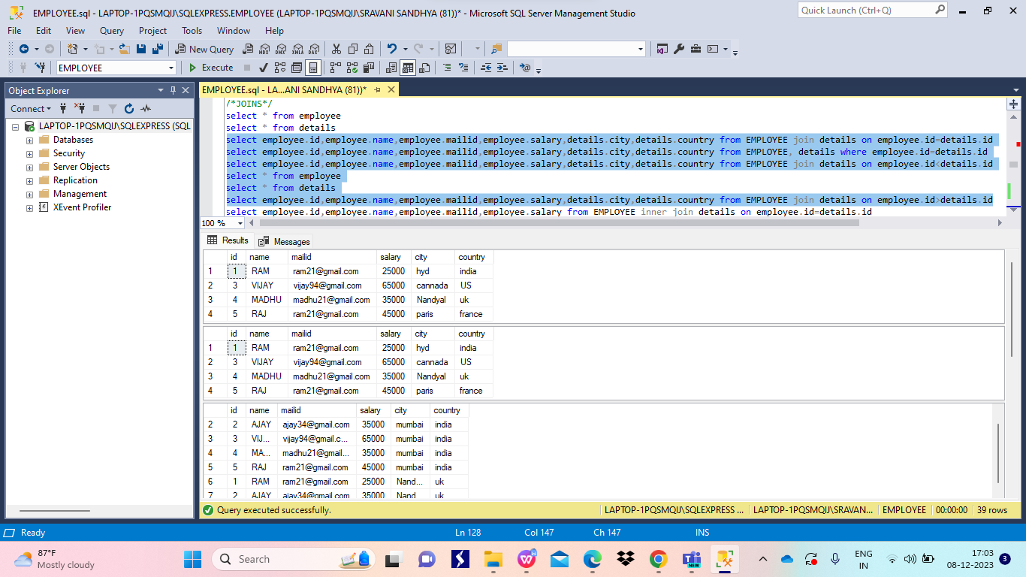

SETFUNCTIONS--these will works with the tables having same no.of columns and compatible datatypes

Union-combines both the tables and results the records in both the tables by removing duplicate records

Intersect-it results the common records present in both the tables

Union all-it results all the records in both the tables with out removing any duplicates

Except-it results the records present only in first table 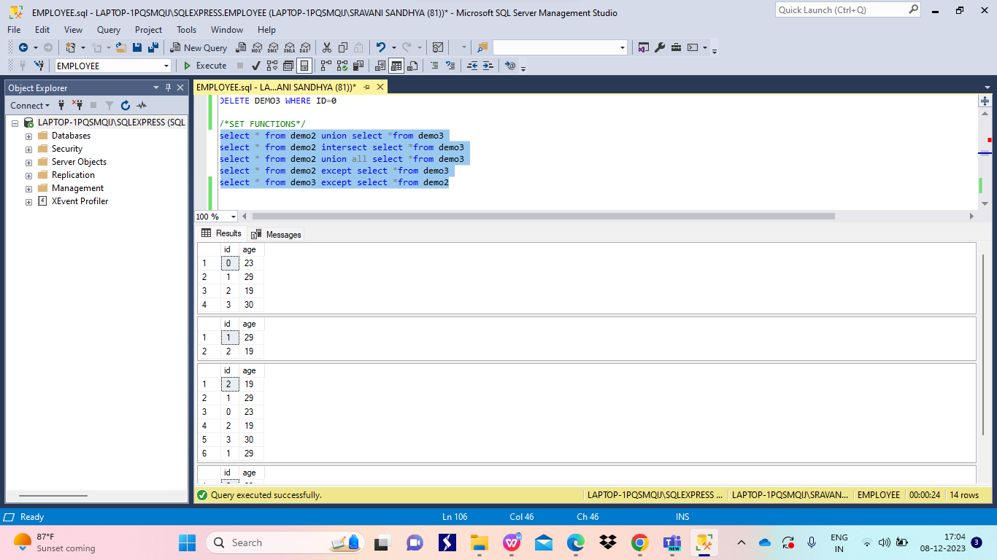

EQUI AND NON EQUI JOINS

EQUI-it joins two tables using equal operator between matching column

NON EQUI-it joins two tables using comparision operators(like >,>=,<,<=….)

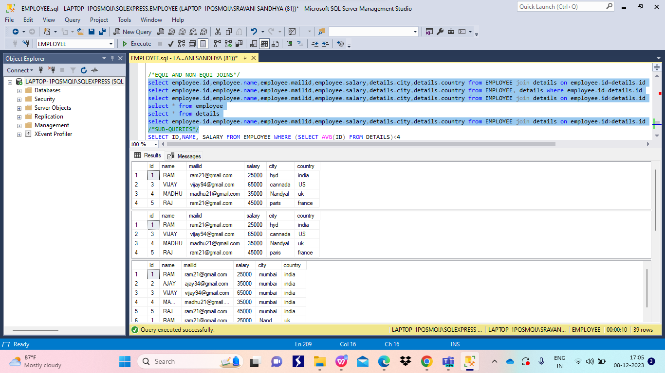

SUB QUERIES--queries written inside another query which helps to filter data 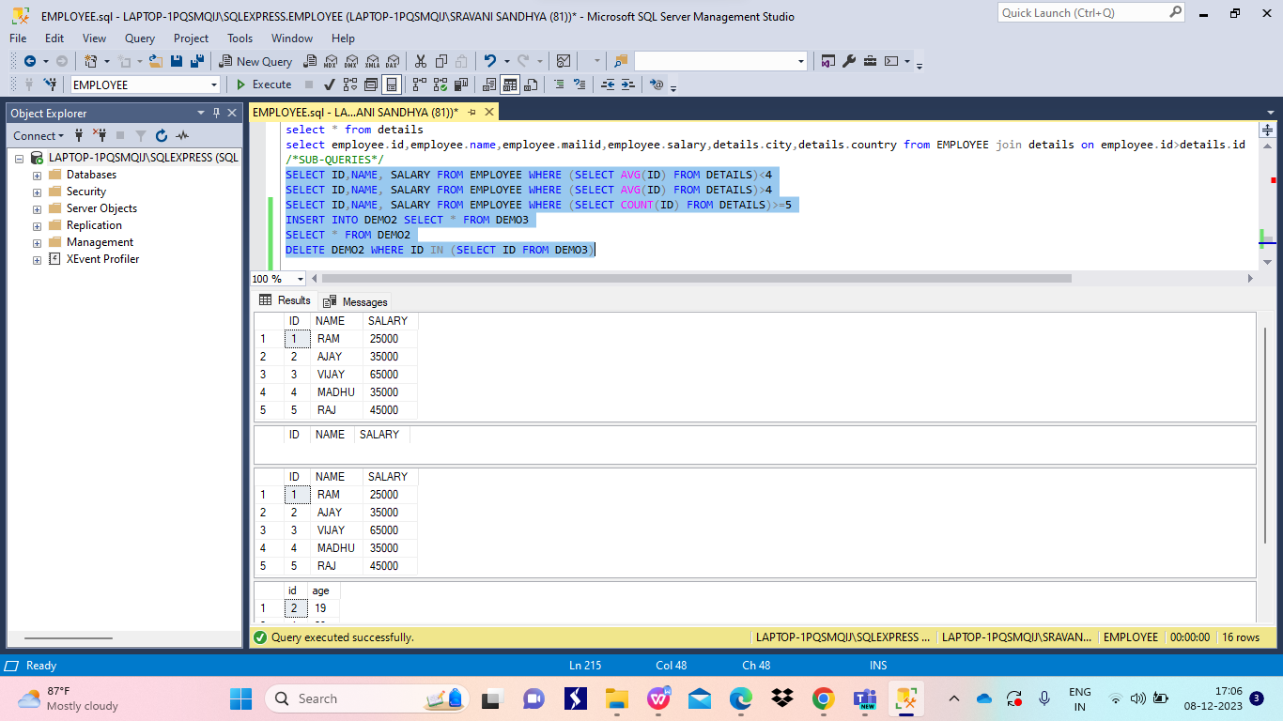

EXISTS-returns boolean value

ANY -it returns true if any values in given set is true

ALL-returns true only if all the values in the set are true 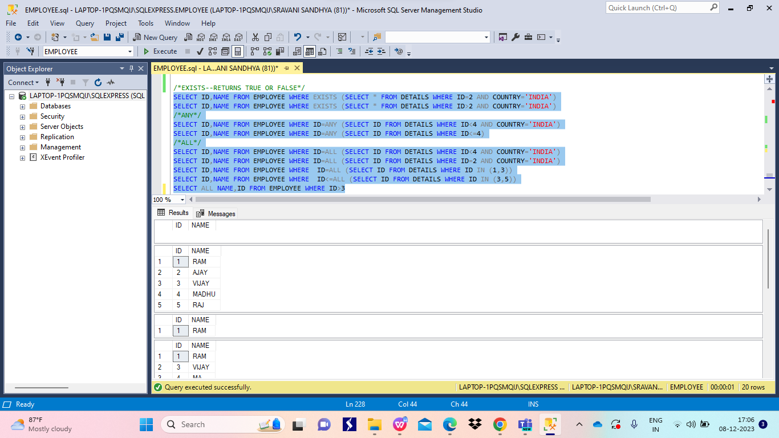

COREALATED SUBQUERIES

Queries that is executed with in the query related to same table

