Mallu Sravana Sandhya Assessment-6 9/12/2023

**Primary key** -which is a column in a table that uniquely identifies a particular record

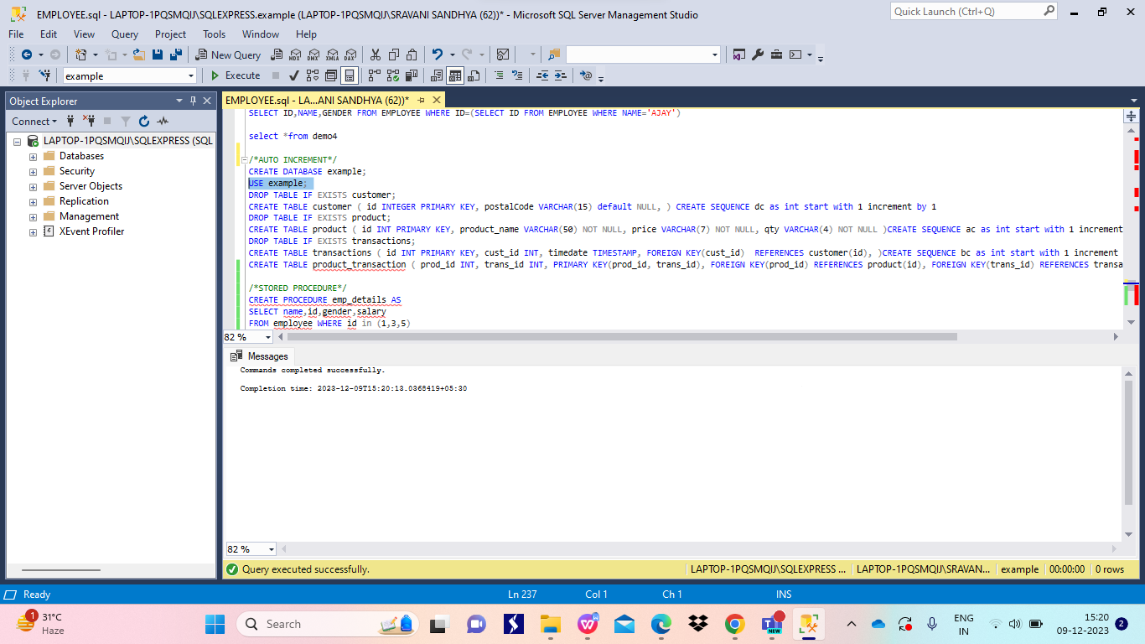

**Stored procedures** are similar to functions in programming language which contains a group of statements and executes all at a time when ever procedure is called

Syntax:

Create procedure procedure_name as Query

The procedure is executed using exec keyword

Syntax:

Exec procedure_name 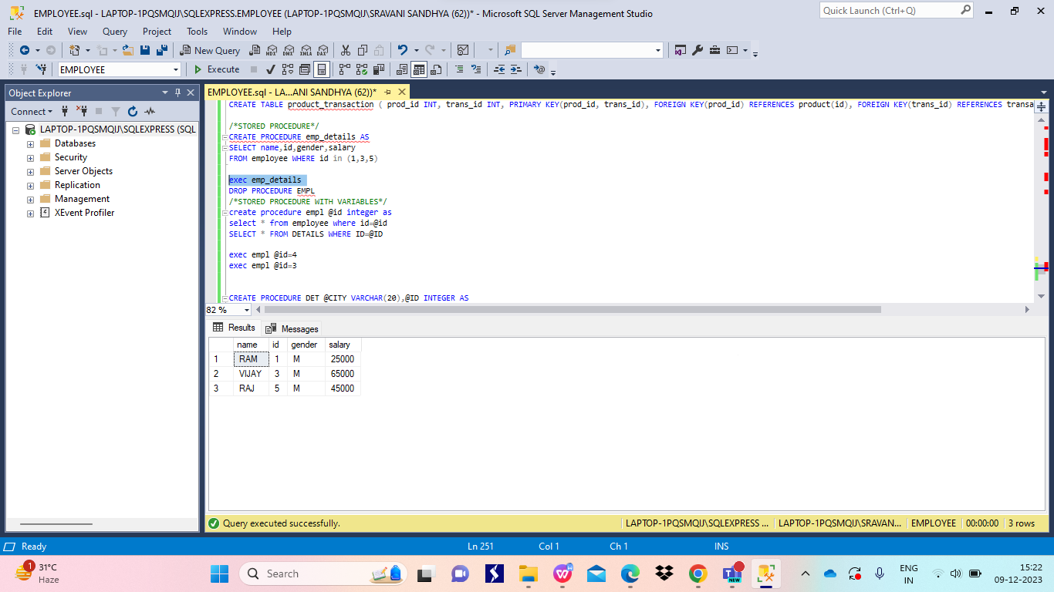

**Stored procedures with variables as arguments**

Here variables can be declared using @

syntax:

Create procedure procedure_name @variable datatype…. as query

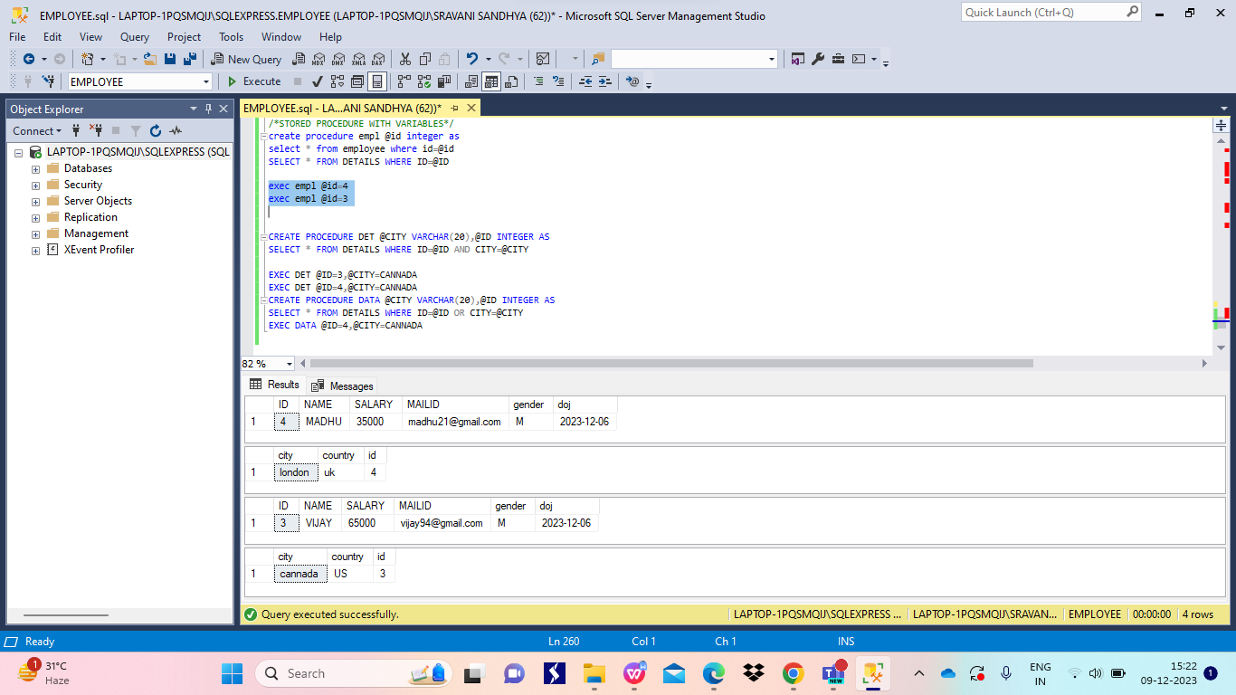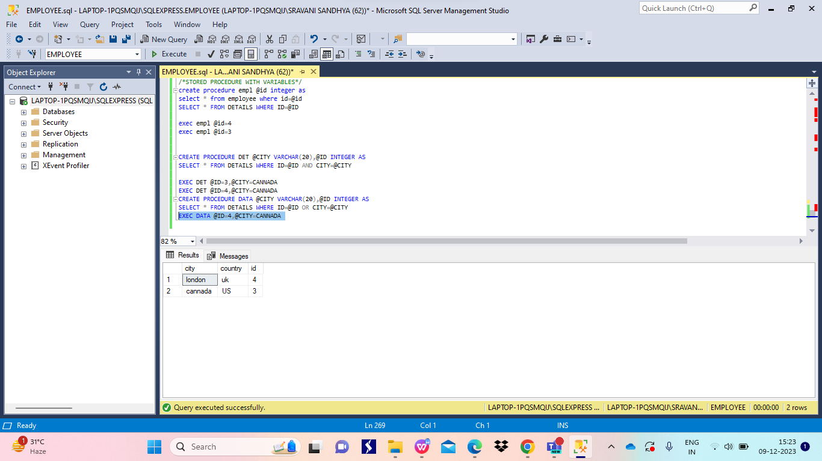

SUBTOTALS-sum of similar sets of data which is not same as final total

ROLLUP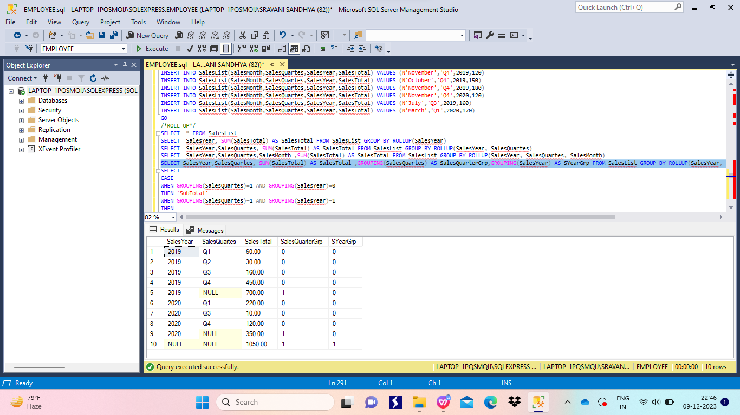

ROLLUP WITH COMMON TABLE EXPRESSION(CTE)

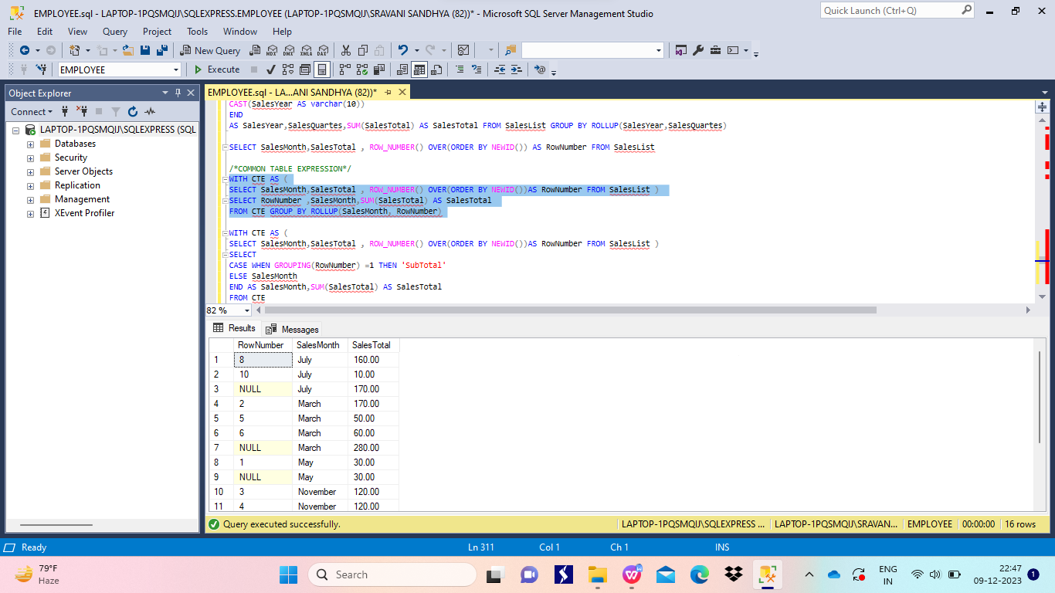

GROUPING SETS-displays multiple groups set in single query

