Mallu Sravana Sandhya Assessment-7 11/12/2023

PARTION BY -this clause is used only with over clause it is used to divide the set of data into some structured format helps in removing duplicate values

UPDATE- It is used to update the data present in the table

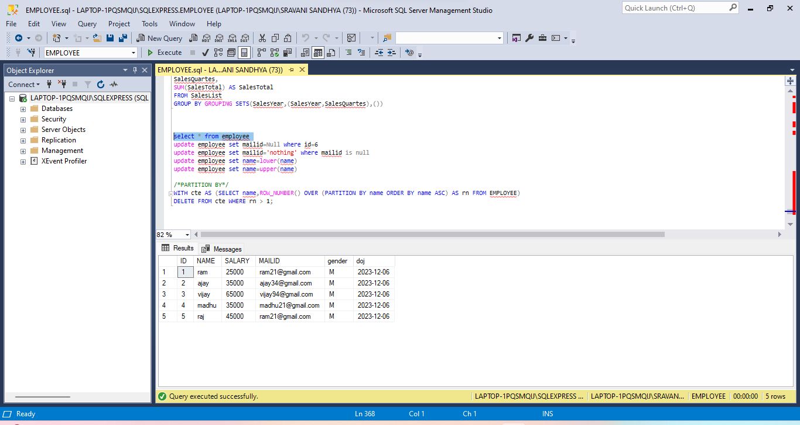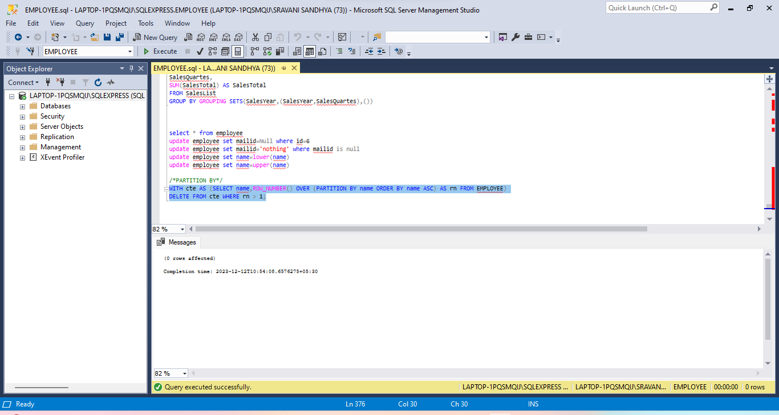

SNOW FLAKE SCHEMA:

-it normalises the dimension tables

-it increases the data integrity,simplify data maintenance and reduce the amount of disk space

-it improves the query performance