1. Navigate to <https://www.cloudflare.com/en-au/developer-platform/solutions/s3-compatible-object-storage/>
2. Click on Get Started
3. Signup with your email account
4. Add PayPal/CC and Add Billing address and Add R2 subscription to account
5. Create bucket

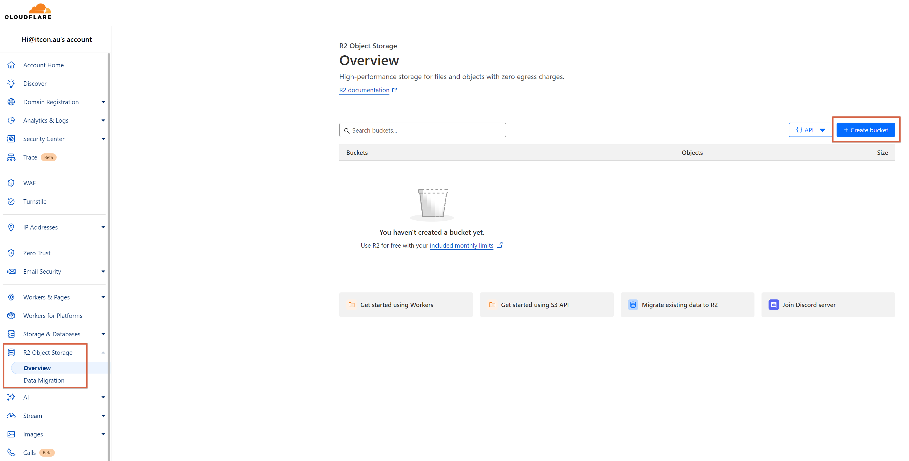

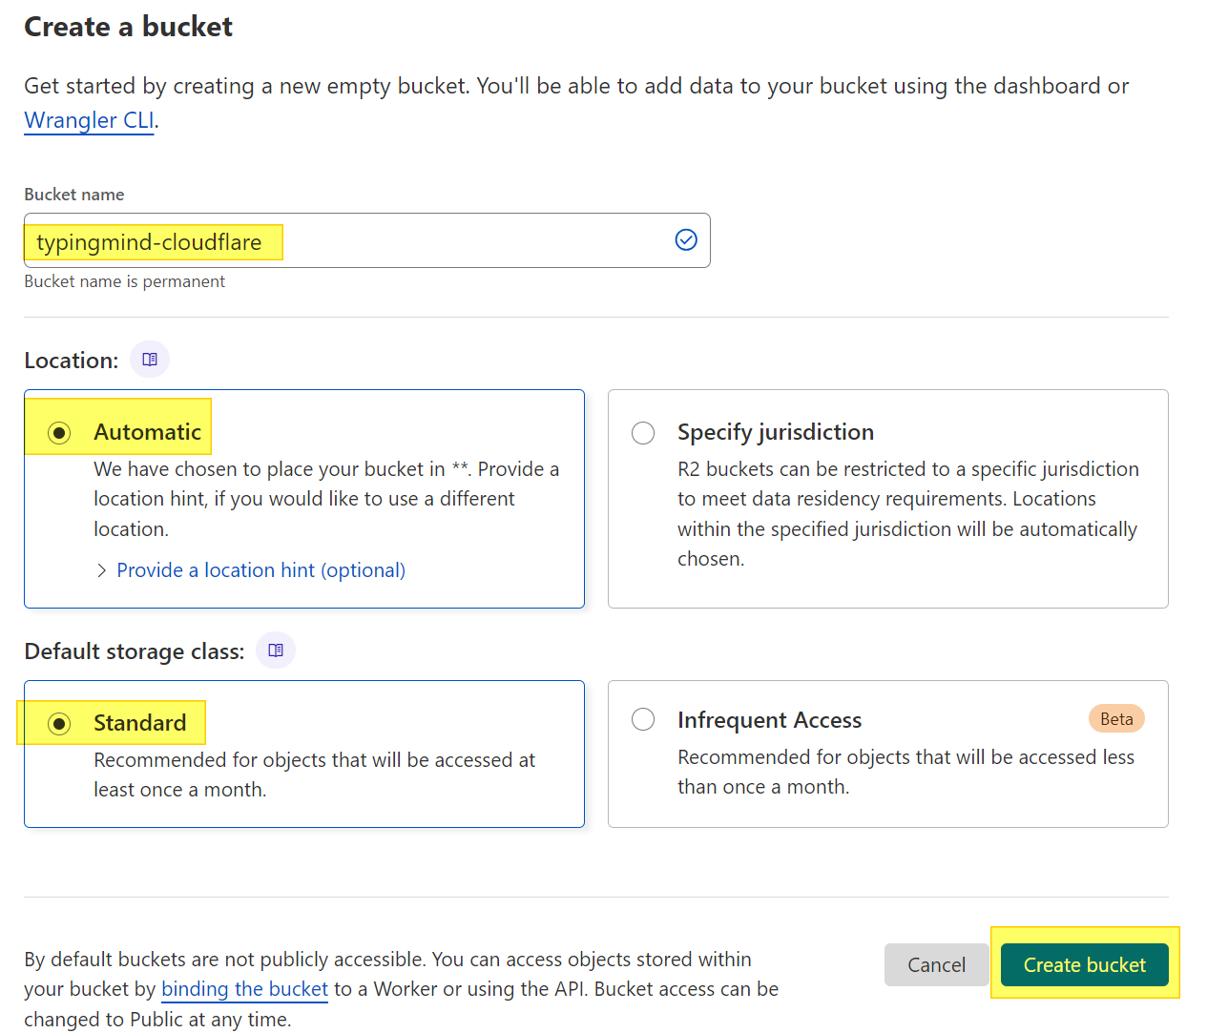

Open Bucket Settings

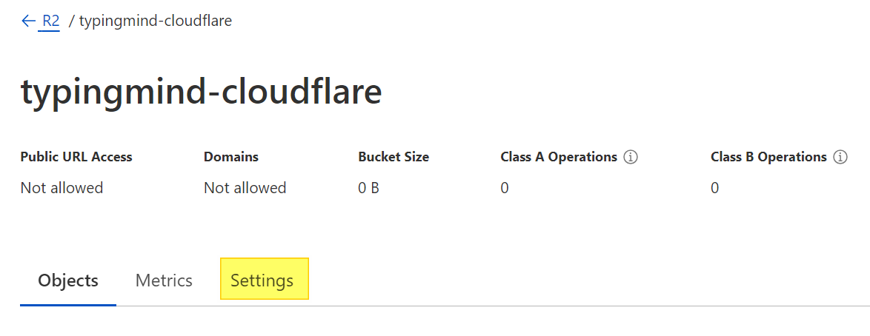

Add CORS policy – Get the CORS from Github readme. There are 2 different versions – one for self-hosted instances and another for typingmind.com. Below is an example for self hosted.

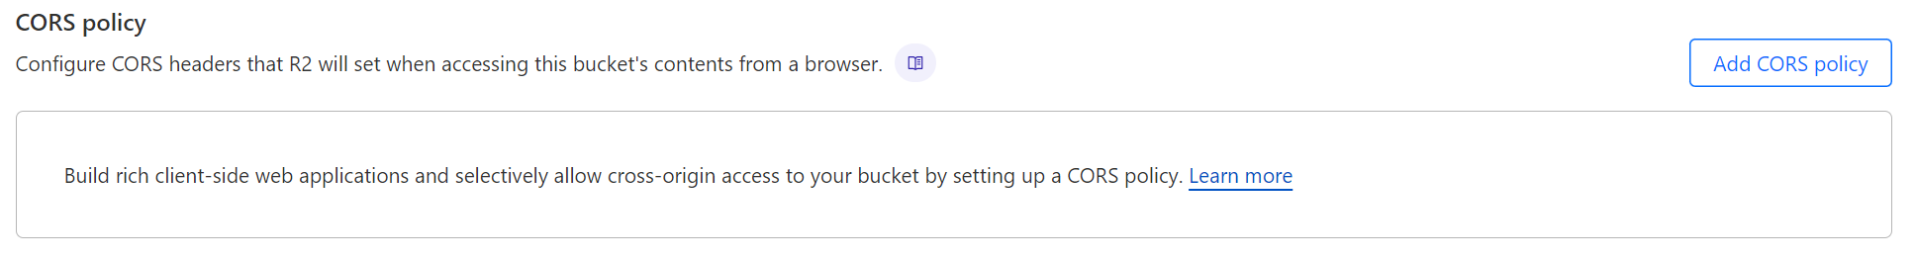

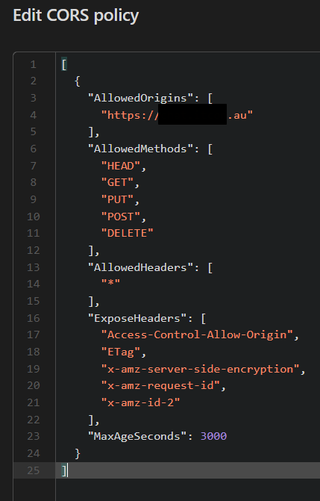

Create API Token

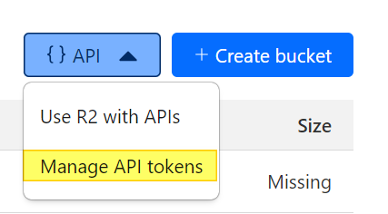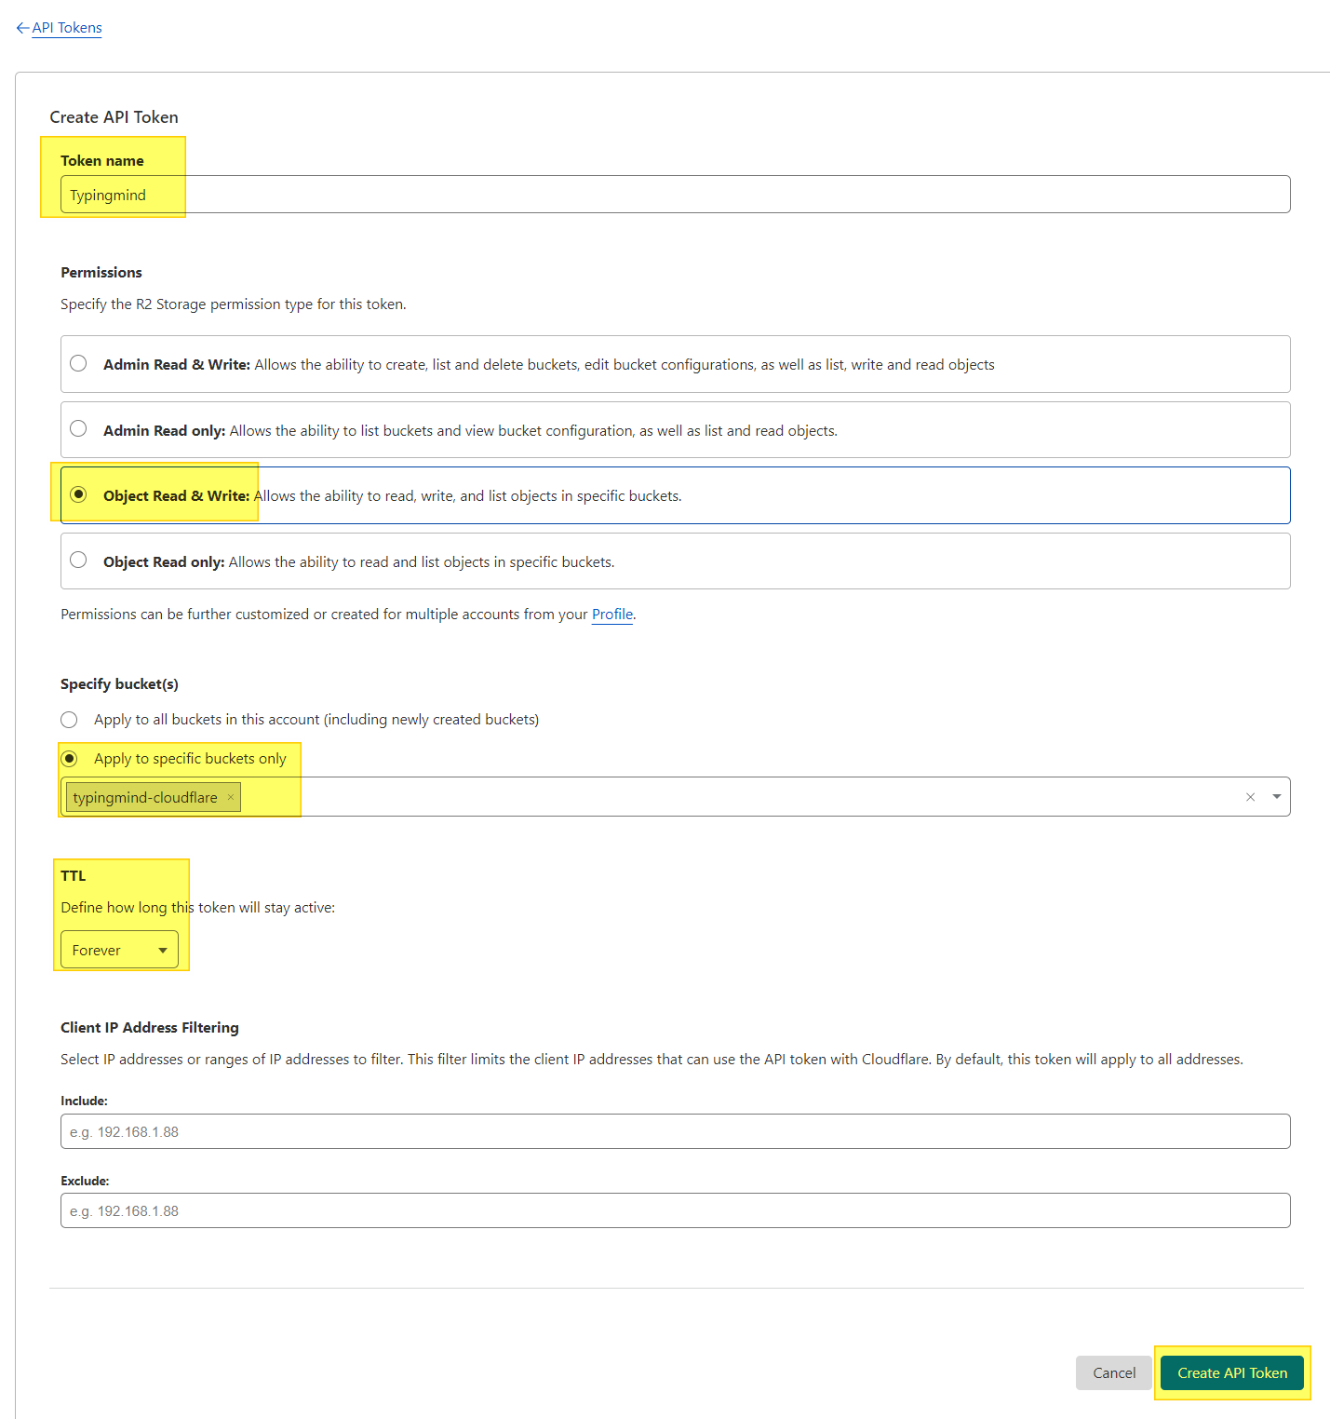

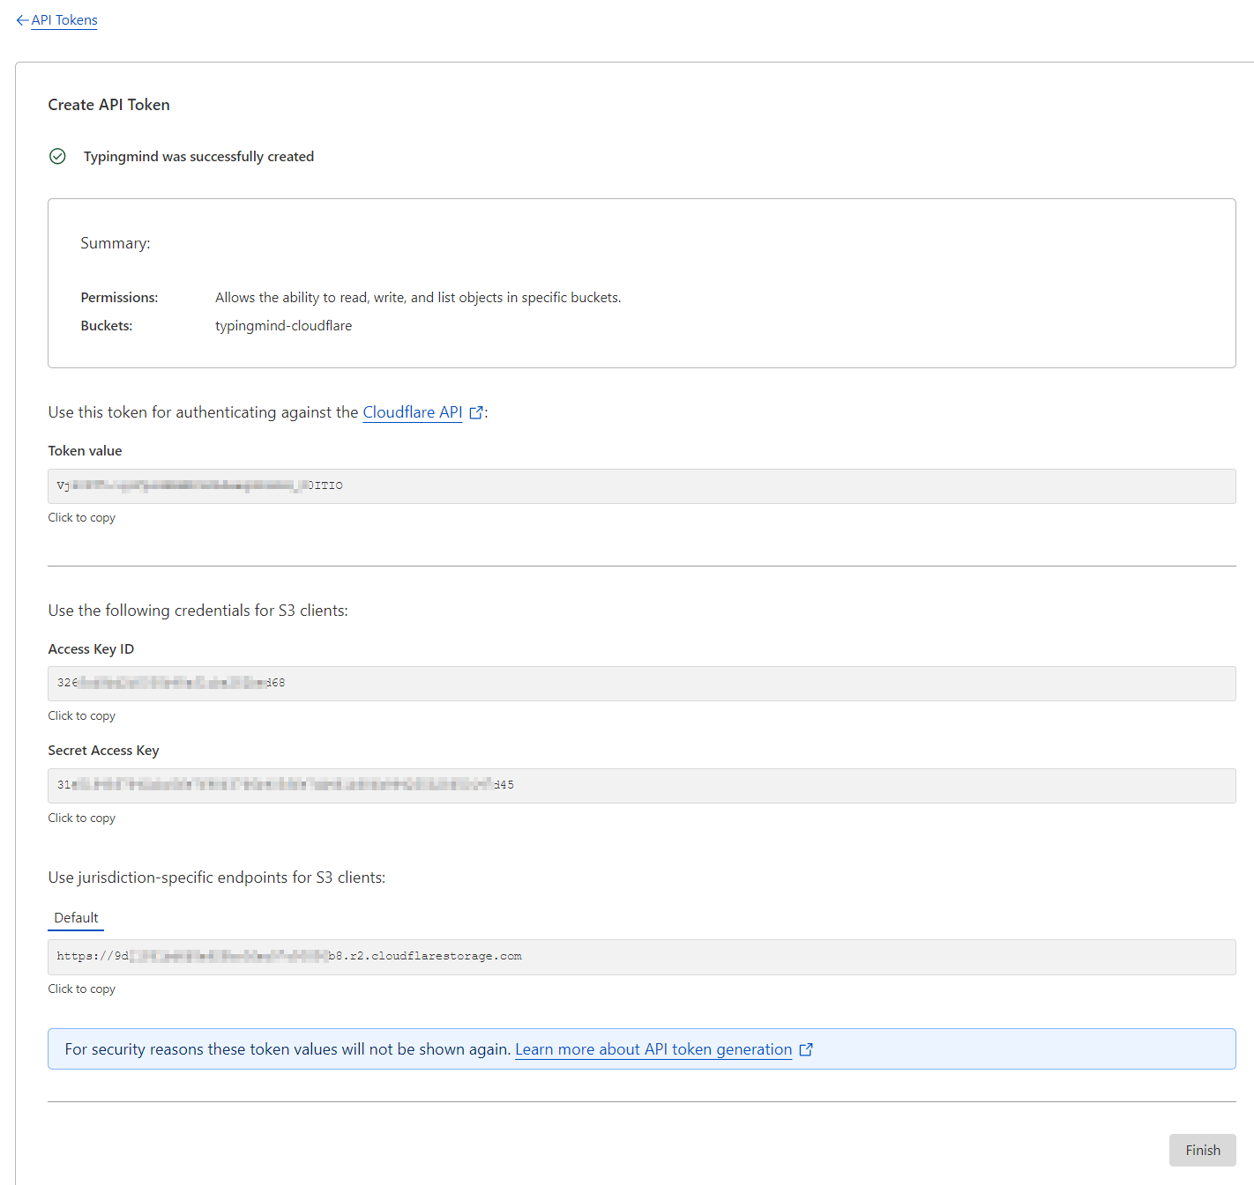

Config to be entered in extension

1. Bucket name
2. AWS Region – ‘auto’
3. AWS Access Key – This is the Access Key ID displayed when the token was generated
4. AWS Secret Key – This is the Secret Access Key displayed when the token was generated
5. AWS/S3 compatible Storage endpoint – This is the “Use Jurisdiction specific endpoints for S3 clients”

