iDrive e2

Register for the Free plan.

Enable a region of your choice.

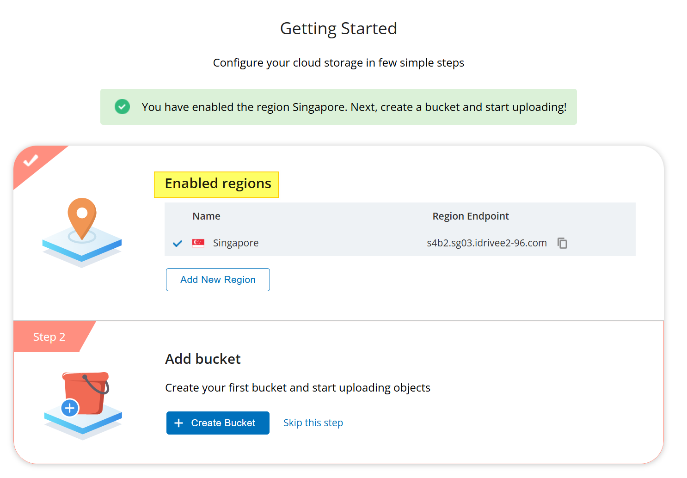

Create bucket

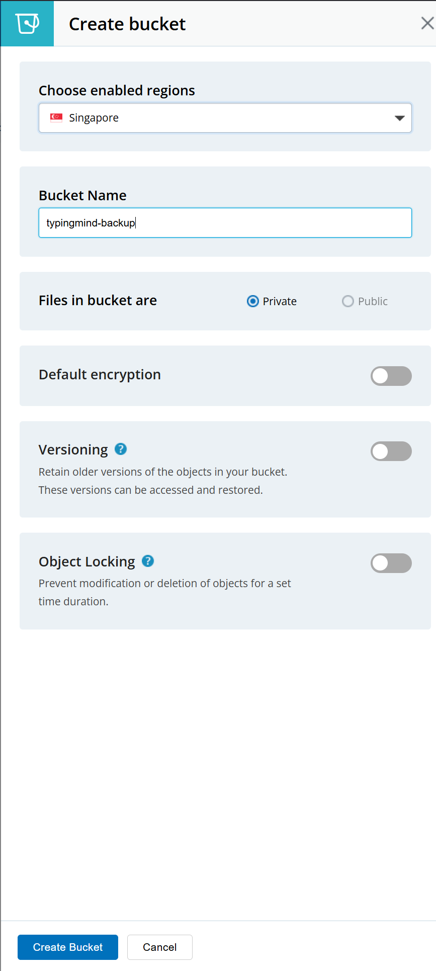

Navigate to Access Keys

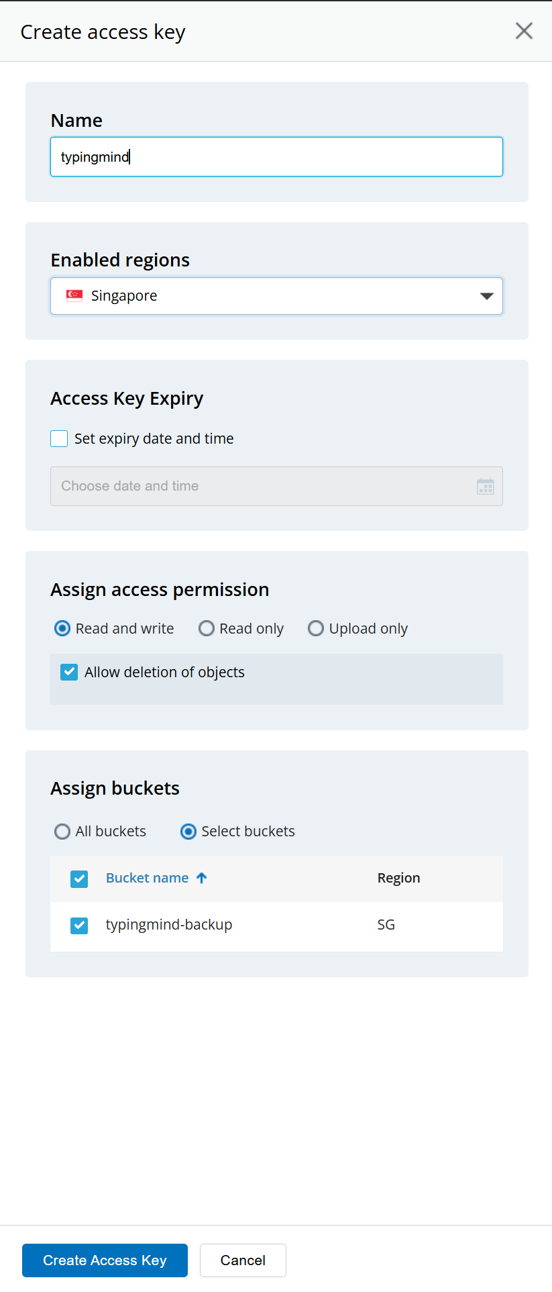

Copy the displayed access key, secret key and endpoint for later use as it will be displayed only once.

Configuration in the extension

|  |  |
| --- | --- |
| Config to be entered in extension   1. Bucket name 2. AWS Region – Select enabled region 3. AWS Access Key – Get it from the previous step 4. AWS Secret Key – Get it from the previous step 5. AWS/S3 compatible Storage endpoint – This is the endpoint from previous step. 6. Backup Interval (sec) – How frequently should the extension backup the data to S3. Minimum is 15 sec. 7. Encryption Key – To secure the backup files in S3, provide an 8+ char password here. Make sure you don’t forget it. Backups can be restored only with this password.   To understand how the extension works, refer GitHub readme -> <https://github.com/itcon-pty-au/typingmind-cloud-backup/tree/main> |  |