How to classify responses to adversity: resilience and vulnerability as deviations from the average

I. Introduction / Main contribution
The main contribution of this work is the introduction of new classification methods to analyze individual responses to adversity in the context of resilience research. These methods offer a shift in perspective by conceptualizing resilience and vulnerability as deviations from the norm. We propose to identify resilient and vulnerable individuals as those whose outcomes are notably better or worse, respectively, than the typical response to a given level of adversity.
With this framework, we provide tools to classify individuals into three groups based on the residuals of a regression between an adversity and an outcome: an average or normative group, consisting of individuals whose response is close to the expected or mean response for their level of adversity, a resilient group, whose outcomes are better than expected, and a vulnerable group, whose outcomes are worse.
Our approach is designed to be flexible and generalizable: all methods can be implemented using open-source standard statistical tools in R, and they are applicable across a wide range of settings and resilience constructs.
In the context of cross-sectional data, we present different approaches to define thresholds of deviation, including approaches based on quantiles, confidence intervals, prediction intervals, credibility intervals, standard deviation, and the k-means algorithm.
We extend this framework to longitudinal data using a Bayesian mixed-effects model with spike-and-slab priors for random effect selection. This allows us to identify individuals whose response systematically deviates from the average pattern, again classifying them as resilient, vulnerable, or average depending on the direction and significance of the deviation.
This document will be separated into two parts. First, we introduce multiple cross-sectional classification methods based on the residuals of a linear regression between an adversity variable and an outcome variable, where, to ensure robustness, we systematically identify and exclude from the fitting overly influential individuals using standard influence diagnostics. We then present the results of these classification methods on a real-world dataset and assess the relevance of each method by evaluating how well the resulting classification supports predictive modeling. Second, we extend the framework to longitudinal data by modeling the residuals of multiple regressions over time with a mixed-effects approach and present the spike-and-slab methodology to detect persistent deviations from the normative response. Then, we illustrate this method on the same real-world dataset. Both illustrations are fully implemented with open-source tools in R.
II. Cross-sectional analysis
II.1. Methods
II.1.1 Overview
In the cross-sectional setting, our objective is to identify individuals whose outcomes deviate from the average response to adversity evaluated at a single point in time.
To do so, we begin by fitting a linear regression model in which an outcome variable (e.g., a psychological functioning score) is regressed on an adversity variable (e.g., a cumulative adversity index). The residuals from this model capture individual deviations from the expected response, given the observed level of adversity.
To ensure that the fitted model is not unduly influenced by some individuals, we use influence diagnostics, specifically Cook's distance, to identify overly influential individuals. These individuals are excluded from the model fitting, but we still compute their residuals from the fitted model for completeness.
Finally, individuals are classified into three groups (resilient, average, vulnerable) based on the distribution of residuals, using one of several methods introduced in the classification methods definition section.
II.1.2 Residualization
The first step of the method consists in a residualization, a commonly used method, where where an outcome variable is linearly regressed on an adversity variable. Formally, the model is written as:
$y=X\hat{β}+ε$
Where $y∈R^{n}$ is the vector of outcomes,$X∈M_{n,2}\left(R\right)$ is the design matrix with a column of ones and a column containing the adversity scores, $\hat{β}∈R^{2}$ is the vector containing the intercept and slope coefficients, and $ε∈R^{n}$ is the vector containing the residuals. The residual for each individual corresponds to the difference between their observed outcome and the predicted outcome given their level of adversity.
It's worth noting that the direction of the association between adversity and outcome varies depending on the choice of variables. Thus, the sign of the residuals must be interpreted in context: when a higher outcome score means better functioning, a positive residual reflects a better outcome whereas when a higher outcome means worse functioning, a positive residual reflects a worse outcome, as you can see in Figure 1.
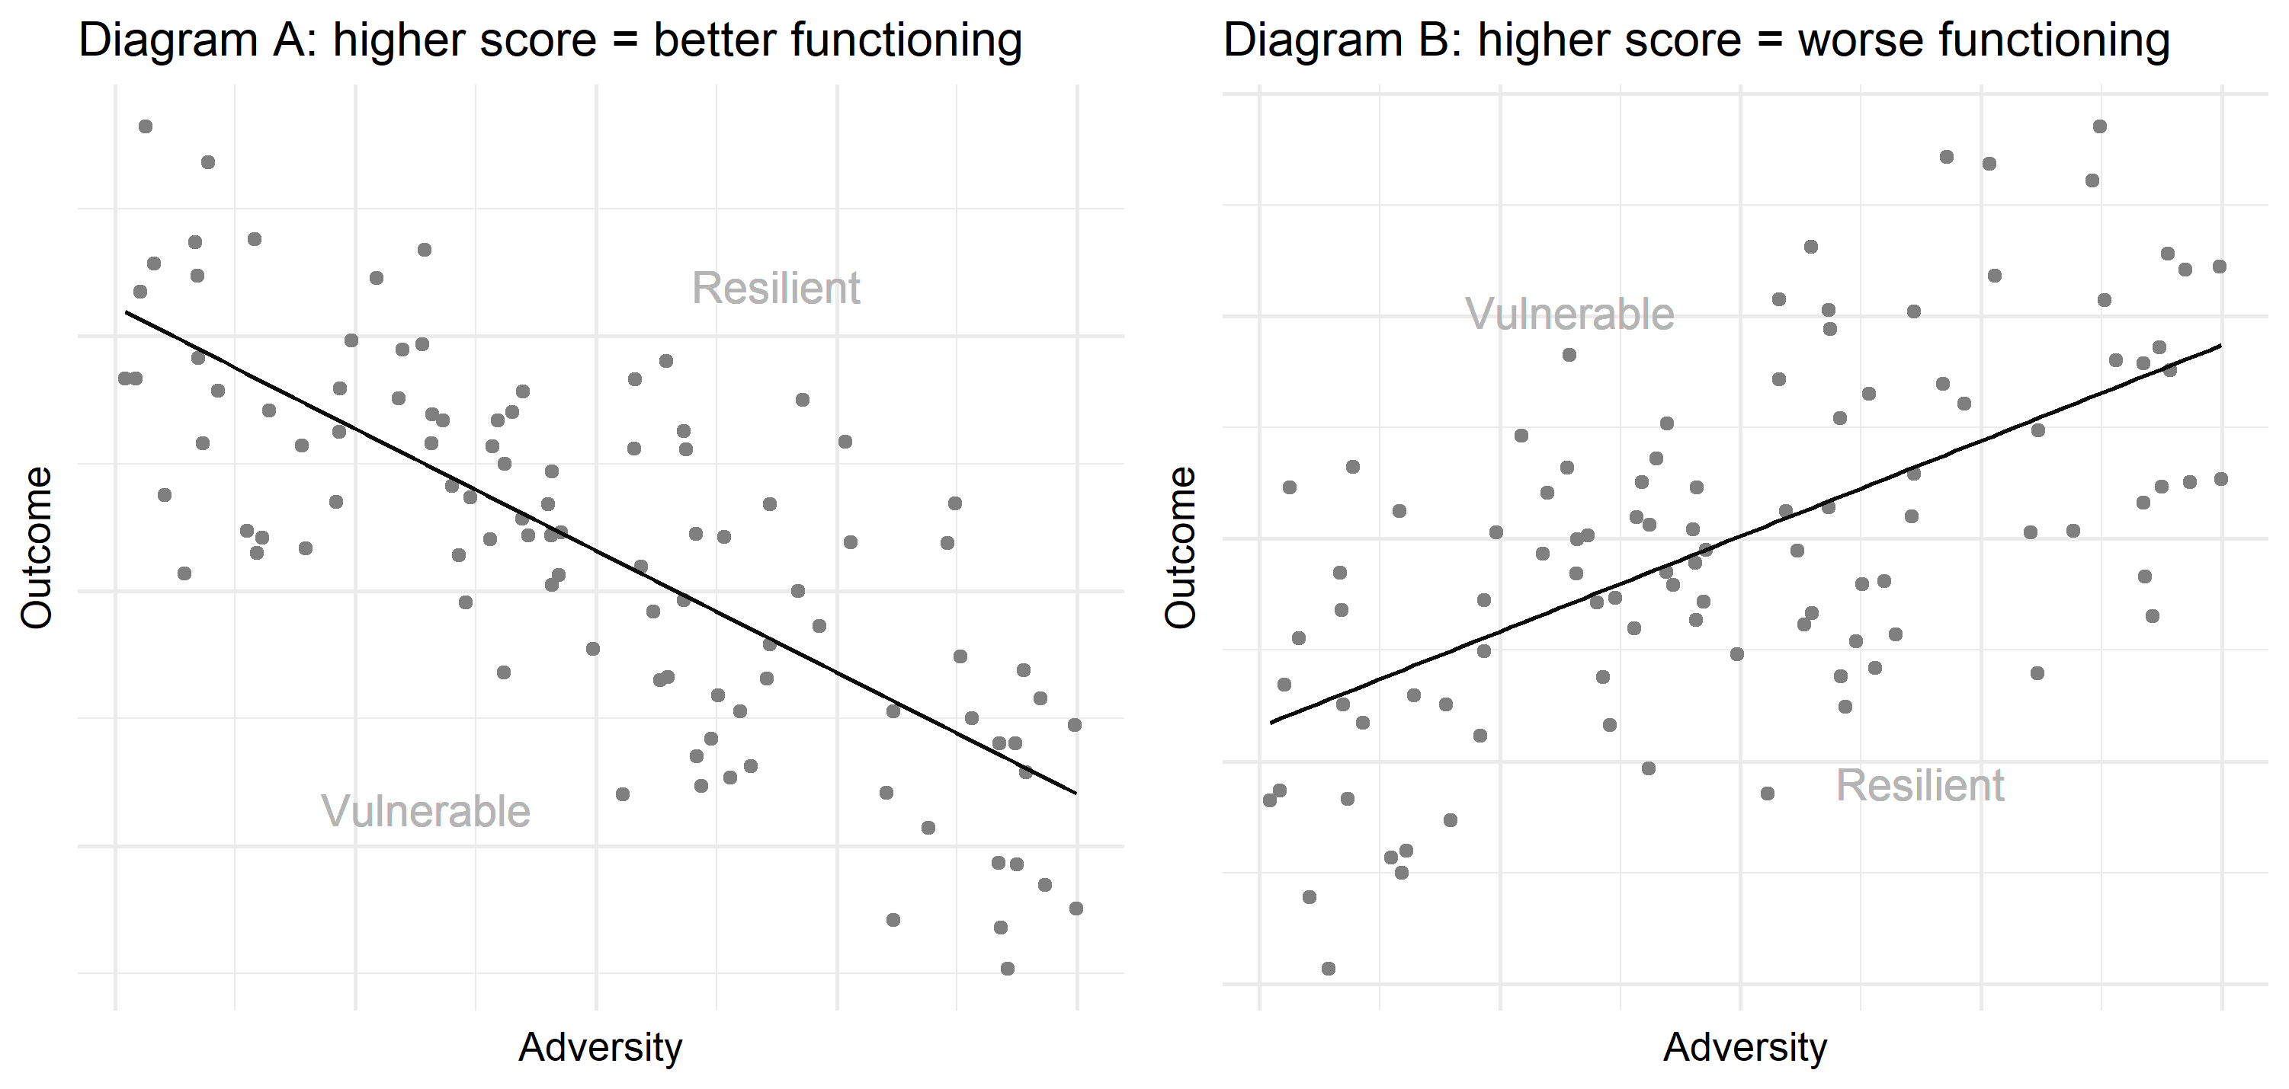
Figure 1: Diagrams explaining the meaning of a residual depending on its sign and the direction of the regression
II.1.3 Influence statistics
To ensure robustness in the estimation of the regression model, we apply influence diagnostics to identify and exclude overly influential individuals. Following the recommendations of [3], we inspect each individual's Cook's distance, which quantifies the impact of removing that individual on the estimated regression coefficients. Cook's distance is defined as:

$D_{j}​=\frac{{\left(\hat{β}−{\hat{β}}_{\left(j\right)}​\right)}^{T}X^{T}X\left(\hat{β}−{\hat{β}}_{\left(j\right)​}\right)}{{ps}^{2}}$
where $\hat{β}$ is the vector of estimated coefficients using the full dataset, $\hat{β_{\left(j\right)}}$ is the coefficient vector estimated without the $j^{th}$ individual, $X$is the design matrix, $(p)$ is the number of parameters in the model (i.e., the rank of $X$), and $s^{2}$ is the mean squared error of the full model.
Individuals with a Cook’s distance strictly greater than $4/n$, where $n$ is the sample size, are considered overly influential and are excluded from the regression fitting. However, we still compute their residuals from the fitted model, so that all individuals are classified.
II.1.4 Classification methods definition
Using the residuals obtained from the residualisation, we propose several approaches to define class membership in the resilient, normative and vulnerable groups:
Naïve approach: Individuals with a non-null residual are classified as resilient or vulnerable depending on the sign of the residual and the relationship between the adversity and the outcome; individuals with a null residual are classified as average.
Confidence and prediction interval-based classification: Individuals are classified based on how their observed outcome compares to the expected interval in the regression model. Specifically, we use either confidence intervals (intervals for the mean predicted outcome) or prediction intervals (intervals for a new individual outcome). An individual is classified as average if their outcome falls within the chosen interval. Otherwise, they are classified as resilient or vulnerable, depending on the sign of their residual.
Formally, let $x_{0}∈R^{p}$ be the design vector for an individual (i.e., a vector with a one for the intercept and the individual's adversity score). The corresponding prediction is:
$\hat{y_{0}}=x_{0}^{T}\hat{β}$
The $100\left(1−α\right)\text{\%}$ confidence interval for $\hat{y_{0}}$is given by:
$\left[\hat{y_{0}} ± t_{n−p,1−\frac{α}{2}}⋅{SE}_{mean}\left(x_{0}\right)\right]$,
where
${SE}_{mean}\left(x_{0}\right)=\hat{σ}⋅\sqrt{x_{0}^{T}{\left(X^{T}X\right)}^{−1}x_{0}}$, ${\hat{σ}}^{2}$ is the estimated residual variance, and $t_{n−p,1−\frac{α}{2}}$is the quantile of the Student distribution with $n−p$ degrees of freedom.
The $100\left(1−α\right)\text{\%}$ prediction interval for a new observation at $x_{0}$ is:
$\left[\hat{y_{0}} ± t_{n−p,1−\frac{α}{2}}⋅{SE}_{pred}\left(x_{0}\right)\right]$
where
${SE}_{pred}\left(x_{0}\right)=\hat{σ}⋅\sqrt{1+x_{0}^{T}{\left(X^{T}X\right)}^{−1}x_{0}}.$
The prediction interval is wider than the confidence interval, as it accounts for both the uncertainty in estimating the mean and the variability of individual outcomes [2].
Credibility interval-based classification: Instead of the original linear regression model, we fit a Bayesian linear regression model using the same sample (i.e., excluding influential individuals). We use the stan_glm() function from the rstanarm package (version~2.32.1) to estimate the relationship between the outcome variable and the adversity variable, using the default weakly informative priors as implemented in rstanarm.
After fitting the model, we use the posterior_linpred() function to generate $S=1000$ draws from the posterior predictive distribution of the expected outcome for each individual, conditional on their observed adversity level. Specifically, for each $x_{j}$, we compute:
${\hat{y_{j}}}^{\left(s\right)}=β_{0}^{\left(s\right)}+β_{1}^{\left(s\right)}x_{j} fors=1,...,S,$
where ${\hat{y_{j}}}^{\left(s\right)}$ is the predicted mean outcome from the $s^{th}$ posterior draw. This yields a posterior distribution of expected outcomes for each individual.
To construct individual-level credibility intervals, we compute the empirical $α/2$ and $1−α/2$quantiles of the ${\hat{y_{j}}}^{\left(s\right)}$values. Individuals whose observed outcome $y_{j}$ falls within their corresponding $100\left(1−α\right)\text{\%}$ posterior credibility interval are classified as average. Those with outcomes outside the interval are classified as either resilient or vulnerable, depending on the direction of the deviation.
Quantile-based thresholds: Individuals are classified based on the empirical distribution of residuals. Those with residuals below the $n\text{\%}$ quantile or above the $\left(100−n\right)\text{\%}$ quantile are identified as atypical (resilient or vulnerable). Individuals with residuals within this central range are classified as average.
Standard deviation-based thresholds using adversity levels: For each adversity score interval (e.g. 5 by 5 or cut-offs associated with the variable), the standard deviation of the residuals of all individuals belonging to this level is computed. Individuals whose residuals deviate by more than 0.5, 1 or 2 times (or another multiple) the standard deviation of the level they belong to are then considered atypical (resilient or vulnerable), and the ones inside the interval are considered average.
K-means classification: Application of the k-means algorithm on the residual values with 3 clusters and random start-points. The group with the intermediary mean residual value is considered the average group. Depending on the direction of the relationship between the adversity and the outcome, the two other groups are the resilient and vulnerable.
These different methods allow for varying group sizes and various shapes, as illustrated in the following illustrative example.
II.2. Illustrative example: LORA Project
II.2.1 Data and variables
For this illustrative example, we used data from the Longitudinal Resilience Assessment (LORA) project, described in [1]. The study was designed to investigate resilience mechanisms in response to everyday stress. The initial sample included $N=1,191$ German-speaking adults aged 18 to 50 at baseline. Data were collected over a five-year period, with online questionnaires administered quarterly and in-depth assessments conducted every 18 months.
For our cross-sectional analysis, we used only the data of the first assessment ($T=1$). For all $N=1,191$ individuals, it was possible to compute a General Health Questionnaire (GHQ) score, along with either a Daily Hassles (DH) score or a Perceived Stress Scale (PSS) score. The DH and PSS scores were used as adversity variables, while the GHQ score served as the outcome variable.
II.2.2 Software
All approaches were implemented in R (version~4.4.3) using the packages dplyr (version~1.1.4), haven (version~2.5.5) to read the data, olsrr (version~0.6.1) for the influence statistics, tidyr (version~1.3.1) and rstanarm (version~2.32.1).
II.2.3 Residualization results
Perceived Stress Scale
69 individuals were identified as overly influential based on Cook's distance and were excluded from the adjusted model. Figure 2 presents the results of both the unadjusted and adjusted linear regressions, with overly influential individuals marked as filled points. While the models yield broadly similar results, the adjusted model shows a smaller slope coefficient than the unadjusted one, indicating a slightly attenuated relationship after excluding influential individuals.
Higher scores on the GHQ variable indicate worse functioning, whereas higher PSS scores correspond to more severe perceived stress. Consequently, the observed positive association between the adversity and the outcome implies that individuals with positive residuals are functioning worse than expected, given their PSS score, while those with negative residuals are functioning better than expected.
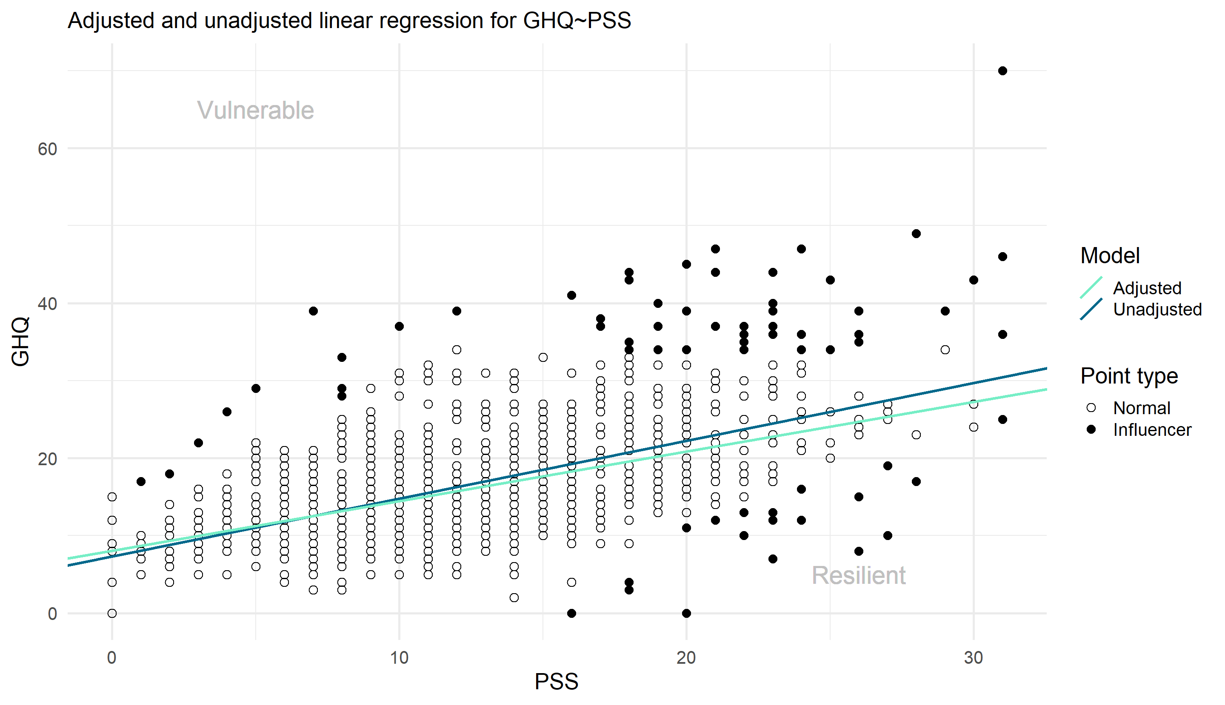
Figure 2 : Residualization of GHQ and PSS
Daily Hassles
75 individuals were identified as overly influential based on Cook's distance and were excluded from the adjusted model. Figure~\ref{fig:residualization_DH} presents the results of both the unadjusted and adjusted linear regressions, with overly influential individuals marked as filled points. In this case, the two regressions are almost the same.
Higher DH scores correspond to more daily hassles. Therefore, the positive association observed between the adversity and the outcome implies that individuals with positive residuals are functioning worse than expected, given their PSS score, while those with negative residuals are functioning better than expected.
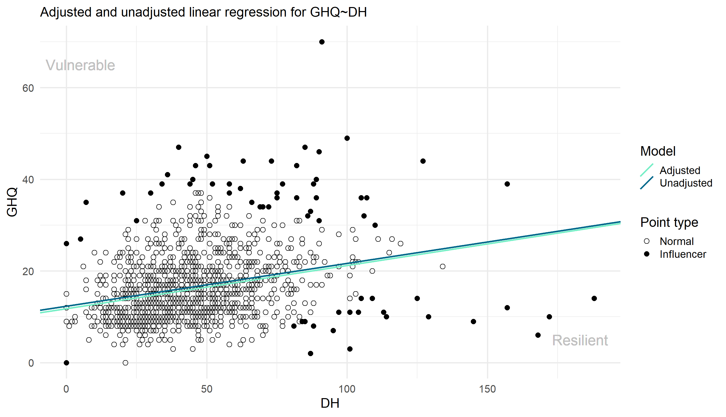
Figure 3: Residualization of GHQ and DH
II.2.4 Group results by method – PSS and DH
We applied each classification method to the residuals from the adjusted linear regression for both DH and PSS and computed the resulting group memberships across all individuals each time.
Naive approach
As shown in Table 1 and Table 2, the naive classification method results in both cases in an extreme classification where no individuals are classified as average, all individuals are assigned either to the resilient or vulnerable group. Figures 4 and 5 illustrate that this method imposes a strict split at zero, without accounting for the variability or uncertainty of the residuals. Even individuals with residuals very close to zero are considered atypical. This method is therefore intended more as a baseline comparison than as a realistic classification approach.

Resilient size | Average size | Vulnerable size
651 | 0 | 540
Table 1 : Group size with the naive approach for DH
Resilient size | Average size | Vulnerable size
626 | 0 | 565
Table 2: Group size with the naive approach for PSS
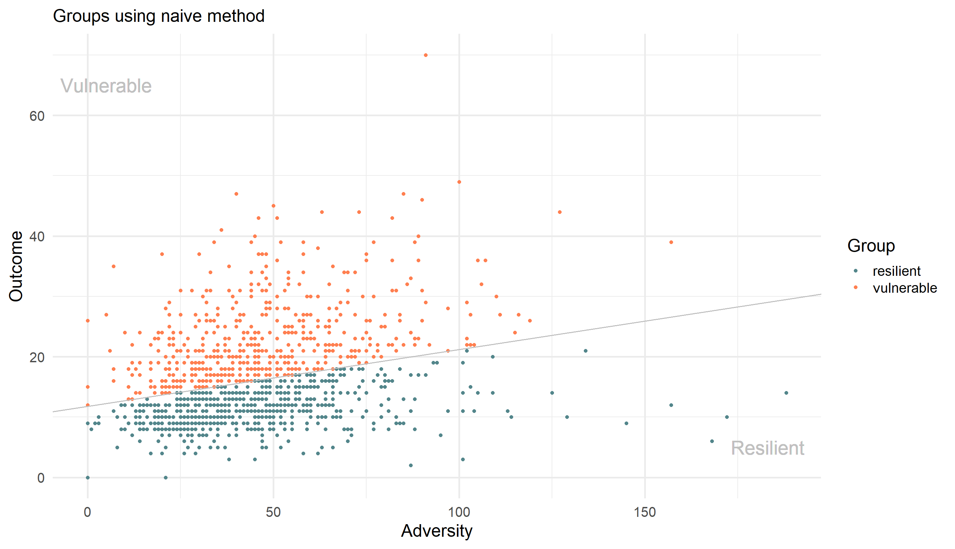
Figure 4:Classification obtained with the naive approach for DH

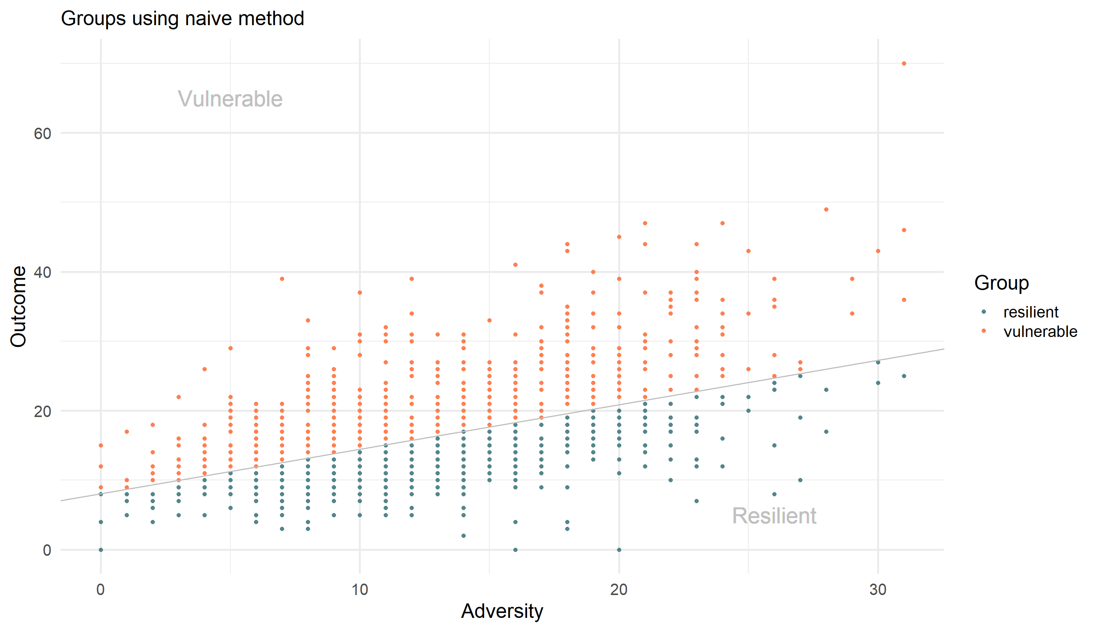
Figure 5: Classification obtained with the naive approach for DH
Confidence and prediction interval-based classification
As shown in Tables 3 and 4 and Figures 6 and 7, prediction intervals produce wider intervals and thus larger average groups compared to confidence intervals. In both cases, the 3 values tested for prediction intervals (50, 60 and 75%) resulted in a dominant average group, but not the two confidence intervals tested (99 and 90%), which resulted in a bigger resilient group. As expected, decreasing the confidence or prediction level (i.e., using a smaller $1−α$ results in narrower intervals and, consequently, smaller average groups.
An important distinction in our results is that confidence intervals exhibit much greater variation in width across levels of adversity than prediction intervals. This arises because, in both models, the leverage term ($x_{0}^{T}{\left(X^{T}X\right)}^{−1}x_{0}$) remains very small in both cases, leading to a wider range of variation for the standard error for the confidence intervals than the prediction intervals:
For the Daily Hassles (DH) model, the standard error for the mean prediction varies between:
$0.0008 ⩽ {SE}_{mean}\left(x_{0}\right) ⩽ 0.020$,
while the standard error for the prediction interval remains nearly constant:
$1.000 ⩽ {SE}_{pred}\left(x_{0}\right) ⩽ 1.009.$
Similarly, for the Perceived Stress Scale (PSS) model:
$0.0008 ⩽ {SE}_{mean}\left(x_{0}\right) ⩽ 0.0115$,
compared to:
$1.000 ⩽ {SE}_{pred}\left(x_{0}\right) ⩽ 1.006$.
These results show that prediction intervals appear almost uniform across the range of adversity, while confidence intervals are more sensitive to an individual’s adversity level.

Resilient size | Average size | Vulnerable size | Detail
125 | 870 | 196 | Prediction interval 75%
252 | 688 | 251 | Prediction interval 60%
342 | 550 | 299 | Prediction interval 50%
612 | 89 | 490 | Confidence interval 99%
620 | 71 | 500 | Confidence interval 90%
Table 3: Group size with the confidence and prediction intervals approach for DH
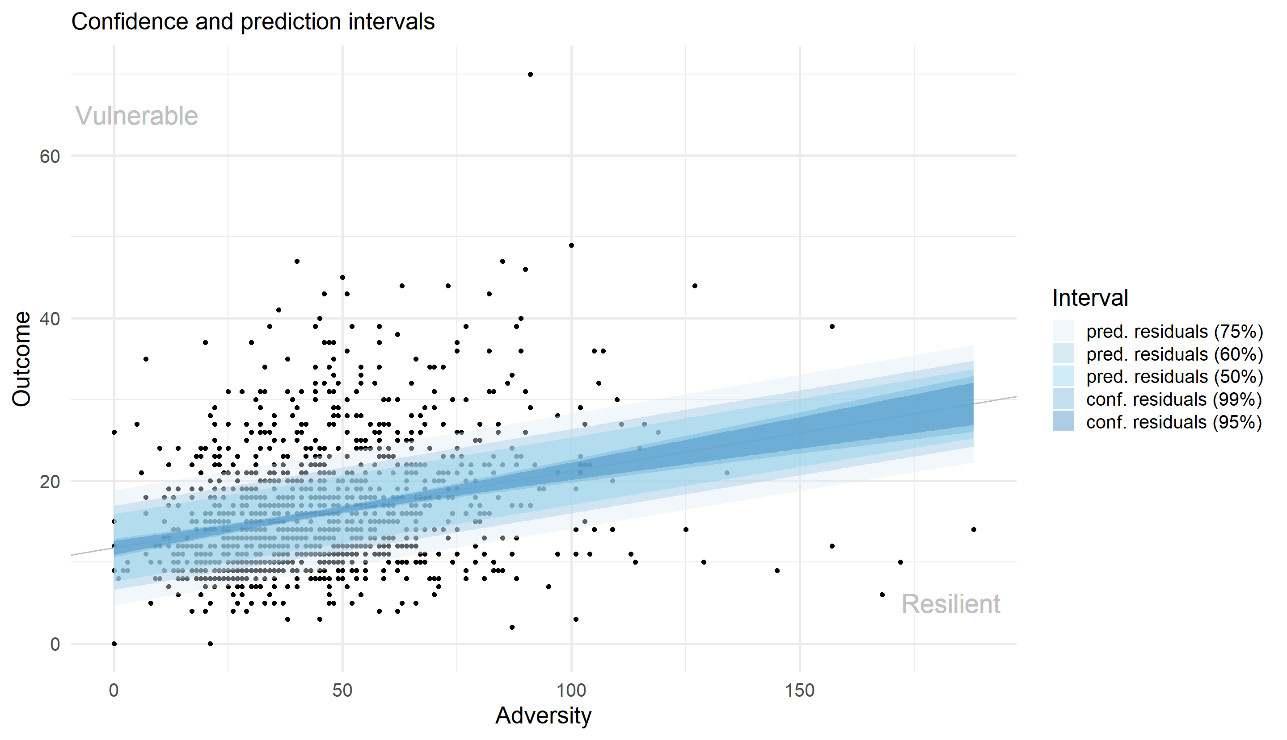
Figure 6: Classification obtained with the confidence and prediction intervals approach for DH

Resilient size | Average size | Vulnerable size | Detail
137 | 850 | 204 | Prediction interval 75%
252 | 665 | 274 | Prediction interval 60%
317 | 554 | 320 | Prediction interval 50%
576 | 101 | 514 | Confidence interval 99%
594 | 74 | 523 | Confidence interval 90%

Table 4: Group size with the confidence and prediction intervals approach for PSS
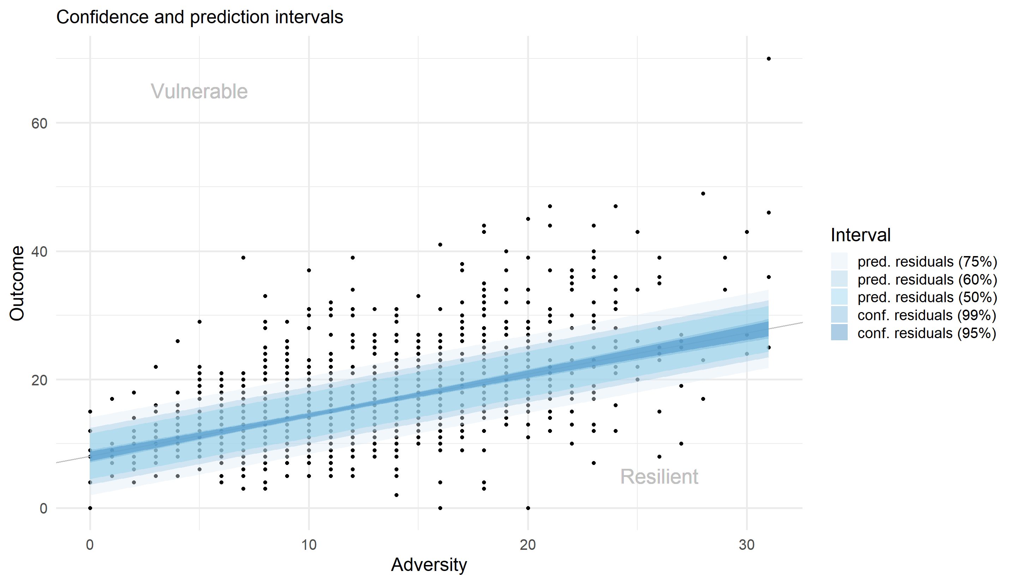
Figure 7: Classification obtained with the confidence and prediction intervals approach for PSS
Credibility interval-based classification
As shown in Figure 8 and Figure 9 and Tables 5 and 6, credibility intervals tend to be very narrow, resulting in small average groups, even when using wide intervals such as the 99.9% credibility level. In practice, the class size produced by credibility intervals resembles those obtained from confidence intervals of the same level.
As with confidence intervals, the width of credibility intervals varies with the level of adversity, since they reflect posterior uncertainty around the expected outcome for each individual.
Resilient size | Average size | Vulnerable size | Detail
629 | 118 | 444 | Credibility interval 99.9%
635 | 102 | 454 | Credibility interval 99%
654 | 70 | 467 | Credibility interval 95%
655 | 64 | 472 | Credibility interval 90%
665 | 43 | 483 | Credibility interval 75%
683 | 20 | 488 | Credibility interval 50%

Table 5 : Group size with the credibility intervals approach for DH

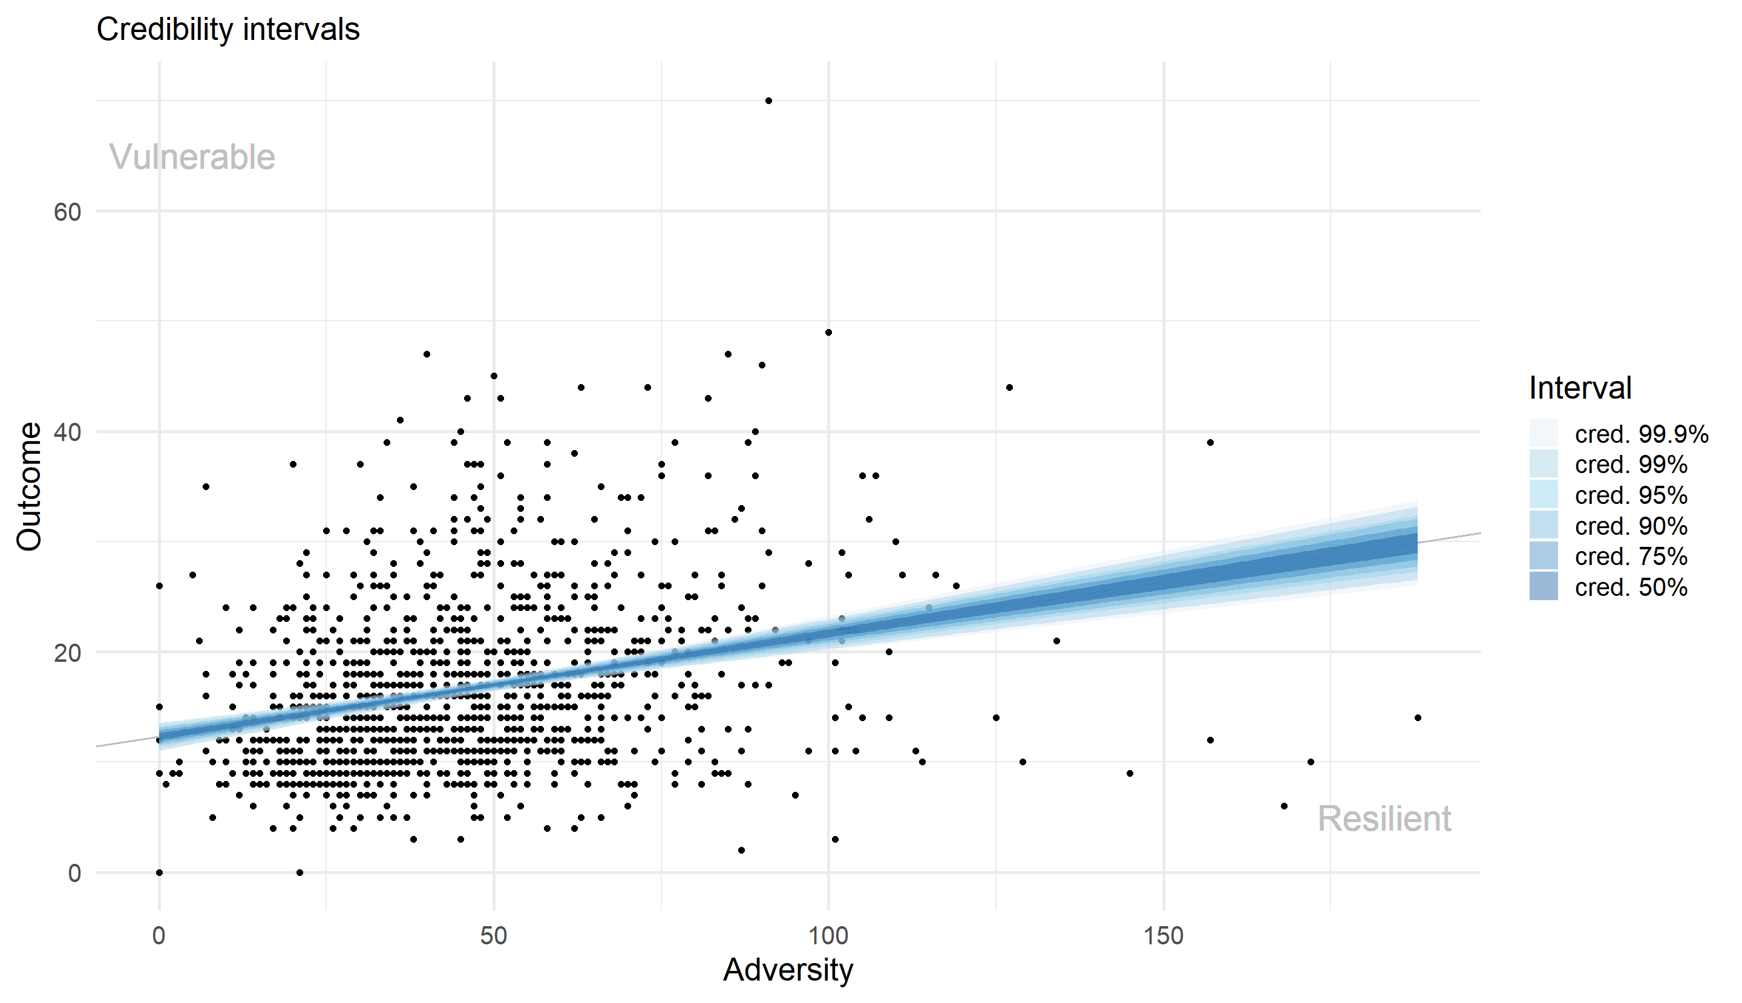
Figure 8: Classification obtained with the credibility intervals approach for DH
Resilient size | Average size | Vulnerable size | Detail
599 | 131 | 461 | Credibility interval 99.9%
610 | 109 | 472 | Credibility interval 99%
622 | 83 | 486 | Credibility interval 95%
633 | 66 | 492 | Credibility interval 90%
643 | 45 | 503 | Credibility interval 75%
652 | 23 | 516 | Credibility interval 50%

Table 6: Group size with the credibility intervals approach for PSS

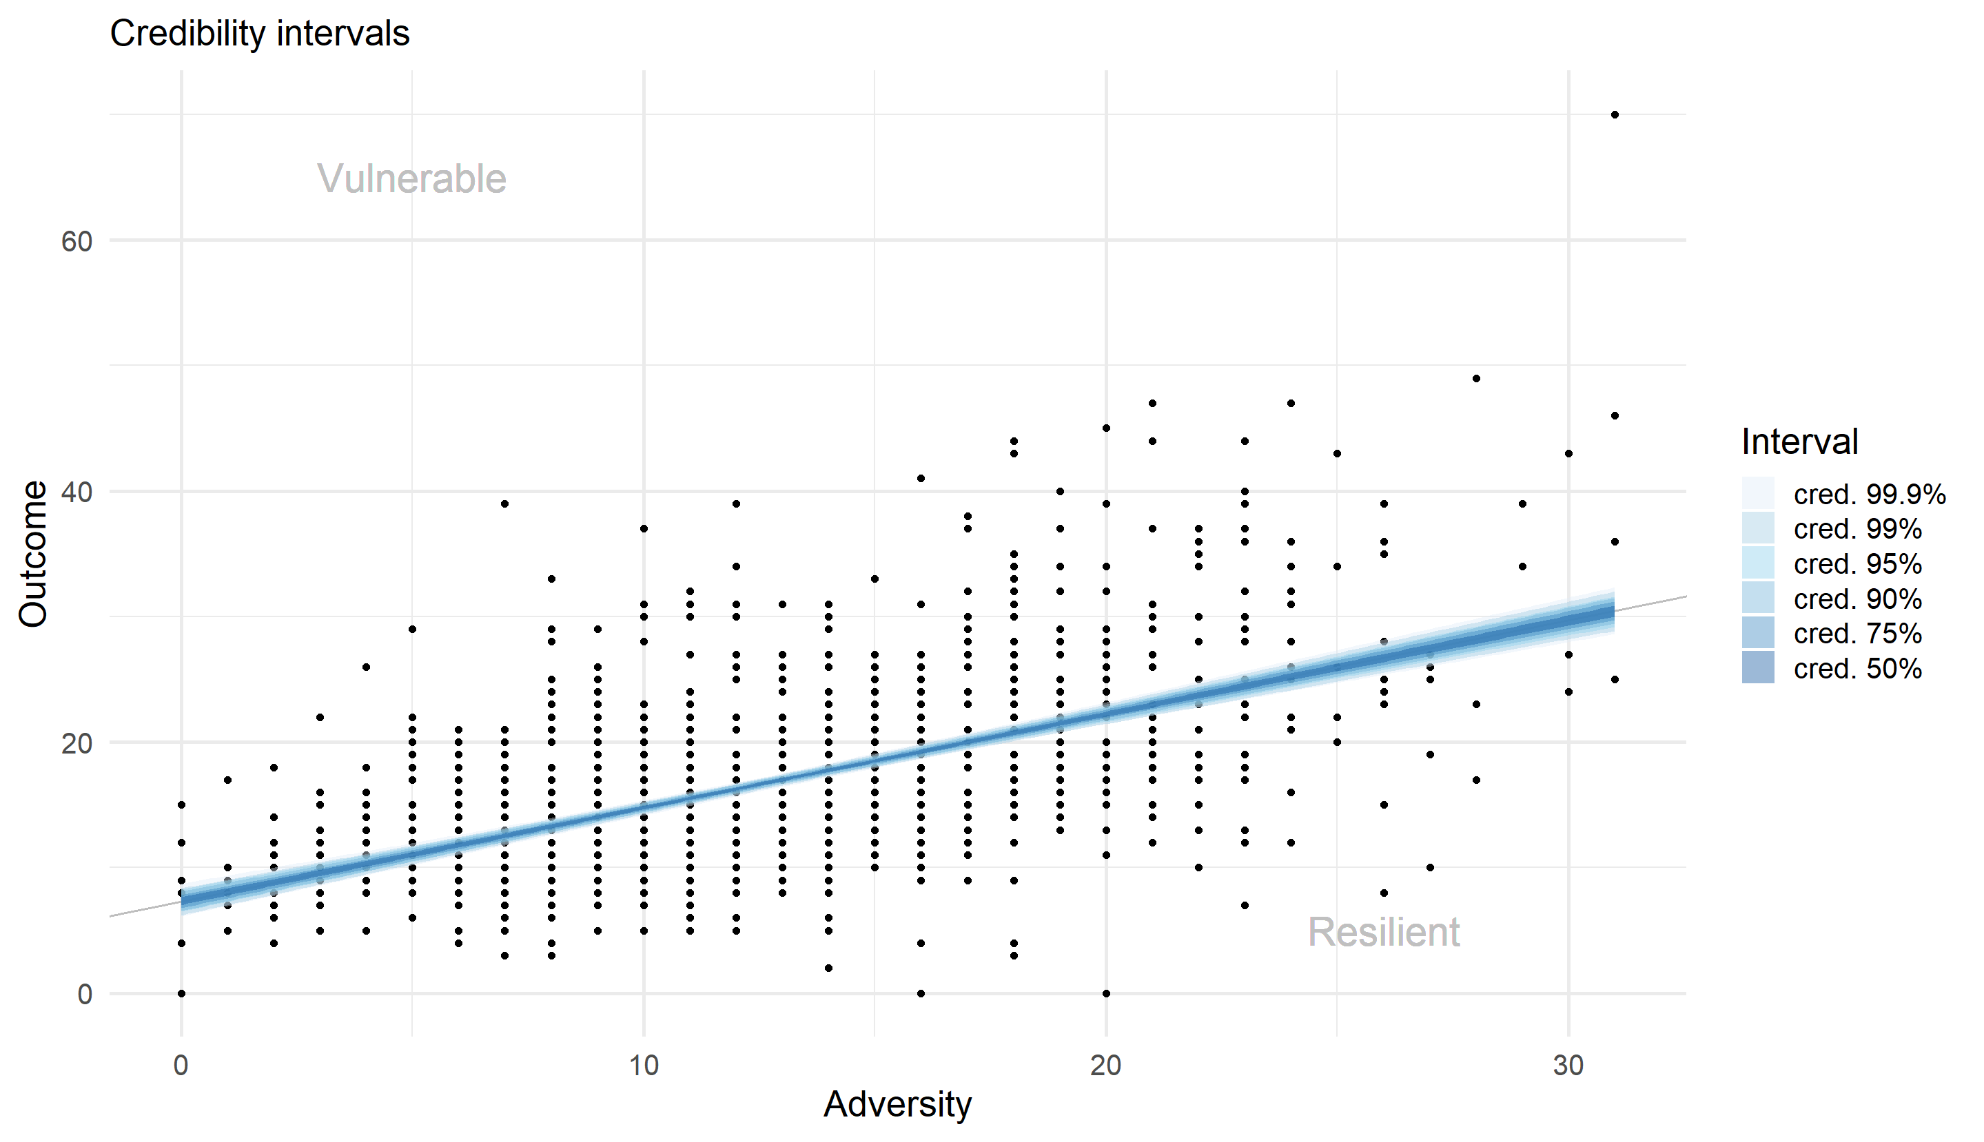
Figure 9: Classification obtained with the credibility intervals approach for PSS
Quantile-based thresholds
In this approach, quantile thresholds were computed using only individuals identified as not overly influential, but the resulting classifications were applied to the full sample. As shown in Tables 7 and 8, the quantile-based method yields approximately symmetrical group sizes by construction, with typically fewer than fifty individuals separating the resilient and vulnerable groups.
The size of the average group depends directly on the chosen quantile level n%. For example, setting n = 5% to 30% results in a dominant average group. However, beyond n=35%, the average group becomes smaller than the two atypical groups.
This method is particularly useful when a predefined proportion of the population is intended to be classified as atypical or normative, offering direct control over group sizes.
Resilient size | Average size | Vulnerable size | Detail
79 | 1013 | 99 | 0.05
137 | 897 | 157 | 0.1
193 | 784 | 214 | 0.15
249 | 672 | 270 | 0.2
307 | 556 | 328 | 0.25
361 | 448 | 382 | 0.3
417 | 336 | 438 | 0.35

Table 7: Group size with the quantile approach for DH
Resilient size | Average size | Vulnerable size | Detail
73 | 1010 | 108 | 0.05
131 | 893 | 167 | 0.1
187 | 780 | 224 | 0.15
252 | 660 | 279 | 0.2
301 | 556 | 334 | 0.25
354 | 444 | 393 | 0.3
418 | 325 | 448 | 0.35

Table 8: Group size with the quantile approach for PSS
Standard deviation-based thresholds with adversity levels
The standard deviation-based approach was applied using the following cutoffs: 0-13,14-26 and 27-40 for PSS and 0-75, 76-150, and 151-226 for DH.
Like for the quantiles, the individuals marked as not overly influential were not used to compute the standard deviation of each bin, but the classification was applied to all individuals. Since all individuals in the 151-226 bin for DH were considered overly influential, the standard deviation of this bin is set to 0, and all individuals are non-average.
As shown in Tables 9 and 10 and Figures 10 and 11, this approach can produce either very large or very small average groups depending on the chosen threshold. For example, using a threshold of 0.5 SD around the prediction results in approximately 16% of individuals being classified as average for DH and 18% for PSS. In contrast, the 2SD threshold yields an average group comprising around 98% of the sample for DH and 99% for PSS.
This method also allows the width of the average band to vary across adversity levels, as the standard deviation is computed within each category. This provides an additional layer of flexibility, as the classification adapts to the variability within each adversity group.
Resilient size | Average size | Vulnerable size | Detail (multiplication)
3 | 1174 | 14 | 2SD
175 | 796 | 220 | 1SD
549 | 197 | 445 | 0.5SD

Table 9: Group size with the standard deviation approach for DH
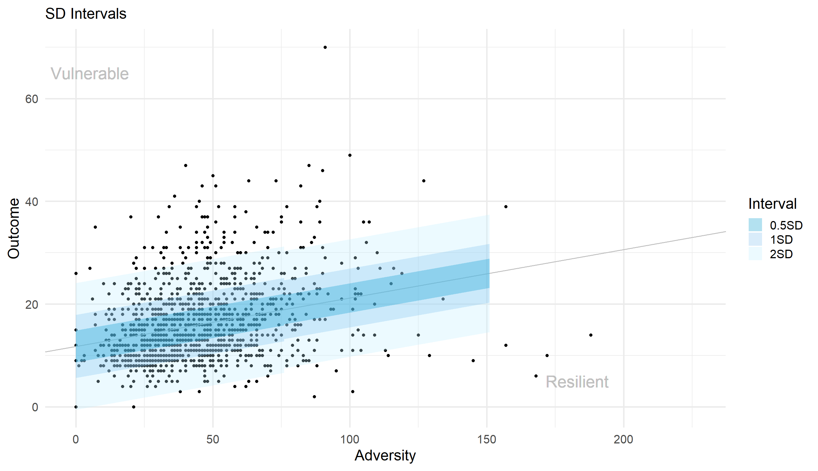
Figure 10: Classification obtained with the standard deviation approach for DH
Resilient size | Average size | Vulnerable size | Detail (multiplication)
1 | 1179 | 11 | 2SD
192 | 762 | 237 | 1SD
524 | 219 | 448 | 0.5SD

Table 10: Group size with the standard deviation approach for PSS

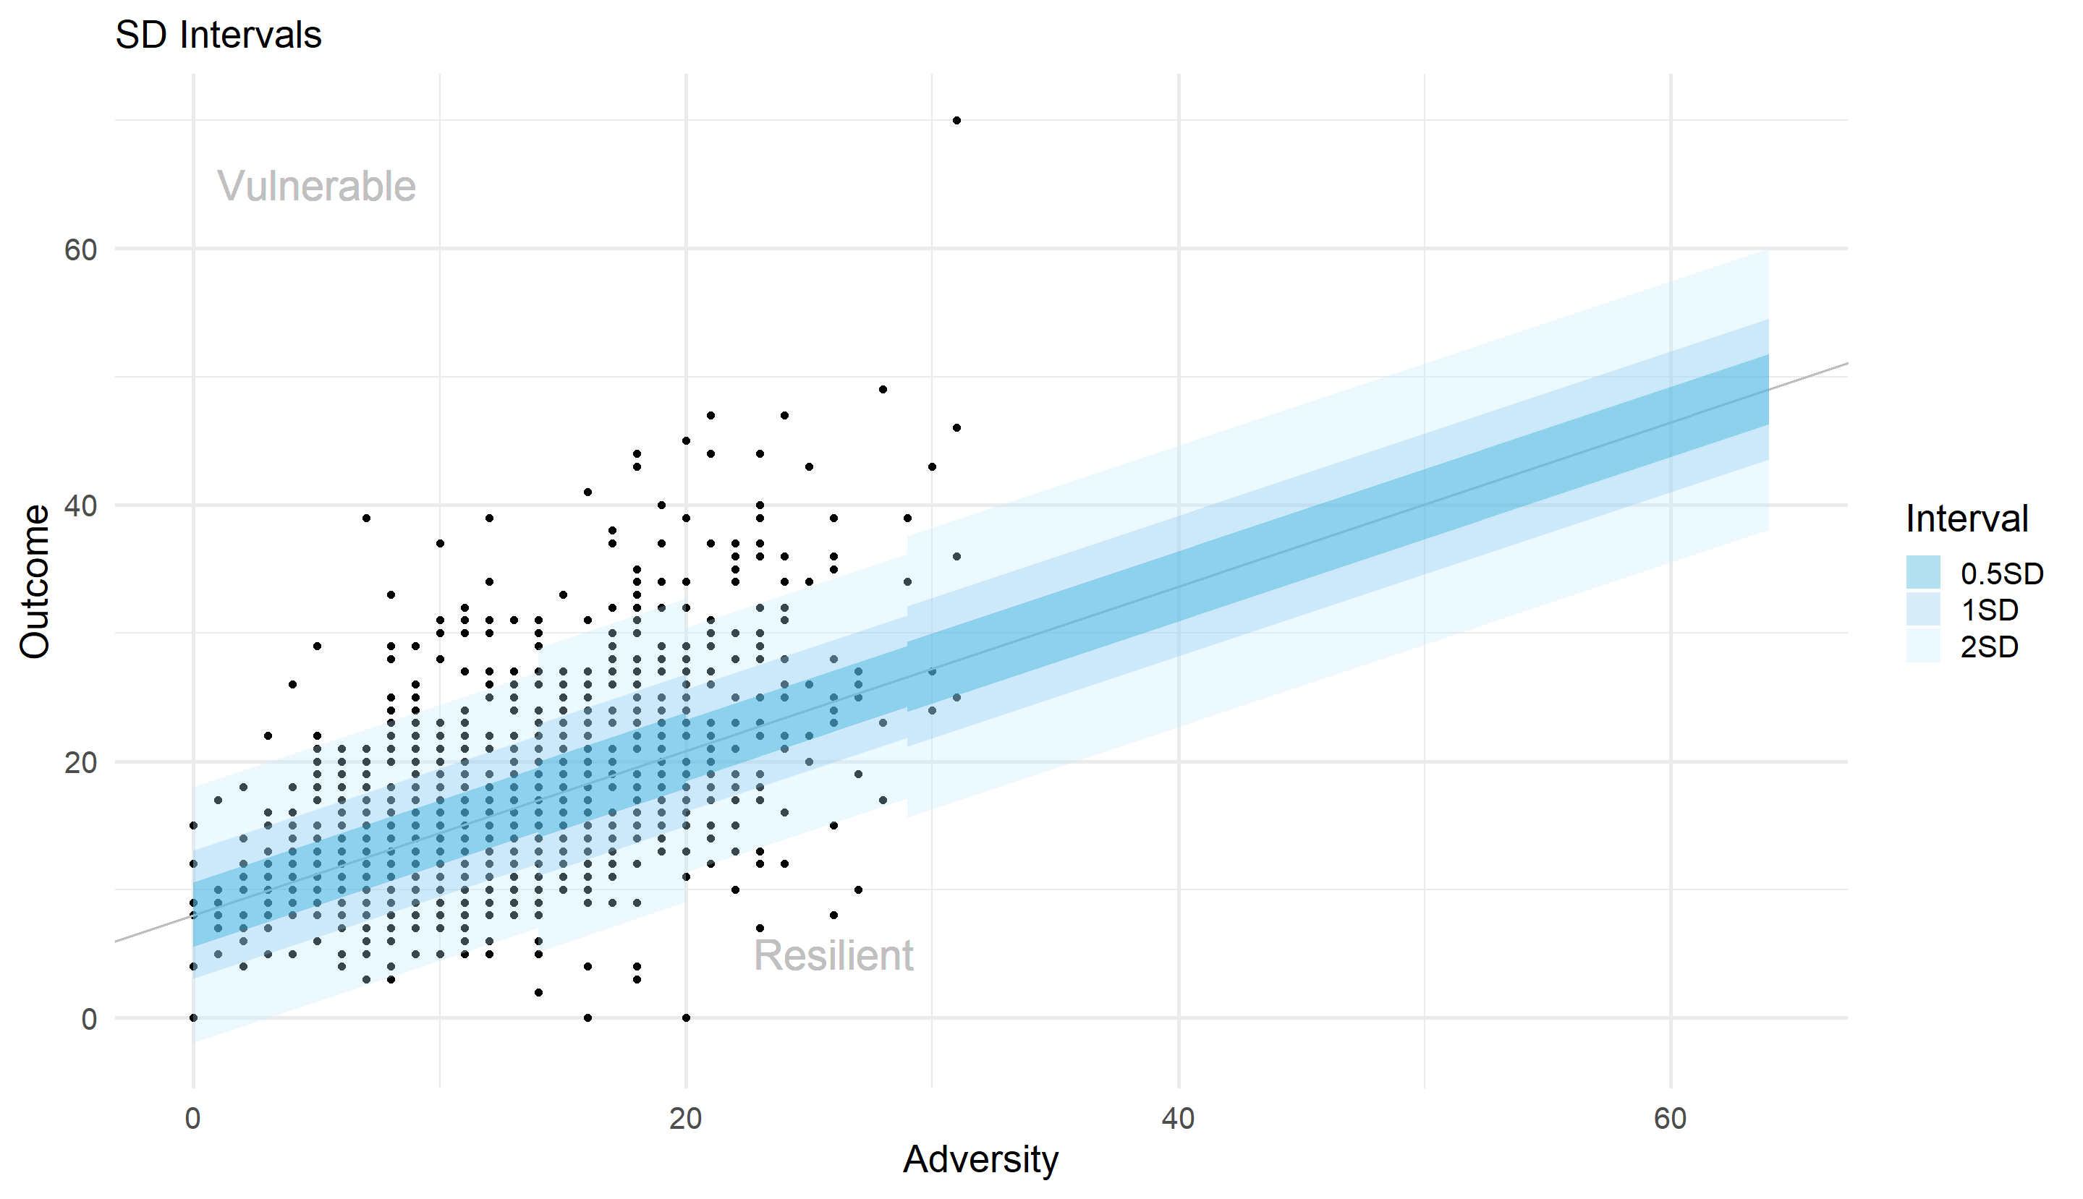
Figure 11: Classification obtained with the standard deviation approach for PSS
K-means classification
Again, for this approach, we only used the individuals identified as not overly influential to construct the k-means clusters. The remaining individuals were assigned to the cluster whose centre they were closest to.
As shown in Tables 11 and 12 the classification produced by the k-means-based approach is not symmetrical: the resilient group is notably bigger than the other two groups for DH and in the case of PSS, although the average group is the biggest, the resilient group is notably bigger than the vulnerable group and closer in size to the average group. This reflects the data-driven nature of the method, which does not impose balanced group sizes or fixed thresholds, but instead discovers clusters based on the structure of the residual distribution.
An advantage of this approach, as shown in Figures 12 and 13 is that, despite relying solely on the data, it still identifies a central group composed of individuals with small positive and small negative residuals, corresponding well to the notion of an average or normative response. In contrast, unsupervised methods could, in principle, produce less interpretable groupings (e.g., two clusters of positive residuals and one of negative), but this was not the case here. However, the fact that the resilient and vulnerable groups can be very different in size and that the average group is not dominant in the case of DH highlights the method’s sensitivity to distributional shape.

Resilient size | Average size | Vulnerable size
537 | 439 | 215

Table 11: Group size with the k-means approach for DH
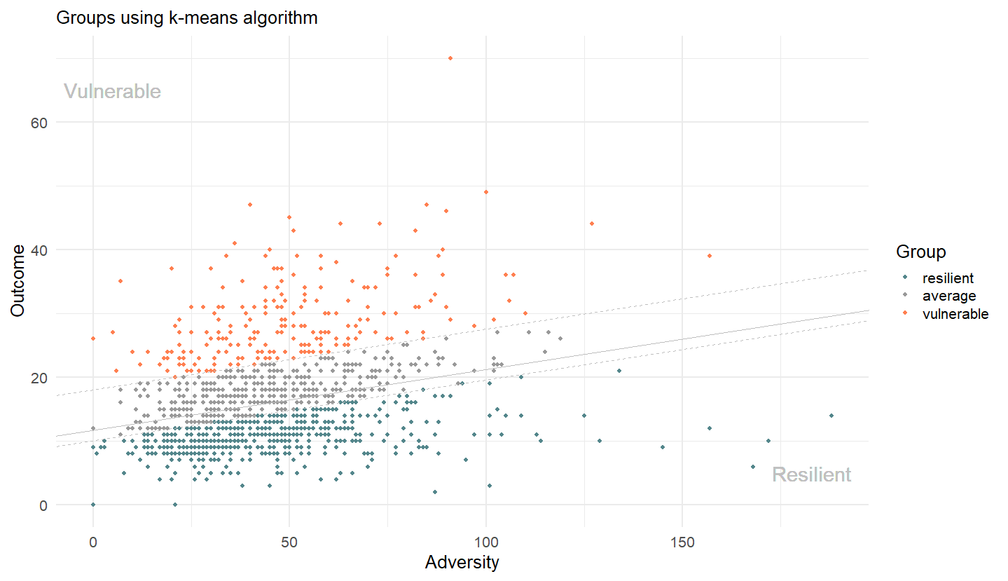
Figure 12: Classification obtained with the k-means method for DH

Resilient size | Average size | Vulnerable size
437 | 475 | 279

Table 12: Group size with the k-means approach for PSS
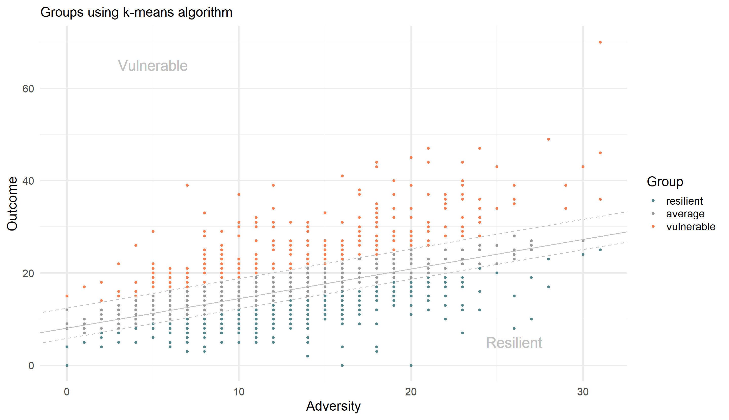
Figure 13: Classification obtained with the k-means method for PSS
II.2.5 Evaluation of predictive relevance
To assess whether certain classification methods are more suitable for resilience research, we evaluated their usability to build a performant training dataset for supervised prediction tasks. Specifically, we compared how well each grouping obtained supports the training of a random forest classifier to predict group membership using a set of covariates.
We used the multiple predictors available in the LORA dataset (listed in Table 13). For BFI, CDRISK, CERQ, CTQ, FSOZU, GPASS, GSE, IELC, LE and LOTR, we used the sum scores. For the COPE variable, we used the sum score of the 14 subscales. The other variables were used as is. We retained only individuals with non-missing gender and age information, and we excluded individuals with more than 30% of missing data across the selected predictors. This resulted in a final sample of N = 1,188 individuals, identical for both the GHQ~DH and GHQ~PSS models. Missing values were imputed using the missForest package (version~1.5).
When building classifiers, to reduce multicollinearity, we applied variance inflation factor (VIF) filtering using the car package (version~3.1-3), with a threshold of 5. We trained random forest classifiers using the randomForest package (version~4.7-1.2) with 500 trees and $\lfloor\sqrt{\text{\#predictors after VIF}} \rfloor$ variables randomly sampled as candidates at each splot. Model performance was evaluated using k-fold cross-validation implemented via the caret package (version~7.0-1), we used 10 folds.
Description | Name
Age | Age
Gender | Gender
Income of the individual | Income
Employment status of the individual (binary) | Employment status
Big Five Inventory | BFI
Connor-Davidson Resilience Scale | CDRISK
Cognitive Emotion Regulation Questionnaire | CERQ
Brief Coping Orientation to Problems Experienced Inventory | COPE
Childhood Trauma Questionnaire | CTQ
Perceived Social Support Questionnaire | FSOZU
Positive Appraisal Style questionnaire | GPASS
General Self-Efficiency Scale | GSE
Locus of Control Scale | IELC
Life Events | LE
Life Orientation Test | LOTR

Table 13: Variables used from the LORA project
First, classifier performance was assessed by comparing the mean accuracy of the random forest model across cross-validation folds to that of a null model that always predicts the dominant class in the training data. As illustrated in Figures 14 and 15, when the average group is large, the null model performs similarly to the classifier. However, beyond a certain point, where the average group becomes smaller and the resilient and vulnerable groups more populated, the classifier begins to outperform the null model.
This pattern suggests that classification schemes resulting in smaller average groups and larger resilient and vulnerable groups provide the classifier with enough variation to effectively learn the distinguishing characteristics of each class. This aligns with expectations: when underrepresented groups are better defined, the model is more capable of identifying informative patterns for those categories.
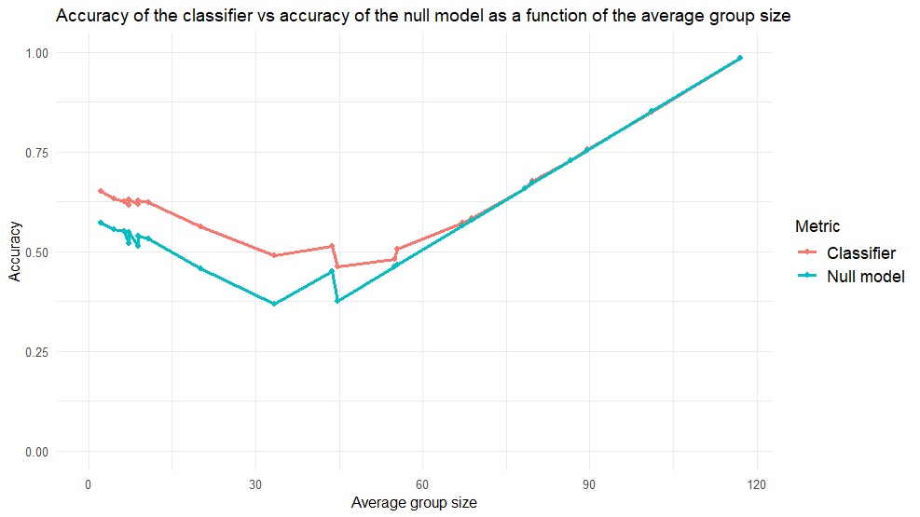
Figure 14: Evolution of the mean accuracy of the classifiers and the accuracy of the null model as a function of the average group size for DH
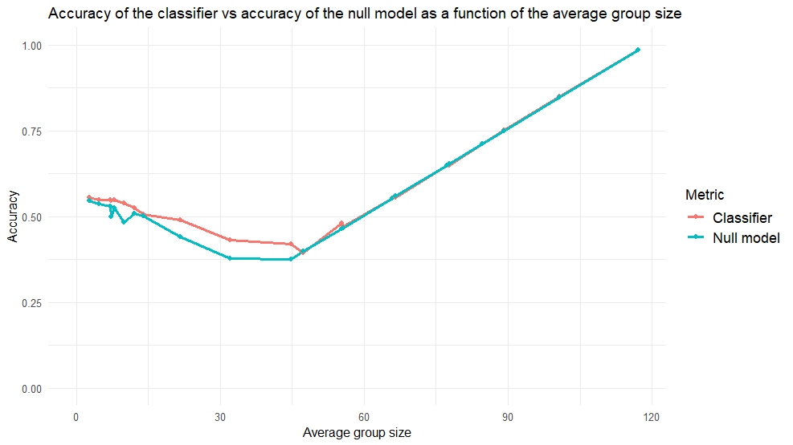
Figure 15: Evolution of the mean accuracy of the classifiers and the accuracy of the null model as a function of the average group size for PSS
In addition, we focused on classification methods that preserved a dominant average group, consistent with our conceptualization of resilience and vulnerability as deviations from the normative response. Within this constraint, we prioritized identifying resilient individuals and therefore examined the precision and recall for the resilient class.
Figures 16 and 17 show that none of the classifiers achieved both high precision and high recall for the resilient class. In particular, no method exceeded 0.5 on both metrics simultaneously. Some classification schemes yielded high precision scores, such as the 1SD threshold for DH and the 10% quantile method for PSS, which both exceeded 0.75, but these were associated with very low recall (below 0.1), indicating poor sensitivity to identifying resilient individuals.
More balanced results were obtained with the 30% quantile method (for both adversity measures) and the k-means approach applied to the PSS residuals. These yielded moderate values for both precision and recall, though still below ideal performance thresholds.
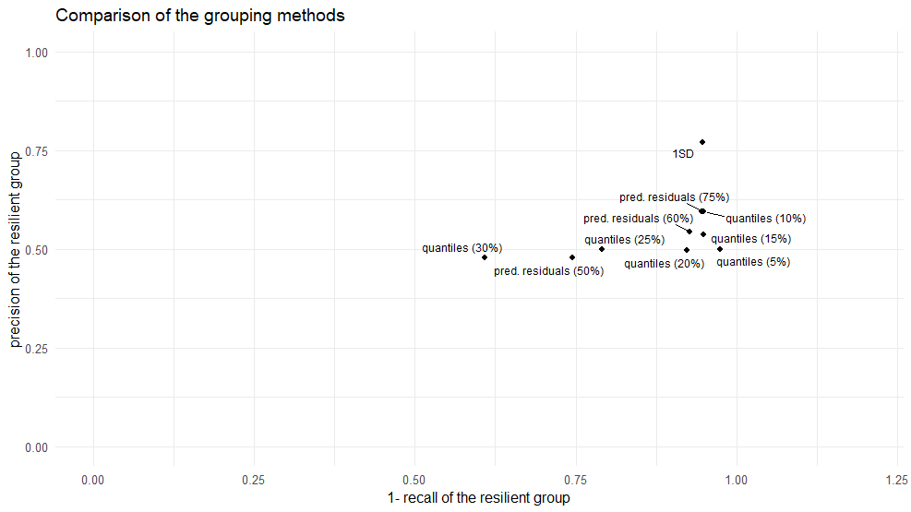
Figure 16 : Recall and precision of classifiers for the DH model
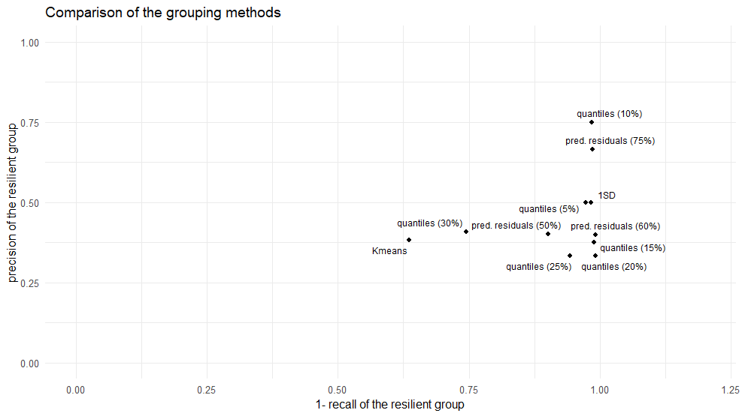
Figure 17: Recall and precision of classifiers for the PSS model
Overall, the results highlight the difficulty in predicting resilience and vulnerability.
III. Longitudinal Analysis
III.1. Methods
The goal of this approach is to estimate which individuals consistently deviate from the mean trajectory over time, and therefore can be categorized as resilient or vulnerable depending on the sign of the deviation. As in the cross-sectional context, we use residualization to obtain individual-level measures of resilience. Specifically, at each time point, we fit a linear regression model in which an outcome variable is regressed on an adversity variable, and we use the residuals as the resilience indicator. Again, to ensure robustness, we exclude overly influential individuals from each regression based on Cook’s distance with the same 4/n threshold (where n is the number of participants). This procedure is repeated independently at each time point.
To model the resilience across time, we then fit a linear mixed-effects model to the residuals, with both fixed effects (capturing the mean trend over all individuals) and individual-level random intercepts. These random intercepts represent persistent deviations from the average trajectory (i.e., stable individual differences in resilience).
To identify which individuals deviate significantly from the average trajectory, we apply the method introduced by [4], which relies on a Bayesian spike-and-slab prior structure. This method estimates the probability that each individual's random effect differs from zero. Using this estimated probability, after setting a threshold, individuals below the threshold are classified as average, and individuals above the threshold are classified as resilient or vulnerable, depending on the sign of the deviation.
The spike-and-slab method models the random effect distribution as a mixture of two components:
- spike, corresponding to a distribution concentrated at zero, representing individuals with no stable deviation;
- slab, a more diffuse distribution around zero, representing individuals with non-zero random effects.
An indicator variable determines, for each MCMC sample, whether an individual is assigned to the spike or slab component. The proportion of MCMC samples in the slab is then used to approximate the posterior inclusion probability (PIP), i.e. the probability that the random effect deviates from zero, and that the individual consistently deviates from the mean and therefore is non-average. Individuals with PIPs below a set threshold are classified as average, while those exceeding the threshold are classified as either resilient or vulnerable, depending on the sign of their random effect.
Note that it is necessary to specify the prior inclusion probability in the slab, set between 0 and 1, which controls the selectivity of the model: a value of 0.5 reflects an absence of initial hypothesis on the presence of effects, while a higher value reflects a prior belief in the existence of non-zero effects.
III.2. Illustrative example: LORA Project
III.2.1 Data and variables
For this illustrative example, we used again the data from the Longitudinal Resilience Assessment (LORA) project, but this time we used multiple time-points.
For our analysis, we restricted the sample to $N=515$ individuals who had completed all of the first $T=12$ quarterly assessments. Again, the Perceived Stress Scale (PSS) and the Daily Hassles questionnaire (DH) were used as adversity variables, and the General Health Questionnaire (GHQ) was used as the outcome variable. The scales and coding of these variables are described in Table 13.
III.2.2 Software
All models were implemented in R (version 4.4.3) using the packages dplyr (version 1.1.4), rjags (version 4.17), and SSranef (version 0.1.0). We fitted the models using the ss_ranef_alpha() function with its default settings, specifically:
- 1,000 burn-in iterations,
- 1,000 sampling iterations for parameter estimation,
- 4 parallel MCMC chains,
- prior inclusion probabilities set to 0.5 for all individuals.
III.2.3 Results
The spike-and-slab method proved to be applicable and coherent in this longitudinal setting. Posterior inclusion probabilities (PIPs) were obtained for each individual, and group membership was assigned based on whether an individual’s PIP exceeded a chosen threshold.
The posterior inclusion probabilities spanned a wide range. For the GHQ~DH model, the PIPs ranged from 0.23 to 1.00, with a median of 0.52 and a mean of 0.58. For the GHQ ~PSS model, the range was 0.27 to 1.00, with a median of 0.44 and a mean of 0.55. These distributions confirm that most individuals were neither clearly average or non-average, and that the classification is sensitive to the choice of PIP threshold.
Figures 18 and 19, along with Tables 14 and 15, show the evolution of group sizes as the PIP threshold increases for the GHQ~PSS and GHQ~DH models, respectively. In both models, increasing the PIP threshold leads to fewer individuals being classified as non-average, as expected.
A small asymmetry between the resilient and vulnerable groups was observed in both models. For the GHQ~PSS model, the vulnerable group was consistently slightly larger than the resilient group across all PIP thresholds. In contrast, for the GHQ~DH model, the resilient group was slightly larger than the vulnerable group up to a threshold of 0.9, after which the trend reversed.
These results confirm that the method is sensitive to the user-defined PIP threshold, while producing stable and interpretable classifications that are, however, slightly asymmetrical between the two non-average groups.
Figures 20 and 21 display the mean residuals of each group across the 12 time points, for different selected PIP thresholds. As the threshold increases, the mean residuals of the resilient and vulnerable groups move further away from zero. This pattern reflects the fact that higher thresholds assign non-average status only to individuals with more extreme and consistent deviations from the normative trajectory, thereby increasing group separation but also reducing group size, as seen previously.
Percentage resilient | Percentage vulnerable | Percentage atypical | PIP
28.54 | 23.88 | 52.43 | 50%
26.6 | 21.17 | 47.77 | 55%
24.27 | 19.22 | 43.5 | 60%
23.11 | 17.48 | 40.58 | 65%
21.17 | 16.7 | 37.86 | 70%
19.81 | 15.92 | 35.73 | 75%
17.86 | 14.76 | 32.62 | 80%
14.95 | 13.79 | 28.74 | 85%
12.82 | 13.4 | 26.21 | 90%
9.51 | 11.07 | 20.58 | 95%
4.27 | 7.18 | 11.46 | 100%

Table 14: Proportions of individuals in each category depending on the chosen PIP threshold for GHQ~DH
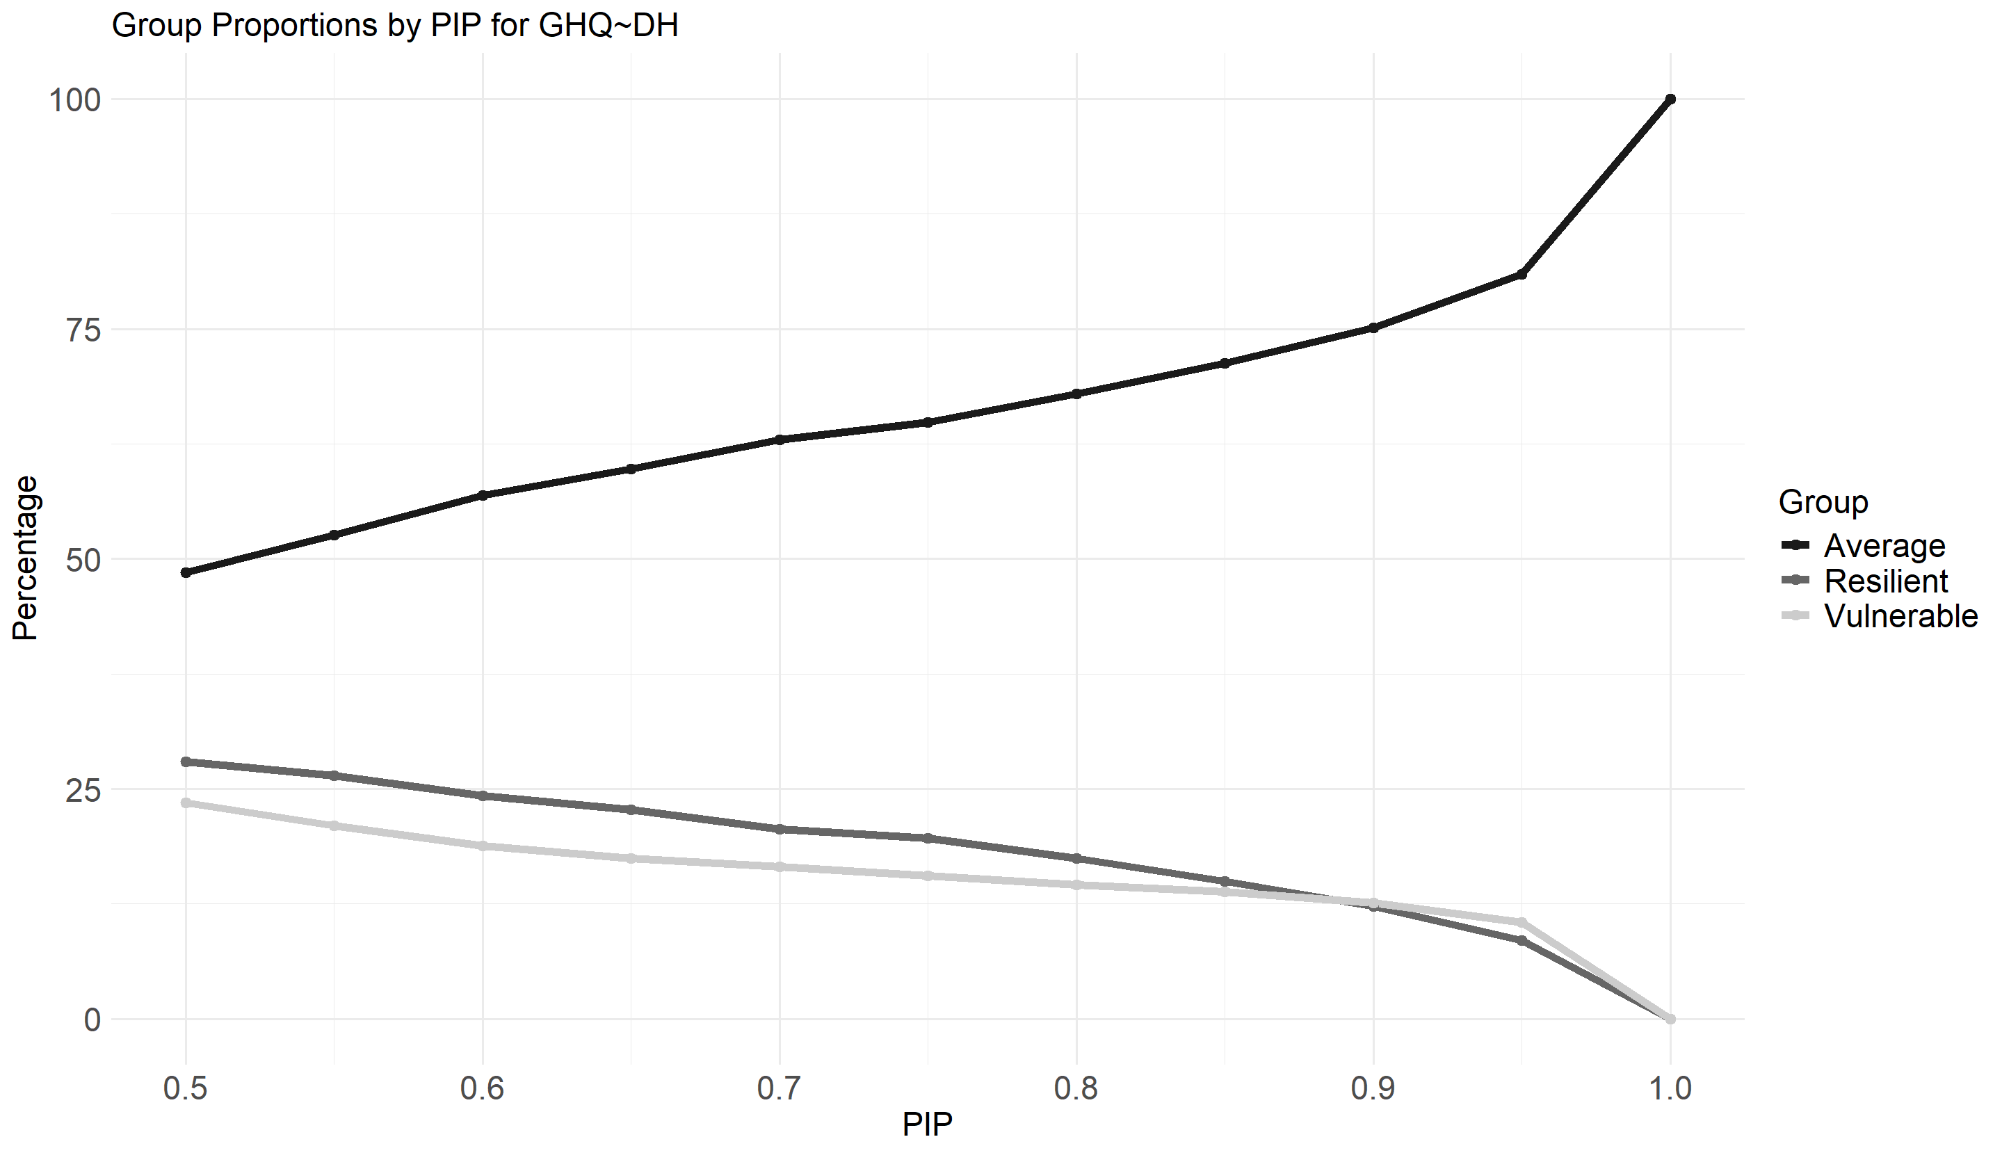
Figure 18: Proportions of individuals in each categories depending on the chosen PIP threshold for GHQ~DH.

Percentage resilient | Percentage vulnerable | Percentage atypical | PIP
21.55 | 23.88 | 45.44 | 50%
19.03 | 21.36 | 40.39 | 55%
16.5 | 20.19 | 36.7 | 60%
14.76 | 19.03 | 33.79 | 65%
13.79 | 17.28 | 31.07 | 70%
12.04 | 15.73 | 27.77 | 75%
11.07 | 13.4 | 24.47 | 80%
8.16 | 11.46 | 19.61 | 85%
6.99 | 9.71 | 16.7 | 90%
6.02 | 8.54 | 14.56 | 95%
1.94 | 4.66 | 6.6 | 100%

Table 15: Proportions of individuals in each category depending on the chosen PIP threshold for GHQ~PSS
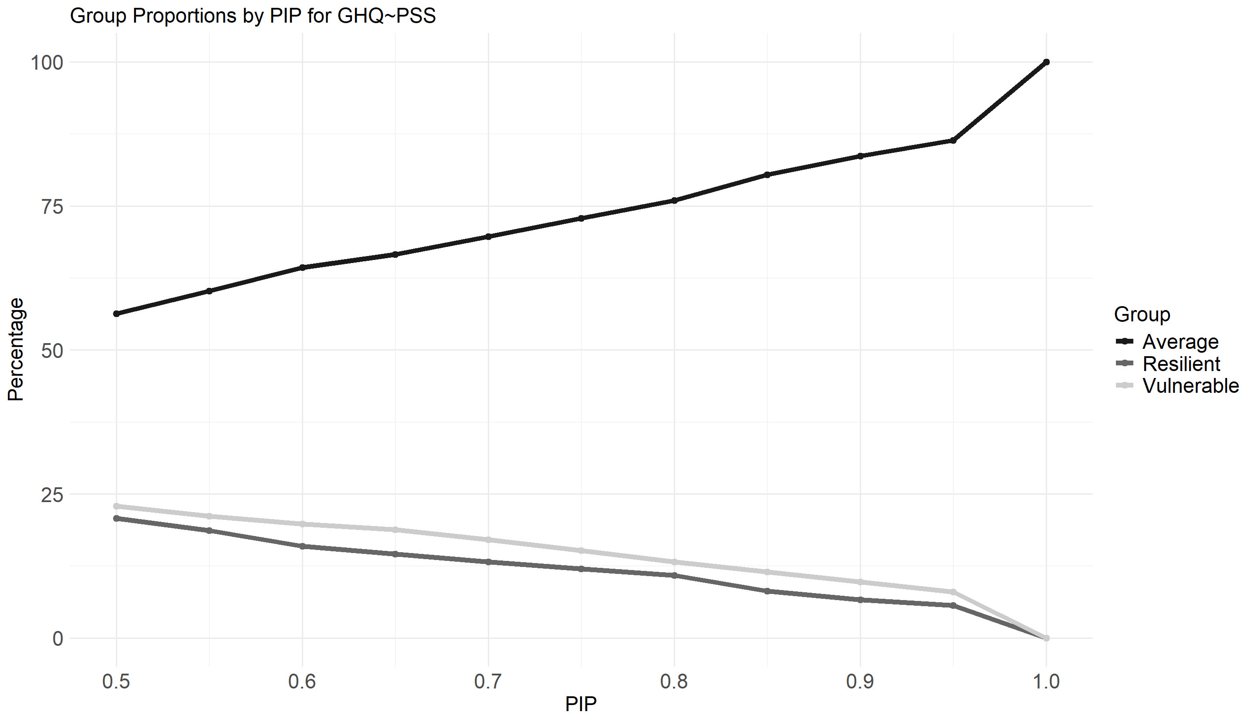
Figure 19: Proportions of individuals in each category depending on the chosen PIP threshold for GHQ~PSS.
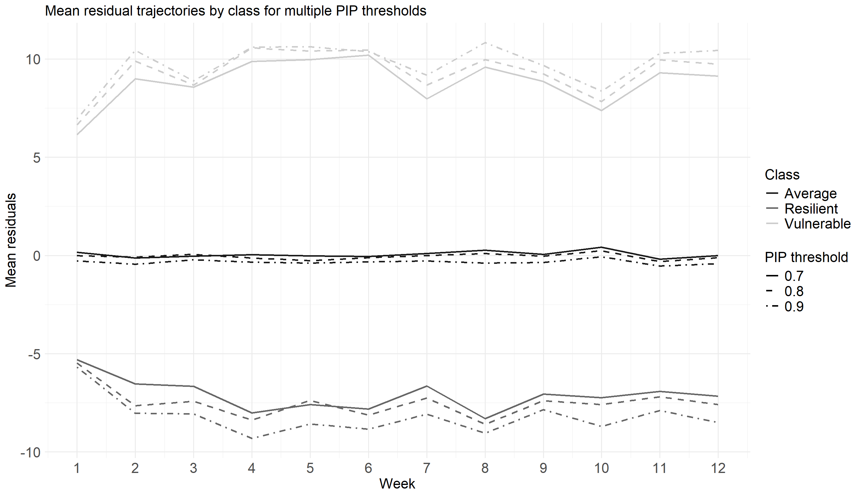
Figure 20: Evolution of the mean residuals for each group using different thresholds to build the groups for DH
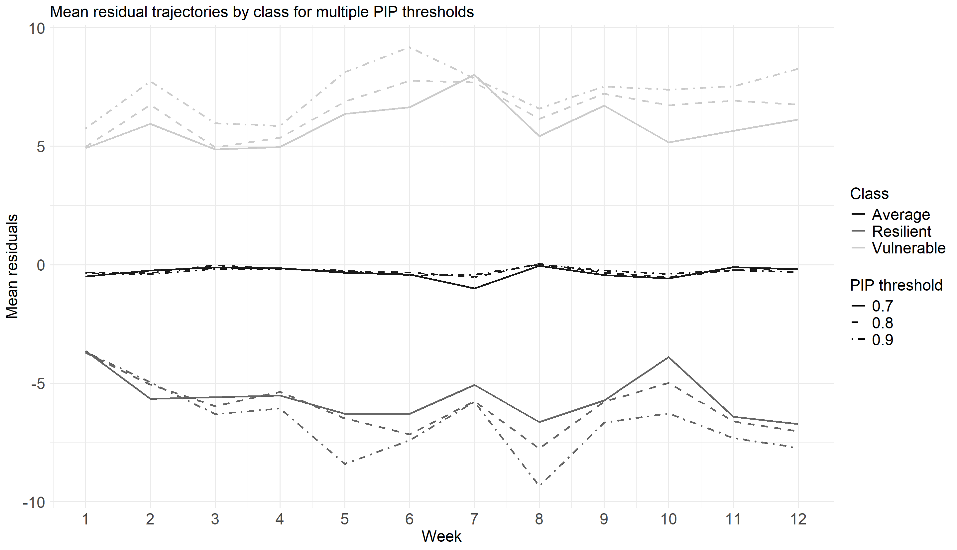
Figure 21: Evolution of the mean residuals for each group using different thresholds to build the groups for PSS
References
[1] A.Chmitorz et al. “Longitudinal determination of resilience in humans to identify mechanisms of resilience to modern-life stressors: the longitudinal resilience assessment (LORA) study”. In: European Archives of Psychiatry and Clinical Neuroscience 271 (2021), pp. 1035–1051. doi: 10.1007/s00406-020-01159-2.
[2] Julian J. Faraway. Practical Regression and Anova using R. 2002.
[3] Jan Höltge and Michael Ungar. “Quantifying Resilience as an Outcome: Advancing the Residual Approach with Influence Statistics to Derive More Adequate Thresholds of Resilience”. In: Adversity and Resilience Science 3 (2022), pp. 381–390. doi: 10.1007/s42844-022-00078-6.
[4] Josue E. Rodriguez, Donald R. Williams, and Philippe Rast. “Who Is and Is Not “Average”? Random Effects Selection With Spike-and-Slab Priors”. In: Psychological Methods 29 (2024), pp. 117–136. doi: 10.1037/met0000535.

