**BPLAN: Marketing Part 1**

**PANTRY PROS**

Target Customer Strategy:

**Consumers**:

We are attempting to ease the gap between affordable, convenient food and another trip to the grocery store by providing an app and/or website that integrates the consumer’s purchased food in their pantry/ fridge to relatable, easy-to-follow recipes and cooking videos. We want it to be a simple design that is extremely user friendly targeting young adults or consumer’s simply on-the-move and aiming to maximize their time and diet on a budget with the products they already posses. Many consumers in the age rage of 18-25 interact regularly with their mobile devices providing us a easy channel to integrate into. The problem we are attempting to solve is budget consumption and lack of knowledge of cooking present in young adults.

Customers that would benefit from our product include intermediate to beginner level cooks that can quickly and easily gain knowledge about preparing a well balanced meal. Customers that maintain a low budget diet and would benefit utilizing the food in their pantry already to cut back on time efficiency of traveling to the store or searching for a recipe. Customers that would seek a cheaper and more convenient food option over the opportunity cost of searching for the proper recipe to meet their demands. These customers maintain a busy lifestyle with priorities outweighing preparing proper meals.

**To whom will these problems be most troublesome?**

* + College students living alone and preparing meals for the first time.
  + Young adults looking for a quality budget meal and attempting to not waste the money spent on filling their pantry.
  + Household parents attempting to make an easy meal for the family without making an extra errand at the end of the work day.

**Who will have the most to lose by not dealing with these issues?**

* + College students spending too much money to buy groceries in order to satisfy the simple recipes they may already know
  + Young adults attempting to maintain a balanced diet without breaking the bank
  + Young adults whom aspire to prepare food for themselves but without the proper tool that is user friendly and directed at them
  + Young adults attempting to host friends over but don’t have the means to do so without the app

Today we live in the world of niche. We can watch what we want at our convenience from almost anywhere in the world; meaning every person can enjoy a unique viewing experience. The web is fantastic at delivering personalised products and services, cutting out many of the distribution challenges that previously existed.

* **Particular types of people** 
  + Low net worth individuals that want to budge their dietary needs and maximize efficiency and level of convenience
  + Men and women alike aimed at the younger generation
* **Certain geographical locations**
  + College campuses the word will spread extremely quickly via internet and word of mouth
  + Highly populated areas with young adults making up the majority of the market
* **Tight market sectors** 
  + Interns
  + College students
  + Low income adults in their first job
* **Do you have particular areas of expertise?**
  + We are all young college students about to enter the workplace. We all experience similar struggles in providing and preparing food for ourselves without another trip to the grocery store or caving in to delivery food. We have the knowledge and capability to market to other young college students directing our product/service to an audience with similar habits, interests, likes, and dislikes as ourselves.
  + We have friends in the cooking industry that can provide feedback to the easiness of a recipe as well as the possibility of substituting ingredients that are more commonly available in young adults pantry.
  + We have basic understanding of computer programing software making it easier for us to develop an app that will accurately mimic our vision, and adjust it where necessary.
  + Our resources and location is based in the market we seek to gain of young adults in or near college campuses.
* **Why am I uniquely placed to solve the problem?**
  + We are uniquely placed with the resources necessary to develop the application surrounded by computer programmers and software engineers. We also have the knowledge and understanding of successful marketing after experiencing what we and other colleagues respond best to. This will help us narrow our means of marketing to few sources based on our knowledge of success with other means of marketing, (i.e Facebook vs Posters, Word of Mouth vs Flyers)

**CUSTOMER DEMOGRAPHICS**

* Age: 18-24 at first until we get the ball rolling and people start to use our product. Ages 18-50 will be the next target market as soon as people use social media platforms.
  + We could probably do some research to find exact numbers of people 18-24 that have social media accounts (Facebook, snap, insta) also do the same thing for like 30-50 year olds. This will be important info.
* Race: All races, this means we will have to have all food from many cultures. At first the basic types of foods - American,Asian,Mexican, etc
* Education: Easy to use try making similar to newspapers having a reading level of 8th grade. Simplifying the website and app.
* Occupation: Young to mature professionals
* Income: Poor college kids to successful parents
* Location: Rural to Central City users
* Life Style: As said before, from athletic to the couch potato
* Interest: For people not interested in cooking to people who like to cook
* Social status: People that can afford technology to access our product

**Buying Decisions:**

**How are buying decisions made?**

* Get on website/download app both will be free and easily accessible.
* Quality? And time of to make purchase - the purpose of our app is to condense cooking recipes, cooking tutorials, ingredients, and simple scrolling into one site that is nearly instantaneous to access and receive quality simplified information

**In the case of business customers there are additional considerations. Are there different approval levels?**

* The approval process is designed to demonstrate that the supplier has developed their design and production process to meet the customer’s requirements, minimizing the risk of failure. Our approval levels have and will go through a graphic designer to determine ease of use and eye appeal. We will also run our application through software engineers to ensure their are no difficulties in the interface. Finally the five of us will approve the final product to ensure quality assurance, customer satisfaction for ease of use, and lastly, that our vision is well represented in the final product.

**Are decisions made centrally or decentralized?**

* Decisions made centrally based on knowledge and expertise of our five person team.

**What is the budgeting cycle?**

* The **budget cycle** refers to the life of a **budget** from creation to evaluation. Although small businesses might not use the term “**budget cycle**,” they use the **process** when they painstakingly work through the steps required to build and implement a **budget**.

**At what level is the ultimate responsibility for approving expenditures?**

* Centralized decision making with 5 CEO’s in company

**How important are: global reach, ISO 9000, design capability, range of products, just-­in-­time, inventory levels, etc.?**

* Once we work through our sample market and determine the response to ease of design, range of products, quality control, and customer retention; then we can advance globally based on the simplicity of design it would be easy to advance into other markets with similar customer demographics and demands.

**What is the sales cycle?**

* Form a Solution Phase of Cycle after determining the pain points.

**Where does the consumer purchase the product?**

-Website/Appstore

**When are purchases made?**

* Daily

**How do customers pay?**

* Possible in app/on website with credit card info

**Customer Behavior**

* today our nation spends more than $110 billion on fast food annually compared to 1972 where we consumers spent around $3 billion annually
* The lobbying ensures farming production subsidies that create a cheaper price for consumers at purchase- $1.50 cheaper per day or about $550 dollars per year than healthier food

*Figure 1*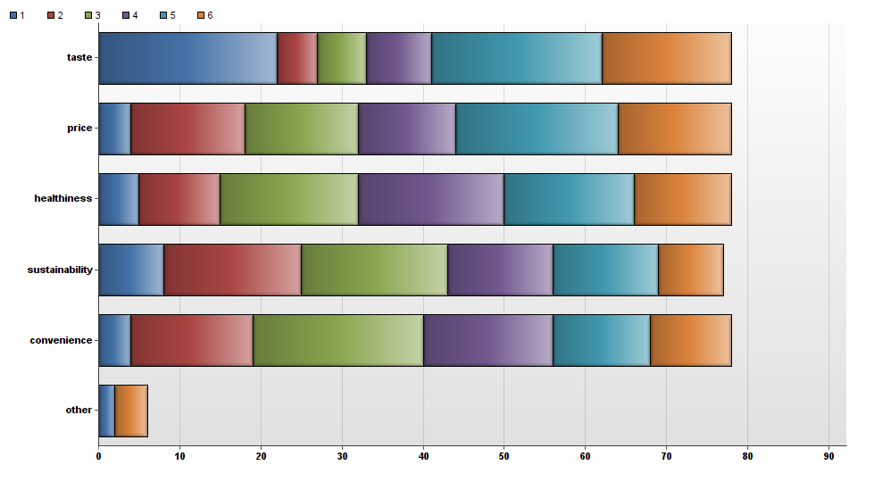

* Based on a study conducted across the CU boulder student population (our sample market) students perceived price most commonly as the main factor when deciding on food, second to that was taste (in blue). Based on the market research we want to identify with fellow college students providing the post cost efficient and tasteful way of preparing and providing balanced meals.

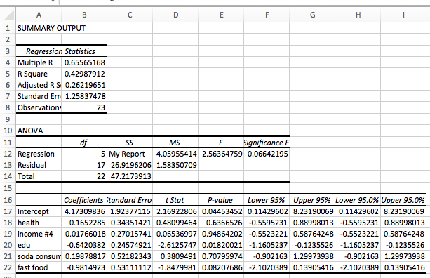

*Figure 2*

* Income was positively correlated with a p-value of 95% to increases in fast food prices, allowing us to make inferences regarding the CU Boulder student population having a high sensitivity to prices in the food market, based on the understanding of low wage and low income students being sensitive to dishing out more money on food.

**Where does the target customer look for information?**

* + Website will have help page as will the app. We will also have a contact us for technical problems. -at first just an email not a phone number to save costs of labor

**How does the target customer perceive the product? What is the level of satisfaction? How willing are they to change?**

* Like the product as it makes their life easier and more efficient.
* Satisfaction will be seen from ratings
* Probably more susceptible to change as they are willing to make new meals

**What attributes and benefits of our product/service are most persuasive in getting the target customer to act?**

* + Ease and new tasty food
* **What does the target customer need to believe about your offering?**
  + That we are the best app/website to gather the information based on ease of use and customer experience and relatability.
* **Does the customer really understand what you are selling? How will it be used? Does it have a real need?**
  + Yes app/website idea is easy to grasp. Used on mobile devices in the kitchen where food is made. Directions will be followed to make great food. Yes it has a real need, every student I have talked to has said they would use this product.
* **Does your customer immediately understand the benefits that your product/service provides? If they don’t, then how will you motivate them to actually spend money to buy it? Are the benefits sufficient to overcome brand loyalty and associated switching costs?**
  + Our goal is to ensure that our brand and website/app will have an immediate response to customers understanding benefit of our service over the competing applications that attempt to satisfy the same pain point.

Channel Strategy:

Our product will reach customers directly through technology, namely in an app form and a website form. Like stated above in the “Target Customer Strategy”, many people that fall into our specific target market interact with their cellular device and/or laptop on a daily basis, which plays to our advantage. Another aspect of this distribution channel that is advantageous, is that we supply directly to the user, giving us a closeness that will help our brand grow and learn more about the customer’s wants and needs directly.

Outside of our actual product, the way Pantry Pros markets is indirect as we will be advertising through social media to gain exposure. To keep Pantry Pros’ market at large, the company will be very consistent in syncing our app and website to have a similar, easy to navigate design.

Channel Strategy SWOT Analysis:

* Strengths:
  + Closer to customer
  + Cheap as there is no middle man in the process of getting our product to customers
* Weaknesses:
  + We are held responsible for any and all mistakes made in getting our product onto a website and an app
* Opportunities:
  + There is a lot of room for expansion
  + Better opportunity to build a brand in working closely with customer feedback
* Threats:
  + Other companies like ours can function the same way, therefore there is a threat of competition.

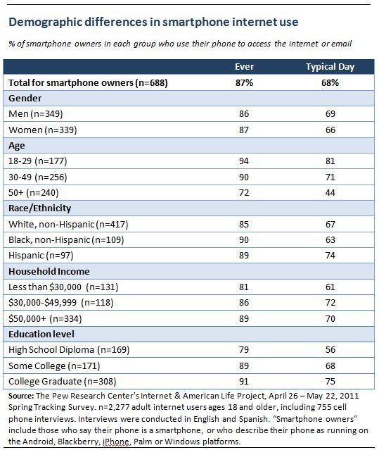

*Figure 3*

Above is the demographics of users that use the internet everyday including using the internet on their cell phones, This data shows that our target market is heavily using the internet everyday as opposed to other ages.

Positioning:

Knowing where our product fits in the market is an important aspect of marketing and sales. Pantry-Pros, provides a convenient, cost effective, and educational service for young adults from the age of 18-25 to create meals with the food that is already in their refrigerator or pantry. Below is are two graphs with four different axises that we feel are important characteristics that affect our customer when making the decision to use our product or our competitors. In figure 4 below our product Pantry-Pros is located in the bottom left and right corners as opposed to our competitors Carrot, top right and FridgeFood, bottom left. Being in the bottom left and right corners is ideal since we will be advertising our product on mobile devices that our customer is already using. In figure 5 our product Pantry-Pros provides a video service that neither of our competitors offer. Providing simplicity and additional services such as videos gives Pantry-Pros the upper edge on our competitors as well as shows room in the market where there is a need for our product.



*Figure 4*



*Figure 5*

**RWD#3: Prototype:**

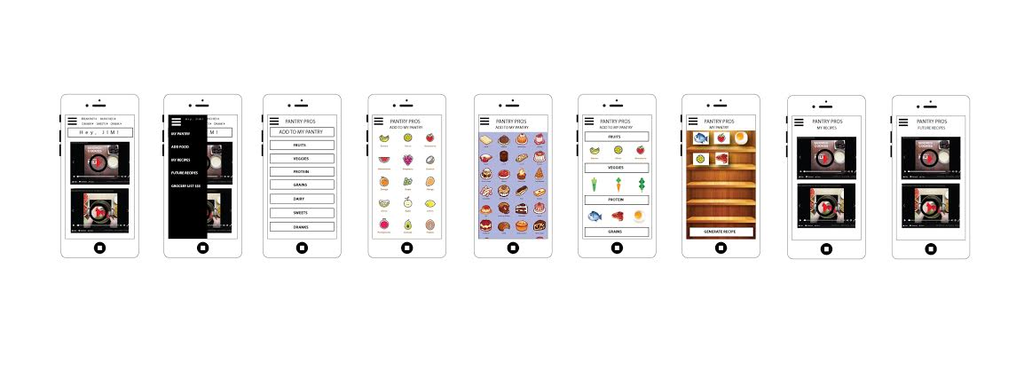

**1. What did you learn about your product/service through the process of prototype creation? This could be insights on materials used, colors, packaging, new/different features needed, proper sizing, etc**

While making a prototype of this app was difficult do to the creative reach of our photoshop skills, this replica provided a solid model for the type of user interaction we aim to create. We learned a lot about simplifying many of our drop down pages as to eliminate any complications or confusions the consumer might face when navigating the application. This was a compromise between presenting our logo and simplifying the application like we originally aimed to do. Color is going to have to be an imperative part of our prototype further down the creation process as we seek to attract customers of a younger population with a unique, intriguing, relatable design. However, this acts as a model to the multiple commands we plan to instill in the app once that becomes possible.

**2. What did you learn about opportunities to improve your product/service (similar to #1 above)? Will your target customer pay for these possible new enhancements?**

We were fortunate to receive help from a graphic designer, offering us a lot of insight into user interaction and ways in which to simplify the experience as much as possible. Our goal in differentiating from our competitors is to have a simple, clean-cut design that is marketed to a younger generation based on ease of use and resourcefulness. This prototype put many of our requirements for the applications interface into a reality. We still need to develop the design, specifically colors and our logo to integrate into our prototype and later application. The prototype was successful at working through the visions we’ve had but also simplifying that vision further to make the application a quality customer experience, removing the confusion and hassle of search.

**3. Please share any additional insights you gained through this experience.**

The prototype became difficult without the knowledge of the actual interface the software engineers will be able to develop. This did not limit our design capabilities quite yet, but could force us to remodel aspects of our site based on our technological limitations in designing the application. Working through the kinks of the design process to replicate our vision and the niche customers we want to reach. The website was originally made with the intention of replicating our applications capabilities, however, this experience made it more clear how we need to model our website keeping more in mind user experience. From our product/service process we learned that a website will be an easier prototype to initially provide. A website will allow us to have a database where we can collect data on the customer and this is how we can suggest what meals the customer can make based off the food in their refrigerator and pantry. We learned about opportunities that our product can make money while also doing the product/service section. Originally we planned on making money from our product from advertisements and in application purchases. We now know from the product and service section that we can take the information that we have from each customer and sell that data to companies as large corporations do like Amazon and Google. There is an example of a company that exist already that is doing something similar that is solely asking customers to just take pictures of their grocery store receipt and they pay the customer for the data they provide. We will do something similar but we will have less expenses as we will not pay the customer for the data they are providing. There is a market for selling our data as grocery stores such as King Soopers, Safeway, and Walmart already pay for data similar to the data we will be collecting. We also have provided pictures of our mobile application layout above. We will continue to advertise this in our business plan because as our overall product will provide both a website and mobile device application.

<http://brandonchavez719.wixsite.com/fridgefood>

Sources:

<http://www.smartphonemarketresearch.com/smartphones-as-an-internet-appliance/>