Analysis & ERD Diagram

1. ERD Diagram

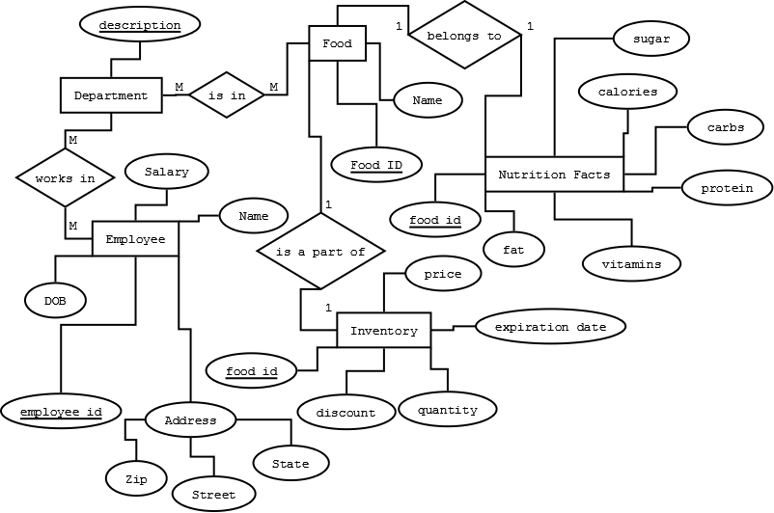

1. Identify nouns and verbs in the project; Decide which nouns are entities and which are attributes

Entities

|  |  |  |  |
| --- | --- | --- | --- |
| **Serial Noun** | **Noun** | **Verb** | **Noun** |
| 1 | Employee | Works In | Department |
| 2 | Inventory | Is part of | Food |
| 3 | Food | Belongs to | Nutrition Facts |
| 4 | Food | Is in | Department |

Attributes

|  |  |  |
| --- | --- | --- |
| **Serial Noun** | **Noun** | **Attribute Nouns** |
| 1 | Department | Description |
| 2 | Employee | Salary |
|  |  | Name |
|  |  | Address |
|  |  | Employee ID |
|  |  | DOB |
| 3 | Inventory | Food ID |
|  |  | Price |
|  |  | Expiration Date |
|  |  | Discount |
|  |  | Quantity |
| 4 | Food | Name |
|  |  | Food ID |
| 5 | Nutrition Facts | Food ID |
|  |  | Fat |
|  |  | Calories |
|  |  | Sugar |
|  |  | Carbs |
|  |  | Protein |
|  |  | Vitamins |

1. Composition – Address is composed of Street, State, and Zip