**Lab 2: Energy Portfolio Optimization [10 pts]**

1. **Formulate the QP [3 pts]**
   1. Notation **[1 pts]**

|  |  |
| --- | --- |
| **Variable** | **Description [Dimensions]** |
| *i* | Index over the sources(1,…8) |
| *xi* | Power provisioned from resource *i* [MWh] |
| *ci* | Expected cost of resource *i* in 2020, [USD/MWh] |
| *c*max | Maximum expected cost [USD/MWh] |
| *d* | Total CA energy demand in 2020 [MWh] |
| *σi* | Standard deviation of resource *i*’s cost [USD/MWh] |

* 1. Cost and constraints **[1 pts]**

$$min \sum_{i=1}^{8}{{{(σ}_{i}x_{i})}^{2}}$$

subject to: $\sum_{i=1}^{8}{x_{i}≥d}$ 2020 energy demand

$\frac{\sum_{i=1}^{8}{c_{i}x_{i}}}{\sum_{i=1}^{8}{x_{i}}}≤c_{max}$ Max. expected cost

$x_{i}≥0, ∀ i$ Non-negativity

**Note:** It’s possible to formulate the 2020 demand constraint as an equality, if the student provides a correct argument for why this constraint will be active.

* 1. *Q, R, A, b* matrices **[0.5 pts]**

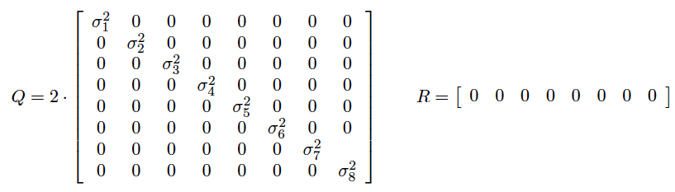

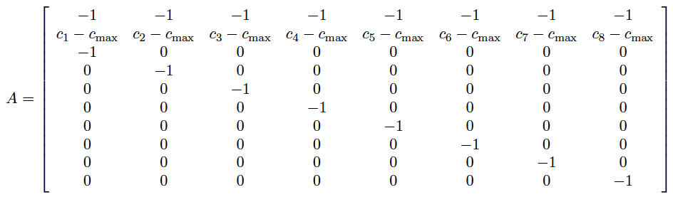



* 1. **[0.5 pts]** The Hessian, *Q*, is **positive definite** since the matrix is diagonal and all diagonal elements, which are also the eigenvalues, are strictly positive.

1. **Solve the QP in Matlab [2 pts]**

|  |
| --- |
| Lab2.m |
| %% Problem 1  %%% Input problem parameters    % Expxected cost of resources in 2020 [USD/MWh]  % Source: http://en.wikipedia.org/wiki/Cost_of_electricity_by_source  c = [100; 90; 130; 108; 111; 90; 144; 87];    % Maximum expected cost [USD/MWh]  cmax = 100;    % CA Demand in 2020 [MWh]  d = 225;    % Standard deviation of resource cost [USD/MWh]  sig = [22; 30; 15; 20; 30; 36; 32; 40];    %%% Create QP matrices  Q = diag(2*sig.^2);  R = zeros(8,1);  A = [-1*ones(1,8);...  (c - cmax)';...  -eye(8)];  b = [-d; zeros(9,1)];    %% Problem 2  %%% Solve QP  [x_star,J_star,exitflag,~,lam] = quadprog(Q, R, A, b);    % Output Results  fprintf(1,'Risk or variance : %1.2e USD^2\n', 0.5 * x_star' * Q * x_star);  fprintf(1,'Normalized Risk : %2.2f USD^2\n', 0.5 * x_star' * Q * x_star / sum(x_star));  fprintf(1,'Expected Cost : %1.2e USD\n', c'*x_star);  fprintf(1,'Normalized Expected Cost : %2.2f USD/MWh\n', c'*x_star/sum(x_star)); |

* **[0.5 pts]** Objective function value: 6,000,000 (USD)2
* **[0.5 pts]** Decision variables in MWh / %:

|  |  |  |  |  |  |  |  |
| --- | --- | --- | --- | --- | --- | --- | --- |
| **Coal** | **Hydro** | **Gas** | **Nuclear** | **Biomass** | **Geo** | **Solar** | **Wind** |
| 55.1 MWh 24.5 % | 38.6 MWh 17.1 % | 11.1 MWh 4.94 % | 50.5 MWh 22.5 % | 19.8 MWh 8.79 % | 26.8 MWh 11.9 % | 0.00 MWh 0.00 % | 23.2 MWh 10.3 % |

* Total cost of energy portfolio: 22,500 USD
* **[0.5 pts]** The active constraints are the minimum demand, max expected cost, and non-negativity for solar power.
* **[0.5 pts]** The optimized 2020 energy portfolio is much more diverse than 2012, with a more even division of resources. Natural gas is significantly reduced, due to the relatively high cost. Solar power is set to zero due to the relatively high cost and moderate risk.

1. **Apply 2012 portfolio to 2020 [1 pts]**

The risk is 3,240,000 USD2 or **17,529 USD2/MWh** and the expected total cost is 21,200 USD or **115 USD/MWh**. In Problem 2, the normalized risk is **26,651** **USD2/MWh** and the cost is **100 USD/MWh.**Indeed, maintaining the same portfolio as 2012 results in slightly less risk, but at the expense of higher expected costs to the CPUC and ultimately the ratepayer. Silly Stanford Graduates! Clearly, an optimal portfolio with a maximum normalized expected cost of 115 USD/MWh has lower risk. Although unnecessary, it’s good if the students re-solve the QP with *c*max = 115 USD/MWh, resulting in a normalized risk of **16,537 USD2/MWh**.

|  |
| --- |
| Lab2.m |
| %% Problem 3  %%% 2012 Energy portfolio applied to 2020 [MWh]  x_prob3 = [7.5; 8.3; 43.4; 9.0; 2.3; 4.4; 0.9; 6.3] / 100 * d;    % Output Results  fprintf(1,'Risk or variance : %1.2e USD^2\n', 0.5 * x_prob3' * Q * x_prob3);  fprintf(1,'Normalized Risk : %2.2f USD^2\n', 0.5 * x_prob3' * Q * x_prob3 / sum(x_prob3));  fprintf(1,'Expected Cost : %1.2e USD\n', c'*x_prob3);  fprintf(1,'Normalized Expected Cost : %2.2f USD/MWh\n', c'*x_prob3/sum(x_prob3)); |

1. **Pareto Optimization [2 pts]**
   1. **[1 pts]** Risk increases as the maximum allowable energy cost decreases. In other words, there exists a trade off between lowering costs and lowering risk.

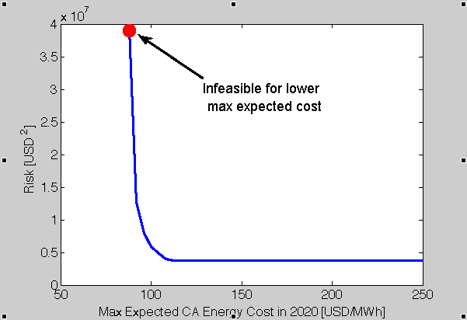

* 1. **[1 pts]** The portfolio with the lowest risk is similar to the result in Problem 2. Interestingly, increasing the maximum allowable expected cost beyond about 120 USD/MWh does not decrease risk. That is, it’s possible to obtain the lowest possible risk for 120 USD/MWh, since the max expected cost constraint is no longer active. In these risk-adverse cases, we can see the optimal solution uses a heavy mix of low variance natural gas (32.7%) and avoids high variance geothermal (5.7%), solar (7.2%), and wind (4.6%).

|  |
| --- |
| Lab2.m |
| %% Problem 4  N = 41;  cmax_vec = linspace(88, 250, N);    % Preallocate matrices  risk = zeros(N,1);    for k = 1:N    % Create new A matrix depending on max energy price c_max  A = [-1*ones(1,8);...  (c - cmax_vec(k))';...  -eye(8)];    % Solve QP  [x_star,J_star,exitflag,~,lam] = quadprog(Q, R, A, b);    % Compute price and standard deviation  risk(k) = J_star;    % Output to command prompt  fprintf(1,'Max price per MWh: %3.0f USD/MWh\n',cmax_vec(k));  fprintf(1,'Risk : %1.2e USD^2 \n',risk(k));  fprintf(1,'Total price : %3.0f USD\n',c'*x_star);    end    % Plot Pareto front  fs = 16;  figure(1); clf;  plot(cmax_vec, risk,'LineWidth',2); hold on;  plot(cmax_vec(1), risk(1),'ro','MarkerSize',16,'MarkerFaceColor','r');  xlabel('Max Expected CA Energy Cost in 2020 [USD/MWh]','FontSize',fs)  ylabel('Risk [USD^2]','FontSize',fs)  set(gca,'FontSize',fs) |

1. **Resource Limits and RPS [2 pts]**
   1. **[0.5 pts]** The additional constraints are

$$x_{i}≤s_{i}, ∀i$$

$$\frac{\sum_{i=1}^{8}{r_{i}x_{i}}}{\sum_{i=1}^{8}{x_{i}}}≥0.33$$

where *si* is the supply limit of resource *i*, *ri* is one if resource *i* is a renewable resource and zero otherwise.

* 1. **[1.5 pts]** The new solution is:
* Objective function value: 7,608,000 (USD)2
* Decision variables in MWh / %:

|  |  |  |  |  |  |  |  |
| --- | --- | --- | --- | --- | --- | --- | --- |
| **Coal** | **Hydro** | **Gas** | **Nuclear** | **Biomass** | **Geo** | **Solar** | **Wind** |
| 40 MWh 17.8 % | 50 MWh 22.2 % | 25 MWh 11.1 % | 35 MWh 15.6 % | 10 MWh 4.44 % | 15 MWh 6.67 % | 2.81 MWh 1.25 % | 47.2 MWh 21.0 % |

* The active constraints include
  + 225 MWh Energy Demand
  + 100 USD/MWh maximum expected cost
  + Coal supply limit
  + Hydro supply limit
  + Nuclear supply limit
  + Biomass supply limit
  + Geothermal supply limit
  + 33% RPS

This new solution caps coal, nuclear, biomass, and geothermal due to California’s resource limitations. In response it adds hydropower, wind, and solar. Natural gas is also added. However this is not preferable since the cost is very high and the maximum expected cost constraint is difficult to satisfy.

|  |
| --- |
| Lab2.m |
| %% Problem 5    % Original constraints  A = [-1*ones(1,8);...  (c - cmax)';...  -eye(8)];  b = [-d; zeros(9,1)];    % Resource Limits  A_rlim = eye(8);  b_rlim = [40; 50; 150; 35; 10; 15; 200; 50];    % RPS constraints  r = [0 0 0 0 1 1 1 1];  A_RPS = 1/3 - r;  b_RPS = 0;    % Add constraints  A5 = [A; A_rlim; A_RPS];  b5 = [b; b_rlim; b_RPS];    %%% Solve QP  [x_star5,J_star5,exitflag5,~,lam5] = quadprog(Q, R, A5, b5);  x_star5  x_star5/d*100 |