The availability of vegetative mesohabitats determines bird behavior in desert habitats

Owen, M.B., Lortie, C.J.

Abstract

Positive interactions, such as mutualism, are key interactions many species employ in order to survive harsh environments like deserts. In animals, mutualistic interactions with plants are usually exhibited in observable interactions (e.g. pollination and seed dispersal). Because plants provide resources like food and shelter to birds, these plants are often the site of these mutualistic behaviors, thereby promoting their own fitness as well as the interacting birds’. However, birds and plants both experience phenological shifts that require interactions from both parties. We investigated the behavioral mesohabitat association shifts that birds make between the migration/flowering season (spring) and the breeding/fruiting season (summer). We recorded the mesohabitat and behavior of all birds seen during line transect walks in both seasons. We found that bird community structure was significantly more diverse in spring (p-value<0.0001), that site-wide behaviors are influenced by the birds found in a system, and that behaviors were influenced by mesohabitat. These findings suggest that availability of foundational and keystone plants species is important for the expression of bird behavior. The expression of behaviors is, in turn, important for the proliferation of mesohabitats many desert taxa rely on.

1. Introduction

Desert ecosystems are generally stressful; ultraviolet radiation, heat, water scarcity, wind, and other abiotic and biotic ecological factors contribute to this harshness (Maestre, Valladares, and Reynolds 2005; Bonanomi, Incerti, and Mazzoleni 2011). Because of this, positive interactions in these ecosystems arise and fluctuate within the system as stress abounds and changes (Lortie and Callaway 2006). Benefactor plant species increase germination, growth, and recruitment of protegee species existing under their canopies (Franco and Nobel 1989) by changing the environment under their canopies, a process known as facilitation. In arid ecosystems, facilitation provides resources like water, shade, and pollinators (Flores-Torres and Galindo-Escamilla 2017; Miranda-Jácome, Montaña, and Fornoni 2013; Mitchell et al. 2009), or protection from trauma by herbivory, trampling, freezing temperatures, predation, and wind (Gómez-Aparicio et al. 2008; Parker 1989; Tewksbury and Lloyd 2001; Nobel 1980). Keystone benefactors which facilitate many interspecifics in an ecosystem are known as foundational species (Angelini et al. 2011; Almeida and Mikich 2018). Shrub species have been documented as the most common foundational species globally, though trees and cacti are two other common vegetative benefactors (Filazzola and Lortie 2014). These large, sturdy plants are largely responsible for habitat infrastructure of wildlife throughout an ecosystem. While most studies have focused on plant-plant facilitation (Callaway 200AD), there is also evidence for the importance of plant-animal interactions on habitat creation in stressful environments (Bertness et al. 1999; Arsenault and Owen-Smith 2002).

Mutualism is a category of positive interaction wherein the participating parties both benefit from said interaction, usually in the form of resource acquisition that increases the survival or fitness of the parties (Barker et al. 2017; Bronstein 2009, 2001). We know that positive interactions influence ecosystem infrastructure (Callaway 1997; Gelmi-Candusso, Heymann, and Heer 2017), thereby determining habitat for any species in the ecosystem, not just the interacting parties. Pollination and seed dispersal are two common forms of mutualism that directly create and maintain habitat in most ecosystems, both of which are performed by birds found in desert ecosystems. The overall habitat structure, therefore, may be dependent on these positive-positive, mutualistic interactions between birds and foundational plant species.

One major influence on the potential of bird-plant mutualism is physical proximity; that is to say, birds and plants must be in the same area in order to interact (Buler, Moore, and Woltmann 2007). Plant phenological cycles (i.e. flowering and fruiting seasons) are plastic in that they are determined by photoperiod and temperature (Schwartz 2003). These two constraints of time and space come into play when considering that, although bird communities migrate on an annual cycle, there is a certain level of plasticity for many birds’ movement due to large scale habitat loss and small scale resource availability (Scott Sillett and Holmes 2002; Runge and Tulloch 2017; Fahse, Dean, and Wissel 1998). In the Mojave Desert, birds fall into similar categories as other bird-supporting ecosystems: migratory spring and fall visitors, or summer, winter, and yearlong residents (Gurin, La Doux, and Coe 2012). Because spring and summer contain the intersections of bird migrating/plant flowering and bird breeding/plant fruiting, respectively, they are two seasons where reproductive-adjacent mutualistic interactions of interest may occur. However, because pollination and seed dispersal may be performed by many different biotic (bees, bats, squirrels, etc.) or abiotic (wind, water, etc.) actors, we must first determine the potentiality for these interactions to even occur.

In this study, we investigated the hypothesis that bird-plant mutualistic interactions are dependent on small-scale geographic and temporal limitations. Our research questions are: 1) How does desert bird community taxonomic diversity change between migratory/flowering seasons (hereafter referred to as spring) and breeding/fruiting seasons (hereafter referred to as summer)? 2) How do birds associate with mesohabitats and exhibit different behaviors in different seasons? And 3) are mesohabitats fostering certain behaviors among birds? We predict that 1) bird community diversity will be different in the spring season than in the summer season, 2) observed mesohabitats and behaviors will be defined by the birds’ functional and taxonomic diversity, and 3) behavior exhibited by birds is dependent on mesohabitat association.

1. Methods

2.1 Study Site

The Mojave Desert is located on the southeastern border of California, with most of the land being designated as the Mojave National Preserve under the United States National Park System. Directly adjacent to the public lands of the preserve is the Sweeney Granite Mountains Desert Research Center (34°48′20″N 115°39′50″W), which is land owned by the University of California as a part of the UC Reserve System. This land is only available to researchers and classes, thereby preventing interference from public visitors. Located in the Granite Mountains of the Eastern Mojave Desert, the 3,600 hectares of the research center’s elevation ranges from 1,128 to 2,071 m. Like many other arid ecosystems, rainfall varies significantly throughout the year, though the yearly average is 22 cm per year. The July average minimum and maximum is 20°C and 33°C respectively, while the December average minimum and maximum is -1°C and 8°C. Geologically, the site is unique with alluvial fans and bajadas and granitic pinnacles. Springs, seeps, and washes are common topographical features throughout the land.

2.2 Study system

This study site within the reserve system is dominated by perennial woody and succulent shrubs such as Cylindropuntia acanthocarpa, Yucca mohavensis, Larrea tridentata, Ambrosia salsola, Pinus monophylla, and numerous other shrub species. A hub of desert diversity, 156 birds, 42 mammals, 2 amphibians, and 504 species of vascular plants have been documented throughout the reserve. The field work for this study was conducted from May to August of 2019, a spring and summer following an unusually strong rainy season. Higher winter rain levels typically result in stronger blooms in this area, with this year being no exception. However, an unusually cool early spring led to a delay for many thermally induced blooms such as several Cylindropuntia ssp.

The avian community of the Mojave Desert includes typical species of the American Southwest, but is also home to desert obligate species which rely on plant species only found in wild desert areas (e.g. the Cactus Wren, Campylorhynchus brunneicapillus). There are currently over 159 bird species on the Sweeney Granite Mountains Desert Research Center (Gurin, La Doux, and Coe 2012), and a complete list of all known avian species to the field site is available via the site’s website.

2.3 Field observations

To sample the bird community makeup, we walked a 500-meter line transect over a two-hour period. We started the transect walks at cooler day times (7-10am or 5-8pm), which were associated with peak bird activity (N=41). We sampled two individual line transects, which were spaced 80 meters a part due to physical blocks of craggy mountains. The starting coordinates for transect 1 and 2 were (34.78299, -115.662) and (34.78303, -115.663), respectively. A single observer familiar with the local bird species recorded all visual (n=755) or auditory (n=463) bird cues and identified each observation to species (though some female/juvenile hummingbirds were identified only to family due to the visual similarity between species). However, we only included visual observations of birds in mesohabitat and behavioral analyses, since the behavioral and mesohabitat data is less fine. Flyovers (defined as birds flying roughly 25 feet above the shrub line that did not land within sight) were not included as an observation. In addition to species, we also recorded behavior (as designated by an ethogram), mesohabitat, geographic coordinates, the time of the sighting/hearing, and an estimate of the distance from the transect (<25 meters, 25-50 meters, or >50 meters). We also took photographs of birds using a Nikon D5300 camera equipped with a Sigma 150-600mm lens which served as identification aids and behavioral/mesohabitat records.

Behavior and mesohabitat functioned as dependent variables for each observation of a bird. Behavioral observations were then categorized into broader behaviors (active movement, cleaning, feeding, inactive, and territorial/mating). Mesohabitat level observations were distilled into two levels (vegetative or non-vegetative) and three levels (cactus, shrub, or other). Trophic guild and migratory class were the metrics we used to define functional diversity. We categorized all observed species into trophic guilds using “Foraging Guilds of North America” (De Graaf, Tilghman, and Anderson 1985) and into migratory classes using *Common Birds of the Sweeney Granite Mountains Desert Research Center* (Gurin, La Doux, and Coe 2012). Taxonomic diversity was originally recorded to species level, and then grouped into broader taxonomic designations (family and order).

2.4 Statistical Analyses

Using each line transect walk as a level of replication, we calculated species abundance (A), richness (S), turnover (T), and evenness (J) using the R Vegan Package (Oksanen et al. 2019). Additionally, we calculated Simpson’s Diversity Index (D) and Shannon’s Diversity Index (H) to encourage transparency on the influence of evenness or richness respectively. Using these different metrics for community structure, we created linear regression models to determine differences in community structure in spring and summer, excluding species richness, for which we performed a general loglinear model (due to the non-normal, poisson distribution of species richness through both seasons). We included each walk of a transect in the models as a random effect. Additionally, to determine the species variance impact on community structure, we performed a Principle Components Analysis for both spring and summer. We then composed two distance-based Moran’s eigenvector maps for each season as a visualization for the species’ variance.

To determine the impact of bird taxonomic diversity on the likelihood of mesohabitat use, we compared bird species abundance across different levels of mesohabitat. Similarly, we determined the impact of bird functional diversity on mesohabitat use. We also compared bird trophic guild abundance as well as bird migratory class abundance across different levels of mesohabitat. Because we observed birds associating with 11 different types of mesohabitat, we compressed these data into three levels (shrub, cactus, or other) and two levels (vegetation or non-vegetation). We conducted a One-way ANOVA across these three or two mesohabitat levels to determine if there was a difference in mesohabitat type birds most often associated with. We conducted this analysis both within and between seasons.

Similarly to our mesohabitat association tests, we compared bird taxonomic diversity (represented as bird species abundance) across different behavior types as well as bird functional diversity (represented as trophic guild abundance and migratory class abundance). Again, because we observed 15 different ethogram-defined behaviors, we categorized behaviors into 5 broad types: active movement, inactivity, cleaning, feeding/foraging, and territorial/mating. We conducted a one-way ANOVA across these five behavior levels to determine if behavior types exhibited by birds significantly differed. Again, we conducted this analysis both within and between seasons. When an ANOVA model showed significant differences in these response variables, we used a Tukey Honest Significance posthoc test to determine exactly which behaviors were more or less frequently exhibited.

To examine the influence of a bird’s mesohabitat on its behavior, we performed two Pearson’s Chi-squared tests; the first including three levels of mesohabitat (shrub, cactus, or other) as the independent variable, the second broadening our perspective with two levels of mesohabitat (vegetative or non-vegetative). Again, we compared within and between seasons. However, due to the small cell size of the “cleaning” level of bird behavior leading to incorrect Chi-squared approximation, we removed “cleaning” as a level, eliminating 5 observations out of 750 total bird interactions. Any Chi-squared tests yielding significant differences were then analyzed using a Bonferroni posthoc test. All analyses were performed in R version 3.5.1 (R Core Team 2017).

1. Results

3.1 Community structure between seasons

Spring had significantly higher levels in all metrics of community structure than summer, except in species turnover (Table 1; Fig. 1). Simpson’s Diversity Index accounts more for evenness in it’s metric, whereas Shannon’s Diversity Index accounts more for richness.  
Seeking an 80% of species variance explained by included principle components, our principle components analysis showed that, for spring, 80.68% of variance in bird species is explained by the first 6 principle components. Summer, however, had 89.24% of species variance explained by principle components 1 and 2 (Fig. 2). Considering that a total 43 species were observed during this study (Table 2), the compression of this community into 6 and 2 principle components shows clarity among represented species.

3.2 Mutualistic interaction possibilities

Comparing the differences in bird species abundance (Table 2) between shrub, cactus, and other mesohabitat types, we found no significant difference either within seasons or between spring and summer. This was also true for our two-level analysis of vegetative or non-vegetative mesohabitats, suggesting no difference in the mesohabitats birds are associating with in spring or summer. There was also no statistical distinction between either of the functional diversity metrics. Trophic guild abundance and migratory classes did not differ within or between seasons, regardless of the number of mesohabitat levels defined (Table 5; Fig.3).

Behaviors exhibited by bird species, however, did differ. When comparing bird species abundance across both seasons, territorial/mating behaviors were higher in spring than cleaning or feeding behaviors in either season and higher than inactivity in summer. For trophic guild abundance across both seasons, we again found that territorial/mating behaviors were higher in spring than cleaning behaviors in spring or summer. However, when representing functional diversity as migratory classes, we found no significant differences in behavior types exhibited (Table 5; Fig. 3).

3.3 Mesohabitats’ influence behavior

Lastly, we compared mesohabitats influence on bird behavior. When comparing the influence of vegetative and non-vegetative mesohabitats on bird behavior and shrub, cactus, and other mesohabitats on behavior, we found significant differences between both the three-level mesohabitat as predictors (Pearson’s Chi-squared Test, X2=26.47, df=6, p<0.001) and the two-level mesohabitat as predictors (Pearson’s Chi-squared Test, X2=23.66, df=3, p<0.0001). The Bonferroni test showed that mesohabitats other than shrubs or cacti had a positive influence on active movement and a negative influence on territorial/mating behaviors (Fig. 4). When we broadened our perspective, we found that vegetative mesohabitats had a negative influence on active movement but a positive influence on territorial/mating behaviors, and that non-vegetative mesohabitats had a positive influence on active movement and a negative influence on territorial/mating behaviors (Fig. 4).

1. Discussion

Positive interactions, including mutualism, are responsible for habitat infrastructure across ecosystems where cohabitation can be beneficial for all parties involved (Cardinale, Palmer, and Collins 2002). This is especially true in ecosystems where abiotic and biotic stressors are abundant, such as degraded arid systems and high-elevation alpine systems (Graff and Aguiar 2011; Choler, Michalet, and Callaway 2001). In this study, we investigated the relationship between birds and their biotic habitat to determine the capacity for mutualistic interactions during different phenological stages (for plants) and migratory stages (for birds) that are important for desert habitat creation and maintenance. Specifically, we tested for differences in bird community structure between spring and summer, for the influence of taxonomic and functional diversity on mesohabitat and behavior, and for the influence of mesohabitats birds associate with on bird behavior.

4.1 Does community structure change between spring and summer?

In our bird community structure between seasons, we found support for the prediction that each season had different species makeups. In fact, we found that spring consistently had more species, more individuals, more evenly distributed individuals in all species, and higher diversity (both in terms of Shannon’s Diversity Index and Simpson’s Diversity Index). However, we did not see significant turnover throughout the season, showing that there was a consistent representation of species throughout each season. These findings support the prediction that bird community structure is changing throughout the seasons. Therefore, we suggest that the shifting of community structures through migration has influence one way or the other on the capacity for mutualistic interactions linked to phenological stages such as pollination and seed endozoochoric seed dispersal.

Our Principle Components Analysis showed that, in spring, the abundance of bird species was less easily collapsible than the abundance of summer bird species. This makes sense considering metrics of diversity, abundance, richness, and evenness all were higher in spring. Similarity among species within seasons is higher in summer, suggesting less opportunity for diverse interactions between plants and birds in the summer. Summer months in deserts, being much hotter and drier than in the spring months, are known to exhibit lower diversity of many vertebrates during this time as species migrate to cooler/wetter areas, or as they enter torpor to conserve energy (Tonkin et al. 2017; Boyles et al. 2017; Geiser and Ruf 1995). While our methods of observation could not account for those species or individuals removing themselves from the desert, our methods do account for active wildlife; any birds that are active during this time of the year and during the day are represented in our study.

As the two communities do appear to differ between spring and summer, this community structural change suggests the opportunity (or compulsion) for plants benefitted by birds to adapt to these birds’ constraints.

4.2 How do birds associate with mesohabitats and exhibit behaviors?

Whether or not these shifting community structures do result in a changed use of habitat for birds/a changed interaction between birds and plants required further investigation. Mesohabitat associations did not differ when we considered taxonomic variation in birds as an explanatory variable; this was true when we compared spring and summer mesohabitat associations against each other, but also when we isolated each season. That is to say, birds associated with shrubs, cacti, and other mesohabitats equally often in spring and summer. This is true even when we broaden our perspectives, as birds associate with vegetation and non-vegetation equally often in spring as they do in summer. However, we did see that behaviors exhibited by birds were not consistent across seasons. Territorial or mating behavior was higher in spring than cleaning or feeding in either season and higher than inactivity in summer.

These findings do not entirely support our original prediction; we see that birds will not alter their mesohabitat associations with the seasons, but instead will alter their behaviors. Remembering that summer is a much hotter and drier season, this is consistent with previous work showing that many animal species must behaviorally adapt to harsh environments (Filazzola et al. 2017). Additionally, territoriality or mating behaviors are the most common in early spring, which aligns with knowledge on the phenology of birds, as nests and mates are determined in spring for many migratory species (Lima 2009). However, the fact that mesohabitats did not differ reflects the importance of consistency and availability of all mesohabitats throughout the seasons in desert ecosystems.

4.3 Are mesohabitats fostering certain behaviors?

Lastly, we saw that mesohabitat association had a clear influence on exhibited bird behavior. This idea is consistent with our previous conclusions that consistency and availability of mesohabitats are deeply important for birds’ behavioral expression. We see similar stories across many species, in that behaviors of many species are exclusive to certain environments (FINK, THOMPSON, and TUDOR 2006), but our findings show the importance of finer-scale mesohabitats on desert bird behavior.

1. Conclusions

Desert habitats, like many other environments, are undergoing severe habitat loss and degradation due to a multitude of anthropogenically-influenced factors such as climate change, invasion of non-native species, livestock grazing, increased human development, and others (Lovich and Bainbridge 1999; Nielsen and Ball 2015; Pfahl, O’Gorman, and Fischer 2017; Singh et al. 2013; Smith 2011; Gutzwiller and Barrow 2003; Hernandez et al. 2014; Rodríguez-Estrella 2007). Our results show the importance of management for infrastructural plant species, as the presence or absence of these foundational and keystone plants have strong implications on the expression of bird behavior. We hope that this information helps environmental managers make informed decisions on how to facilitate successful taxonomic diversity, food-web interactions, and migratory safe-havens.

Table 1: Here we report the means and standard deviation, p-values, adjusted R2, and F-statistics & degrees of freedom of the models testing for the differences between seasons using a variety of community metrics.

|  |  |  |  |  |
| --- | --- | --- | --- | --- |
| Community Metric | Mean ± SD | p-value | Adjusted R2 | F-statistic |
| Abundance | 16.06 ±9.18 | >0.0001 | 0.3121 | F(1,45)=21.87 |
| Richness | 6.23 ± 3.56 | >0.0001 | 0.5738 | F(1,45)=62.92 |
| Evenness | 0.74 ± 0.27 | >0.0001 | 0.3271 | F(1,41)=21.41 |
| Turnover | 0.67 ± 0.17 | 0.9473 | -0.02315 | F(1,43)=0.004424 |
| Simpson’s Diversity | 0.61 ± 0.27 | >0.0001 | 0.5709 | F(1,45)=62.21 |
| Shannon’s Diversity | 1.36 ± 0.71 | >0.0001 | 0.6419 | F(1,45)=83.44 |

Table 2: Excluding unidentifiable birds, 39 distinct species were observed in spring and summer 2019 at the Granite Mountains site. In total, 755 individual birds were visually observed, 539 in spring and 216 in summer.

|  |  |  |
| --- | --- | --- |
| Bird Species | Spring Abundance | Summer Abundance |
| Anna’s Hummingbird | 10 | 0 |
| Ash-throated Flycatcher | 23 | 1 |
| Bewick’s Wren | 0 | 3 |
| Black-chinned Hummingbird | 1 | 0 |
| Black-headed Grosbeak | 5 | 0 |
| Black-tailed Gnatcatcher | 18 | 2 |
| Black-throated Sparrow | 144 | 131 |
| Blue-gray Gnatcatcher | 65 | 6 |
| Cactus Wren | 1 | 11 |
| Costa’s Hummingbird | 14 | 0 |
| Crissal Thrasher | 1 | 5 |
| Gambel’s Quail | 9 | 22 |
| Gray Flycatcher | 3 | 0 |
| Greater Roadrunner | 0 | 2 |
| Green-tailed Towhee | 4 | 0 |
| Hammond’s Flycatcher | 1 | 0 |
| Hooded Oriole | 1 | 0 |
| House finch | 9 | 0 |
| Loggerhead Shrike | 0 | 3 |
| MacGillivray’s Warbler | 2 | 0 |
| Mourning Dove | 25 | 0 |
| Nashville Warbler | 1 | 0 |
| Northern Mockingbird | 36 | 0 |
| Nuttall’s Woodpecker | 0 | 1 |
| Nuttall’s/Ladderback Woodpecker Hybrid | 1 | 1 |
| Pacific-slope Flycatcher | 2 | 0 |
| Phainopepla | 33 | 0 |
| Rock Wren | 36 | 0 |
| Say’s Phoebe | 12 | 0 |
| Scott’s Oriole | 0 | 5 |
| Townsend’s Warbler | 3 | 0 |
| Verdin | 18 | 9 |
| Violet-green Swallow | 9 | 0 |
| Warbling Vireo | 1 | 0 |
| Western Kingbird | 0 | 1 |
| Western Wood-pewee | 3 | 0 |
| White-throated Swift | 18 | 0 |
| Wilson’s Warbler | 9 | 1 |
| Unknown Hummingbird | 16 | 0 |
| Unknown Passerine | 1 | 1 |
| Unknown | 7 | 0 |

Table 3: Migratory classes of all visually observed birds were mostly residents in both seasons.

|  |  |  |
| --- | --- | --- |
| Migratory Class | Spring Abundance | Summer Abundance |
| Migrant | 30 | 1 |
| Resident | 358 | 201 |
| Summer resident | 143 | 13 |
| Unknown | 8 | 1 |

Table 4: Granivores and insectivores were the most commonly observed trophic guilds at the Granite Mountains site in spring and summer 2019

|  |  |  |
| --- | --- | --- |
| Trophic Guild | Spring Abundance | Summer Abundance |
| Carnivore | 0 | 3 |
| Frugivore | 44 | 4 |
| Granivore | 169 | 131 |
| Herbivore | 9 | 22 |
| Insectivore | 221 | 34 |
| Nectarivore | 41 | 0 |
| Omnivore | 47 | 21 |
| Unknown | 8 | 1 |

Table 5: Here we present the means ± standard deviances of spring and summer for species abundances, trophic guild abundances, and migratory classes abundances between each mesohabitat type, and behavior type. Frequency of behaviors exhibited by differing bird species and trophic guilds were significantly different between each other.

|  |  |  |  |  |  |
| --- | --- | --- | --- | --- | --- |
|  |  |  | Mean ± SD (spring, summer) | p-value | F |
| Species | 3 mesohabitat | Shrub | 5.88 ± 14.4, 2.00 ± 8.4 | 0.122 | 1.758 |
|  |  | Cactus | 2.30 ± 6.69, 1.77 ± 7.84 |  |  |
|  |  | Other | 4.35 ± 8.03, 1.26 ± 5.02 |  |  |
|  | 2 mesohabitat | Vegetative | 8.40 ± 7.77, 1.23 ± 5.02 | 0.114 | 2.010 |
|  |  | Non-vegetative | 4.14 ± 20.20, 3.79 ± 16.13 |  |  |
|  | Behavior | Active movement | 3.63 ± 6.44, 1.51 ± 6.17 | **<0.001** | 3.304 |
|  |  | Cleaning | 0.09 ± 0.37 |  |  |
|  |  | Feeding | 0.79 ± 1.57, 0.74 ± 3.26 |  |  |
|  |  | Inactivity | 2.02 ± 3.14, 1.00 ± 5.35 |  |  |
|  |  | Territorial/mating | 6.00 ± 15.31, 1.74 ± 8.21 |  |  |
| Trophic | 3 mesohabitat | Shrub | 28.11 ± 42.96, 9.56 ± 18.10 | 0.345 | 1.155 |
|  |  | Cactus | 11.00 ± 13.64, 8.44 ± 16.33 |  |  |
|  |  | Other | 20.78 ± 26.84, 6.00 ± 10.09 |  |  |
|  | 2 mesohabitat | Vegetative | 40.11 ± 53.76, 18.11 ± 34.36 | 0.237 | 1.486 |
|  |  | Non-vegetative | 19.78 ± 26.46, 5.89 ± 10.12 |  |  |
|  | Behavior | Active movement | 17.33 ± 19.94, 7.22 ± 13.46 | **0.038** | 2.11 |
|  |  | Cleaning | 0.44 ± 1.01, 0.11 ± 0.33 |  |  |
|  |  | Feeding | 3.78 ± 5.78, 3.56 ± 6.71 |  |  |
|  |  | Inactivity | 9.67 ± 10.62, 4.78 ± 11.41 |  |  |
|  |  | Territorial/mating | 28.67 ± 45.16, 8.33 ±17.30 |  |  |
| Migratory | 3 mesohabitat | Shrub | 63.25 ± 60.92, 21.50 ± 35.95 | 0.631 | 0.699 |
|  |  | Cactus | 24.75 ± 36.65, 19.00 ± 36.67 |  |  |
|  |  | Other | 46.75 ± 66.79, 13.50 ± 25.68 |  |  |
|  | 2 mesohabitat | Vegetative | 90.25 ± 97.50, 40.75 ± 72.99 | 0.500 | 0.835 |
|  |  | Non-vegetative | 44.50 ± 63.66, 13.25 ± 25.18 |  |  |
|  | Behavior | Active movement | 39.00 ± 45.74, 16.25 ± 28.03 | 0.352 | 1.165 |
|  |  | Cleaning | 1.00 ± 1.15, 0.25 ± 0.50 |  |  |
|  |  | Feeding | 8.50 ±6.61, 8.00 ± 12.78 |  |  |
|  |  | Inactivity | 21.75 ± 23.87, 10.75 ± 21.50 |  |  |
|  |  | Territorial/mating | 64.50 ± 88.19, 18.75 ± 36.17 |  |  |

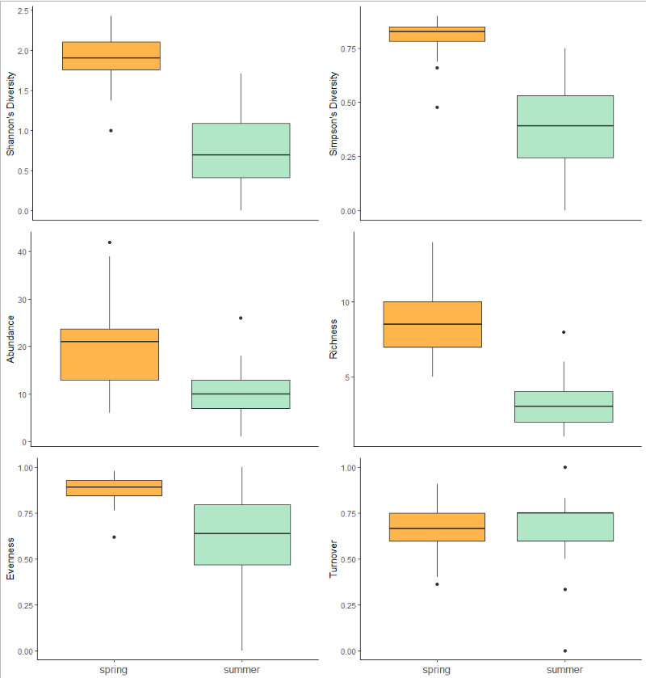

Figure 1: Spring levels of Shannon's Diversity Index, Simpson's Diversity Index, abundance, richness, and evenness. Turnover, however, did not show any difference between the two seasons.

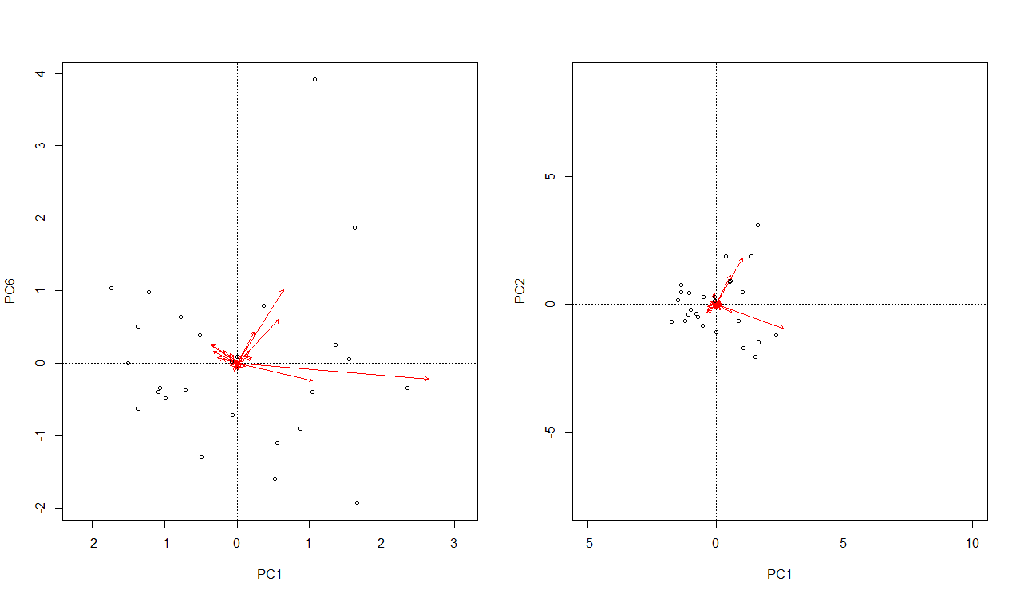

Figure 2: 80% of variance is explained by six principle components in spring, whereas in summer, 80% is explained by only two principle components.

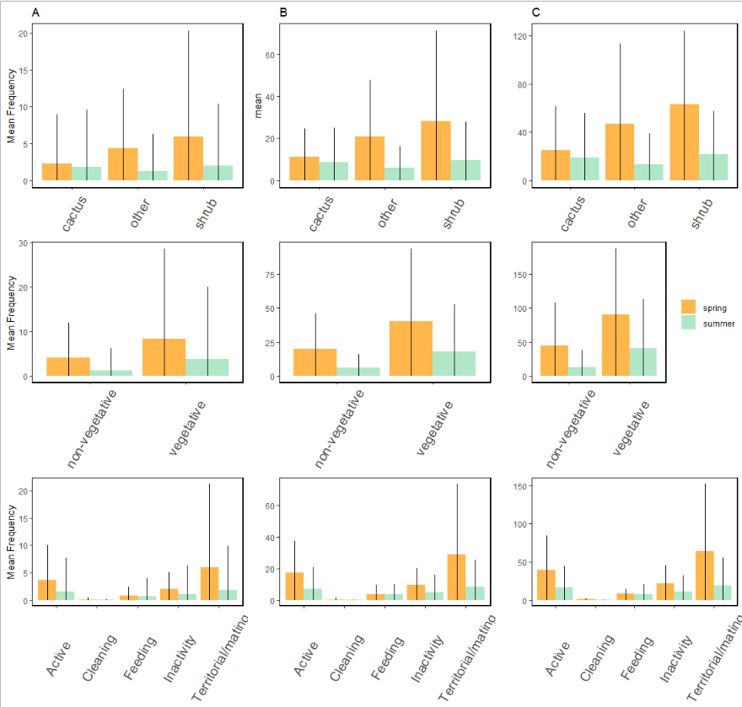

Figure 3: Mesohabitats, regardless of season and number of mesohabitat levels showed no significant differences in bird association. However, analyses on bird behaviors showed territorial/mating behaviors were significantly higher than cleaning behaviors. Between A) species abundance, B) trophic guild abundance, and C) migration class abundance analyses, behavior was consistently the only model that showed significant differences.

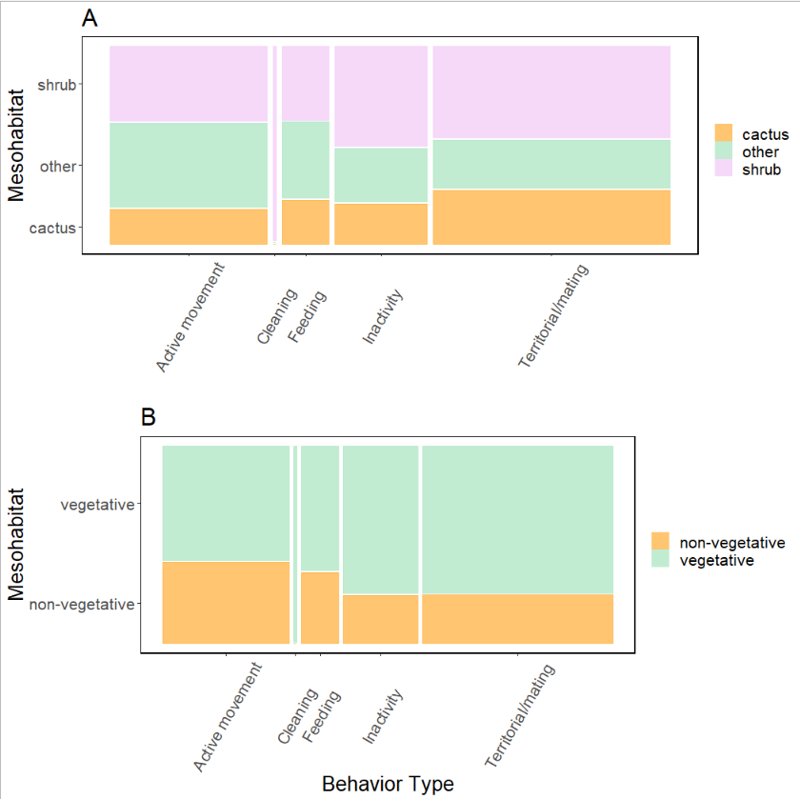

Figure 4: The mesohabitat a bird associated with had significant impact on the behavior that bird was exhibiting. When delineating mesohabitat into A) three levels, we found that mesohabitats that were not shrub or cacti positively influenced active movement but negatively influenced territorial/mating behaviors. This information was recontextualized when mesohabitat was broaden into B) two levels, where we then found vegetative mesohabitats had a negative influence on active movement and a positive influence on territorial/mating behaviors and for non-vegetative mesohabitats, the opposite was true: non-vegetative mesohabitat positively influenced active movement but restricted territorial/mating behaviors.

References:

Almeida, Adriana de, and Sandra Bos Mikich. 2018. “Combining plant–frugivore networks for describing the structure of neotropical communities.” *Oikos* 127 (2): 184–97. <https://doi.org/10.1111/oik.04774>.

Angelini, Christine, Andrew H. Altieri, Brian R. Silliman, and Mark D. Bertness. 2011. “Interactions among Foundation Species and Their Consequences for Community Organization, Biodiversity, and Conservation.” *BioScience* 61 (10): 782–89. <https://doi.org/10.1525/bio.2011.61.10.8>.

Arsenault, Randal, and Norman Owen-Smith. 2002. “Facilitation versus competition in grazing herbivore assemblages.” *Oikos* 97 (3): 313–18. <https://doi.org/10.1034/j.1600-0706.2002.970301.x>.

Barker, Jessica L., Judith L. Bronstein, Maren L. Friesen, Emily I. Jones, H. Kern Reeve, Andrew G. Zink, and Megan E. Frederickson. 2017. “Synthesizing perspectives on the evolution of cooperation within and between species.” *Evolution* 71 (4): 814–25. <https://doi.org/10.1111/evo.13174>.

Bertness, Mark D., George H. Leonard, Jonathan M. Levine, Paul R. Schmidt, and Aubrey O. Ingraham. 1999. “Testing the relative contribution of positive and negative interactions in rocky intertidal communities.” *Ecology* 80 (8): 2711–26. [https://doi.org/10.1890/0012-9658(1999)080[2711:TTRCOP]2.0.CO;2](https://doi.org/10.1890/0012-9658(1999)080%5B2711:TTRCOP%5D2.0.CO;2).

Bonanomi, Giuliano, Guido Incerti, and Stefano Mazzoleni. 2011. “Assessing occurrence, specificity, and mechanisms of plant facilitation in terrestrial ecosystems.” *Plant Ecology* 212 (11): 1777–90. <https://doi.org/10.1007/s11258-011-9948-5>.

Boyles, Justin G., Nigel C. Bennett, Osama B. Mohammed, and Abdulaziz N. Alagaili. 2017. “Torpor patterns in desert hedgehogs (Paraechinus aethiopicus) represent another new point along a thermoregulatory continuum.” *Physiological and Biochemical Zoology* 90 (4): 445–52. <https://doi.org/10.1086/691542>.

Bronstein, Judith L. 2001. “The costs of mutualism.” *American Zoologist* 41 (4): 825–39. <https://doi.org/10.1093/icb/41.4.825>.

———. 2009. “The evolution of facilitation and mutualism.” *Journal of Ecology* 97 (6): 1160–70. <https://doi.org/10.1111/j.1365-2745.2009.01566.x>.

Buler, Jeffrey J., Frank R. Moore, and Stefan Woltmann. 2007. “A multi-scale examination of stopover habitat use by birds.” *Ecology* 88 (7): 1789–1802. <https://doi.org/10.1890/06-1871.1>.

Callaway, Ragan M. 200AD. *Positive Interactions and Interdependence in Plant Communities*. First. Dordrecht: Springer.

———. 1997. “Positive interactions in plant communities and the individualistic-continuum concept.” *Oecologia* 112 (2): 143–49. <https://doi.org/10.1007/s004420050293>.

Cardinale, Bradley J., Margaret A. Palmer, and Scott L. Collins. 2002. “Species diversity enhances ecosystem functioning through interspecific facilitation.” *Nature* 415 (6870): 426–29. <https://doi.org/10.1038/415426a>.

Choler, Philippe, Richard Michalet, and Ragan M. Callaway. 2001. “Facilitation and competition on gradients in alpine plant communities.” *Ecology* 82 (12): 3295–3308. [https://doi.org/10.1890/0012-9658(2001)082[3295:FACOGI]2.0.CO;2](https://doi.org/10.1890/0012-9658(2001)082%5B3295:FACOGI%5D2.0.CO;2).

De Graaf, Richard M, Nancy G. Tilghman, and Stanley H. Anderson. 1985. “Foraging Guilds of North American Birds.” *Environmental Management* 9 (6): 493–536.

Fahse, L., W. R. J. Dean, and C. Wissel. 1998. “Modelling the size and distribution of protected areas for nomadic birds: Alaudidae in the Nama-Karoo, South Africa.” *Biological Conservation* 85 (1-2): 105–12. <https://doi.org/10.1016/S0006-3207(97)00137-7>.

Filazzola, Alessandro, and Christopher J. Lortie. 2014. “A systematic review and conceptual framework for the mechanistic pathways of nurse plants.” *Global Ecology and Biogeography* 23 (12): 1335–45. <https://doi.org/10.1111/geb.12202>.

Filazzola, Alessandro, Michael Westphal, Michael Powers, Amanda Rae Liczner, Deborah A. Smith Woollett, Brent Johnson, and Christopher J. Lortie. 2017. “Non-trophic interactions in deserts: Facilitation, interference, and an endangered lizard species.” *Basic and Applied Ecology* 20: 51–61. <https://doi.org/10.1016/j.baae.2017.01.002>.

FINK, ALIX D., FRANK R. THOMPSON, and APRIL A. TUDOR. 2006. “Songbird Use of Regenerating Forest, Glade, and Edge Habitat Types.” *Journal of Wildlife Management* 70 (1): 180–88. [https://doi.org/10.2193/0022-541x(2006)70[180:suorfg]2.0.co;2](https://doi.org/10.2193/0022-541x(2006)70%5B180:suorfg%5D2.0.co;2).

Flores-Torres, Arnoldo, and Andrea Galindo-Escamilla. 2017. “Pollination biology of Agave horrida (Agavaceae) in the Chichinautzin mountain range, Central Mexico.” *Botanical Sciences* 95 (3): 423–31. <https://doi.org/10.17129/botsci.1022>.

Franco, A C, and P S Nobel. 1989. “Effect of Nurse Plants on the Microhabitat and Growth of Cacti.” *Journal of Ecology* 77 (3): 870–86.

Geiser, Fritz, and Thomas Ruf. 1995. “Hibernation versus Daily Torpor in Mammals and Birds: Physiological Variables and Classification of Torpor Patterns.” *Physiological Zoology* 68 (6): 935–66.

Gelmi-Candusso, Tiziana A., Eckhard W. Heymann, and Katrin Heer. 2017. “Effects of zoochory on the spatial genetic structure of plant populations.” *Molecular Ecology* 26 (21): 5896–5910. <https://doi.org/10.1111/mec.14351>.

Gómez-Aparicio, Lorena, Regino Zamora, Jorge Castro, and Jose A. Hódar. 2008. “Facilitation of tree saplings by nurse plants: Microhabitat amelioration or protection against herbivores?” *Journal of Vegetation Science* 19 (2): 161–72. <https://doi.org/10.3170/2008-8-18347>.

Graff, Pamela, and Martín R. Aguiar. 2011. “Testing the role of biotic stress in the stress gradient hypothesis. Processes and patterns in arid rangelands.” *Oikos* 120 (7): 1023–30. <https://doi.org/10.1111/j.1600-0706.2010.19059.x>.

Gurin, Catherine, Tasha La Doux, and Sharon Coe. 2012. *Checklist for Birds of the Granite Mountains*. First. Natural Reserve System University for California.

Gutzwiller, Kevin J., and Wylie C. Barrow. 2003. “Influences of roads and development on bird communities in protected Chihuahuan Desert landscapes.” *Biological Conservation* 113 (2): 225–37. <https://doi.org/10.1016/S0006-3207(02)00361-0>.

Hernandez, R. R., S. B. Easter, M. L. Murphy-Mariscal, F. T. Maestre, M. Tavassoli, E. B. Allen, C. W. Barrows, et al. 2014. “Environmental impacts of utility-scale solar energy.” *Renewable and Sustainable Energy Reviews* 29: 766–79. <https://doi.org/10.1016/j.rser.2013.08.041>.

Lima, Steven L. 2009. “Predators and the breeding bird: Behavioral and reproductive flexibility under the risk of predation.” *Biological Reviews* 84 (3): 485–513. <https://doi.org/10.1111/j.1469-185X.2009.00085.x>.

Lortie, Christopher J., and Ragan M. Callaway. 2006. “Re-analysis of meta-analysis: Support for the stress-gradient hypothesis.” *Journal of Ecology* 94 (1): 7–16. <https://doi.org/10.1111/j.1365-2745.2005.01066.x>.

Lovich, Jeffrey E., and David Bainbridge. 1999. “Anthropogenic degradation of the southern California desert ecosystem and prospects for natural recovery and restoration.” *Environmental Management* 24 (3): 309–26. <https://doi.org/10.1007/s002679900235>.

Maestre, Fernando T., Fernando Valladares, and James F. Reynolds. 2005. “Is the change of plant-plant interactions with abiotic stress predictable? A meta-analysis of field results in arid environments.” *Journal of Ecology* 93 (4): 748–57. <https://doi.org/10.1111/j.1365-2745.2005.01017.x>.

Miranda-Jácome, Antonio, Carlos Montaña, and Juan Fornoni. 2013. “Sun/shade conditions affect recruitment and local adaptation of a columnar cactus in dry forests.” *Annals of Botany* 111 (2): 293–303. <https://doi.org/10.1093/aob/mcs255>.

Mitchell, Randall J., Rebecca J. Flanagan, Beverly J. Brown, Nickolas M. Waser, and Jeffrey D. Karron. 2009. “New frontiers in competition for pollination.” *Annals of Botany* 103 (9): 1403–13. <https://doi.org/10.1093/aob/mcp062>.

Nielsen, Uffe N., and Becky A. Ball. 2015. “Impacts of altered precipitation regimes on soil communities and biogeochemistry in arid and semi-arid ecosystems.” *Global Change Biology* 21 (4): 1407–21. <https://doi.org/10.1111/gcb.12789>.

Nobel, Park S. 1980. “Morphology , Nurse Plants , and Minimum Apical Temperatures for Young Carnegiea gigantea.” *Botanical Gazette* 141 (2): 188–91.

Oksanen, Jari F., Guillaume Blanchet, Michael Friendly, Roeland Kindt, Pierre Legendre, Dan McGlinn, Peter R. Minchin, et al. 2019. “Vegan: Community Ecology Package.” <https://cran.r-project.org/package=vegan>.

Parker, Kathleen C. 1989. “Nurse plant retationships of columnar cacti in arizona.” *Physical Geography* 10 (4): 322–35. <https://doi.org/10.1080/02723646.1989.10642386>.

Pfahl, S., P. A. O’Gorman, and E. M. Fischer. 2017. “Understanding the regional pattern of projected future changes in extreme precipitation.” *Nature Climate Change* 7 (6): 423–27. <https://doi.org/10.1038/nclimate3287>.

R Core Team. 2017. “R: A language and environment for statistical computing.” Vienna, Austria. <https://www.r-project.org/>.

Rodríguez-Estrella, Ricardo. 2007. “Land use changes affect distributional patterns of desert birds in the Baja California peninsula, Mexico.” *Diversity and Distributions* 13 (6): 877–89. <https://doi.org/10.1111/j.1472-4642.2007.00387.x>.

Runge, Claire, and Ayesha I. T. Tulloch. 2017. “Solving problems of conservation inadequacy for nomadic birds.” *Australian Zoologist* 39 (2): 280–95. <https://doi.org/10.7882/AZ.2016.003>.

Schwartz, Mark D. 2003. *Phenology: An integrative environmental science*. Second. New York: Springer Science+Business Media. <https://doi.org/10.1007/978-94-007-6925-0>.

Scott Sillett, T., and Richard T. Holmes. 2002. “Variation in survivorship of a migratory songbird throughout its annual cycle.” *Journal of Animal Ecology* 71 (2): 296–308. <https://doi.org/10.1046/j.1365-2656.2002.00599.x>.

Singh, Deepti, Michael Tsiang, Bala Rajaratnam, and Noah S. Diffenbaugh. 2013. “Precipitation extremes over the continental United States in a transient, high-resolution, ensemble climate model experiment.” *Journal of Geophysical Research Atmospheres* 118 (13): 7063–86. <https://doi.org/10.1002/jgrd.50543>.

Smith, Melinda D. 2011. “The ecological role of climate extremes: Current understanding and future prospects.” *Journal of Ecology* 99 (3): 651–55. <https://doi.org/10.1111/j.1365-2745.2011.01833.x>.

Tewksbury, Joshua J., and John D. Lloyd. 2001. “Positive interactions under nurse-plants: Spatial scale, stress gradients and benefactor size.” *Oecologia* 127 (3): 425–34. <https://doi.org/10.1007/s004420000614>.

Tonkin, Jonathan D., Michael T. Bogan, Núria Bonada, Blanca Rios-Touma, and David A. Lytle. 2017. “Seasonality and predictability shape temporal species diversity.” *Ecology* 98 (5): 1201–16. <https://doi.org/10.1002/ecy.1761>.