Owen Spring MSc1 Progress Report

York University, Toronto, Ontario

April 5th, 2019

Pollination and Frugivory of *Cactaceae* by Avian Interactors – maybe just say birds?

Also – title does not pop or imply the main theory – what is the main theory or hypothesis that your thesis is testing? Might be cooler to that have that – Facilitation and interactions between cacti and birds as a test of interaction costs? Or trade-offs or trophic facilitation cascades or biodiversity resilience that cacti provide for other taxa: case study birds?

Malory Owen & Christopher Lortie

Examination Committee

Dr. Christopher Lortie

Dr. Bridget Stutchbury

Timeline

Table 1: A timeline of research plans and progress.

|  |  |  |  |
| --- | --- | --- | --- |
| Chapter | Title | Completed | Future |
| 1 | A meta-analysis of allocation strategies in *Cactaceae* reproductive structures | Three rounds of qualitative and quantitative data extracted, maps of studies created, and primary numeric values obtained. | Expansion of dataset, data analysis, and writing in progress. Chapter 1 draft September 2020. |
| 2 | Linking Avian double-mutualistic interactions to *Cactaceae* seed dispersal and facilitation | Preliminary data collected and analyzed, protocols written, datasheets prepped, equipment gathered, and field preparation. | Flowering field season from April 25th-May 25th, fruiting field season August 1st-30th, data analyzed by late Fall 2020, and writing/presentation/communication in Spring 2020. |

Background

Positive interactions drive ecosystem infrastructure (R. M. Callaway 1997; Gelmi-Candusso, Heymann, and Heer 2017). A positive interaction is any association between multiple individuals where one or more of the interactors benefits either in physical health or reproductive fitness (M. D. M. Bertness and Callaway 1994). These interactions are described by the Kingdom-level pathway they follow from benefactor to protégé (e.g. plant-plant, plant-animal, plant-animal-plant, etc.). By analyzing more narrow taxonomic interactions in a variety of ecosystems, we are able to further understand the importance of positive interactions in ecosystem structure and dynamics and infer biodiversity impacts. Mutualism is a more specific interspecific interaction when *both* interacting parties involved benefit (Barker et al. 2017; Bronstein 2009; Bronstein 2001). In harsh ecosystems (like deserts or islands), we see examples of “double mutualism” where each interactor exists in two distinct niches to provide two distinct services to an interspecific (Ladley and Kelly 1996; Kelly et al. 2004; Garcia, Espadaler, and Olesen 2012; Gomes, Quirino, and Araujo 2014). Mutualism and double mutualism are most commonly discussed when an animal is the interacting species with a benefactor plant species?.

Facilitation usually describes positive interactions wherein the benefactor and protégé species are both plants (i.e. plant-plant) and less commonly plant-animal interactions (F. T. Maestre et al. 2009). Benefactor plant species increase germination, growth, and recruitment of protégé species under its canopy (Franco and Nobel 2009). In arid ecosystems, facilitation takes the form of benefactor species providing resources like water, shade, and pollinators (Flores-Torres and Galindo-Escamilla 2017; Miranda-Jacome, Montaña, and Fornoni 2013; Mitchell et al. 2009), or protection from trauma by herbivory, trampling, freezing temperatures, predation, and wind (Gomez-Aparicio et al. 2008; Parker 1989; Tewksbury and Lloyd 2001; P. S. Nobel 1980) great list. Keystone benefactor species which facilitate many species in an ecosystem are known as foundational species (Angelini et al. 2011; Almeida and Mikich 2018) and are dominant species in a ecosystem. Shrub species have been documented as the most common foundational species globally (Filazzola et al. 2017). *Cylindropuntia acanthocarpa*, a many-branched columnar member of the *Cactaceae* family is found as a dominant species in the Mojave Desert. It is morphologically similar to foundational shrubs, and it is likely a keystone foundational species itself. Members of the *Cactaceae* family have been documented as both protégée etc species and benefactor species in deserts. *Carnegiea gigantea*, a keystone columnar cactus species found in the Sonoran Desert, was the subject of the classic paper on facilitation, as a protegee species (Turner et al. 1966). It is an obligate protegee in that its seeds must be deposited under a benefactor shrub’s canopy in order to germinate (Taly D. Drezner and Garrity 2003; Taly Dawn Drezner 2010). This dual role as a benefactor and protegee at different life stages makes *Cactaceae* an interesting player in interaction ecology. Agreed!

Before a plant can germinate, grow, and eventually facilitate other species, it must first be created (via sexual reproduction) and then disperse from the mother plant as a seed (Nathan and Muller-landau 2000). While clonal reproduction is common in *Cylindropuntia* species, it is seed dispersal which allows a mother plant to expand its seed shadow over a larger landscape in a shorter period of time (Willson 1993). Seed dispersal can rely on biotic or abiotic vectors, but endozoochorous seed dispersal (dispersal through the gut of an animal) is shown to increase germination rate, especially by birds (Verdu and Traveset 2004; A Traveset, Riera, and Mas 2001; A. Traveset and Verdú 2002). Maybe reduce to 1-2 sentences and wrap into next para – ie reproduction and earlier life stages are critical for plants and seed dispersal is often a limitation (citations). Then keep going with next paragraph?

Birds can be nectarivores and frugivores of cacti (Montiel and Montaña 2000; Gorostiague and Ortega-Baes 2016). These interactions provide food resources for birds and pollination/seed dispersal for cacti – a classic example of single mutualism. If the same taxonomic groups are in one habitat, these interactions may be described as double mutualism – does this mean animal animal to be double???. However, nectarivores and frugivores do not forage randomly, but instead follow optimal foraging theory which suggests that foragers will continue to forage in one area until resources are depleted to levels below the average resource availability of the larger habitat. This value resource density is known as the Giving Up Density, or GUD, which exists based on predictions made in ecosystems with patchy resource available (Marginal Value Theorem) (Charnov 1976). This suggests that in a mutualistic foraging interaction, cacti will evolve to have more reproductive output and showier displays to draw in more nectarivores (Wolf and Hainsworth 1990; Mitchell 1994). However, allocation theory suggests that plants must make physiological tradeoffs due to their finite energy to anatomical traits that best increase their relative fitness (Obeso 2004). Therefore, plants which maximize reproductive output *and* size will be the most likely to encourage pollinator and frugivorous visitation. GOOD

Deserts habitats are declining because of climate change, fragmentation, and invasive species (Nielsen and Ball 2015; Pfahl, O’Gorman, and Fischer 2017; Singh et al. 2013; Smith 2011; Gutzwiller and Barrow 2003; Hernandez et al. 2014; Rodriguez-Estrella 2007) and the family *Cactaceae* is protected under CITES Appendix II, with many species protected under Appendix I (CITES 2017). Understanding how cacti come to be dominant species in an ecosystem may illuminate new avenues for utilizing biotic vectors in conservation and restoration applications.

Chapter 1

A meta-analysis of physical allocation in *Cactaceae* reproductive structures

Purpose: Review literature on *Cactaceae* reproduction outputs, analyze reported values, and determine research gaps and future directions for agro-eco investigations. Produce editorial paper on current state of agro-eco *Cactaceae* research, as well as a meta-analysis paper quantifying reported allocation tradeoffs of *Cactaceae*. I would say make the purpose more about the science –

To review and summarize the research examining allocation trade-offs and reproductive outputs in cacti?

Research Questions: Are different reproductive output measures in *Cactaceae* (i.e., flowers, fruits, and seeds) correlated? How does *Cactaceae* phylogenetic distance relate to reproductive output? Where are *Cactaceae* reproductive studies relative to *Cactaceae* locations? What research gaps exist in *Cactaceae* allocation research, and what opportunities for agro-eco interdisciplinary work have been unexplored? Not bad – could clean these up a bit more

Hypothesis: Flower production will be greater than but correlated to fruit production. However, fruit production will be negatively correlated with seed production. Abundance of fruit or seeds will also be negatively correlated with mass of fruit or seeds, respectively.

Methods: Web of Science was used to examine key reproductive allocation research in the primary literature (see Table 2 for term lists) . Screening for a qualitative synthesis versus screening for a quantitative analysis led to one additional study for the qualitative. Since only 14 studies have been identified, the search will be expanded to include “flower*" as a search term, and allow for papers published more than five years ago. A PRISMA statement shows the current exclusion for all studies (Figure 1). Clunky – A total of 14 studies were identified using these specific terms, and an expanded search was done to include the term ‘flowers’ generating X additional studies. The following measures will be extracted from each study: list them. Then say how will be analyzed. Data will be analyzed using the R Package “metafor” with generalized linear mixed models (Citation to metafor).

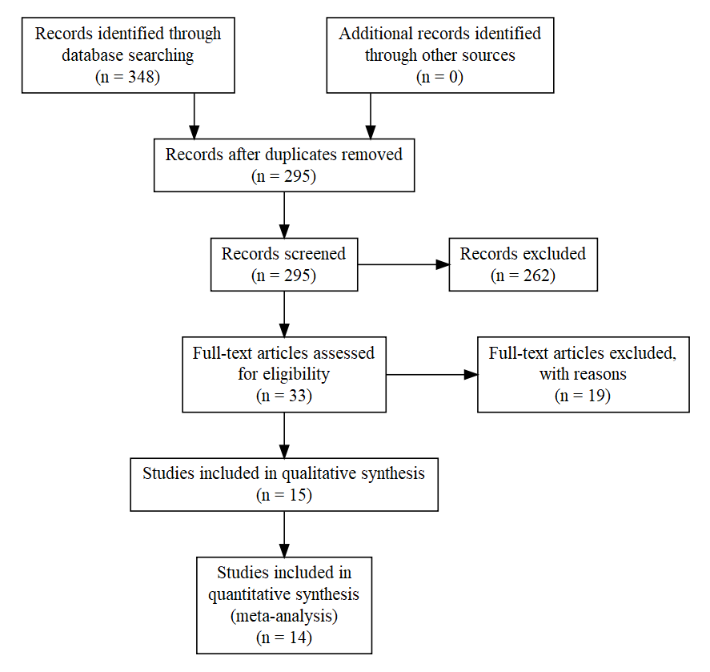

Figure 1: A PRISMA statement showing sample size of papers included in qualitative and quantitative datasets. Without flowers?

Table 2: The number of studies returned for each combination of search terms in Web of Science.

|  |  |  |  |
| --- | --- | --- | --- |
| Search | Terms | Hits | Refines |
| 1 | cact* and allocat* | 25 | topic, last five years |
| 2 | cact* and fruit* and size | 63 | topic, last five years |
| 3 | cact* and seed and fruit* | 110 | topic, last five years, articles |
| 4 | cact* and seed and size | 53 | topic, last five years |
| 5 | fruit* and seed and size and allocat* | 69 | topic, last five years |
| 6 | cact* and size and allocat* | 10 | topic, last five years |
| 7 | cact* and fruit and agricultur* | 18 | topic, last five years |
|  | total | 348 |  |

Maybe just update prisma and table with flowers?

Preliminary Results:

This study has changed from its original construct which relied on reports of correlation coefficients between reproductive structures measured in the study. Because only one paper reported this value, we adapted by creating two datasets: one for qualitative analysis that includes any measurement of a reproductive structure, and a second which compares reproductive structures under treatment against controls. These datasets will likely be processed into two papers. One will be an “insight” style paper which describes the current state and research gaps of *Cactaceae* reproductive studies and refines opportunities for agro-eco interdisciplinary work. The second will be a formal meta-analysis correlating different reproductive structures, investigating allocation theory in *Cactaceae*. Good – can leave or edit and just streamline to be more like a result?

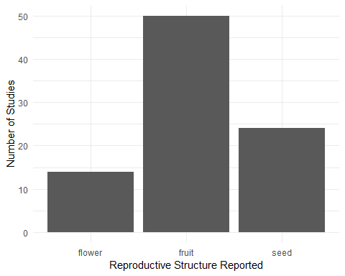Based on the data extracted now, fruit is the most frequently reported reproductive structure (Figure 2). While flowers are the most infrequently reported at this time, an inclusion of “flower*" in a new search will drastically increase this count.

Figure 2: Studies most frequently reported fruit, followed by seed, followed by flower.

*Cactaceae* are only native to the Western Hemisphere, excluding one species in Africa (Cota-Sanchez and Bomfim-Patricio 2010). However, members of the family can be found globally thanks to nonnative introductions and agriculture. Of the current studies, most data points are reported in studies occurring in the Western Hemisphere, where they are native (Figure 3). Most reported values and studies occur in field experiments, and field experiments are more likely to report more values per study (Figure 4).

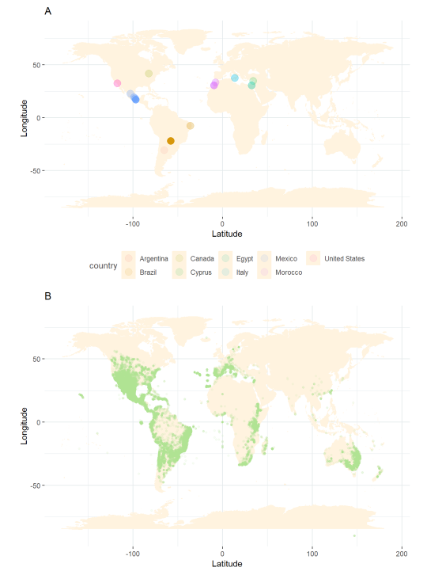

Figure 3: Studies on cactus reproduction are more prevalent and report more values in the Western Hemisphere (Figure 3A). Cacti are found globally, but all occurrences in the Eastern Hemisphere are either agricultural or introduced populations (Figure 3B). SUPER

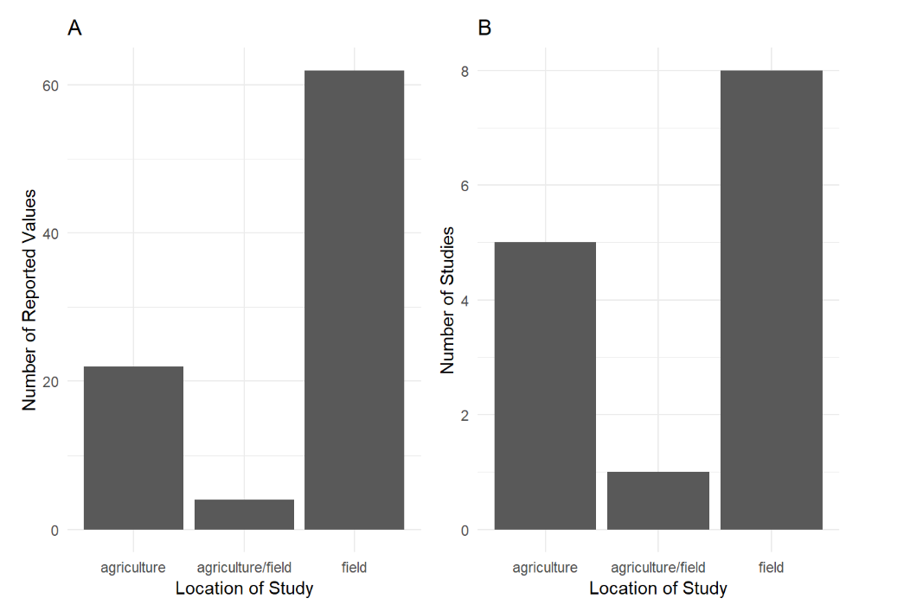

Figure 4: More studies take place in the field than in an agricultural plot (Figure 4A), and field studies tend to report more reproductive structure metrics (Figure 4B). good – revise fig legend so that it does not state result but states what the figure is – ie Data from systematic review describing frequency of…

Chapter 20?? 20 whoa!!

Linking Avian Double Mutualistic Interactions to *Cactaceae* Seed Dispersal and Facilitation

Purpose: The aim of this study is to determine the magnitude? Or frequency? of this double mutualistic interaction between birds and a foundational species of cactus based on morphological characteristics of cactus individuals. Great.

Research Questions: Are different reproductive structures of cacti correlated with one another or with *Cylindropuntia acanthocarpa* estimated plant volumes? What avian communities are associated with *C. acanthocarpa*? How strong are Avian-*C. acanthocarpa* double mutualistic interactions? Good.

Hypothesis: *C. acanthocarpa* individuals that maximize size *and* reproductive output via allocational tradeoffs will have the showiest reproductive displays, and therefore the most pollinating and seed dispersing avian visitors. Not bad – kind of a prediction too – did Bridget have any suggestions on this? I might flip order and match it more to the purpose – Double-mutualism between cacti and birds is …. Most frequent? Or most intense? When cacti are relatively larger? Is that is.

Predictions:

1. Flower and fruit production will be positively correlated, but cactus volume and reproductive output will be negatively correlated.
2. Avian visitation rates and diversity are dependent on cactus morphological characteristics.
3. Avian diversity at a *C. acanthocarpa* individual is different than avian diversity at the entire site. Hmm ok

So predictions not a perfect match for hypothesis about double-mutualisms. Can you get them to match up?

Methods:

Preliminary Cactus Survey

Prior to the flowering and fruiting experiments, we did a pilot survey using transect sampling of *Cylindropuntia acanthocarpa*, *Cylindropuntia echinocarpa*, and a haphazard sampling of *Opuntia basilaris* to determine an appropriate study species. We measured the major, minor, and vertical axis of the nearest neighbor cactus every five meters, with distance between transects being five (*C. acanthocarpa*) or ten (*C. echinocarpa*) meters. Because *C. acanthocarpa* was so dense, we were able to sample 105 individuals (n=105) over 5 transects. However, *C. echinocarpa* was less dense and therefore required 9 transects to be sampled (n=98). *O. basilaris* was so infrequent that a haphazard search for any individuals was the most effective way to measure the cacti (n=26). We also rated the health of each individual considering the overall percentage of plant death, rot, and scarification. Using these data, we confirmed that *C. acanthocarpa* is the most appropriate study species for studies that need variation in plant sizes?.

Experimental Manipulations

In April/May 2019 flowering season, a second survey to observe pollinating bird interactions with 105 cactus individuals (7 replications per characteristic combination). The cacti will have different levels of manipulated “floral showiness” (0%, 25%, 50%, 75%, 100% percent of flowers) of the 3 size classes. We will remove each percent level of total flowers off the cactus (and record total number of actual flowers).,The number of nonblooming buds on each individual will also be recorded because not all flowers of a cactus bloom concurrently.

While the flowering season for our study cacti is in May, the cactus individual itself only blooms for 1-2 days throughout the season. We will primarily rely on focal observations aided by a 150-600mm lens equipped to a digital camera. We will do 1-hour observations in mornings and evenings at each combination of variables 7 times (105 hours of observations). To avoid impacting bird visitation, we will be at least 10m from the cactus individual and remain still. We will record each bird individual’s species and behavior (using an ethogram). Should there be more than one individual present, we will record the visiting species, but continue behavior observation for the first arrival birds (for up to 10 minutes, although this time limit is unlikely to be surpassed considering bird movement). Once the focal bird has left the cactus of interest, we will record the ecological? location it arrived at after leaving the cactus of interest.

We will also leave out omnidirectional microphones to record bird calls which will give us an estimate of bird diversity at the site level. Sound recorders have been shown to be as reliable a measurement of bird presence compared to walking point transects and are more time and cost effective (Darras et al. 2018). To identify bird calls, we will classify the calls by ear, and then use a audio software program, like Sound Analysis Pro 2011 to identify the many hours of audio data (L. A. Grieves, Logue, and Quinn 2014; Leanne A. Grieves, Logue, and Quinn 2015).

In August, the fruiting observation and experiment will be done, and it parallels the flowering experiment. Each combination of variables (species, size, and fruit percent) will again have 7 replicates, meaning 105 cacti will be a part of the study. We will also remove 0%, 25%, 50%, 75%, and 100% of fruits from small, medium, and large cacti. We will immediately place each cactus’s fruit in a sealed zip lock bag to prevent desiccation while in the field. Post collection, we will weigh fresh and dried fruits, and sieve the seeds for weighing and counting. For the fruiting season, all focal observation protocols will be identical to the flowering season’s but replacing flowers for fruit. LOVE IT!!! So solid right!

Joy Sampling

In addition to our manipulated experiments, we will also perform joy sampling protocols, that do not manipulate cacti and are purely for the joy of bird observations but nonetheless collect quantitative data. First, we will perform 50 hours of area searches (2 hours per session) recording any and all bird locations, behaviors, and mesohabitats (shrub, cactus, open, etc.). Similarly, we will perform 50 hours of point counts at individual cacti. This protocol is easily replicable at other sites with different collaborators and has been proposed to WindWolves Preserve.

Preliminary Results:

Abundance, size, and health are three factors under consideration when choosing a study species. *C. acanthocarpa* was dominant, *C. echinocarpa* was second most common, and *O. basilaris* was infrequent (Figure 5). Based on our proposed methods, a total of 210 distinct individuals will be manipulated for observation, as well as an additional 100 for point count observations, and 20 for flower-fruit paired observations (n=360), so an abundant species is necessary.

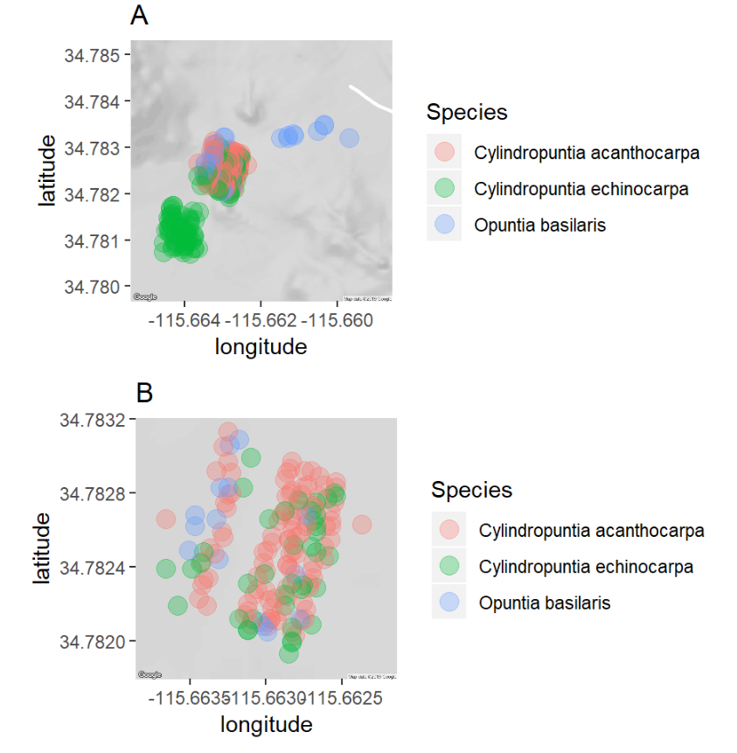

Figure 5: *C. acanthocarpa* is the most abundant cactus species, *C. echinocarpa* is the second most common, and *O. basilaris* is infrequent. Figure 5a shows all cacti measured, figure 5b zooms in on *C. acanthocarpa* area. Same as before – fig legend explains what figure is not what it found etc.

In addition to abundance, sufficient variation in cacti size is critical for analyses both in terms of simple blocking or strata, i.e. small, medium, and large and continuous analyses post hoc. While we do have a total volume available, height of cacti is a better metric to consider if nectarivorous and frugivorous birds will engage with a cactus because they prefer to engage with higher inflorescence and fruits (Wolf and Hainsworth 1990; Mitchell 1994). Sampled *O. basilaris* size individuals were normally distributed (*Shapiro Wilks*, p = 0.008519, W = 0.88797), but *C. acanthocarpa* (*Shapiro Wilks*, p = 0.06667, W = 0.97717) and *C. echinocarpa* (*Shapiro Wilks*, p = 0.349, W = 0.98532) were not. A Kruskal-Wallis rank sum test revealed that each cactus had non-identical means (*Kruskal-Wallis*, Chi-square = 3.71, p > 0.0001, df = 52), with a mean height in meters of 1.04 meters for *C. acanthocarpa*, 0.55 meters for *C. echinocarpa*, and 0.17 meters for *O. basilaris* (Figure 6). Additionally, the selected study species must have enough variety in heights so as to be binned into three size class (small, medium, large). Based on the distributions of sizes of each cactus, a equal-sized binned class system is most appropriate. *C. acanthocarpa* has the largest bin classes, which is a benefit in that having large size classes translates to a clearer distinction among flower/fruit height for birds.

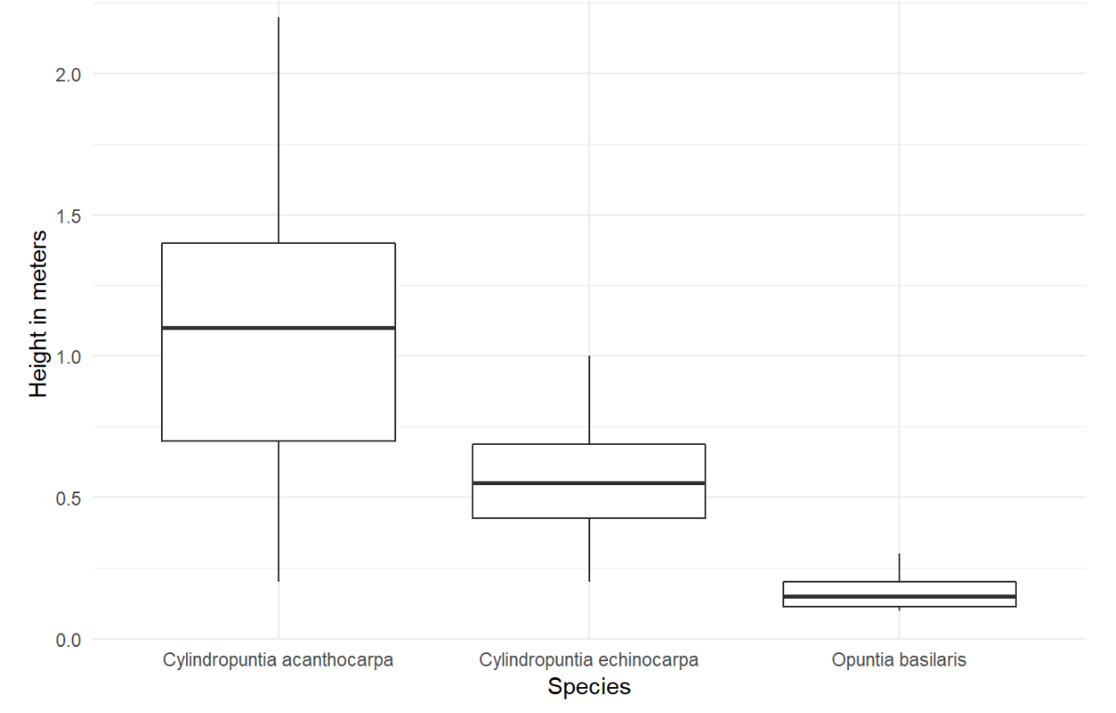

Figure 6: Each cactus species had significantly different mean heights (*Kruskal-Wallis*, Chi-square = 3.71, p > 0.0001, df = 52).

|  |  |  |  |
| --- | --- | --- | --- |
| Species | Small | Medium | Large |
| *Cylindropuntia acanthocarpa* | <85cm | 86cm - 152cm | >153cm |
| *Cylindropuntia echinocarpa* | <45cm | 46cm - 72cm | >73cm |
| *Opuntia basilaris* | <15cm | 16cm - 22cm | >23cm |

Table 3: Size classes for each study species candidate. *C. acanthocarpa* has the largest bin sizes.

Overall health is another important factor to consider when exploring potential study species, as health can determine an individual’s likelihood to flower and fruit. *C. acanthocarpa* and *C. echinocarpa* are left skewed, with most individuals having health ratings of “4” or “5”, whereas *O. basilaris* has an even distribution of health classes among all individuals (Figure 7). Great – can be a bit more direct tho.

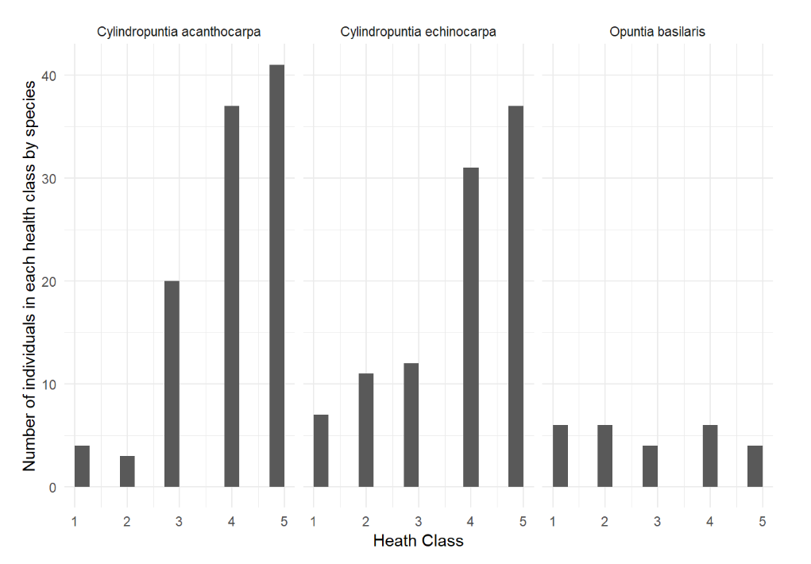

Figure 7: The *Cylindropuntia* species tend to have more individuals with “4” or “5” health index ratings, whereas the *O. basilaris* individuals are evenly distributed along the health index scale.

Considering the abundance, the density, the health, and size class options, *O. basilaris* is not a realistic contender as a study species. It can be overlooked by birds, not bloom/fruit due to health, and is in short supply. Both of *Cylindropuntias* are healthy. *C. echinocarpa*, however, is still less dominant than *C. acanthocarpa*, is smaller overall, and doesn’t have the width of size classes that *C. acanthocarpa* does. While these traits do not mean the *C. echinocarpa* could not be viable study species, I propose that focusing more deeply on *C. acanthocarpa* and deepening the methods of observation will be more beneficial to answering my study questions than a comparative study between cacti species would. GOOD – I think you could streamline all this. I like the workflow though but could be much more succinct – list criteria, explain what you found for each, then outcome.

Literature Cited

Almeida, Adriana de, and Sandra Bos Mikich. 2018. “Combining plant–frugivore networks for describing the structure of neotropical communities.” *Oikos* 127 (2): 184–97. doi:[10.1111/oik.04774](https://doi.org/10.1111/oik.04774).

Angelini, Christine, Andrew H. Altieri, Brian R. Silliman, and Mark D. Bertness. 2011. “Interactions among Foundation Species and Their Consequences for Community Organization, Biodiversity, and Conservation.” *BioScience* 61 (10): 782–89. doi:[10.1525/bio.2011.61.10.8](https://doi.org/10.1525/bio.2011.61.10.8).

Barker, Jessica L., Judith L. Bronstein, Maren L. Friesen, Emily I. Jones, H. Kern Reeve, Andrew G. Zink, and Megan E. Frederickson. 2017. “Synthesizing perspectives on the evolution of cooperation within and between species.” *Evolution* 71 (4): 814–25. doi:[10.1111/evo.13174](https://doi.org/10.1111/evo.13174).

Bertness, Mark D. M.D., and Ragan Callaway. 1994. “Positive interactions in communities.” *Tree* 9 (5): 191–93. doi:[10.1016/0169-5347(94)90088-4](https://doi.org/10.1016/0169-5347(94)90088-4).

Bronstein, Judith L. 2001. “The Costs of Mutualism.” *American Zoology* 41: 825–39.

———. 2009. “The evolution of facilitation and mutualism.” *Journal of Ecology* 97 (6): 1160–70. doi:[10.1111/j.1365-2745.2009.01566.x](https://doi.org/10.1111/j.1365-2745.2009.01566.x).

Callaway, Ragan M. 1997. “Positive interactions in plant communities and the individualistic-continuum concept.” *Oecologia* 112: 143–49.

Charnov, Eric. 1976. “Optimal foraging : The marginal value theorem.” *Theoretical Population Biology* 9 (2): 129–36.

CITES. 2017. “The Conventional on International Trade in Endagered Species of Wild Fauna and Flora.”

Cota-Sanchez, J. Hugo, and Marcia Bomfim-Patricio. 2010. “Seed morphology, polyploidy and the evolutionary history of the epiphytic cactus.” *Polibotanica* 29: 107–29.

Darras, Kevin, Péter Batáry, Brett Furnas, Antonio Celis-Murillo, Steven L. Van Wilgenburg, Yeni A. Mulyani, and Teja Tscharntke. 2018. “Comparing the sampling performance of sound recorders versus point counts in bird surveys: A meta-analysis.” *Journal of Applied Ecology*, no. June: 2575–86. doi:[10.1111/1365-2664.13229](https://doi.org/10.1111/1365-2664.13229).

Drezner, Taly D., and Colleen M. Garrity. 2003. “Saguaro distribution under nurse plants in arizona’s sonoran desert: Directional and microclimate influences.” *Professional Geographer* 55 (4): 505–12. doi:[10.1111/0033-0124.5504008](https://doi.org/10.1111/0033-0124.5504008).

Drezner, Taly Dawn. 2010. “Nurse tree canopy shape, the subcanopy distribution of cacti, and facilitation in the Sonoran Desert.” *The Journal of the Torrey Botanical Society* 137 (2–3): 277–86. doi:[10.3159/09-RA-069R1.1](https://doi.org/10.3159/09-RA-069R1.1).

Filazzola, Alessandro, Michael Westphal, Michael Powers, Amanda Rae Liczner, Deborah A. Smith Woollett, Brent Johnson, and Christopher J. Lortie. 2017. “Non-trophic interactions in deserts: Facilitation, interference, and an endangered lizard species.” *Basic and Applied Ecology* 20. Elsevier GmbH: 51–61. doi:[10.1016/j.baae.2017.01.002](https://doi.org/10.1016/j.baae.2017.01.002).

Flores-Torres, Arnoldo, and Andrea Galindo-Escamilla. 2017. “Pollination biology of Agave horrida (Agavaceae) in the Chichinautzin mountain range, in Central Mexico".” *Botanical Sciences* 95 (3): 423–31. doi:[10.17129/botsci.1022](https://doi.org/10.17129/botsci.1022).

Franco, Author A C, and P S Nobel. 2009. “Effect of Nurse Plants on the Microhabitat and Growth of Cacti Published by : British Ecological Society Stable URL : http://www.jstor.org/stable/2260991” 77 (3): 870–86.

Garcia, Maria B., Xavier Espadaler, and Jens M. Olesen. 2012. “Extreme Reproduction and Survival of a True Cliffhanger : The Endangered Plant Borderea chouardii.” *PLOS One* 7 (9): 1–7. doi:[10.1371/journal.pone.0044657](https://doi.org/10.1371/journal.pone.0044657).

Gelmi-Candusso, Tiziana A., Eckhard W. Heymann, and Katrin Heer. 2017. “Effects of zoochory on the spatial genetic structure of plant populations.” *Molecular Ecology* 26 (21): 5896–5910. doi:[10.1111/mec.14351](https://doi.org/10.1111/mec.14351).

Gomes, VGN, ZGM Quirino, and HFP Araujo. 2014. “Frugivory and seed dispersal by birds in Cereus jamacaru DC. ssp. jamacaru (Cactaceae) in the Caatinga of Northeastern Brazil.” *Brazilian Journal of Biology* 74 (1): 32–40. doi:[10.1590/1519-6984.15312](https://doi.org/10.1590/1519-6984.15312).

Gomez-Aparicio, Lorena, Regino Zamora, Jorge Castro, and Jose A. Hódar. 2008. “Facilitation of tree saplings by nurse plants: Microhabitat amelioration or protection against herbivores?” *Journal of Vegetation Science* 19 (2): 161–72. doi:[10.3170/2008-8-18347](https://doi.org/10.3170/2008-8-18347).

Gorostiague, P., and P. Ortega-Baes. 2016. “How specialised is bird pollination in the Cactaceae?” *Plant Biology* 18 (1): 63–72. doi:[10.1111/plb.12297](https://doi.org/10.1111/plb.12297).

Grieves, L. A., D. M. Logue, and J. S. Quinn. 2014. “Joint-nesting smooth-billed anis, Crotophaga ani, use a functionally referential alarm call system.” *Animal Behaviour* 89. Elsevier Ltd: 215–21. doi:[10.1016/j.anbehav.2014.01.008](https://doi.org/10.1016/j.anbehav.2014.01.008).

Grieves, Leanne A., David M. Logue, and James S. Quinn. 2015. “Vocal repertoire of cooperatively breeding Smooth-billed Anis.” *Journal of Field Ornithology* 86 (2): 130–43. doi:[10.1111/jofo.12096](https://doi.org/10.1111/jofo.12096).

Gutzwiller, Kevin J., and Wylie C. Barrow. 2003. “Influences of roads and development on bird communities in protected Chihuahuan Desert landscapes.” *Biological Conservation* 113 (2): 225–37. doi:[10.1016/S0006-3207(02)00361-0](https://doi.org/10.1016/S0006-3207(02)00361-0).

Hernandez, R. R., S. B. Easter, M. L. Murphy-Mariscal, F. T. Maestre, M. Tavassoli, E. B. Allen, C. W. Barrows, et al. 2014. “Environmental impacts of utility-scale solar energy.” *Renewable and Sustainable Energy Reviews* 29. Elsevier: 766–79. doi:[10.1016/j.rser.2013.08.041](https://doi.org/10.1016/j.rser.2013.08.041).

Kelly, Dave, Jenny J Ladley, Alastair W Robertson, and Jenny J Ladley. 2004. “Is dispersal easier than pollination ? Two tests in New Zealand Loranthaceae.” *New Zealand Journal of Botany* 42: 89–103. doi:[10.1080/0028825X.2004.9512892](https://doi.org/10.1080/0028825X.2004.9512892).

Ladley, Jenny J, and Dave Kelly. 1996. “DISPERSAL , GERMINATION AND SURVIVAL OF NEW ZEALAND MISTLETOES ( LORANTHACEAE ): DEPENDENCE.” *New Zealand Journal of Ecology* 20 (1): 69–79.

Maestre, Fernando T., Ragan M. Callaway, Fernando Valladares, and Christopher J. Lortie. 2009. “Refining the stress-gradient hypothesis for competition and facilitation in plant communities.” *Journal of Ecology* 97 (2): 199–205. doi:[10.1111/j.1365-2745.2008.01476.x](https://doi.org/10.1111/j.1365-2745.2008.01476.x).

Miranda-Jacome, Antonio, Carlos Montaña, and Juan Fornoni. 2013. “Sun/shade conditions affect recruitment and local adaptation of a columnar cactus in dry forests.” *Annals of Botany* 111 (2): 293–303. doi:[10.1093/aob/mcs255](https://doi.org/10.1093/aob/mcs255).

Mitchell, Randall J. 1994. “Effects of Floral Traits , Pollinator Visitation , and Plant Size on Ipomopsis aggregata Fruit Production.” *American Society of Naturalists* 143 (5): 870–89.

Mitchell, Randall J, Rebecca J Flanagan, Beverly J Brown, Nickolas M Waser, and Jeffrey D Karron. 2009. “New frontiers in competition for pollination,” 1403–13. doi:[10.1093/aob/mcp062](https://doi.org/10.1093/aob/mcp062).

Montiel, Salvador, and Carlos Montaña. 2000. “Vertebrate Frugivory and Seed Dispersal of a Chihuahuan Desert Cactus” 146 (2): 221–29.

Nathan, R., and H. C. Muller-landau. 2000. “Spatial patterns of seed dispersal, their determinants and consequences for recruitment.” *Trends in Ecology & Evolution* 15 (7): 278–85. doi:[10.1016/S0169-5347(00)01874-7](https://doi.org/10.1016/S0169-5347(00)01874-7).

Nielsen, Uffe N., and Becky A. Ball. 2015. “Impacts of altered precipitation regimes on soil communities and biogeochemistry in arid and semi-arid ecosystems.” *Global Change Biology* 21 (4): 1407–21. doi:[10.1111/gcb.12789](https://doi.org/10.1111/gcb.12789).

Nobel, Park S. 1980. “Morphology , Nurse Plants , and Minimum Apical Temperatures for Young Carnegiea gigantea Author ( s ): Park S . Nobel Published by : The University of Chicago Press Stable URL : http://www.jstor.org/stable/2474851 Accessed : 16-05-2016 19 : 34 UTC Your us.” *Botanical Gazette* 141 (2): 188–91.

Obeso, José Ramón. 2004. “A hierarchical perspective in allocation to reproduction from whole plant to fruit and seed level.” *Perspectives in Plant Ecology, Evolution and Systematics* 6 (4): 217–25. doi:[10.1078/1433-8319-00080](https://doi.org/10.1078/1433-8319-00080).

Parker, Kathleen C. 1989. “Nurse plant retationships of columnar cacti in arizona.” *Physical Geography* 10 (4): 322–35. doi:[10.1080/02723646.1989.10642386](https://doi.org/10.1080/02723646.1989.10642386).

Pfahl, S., P. A. O’Gorman, and E. M. Fischer. 2017. “Understanding the regional pattern of projected future changes in extreme precipitation.” *Nature Climate Change* 7 (6): 423–27. doi:[10.1038/nclimate3287](https://doi.org/10.1038/nclimate3287).

Rodriguez-Estrella, Ricardo. 2007. “Land use changes affect distributional patterns of desert birds in the Baja California peninsula, Mexico.” *Diversity and Distributions* 13 (6): 877–89. doi:[10.1111/j.1472-4642.2007.00387.x](https://doi.org/10.1111/j.1472-4642.2007.00387.x).

Singh, Deepti, Michael Tsiang, Bala Rajaratnam, and Noah S. Diffenbaugh. 2013. “Precipitation extremes over the continental United States in a transient, high-resolution, ensemble climate model experiment.” *Journal of Geophysical Research Atmospheres* 118 (13): 7063–86. doi:[10.1002/jgrd.50543](https://doi.org/10.1002/jgrd.50543).

Smith, Melinda D. 2011. “The ecological role of climate extremes: Current understanding and future prospects.” *Journal of Ecology* 99 (3): 651–55. doi:[10.1111/j.1365-2745.2011.01833.x](https://doi.org/10.1111/j.1365-2745.2011.01833.x).

Tewksbury, Joshua J., and John D. Lloyd. 2001. “Positive interactions under nurse-plants: Spatial scale, stress gradients and benefactor size.” *Oecologia* 127 (3): 425–34. doi:[10.1007/s004420000614](https://doi.org/10.1007/s004420000614).

Traveset, A, N Riera, and R E Mas. 2001. “Passage throgh bird guts causes interspecific differences in.PDF,” 669–75.

Traveset, A., and M. Verdú. 2002. “A meta-analysis of the effect of gut treatment on seed germination.” *Seed Dispersal and Frugivory: Ecology, Evolution and Conservation. Third International Symposium-Workshop on Frugivores and Seed Dispersal, São Pedro, Brazil, 6-11 August 2000*, 339–50. doi:[10.1079/9780851995250.0339](https://doi.org/10.1079/9780851995250.0339).

Turner, Raymond M., Stanley M. Alcorn, George Olin, and John A. Booth. 1966. “The Influence of Shade, Soil, and Water on Saguaro Seedling Establishment.” *Botanical Gazette* 127 (2-3): 95–102.

Verdu, Miguel, and Anna Traveset. 2004. “Bridging meta-analysis and the comparative method: A test of seed size effect on germination after frugivores’ gut passage.” *Oecologia* 138 (3): 414–18. doi:[10.1007/s00442-003-1448-4](https://doi.org/10.1007/s00442-003-1448-4).

Willson, M. F. 1993. “Dispersal mode, seed shadows, and colonization patterns.” *Vegetatio* 107-108 (1): 261–80. doi:[10.1007/BF00052229](https://doi.org/10.1007/BF00052229).

Wolf, Author L L, and F R Hainsworth. 1990. “Non-Random Foraging by Hummingbirds : Patterns of Movement Between Ipomopsis.” *Functional Ecology* 4 (2): 149–57.