Owen Spring MSc1 Progress Report

York University, Toronto, Ontario

April 5th, 2019

Double Mutualistic Trophic Facilitation Cascades between *Cactaceae* and Birds

Malory Owen & Christopher Lortie

Examination Committee

Dr. Christopher Lortie

Dr. Bridget Stutchbury

Timeline

Table 1: A timeline of research plans and progress.

|  |  |  |  |
| --- | --- | --- | --- |
| Chapter | Title | Completed | Future |
| 1 | A meta-analysis of allocation strategies in *Cactaceae* reproductive structures | Three rounds of qualitative and quantitative data extracted, maps of studies created, and primary numeric values obtained. | Expansion of dataset, data analysis, and writing in progress. Chapter 1 draft September 2020. |
| 2 | Linking Avian double-mutualistic interactions to *Cactaceae* seed dispersal and facilitation | Preliminary data collected and analyzed, protocols written, datasheets prepped, equipment gathered, and field preparation. | Flowering field season from April 25th-May 25th, fruiting field season August 1st-30th, data analyzed by late Fall 2020, and writing/presentation/communication in Spring 2020. |

Background

~~Positive interactions drive ecosystem infrastructure (R. M. Callaway 1997; Gelmi-Candusso, Heymann, and Heer 2017). A positive interaction is any association between multiple individuals where one or more of the interactors benefits either in physical health or reproductive fitness (M. D. M. Bertness and Callaway 1994). These interactions are described by the Kingdom-level pathway they follow from benefactor to protégé (e.g. plant-plant, plant-animal, plant-animal-plant, etc.). By analyzing more narrow taxonomic interactions in a variety of ecosystems, we are able to further understand the importance of positive interactions in ecosystem structure and dynamics and infer biodiversity impacts.~~ Mutualism is a more specific interspecific interaction when *both* interacting parties involved benefit (Barker et al. 2017; Bronstein 2009; Bronstein 2001). In harsh ecosystems (like deserts or islands), we see examples of “double mutualism” where each interactor exists in two distinct niches to provide two distinct services to an interspecific (Ladley and Kelly 1996; Kelly et al. 2004; Garcia, Espadaler, and Olesen 2012; Gomes, Quirino, and Araujo 2014).

Facilitation usually describes positive interactions wherein the benefactor and protégé species are both plants (i.e. plant-plant) and less commonly plant-animal interactions (F. T. Maestre et al. 2009). Benefactor plant species increase germination, growth, and recruitment of protégé species under its canopy (Franco and Nobel 2009). In arid ecosystems, facilitating benefactor species provide resources like water, shade, and pollinators (Flores-Torres and Galindo-Escamilla 2017; Miranda-Jacome, Montaña, and Fornoni 2013; Mitchell et al. 2009), or protection from trauma by herbivory, trampling, freezing temperatures, predation, and wind (Gomez-Aparicio et al. 2008; Parker 1989; Tewksbury and Lloyd 2001; P. S. Nobel 1980). Keystone benefactor species which facilitate many species in an ecosystem are known as foundational species (Angelini et al. 2011; Almeida and Mikich 2018) and are dominant species in an ecosystem. Shrub species have been documented as the most common foundational species globally (Filazzola et al. 2017). *Cylindropuntia acanthocarpa*, a many-branched columnar member of the *Cactaceae* family is found as a dominant species in the Mojave Desert. It is morphologically similar to foundational shrubs, and it is likely a keystone foundational species itself. Members of the *Cactaceae* family have been documented as both protégée species and benefactor species in deserts. *Carnegiea gigantea*, a keystone columnar cactus species found in the Sonoran Desert, was the subject of the classic paper on facilitation, as a protégée species (Turner et al. 1966). It is an obligate protégée in that its seeds must be deposited under a benefactor shrub’s canopy to germinate which in turn requires dispersal away from the mother plant (Taly D. Drezner and Garrity 2003; Taly Dawn Drezner 2010). ~~But before a plant can germinate, grow, and eventually facilitate other species, it must first be created (via sexual reproduction) and then disperse from the mother plant as a seed~~ (Nathan and Muller-landau 2000; Wilson 1993). Seed dispersal can rely on biotic or abiotic vectors, but endozoochorous seed dispersal (dispersal through the gut of an animal) is shown to increase germination rate, especially by birds (Verdu and Traveset 2004; A Traveset, Riera, and Mas 2001; A. Traveset and Verdú 2002). This dual role as a benefactor and protégée at different life stages makes *Cactaceae* an interesting player in interaction ecology.

Birds can be nectarivores and frugivores of cacti (Montiel and Montaña 2000; Gorostiague and Ortega-Baes 2016). These interactions provide food resources for birds and pollination/seed dispersal for cacti – a classic example of single mutualism. If two interacting taxonomic groups are in one habitat, these interactions may be described as double mutualism. However, nectarivores and frugivores do not forage randomly, but instead follow optimal foraging theory which suggests that foragers will continue to forage in one area until resources are depleted to levels below the average resource availability of the larger habitat. This value resource density is known as the Giving Up Density, or GUD, which exists based on predictions made in ecosystems with patchy resource available (Marginal Value Theorem) (Charnov 1976). [you do not need optimal foraging theory to understand why plants make showing flowers and fruit – these are for attracting birds and competing with other plants trying to do the same thing] This suggests that in a mutualistic foraging interaction, cacti will evolve to have more reproductive output and showier displays to draw in more nectarivores (Wolf and Hainsworth 1990; Mitchell 1994). However, allocation theory [need to explain] suggests that plants must make physiological tradeoffs (e.g. between reproductive displays and plant growth) due to their finite energy to anatomical traits that best increase their relative fitness (Obeso 2004). Therefore, plants which maximize reproductive output *and* size will be the most likely to encourage pollinator and frugivorous visitation [reference? How can both be maximized if there is a trade-off?].

Deserts habitats are declining because of climate change, fragmentation, and invasive species (Nielsen and Ball 2015; Pfahl, O’Gorman, and Fischer 2017; Singh et al. 2013; Smith 2011; Gutzwiller and Barrow 2003; Hernandez et al. 2014; Rodriguez-Estrella 2007) and the family *Cactaceae* is protected under CITES Appendix II, with many species protected under Appendix I (CITES 2017). Understanding how cacti come to be dominant species in an ecosystem may illuminate new avenues for utilizing biotic vectors in conservation and restoration applications.

Chapter 1

A meta-analysis of allocation in *Cactaceae* reproductive structures

Progress to date: We have completed the first round of data extraction with the original meta-analysis requirements of a correlation coefficient reported, but because only one study provided this value, we have collected two more datasets with the data necessary to reverse engineer a correlation coefficient from reported reproduction output metrics. After having scraped studies focusing on fruit and seed search terms, we have expanded our studies-to-be-screened to include flower as a search term. Extracting data from these studies is the next step of this chapter.

Purpose: Review and summarize research examining allocational trade-offs of reproductive outputs across the family *Cactaceae*. Identify gaps in overlapping agricultural and ecological studies.

Research Questions: Are different reproductive output measures in *Cactaceae* (i.e., flowers, fruits, and seeds) correlated? How does *Cactaceae* phylogenetic and geographic distance relate to reproductive output? What opportunities for agro-eco interdisciplinary work are unexplored?

Hypothesis: Flower production will be positively correlated to fruit production. However, fruit production will be negatively correlated with seed production???. Abundance of fruit or seeds will also be negatively correlated with mass of fruit or seeds, respectively.

Methods: Web of Science was used to examine key reproductive allocation research in the primary literature (see Table 2 for term lists). A total of 14 studies were identified using these specific terms, and an expanded search was done to include the term ‘flowers’ generating an additional 76 total studies to be screened. However, additional “flower*” studies are yet to be screened (Figure 1). The following measures will be extracted from each study: fruit abundance, fruit length/width, fruit mass, fruit set, flower abundance, number of flowers per fruit, seed abundance, seed length/width, seed mass, seed set, and number of seeds/fruit. Should any unforeseen metrics of reproductive output appear in screening, that data will be extracted as well. Additionally, we will extract data from the plant trait database, TRY Plant Traits, to join with extracted data for all reported species. We will identify the correlation coefficient (r) between all reproductive output metrics. Data will be analyzed using the R Package “metafor” with generalized linear mixed models (Viechtbauer 2010).

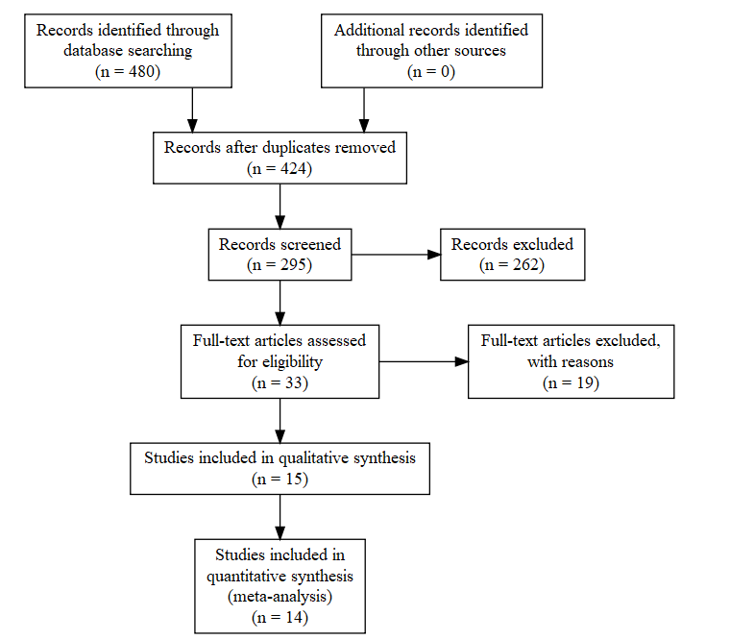

Figure 1: A PRISMA statement showing sample size of papers included in qualitative and quantitative datasets including search terms found in Table 2.

Table 2: The number of studies returned for each combination of search terms in Web of Science.

|  |  |  |  |
| --- | --- | --- | --- |
| Search | Terms | Hits | Refines |
| 1 | cact* and allocat* | 25 | topic, last five years |
| 2 | cact* and fruit* and size | 63 | topic, last five years |
| 3 | cact* and seed and fruit* | 110 | topic, last five years, articles |
| 4 | cact* and seed and size | 53 | topic, last five years |
| 5 | fruit* and seed and size and allocat* | 69 | topic, last five years |
| 6 | cact* and size and allocat* | 10 | topic, last five years |
| 7 | cact* and fruit and agricultur* | 18 | topic, last five years |
| 8 | cact* and flower* | 127 | topic, last five years |
| 9 | cact* and flower* and agricultur* | 5 | topic, last five years |
|  | total | 424 |  |

Preliminary Results:

This study has changed from its original construct which relied on reports of correlation coefficients between reproductive structures measured in the study. However, because only one study reported this value, a qualitative and a quantitative dataset were created. The former includes any measurement of a reproductive structure, and the latter compares reproductive structures under treatment against controls. These datasets will result in an editorial paper describing research gaps of *Cactaceae* reproductive studies and opportunities for agro-eco interdisciplinary work and a formal meta-analysis investigating allocation theory in *Cactaceae*

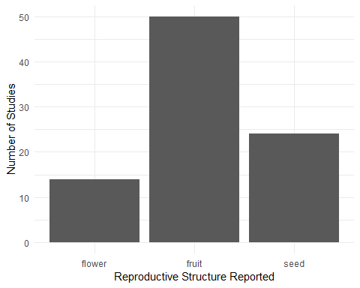Based on the data extracted now, fruit is the most frequently reported reproductive structure (Figure 2). While flowers are the most infrequently reported at this time, an inclusion of “flower*" in a new search will drastically increase this count.

Figure 2: The number of studies which report some metric of a reproductive structure (flower, fruit, or seed). Studies typically report on more than one reproductive structure.

Studies on cactus reproduction are more prevalent and report more values in the Western Hemisphere, where they are native excluding one species in Africa (Cota-Sanchez and Bomfim-Patricio 2010) (Figure 3A). Cacti are found globally, but all occurrences in the Eastern Hemisphere are either agricultural or introduced populations (Figure 3B). Field experiments are more likely to report more values per study than agriculture experiments (Figure 4A), and most reported values and studies occur in field experiments (Figure 4B).

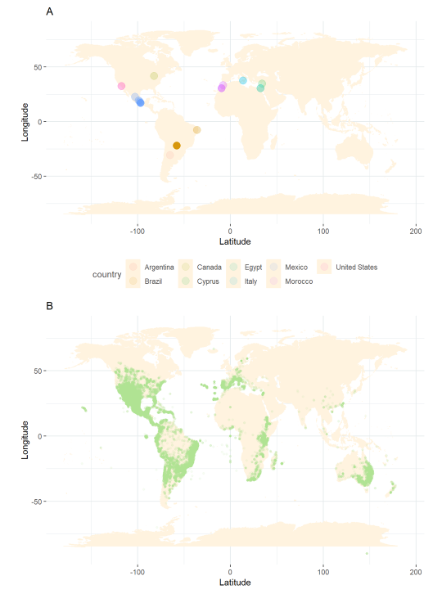

Figure 3: Compare the map of all reported values in *Cactaceae* allocation studies (Figure 3A) to the map of all occurrences of both native and nonnative *Cactaceae* individuals, globally (Figure 4A).

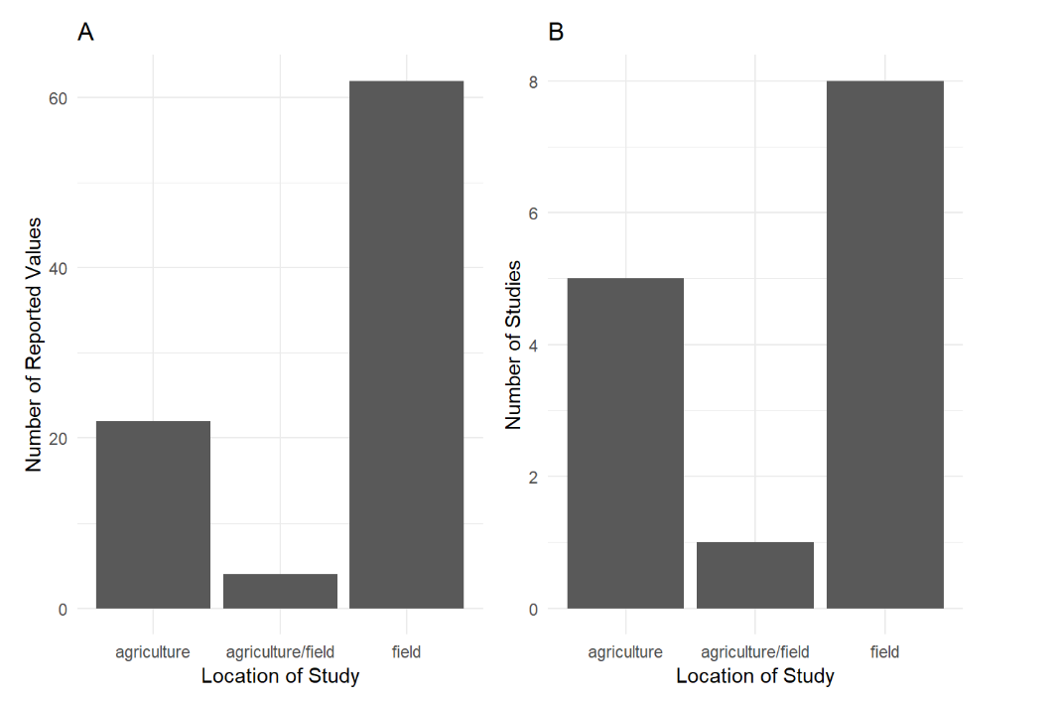

Figure 4: Data extracted from the systematic review describing frequency of the number of reported values for field versus agricultural experiments (Figure 4A), and the number of fields versus agricultural studies (Figure 4B).

Chapter 2

Linking Avian Double Mutualistic Interactions to *Cactaceae* Seed Dispersal and Facilitation

Progress to Date: Having completed the preliminary cactus size and health survey, we have decided to complete more hours of observation for one species of cactus, *Cylindropuntia acanthocarpa.* Instead of collecting audio recording in concurrence with focal observations, we will use omnidirectional microphones to record site-wide bird calls. Additionally, we have added two protocols for Joy Sampling, which will provide us with site-wide bird metrics. We have refined our hypothesis and predictions and have procured all equipment and accommodations.

Purpose: The aim of this study is to determine the magnitude and frequency of double mutualistic interactions between birds and a foundational species of cactus based on morphological characteristics of cactus individuals.

Research Questions: Are different reproductive structures of cacti correlated with one another or with *Cylindropuntia acanthocarpa* estimated plant volumes? What avian communities are associated with *C. acanthocarpa*? How frequent are Avian-*C. acanthocarpa* double mutualistic interactions?

Hypothesis: *Cactaceae* individuals that compromise on allocation to reproductive and non-reproductive structures are double mutualistically facilitated by avian nectarivores and frugivores.

Predictions:

1. Flower and fruit production will be positively correlated, but cactus height/volume and reproductive output will be negatively correlated.
2. Bird visitation rates are dependent on cactus morphological characteristics, with intermediately sized cacti with intermediate reproductive output (intermediate being defined as 1 standard deviation from the mean) drawing the most avian nectarivores and frugivores.
3. *Cylindropuntia acanthocarpa* bird visitation is greater than open-mesohabitat visitation and site-wide visitation.

Methods:

Pilot Cactus Survey

Prior to the flowering and fruiting experiments, we did a pilot survey using transect sampling of *Cylindropuntia acanthocarpa*, *Cylindropuntia echinocarpa*, and a haphazard sampling of *Opuntia basilaris* to determine an appropriate study species. We measured the major, minor, and vertical axis of the nearest neighbor cactus every five meters, with distance between transects being five (*C. acanthocarpa*) or ten (*C. echinocarpa*) meters. Because *C. acanthocarpa* was so dense, we were able to sample 105 individuals (n=105) over 5 transects. However, *C. echinocarpa* was less dense and therefore required 9 transects to be sampled (n=98). *O. basilaris* was so infrequent that a haphazard search for any individuals was the most effective way to measure the cacti (n=26). We also rated the health of each individual considering the overall percentage of plant death, rot, and scarification. Using these data, we confirmed that *C. acanthocarpa* is the most appropriate study species for experiments that need large plant size variation.

Experimental Manipulations

In April/May 2019 flowering season, a second survey to observe pollinating bird interactions with 105 cactus individuals (7 replications per characteristic combination). The cacti will have different levels of manipulated “floral showiness” (0%, 25%, 50%, 75%, 100% percent of flowers) of the 3 size classes. We will remove each percent level of blooming flowers and record the total buds (pre-blooming and blooming) because not all flowers of a cactus bloom concurrently. While the flowering season for our study cactus is in May, the cactus individual itself only blooms for 1-2 days throughout the season.

We will primarily rely on focal observations aided by a 150-600mm lens equipped to a digital camera. We will do 1-hour observations throughout the day at each combination of variables 7 times (105 hours of observations). To avoid impacting bird visitation, we will be at least 10m from the cactus individual and remain still. We will record each bird individual’s species and behavior (using an ethogram). Should there be more than one individual present, we will record the visiting species, but continue behavior observation for the first arrival birds (for up to 10 minutes, although this time limit is unlikely to be surpassed considering bird movement). Once the focal bird has left the cactus of interest, we will record the mesohabitat it arrived at after leaving the cactus of interest.

We will also leave out omnidirectional microphones to record bird calls which will give us an estimate of bird diversity at the site level. Sound recorders have been shown to be as reliable a measurement of bird presence compared to walking point transects and are more time and cost effective (Darras et al. 2018). To identify bird calls, we will classify the calls by ear, and then use an audio software program, like Sound Analysis Pro 2011 to identify the many hours of audio data (L. A. Grieves, Logue, and Quinn 2014; Leanne A. Grieves, Logue, and Quinn 2015).

In August, the fruiting observation and experiment will be done, and it parallels the flowering experiment. Each combination of variables (species, size, and fruit percent) will again have 7 replicates, meaning 105 cacti will be a part of the study. We will also remove 0%, 25%, 50%, 75%, and 100% of fruits from small, medium, and large cacti. We will immediately place each cactus’s fruit in a sealed zip lock bag to prevent desiccation while in the field. Post collection, we will weigh fresh and dried fruits, and sieve the seeds for weighing and counting. For the fruiting season, all focal observation protocols will be identical to the flowering season’s but replacing flowers for fruit.

Joy Sampling

In addition to our manipulated experiments, we will also perform “joy sampling” protocols, that do not manipulate cacti and are purely for the joy of bird observations but nonetheless collect quantitative data. First, we will perform 50 hours of area searches (2 hours per session) recording any and all bird locations, behaviors, and mesohabitats (shrub, cactus, open, etc.). Similarly, we will perform 50 hours of point counts at individual cacti. This protocol is easily replicable at other sites with different collaborators and has been proposed to Wind Wolves Preserve, where large and variable populations of *Opuntia basilaris* var. *treleasei* (the endangered Bakersfield cactus) exist.

Paired Observations

Because the manipulated flowering and fruiting cacti will not be paired, we will also perform a paired observational study. To link flowering number to fruiting number, we will find 20 cactus individuals in flowering season, and count the number of flowers/buds, determine the branching pattern, and measure their volume (x, y, z axis). We will also measure the sucrose content of the nectar for each plant using a hand refractometer, as sucrose is the nutritional source in nectar for hummingbirds (Martinez Del Rio 1990). These cacti will be geographically logged and revisited in the fruiting season. In August, we will similarly collect and count fruit set and record fruit metrics (weight, size, seed abundance, seed set). These data will allow us to compare reproductive output at different phenological stages in paired individual.

Preliminary Results:

Abundance, size, and health are three factors under consideration when choosing a study species. *C. acanthocarpa* was dominant, *C. echinocarpa* was second most common, and *O. basilaris* was infrequent (Figure 5). Based on our proposed methods, a total of 210 distinct individuals will be manipulated for observation, as well as an additional 100 for point count observations, and 20 for flower-fruit paired observations (n=360), so an abundant species is necessary.

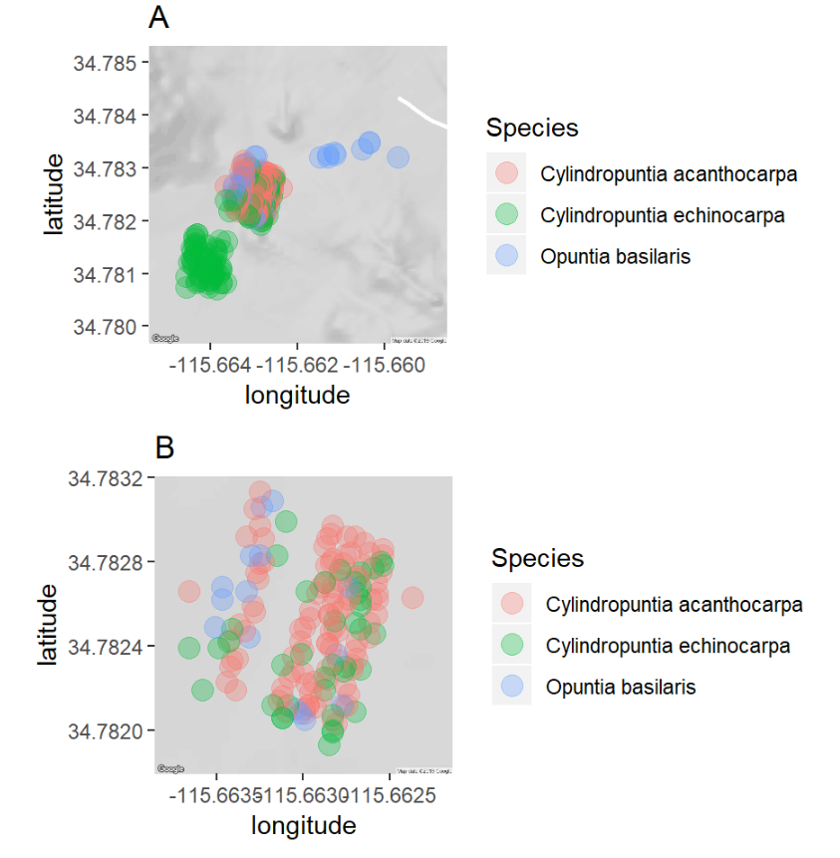

Figure 5: All cacti measured in the pilot survey study (Figure 5A). A zoomed in map on the area where *C. acanthocarpa* was measured (Figure 5B). Note the wide dispersal of *C. echinocarpa* and *O. basilaris,* as enough individuals could not be measured in the same space as *C. acanthocarpa.*

In addition to abundance, sufficient variation in cacti size is critical for analyses both in terms of simple blocking or strata, i.e. small, medium, and large and continuous analyses post hoc. While we do have a total volume available, height of cacti is a better metric to consider if nectarivorous and frugivorous birds will engage with a cactus because they prefer to engage with higher inflorescence and fruits (Wolf and Hainsworth 1990; Mitchell 1994). Sampled *O. basilaris* individuals’ sizes were normally distributed (*Shapiro Wilks*, p = 0.008519, W = 0.88797), but *C. acanthocarpa* (*Shapiro Wilks*, p = 0.06667, W = 0.97717) and *C. echinocarpa* (*Shapiro Wilks*, p = 0.349, W = 0.98532) were not. A Kruskal-Wallis rank sum test revealed that each cactus had non-identical means (*Kruskal-Wallis*, Chi-square = 3.71, p > 0.0001, df = 52), with a mean height in meters of 1.04 meters for *C. acanthocarpa*, 0.55 meters for *C. echinocarpa*, and 0.17 meters for *O. basilaris* (Figure 6). Additionally, the selected study species must have enough variety in heights so as to be binned into three size class (small, medium, large). Based on the distributions of sizes of each cactus, an equal-sized binned class system is most appropriate. *C. acanthocarpa* has the largest bin classes, which is a benefit in that having large size classes translates to a clearer distinction among flower/fruit height for birds.

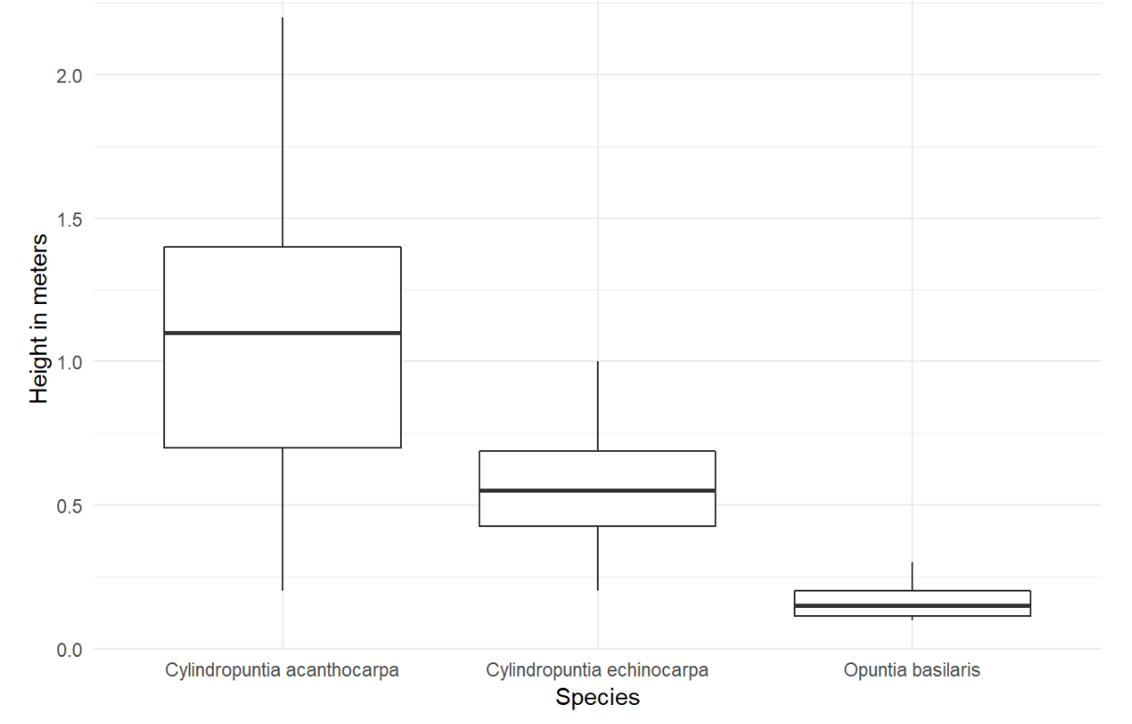

Figure 6: Boxplots of mean heights for *C. acanthocarpa* (n=105), *C. echinocarpa* (n = 98), and *O. basilaris* (n = 26).

Table 3: Small, medium, and large classes for each study species candidate separated by equal binning.

|  |  |  |  |
| --- | --- | --- | --- |
| Species | Small | Medium | Large |
| *Cylindropuntia acanthocarpa* | <85cm | 86cm - 152cm | >153cm |
| *Cylindropuntia echinocarpa* | <45cm | 46cm - 72cm | >73cm |
| *Opuntia basilaris* | <15cm | 16cm - 22cm | >23cm |

Health can determine an individual’s likelihood to flower and fruit, which are important variables for pollination/seed dispersal studies. *C. acanthocarpa* and *C. echinocarpa* are left skewed, with most individuals having health ratings of “4” or “5”, whereas *O. basilaris* has an even distribution of health classes among all individuals (Pearson’s Chi-squared Test, X-squared = 27.325, df = 8, p > 0.001) (Figure 7).

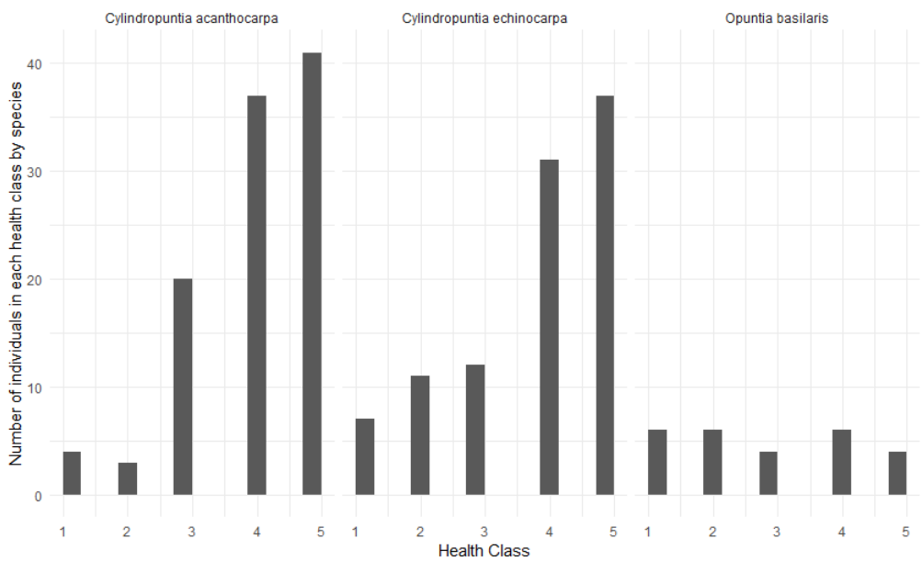

Figure 7: Distribution of health index scores among three different species of cacti, with 1 being the least healthy and 5 being the healthiest. An individual with 0-20% branch scarification, rot, or death was considered a 5, with equal branch scarification, rot, or death percentage bins per score.

Considering the abundance, the density, the health, and size class options, *O. basilaris* did not meet requirements for any of the criteria, and *C. echinocarpa* is not variable in size or abundant enough. Therefore, *O. basilaris* and *C. echinocarpa* are not realistic contenders as a study species for a pollination/seed dispersal study. We propose that focusing more deeply on *C. acanthocarpa* and deepening the methods of observation will be more beneficial to answering our study questions than a comparative study between cacti species would be.

Literature Cited

Almeida, Adriana de, and Sandra Bos Mikich. 2018. “Combining plant–frugivore networks for describing the structure of neotropical communities.” *Oikos* 127 (2): 184–97. doi:[10.1111/oik.04774](https://doi.org/10.1111/oik.04774).

Angelini, Christine, Andrew H. Altieri, Brian R. Silliman, and Mark D. Bertness. 2011. “Interactions among Foundation Species and Their Consequences for Community Organization, Biodiversity, and Conservation.” *BioScience* 61 (10): 782–89. doi:[10.1525/bio.2011.61.10.8](https://doi.org/10.1525/bio.2011.61.10.8).

Barker, Jessica L., Judith L. Bronstein, Maren L. Friesen, Emily I. Jones, H. Kern Reeve, Andrew G. Zink, and Megan E. Frederickson. 2017. “Synthesizing perspectives on the evolution of cooperation within and between species.” *Evolution* 71 (4): 814–25. doi:[10.1111/evo.13174](https://doi.org/10.1111/evo.13174).

Bertness, Mark D. M.D., and Ragan Callaway. 1994. “Positive interactions in communities.” *Tree* 9 (5): 191–93. doi:[10.1016/0169-5347(94)90088-4](https://doi.org/10.1016/0169-5347(94)90088-4).

Bronstein, Judith L. 2001. “The Costs of Mutualism.” *American Zoology* 41: 825–39.

———. 2009. “The evolution of facilitation and mutualism.” *Journal of Ecology* 97 (6): 1160–70. doi:[10.1111/j.1365-2745.2009.01566.x](https://doi.org/10.1111/j.1365-2745.2009.01566.x).

Callaway, Ragan M. 1997. “Positive interactions in plant communities and the individualistic-continuum concept.” *Oecologia* 112: 143–49.

Charnov, Eric. 1976. “Optimal foraging: The marginal value theorem.” *Theoretical Population Biology* 9 (2): 129–36.

CITES. 2017. “The Conventional on International Trade in Endangered Species of Wild Fauna and Flora.”

Cota-Sanchez, J. Hugo, and Marcia Bomfim-Patricio. 2010. “Seed morphology, polyploidy and the evolutionary history of the epiphytic cactus.” *Polibotanica* 29: 107–29.

Darras, Kevin, Péter Batáry, Brett Furnas, Antonio Celis-Murillo, Steven L. Van Wilgenburg, Yeni A. Mulyani, and Teja Tscharntke. 2018. “Comparing the sampling performance of sound recorders versus point counts in bird surveys: A meta-analysis.” *Journal of Applied Ecology*, no. June: 2575–86. doi:[10.1111/1365-2664.13229](https://doi.org/10.1111/1365-2664.13229).

Drezner, Taly D., and Colleen M. Garrity. 2003. “Saguaro distribution under nurse plants in Arizona’s Sonoran Desert: Directional and microclimate influences.” *Professional Geographer* 55 (4): 505–12. doi:[10.1111/0033-0124.5504008](https://doi.org/10.1111/0033-0124.5504008).

Drezner, Taly Dawn. 2010. “Nurse tree canopy shape, the subcanopy distribution of cacti, and facilitation in the Sonoran Desert.” *The Journal of the Torrey Botanical Society* 137 (2–3): 277–86. doi:[10.3159/09-RA-069R1.1](https://doi.org/10.3159/09-RA-069R1.1).

Filazzola, Alessandro, Michael Westphal, Michael Powers, Amanda Rae Liczner, Deborah A. Smith Woollett, Brent Johnson, and Christopher J. Lortie. 2017. “Non-trophic interactions in deserts: Facilitation, interference, and an endangered lizard species.” *Basic and Applied Ecology* 20. Elsevier GmbH: 51–61. doi:[10.1016/j.baae.2017.01.002](https://doi.org/10.1016/j.baae.2017.01.002).

Flores-Torres, Arnoldo, and Andrea Galindo-Escamilla. 2017. “Pollination biology of *Agave horrida* (Agavaceae) in the Chichinautzin mountain range, in Central Mexico".” *Botanical Sciences* 95 (3): 423–31. doi:[10.17129/botsci.1022](https://doi.org/10.17129/botsci.1022).

Franco, Author A C, and P S Nobel. 2009. “Effect of Nurse Plants on the Microhabitat and Growth of Cacti Published by: British Ecological Society Stable URL: http://www.jstor.org/stable/2260991” 77 (3): 870–86.

Garcia, Maria B., Xavier Espadaler, and Jens M. Olesen. 2012. “Extreme Reproduction and Survival of a True Cliffhanger: The Endangered Plant *Borderea chouardii.”* *PLOS One* 7 (9): 1–7. doi:[10.1371/journal.pone.0044657](https://doi.org/10.1371/journal.pone.0044657).

Gelmi-Candusso, Tiziana A., Eckhard W. Heymann, and Katrin Heer. 2017. “Effects of zoochory on the spatial genetic structure of plant populations.” *Molecular Ecology* 26 (21): 5896–5910. doi:[10.1111/mec.14351](https://doi.org/10.1111/mec.14351).

Gomes, VGN, ZGM Quirino, and HFP Araujo. 2014. “Frugivory and seed dispersal by birds in *Cereus jamacaru* DC. ssp. *jamacaru* (Cactaceae) in the Caatinga of Northeastern Brazil.” *Brazilian Journal of Biology* 74 (1): 32–40. doi:[10.1590/1519-6984.15312](https://doi.org/10.1590/1519-6984.15312).

Gomez-Aparicio, Lorena, Regino Zamora, Jorge Castro, and Jose A. Hódar. 2008. “Facilitation of tree saplings by nurse plants: Microhabitat amelioration or protection against herbivores?” *Journal of Vegetation Science* 19 (2): 161–72. doi:[10.3170/2008-8-18347](https://doi.org/10.3170/2008-8-18347).

Gorostiague, P., and P. Ortega-Baes. 2016. “How specialized is bird pollination in the Cactaceae?” *Plant Biology* 18 (1): 63–72. doi:[10.1111/plb.12297](https://doi.org/10.1111/plb.12297).

Grieves, L. A., D. M. Logue, and J. S. Quinn. 2014. “Joint-nesting smooth-billed anis, Crotophaga ani, use a functionally referential alarm call system.” *Animal Behaviour* 89. Elsevier Ltd: 215–21. doi:[10.1016/j.anbehav.2014.01.008](https://doi.org/10.1016/j.anbehav.2014.01.008).

Grieves, Leanne A., David M. Logue, and James S. Quinn. 2015. “Vocal repertoire of cooperatively breeding Smooth-billed Anis.” *Journal of Field Ornithology* 86 (2): 130–43. doi:[10.1111/jofo.12096](https://doi.org/10.1111/jofo.12096).

Gutzwiller, Kevin J., and Wylie C. Barrow. 2003. “Influences of roads and development on bird communities in protected Chihuahuan Desert landscapes.” *Biological Conservation* 113 (2): 225–37. doi:[10.1016/S0006-3207(02)00361-0](https://doi.org/10.1016/S0006-3207(02)00361-0).

Hernandez, R. R., S. B. Easter, M. L. Murphy-Mariscal, F. T. Maestre, M. Tavassoli, E. B. Allen, C. W. Barrows, et al. 2014. “Environmental impacts of utility-scale solar energy.” *Renewable and Sustainable Energy Reviews* 29. Elsevier: 766–79. doi:[10.1016/j.rser.2013.08.041](https://doi.org/10.1016/j.rser.2013.08.041).

Kelly, Dave, Jenny J Ladley, Alastair W Robertson, and Jenny J Ladley. 2004. “Is dispersal easier than pollination? Two tests in New Zealand Loranthaceae.” *New Zealand Journal of Botany* 42: 89–103. doi:[10.1080/0028825X.2004.9512892](https://doi.org/10.1080/0028825X.2004.9512892).

Ladley, Jenny J, and Dave Kelly. 1996. “DISPERSAL, GERMINATION AND SURVIVAL OF NEW ZEALAND MISTLETOES (LORANTHACEAE): DEPENDENCE.” *New Zealand Journal of Ecology* 20 (1): 69–79.

Maestre, Fernando T., Ragan M. Callaway, Fernando Valladares, and Christopher J. Lortie. 2009. “Refining the stress-gradient hypothesis for competition and facilitation in plant communities.” *Journal of Ecology* 97 (2): 199–205. doi:[10.1111/j.1365-2745.2008.01476.x](https://doi.org/10.1111/j.1365-2745.2008.01476.x).

Martinez Del Rio, Carlos. 1990. “Sugar Preferences in Hummingbirds: The Influence of Subtle Chemical Differences on Food Choice.” *The Condor* 92 (4): 1022–30.

Miranda-Jacome, Antonio, Carlos Montaña, and Juan Fornoni. 2013. “Sun/shade conditions affect recruitment and local adaptation of a columnar cactus in dry forests.” *Annals of Botany* 111 (2): 293–303. doi:[10.1093/aob/mcs255](https://doi.org/10.1093/aob/mcs255).

Mitchell, Randall J. 1994. “Effects of Floral Traits, Pollinator Visitation, and Plant Size on *Ipomopsis aggregata* Fruit Production.” *American Society of Naturalists* 143 (5): 870–89.

Mitchell, Randall J, Rebecca J Flanagan, Beverly J Brown, Nickolas M Waser, and Jeffrey D Karron. 2009. “New frontiers in competition for pollination,” 1403–13. doi:[10.1093/aob/mcp062](https://doi.org/10.1093/aob/mcp062).

Montiel, Salvador, and Carlos Montaña. 2000. “Vertebrate Frugivory and Seed Dispersal of a Chihuahuan Desert Cactus” 146 (2): 221–29.

Nathan, R., and H. C. Muller-landau. 2000. “Spatial patterns of seed dispersal, their determinants and consequences for recruitment.” *Trends in Ecology & Evolution* 15 (7): 278–85. doi:[10.1016/S0169-5347(00)01874-7](https://doi.org/10.1016/S0169-5347(00)01874-7).

Nielsen, Uffe N., and Becky A. Ball. 2015. “Impacts of altered precipitation regimes on soil communities and biogeochemistry in arid and semi-arid ecosystems.” *Global Change Biology* 21 (4): 1407–21. doi:[10.1111/gcb.12789](https://doi.org/10.1111/gcb.12789).

Nobel, Park S. 1980. “Morphology, Nurse Plants, and Minimum Apical Temperatures for Young Carnegiea gigantea.” Published by: The University of Chicago Press Stable URL: http://www.jstor.org/stable/2474851 Accessed: 16-05-2016 19: 34 UTC Your us.” *Botanical Gazette* 141 (2): 188–91.

Obeso, José Ramón. 2004. “A hierarchical perspective in allocation to reproduction from whole plant to fruit and seed level.” *Perspectives in Plant Ecology, Evolution and Systematics* 6 (4): 217–25. doi:[10.1078/1433-8319-00080](https://doi.org/10.1078/1433-8319-00080).

Parker, Kathleen C. 1989. “Nurse plant relationships of columnar cacti in Arizona.” *Physical Geography* 10 (4): 322–35. doi:[10.1080/02723646.1989.10642386](https://doi.org/10.1080/02723646.1989.10642386).

Pfahl, S., P. A. O’Gorman, and E. M. Fischer. 2017. “Understanding the regional pattern of projected future changes in extreme precipitation.” *Nature Climate Change* 7 (6): 423–27. doi:[10.1038/nclimate3287](https://doi.org/10.1038/nclimate3287).

Rodriguez-Estrella, Ricardo. 2007. “Land use changes affect distributional patterns of desert birds in the Baja California peninsula, Mexico.” *Diversity and Distributions* 13 (6): 877–89. doi:[10.1111/j.1472-4642.2007.00387.x](https://doi.org/10.1111/j.1472-4642.2007.00387.x).

Singh, Deepti, Michael Tsiang, Bala Rajaratnam, and Noah S. Diffenbaugh. 2013. “Precipitation extremes over the continental United States in a transient, high-resolution, ensemble climate model experiment.” *Journal of Geophysical Research Atmospheres* 118 (13): 7063–86. doi:[10.1002/jgrd.50543](https://doi.org/10.1002/jgrd.50543).

Smith, Melinda D. 2011. “The ecological role of climate extremes: Current understanding and future prospects.” *Journal of Ecology* 99 (3): 651–55. doi:[10.1111/j.1365-2745.2011.01833.x](https://doi.org/10.1111/j.1365-2745.2011.01833.x).

Tewksbury, Joshua J., and John D. Lloyd. 2001. “Positive interactions under nurse-plants: Spatial scale, stress gradients and benefactor size.” *Oecologia* 127 (3): 425–34. doi:[10.1007/s004420000614](https://doi.org/10.1007/s004420000614).

Traveset, A, N Riera, and R E Mas. 2001. “Passage through bird guts causes interspecific differences in.PDF,” 669–75.

Traveset, A., and M. Verdú. 2002. “A meta-analysis of the effect of gut treatment on seed germination.” *Seed Dispersal and Frugivory: Ecology, Evolution and Conservation. Third International Symposium-Workshop on Frugivores and Seed Dispersal, São Pedro, Brazil, 6-11 August 2000*, 339–50. doi:[10.1079/9780851995250.0339](https://doi.org/10.1079/9780851995250.0339).

Turner, Raymond M., Stanley M. Alcorn, George Olin, and John A. Booth. 1966. “The Influence of Shade, Soil, and Water on Saguaro Seedling Establishment.” *Botanical Gazette* 127 (2-3): 95–102.

Verdu, Miguel, and Anna Traveset. 2004. “Bridging meta-analysis and the comparative method: A test of seed size effect on germination after frugivores’ gut passage.” *Oecologia* 138 (3): 414–18. doi:[10.1007/s00442-003-1448-4](https://doi.org/10.1007/s00442-003-1448-4).

Viechtbauer, W. 2010. “Conducting meta-analyses in R with the metafor package. Journal of Statistical Software.” 36(3), 1-48. URL: <http://www.jstatsoft.org/v36/i03/>

Willson, M. F. 1993. “Dispersal mode, seed shadows, and colonization patterns.” *Vegetation* 107-108 (1): 261–80. doi:[10.1007/BF00052229](https://doi.org/10.1007/BF00052229).

Wolf, L. L. and F R Hainsworth. 1990. “Non-Random Foraging by Hummingbirds : Patterns of Movement Between Ipomopsis.” *Functional Ecology* 4 (2): 149–57.