**Development Task 3**

**In this task as a group, we implemented both relational and non-relational databases**

**Relational Database (MySQL):**

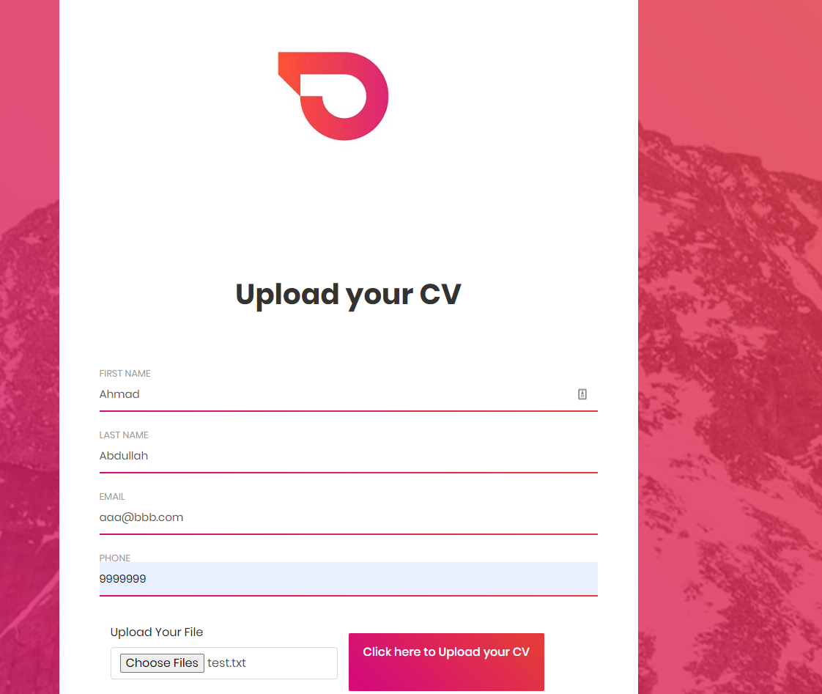



**This is our database called test and it has a table called cv_upload**

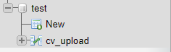

**Inside our table, we have 6 columns to store the client information**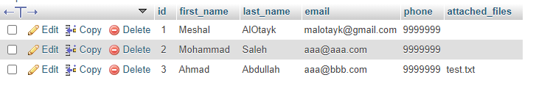

**Non-Relational Database (MongoDB):**

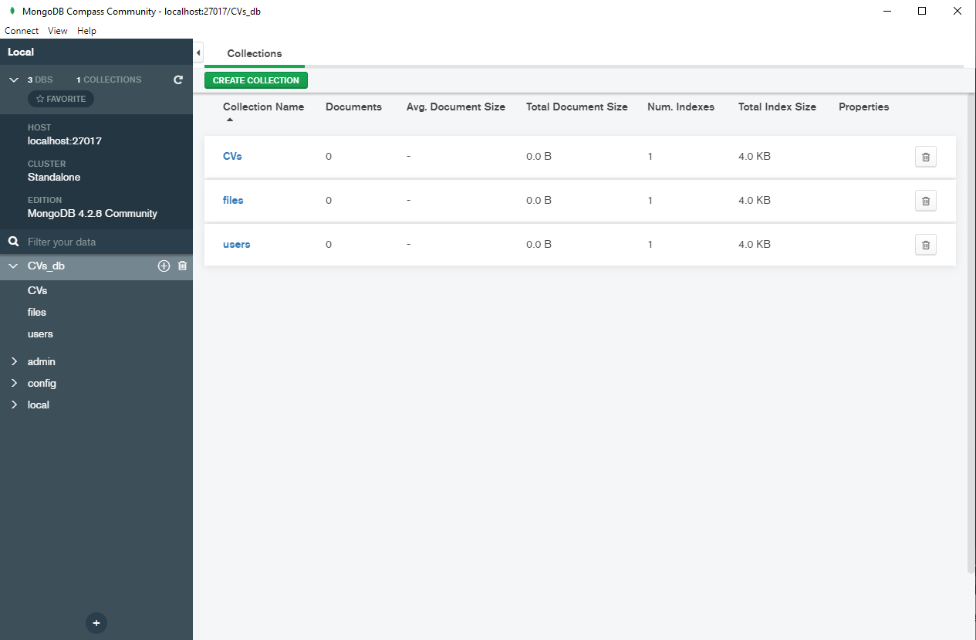**Inside our CVs_db we have 3 collections CVs, files and users**

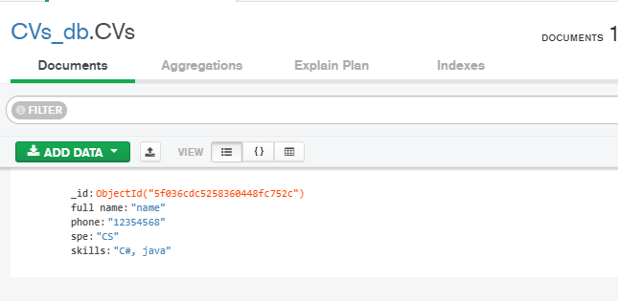**Inside our CVs collection**

**Inside our users collection**

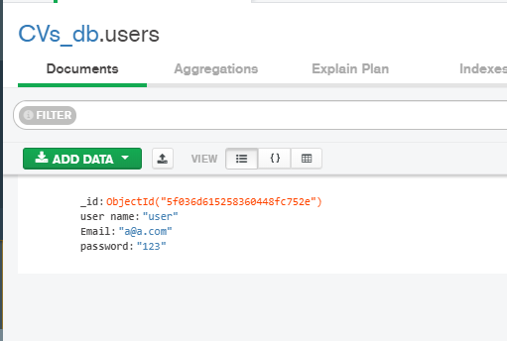

Group Leader: Meshal Al Otayk

Group Member: Abdullah Alotaibi

Group Member: Ahmed Amin

Group Member: Amin Alahmad

Group Member: Azzam Aldulaylan

Group Member: Yazzed Alammar