

SIMATS ENGINEERING
Saveetha Institute of Medical and Technical Sciences Chennai- 602105
Student Name: P.Mal Reddy Reg. No.: 192372015
Course Code: EEA01117 Slot: A
Course Name: Basic Electrical and Electronics for Home Instrumentation Course Faculty: Dr. Valantine Stephen & Dr. R. Sivakumar
Project Title: Intelligent Emergency Vehicle Priority System for Driveway Traffic Control
Module Photographs: (3 photographs –Module Photo, Individual student contribution module work in the project and presentation image)
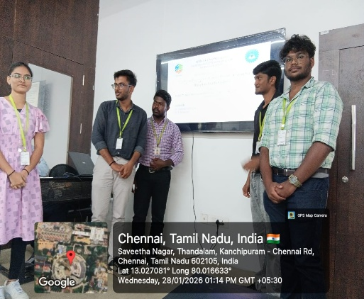
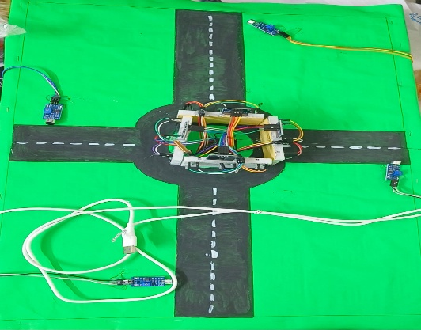
Project Description: (here you write what you did in this project (contribution) including Model Description
In this project, I designed and implemented an intelligent traffic assistance system to support emergency vehicles at road junctions. The system focuses on detecting an approaching ambulance using sound sensing technology and alerting traffic participants in real time.
My contribution involved integrating sound sensors capable of identifying the distinct siren sound of an ambulance. When the siren sound crosses a predefined threshold, the system processes the signal and immediately triggers a warning mechanism. Upon detection, a message “Emergency Vehicle Detected” is displayed simultaneously on all four digital displays placed at a four-way junction.
This real-time alert helps inform drivers in advance, allowing them to clear the path and reduce delays for emergency vehicles. The project demonstrates practical use of embedded systems, sensor-based detection, and real-time signal processing to improve traffic safety and emergency response efficiency.

Student Signature Guide Signature

