simulating room ducts using Cell-devs co2 with occupants model

Term Project
SYSC 5104 - Methodologies for Discrete Event Modeling and Simulations
Fall 2020

Source Code:
Term Project:
https://github.com/malsaeedi/Cell-DEVS_CO2_with_Room_Ducts_Model

2D Drawing to Cell-DEVS CO2 Model (sub-module in Term Project clone):
https://github.com/malsaeedi/2D_Drawing_to_CO2_CELL_DEVS_Model

Demo:
https://www.youtube.com/watch?v=iOB9FCErZJ8

Mohammed Al-Saeedi
101109046
Carleton University

simulating room ducts using Cell-devs co2 with occupants model

Mohammed Alsaeedi | Gabriel Wainer
Department of Systems and Computer Engineering | Department of Systems and Computer Engineering
Carleton University | Carleton University
1125 Colonel By Drive | 1125 Colonel By Drive
Ottawa, ON. K1S-5B6 Canada | Ottawa, ON. K1S-5B6 Canada
mohammedalsaeedi@cmail.carleton.ca | gwainer@sce.carleton.ca

ABSTRACT
Cell-DEVS (Wainer and Giambiasi 2001) is a formalism that enables the simulation of cellular automata models asynchronously with different timing delays. The indoor CO2 diffusion by breathing occupants has been studied using Cell-DEVS formalism (Khalil et al. 2020), (Khalil and Wainer 2020). The model takes into consideration room dimensions, ventilation, doors, windows, and occupants as a source of producing CO2. Developing new Cell-DEVS CO2 scenarios with a new type of cells is needed and can take some amount of manual work. In this paper, we developed a new implementation to draw a two-dimensional floor plan, add any new type of cell, and create a 2D or 3D model quickly. Furthermore, we added ducts between rooms and show the indoor concentration and diffusion of CO2 with the presence of these ducts. The results show that implementing ducts between rooms and with the presence of vents can efficiently reduce the concentration of CO2 inside rooms.

INTRODUCTION
The need to use modeling and simulation techniques lies in the difficulty of experimenting with complex artificial systems or very dangerous experiments. One of the most important of these techniques is Cell-DEVS (Wainer and Giambiasi 2001) which is a formalism that enables building very complex cellular automata models asynchronously with different timing delays. The indoor CO2 diffusion by breathing occupants is one of these experiments that has been studied using Cell-DEVS formalism (Khalil et al. 2020), (Khalil and Wainer 2020). The model takes into consideration room dimensions, ventilation, doors, windows, and occupants as a source of producing CO2.
Sensors are used in closed spaces for occupancy detection and controlling the HVAC systems to reduce energy consumption while reducing the amount of CO2 inside. However, these sensors are limited since it does not give a precise estimate of the number of people occupying the space because they are highly sensitive to the configuration parameters. As such, this model (Khalil et al. 2020) is simulating the different configurations and sensors placed in a close space (Computer Lab as a use case) while the arrival/departure of occupants and shows the increase/decrease in the CO2 levels. The model uses the Cell-DEVS formalism (Wainer and Giambiasi 2001) to study the relationship between configuration parameters (e.g. room dimensions, window locations, and occupant’s mobility) and the ability of CO 2 sensors to detect occupants and how this relationship can be used to determine the best placement of CO 2 sensors.
In this research work, we developed a new implementation to quickly build 2D or 3D scenarios for the Cell-DEVS CO2 model. Furthermore, we created some scenarios modeling ducts between rooms and measured the indoor concentration and diffusion of CO2 using the Cell-DEVS CO2 model (Khalil et al. 2020). Finally, we discuss the results and advantages of adding these indoor ducts between rooms.

Background
DEVS (Wainer 2009) is a mathematical formalism for modeling and simulating discrete event systems. It can represent a system as a hierarchy structure of coupled and atomic components. An atomic model can communicate with other models using input/output ports. Each atomic component has an internal, external transaction to change its state and time advance functions. Cell-DEVS formalism (Wainer and Giambiasi 2001) is an extension to DEVS that allows the implementation of Cellular Automata (CA) with timing delay. Each atomic model in Cell-DEVS is represented by a cell that communicates with its N neighbor cells to compute its next state. The atomic model in Cell-DEVS is defined as < X, Y, S, N, delay, δ int , δ ext , t, λ, D > where X and Y are the input and output events set respectively. S is the states set, N is the neighbors’ input values, δ int and δ ext are the internal and external transition functions respectively, t is the local computing function and λ is the output function. The next state of a cell is calculated by the local computing function t. The delay associated with each cell can either be transport or intertial.
The authors in (Khalil et al. 2020) studied the relationship between the CO2 levels and the room configurations and how minor changes may result in significant changes in indoor CO2 levels. The model takes into consideration the configuration of ventilation, windows, doors, and occupants (CO2 sources). Ducts between rooms can also play a significant role in changing the indoor CO2 levels. Therefore, this research work simulates different indoor configuration of ducts between rooms and evaluates the rate of its effect on the concentration and diffusion of CO2.

2d to cell-devs co2 model Implementation
This implementation allows the development of different 2d or 3d scenarios for the Cell-DEVS CO2 models. Here, we will present the structure, configuration, and functionalities of this implementation.

Structure
The implementation uses pre-defined configurations to draw a 2D floor plan grid and convert it to a 2D or 3D Cell-DEVS CO2 model scenario as shown in Figure 1. The structure of the implementation consists of three main modules as demonstrated in Figure 2.
The DrawGrid module is responsible for drawing a 2D grid using the pre-defined simulation and cell configuration. It has some functionalities like creating a 2D and 3D Cell-DEVS CO2 models, preview the model in 3D view, and save the model for later use. The ConvertTool module creates the JSON structure of the output model while the GenerateTool module exports the output model.

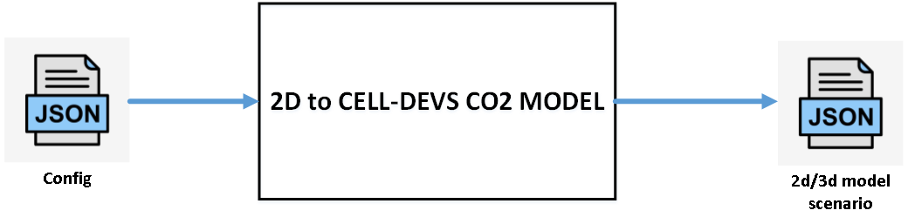
Figure 1: 2D Drawing to Cell-DEVS CO2 Model.

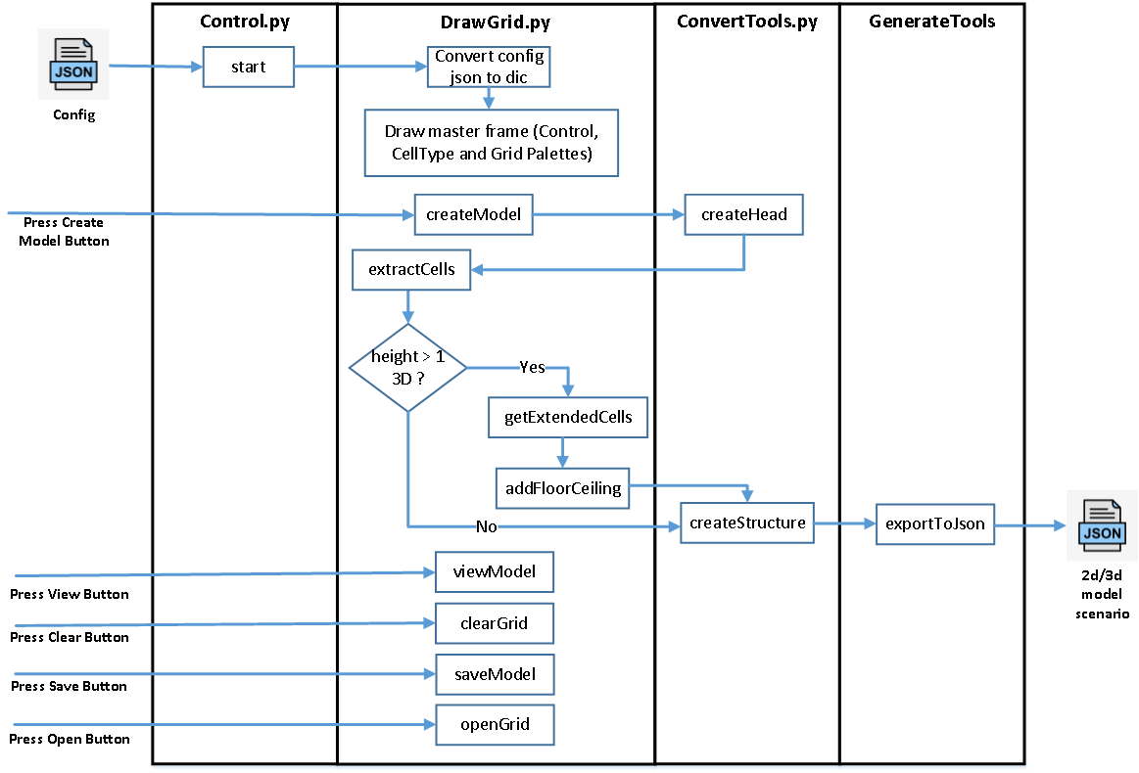
Figure 2: Implementation Structure.

Configuration
The simulation configuration defines the main Cell-DEVS CO2 model parameters such as the floor plan dimensions, the cell’s neighborhood type and the different type of cells. To add new type of cell, the following parameters need to be defined under colours key value in the configuration input file:
"<color_name>": {
"name" : "<cell_name>",
"parent_cell" : "<parent_cell>",
"alpha" : <transparency_alpha_value>,
"bottom" : <cell_bottom>,
"top" : <cell_top>,
"concentration" : <CO2_concentration>,
"type" : <cell_type>,
"counter" : <counter_to_be_CO2_source>},

In addition to the current default type of cells, we defined a new cell to simulate ducts between indoor rooms. The different types of cells available in the configuration file are listed in Table 1. Any cell is part of other cells which we call a parent cell. For instance, a window cell is located within walls, so its parent cell is the wall. The parent cell is used to extend the cell’s 3d structure beyond its bottom and top. The alpha value is used to define the transparency of the cell for visualization purposes. The size of a cell in the configuration corresponds to 25cm³ in the real world.

Table 1: Type of Cells in Cell-DEVS CO2 Model.
Color | name | Parent Cell Color | Alpha | Bottom | Top | CO2 Concentration | Type
white | air | white | 0 | 0 | 12 | 500 | -100
cyan | co2_source | white | 100 | 0 | 6 | 0 | -200
gray | wall | gray | 100 | 0 | 12 | 0 | -300
green | door | gray | 90 | 0 | 8 | 500 | -400
yellow | window | gray | 90 | 4 | 7 | 400 | -500
blue | vent | white | 100 | 10 | 11 | 300 | -600
red | workstation | white | 100 | 0 | 4 | 500 | -700
fuchsia | duct | gray | 90 | 8 | 10 | 500 | -800

2D and 3D Modeling
The construction of 2D or 3D Cell-DEVS CO2 model scenarios is simply defined by updating the dimensions in the configuration. A 3D model can be defined by setting the height value to greater than one. A value less than or equal to two will be considered as a 2D model. An example of the implementation 2D grid user interface of 25x30 is shown in Figure 3. The colors represent the type of cells in the configuration file.
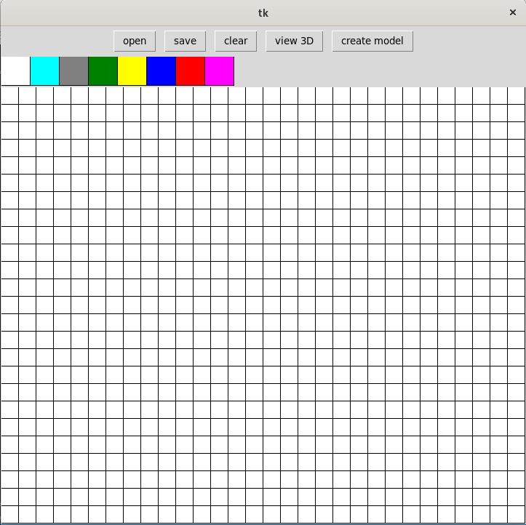
Figure 3: 2D Grid of 25x30 size.

Simulation and results
In this section, we simulate and discuss the results of simulating an indoor structure with the presence of a static number of occupants but different setup scenarios of ducts between rooms using the Cell-DEVS CO2 model (Khalil et al. 2020). Table 2 shows the static and variant parameters of the simulation setup. Table 3 shows the type of cells and configuration used in this simulation. The simulation time is 500 units of time. The idea is to change the number and location of ducts while keeping other parameters static and measure the diffusion and concentration of CO2 in every room. Six cells (room1 (5,5), room2 (15,5), room3 (21,5), room4 (5,25), room5 (15,25), room6 (21,25)) are selected to measure and compare the concentration of CO2 in every room with occupants.
The research hypothesis is to prove that the efficient distribution of ducts between rooms can effectively balance the level of CO2 indoor, which reduces the harmful effect on occupants resulted from exposure to high CO2 levels.

Table 2: Simulation Setup.
Parameter | Value | Variant | Location Change
Dimensions | 25x30x12 | No | No
Rooms | 7 | No | No
Occupants | 6 | No | Yes
Occupants movement | random | Yes | Yes
Ducts | 5 | Yes | Yes
Vents | 6 | No | No
Windows | 3 | No | No

Table 3: Type of Cells Configuration.
Color | name | Parent Cell Color | Alpha | Bottom | Top | CO2 Concentration | Type
white | air | white | 0 | 0 | 12 | 500 | -100
cyan | co2_source | white | 100 | 0 | 6 | 0 | -200
gray | wall | gray | 100 | 0 | 12 | 0 | -300
green | door | gray | 90 | 0 | 8 | 500 | -400
yellow | window | gray | 90 | 4 | 7 | 400 | -500
blue | vent | white | 100 | 10 | 11 | 300 | -600
red | workstation | white | 100 | 0 | 4 | 500 | -700
fuchsia | duct | gray | 90 | 8 | 10 | 500 | -800

Simulation Scenario 1
The initial simulation 2D and 3D setup are demonstrated in Figures 4 and 5. In this scenario, three rooms have ducts, while the other three rooms have no ducts. Each room has one occupant and one vent. The living room has no occupants and has two vents. The simulation runs for 500 units of time to show the continuous change in CO2 level inside these rooms.

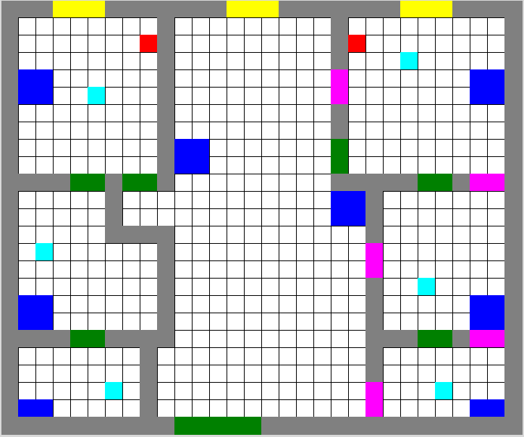
Figure 4: 2D Simulation Setup of Scenario 1.
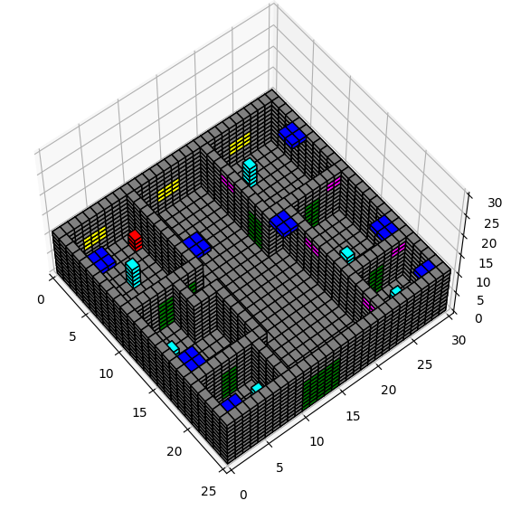
Figure 5: 3D Simulation Setup of Scenario 1.

The results in Figure 6 shows that the CO2 concentration in rooms with ducts is less than in those rooms without ducts. The presence of ducts between rooms assists the ventilation system in reducing the CO2 level inside these rooms. The results in Figure 7 and 8 show that cells in room 5 with ducts reaches a maximum CO2 concentration of nearly 600ppm while in room 2 without ducts reaches a maximum of nearly 1000ppm.

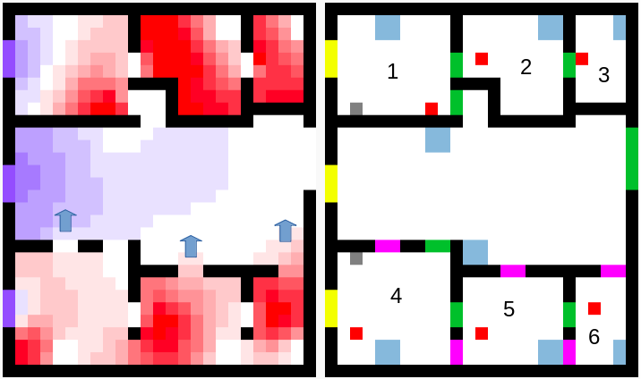
Figure 6: Scenario 1 Results (at 498 unit of time).
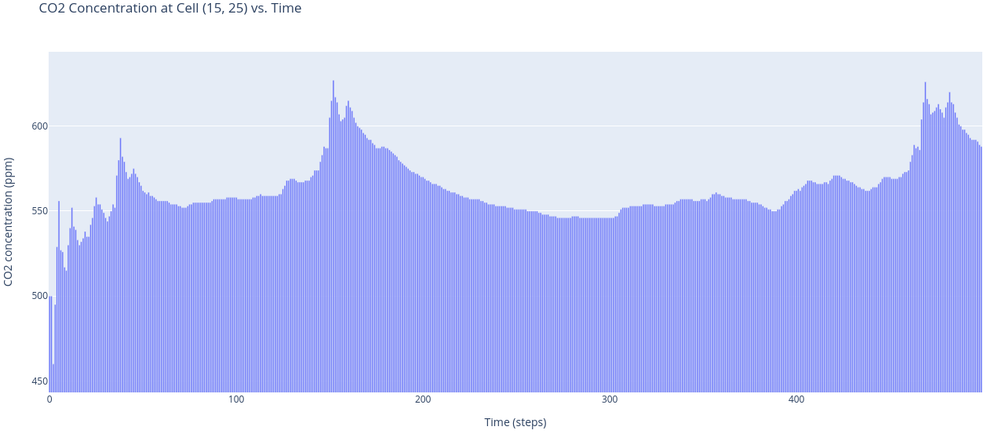
Figure 7: Scenario 1 Room5.
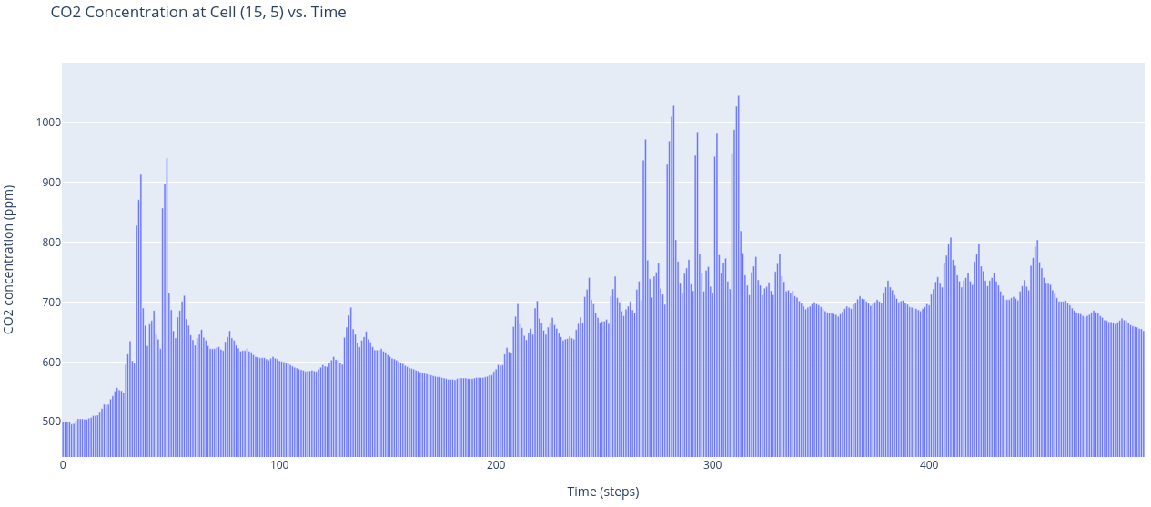
Figure 8: Scenario 1 Room2.

Simulation Scenario 2
The second simulation 2D and 3D setup are demonstrated in Figures 9 and 10. In this scenario, all six rooms have no ducts. Each room has one occupant and one vent. The living room has no occupants and has two vents. The simulation runs for 500 units of time to show the continuous change in CO2 level inside these rooms.
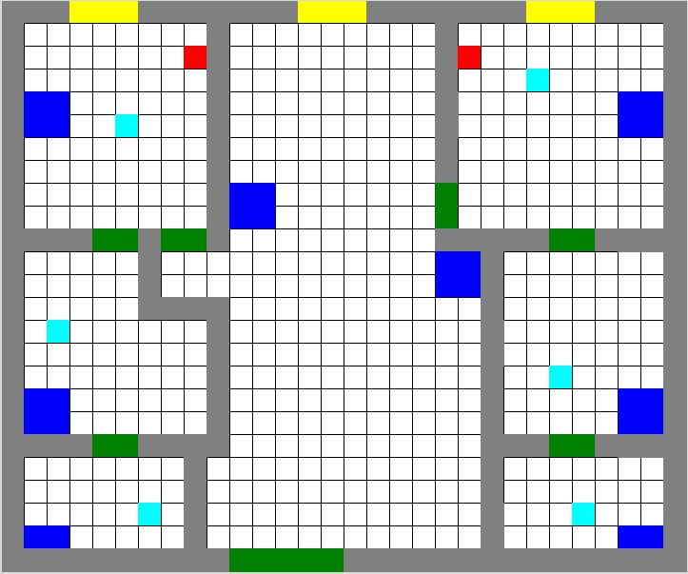
Figure 9: 2D Simulation Setup of Scenario 2.
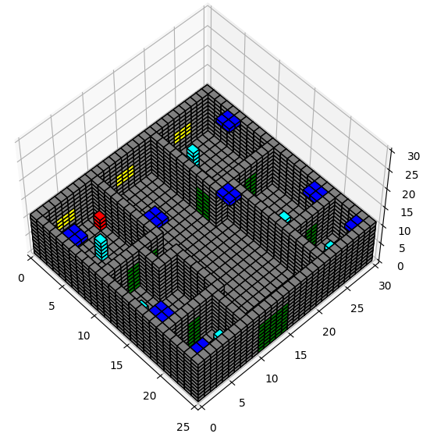
Figure 10: 3D Simulation Setup Scenario 2.

The results in Figure 11 show that the CO2 level gradually increases in all rooms with occupants. Although the ventilation system is the same as in scenario one, the CO2 level in this scenario is higher. The absence of ducts between rooms increases the concentration of CO2 and reduces the efficiency of the ventilation system due to the imbalance distribution of CO2 in the apartment. The results in Figures 12 and 13 show that cells in both rooms 5 and 2 can reach a maximum CO2 concentration of nearly 1000ppm.

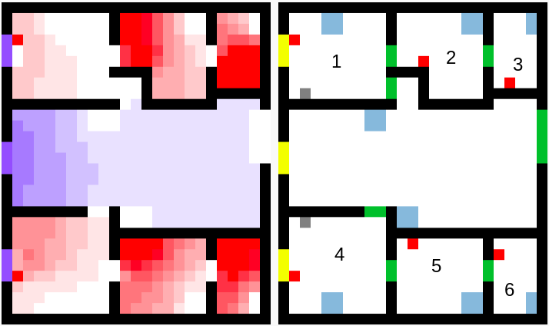
Figure 11: Scenario 2 Results (at 498 unit of time).
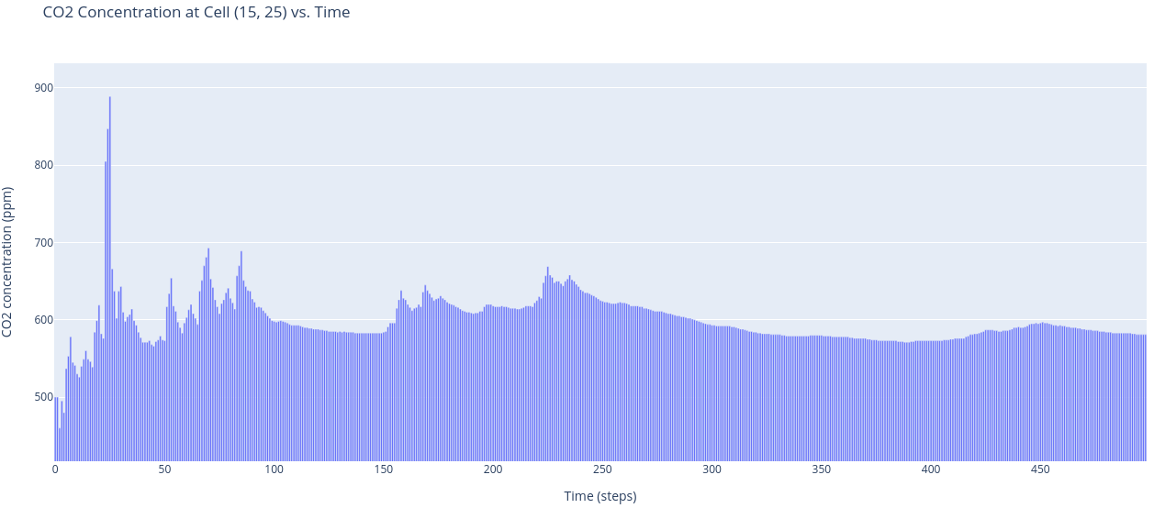
Figure 12: Scenario 2 Room5.
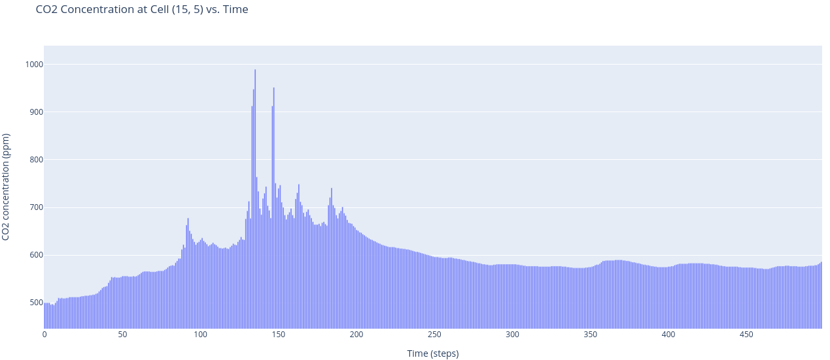
Figure 13: Scenario 2 Room2.

Simulation Scenario 3
The third simulation 2D and 3D setup are demonstrated in Figures 14 and 15. In this scenario, all six rooms have ducts. Each room has one occupant and one vent. The living room has no occupants and has two vents. The simulation runs for 500 units of time to show the continuous change in CO2 level inside these rooms.

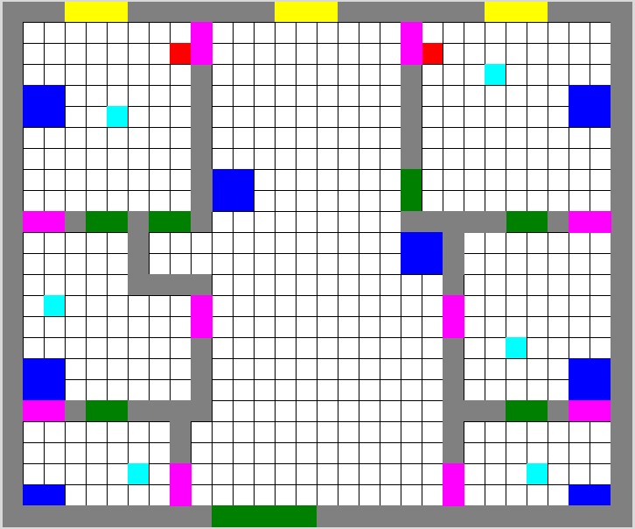
Figure 14: 2D Simulation Setup of Scenario 3.
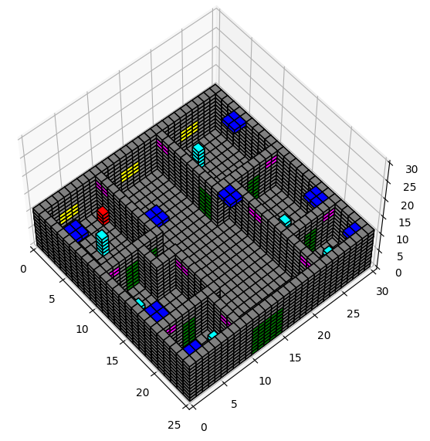
Figure 15: 3D Simulation Setup Scenario 3.
The results in Figure 16 shows that the CO2 level significantly reduced in all rooms with occupants. The presence of ducts between all rooms reduces the concentration of CO2 and assists in increasing the efficiency of the ventilation system due to the balanced distribution of CO2 inside the apartment. The results in Figures 17 and 18 show that cells in both rooms 5 and 2 can reach a maximum CO2 concentration of nearly 600ppm which is lower than the CO2 level in scenario 2 with no ducts between rooms.

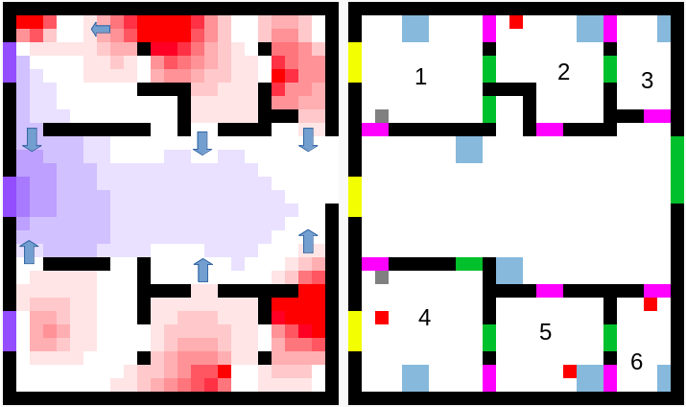
Figure 16: Scenario 3 Results (at 498 unit of time).
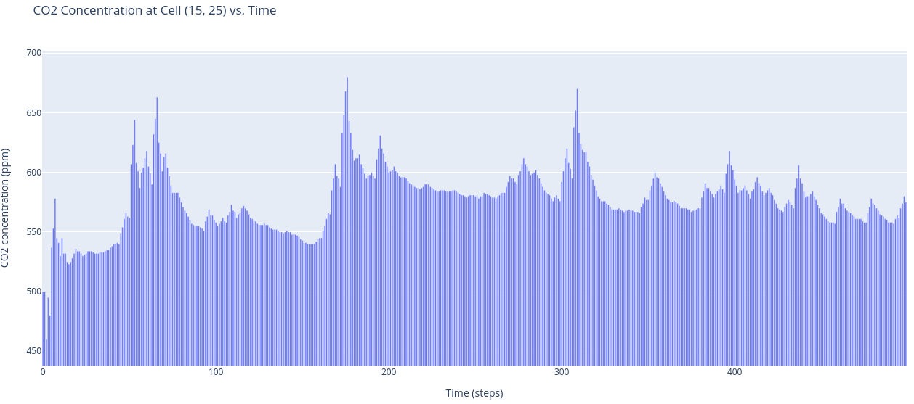
Figure 17: Scenario 3 Room5.
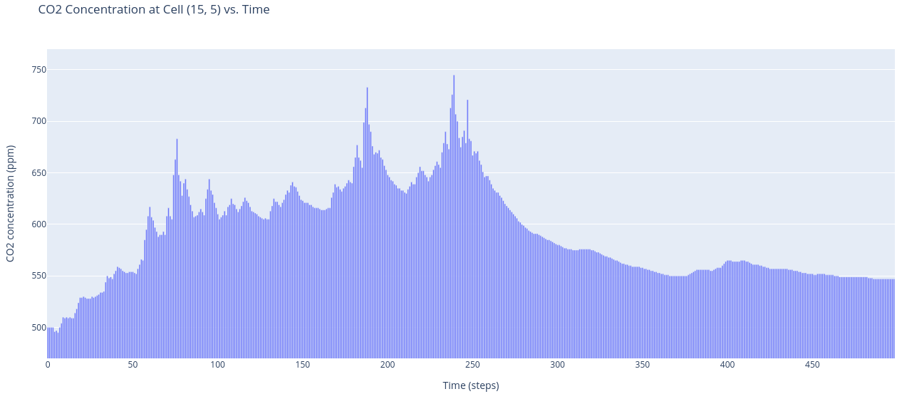
Figure 18: Scenario 3 Room2.

Simulation Scenario 4
The fourth simulation 2D and 3D setup are demonstrated in Figures 19 and 20. In this scenario, all six rooms have ducts that are also connected to the outside of the apartment. Each room has one occupant and one vent. The living room has no occupants and has two vents. The simulation runs for 500 units of time to show the continuous change in CO2 level inside these rooms.

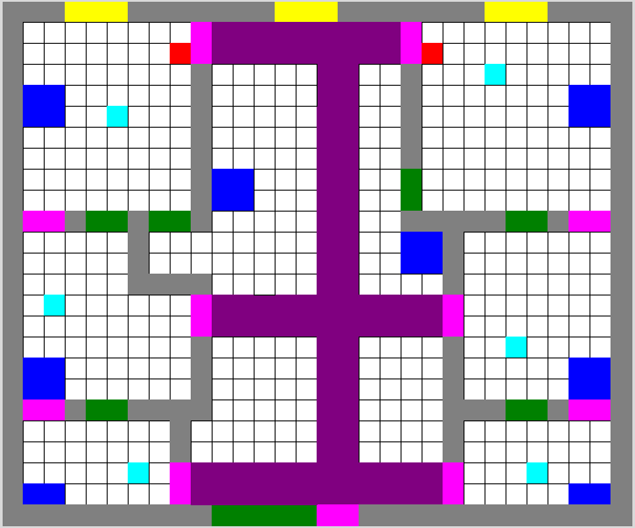
Figure 19: 2D Simulation Setup of Scenario 4.
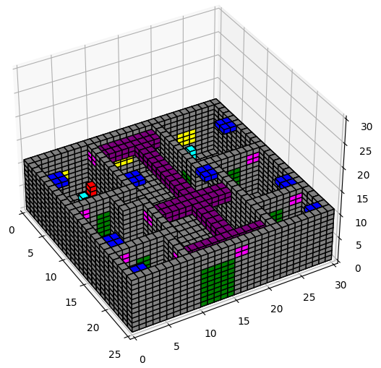
Figure 20: 3D Simulation Setup Scenario 4.

The results in Figure 21 shows that the CO2 level significantly reduced in all rooms with occupants. Same as in scenario 3, the presence of ducts between all rooms reduces the concentration of CO2 and assists in increasing the efficiency of the ventilation system due to the balanced distribution of CO2 inside the apartment. The results in Figures 22 and 23 show that cells in both rooms 5 and 2 can reach a maximum CO2 concentration of nearly 600-700ppm which is lower than the CO2 level in scenario 2 with no ducts between rooms.
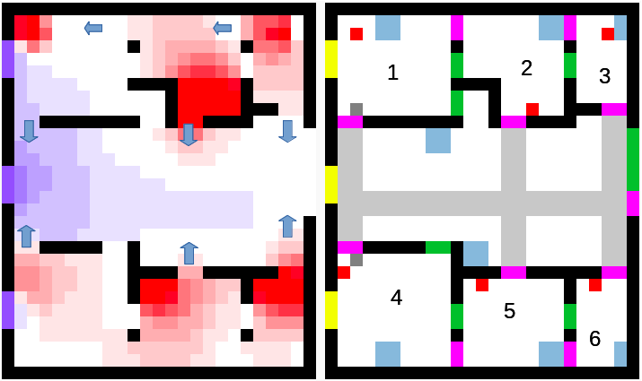
Figure 20: Scenario 4 Results (at 498 unit of time).
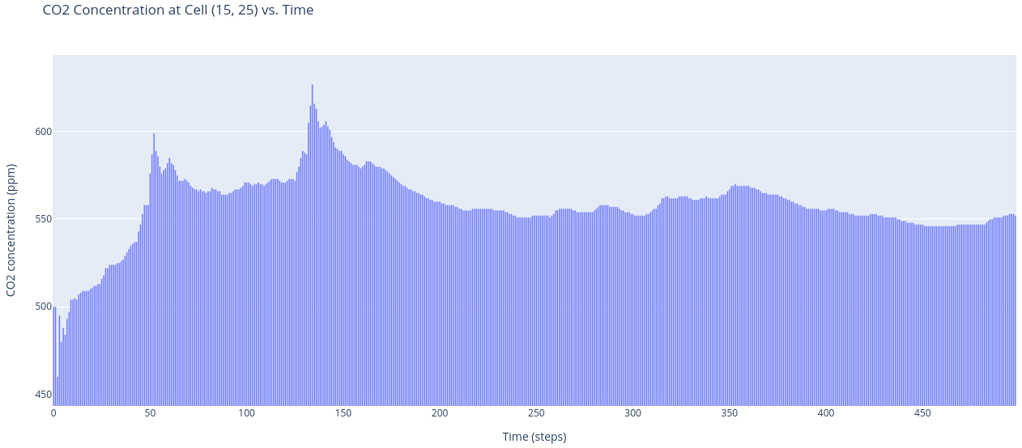
Figure 21: Scenario 4 Room5.
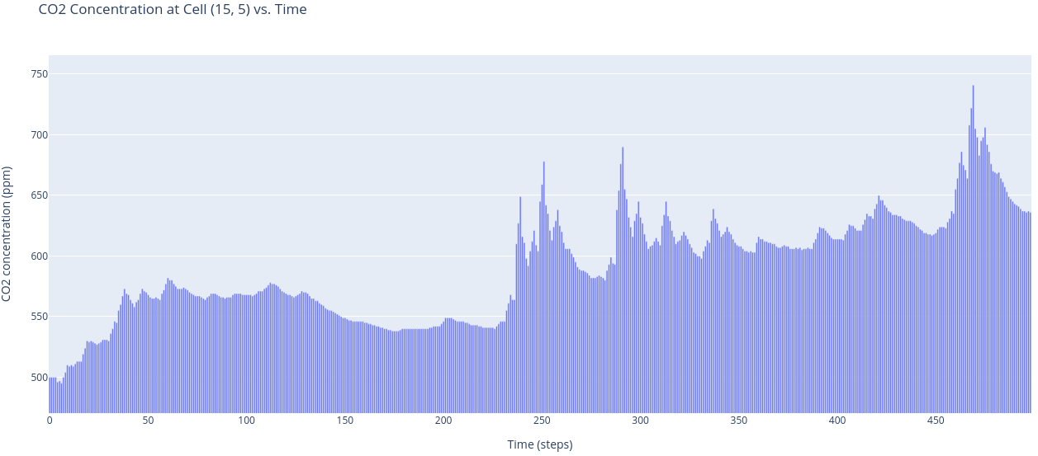
Figure 22: Scenario 4 Room2.

Conclusion
In conclusion, the example presented in this paper showed that the implementation and configuration of ducts between rooms in a building can result in a significant difference in the concentration of CO2 inside rooms. The results showed that the ventilation system works efficiently with the presence of ducts. In future work, the optimal setup of ducts between rooms can be measured with respect to the ventilation system setup and the number of rooms.
REFERENCES
Wainer G., 2009. Discrete-Event Modeling and Simulation: A Practitioner’s Approach. 1st ed. CRC Press.
G. Wainer; N. Giambiasi: "Application of the Cell-DEVS Paradigm for Cell Spaces Modeling and Simulation", Simulation, Vol. 71, No. 1, pp. 22-39, January 2001.
Hoda khalil, Gabriel A. Wainer, Z Dunnigan “Cell-Devs Models for CO2 Sensors Locations In
Closed Spaces”, Proceedings of the Winter Simulation Conference 2020, Orlando, Florida, USA – 2020.
Khalil, H., & Wainer, G. (in press). Modeling carbon dioxide dispersion indoors: a Cell-DEVS experiment. In Proceedings of the 2020 Cellular Automata for Research and Industry (ACRI), December 2-4, 2020, Virtual.

