Lab4.R
mayalsoufi
2026-01-16
x<-1:50
plot(x)
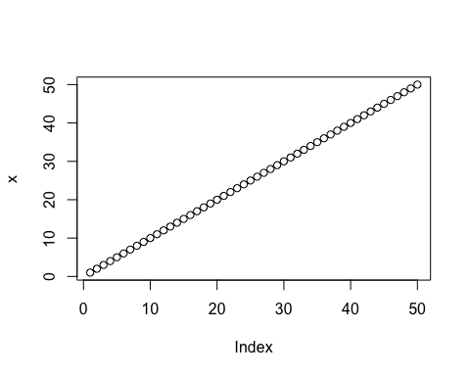
plot(x,sin(x))
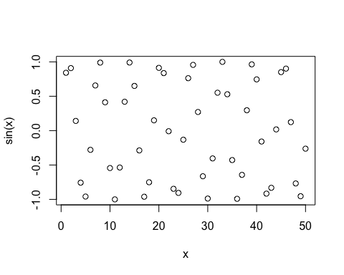
plot(x, sin(x), typ='l',col="blue", lwd=3,
xlab="Is it lunch time yet?")
