

Hypermedia Applications a.y. 2018/19

Design document 04/07/19

**Alessandro Carughi – alessandro.carughi@mail.polimi.it**

**Luca Maltagliati – luca.maltagliati@mail.polimi.it**

**Marco Turetta – marco3.turetta@mail.polimi.it**

**Abstract**

The following document aims at resuming the work done during the preliminary design phase of the project of the Hypermedia Applications course.

The main goal of the project is **facilitare il commercio di libri tramite questo e-commerce.  
Un altro obiettivo del sito sarebbe quello di facilitare la scelta di un nuovo libro da leggere attraverso la divisione in categorie fornita dal sito.   
Inoltre, si vorrebbe alimentare la passione dei lettori attraverso l’iterazione degli utenti tramite i commenti ai libri stessi, infatti lo scopo sarebbe creare una community attiva.**

In the following, we report the work executed in each step of the design process. In particular:

* **Graphical Representation: For the design in the large, where we used the Interactive Dialogue Model for the planning of the content architecture of the web-site, we have included the C-IDM and L-IDM schemas along with some textual descriptions;**
* **For the scenarios ideation, the textual description of three possible use cases of our application;**
* **For the design in the small, the textual description of the requirements of the pages involved in our scenarios along with their graphical representation;**
* **For the database design, the ER schema and logical model.**

**Graphical Representation**

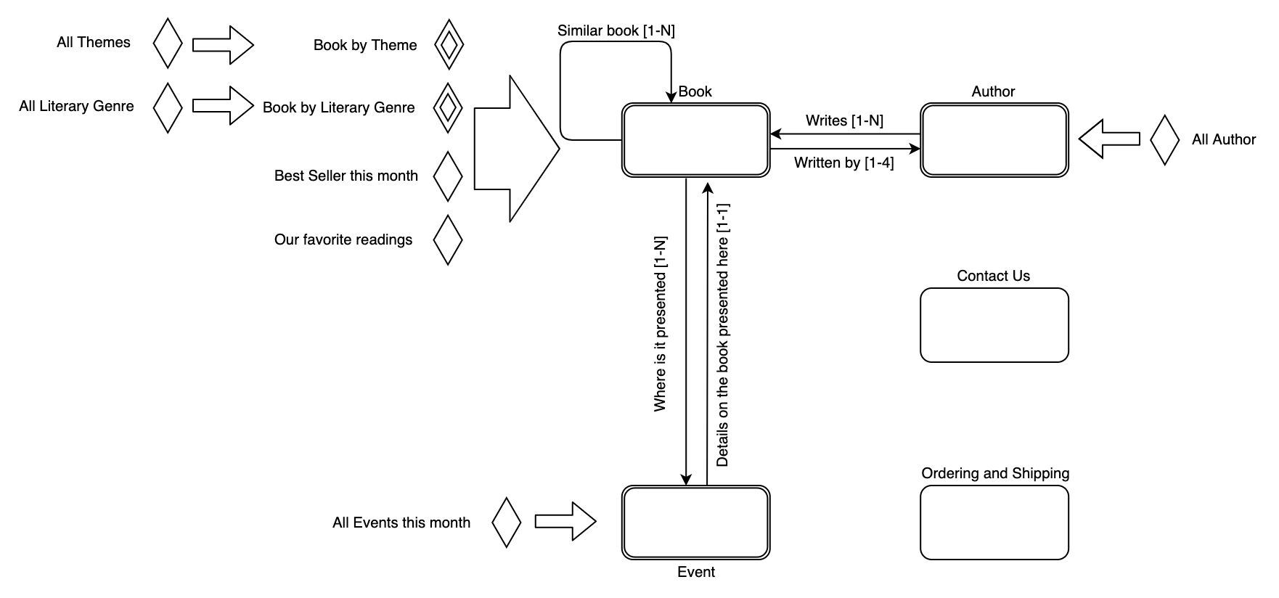C-IDM

Diagram 1 - C-IDM

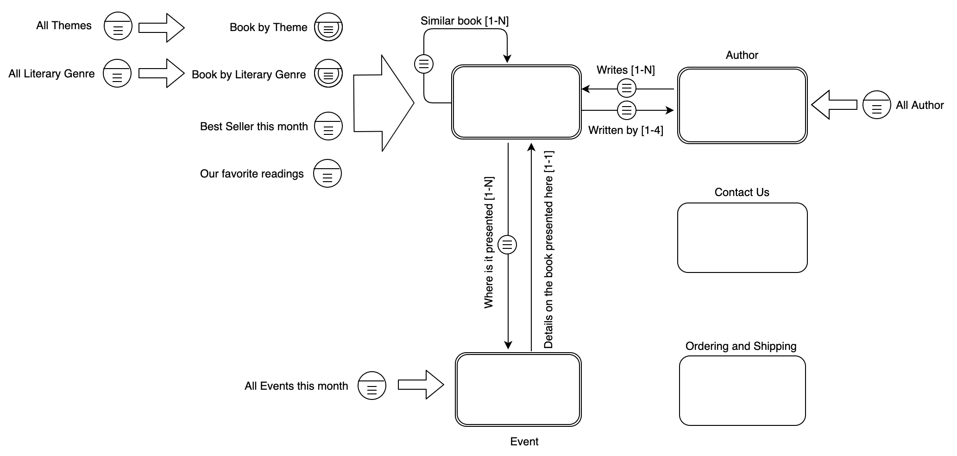L-IDM

* Name
* Surname
* Biography
* Picture

Genre

* Email
* Phone
* Address
* Location
* Book
* Date
* Title
* Author
* Themes
* Literary Genre
* Picture
* Items
* Address
* Date

Diagram 2 - L-IDM

**Scenarios**

**Scenario 1:** Alessandro is in a library and sees a book that he want to buy, but there are no more copies, so he visits the website BookHub and search the name of the book, then when the book appears on the page he click on it and then the information of the book is shown.  
Now he can read the reviews or directly add to the cart and then buy it.

**Scenario 2:** Luca has a favorite author and he knows that he releases a book soon.  
Luca decides to open the website to search where and when the presentation is.  
Once the website is open, he clicks on the author section then search it’s favorite author.  
The page of author shows the correlated book and also the new book and clicking on it, it shows the event correlated to its book.  
Once the event is shown, Luca can see where and when the presentation are.

**Scenario 3:** Marco ha appena finito di leggere un libro che gli è piaciuto tantissimo, allora decide di leggerne uno dello stesso genere ma non ne conosce.  
Allora decide di utilizzare BookHub per trovare letture simili.  
Può cercare il libro appena finito e vedere i libri simili, oppure vedere il genere del libro e cercare nella homepage tutti i libri dello stesso genere di quello appena finito attraverso la barra di ricerca.

**Design in-the-small**

In order to specify correctly the requirements of our front-end prototype, in the design in-the-small phase of the assignment we have defined the basic visual organization of contents, navigation and interaction elements of our website.

In order to do so, we have created several **medium fidelity wireframes**, one for each page involved in our scenarios.

For almost all the pages of the website, we used the same basic structure, composed by:

1. an **header**;
2. the main content **body**;
3. a **footer**.

Header and footer contain the **landmarks** links, which direct to the main topic of our website, in particular:

* the **header** contains the clickable title that **RIMANDA ALLA HOME**, landmarks links for all the website main pages, the cart and the search bar;
* the **footer** theinformationfor the **Contact us** and the landmark for the **FAQ** page.

The main content **body** instead, present content and transition links for the topic and multiple topic pages.

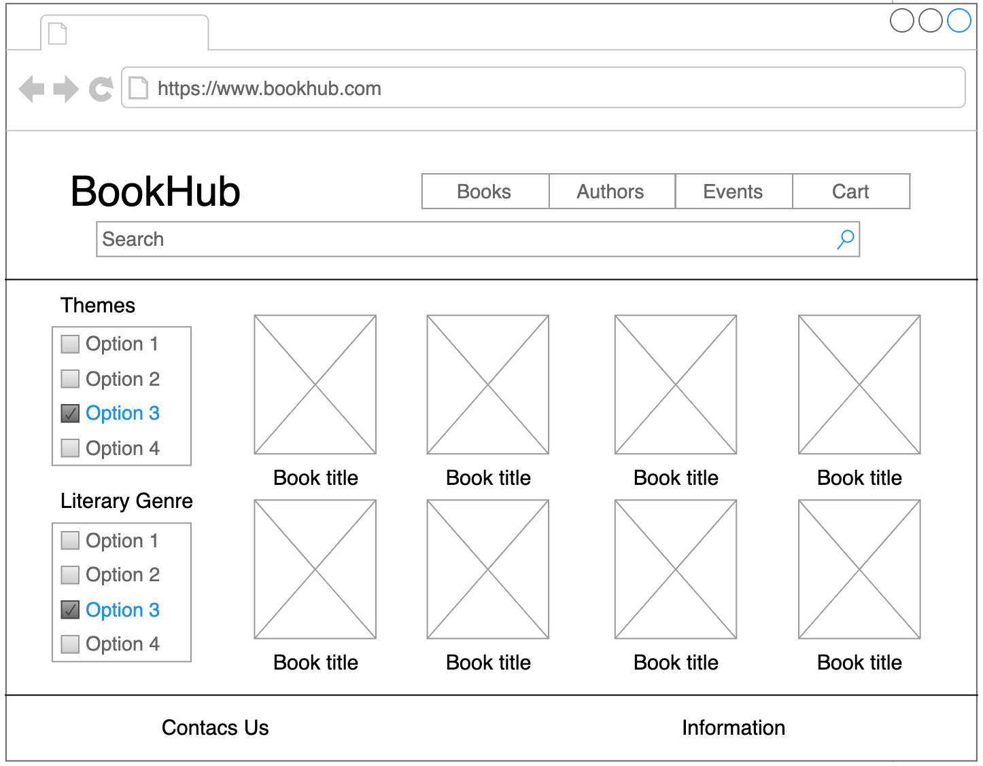

Figure 1 – Home Page (Book page)

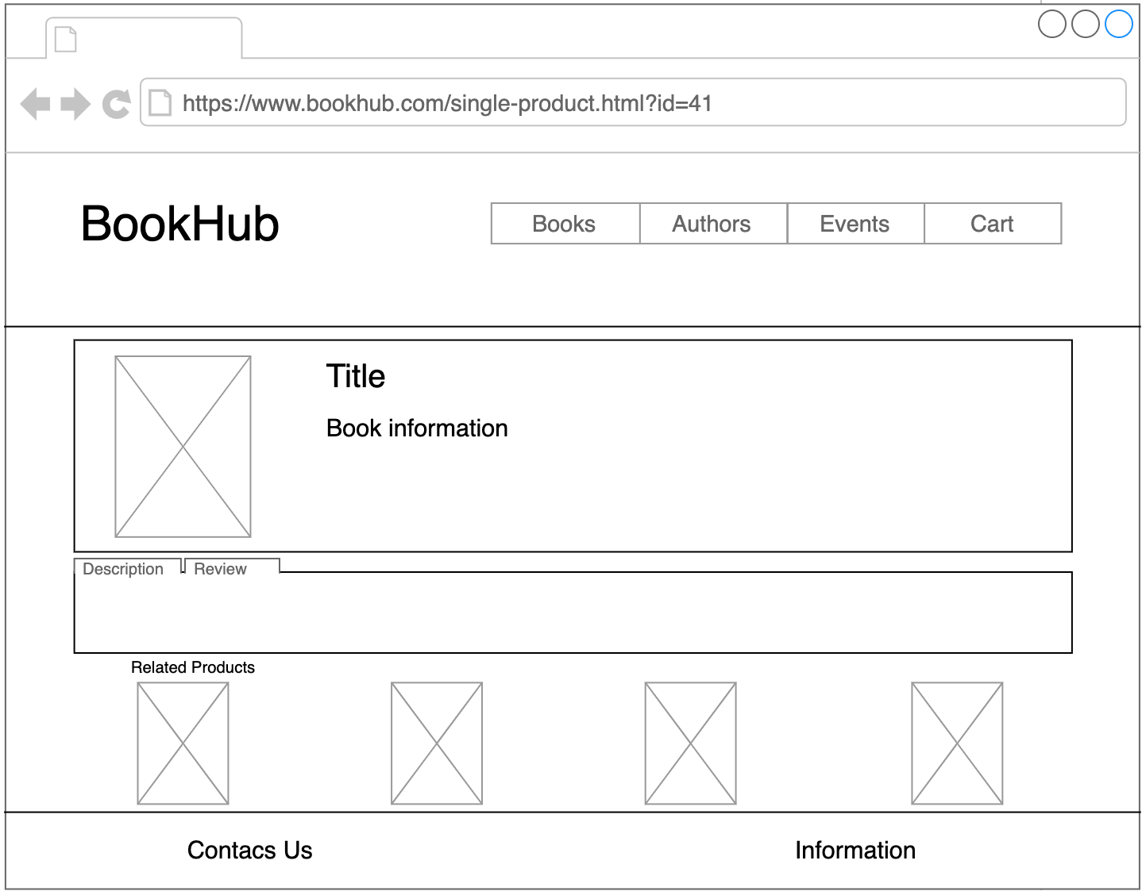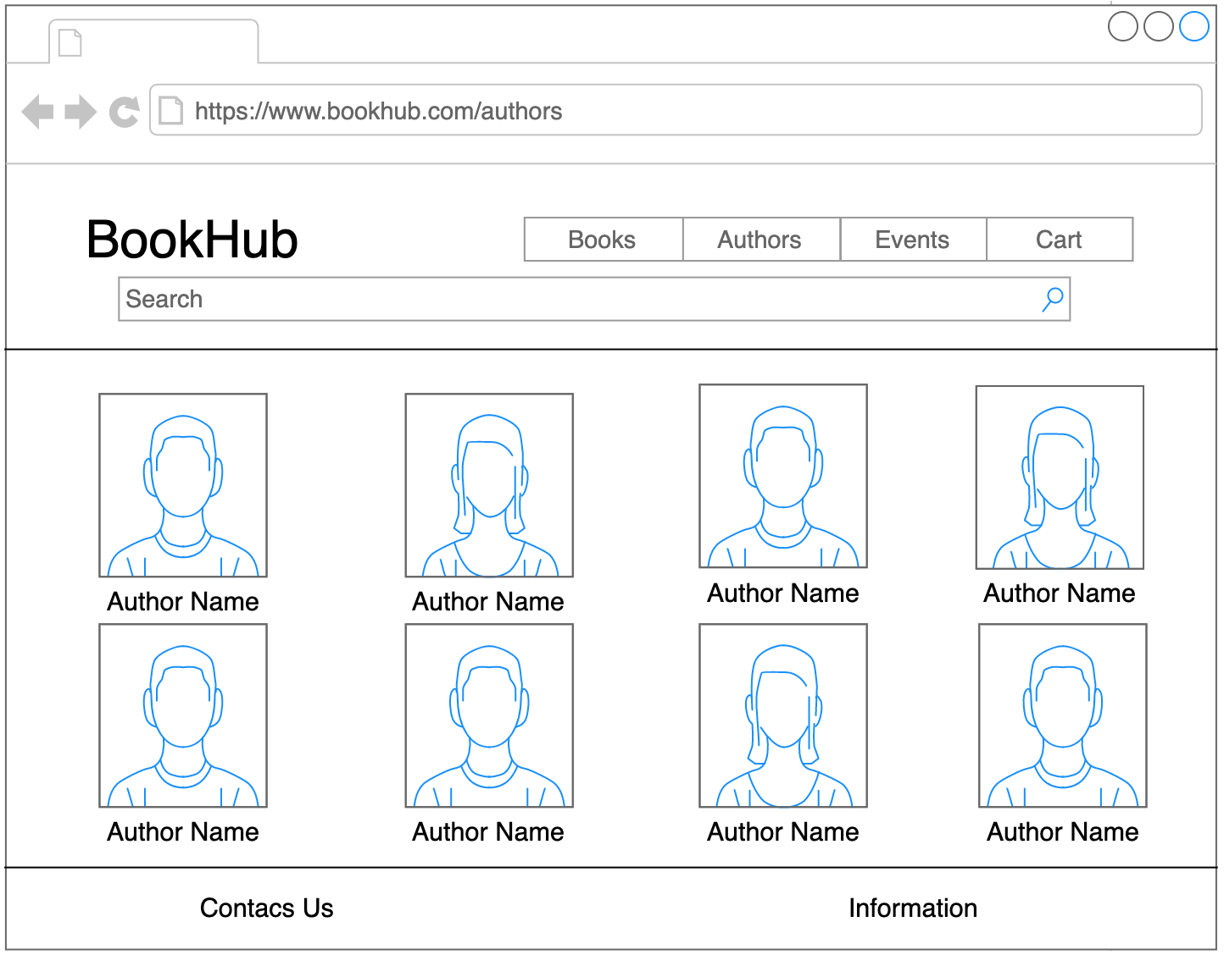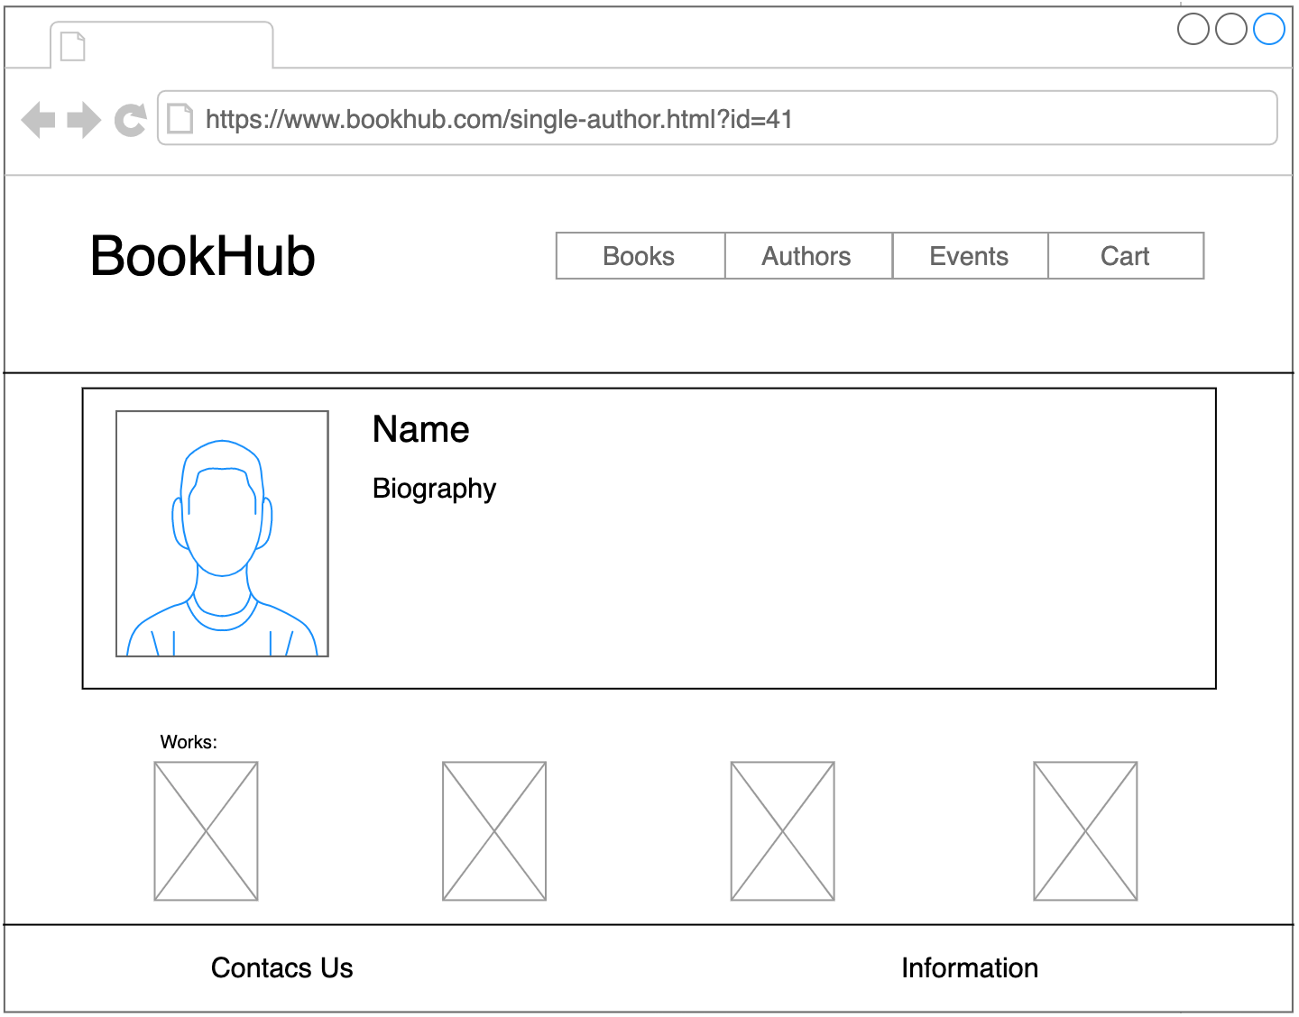

Figure 2 – Single Product page

Figure 3 – Author Page

Figure 4 – Single Author Page

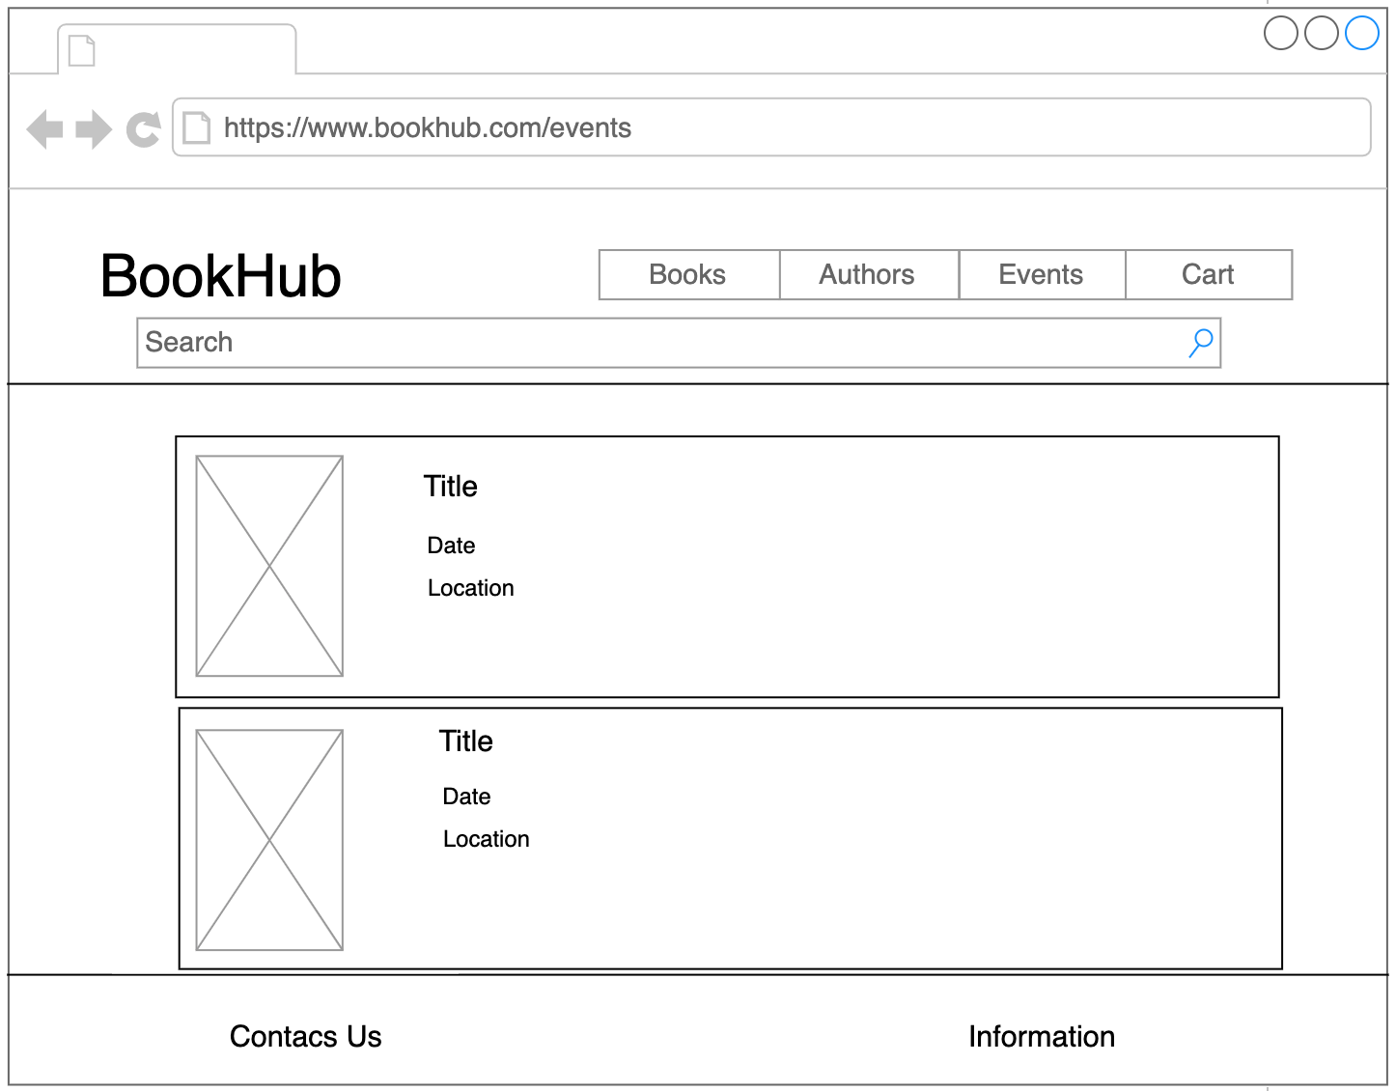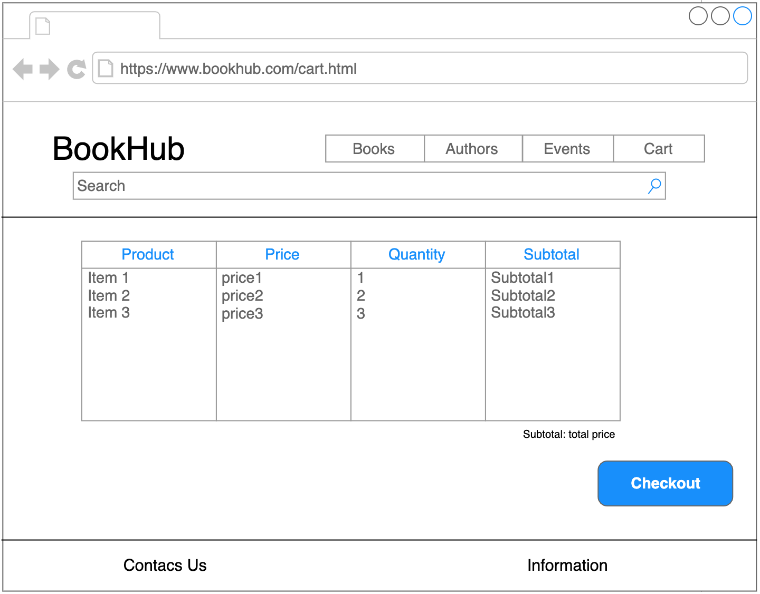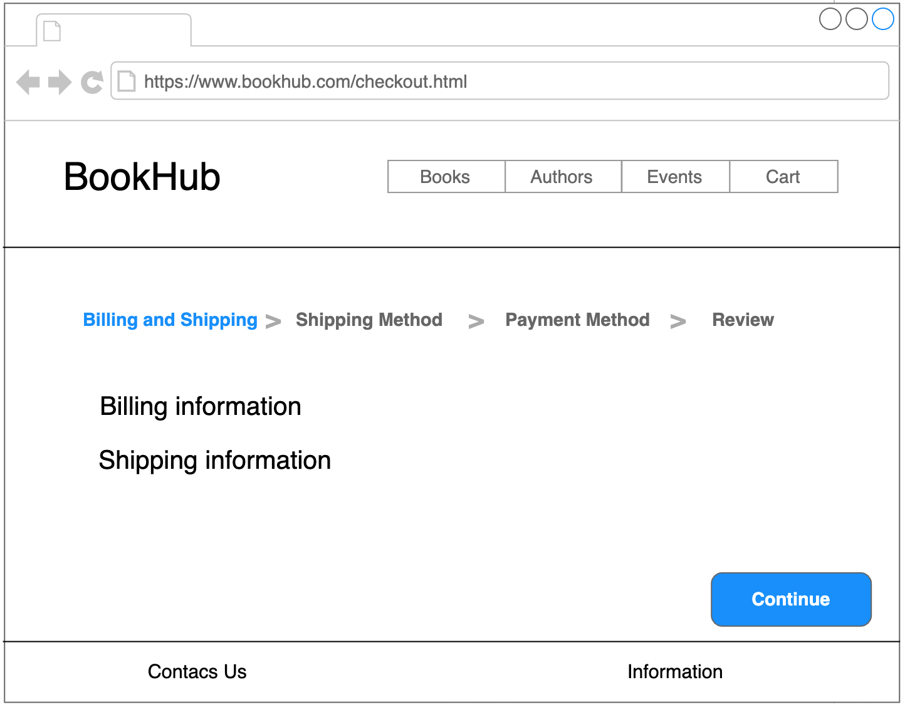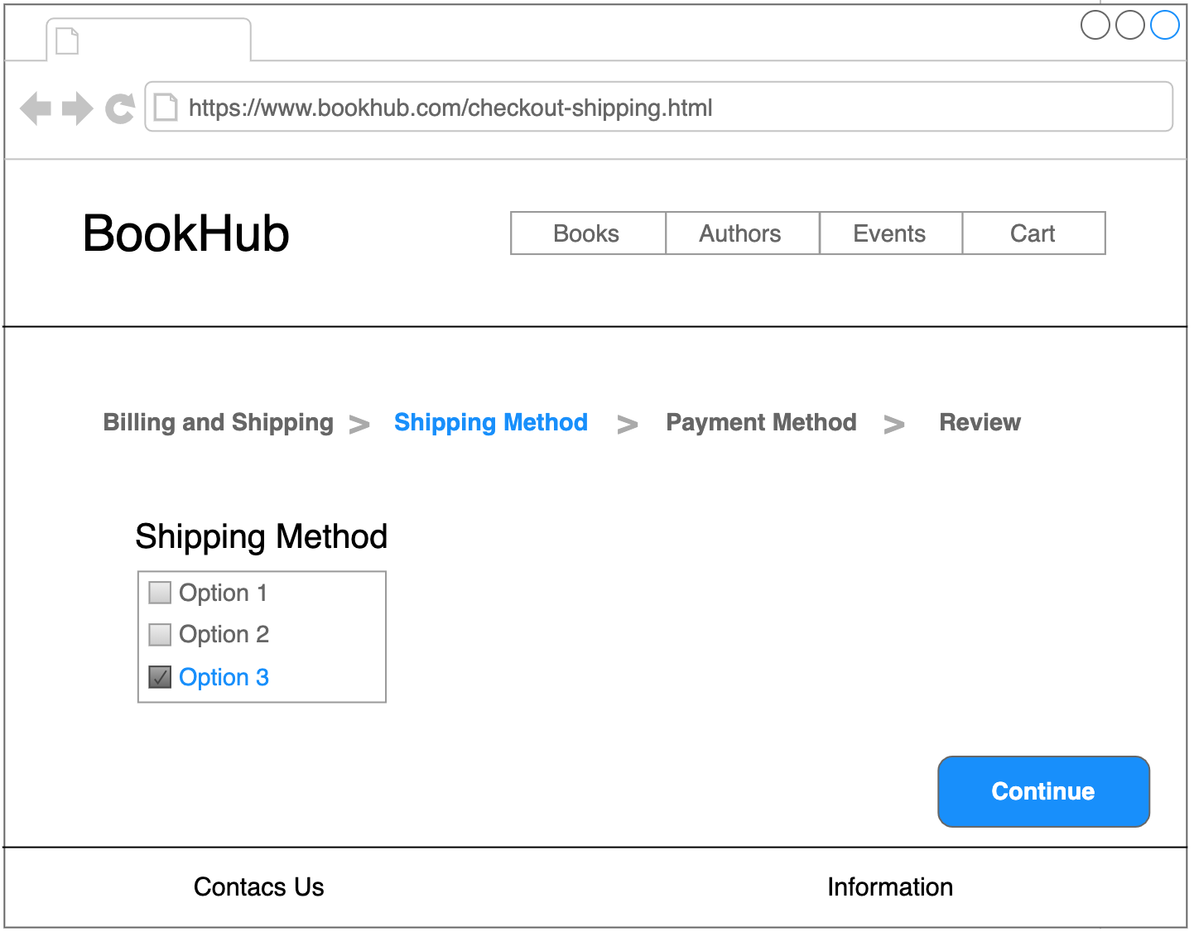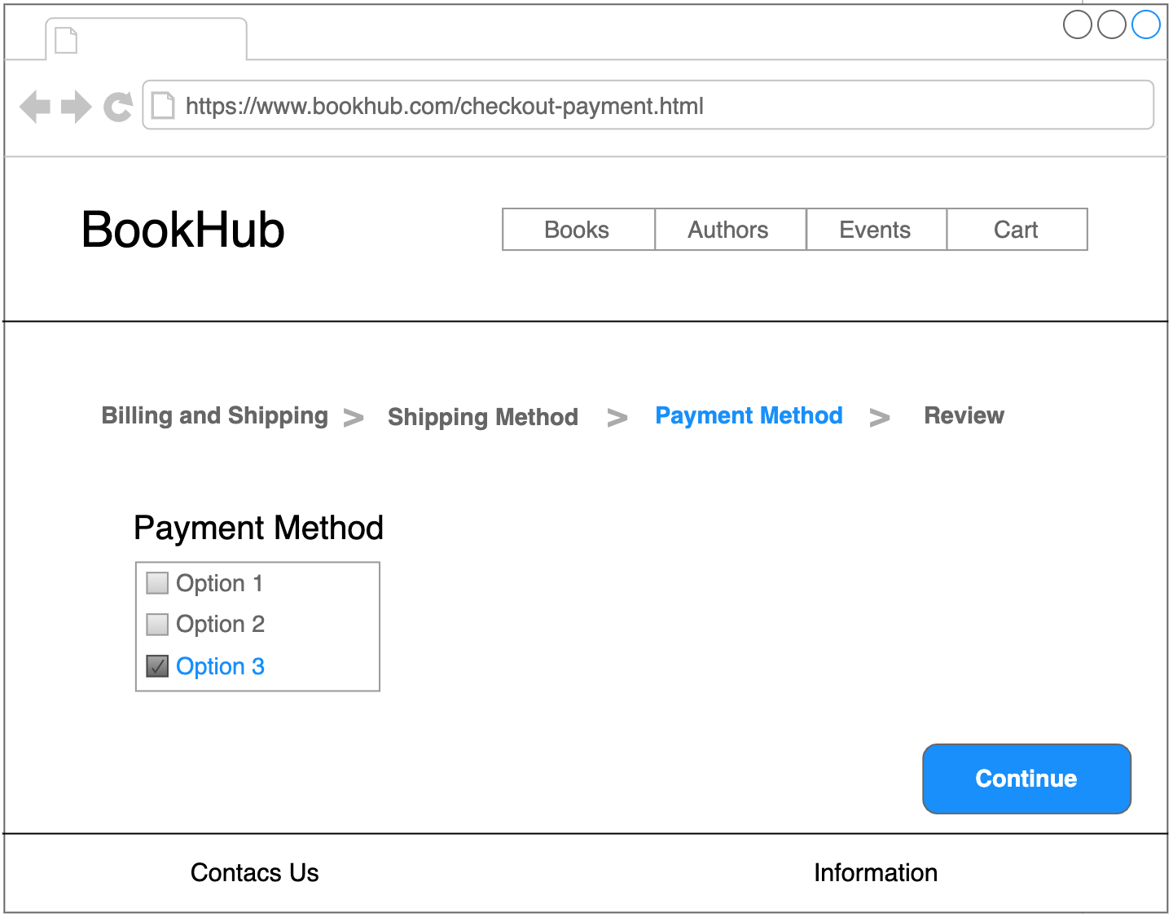

Figure 5 – Event Page

Figure 6 – Cart Page

Figure 7 – Checkout Page

Figure 8 – Checkout Shipping Method Page

Figure 9 – Checkout Payment Method Page

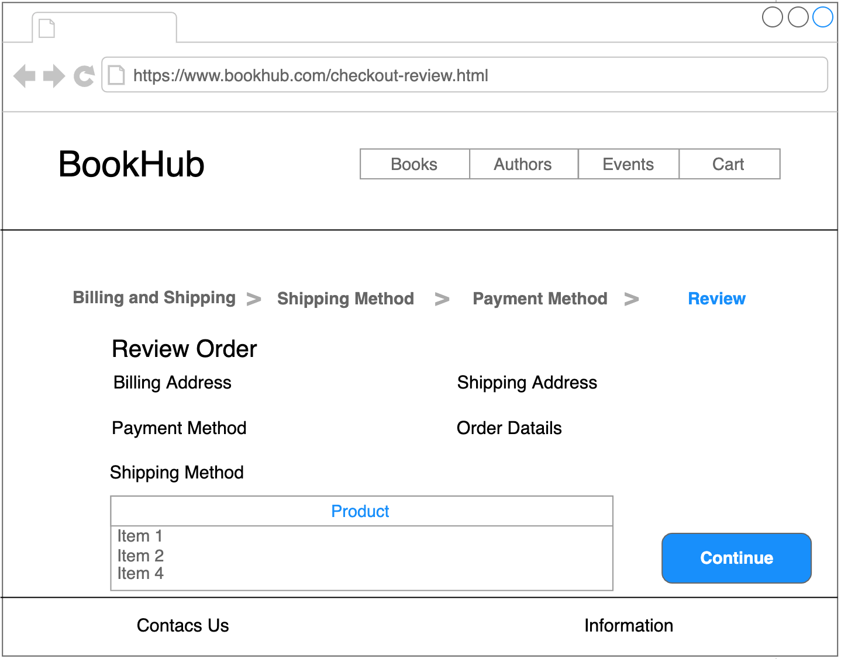

Figure 10 – Checkout Review Page

**Database Design**

In the **ER diagram** we have represented the main **entities**, along with their **attributes**, that we thought may be useful in the implementation of our application, and the **relations** between them.

The entities we have found so far are:

* **Service**: represents all the details and information about a service offered by “Abilitiamoci” in one or more Locations;
* **Location:** represents information and address of a Location in which “Abilitiamoci” operates;
* **Location_Pic**: represents a picture of a specific Location;
* **Person**: represents the information, generalities and role of a Person;
* **Event**: represents the details of a specific Event such as the Location and how to participate;
* **News**: represents the information about a News.

All the entities are identified by an **ID**, a univocal code.

The **N:N** relationship are:

* **Performed in**: Service <-> Location;
* **Performs**: Person <-> Service;
* **Participates**: Person <-> Event.

The **1:N** relationship instead are:

* **Represents**: Location_Pic <-> Location;
* **Takes place**: Event <-> Location;
* **Talks about**: News <-> Event.

In the **Logical Model** we have developed the **relationships** between all the entities in ER diagram, adding new tables to represent a tuple of a N:N relation and inserting the foreign keys where necessary.

The new tables are:

* **ServInLoc**: represents the association between a specific Service and a specific Location;
* **PersPerformsServ:** represent the association between a specific Person and a specific Service;
* **PersParticipatesEv**: represent the association between a specific Person and a specific Event.

Foreign keys have been inserted in:

* News from Event;
* Location_Pic from Location.

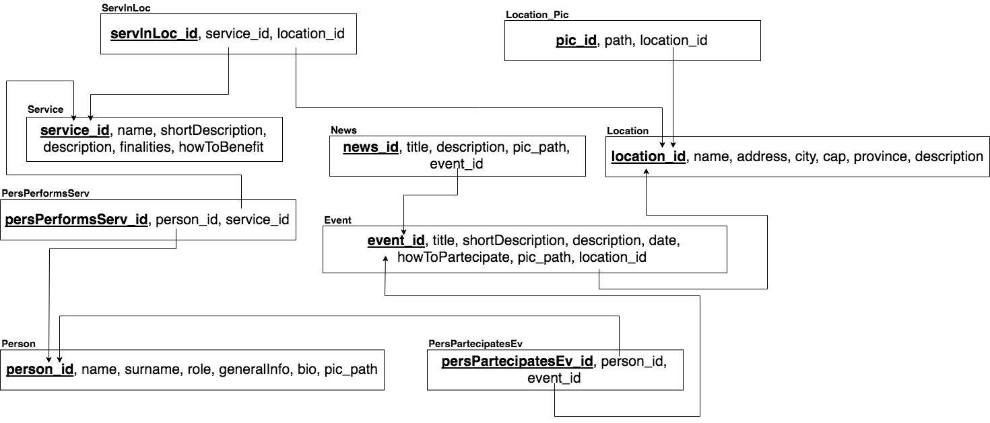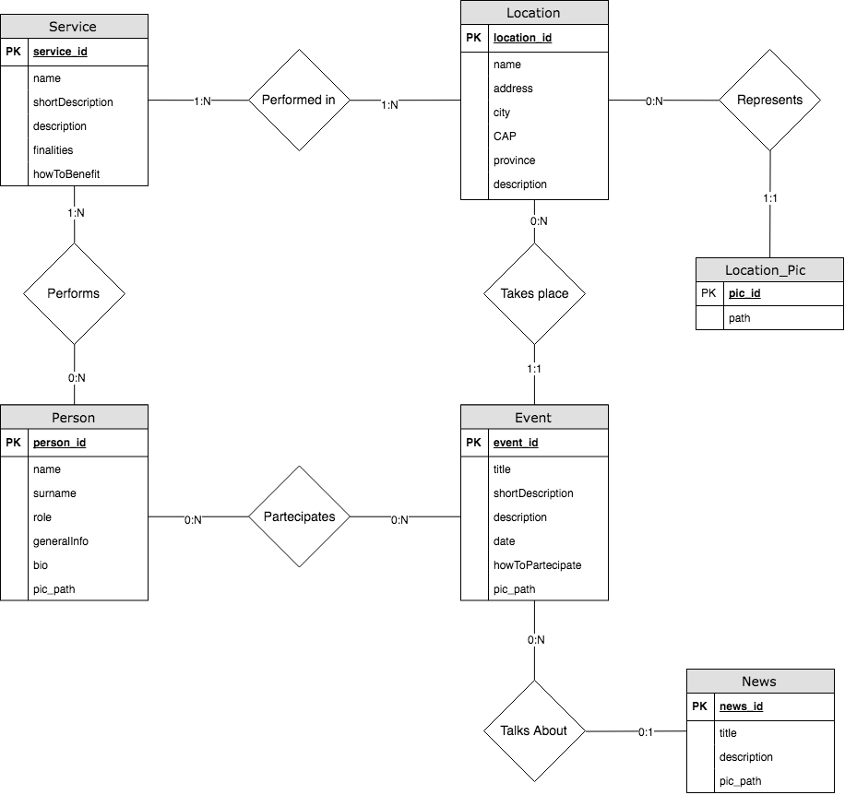

diagram 5 - logical model

diagram 4 – er schema