slideshow
-slides
x globalAmbientMusic
-player
-globalPreferences
-utils:
--mediaManager
--dialogsUtil
slide
-dialogs
-title
-backgroundImage
x ambientMusic
x objects
x plugin

dialog
-texts
x iconImage
text
-target

target -> leads to dialog or slide

player
x figures
x points
x bag
x visitedSlides
x usedTargets

object
-image
-dimension w,h
-position x,y
x footPosition
x footDimension

plugin
<code>

utils:
interfaceLoadable
implementing load and save. all in one file
interfaceDumpable
implementing loadDump and saveDump
multiple files
dumpHelper
dumpParser
dumpUtil

dialogUtil
-dialogs

mediaManager
-sounds
x globalSounds
-images
x globalImages
-iconImages
-animations
x gloabalAnimations

connection
for download, upload and chat

connectionProtokoll

-is default
x is optional

the basic interface design

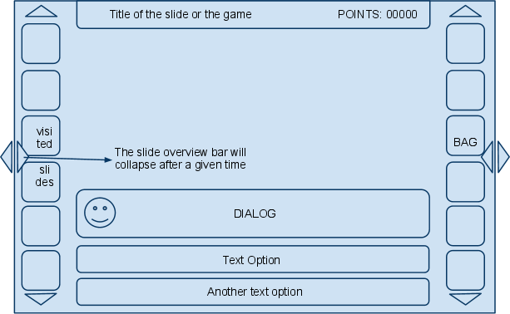

layout of the interface design is optional

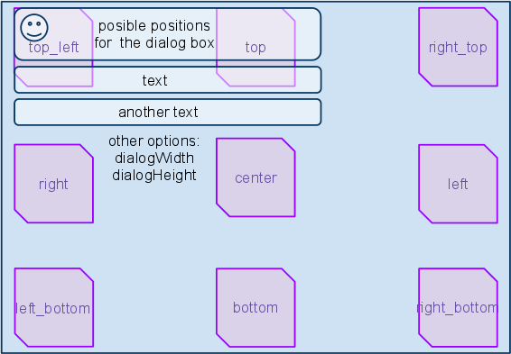

It's possible to load different fonts and set the font color.

