Predicting collective benefit from the language of interaction partners

Malte Lau Petersen / au540041, Cognitive Science, Århus University
Exam paper for Social and Cultural Dynamics

Abstract
How do dyads that successfully collaborate coordinate their communication? Some tasks, such as a scrabble game, can easily be parallelized, and the results from many individuals can simply be added together. Other tasks require collaborative effort in an ongoing social interaction to benefit from multiple people working on the same problem. But why do some groups benefit more from collaboration than others? Language is central for collaboration, and various mechanisms have been proposed to explain differences in collective benefit. This paper extends a previously reported experimental setup (Bahrami et al. 2010, Fusaroli et al 2012a, Bang et al. 2014, Fusaroli & Tylén 2015, Bang et al 2017) to the auditory domain – and considers linguistic similarity and diversity, linguistic alignment and synergy, and explicit metacognition as drivers of collective benefit.

Keywords: social cognition; group performance; linguistic alignment; bayesian modelling; auditory discrimination

Introduction
Collaboration
evolutionary advantages
humans unique?
Language and social brain hypothesis
understanding – how can humans combine into “one” cooupled cognitive system
applications – collaborations with linguistic interactions very very common. Every life, survival in critical situations, efficiency in organisations

prev research in paradigm: verbal vs non-verbal (bahrami 2012)
equality bias: can lead to negative collective benefit (bang 2017)

Collaboration

Similarity (skill) and / or Diversity (area of expertise)
Literature references here! Mini review of field
mechanisms:
Similarity: Common ground (familiarity → synergy), alignment
Diversity: Different perspectives (opposite of common ground?), division of labour

Alignment vs synergy (rqa)
I also wanted to replicate the analysis from Fusaroli & Tylén 2015, where they used RQA to compare the predictive power of the existing theory of linguistic alignment against their own synergy theory of dialog.
We would expect all of these measures to be positively correlated with collective benefit, that is – the more structured the language use, the more the dyad should benefit from the collaboration.
Fusaroli: cases of counter-productive alignment
total (coupled cognitive) system needs to be “in tune” acts towards a goal – copying other’s words not enough
functional specificity
dimensional compression
reciprocal compensation

Linguistic alignment (global & confidence)
Alignment → common ground (pickering & garrod 2004)
two people “mesh” → alignment
two people “mesh” → collective benefit

global alignment → look up fusaroli’s references
explicit metacognition (look up karsten’s stuff!)

Visual vs auditory domain
Original: actually multimodal in that they had to combine visual info with temporal info.
Mine: compare stimuli to stored representation

In general: collaborating about perceptual judgements

explain formants

Method
In the experiment, participants sat in a classroom at a computer each with headphones on (identical computers and headphones) and were paired up into dyads with a random other person in the room so they could only communicate through the experiment. Participants knew each other (undergrad classmates), but didn’t know who specifically they were paired with. They then read the instructions, were able to familiarize themselves with the stimuli and adjust the sound volume, and gave oral consent to data collection for research purposes. In each trial, they both heard the same 450 ms random vowel (e, i, o, u) sound at a random formant intensity (5, 8, 11, 14, 17, 20, 23, or 26 dB). They were then individually asked which vowel they heard, and if they answered the same, they moved on to the next trial. If they disagreed, they were put into a chat-room and asked to discuss and reach a consensus decision. In even-numbered rounds, one player had to input the decision, and in odd-numbered rounds, the other player did it. After every trial, participants were given feedback on their own, their dyad partner’s, and their consensus performance. 18 participants (9 dyads) played as many rounds (mean=79.2 rounds, sd=36.5) as they could in 45 minutes. The experiment was designed to resemble the protocol presented in Bahrami et al. 2010: Experiment 1 as closely as possible (except for the stimulus).
The vowel sounds were generated with a parametric speech synthesizer (REF) using a base sound common to all the vowels and adding formants at varying intensities. At intensity = 0 dB, the four vowels would be completely indistinguishable, and the intensity levels were chosen in order to capture the whole range of the psychometric function. The experiment was run using oTree (REF), the data was processed with R (REF) and modelled using Stan (REF). All code for the experiment, text processing, modelling, and visualizing is available on http://github.com/maltelau/SocKult-AuditoryConfidence

Psychometric curves
For quantifying performance in perceptual tasks, I use a psychometric curve model (REF josh’s class). Separately for individuals’ and dyads’ data, I used a hierarchical generalized linear model with a logit link, a binomial outcome distribution, and crossed random effects corresponding to the model specification:
k | n ~ 1 + intensity + (1 | group) + (0+intensity | group) + (1 | vowel) + (0+intensity | vowel)
Where k is the number of correctly perceived vowels out of n trials. I use a hierachical model in order to get an estimate for the overall main effect while downplaying the impact of the structured variance accounted for by the different groups and the different vowels.
The parameter for stimulus intensity is the change in log odds of detecting the right vowel per dB of formant intensity. In other words, it represents the sharpness of the category boundary for detecting the vowel correctly. So the steeper the curve is (the higher the parameter value), the better you are are at distinguishing between the stimuli.
Following Fusaroli et al (2012a), the collective benefit of a group is then defined as the ratio between the slope for the collective decisions to the slope for the individual decisions of the best individual in that group.
collective benefit = dyad slope / individual slope

Dialog quantification
Dyads chatted in the experiment using otree chat (REF), and the following text processing was done at the word level. The hypothesized benefit of similarity comes from being able to use each other well if you’re at a similar level, so it was defined as the difference in vocabulary size (in the experiment) between the two dyad partners. Diversity on the other hand is supposed to help if the dyad can “cover more ground” together than alone, so it was defined as the cosine distance between the word sets of the the dyad partners.
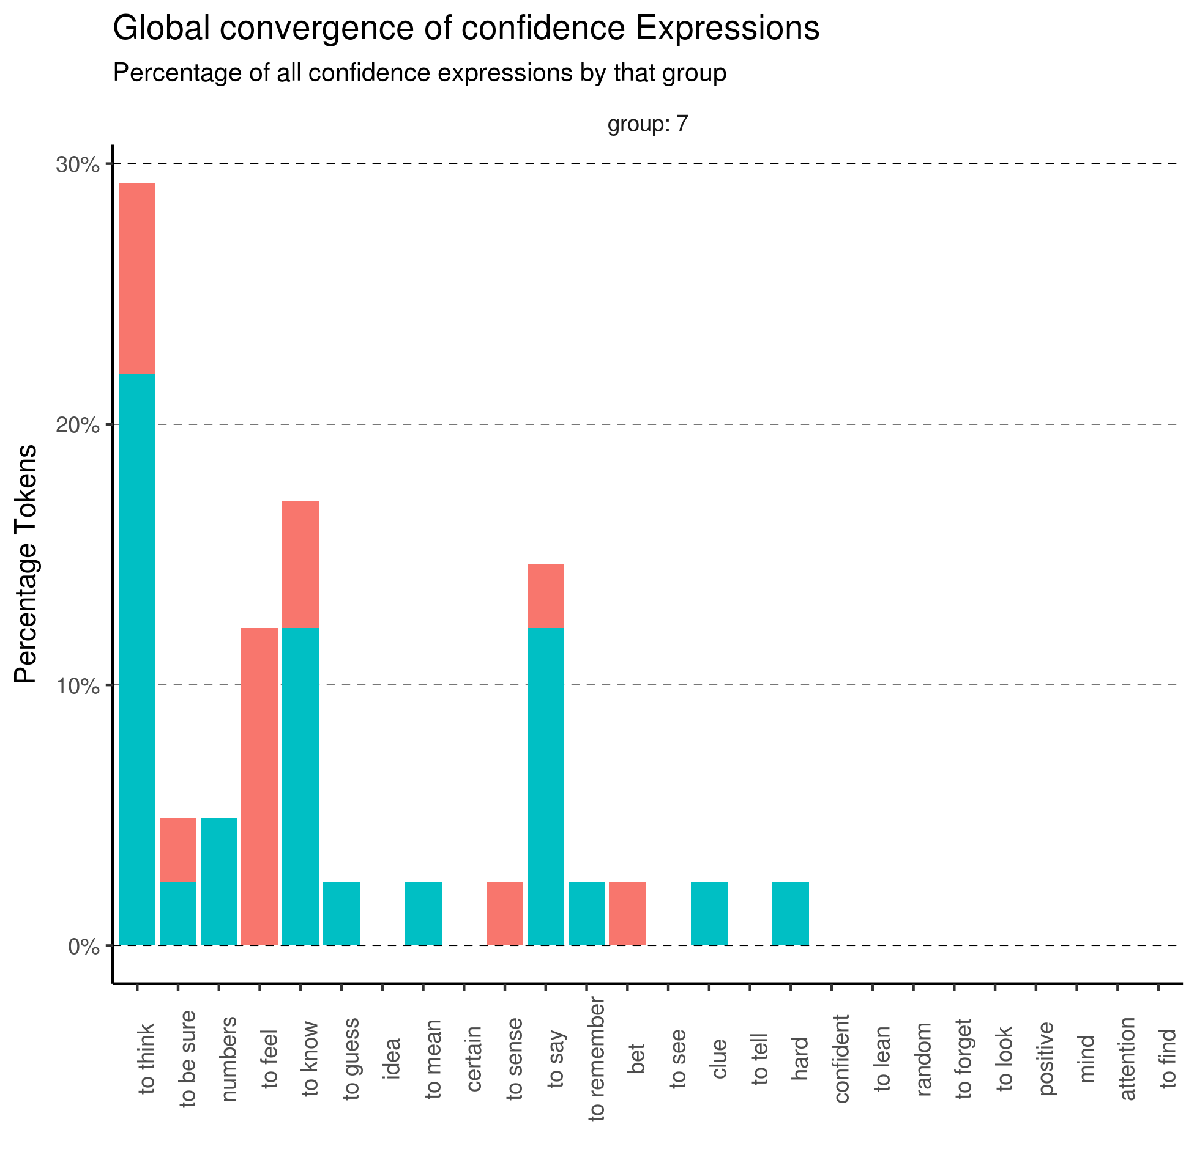Distribution of confidence-expression types of one group. Each colour is one participant. This group converged somewhat (29.3%) on “to think” as an expression of confidence. The rest of the groups are in the appendix (REF)
Linguistic alignment was defined as the proportion of words that had been used by the other participant in the previous utterance. For indiscriminate alignment, this was done for all words, while for confidence alignment, this was run only on the subset of words that matched a category in the confidence scheme from Fusaroli et al 2012. In other words, if one participant produced an expression of confidence, what was the probability that the other participant had used a version of the same expression of confidence last time they used one?
Global convergence was defined, again following Fusaroli et al 2012, as the proportion of all confidence-expressions for each dyad that was of the most popular kind.

Recurrence Quantification Analysis
Recurrence Quantification Analysis (RQA) is … (REF)
First, words were split up into characters, which were then converted to numbers. Then I ran RQA using the crqa package in R (REF) with the parameters: radius = 0, delay = 1, embedding dimension = 2. This means that a recurrence is defined as a two-letter pair anywhere in the sequence that is the same as any two-letter pair in the same or another position in the sequence, and that the smallest recurrent structure that can create a diagonal line on the recurrence plot is 3 letters.
Using RQA on different parts of the chat data, I quantify three different kinds of recurrence. The baseline is individual self-consistency, which is RQA applied to each participant’s corpus individually. Second, I can apply Cross-Recurrence Quantification Analysis to each group by taking each participant’s corpus as an individual time-series. This quantifies the structural organization that we would expect from theories of alignment. Thirdly, if we combine both dyad partners’ chat logs into one (while respecting the timings) and run RQA on that, we can quantify the structural organization of the combined cognitive system predicted by the synergy approach.
It is possible to extract a number of different measures from a recurrence plot, but following Fusaroli & Tylén 2015, I focus only on recurrence rate (RR), proportion of recurrent points that fall in a diagonal line (L), and entropy of the distribution of diagonal line lengths (ENTR).

Bayesian model
To fit the full model, I use a bayesian model for several reasons: Most importantly, to my knowledge, it’s not possible to do this whole analysis in a non-bayesian framework without splitting up into different parts and thus losing the ability for each part to influence the others. This leads to my second reason: building a bayesian computational model in stan allows us to carry the uncertainty all the way through the analysis to a model with the full distributions rather than the point estimates we typically use in a frequentist framework. And finally, when we do bayesian modeling, we specify our prior beliefs in the model, which guides us to being much more explicit about the assumptions our model holds. (REF Gelman?)
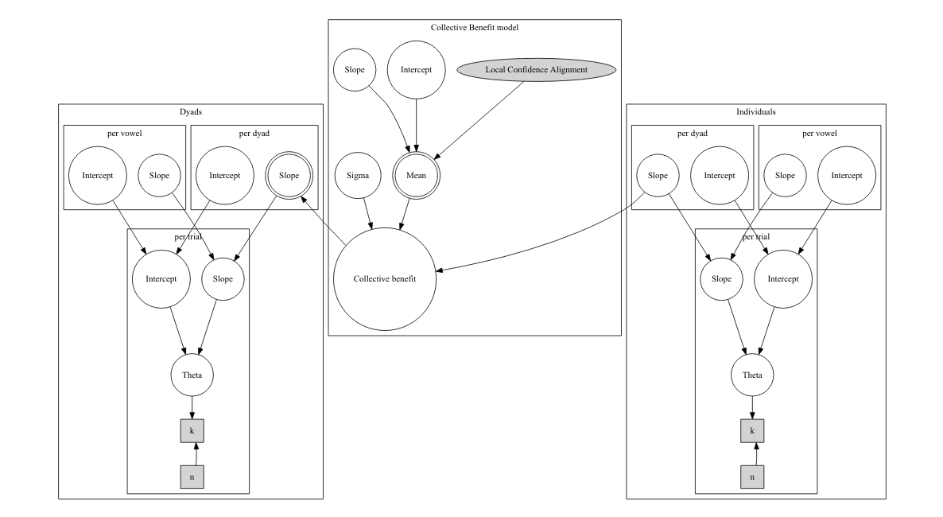
The model consists of three parts: The two logistic regressions for individuals and dyads, and a linear regression predicting each dyad’s collective benefit from the measures we extracted from the chat data. In the plate notation below, this is local confidence agreement, but the structure is the same for all the models: only the independent variables (and corresponding slope parameters) in the collective benefit part of the model changes between models.

Above: Plate notation for the model. Notice that the per dyad slope in the dyad section of the model is deterministic since it’s calculated from the collective benefit in order to make the model generative. It’s still equivalent to collective_benefit ~ dyad slope / individual slope. This was done for computational purposes (REF) http://discourse.mc-stan.org/t/hierachical-hierachical-model-possibly-a-transformed-parameters-jacobian-issue/
The stan code for this model is in the appendix, and the rest of the models are available on github.

prior choice (!)
waic (define group and individual as separate observations for waic calculation)

Results

Correlations and causation
I want to emphathize ...

Conclusion

References
Bahrami et al. 2010, Fusaroli et al 2012a, Bang et al. 2014, Fusaroli & Tylén 2015, Bang et al 2017
otree
R
stan
sound synthesizer

Appendix
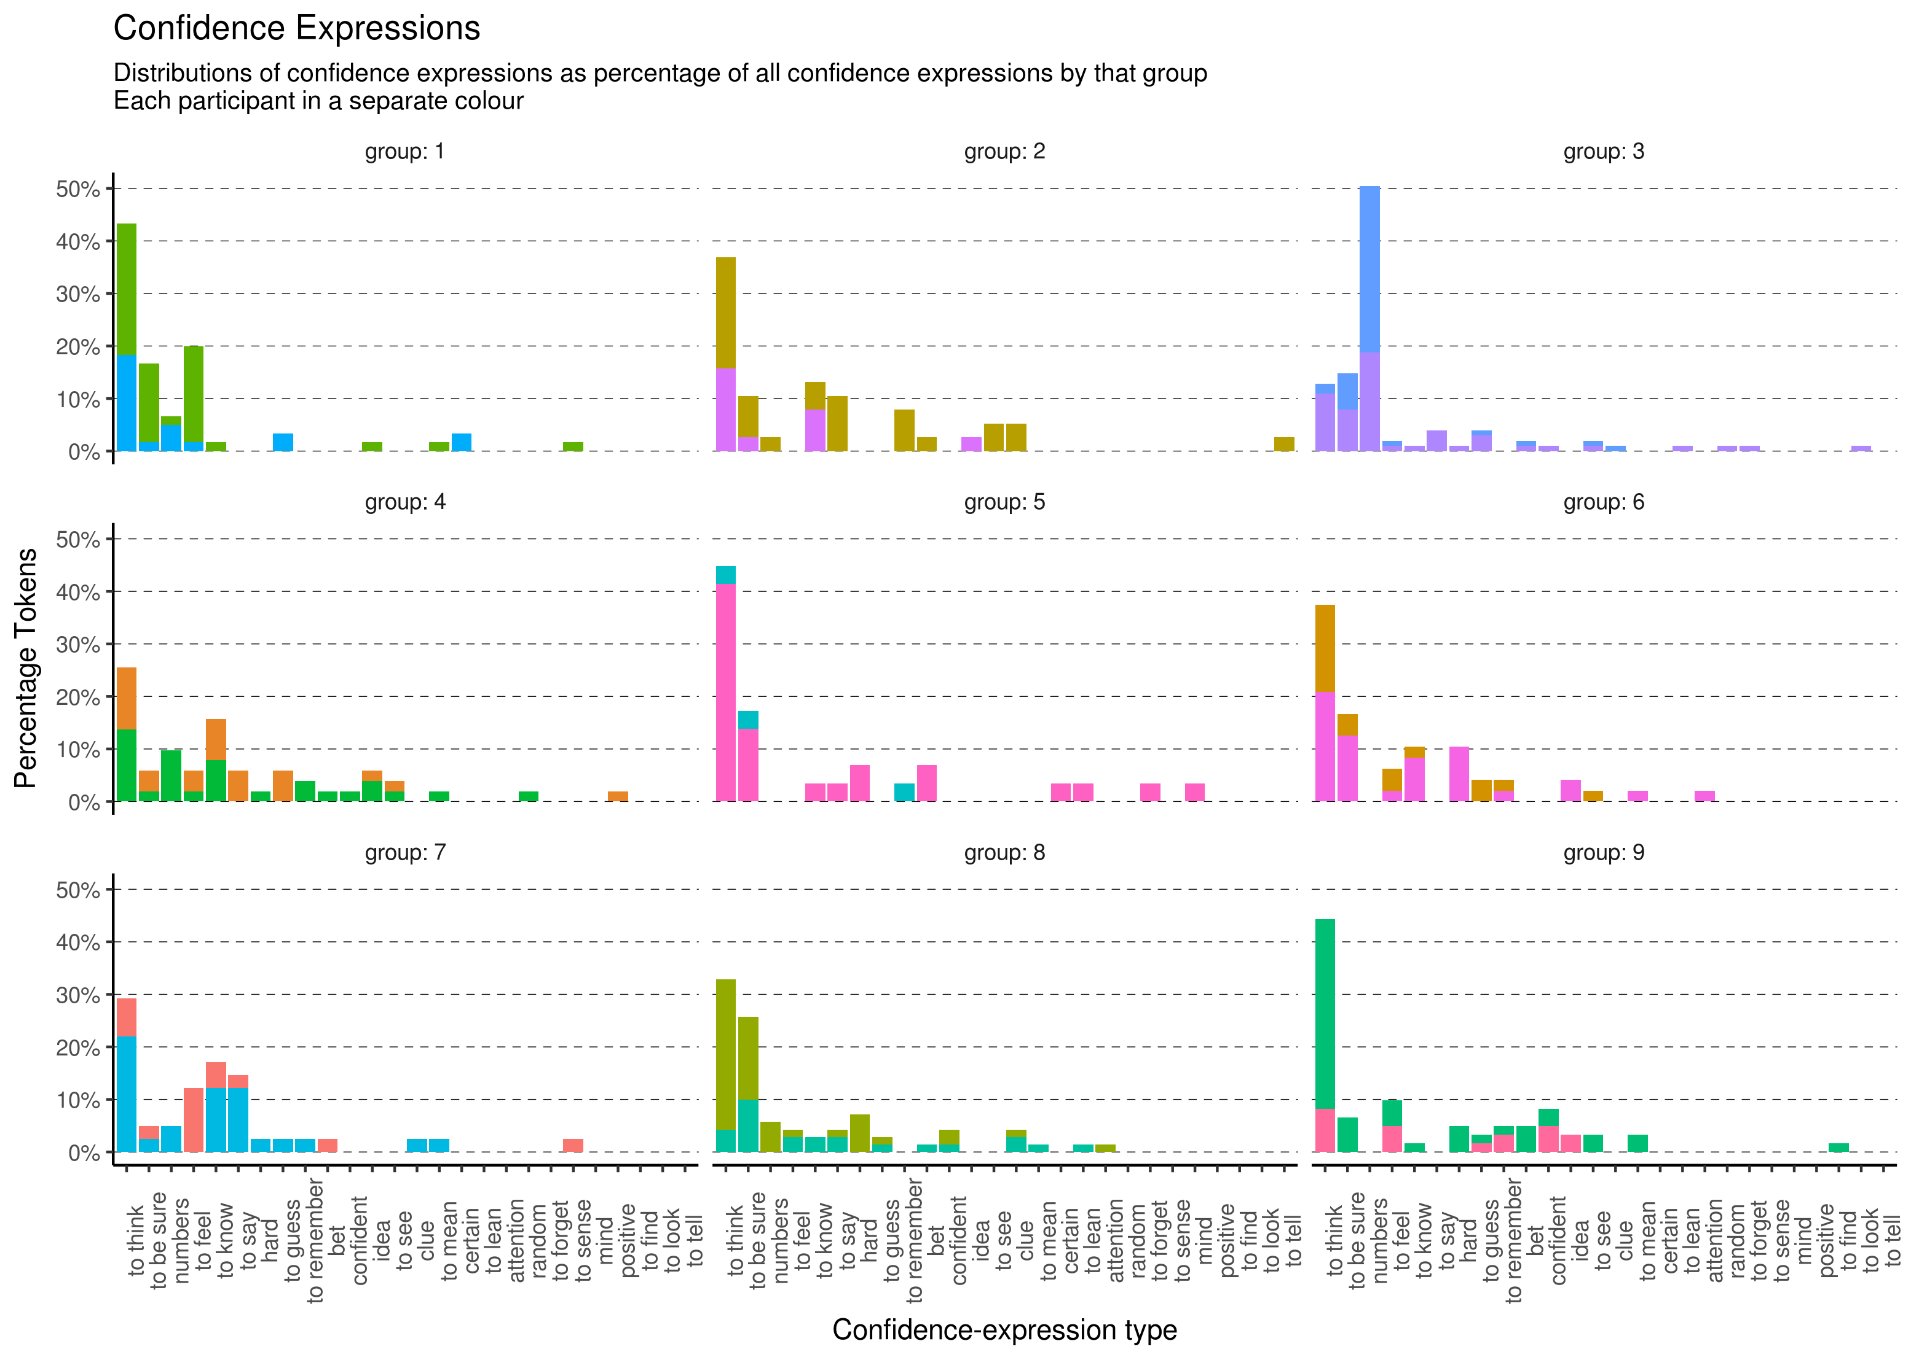

Stan code for the local confidence alignment model
data{
// number of data points, groups, and vowels
int<lower=1> N;
int<lower=1> N_group;
int<lower=1> N_vowel;

// binomial data for the two psychometric functions
int<lower=0> k_ind[N];
int<lower=0> k_gro[N];
int<lower=0> n_ind[N];
int<lower=0> n_gro[N];

// input data
int group[N];
int vowel[N];
vector[N] intensity;

// collective benefit model
vector[N_group] local_confidence;
}

parameters{
// random effects
vector[N_group] ia_group;
vector[N_group] ib_group;
vector[N_group] ga_group;

vector[N_vowel] ia_vowel;
vector[N_vowel] ib_vowel;
vector[N_vowel] ga_vowel;
vector[N_vowel] gb_vowel;

// main effects
real ga;
real gb;
real ia;
real ib;

// =========================================================
// parameters for the collective benefit model
real<lower=0> collective_benefit[N_group];
real<lower=0> collective_sigma;
real col_a;
real col_b_confidence;

}

transformed parameters{
vector[N_group] gb_group;
vector<lower=0,upper=1>[N] gb_group_theta;

for (i in 1:N) {
// collective benefit = inv_logit(dyad slope) / inv_logit(individual slope)
// isolate for the group effect of the dyad slope
gb_group_theta[i] = inv_logit(ib +ib_vowel[vowel[i]] +ib_group[group[i]]) *
collective_benefit[group[i]];
gb_group[group[i]] = logit(gb_group_theta[i]) - (gb + gb_vowel[vowel[i]]);
}
}

model{
// intermediate parameters for the psychometric curves
vector[N] gtheta;
vector[N] gA;
vector[N] gB;

vector[N] itheta;
vector[N] iA;
vector[N] iB;

// intermediate parameter for the collective benefit model
vector[N] collective_mu;

// priors for the psychometric curves
ia_group ~ normal(0,1);
ib_group ~ normal(0,1);
ga_group ~ normal(0,1);

ia_vowel ~ normal(0,1);
ib_vowel ~ normal(0,1);
ga_vowel ~ normal(0,1);
gb_vowel ~ normal(0,1);

ia ~ normal(0, 1);
ib ~ normal(0, 1);
ga ~ normal(0, 1);
gb ~ normal(0, 1);

// psychometric function for both individuals and groups
gA = ga + ga_vowel[vowel] + ga_group[group];
gB = gb + gb_vowel[vowel] + gb_group[group];

iA = ia + ia_vowel[vowel] + ia_group[group];
iB = ib + ib_vowel[vowel] + ib_group[group];

for (i in 1:N){
// theta is not actually a rate parameter since I'm using binomial_logit
gtheta[i] = gA[i] + gB[i] * intensity[i];
itheta[i] = iA[i] + iB[i] * intensity[i];
}

k_gro ~ binomial_logit(n_gro, gtheta);
k_ind ~ binomial_logit(n_ind, itheta);

// priors for the collective benefit model
col_a ~ normal(1,1);
col_b_confidence ~ normal(0,1);
collective_sigma ~ cauchy(0,2);

// likelihood function for the collective benefit model
for (k in 1:N_group) {
collective_mu[k] = col_a + col_b_confidence * local_confidence[k];
collective_benefit[k] ~ normal(collective_mu[k], collective_sigma);
}
}

