# SellToken Launches the World’s First DEX Short-Trading Aggregation Platform 2a30809a7721f0cbcd49e3744904582

SellToken, the pioneering decentralized short-trading exchange based on smart contracts, is proud to announce the launch of its short-trading aggregation platform. The platform operates entirely on unmodifiable smart contract code, ensuring complete security and reliability in every transaction.

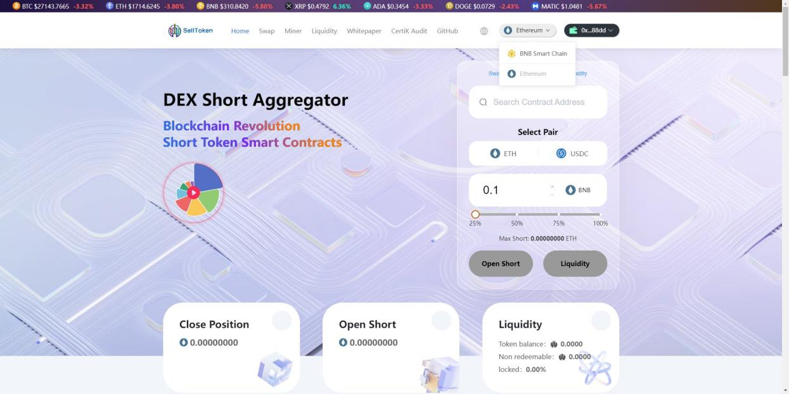

SellToken offers users a unique trading experience compared to traditional centralized exchanges (CEX) that conduct forced liquidation when opening short price positions, exposing traders to malicious price manipulation by large whales. SellToken does not engage in these practices, resulting in a more transparent and user-friendly approach.

All cryptocurrencies can be shorted on SellToken at any time and anywhere, and ERC20 token project parties can add irrevocable short liquidity. The platform currently supports Binance Smart Chain’s BNB and USDT trading pairs, with support for the Ethereum Chain launching soon.

To promote the platform and reward users, SellToken has announced a 5% supply air drop of its SELLC token.

Security is SellToken’s top priority, which is why the platform underwent a thorough security audit by CertiK, a leading blockchain security auditing firm. SellToken emerged from the audit with no critical or high-risk vulnerabilities, indicating its exceptional standards of security and reliability.

SELLC Global IDO 5% Airdrop in April

The SELLTOKEN platform enables TRDT as follows:

1. All tokens across the network short order 1% pull TRDT

2. Network wide project parties create their own token short pool BNB fees, and buy TRDT in real time to return to the TRDT short pool

3. Using BNB to mine TRDTs will result in 10% destruction of TRDTs

TRDT contract

0x61f834516504fc02b3cd80d41722df08fd030141

Platform currency contract

0xa645995e9801F2ca6e2361eDF4c2A138362BADe4

(April ido)

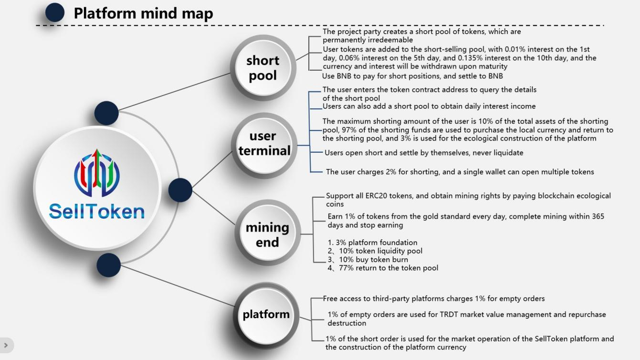

SellToken is the world’s first platform to offer a decentralized short-trading aggregation tool. The platform’s unique approach delivers a safer and fairer trading experience for users, with transactions executed on smart contracts, eliminating the risk of fund attacks and theft.

SellToken invites traders to join its revolution in short-trading, enjoy its enhanced benefits, and experience a new level of financial freedom.

To learn more, visit the official SellToken website at selltoken.org and read the whitepaper at selltoken.org/Whitepaper.pdf.  
  
CertiK audit: <https://certik.com/projects/selltoken>

Twitter: <https://twitter.com/TrustTheTrident>

Telegram: <https://t.me/selltokenGroup>