bambooBSC VM version

author: Chen Xin Nien / Bill Chen

mail: chen.xin.nien@gmail.com

1. Create new VM and import bambooBSC vdmk file to VirtualBox
1.1 Create operation system
OS-Type select BSD
Version select FreeBSD (32-bit)
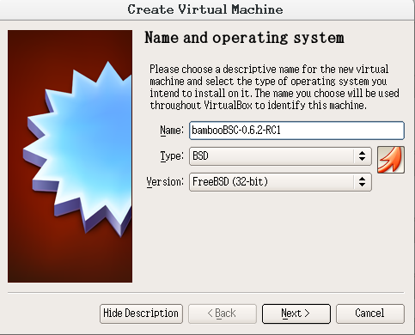

1.2 Memory settings
Please setting value min to 1680MB
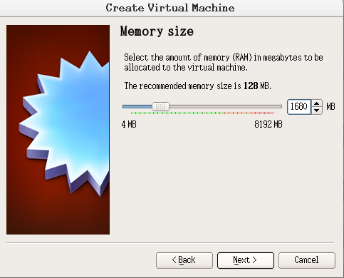

1.3 Select VDMK file
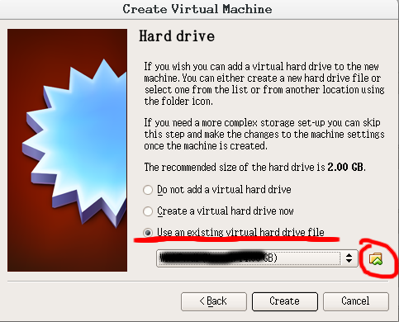

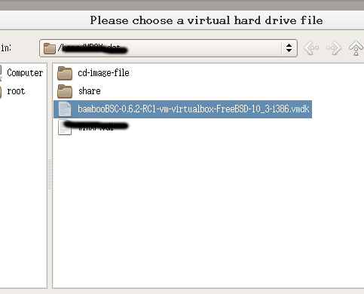

2. Settings VM
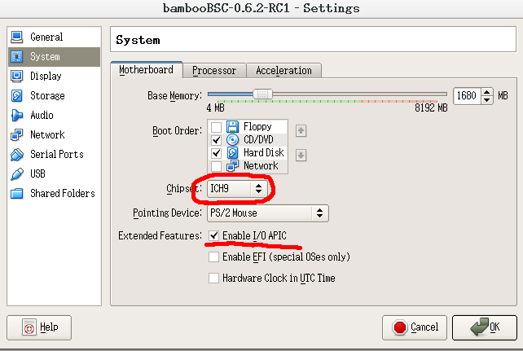
Chipset select ICH9 and Enable I/O APIC

Enable Acceleration options.
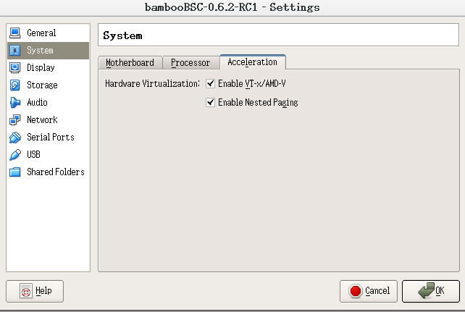

Adapter must attached to “Bridged Adapter” and Type select Intel PRO/1000 MT Desktop

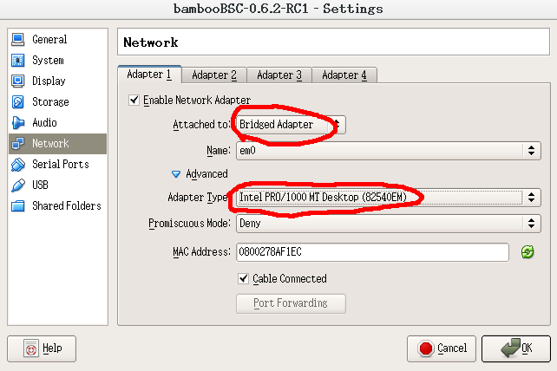

*** bambooBSC VM must be under the DHCP network environment to work. ***

*** bambooBSC VM must be under the DHCP network environment to work. ***

*** bambooBSC VM must be under the DHCP network environment to work. ***

3. Run VM
bambooBSC startup completion may have to wait more than 10 minutes.
and will show URL display on screen, the IP-Address ( 192.168.1.103 ) is request by DHCP.
So after each restart, IP address may be different
Open browser, input URL on Google-Chrome or FireFox.
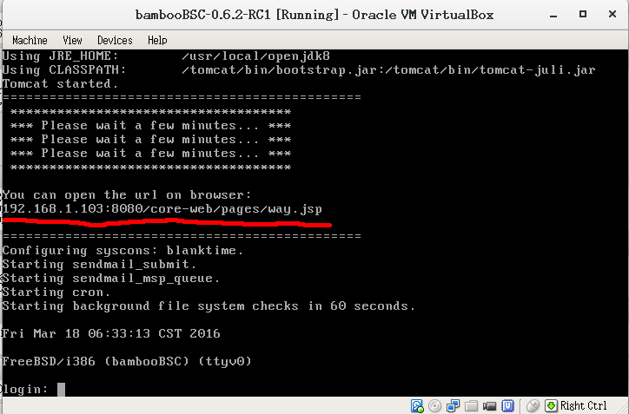

root password : bamboobscadmin123

