Samuel Maltz ECE408: Wireless Communications

Communications Link Assignment

In this assignment, a wireless communications link is simulated using three different channels. In all channels, additive white Gaussian noise is applied to the symbols using a variety of signal-to-noise (SNR) ratios. What differs between the three channels is how much inter-symbol interference (ISI) there is. In the first channel there is no ISI, in the second channel there is moderate ISI and in the third channel there is severe ISI. In what follows are 3 tasks in which different simulations are done varying the channel, modulation scheme, SNR and methods. In each simulation, one packet of length 1000 symbols is passed through the channel. Subsequently, the average bit error rate (BER) over 1000 iterations and bit rate (BR) are computed and are compared to theoretical values. The first two tasks correspond to Part 1 of Prof. Keene’s final project from ECE300 and the third task corresponds to Part 2 of that project.

In task 1, the channel without ISI is used. Simulations were done with SNR values ranging from 0 to 16 dB with 2 dB intervals and three modulation schemes: binary phase shift keying (BPSK), 4-ary quadrature amplitude modulation (QAM) and 16-ary QAM. For each modulation scheme BER curves from the simulation and theoretical values were plotted. Figures 1-3 show the results from these simulations. As the SNR increases, the BER decreases in all modulation schemes. Note that the simulated results and theoretical results match so closely that it is hard to tell the difference between the two. Also note that starting at 12 dB SNR for BPSK and 16 dB SNR for 4QAM, there were no bit errors at all in the simulation leading to a drop off in the graphs.

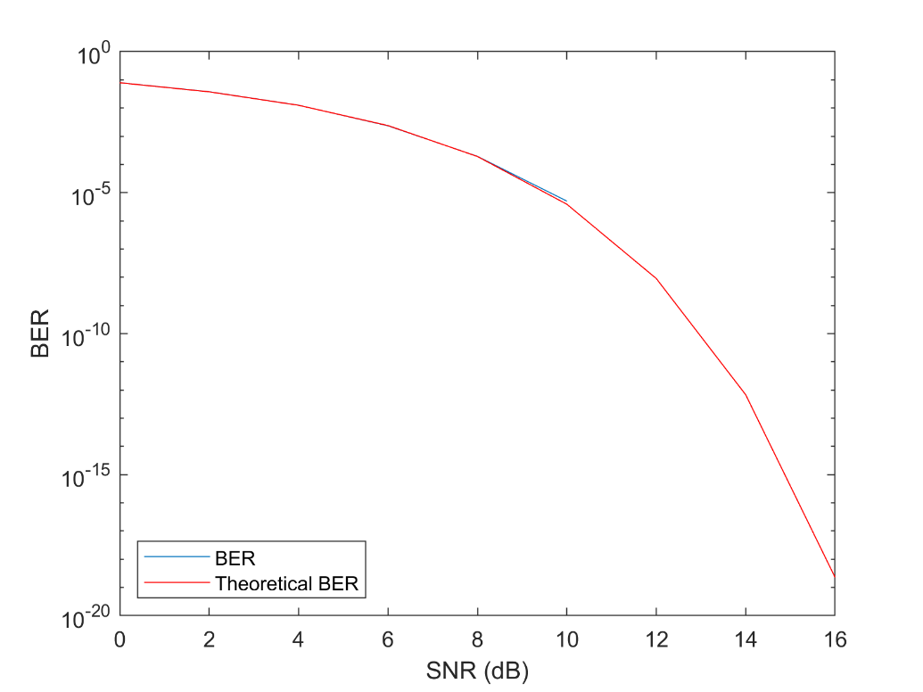

*Figure 1: BER vs. theoretical BER (BPSK)*

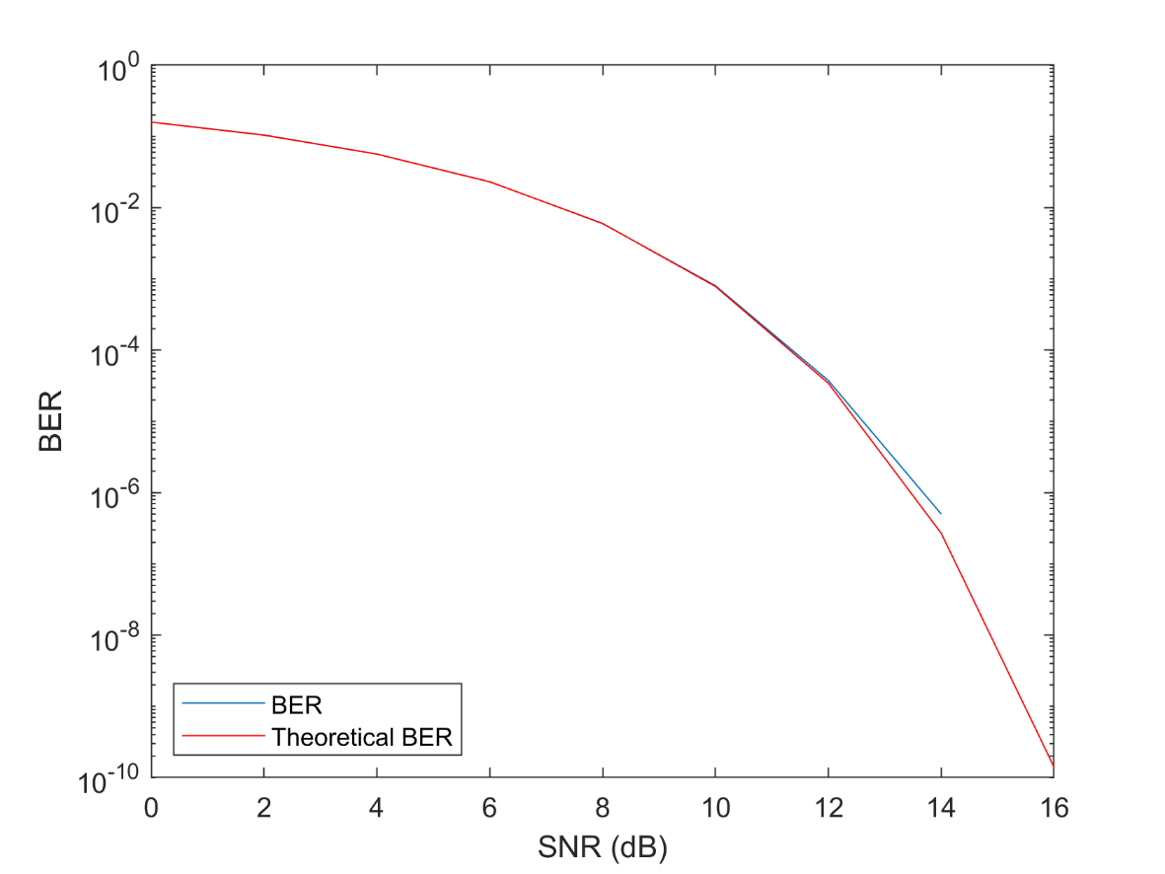

*Figure 2: BER vs. theoretical BER (4QAM)*

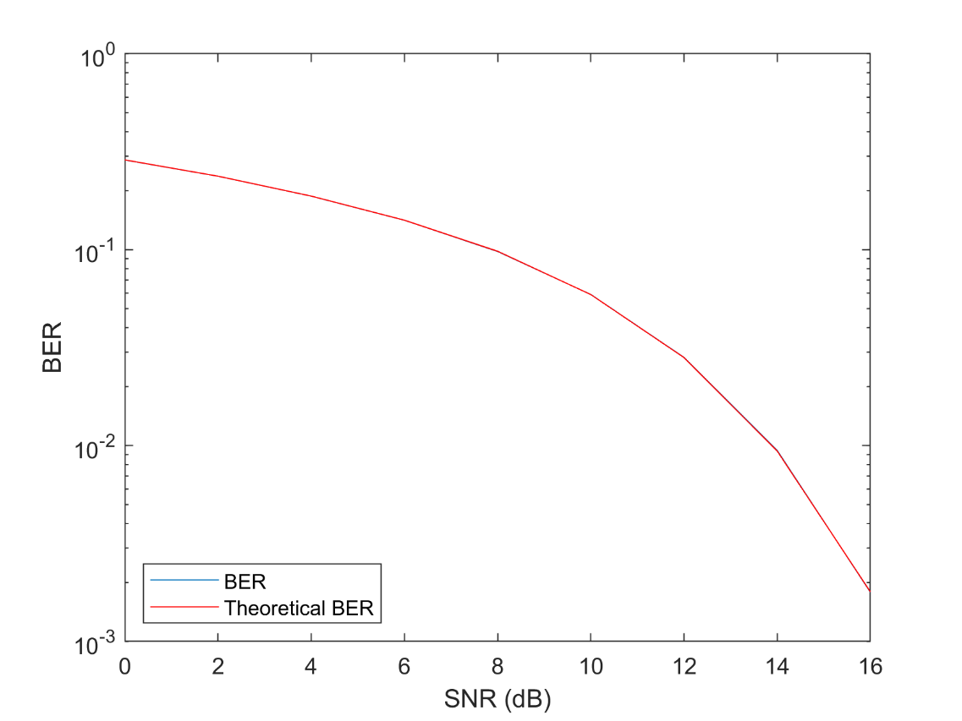

*Figure 3: BER vs. theoretical BER (16QAM)*

Table 1 shows the BR for each of the modulation schemes. Modulation schemes which pack more bits into a symbol have a larger BR.

*Table 1: BR for each modulation scheme*

|  |  |
| --- | --- |
| Modulation | BR (bits/sym) |
| BPSK | 1 |
| 4QAM | 2 |
| 16QAM | 4 |

In task 2, the two channels with ISI are applied and equalization is used to mitigate their effects. The equalization technique used is an adaptive linear technique which uses recursive mean squares to calculate the residual errors. The filter has 3 taps and uses the identity matrix as its initial inverse correlation matrix. The equalization reduces the effects from the ISI and lowers the average BER; however, it requires training symbols to learn its initial weights which lowers the BR of the link. Table 2 shows the average BER of the two channels and the BR of the link when a BPSK modulation scheme is employed and the SNR is 12 dB. Note that the equalization was tuned with respect to the moderate ISI channel and not the severe ISI channel. This and the severity of the ISI of the third channel is why the BER for that channel is higher than that of the second channel.

Finally, in task 3, error correction coding is included to further reduce the BER in the moderate ISI channel when using BPSK modulation and at 12 dB SNR. The code used is a 4/7 Bose–Chaudhuri–Hocquenghem (BCH) code. As table 2 shows, this further reduces the average BER to exactly 0 over 1000 iterations; however, it reduces the BR since additional bits are needed for the BCH code. This is in addition to the message bits in the symbols which are used for training the equalization filter. These three simulations show the tradeoff between BER and BR and the decision which has to be made when designing a communications link.

*Table 2: BER and BR on ISI channels with different techniques*

|  |  |  |  |
| --- | --- | --- | --- |
| Technique | Moderate ISI BER | Severe ISI BER | BR (bits/sym) |
| Equalization | 0.000853 | 0.39413 | 0.9 |
| Equalization & Coding | 0 | 0.41025 | 0.512 |