TASK 1: COLOUR SPACES AND A COLOUR PICKER

Question

Load a colourful image and convert it to HSV and LAB. Display the three channels of each colour space side by side and describe what each channel encodes. Choose a strongly coloured object, determine its hue range, and use cv2.inRange to produce a binary mask that isolates it. Explain why this is easier in HSV than in RGB.

Answer

The colourful cake image was loaded using OpenCV and converted from BGR to RGB for display. It was then converted to the HSV and LAB colour spaces.

In HSV, the Hue (H) channel represents the type of colour, the Saturation (S) channel represents the purity or intensity of the colour, and the Value (V) channel represents brightness. In LAB, the Lightness (L) channel represents perceived brightness, the a channel represents colours along the green-to-red axis, and the b channel represents colours along the blue-to-yellow axis.

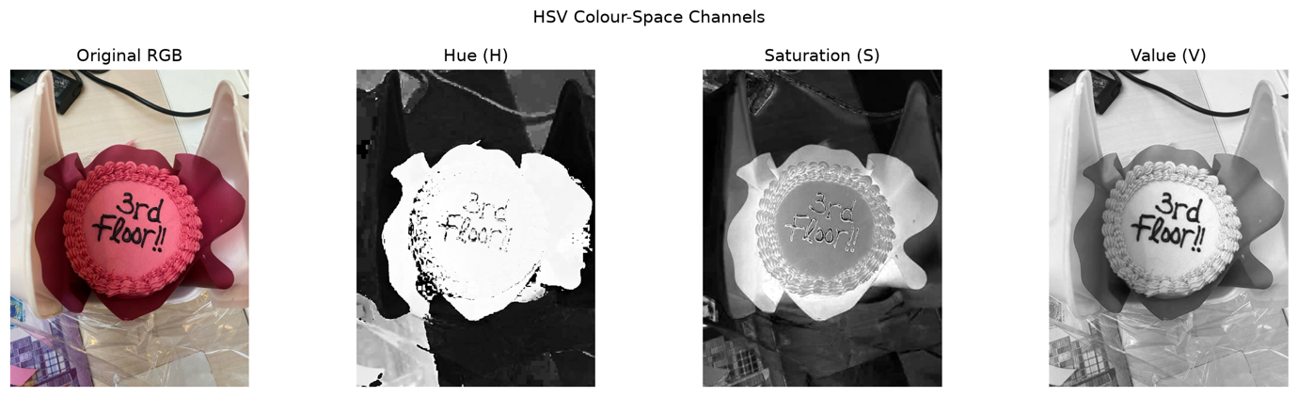
[Figure 1: hsv_channels.png]

Figure 1: Original cake image and its HSV channels.

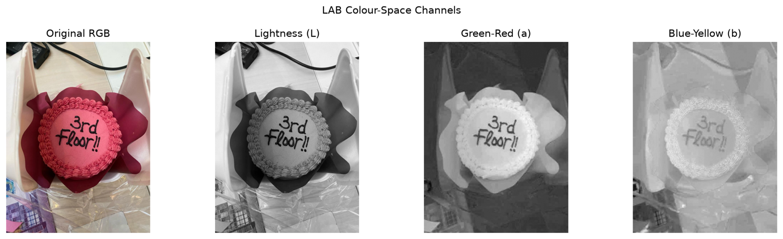
[Figure 2: lab_channels.png]

Figure 2: Original cake image and its LAB channels.

The pink and magenta parts of the cake arrangement were selected using an OpenCV hue range of 155–179. Minimum saturation and value values of 55 were used to reduce the inclusion of grey, white and very dark pixels. The binary mask was created using cv2.inRange, and the mask was applied to the original image using cv2.bitwise_and.

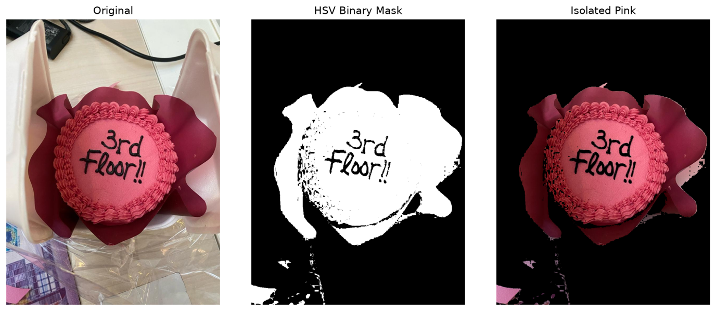
[Figure 3: colour_picker_result.png]

Figure 3: Original image, HSV binary mask and isolated pink regions.

Colour-based selection is easier in HSV than in RGB because HSV separates colour information from brightness. The hue channel can therefore be thresholded directly, while saturation and value can be used to exclude weak or dark colours. In RGB, changes in lighting affect the red, green and blue values simultaneously, making it harder to define a stable range for one colour.

The mask successfully isolated most of the cake and its pink or burgundy wrapping. Some surrounding wrapping was also selected because its hue was similar to the cake. This demonstrates that colour segmentation cannot distinguish different objects when they have overlapping colour ranges.

