UNIVERSITY OF ZAMBIA

SCHOOL OF NATURAL AND APPLIED SCIENCES

DEPARTMENT OF COMPUTING AND INFORMATICS

CSC6302 - COMPUTER VISION

PRACTICAL 3 REPORT

DETECTING THINGS: FROM TEMPLATE MATCHING TO YOLO, PLUS YOUR FIRST VISION APP

STUDENT NAME: MALUBA MULEBI

COMPUTER NUMBER: 2025025124

PROGRAMME: MASTER OF SCIENCE IN ARTIFICIAL INTELLIGENCE

COURSE CODE: CSC6302

COURSE NAME: COMPUTER VISION

PRACTICAL: PRACTICAL 3 (WEEKS 6–7)

Introduction

Object detection is an important area of computer vision concerned with identifying and locating objects within digital images and video sequences. This practical investigated the development of object detection techniques, from traditional template matching and Viola–Jones face detection to modern deep learning approaches using YOLOv8.

The practical began by implementing template matching using OpenCV's normalized cross-correlation method to examine its sensitivity to changes in object orientation and viewpoint. The Viola–Jones Haar cascade detector was then evaluated on a group photograph and video, including an experimental comparison of different scale factors and minimum neighbour parameters.

A pretrained YOLOv8n model was subsequently used to detect people and everyday objects, investigate the effect of confidence thresholds, and compare processing performance against the Haar cascade detector. An interactive application was also developed using Gradio to enable users to upload images and select between the two detection methods.

The implementation was carried out using Python, OpenCV, Ultralytics YOLOv8n and Gradio. The practical additionally examined ethical concerns associated with face detection, including privacy, informed consent and algorithmic fairness in the Zambian context.

Task 1: Template Matching and Its Limitations

Methodology
Template matching was implemented using OpenCV's cv2.matchTemplate() function with the normalized cross-correlation method (TM_CCOEFF_NORMED). A distinctive region containing the Jameson bottle label was cropped from the original photograph and used as the reference template.

The template was first matched against the original image and subsequently against a second photograph showing the same bottle from a different angle. The maximum correlation score and corresponding bounding box were recorded for each image. Correlation score maps were generated to visualize the similarity between the template and candidate image regions.

Experimental Results

Table 1: Template Matching Correlation Results
Test Image | Maximum Correlation Score.
Original bottle photograph | 1.0000
Changed-angle photograph | 0.2155
Difference | 0.7845


Figure 1: Reference template extracted from the original bottle photograph

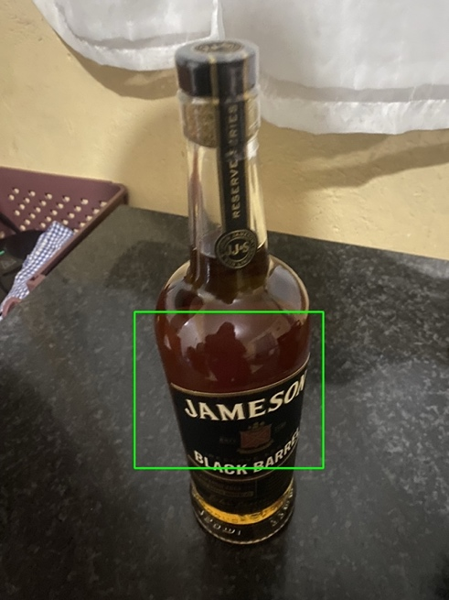
Figure 2: Template matching on the original photograph (score = 1.0000)

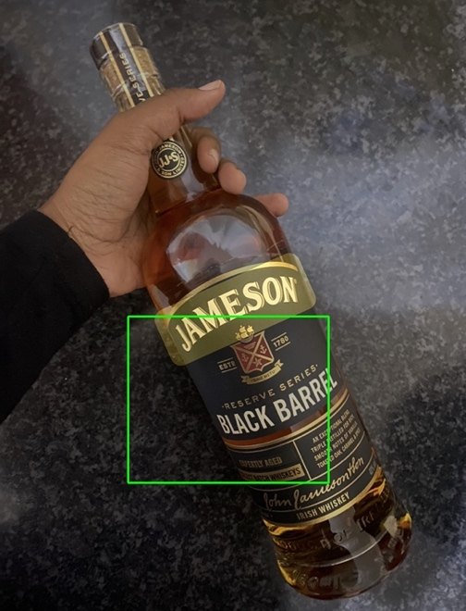
Figure 3: Template matching on the changed-angle photograph (score = 0.2155)
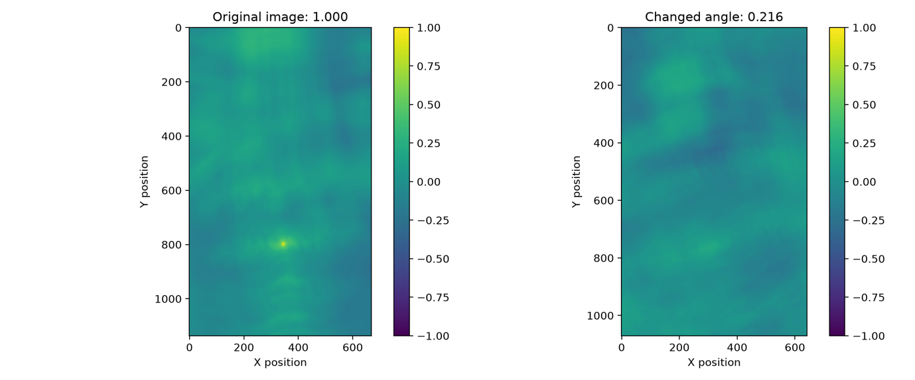
Figure 4: Normalized cross-correlation score maps for the original and changed-angle images
The original photograph produced a maximum correlation score of 1.0000, indicating an exact match with the extracted template. In contrast, the changed-angle photograph produced a substantially lower maximum score of 0.2155.

Discussion

Normalized cross-correlation achieved a perfect score of 1.0000 in the original photograph because the template matched an identical region, but its maximum score dropped to 0.2155 in the changed-angle photograph. This reduction demonstrates the sensitivity of conventional template matching to changes in rotation, viewpoint, scale and appearance, which disrupt the spatial alignment of pixel intensities.

Task 2: Viola–Jones Face Detection

Methodology

The Viola–Jones face detection algorithm was implemented using OpenCV's pretrained Haar cascade classifier (haarcascade_frontalface_default.xml). The detector was evaluated on a group photograph containing four individuals and a video consisting of 384 frames.

The input images were converted to grayscale and processed using histogram equalization to improve intensity contrast. A parameter study was conducted using three scaleFactor values (1.05, 1.10 and 1.30) and three minNeighbors values (3, 5 and 8), producing nine configurations.

For each configuration, the number of detections and processing time were recorded. The annotated output images were visually examined to distinguish correct face detections, missed faces and false positives.

Parameter Study Results

Table 2: Haar Cascade Parameter Study
scaleFactor | minNeighbors | Detections | Correct (TP) | Missed (FN) | False (FP) | Time (ms)
1.05 | 3 | 6 | 0 | 4 | 6 | 930.96
1.05 | 5 | 1 | 0 | 4 | 1 | 419.29
1.05 | 8 | 1 | 0 | 4 | 1 | 414.79
1.1 | 3 | 2 | 0 | 4 | 2 | 215.41
1.1 | 5 | 1 | 0 | 4 | 1 | 203.62
1.1 | 8 | 1 | 0 | 4 | 1 | 202.79
1.3 | 3 | 1 | 0 | 4 | 1 | 97.69
1.3 | 5 | 1 | 0 | 4 | 1 | 94.76
1.3 | 8 | 0 | 0 | 4 | 0 | 106.33

Note: True positives, missed faces and false positives were estimated through visual inspection of the annotated photographs.

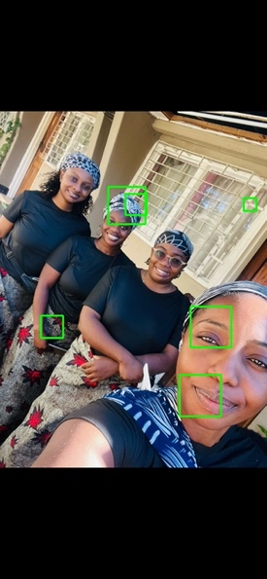
Figure 5: Haar detection with scaleFactor = 1.05, minNeighbors = 3

Figure 6: Haar detection with scaleFactor = 1.10, minNeighbors = 5

Figure 7: Haar detection with scaleFactor = 1.30, minNeighbors = 8

Video Processing Results

The Haar cascade detector successfully processed all 384 frames of the input video and generated an annotated output video with bounding boxes around predicted facial regions.

The average face detection processing time was 150.15 milliseconds per frame, corresponding to approximately 6.66 frames per second for the measured detection operation.

Although detection boxes appeared in the video, some were incorrectly positioned. This demonstrated the difficulty of applying a frontal-face detector to uncontrolled scenes.

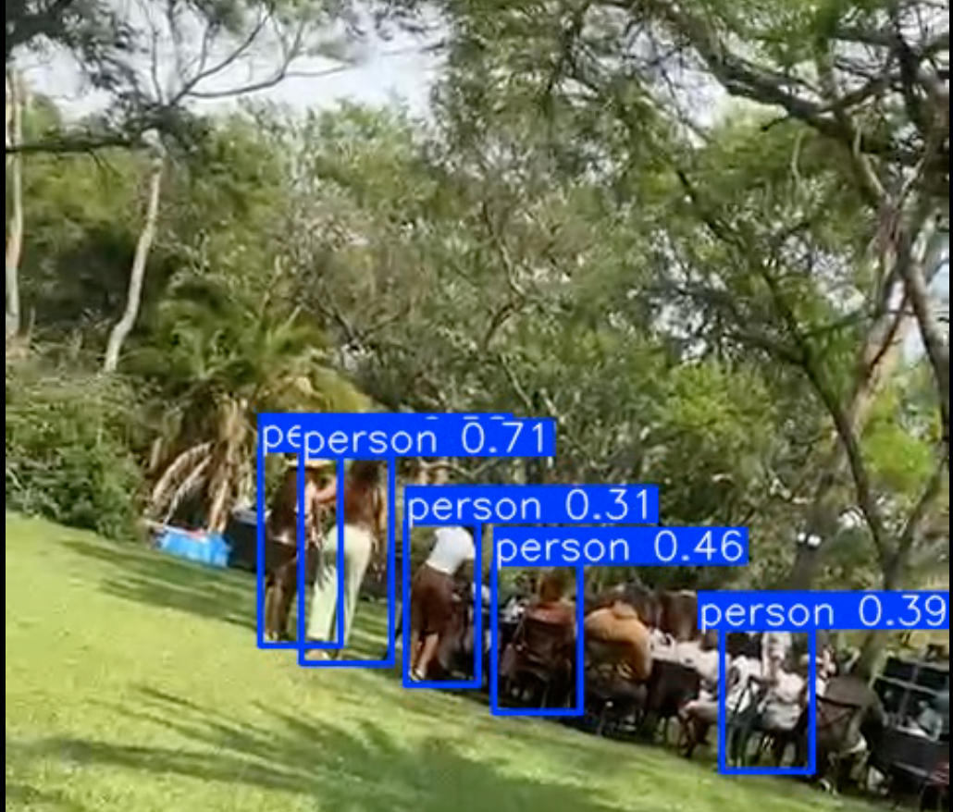
Figure 8: Example frame from the Haar-annotated video showing predicted face regions.

Discussion

The experiment demonstrated that both scaleFactor and minNeighbors influence detection sensitivity, computational cost and false-positive rates.

A smaller scaleFactor of 1.05 examined more closely spaced image scales, increasing processing time and producing more detections. Increasing scaleFactor to 1.30 reduced processing time but also reduced the number of detected regions.

Lower minNeighbors values allowed more candidate detections, including false positives. Higher values imposed stricter acceptance conditions, reducing detections and potentially rejecting genuine faces.

None of the tested configurations correctly enclosed all four faces in the photograph. The results may be associated with tilted facial orientations, differences in scale, partial occlusion and challenging visual conditions.

Viola–Jones relies on Haar-like rectangular intensity features and a cascade of classifiers trained to recognize particular facial patterns. Changes in facial orientation, lighting and appearance can disrupt these patterns, reducing detection reliability.

Task 3: Modern One-Shot Object Detection Using YOLOv8n

Methodology

A pretrained YOLOv8n (You Only Look Once, version 8 nano) model was implemented using the Ultralytics library to perform object detection on a group photograph, an everyday-object photograph and a video sequence.

The group photograph was evaluated using the COCO person class, while the everyday-object photograph was processed using the model's available object categories. The video was processed frame by frame using a confidence threshold of 0.25.

Four confidence thresholds (0.10, 0.25, 0.50 and 0.75) were evaluated to investigate their influence on the number of detections. The model was executed on the CPU, and average per-frame processing time was measured for comparison with the Viola–Jones Haar cascade detector.

Confidence Threshold Experiment

Table 3: YOLOv8n Detection Counts at Different Confidence Thresholds
Confidence Threshold | Group Photograph (Person) | Object Photograph
0.1 | 8 | 2
0.25 | 7 | 2
0.5 | 4 | 1
0.75 | 1 | 0

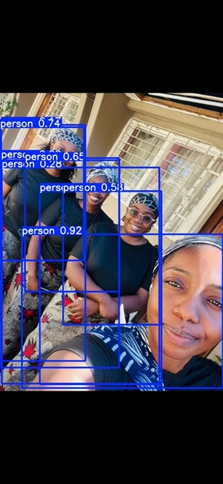
Figure 9: YOLO person detections at confidence 0.10
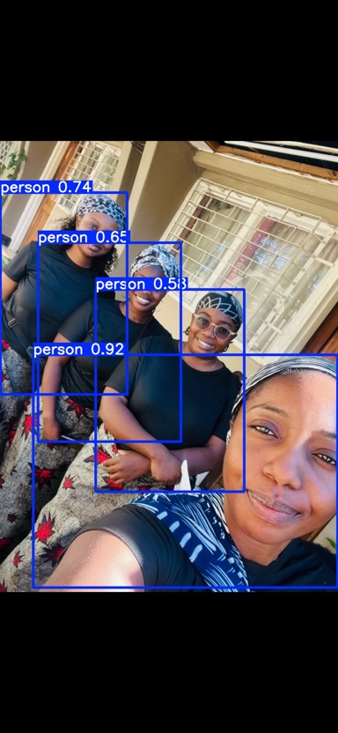
Figure 10: YOLO person detections at confidence 0.50
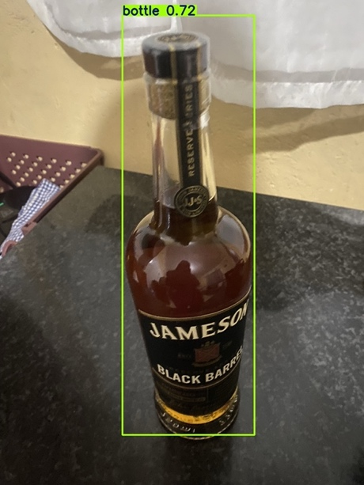
Figure 11: YOLO everyday-object detection at confidence 0.25
The number of detections decreased as the confidence threshold increased. In the group photograph, the model returned eight detections at a threshold of 0.10 and four at 0.50. At 0.75, only one detection remained.

For the everyday-object photograph, YOLO identified a bottle with a confidence score of approximately 0.72. At a confidence threshold of 0.25, the model also identified a dining table with a lower confidence score of approximately 0.28. Increasing the threshold to 0.50 removed the lower-confidence prediction while retaining the bottle.

These results demonstrate the trade-off between detection sensitivity and confidence-based filtering. Lower thresholds admit more detections, including uncertain predictions, while higher thresholds may reject valid objects.

Non-Maximum Suppression (NMS)

Non-Maximum Suppression is a post-processing technique used to reduce duplicate object detections. It retains a high-confidence bounding box and suppresses lower-confidence boxes that overlap substantially with it, typically based on an Intersection over Union (IoU) threshold.

Ultralytics YOLOv8n applies NMS internally during prediction. Consequently, the annotated output images represent detections after suppression rather than the complete set of raw candidate boxes.

Some overlapping person boxes remained in the group photograph at lower confidence thresholds. However, overlapping boxes do not necessarily indicate incorrect NMS, because separate nearby individuals may have overlapping bounding regions.

The experiment demonstrates confidence-threshold filtering, while the NMS explanation describes the model's internal suppression process. A separate raw-versus-suppressed box comparison was not generated.

Processing Speed Comparison

Table 4: Average Per-Frame Processing Times
Detection Method | Frames Processed | Average Time per Frame
Haar Cascade | 384 | 150.15 ms
YOLOv8n | 384 | 146.04 ms

Figure 12: Example frame from the YOLO-annotated video demonstrating object detection during frame-by-frame processing.

Both methods successfully processed the same 384-frame video on the CPU. YOLOv8n recorded an average processing time of 146.04 milliseconds per frame, compared with 150.15 milliseconds for the Haar cascade.

However, the timing measurements were not strictly equivalent: the Haar experiment timed the face-detection operation, whereas the YOLO experiment timed the complete model prediction call. Therefore, the small difference should not be interpreted as conclusive evidence that YOLOv8n is computationally faster.

Robustness and Detection Performance

The Haar cascade struggled to correctly locate faces in the tilted group photograph, producing false positives and missing visible faces. In contrast, YOLOv8n detected four plausible person regions at a confidence threshold of 0.50.

The results suggest that YOLOv8n handled the varied person positions and orientations in this photograph more effectively. However, the methods detect different targets: Haar detects frontal faces, while YOLO was configured to detect whole people.

Variations in viewing angle, partial occlusion and lighting can reduce the reliability of both detectors. This practical provided qualitative observations rather than separate controlled experiments isolating each of these factors.

Conclusion

YOLOv8n demonstrated effective detection of people and everyday objects using a pretrained deep learning model. Although the Haar cascade performed poorly on the selected group photograph, it remains useful for lightweight frontal-face detection in controlled environments, particularly when computational resources are limited or a simpler detection system is sufficient.

Task 4: Interactive Gradio Vision Application

Application Development

An interactive object detection application was developed using Gradio to provide a user-friendly interface for the computer vision techniques implemented in this practical. The application integrates two detection backends: the traditional Viola–Jones Haar cascade for face detection and the pretrained YOLOv8n model for general object detection.

The application was implemented in Python in the app.py file and designed to launch locally using the command python app.py. Once launched, users can access the interface through a web browser without interacting directly with the underlying Python code.

The interface provides four main features:

An image upload component for selecting an input photograph.

A radio button for choosing between Haar face detection and YOLO object detection.

A confidence slider for adjusting the YOLO detection threshold.

An annotated image output displaying detected regions with bounding boxes and labels.

The confidence slider applies only to YOLOv8n, while the Haar cascade operates using fixed parameters (scaleFactor = 1.1, minNeighbors = 5).

Application Testing and Results

The application was tested using the group photograph and the everyday-object photograph.

When the YOLO detection backend was selected, the application successfully identified the bottle and displayed its bounding box and confidence score. An initial RGB/BGR colour conversion issue was identified during testing and corrected to preserve the original image colours.

The Haar cascade backend also processed the group photograph and returned an annotated output. However, the bounding box did not correctly identify a face, consistent with the limitations observed during the earlier Viola–Jones experiment.

Both detection methods were accessible through the same interface, and the application successfully returned annotated images after users selected their preferred detection method.

Discussion

The Gradio application demonstrates how computer vision algorithms can be incorporated into an accessible interface without requiring end users to understand the underlying implementation.

The YOLO backend produced more useful detections for the selected everyday-object photograph, while the Haar backend demonstrated the limitations of traditional face detection when applied to challenging images.

Overall, the application met the functional requirements of image uploading, detector selection, confidence adjustment and annotated output generation.

Figure 13: Gradio application using Haar cascade face detection

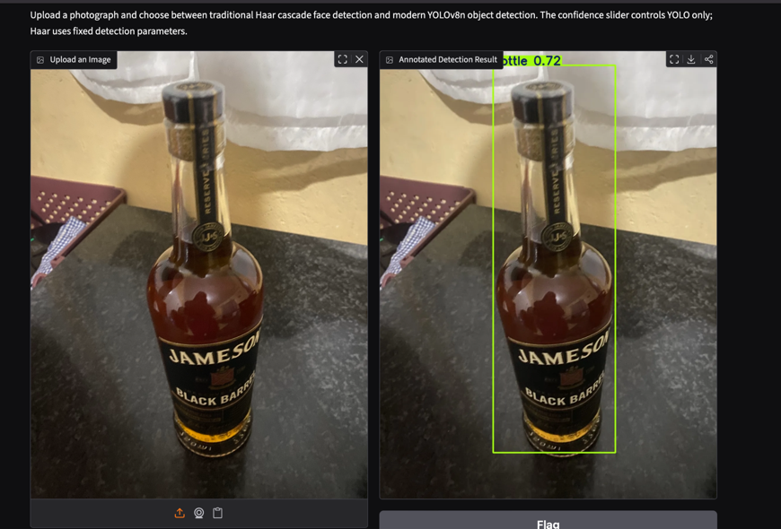
Figure 14: Gradio application using YOLOv8n object detection

Task 5: Ethical Reflection on Face Detection

Face detection technology raises ethical concerns regarding privacy, consent and algorithmic fairness. In Zambia, its deployment in CCTV surveillance systems around Lusaka could improve security but also expose individuals to excessive monitoring without their knowledge or consent.

A major risk is inaccurate detection. During this practical, the Haar cascade produced false positives and failed to correctly locate faces in the group photograph. In real-world surveillance, such errors could result in individuals being unfairly flagged. Detection performance may also vary across skin tones, lighting conditions and facial orientations, potentially creating unequal outcomes.

An essential safeguard is human verification before making decisions based on automated detections. Systems should also implement data protection measures, transparency and fairness testing using representative Zambian datasets.

For this practical, I personally contacted the other three individuals in the group photograph and obtained their consent to use their images for the assignment. This reinforced the importance of informed consent and responsible use of identifiable data.

Conclusion

This practical demonstrated the capabilities and limitations of traditional and modern object detection techniques. Template matching achieved a correlation score of 1.0000 on the original photograph but decreased to 0.2155 when the object's viewpoint changed, highlighting its sensitivity to variations in appearance.

The Viola–Jones Haar cascade struggled to accurately detect faces in the selected group photograph, while YOLOv8n produced more reliable person and object detections. The video experiments recorded average processing times of 150.15 ms for Haar and 146.04 ms for YOLO, although the different timing procedures limit direct performance comparisons.

The successful development of an interactive Gradio application demonstrated how these detection techniques can be made accessible through a simple interface. Overall, the practical highlighted the importance of selecting appropriate detection methods, evaluating their limitations and considering ethical issues such as privacy, consent and algorithmic fairness.

References

Gradio. (n.d.). Gradio documentation. https://www.gradio.app/docs

OpenCV. (n.d.). OpenCV documentation. https://docs.opencv.org/4.x/

Ultralytics. (n.d.). Ultralytics YOLO documentation. https://docs.ultralytics.com/

Viola, P., & Jones, M. (2001). Rapid object detection using a boosted cascade of simple features. In Proceedings of the 2001 IEEE Computer Society Conference on Computer Vision and Pattern Recognition (CVPR). https://doi.org/10.1109/CVPR.2001.990517

Declaration of AI Assistance

OpenAI ChatGPT (GPT-6) was used to assist with Python environment configuration, code development, debugging, interpretation of experimental results, and preparation and editing of this report. The practical was executed and tested locally using the student's selected images and video. The reported measurements were obtained from the actual program outputs, and the resulting annotations were reviewed during the experiments.

AI assistance was used as a supporting tool, and the student remains responsible for verifying the results, understanding the implementation and ensuring the accuracy of the submitted work.

