Team: Rokas Malukas, Rokas Ščepanovas. Group: 4.

NGBLA
(National German Basketball League for Amateurs)

Goal:

Create fan page for national German basketball league.

Iterations:
0. (login, register, logout);
- First iteration:
  - Create post(for superuser);
  - Edit post(for superuser);
  - Delete post(for superuser);
  - Read posts list;
  - Read post in detail;
- Second iteration:
  - Create forum post;
  - Edit forum post;
  - Delete forum post;
  - Display forum post list and post in detail;
- Third iteration:
  - Comment in forum and news feed;
  - Delete comment;
  - Submit match details (for superuser);
  - Submit player details (for superuser);
- Fourth iteration:
  - Submit score (for superuser);
  - Sort out news by team;
  - Front-end implementation;
  - CRUD player statistics(for superuser);

Technologies used:
- Python Django (framework);
- JavaScript;
- SQLite;
- Git (github);

Service actions diagram:
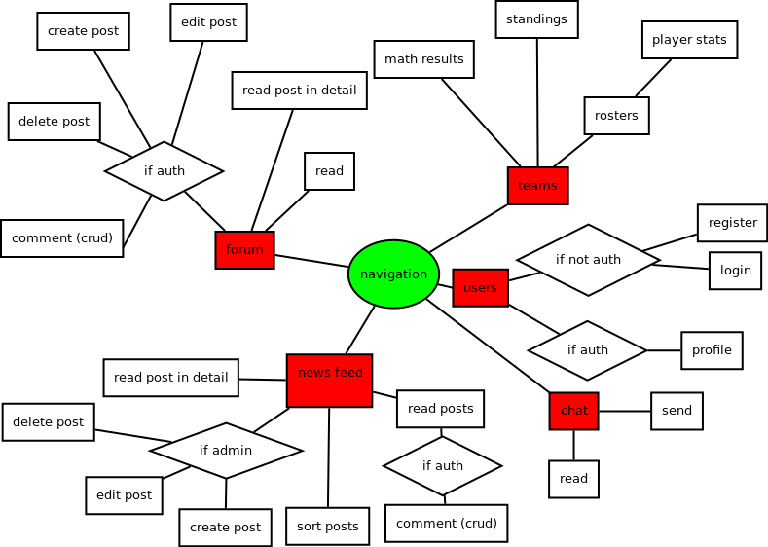
Forum for teams fans (crud functions);
- read post;
- create post;
- edit post;
- delete;
- comment;
Chat (AJAX);
- read;
- post;
Login/register forms;
- create user;
- authenticate user;
Teams statistics;
- roster;
- standings;
- results;
- players stats;
Schedule;
- upcoming matches;
- history;
News feed;
- read post;
- create post;
- edit post;
- delete;
- comment;
- sort by team;

Database structure:

Diagram:

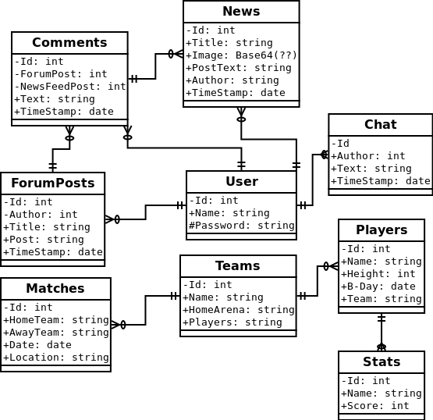

Listed tables can be found in the following page.

Tables:
- Users;
  - Name;
  - Password;
- News;
  - Title;
  - Image;
  - PostText;
  - Author(User.Id);
  - TimeStamp;
- Players;
  - Name;
  - Height;
  - B-Day;
  - Team(Team.Name);
- Stats;
  - Player(Player.id);
  - Player(Player.Name);
  - Score;
- Teams;
  - Name;
  - HomeArena;
  - Players(Player.Name);
- Matches;
  - HomeTeam(Team.Name);
  - AwayTeam(Team.Name);
  - Date;
  - Location(Team.HomeArena);
- ForumPosts;
  - Author(User.Id);
  - Title;
  - Post;
  - TimeStamp;
- Comments;
  - ForumPost(ForumPosts.Id);
  - NewsFeedPost(News.Id);
  - Text;
  - TimeStamp;
- Chat;
  - Author(User.Id);
  - Text;
  - TimeStamp;
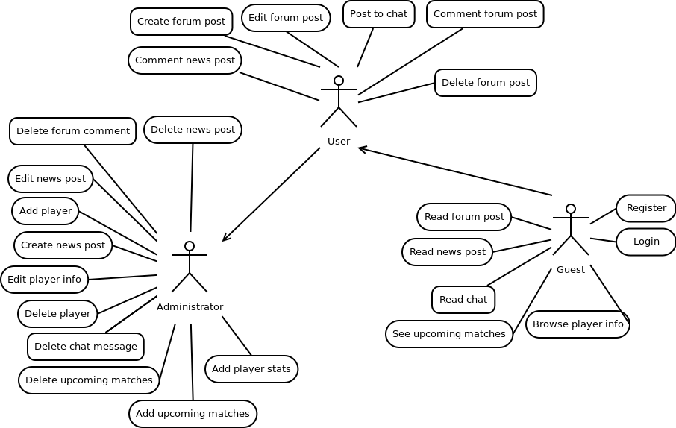
Use case diagram:

User inherits Guest’s functions and Administrator inherits both User’s and Guest’s functionality.

