
PIPELINEOS
End-to-End Product & Technical Documentation
Modern AI-ready sales pipeline operations, backed by Supabase
Prepared for: Alba Corp — Data Dashboard on a Backend Service
Document version: 1.0 | July 24, 2026 | Status: production deployment
REVIEWER-READY
This guide includes two seeded workspaces, complete credentials, a product walkthrough, the full schema, services and SQL functions, RLS proof, setup from zero, deployment instructions, and measured Lighthouse results.

1. Executive overview
PipelineOS is a focused CRM and revenue-intelligence workspace for a small sales team. It replaces spreadsheet-driven pipeline tracking with a normalized, authenticated data model; clear operational workflows; and dashboards that show how opportunities move from first signal to closed revenue.
The product is designed to feel like real SaaS software rather than a generic administration template. Users manage companies, people, opportunities, and follow-up activity from one persistent workspace. PostgreSQL performs the analytical work, Supabase enforces each user's security boundary, and Next.js renders the product interface.

What the product achieves
- One private pipeline workspace per authenticated user, enforced in PostgreSQL rather than only in the UI.
- Complete create, read, update, and delete workflows for the core CRM entities, with optimistic or clearly handled feedback.
- Operational dashboards and deeper analytics powered by backend aggregates rather than browser-side calculations.
- A reproducible backend defined by migrations, policies, functions, indexes, seed data, and documented test accounts.
- A polished, responsive product shell with global search, keyboard navigation, loading skeletons, empty states, and error recovery.

Scope at a glance
Area | Delivered
Core requirements | 7 of 7 complete
Advanced features | Authentication + RLS + server analytics
Application entities | 7 owner-scoped PostgreSQL tables
Product routes | Dashboard, Companies, Contacts, Deals, Activities, Analytics, Settings
Demo workspaces | 2 isolated users with different datasets
Measured quality | Lighthouse median: 95 / 100 / 96 / 100

2. Reviewer quick start
FASTEST PATH
Open the deployed application link supplied with the submission, sign in with either account below, and follow the ten-minute walkthrough. If the deployment URL is protected, run the repository locally using Section 13.

Repository
github.com/maluraditya/alba-assessments/tree/main/02-dashboard

Demo credentials
Persona | Email | Password | Seeded workspace
Alex Morgan | alex@pipelineos.demo | PipelineOS-demo-2026! | 9 companies · 13 deals · enterprise, multi-channel
Sam Rivera | sam@pipelineos.demo | PipelineOS-demo-2026! | 4 companies · 7 deals · smaller mid-market pipeline

SECURITY DEMONSTRATION
The accounts intentionally contain different customers, values, stages, sources, revenue history, tags, and activities. Switching between them demonstrates that RLS prevents one user from seeing the other's rows.

Ten-minute walkthrough
- Sign in as Alex and review the command-center dashboard: open pipeline, win rate, revenue funnel, source mix, activity velocity, and priority queue.
- Open Companies and create a temporary company. Edit one field, then delete the row to observe mutation feedback.
- Open Contacts, Deals, and Activities to see how related entities retain company, person, opportunity, and follow-up context.
- Press Cmd/Ctrl+K and search for a company, contact, or deal. Results are returned by an authenticated PostgreSQL function.
- Open Analytics and inspect the server-computed revenue, coverage, source, activity, and pipeline metrics.
- Sign out, sign in as Sam, and confirm that the data, charts, and metrics change and Alex's rows do not appear.

3. Product guide

Authentication and account access
The login surface supports sign-in, registration, email confirmation, password recovery, and a dedicated new-password screen. Protected pages verify the Supabase user on the server before loading CRM data. Signing out clears the session and returns the user to login.

Dashboard — the operational command center
The dashboard is for decisions and execution, not only reporting. It combines headline pipeline health with the conversion funnel, acquisition channel mix, seven-day execution velocity, the largest active opportunities, and the next scheduled commitments.
- Use View deals to move from summary metrics into the complete pipeline.
- Use Deep analytics when you need trend and coverage detail rather than today's action queue.
- Hover charts for consistent high-contrast tooltips with the exact stage, source, value, or activity total.

Companies and contacts
Companies represent customer or prospect organizations. Contacts belong to a company and capture the people involved in a buying process. Create the company first, then add its stakeholders so later deals can reference both records without duplicating data.

Deals
Deals are revenue opportunities. Each record includes a company, optional primary contact, value, pipeline stage, probability, source, expected close date, closed timestamp, and optional loss reason. Filters and sorting help users isolate a stage or search by opportunity name.
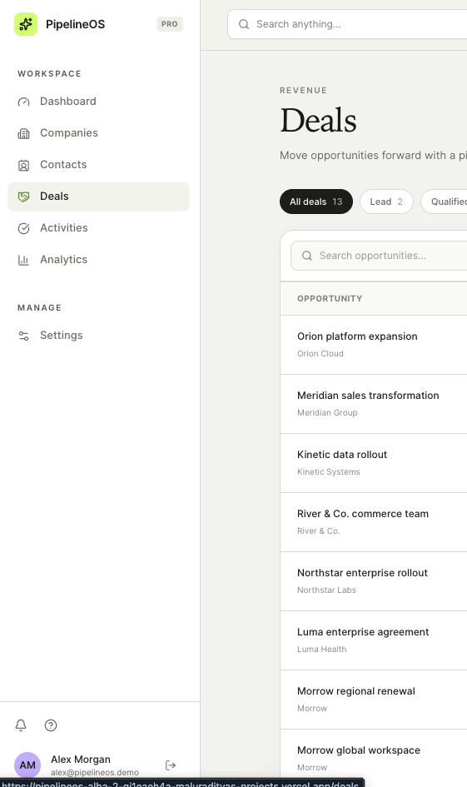
Figure 1. Persistent workspace navigation and the Deals surface.

Activities
Activities capture calls, emails, meetings, tasks, and notes connected to a deal and optionally a contact. Due dates create the follow-up queue; a completion timestamp separates finished work from outstanding commitments.

Analytics
Analytics is the reporting surface. It shows closed-won revenue, pipeline coverage by active stage, acquisition source mix, activity completion, win rate, average deal size, open opportunities, and overdue work. The page consumes one authenticated analytics payload from PostgreSQL.

Global search, navigation, and settings
- Open global search from the header or press Cmd/Ctrl+K. Results are limited to the current user's companies, contacts, and deals.
- Use the persistent sidebar to move between pages. During data loading, the sidebar and global-search header remain mounted while only the page content becomes a skeleton.
- Use Settings to update the profile and workspace preferences. Use the account control in the sidebar to sign out.

4. Core CRM workflows

Recommended record sequence
- Create a Company to establish the organization.
- Create one or more Contacts under that company.
- Create a Deal and connect it to the company and optional primary contact.
- Add Activities to record follow-ups, meetings, notes, or tasks for the deal.
- Classify the deal with Tags when segmentation is useful.

Mutation behavior
Creates show a pending state and produce success or error notifications. Updates and deletes use optimistic collection state where appropriate. If Supabase rejects a request, the interface rolls back to the previous state and surfaces the error rather than leaving the browser out of sync with PostgreSQL.

Relationship and deletion behavior
Relationship | Behavior
Company → Contacts | Contacts are removed if their company is deleted.
Company → Deals | Company deletion is restricted while deals reference it.
Contact → Deals / Activities | Primary-contact references become null if the contact is removed.
Deal → Activities | Dependent activities are removed with the deal.
Deal ↔ Tags | Join rows cascade when either side is removed.

5. Backend choice

Why Supabase
Supabase was selected because the assignment rewards a backend that does real work. It combines managed PostgreSQL, relationships, SQL, migrations, authentication, Row Level Security, REST access, and RPC functions without introducing a separate application server for routine CRM operations.

Alternatives considered
Option | Strength | Why it was not selected
Supabase | PostgreSQL, SQL analytics, RLS, Auth, migrations | Selected — best fit for relational CRM data and security proof.
Convex | Excellent Realtime developer experience | The assessment emphasized SQL, normalized relationships, and database-level RLS.
Appwrite | Integrated auth, database, and storage | Relational analytics and SQL policy verification were more direct in Supabase.

Authorization boundary
KEY PRINCIPLE
The publishable key is intentionally available to the browser. It identifies the Supabase project but does not grant access to another user's rows. PostgreSQL RLS, authenticated sessions, function grants, and ownership triggers form the authorization boundary. The service-role key is never shipped to the client.

6. Technical architecture
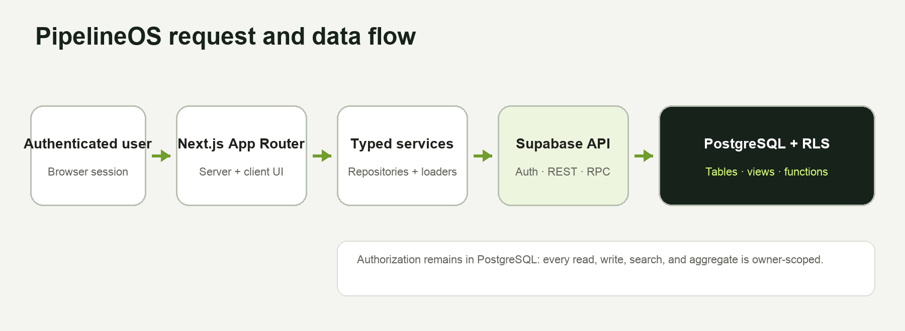
Figure 2. Frontend → Supabase → PostgreSQL request and authorization flow.

Frontend composition
- Next.js App Router Server Components own initial authenticated reads and page composition.
- Client Components are limited to forms, optimistic collections, charts, filtering, sorting, command search, and other interactions.
- A root application frame keeps the sidebar and search header persistent while route-level loading skeletons stream in the page body.
- Reusable services, hooks, UI primitives, chart components, and dialogs keep behavior consistent across routes.

Data access path
lib/data/service.ts provides reusable repositories for every entity. Before any operation, the service verifies the authenticated Supabase user. Reads are bounded and relationship projections are explicit. Mutations include the authenticated owner ID, while RLS independently validates access in PostgreSQL.

Deployment targets
Vercel uses the native next build target and .next output. The repository also retains build:sites for the existing Vinext/Cloudflare-compatible workflow, but the production default is native Next.js.

7. Data model and relationships
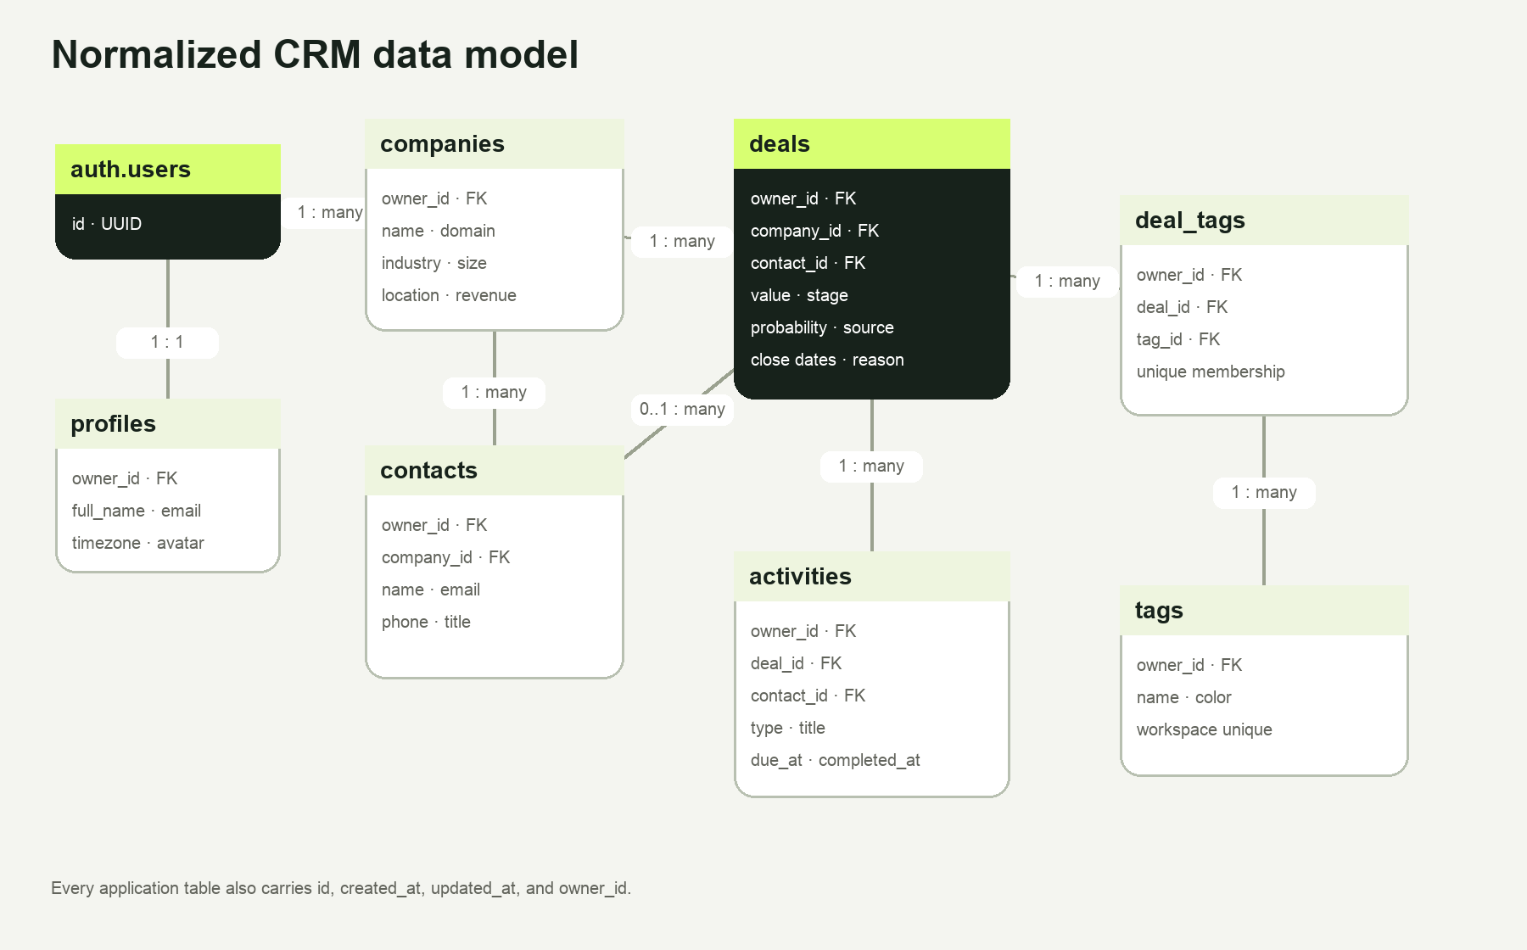
Figure 3. Entity relationship diagram. Every application entity is owner-scoped.

Normalization rules
- Organizations, people, opportunities, activities, and classifications live in separate relations.
- A deal belongs to one company and may reference one primary contact.
- An activity belongs to a deal and may reference a contact.
- Deals and tags use deal_tags rather than repeated arrays.
- Every application table has a UUID primary key, created_at, updated_at, and owner_id.

Enums
Type | Allowed values
deal_stage | lead · qualified · proposal · negotiation · closed_won · closed_lost
activity_type | call · email · meeting · task · note

8. Full schema reference

profiles
Field | Type | Rules / relationship
id | uuid | PK; generated
created_at | timestamptz | required; default now
updated_at | timestamptz | required; trigger maintained
owner_id | uuid | required; unique FK → auth.users
full_name | text | required; default empty
email | text | required
avatar_url | text | optional
timezone | text | required; default UTC

companies
Field | Type | Rules / relationship
id | uuid | PK; generated
created_at | timestamptz | required; default now
updated_at | timestamptz | required; trigger maintained
owner_id | uuid | required FK → auth.users
name | text | required; 1–160 chars; owner unique
domain | text | optional
industry | text | optional
size | text | optional
location | text | optional
annual_revenue | numeric(16,2) | optional; non-negative

contacts
Field | Type | Rules / relationship
id | uuid | PK; generated
created_at | timestamptz | required; default now
updated_at | timestamptz | required; trigger maintained
owner_id | uuid | required FK → auth.users
company_id | uuid | required FK → companies; cascade
first_name | text | required; 1–80 chars
last_name | text | required; 1–80 chars
email | text | required; owner unique
phone | text | optional
title | text | optional

deals
Field | Type | Rules / relationship
id | uuid | PK; generated
created_at | timestamptz | required; default now
updated_at | timestamptz | required; trigger maintained
owner_id | uuid | required FK → auth.users
company_id | uuid | required FK → companies; restrict delete
contact_id | uuid | optional FK → contacts; set null
name | text | required; 3–200 chars
value | numeric(16,2) | required; non-negative
stage | deal_stage | required; default lead
probability | smallint | required; 0–100
source | text | required
expected_close_date | date | optional
closed_at | timestamptz | optional
lost_reason | text | optional

activities
Field | Type | Rules / relationship
id | uuid | PK; generated
created_at | timestamptz | required; default now
updated_at | timestamptz | required; trigger maintained
owner_id | uuid | required FK → auth.users
deal_id | uuid | required FK → deals; cascade
contact_id | uuid | optional FK → contacts; set null
type | activity_type | required
title | text | required; 1–200 chars
description | text | optional
due_at | timestamptz | optional
completed_at | timestamptz | optional

tags
Field | Type | Rules / relationship
id | uuid | PK; generated
created_at | timestamptz | required; default now
updated_at | timestamptz | required; trigger maintained
owner_id | uuid | required FK → auth.users
name | text | required; 1–40 chars; owner unique
color | text | required; six-digit hex

deal_tags
Field | Type | Rules / relationship
id | uuid | PK; generated
created_at | timestamptz | required; default now
updated_at | timestamptz | required; trigger maintained
owner_id | uuid | required FK → auth.users
deal_id | uuid | required FK → deals; cascade
tag_id | uuid | required FK → tags; cascade
deal_id + tag_id | unique pair | prevents duplicate membership

9. Services, functions, and backend surface

Supabase services used
Service | Used | Purpose
PostgreSQL | Yes | Normalized CRM data, constraints, indexes, triggers, views, and analytics functions.
Authentication | Yes | Email/password registration, confirmation, sessions, logout, and recovery.
Row Level Security | Yes | Owner isolation for all seven application tables.
PostgREST | Yes | Authenticated CRUD and relationship projections.
RPC | Yes | Chart-ready analytics and global search.
Storage buckets | No | No file workflow is required in the selected scope; zero buckets are provisioned.
Edge Functions | No | Business aggregation remains in PostgreSQL; zero Edge Functions are deployed.
Realtime | No | Optional advanced feature not selected; RLS and server analytics were prioritized.

Views
View | Result
monthly_revenue | Closed-won revenue and won-deal count by owner and month.
pipeline_by_stage | Open deal count, total value, and weighted value by stage.
deal_conversion | Won/lost counts and win rate by owner.
average_sales_cycle | Average days from creation to closed won.

Functions and triggers
Object | Security / purpose
get_dashboard_analytics() | SECURITY INVOKER; authenticated only; returns the complete chart-ready JSON payload.
search_workspace(text) | SECURITY INVOKER; authenticated only; at most 12 owner-scoped company, contact, and deal results.
set_updated_at() | Trigger function that maintains updated_at on every application table.
handle_new_user() | SECURITY DEFINER auth trigger that creates one profile for a new auth user.
validate_owned_relationships() | Rejects cross-owner company, contact, deal, activity, or tag references.

10. Authentication and Row Level Security

Authentication lifecycle
- Registration sends full_name as user metadata and creates a profile through the auth trigger.
- When email confirmation is required, the form becomes a dedicated inbox-confirmation state.
- The callback exchanges the one-time code for a session and validates the next route before redirecting.
- Protected Server Components validate the current user before any repository read.
- Forgot password opens an email-only step; the recovery link returns through the callback to the new-password page.
- Sign-out clears the Supabase session and returns the user to login.

Policy model
RLS is enabled on profiles, companies, contacts, deals, activities, tags, and deal_tags. Each table has four explicit authenticated policies: select, insert, update, and delete. Policies compare (select auth.uid()) with owner_id; inserts and updates also enforce the same value through WITH CHECK.
Operation | Rule
SELECT | Authenticated users can read rows only when auth.uid() equals owner_id.
INSERT | The new row must carry the authenticated user's owner_id.
UPDATE | The existing and resulting row must both remain owned by the authenticated user.
DELETE | Only an owner-visible row can be deleted.

Defense in depth
- Relationship triggers reject foreign keys that point into another user's workspace.
- Analytics views use security_invoker so their table reads retain RLS.
- Analytics and search execution is revoked from PUBLIC and anon, then granted only to authenticated.
- The service-role key is absent from the frontend and documentation.

11. Advanced feature verification
SELECTED ADVANCED FEATURES
PipelineOS implements authentication plus owner-isolated RLS and server-computed SQL analytics. This exceeds the requirement to choose one advanced option.

Two-account security test
- Sign in as Alex, create representative company, contact, deal, activity, and tag rows, and record only their UUIDs.
- Sign out and sign in as Sam. List every table and request Alex's recorded UUIDs directly.
- Attempt to update or delete Alex's UUIDs and attempt to create Sam-owned rows linked to Alex-owned foreign keys.
- Call the analytics and search RPCs from each account and repeat anonymous calls without a session.
- Return to Alex and verify the original rows remain unchanged.

Hosted evidence
Check | Alex | Sam | Expected boundary
Companies visible | 9 | 4 | Each sees only own rows
Contacts visible | 9 | 3 | Each sees only own rows
Deals visible | 13 | 7 | Each sees only own rows
Activities visible | 13 | 8 | Each sees only own rows
Tags visible | 3 | 2 | Each sees only own rows
Other user's companies | 0 | 0 | Direct owner queries return zero
Analytics RPC | Account-specific | Account-specific | RLS-scoped aggregates

Additional evidence: anonymous inserts return PostgreSQL error 42501; anonymous analytics and search calls return HTTP 401; cross-owner activity and deal-tag writes are rejected. Reversible hosted CRUD checks passed for companies, contacts, deals, activities, tags, and deal_tags, and all temporary rows were removed.

12. Server-computed analytics
The frontend does not download the entire pipeline and recompute business metrics in React. PostgreSQL filters the authenticated owner's rows, aggregates the results near the data, and returns one JSON payload through get_dashboard_analytics().
Payload section | Business meaning | Used by
metrics | Pipeline value, won revenue, win rate, average size, open deals, overdue activities | Headline cards and pipeline brief
monthlyRevenue | Six-month closed-won revenue series | Revenue performance chart
pipelineByStage | Open-stage count, value, and weighted value | Pipeline coverage chart
conversionFunnel | Deal volume and value from lead through closed won | Dashboard funnel
dealsBySource | Deal count and value by acquisition source | Channel/source charts
activitiesCompleted | Zero-filled seven-day completion series | Execution velocity

Why the backend owns analytics
- Lower browser payloads and one round trip for the dashboard.
- One definition of revenue, conversion, and pipeline value across every client.
- RLS remains active inside security-invoker views and functions.
- Indexes can serve common owner, stage, close-date, and due-date access paths.

13. Setup from zero

Prerequisites
- Node.js 22.13 or newer
- npm
- Supabase CLI
- Docker for local Supabase
- Git

Clone and install
git clone https://github.com/maluraditya/alba-assessments.git
cd alba-assessments/02-dashboard
npm install

Provision Supabase locally
supabase start
supabase db reset
supabase db reset applies every migration in supabase/migrations/ in timestamp order and then executes supabase/seed.sql because the repository's supabase/config.toml enables database seeding.

Configure the application
cp .env.example .env.local
NEXT_PUBLIC_SUPABASE_URL=http://127.0.0.1:54321
NEXT_PUBLIC_SUPABASE_PUBLISHABLE_KEY=<local publishable key from supabase status>
DO NOT USE THE DASHBOARD URL
NEXT_PUBLIC_SUPABASE_URL must be the Supabase API endpoint, such as https://project-ref.supabase.co for hosted projects. Never add a service-role key to a NEXT_PUBLIC variable.

Run and verify
npm run dev
# Complete release gate
npm run check
Open http://localhost:3000/login and use either demo account. The release gate runs strict TypeScript, ESLint, the Sites-compatible build, repository contract tests, and the native Next.js production build.

14. Seed data and reviewer access

Local seed
supabase/seed.sql provides deterministic local or disposable test data. A clean local project can therefore be provisioned and populated with the two reviewer workspaces through one supabase db reset command.

Hosted seed
Supabase's hosted GitHub integration applies migrations but does not automatically execute supabase/seed.sql. To keep the assessment environment reproducible, hosted demo users and their different datasets are also represented through versioned assessment seed migrations.

What each account demonstrates
Account | Data profile | Useful review path
Alex Morgan | Larger enterprise, multi-channel pipeline with more companies, deals, activities, and tags | Dashboard funnel, priority queue, channel mix, analytics depth
Sam Rivera | Smaller mid-market pipeline with different values, sources, stages, and revenue history | Compare every dashboard metric and prove account isolation

ASSESSMENT FIXTURES
These accounts and rows are synthetic. Remove the assessment users and seed migrations before using the repository for real customer data.

15. Production deployment

Supabase GitHub integration
- Connect the maluraditya/alba-assessments repository.
- Set Working directory to 02-dashboard because that directory contains supabase/.
- Enable production migration deployment from the main branch.
- Confirm all seven tables appear in the public schema with RLS enabled.

Vercel
- Import the GitHub repository and select 02-dashboard as the Root Directory.
- Keep Framework Preset as Next.js. vercel.json runs npm run build and expects .next.
- Set NEXT_PUBLIC_SUPABASE_URL to the hosted API URL and NEXT_PUBLIC_SUPABASE_PUBLISHABLE_KEY to the browser-safe publishable key for Production and Preview.
- Deploy, then repeat registration, login, CRUD, analytics, search, and two-account checks on the production URL.

Authentication URLs
Site URL: https://your-domain.example
Redirect URLs:
https://your-domain.example/auth/callback
https://your-domain.example/auth/reset
Environment changes to NEXT_PUBLIC variables require a redeploy because their values are embedded in the browser bundle during compilation.

16. Quality, performance, and accessibility

Automated quality gate
- Strict TypeScript (tsc --noEmit)
- Next.js ESLint and React rules
- Native Vercel production build
- Vinext/Sites-compatible build
- Ten repository contract tests covering routes, authentication, persistent loading shell, RLS, SQL analytics, global search, and deployment configuration

Lighthouse
Lighthouse 12.8.2 was run three times against /login from the native Next.js production build using its default mobile profile. Median scores are reported to reduce single-run variance. Scores are out of 100; 90 or above is Lighthouse's highest, green rating band.
Category | Median score
Performance | 95
Accessibility | 100
Best Practices | 96
SEO | 100

Lab metric | Median
First Contentful Paint | 0.8 s
Largest Contentful Paint | 2.9 s
Total Blocking Time | 130 ms
Cumulative Layout Shift | 0
Speed Index | 1.5 s

The generated Vercel deployment URL requires Vercel authentication for unauthenticated visitors, so the production bundle was audited through a local production server rather than measuring Vercel's protection page.

Accessibility design
- Semantic headings, tables, labels, buttons, and navigation landmarks.
- Visible keyboard focus and Cmd/Ctrl+K command-menu access.
- ARIA names on icon controls and live status messaging on authentication steps.
- Reduced-motion behavior for users who request it.
- High-contrast chart tooltips and persistent loading context.

17. Folder structure and source-of-truth map
app/ App Router pages, auth callbacks, loading and errors
components/ Feature, layout, chart, form and UI components
hooks/ Reusable optimistic collection state
lib/data/ Authenticated repositories, loaders and analytics client
lib/supabase/ Browser/server clients and validated public configuration
supabase/migrations/ Schema, RLS, functions, fixes and hosted assessment seed
supabase/seed.sql Deterministic local demo data
docs/ ERD, architecture, schema, security, deployment and build log
tests/ Repository contract and regression tests

No duplicated data stack
Supabase is the only CRM source of truth. The application contains no local JSON fallback, browser-storage CRM database, inline application SQL, or alternate persistence layer. Database behavior belongs in migrations; frontend access belongs in reusable typed services.

18. Known limitations and next steps

Deliberately out of scope
- Realtime subscriptions: the selected advanced work focused on authentication, RLS, and server analytics.
- File attachments: no Storage bucket or Edge Function is required for the selected CRM workflows.
- Dark mode: after visual review, the final product favors one consistent, polished light theme.

Production hardening roadmap
- Replace bounded offset reads with cursor-based pagination and URL-persisted filters for very large workspaces.
- Add Playwright browser tests in CI against disposable Supabase branches.
- Add production error monitoring with customer-data redaction, database monitoring, alerts, and restore drills.
- Configure production SMTP, auth rate limits, point-in-time recovery, and a documented backup policy.
- Disable Vercel deployment protection for the reviewer-facing production URL, then repeat Lighthouse directly against the hosted page.

Appendix A. Migration map
Migration | Purpose
202607240001_initial_schema.sql | Enums, seven tables, constraints, indexes, triggers, views, first analytics RPC
202607240002_rls.sql | Enable RLS and create four owner policies per table
202607240003_secure_analytics_rpc.sql | Restrict analytics execution to authenticated
202607240004_fix_relationship_validation.sql | Harden ownership validation trigger
202607240005_seed_demo_workspace.sql | Hosted Alex assessment workspace
202607240006_authenticated_global_search.sql | Owner-scoped search_workspace RPC and grants
202607240007_seed_rls_verification_workspace.sql | Second isolated security-test workspace
202607240008_executive_dashboard.sql | Executive dashboard analytics payload and zero-filled series
202607240009_seed_second_demo_workspace.sql | Hosted Sam workspace with different data

Appendix B. Requirement traceability
Requirement | Where covered | Evidence
Backend choice | Section 5 | Supabase rationale and alternatives
Full schema | Sections 7–8 | ERD plus every field, type, rule, and relationship
Services used | Section 9 | PostgreSQL, Auth, RLS, REST, RPC; zero buckets/Edge Functions
Advanced verification | Sections 10–12 | Authentication, RLS proof, two-account evidence, SQL analytics
Setup from zero | Section 13 | Clone, install, provision, seed, configure, run, and verify
A way in | Sections 2 and 14 | Two credentials, one-command local seed, hosted seed explanation
Product usage | Sections 3–4 | Surface-by-surface guide and recommended workflow
Performance | Section 16 | Three-run median Lighthouse scores and lab metrics

Appendix C. Build summary
The initial assessment-ready build took approximately 3.5 hours. Review-driven polish and production hardening took approximately 2 hours, for roughly 5.5 hours total.
Phase | Approximate time
Product scope, schema, and architecture | 35 minutes
Supabase migrations, authentication, RLS, and seed workspaces | 60 minutes
CRUD services, forms, search, and route implementation | 65 minutes
SQL analytics, charts, and dashboard composition | 60 minutes
Documentation and security verification | 35 minutes
UI iteration, authentication UX, deployment diagnosis, and hardening | 75 minutes

FINAL STATUS
All core assignment requirements are complete. Optional Realtime and Storage features were not selected. The repository, migrations, seed data, credentials, security proof, setup guide, build log, and performance evidence are included.

