|  |  |  |
| --- | --- | --- |
| Data Set 1 | **Average Depth** | **Number of Nodes** |
| Tree Constructed using ID3 | 8 | 275 |
| Tree Constructed using random attribute Selection | 10 | 1077 (Since its random each execution will give different result) |

**DATASET1:**

Output Screenshot:

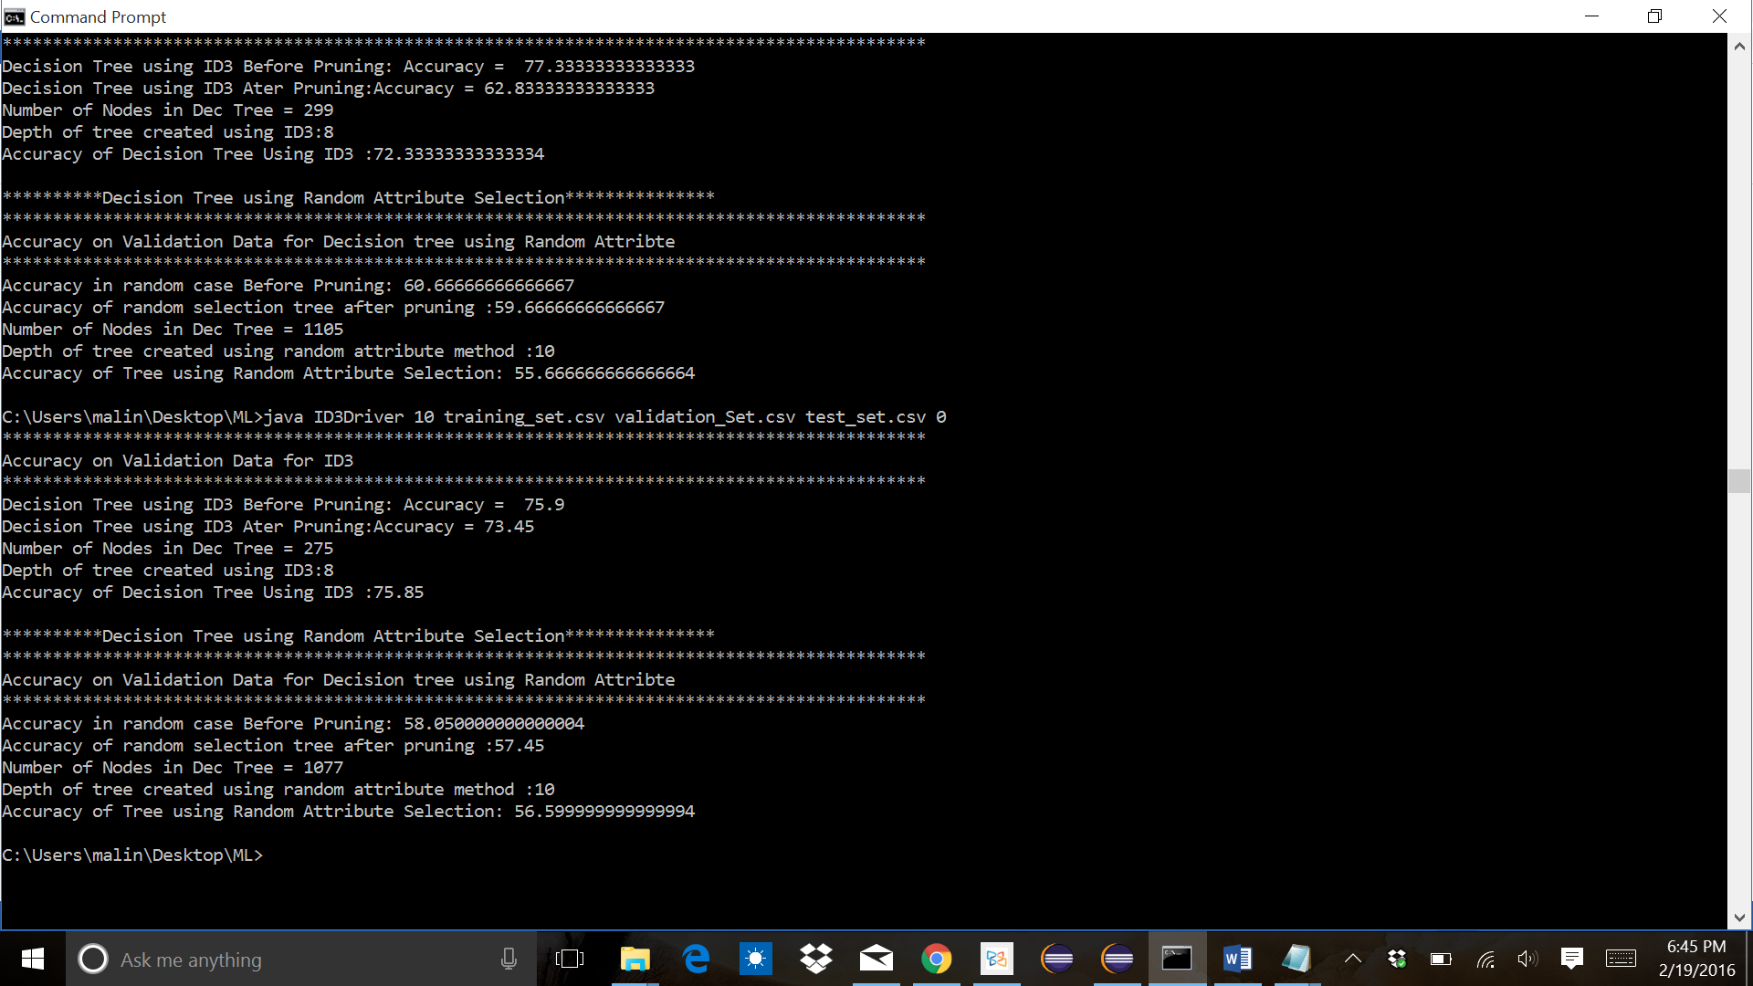

**DATASET2:**

|  |  |  |
| --- | --- | --- |
| Data Set 2 | **Average Depth** | **Number of Nodes** |
| Tree Constructed using ID3 | 8 | 299 |
| Tree Constructed using random attribute Selection | 9 | 883 (Since its random each execution will give different result) |

Output Screenshot:

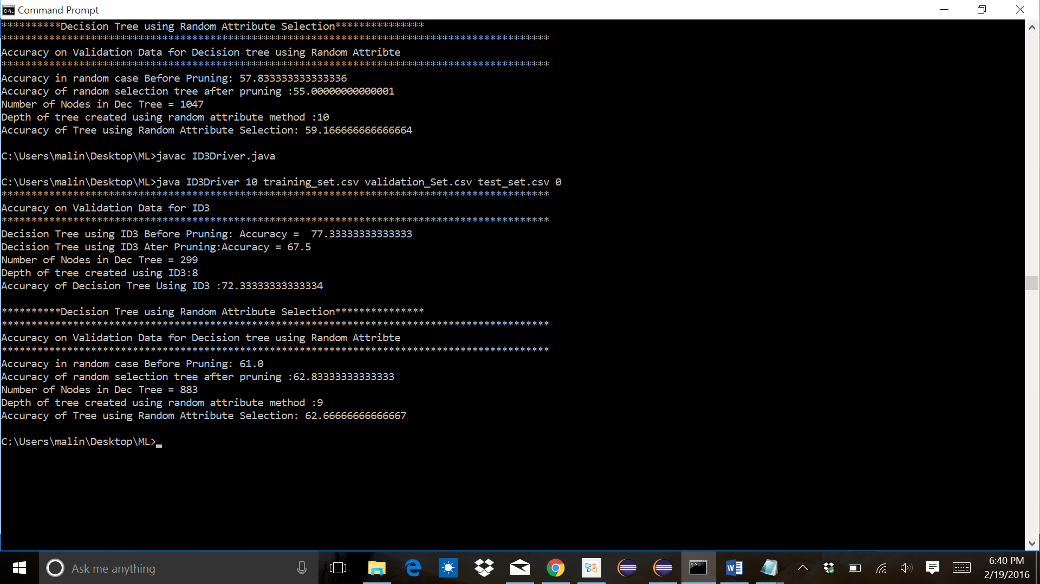

As the ID3 algorithm says, it gives the compact tree which is having shorter depth.

**DATASET1:**

|  |  |  |
| --- | --- | --- |
| **Number of nodes pruned** | **Accuracy of tree constructed using ID3** | **Accuracy of tree constructed using random attribute selection** |
| 0 | 75.85 | 58.3 |
| 10 | 75.85 | 56.5999 |
| 5 | 75.85 | 58.8 |
| 15 | 75.85 | 66.2 |
| 1 | 75.949999999 | 64.14 |
| 3 | 75.649999999 | 64.0 |

**DATASET2:**

|  |  |  |
| --- | --- | --- |
| **Number of nodes pruned** | **Accuracy of tree constructed using ID3** | **Accuracy of tree constructed using random attribute selection** |
| 0 | 72.33333333333334 | 59.166666666666664 |
| 1 | 72.33333333333334 | 58.833333333333336 |
| 2 | 72.66666666666667 | 59.333333333333336 |
| 3 | 72.33333333333334 | 58.333333333333336 |
| 5 | 72.33333333333334 | 58.333333333333336 |
| 10 | 72.33333333333334 | 54.833333333333336 |
| 15 | 72.33333333333334 | 55.666666666666664 |

Accuracy wise, ID3 algorithm is better and it has almost constant accuracy, whereas the random attribute method gives varying accuracy in each case. So we can’t rely on the random attribute method.