Can We Predict Which Hospitals Have the Best Heart Attack Survival Rates?

Data Science Journey Through 5,400+ US Hospitals
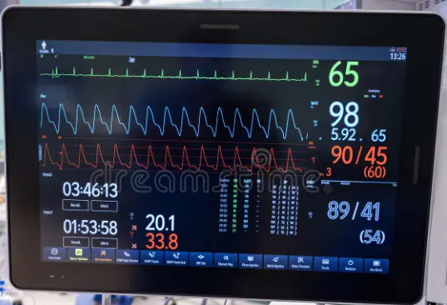
Search terms: heart monitor data, hospital technology, medical analytics
By: Stella Motlou Date: 23 March 2026 Read Time: 8 minutes
Every 40 seconds, someone in the United States has a heart attack. When it happens, which hospital you go to could mean the difference between life and death. But how do we know which hospitals are best equipped to save lives?
Data that was analyzed are from over 5,400 US hospitals to answer this exact question. Using machine learning and data from Medicare, I managed to build a predictive model that can estimate 30-day mortality rates after heart attacks (acute myocardial infarction, or AMI).

The Challenge
The Problem: Heart disease kills over 650,000 Americans every year, making it the leading cause of death in the US. While we track hospital quality metrics, we don't always know which factors truly predict patient outcomes.
The Opportunity:
• Identify hospitals that need improvement
• Understand what makes some hospitals more successful
• Guide patients to higher-quality care
• Help policymakers allocate resources effectively
Data: Four public datasets was used from the Centers for Medicare & Medicaid Services (CMS) containing:
• 5,418 hospitals across the United States
• 72 different quality metrics per hospital
• Information on spending, complications, readmissions, and mortality rates
Image : Map of United States showing hospital locations or density visualization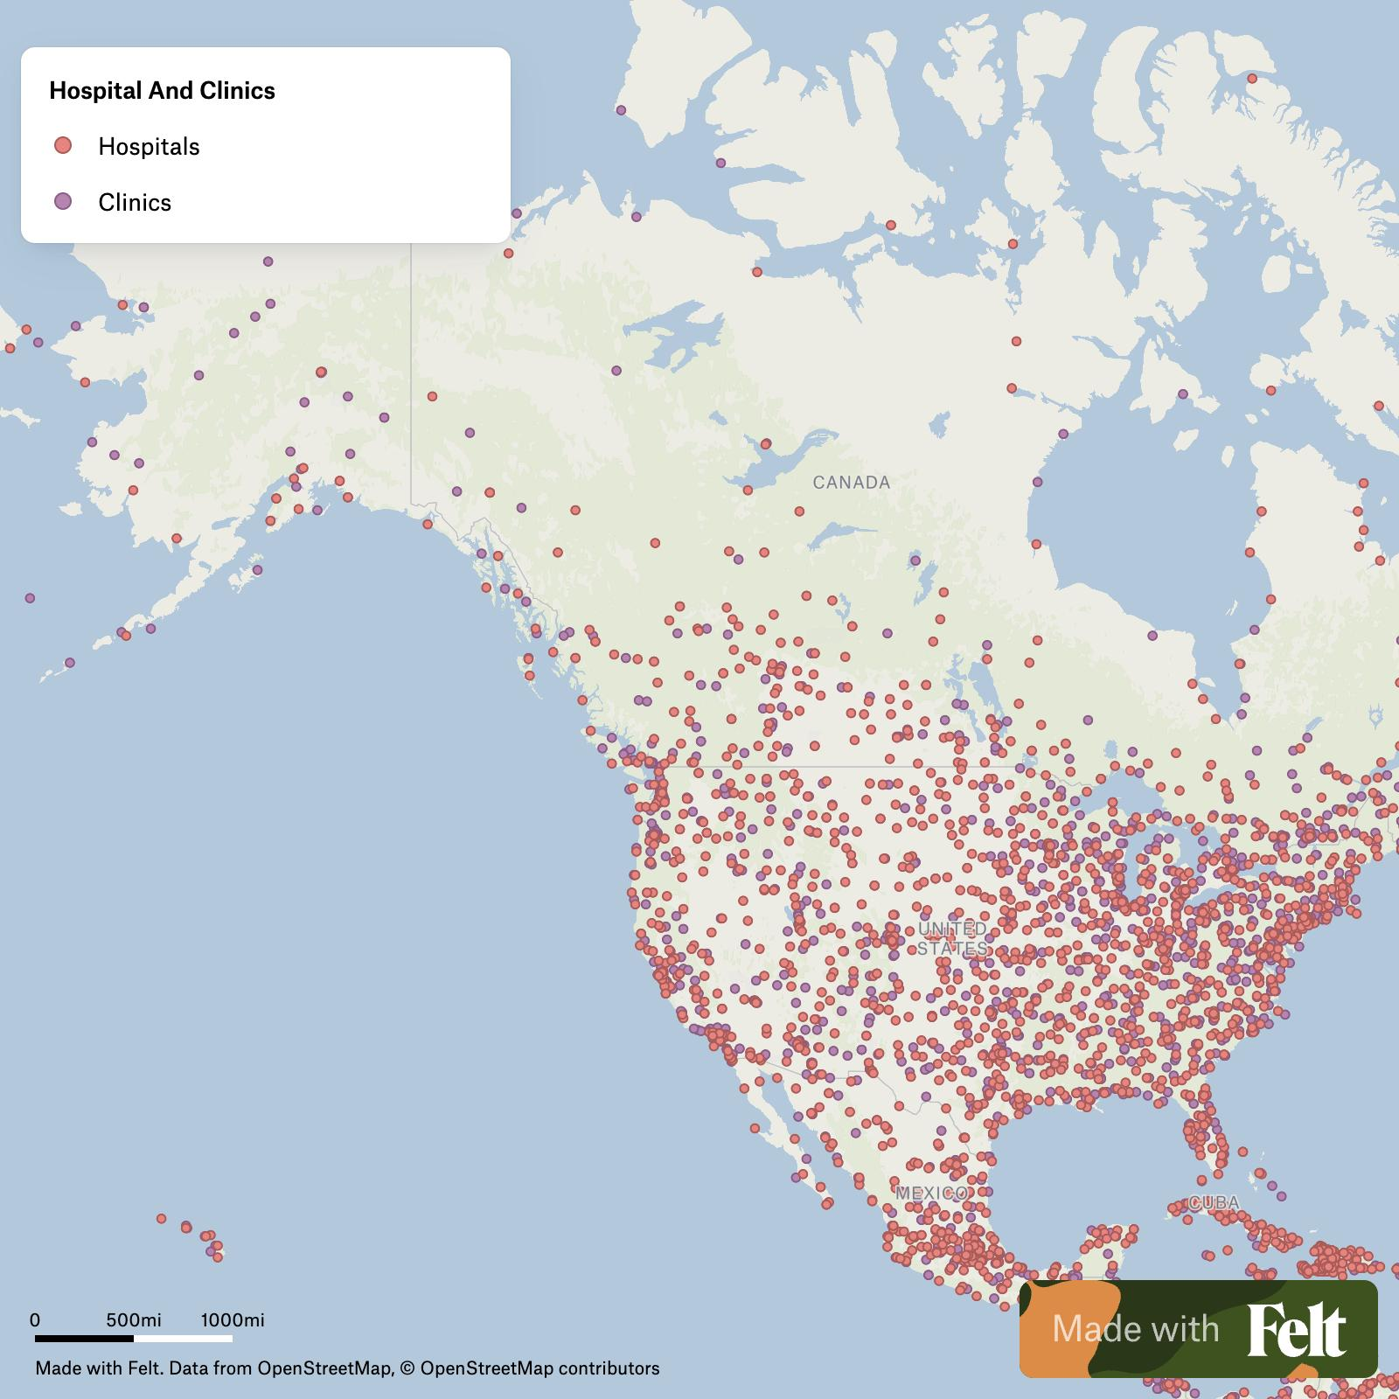

The Approach: Data Science in Action
Step 1: Understanding the Business Problem – Defined 5 key questions that hospital administrators and policymakers need answered.
Step 2: Exploring the Data – Analyzed patterns, checked for missing information, and examined relationships between variables.
Step 3: Preparing the Data – Cleaned the data, handled missing values, and transformed variables for machine learning.
Step 4: Building Models – Tested 4 different predictive algorithms to find the best approach.
Step 5: Evaluating Performance – Compared models using statistical metrics to select the most accurate one.
Step 6: Deploying the Solution – Saved the final model and generated predictions for real hospitals.
Chart : Flowchart showing the 6 CRISP-DM phases
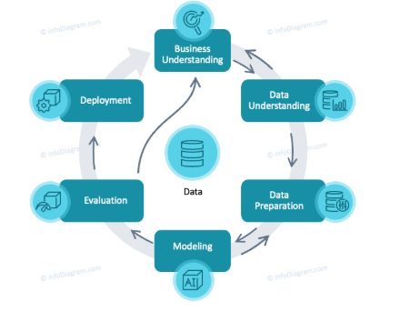

Five Critical Questions (And my findings)

Question 1: Which hospital characteristics most strongly predict mortality rates?
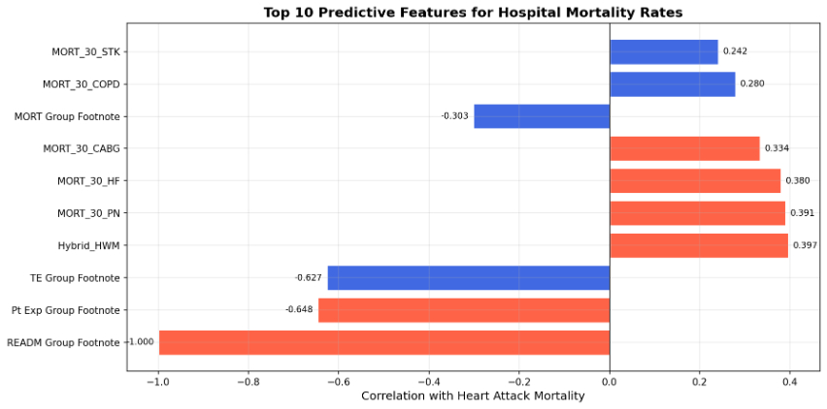
The strongest predictors of heart attack survival weren't as expected. Instead of focusing on cardiac-specific metrics, hospitals with poor outcomes in one area tend to have poor outcomes across the board.
Top Predictors:
• Other mortality rates (pneumonia, heart failure, COPD) - 0.39 correlation
• Patient safety indicators (surgical complications, infections) - 0.21 correlation
• Hospital spending efficiency - 0.40 correlation
• Readmission patterns - Moderate correlation

Question 2: How do mortality rates vary by hospital type and location?
Patterns are based on hospital characteristics:
• Hospital Type: Acute care hospitals and critical access hospitals show different mortality patterns
• Ownership: Voluntary non-profit vs. for-profit vs. government-owned hospitals have distinct outcomes
• Geography: Some states have consistently better or worse outcomes (though this needs case-mix adjustment)
The Caveat: 36% of hospitals (1,953 out of 5,418) actually report AMI mortality data. This creates selection bias-hospitals that don't report may be hiding poor performance or simply don't treat enough heart attack patients to generate reliable statistics.
Map : US map showing state-level variations in mortality rates
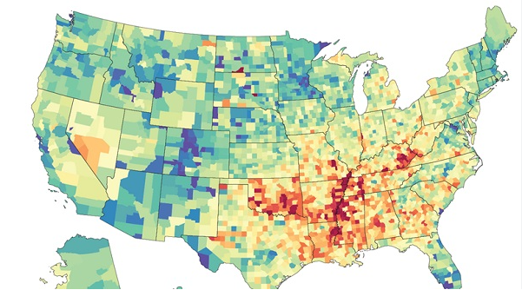

Question 3: Can we accurately predict mortality rates?
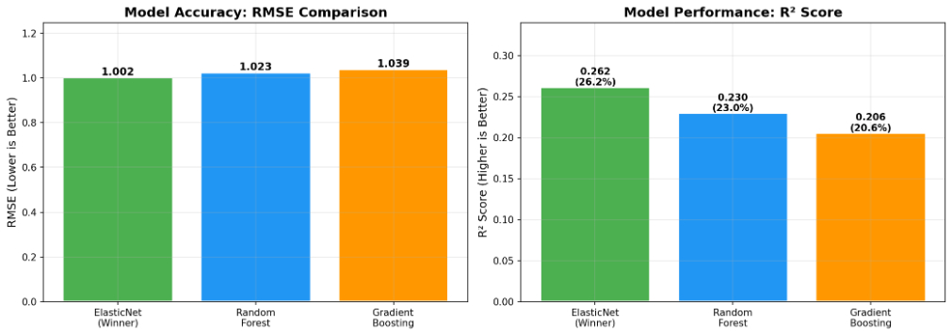
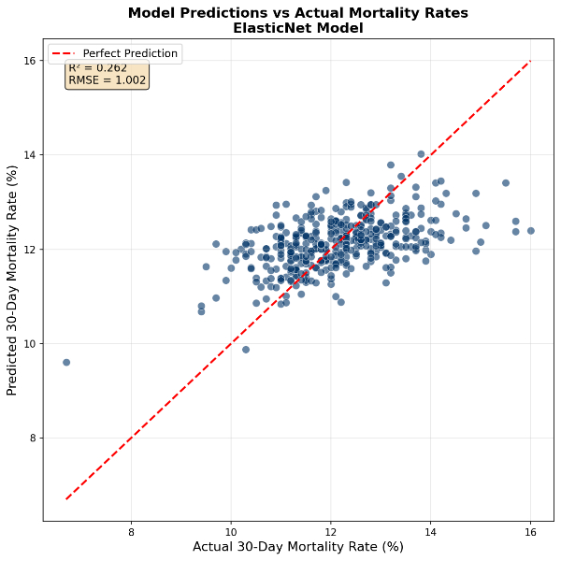
Yes—but with important limitations.
Model Performance:
• ElasticNet (Winner) – R²: 26.2% | Average Error: ±1.0%
• Random Forest – R²: 23.1% | Average Error: ±1.0%
• Gradient Boosting – R²: 20.6% | Average Error: ±1.0%
What This Means:
• The best model explains 26% of the variation in mortality rates
• Predictions are typically within 1 percentage point of actual rates
• For example: If actual mortality is 12%, the model predicts 11–13%

Question 4: What factors should hospitals focus on to improve?
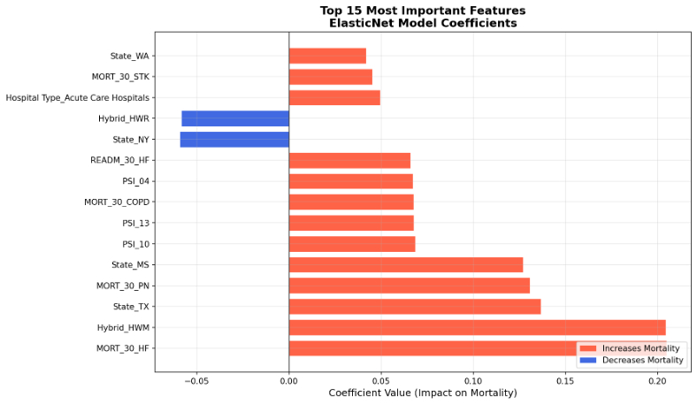
Top Priority Actions for Hospitals:
• Reduce Preventable Complications: Focus on Patient Safety Indicators (PSI scores). These directly correlate with mortality across all conditions.
• Improve Cross-Condition Care Quality: If pneumonia outcomes improve, AMI outcomes typically improve too. Invest in hospital-wide quality programs, not siloed departments.
• Optimize Spending Efficiency: Higher costs DON'T automatically mean better outcomes. Some high-spending hospitals have worse mortality rates. Focus on value (outcomes per dollar).
• Monitor Readmission Patterns: High readmission rates signal gaps in care transitions. Better discharge planning reduces both readmissions and mortality.

Question 5: Is expensive care better care?
No, Higher spending does not guarantee better survival rates.
• Some high-spending hospitals have high mortality rates
• Some low-spending hospitals have excellent outcomes
• The correlation between spending and quality is weak
Policy Implication: Value-based reimbursement (paying for outcomes, not procedures) makes more sense than simply increasing healthcare budgets.

Key Takeaways

For Patients and Families:
✅ Ask about hospital-wide quality, not just cardiac program reputation
✅ Look at patient safety scores (infections, complications, readmissions)
✅ Higher cost doesn't mean better care — check outcomes data
✅ Use Hospital Compare (data.medicare.gov) to research hospitals

For Hospital Administrators:
✅ Invest in systematic quality improvement, not condition-specific programs
✅ Track Patient Safety Indicators (PSI) as leading indicators of mortality
✅ Benchmark against efficient peers — spending more isn't the answer
✅ Share best practices across departments (pneumonia protocols help cardiac care)

For Policymakers:
✅ Incentivize value, not volume — reimburse outcomes per dollar
✅ Mandate risk-adjusted reporting — account for patient complexity
✅ Improve data infrastructure — 64% missing mortality data is unacceptable
✅ Fund hospital-wide quality initiatives — siloed programs don't work
Dataset Characteristics:
• 5,418 hospitals analyzed across all 50 states
• 72 features per hospital (quality metrics, spending, characteristics)
• 1,953 hospitals (36%) with complete AMI mortality data
Model Development:
• 4 algorithms tested: Linear Regression, ElasticNet, Random Forest, Gradient Boosting
• Best model: ElasticNet with L1/L2 regularization
• Hyperparameters: alpha=0.01, l1_ratio=0.8
• Feature selection: Top 200 features by correlation with target
Performance Metrics:
• RMSE: 1.002 (Root Mean Squared Error)
• MAE: 0.779 (Mean Absolute Error)
• R²: 0.262 (26.2% variance explained)
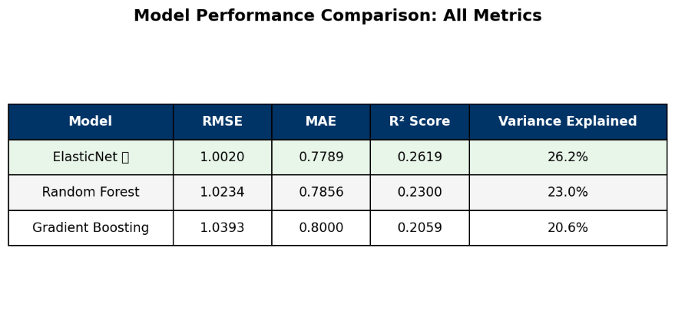

Model Limitations
Can't account for:
❌ Patient-level factors (age, comorbidities, heart attack severity)
❌ Hospital staffing levels and experience
❌ Specific clinical protocols and technologies used
❌ Recent changes or improvement initiatives
Should NOT be used for:
❌ Making individual patient treatment decisions
❌ Punitive measures against hospitals without investigation
❌ Ignoring the 64% of hospitals with missing data
❌ Assuming correlation means causation
Should be used for:
✅ Identifying hospitals for quality improvement programs
✅ Guiding policy decisions on resource allocation
✅ Motivating data infrastructure improvements
✅ Starting conversations about systematic quality
Phase 2 Ideas:
• Add patient-level data — Link to actual Medicare claims with demographics and severity
• Include staffing metrics — Nurse-to-patient ratios, physician board certifications
• Time series analysis — Track mortality trends over time, measure intervention effects
• Explainable AI — Use SHAP values to explain individual hospital predictions
• Interactive dashboard — Build web tool for stakeholders to explore data

The Conversation
• Should hospitals be required to report mortality data publicly?
• How would you use this information when choosing a hospital?
• What other factors should be included in quality predictions?
Connect with me:
• Email Address : Stella.Motlou@Vodacom.co.za

About This Project
• Data integration from multiple sources
• Exploratory data analysis techniques
• Machine learning model development and validation
• Communication of technical findings to non-technical audiences
Data Source: Centers for Medicare & Medicaid Services (CMS) Hospital Compare
Tools Used: Python, pandas, scikit-learn, matplotlib
Methodology: CRISP-DM framework

References and Further Reading
1) CMS Hospital Compare Data — Public dataset updated quarterly
1) CRISP-DM Methodology — Chapman et al. (2000)
1) Healthcare Quality Research — AHRQ Patient Safety Indicators
1) Machine Learning in Healthcare — Obermeyer & Emanuel (2016)

Final Notes
Heart attacks are unpredictable, but hospital quality doesn't have to be. By analyzing data from thousands of hospitals, we can identify patterns that save lives. This project shows that quality is measurable, predictable, and improvable— but only if we:
• Collect comprehensive data (no more 64% missing rates!)
• Focus on systematic improvement (not isolated programs)
• Value outcomes over spending (efficiency matters)
• Empower stakeholders (patients, hospitals, policymakers) with information
Thank you for reading. If this post helped you understand healthcare analytics better.

