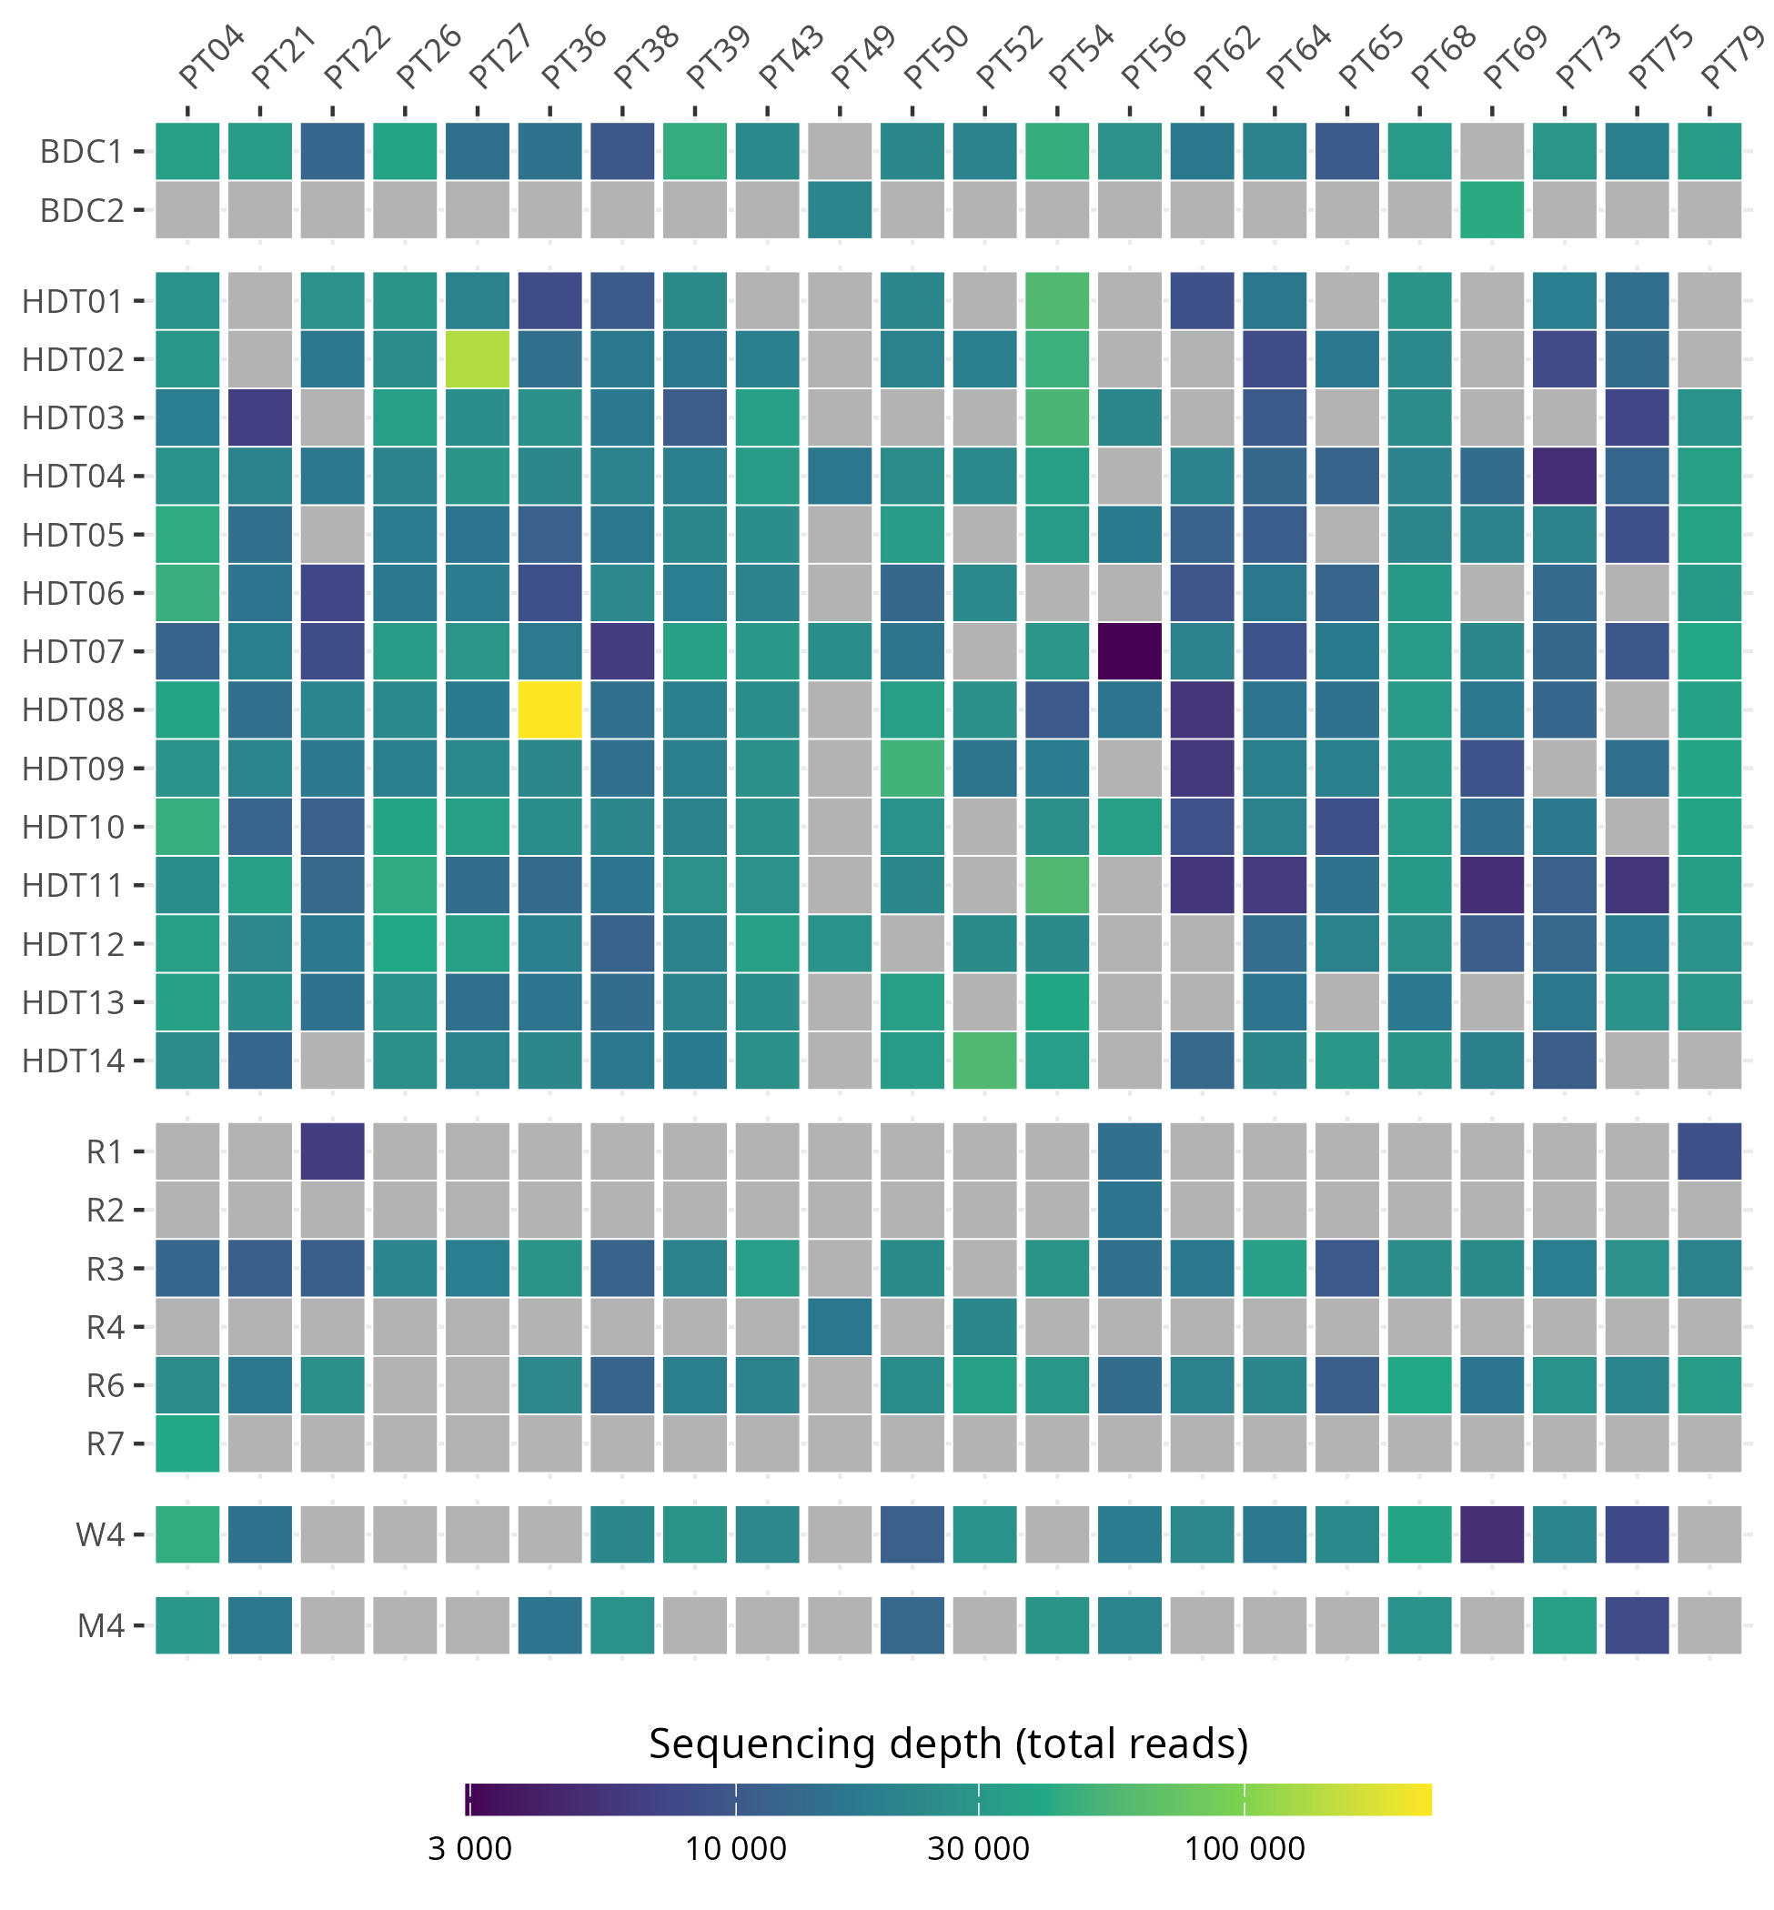
Figure S1: Availability and sequencing depth for fecal 16S rRNA gene samples. Sample read depth is shown for processed and decontaminated samples. Gray values indicate sample was not collected. BDC: baseline phase; HDT: HDBR phase; R: recovery phase; W: week; M: month

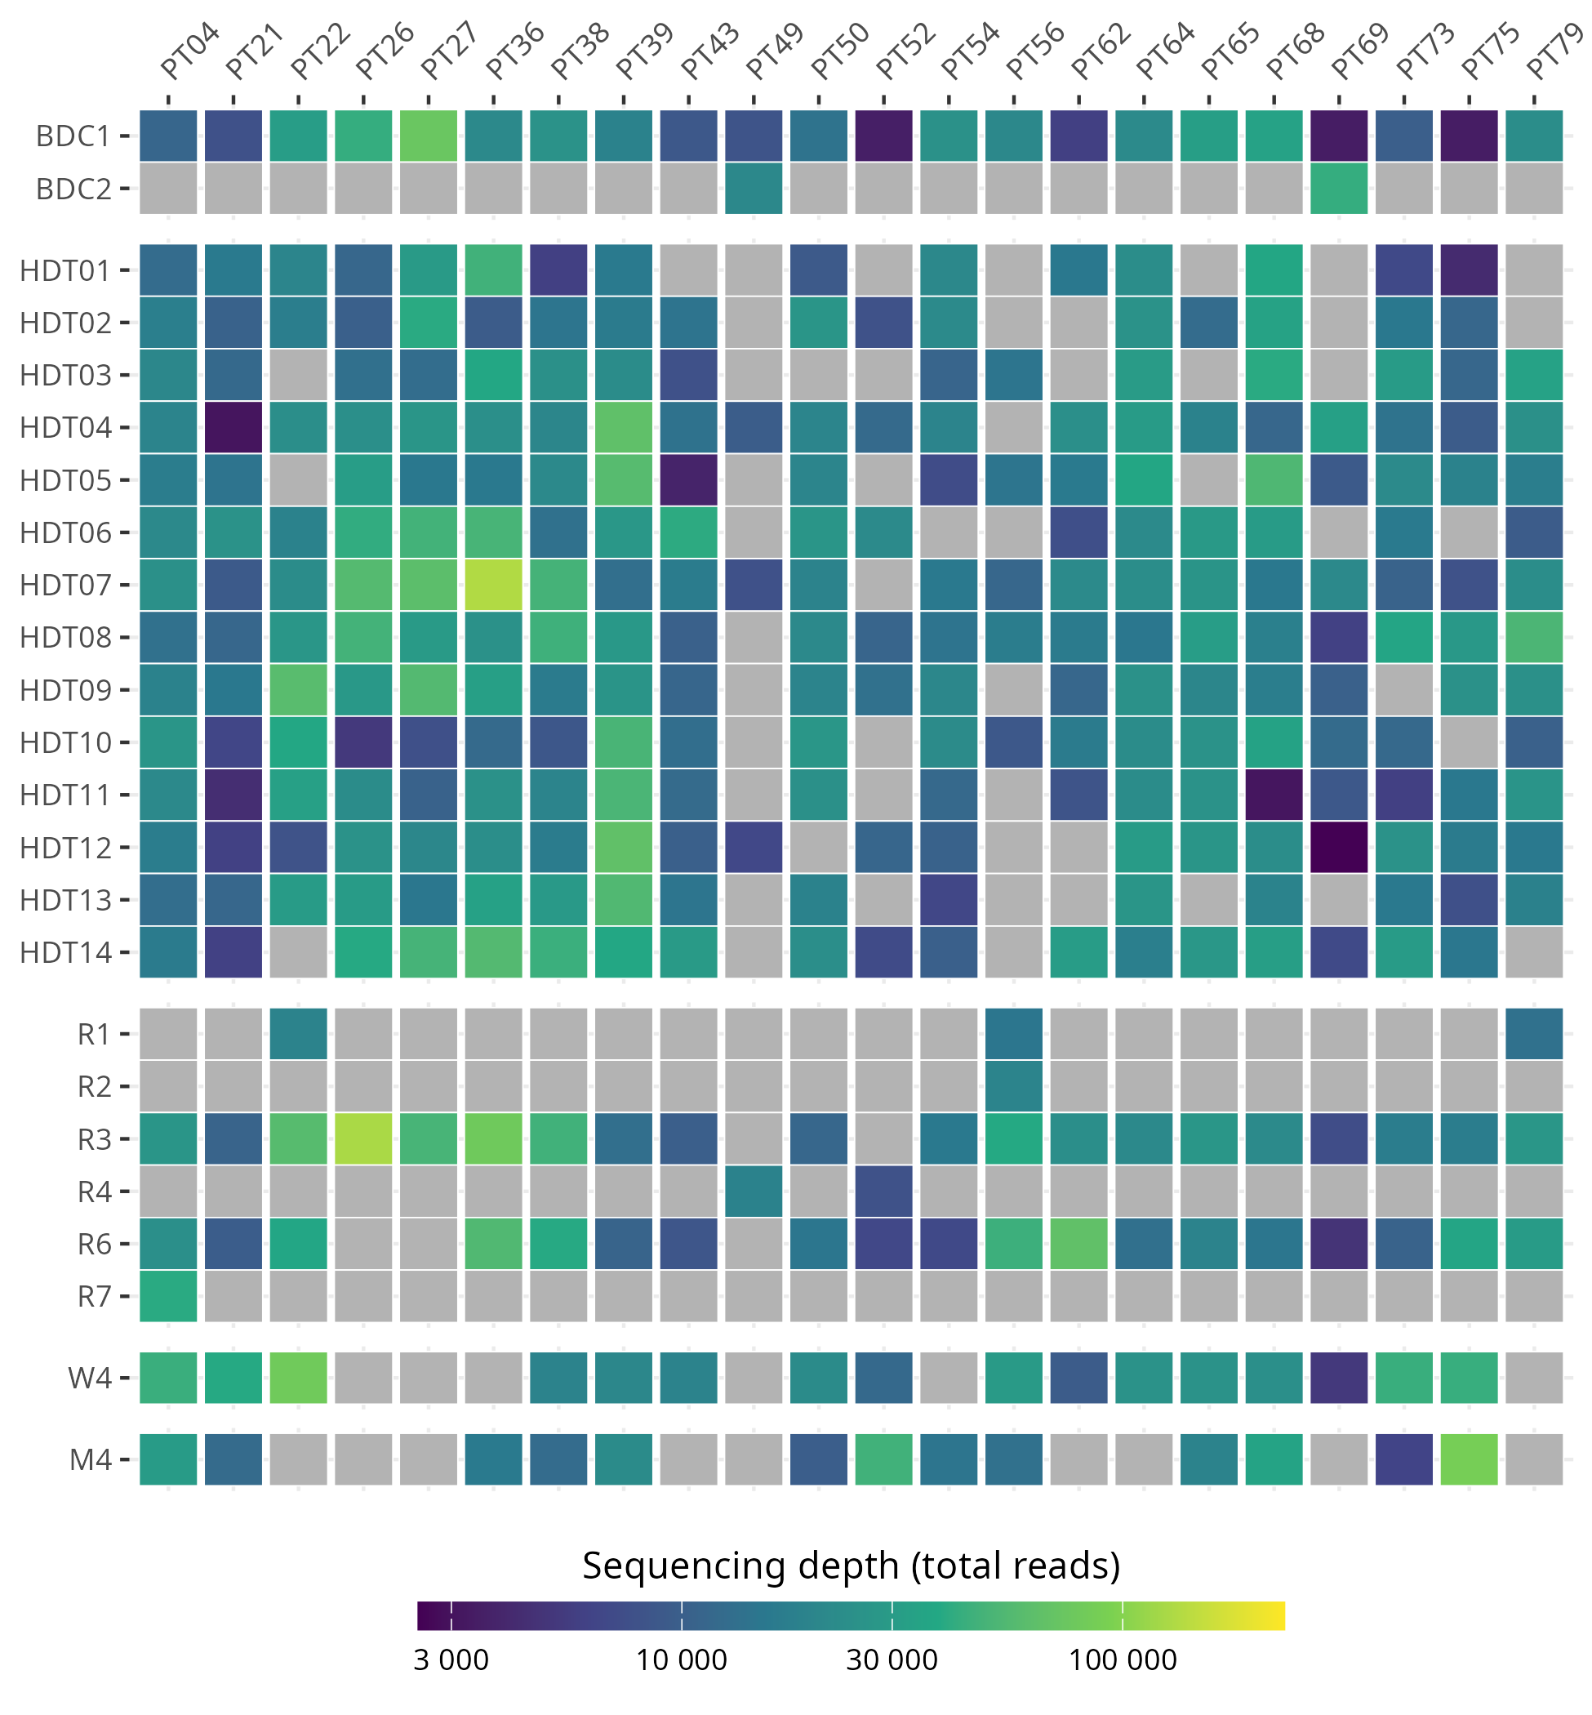

Figure S2: Availability and sequencing depth for salivary 16S rRNA gene samples. Sample read depth is shown for processed and decontaminated samples. Gray values indicate sample was not collected. BDC: baseline phase; HDT: HDBR phase; R: recovery phase; W: week; M: month.

Table S1: R² and p values of the associations between participant ID, cohort, sex, exercise group and FI-36 on gut and oral microbiome β-diversity. Associations were assessed using PERMANOVA. Associations with FI-36 were corrected for participant ID. Results are bolded where p<0.1
 | Gut microbiome |  |  | Oral microbiome
 | Bray-Curtis | Weighted UniFrac | Phylogen. RPCA | Bray-Curtis | Weighted UniFrac | Phylogen. RPCA
Pt. ID | 0.812 p=0.001 | 0.713 p=0.001 | 0.953 p=0.001 | 0.631 p=0.001 | 0.512 p=0.001 | 0.845 p=0.001
Cohort | 0.113 p=0.001 | 0.114 p=0.001 | 0.124 p=0.001 | 0.104 p=0.001 | 0.112 p=0.001 | 0.155 p=0.001
Sex | 0.043 p=0.001 | 0.043 p=0.001 | 0.096 p=0.001 | 0.046 p=0.001 | 0.018 p=0.001 | 0.124 p=0.001
Exercise group | 0.039 p=0.001 | 0.021 p=0.002 | 0.067 p=0.001 | 0.038 p=0.001 | 0.024 p=0.001 | 0.019 p=0.001
FI-36 | 0.00210  p=0.142 | 0.00103  p=0.706 | 0.00023  p=0.588 | 0.00413  p=0.099 | 0.00257  p=0.589 | 0.00329  p=0.086
FI-36 (no outlier) | 0.00365  p=0.002 | 0.00871  p=0.023 | 0.00038  p=0.434 | 0.00544  p=0.023 | 0.00638  p=0.119 | 0.00442  p=0.035

Table S2: R² and p values of the associations between gut and oral microbiome β-diversity and symptom-based components of the FI-36. Associations were assessed using PERMANOVA and p-values were corrected using Benjamini-Hochberg. Results are bolded where p < 0.05

 |  | Gut microbiome |  |  | Oral microbiome
 | n | BC | WU | RPCA | BC | WU | RPCA
Musculoskeletal pain and function
Pain in back, joints | 33 | 0.019 p=0.016 | 0.019 p=0.242 | 0.009 p=0.825 | 0.024 p=0.032 | 0.021 p=0.112 | 0.04 p=0.026
Swollen joints | 2 | 0.005 p=0.824 | 0.004 p=0.726 | 0.003 p=0.875 | 0.007 p=0.343 | 0.006 p=0.699 | 0.016 p=0.232
Muscle spasms | 6 | 0.006 p=0.521 | 0.006 p=0.541 | 0.004 p=0.825 | 0.009 p=0.277 | 0.005 p=0.699 | 0.006 p=0.551
Muscle weakness | 5 | 0.006 p=0.521 | 0.002 p=0.868 | 0.001 p=0.896 | 0.008 p=0.343 | 0.003 p=0.865 | 0.023 p=0.146
Cardiopulmonary symptoms
Heart trouble  or chest pain | 0
Breathlessness | 5 | 0.012 p=0.062 | 0.022 p=0.237 | 0.005 p=0.825 | 0.018 p=0.032 | 0.03 p=0.048 | 0.006 p=0.563
Persistent cough | 4 | 0.012 p=0.062 | 0.018 p=0.242 | 0.004 p=0.825 | 0.015 p=0.059 | 0.037 p=0.048 | 0.005 p=0.597
Neurological and sensory symptoms
Numbness/tingling in arms/legs | 1 | 0.007 p=0.308 | 0.016 p=0.243 | 0.004 p=0.825 | 0.008 p=0.339 | 0.007 p=0.699 | 0.022 p=0.146
Dizziness, light-headedness, faint | 7 | 0.016 p=0.023 | 0.006 p=0.566 | 0.015 p=0.698 | 0.009 p=0.277 | 0.004 p=0.799 | 0.023 p=0.146
Trouble concentrating | 4 | 0.007 p=0.499 | 0.002 p=0.937 | 0.001 p=0.896 | 0.007 p=0.349 | 0.006 p=0.699 | 0.021 p=0.147
Confusion | 2 | 0.011 p=0.062 | 0.01 p=0.391 | 0.008 p=0.825 | 0.007 p=0.343 | 0.007 p=0.699 | 0.014 p=0.26
Headache | 17 | 0.008 p=0.328 | 0.009 p=0.43 | 0.003 p=0.85 | 0.008 p=0.304 | 0.006 p=0.699 | 0.016 p=0.234
Ringing in the ears | 3 | 0.009 p=0.128 | 0.012 p=0.317 | 0.003 p=0.825 | 0.011 p=0.174 | 0.008 p=0.699 | 0.039 p=0.024
Eye pain or dryness | 7 | 0.01 p=0.094 | 0.005 p=0.609 | 0.002 p=0.896 | 0.009 p=0.281 | 0.002 p=0.954 | 0.003 p=0.691
Upper respiratory/ENT symptoms
Sore throat | 8 | 0.013 p=0.028 | 0.04 p=0.096 | 0.015 p=0.698 | 0.016 p=0.032 | 0.028 p=0.064 | 0.004 p=0.643
Sleep and fatigue-related symptoms
Sleeping problems | 23 | 0.017 p=0.019 | 0.017 p=0.242 | 0.006 p=0.825 | 0.011 p=0.202 | 0.009 p=0.699 | 0.013 p=0.342
Vivid dreams | 14 | 0.017 p=0.016 | 0.016 p=0.242 | 0.001 p=0.896 | 0.01 p=0.236 | 0.011 p=0.677 | 0.01 p=0.359
Hallucinations | 2 | 0.011 p=0.062 | 0.01 p=0.391 | 0.008 p=0.825 | 0.01 p=0.205 | 0.009 p=0.699 | 0.009 p=0.394
Sleepy during the day | 22 | 0.017 p=0.016 | 0.022 p=0.237 | 0.004 p=0.825 | 0.01 p=0.205 | 0.008 p=0.699 | 0.004 p=0.603
Fatigue | 9 | 0.009 p=0.172 | 0.003 p=0.835 | 0.001 p=0.896 | 0.007 p=0.343 | 0.005 p=0.699 | 0.02 p=0.151
Gastointestinal and appetite-related symptoms
Stomach or intestinal problems | 42 | 0.014 p=0.032 | 0.005 p=0.599 | 0.011 p=0.825 | 0.012 p=0.092 | 0.007 p=0.699 | 0.037 p=0.024
Heartburn or indigestion | 6 | 0.01 p=0.094 | 0.005 p=0.609 | 0.007 p=0.825 | 0.009 p=0.256 | 0.006 p=0.699 | 0.011 p=0.359
Nausea | 6 | 0.007 p=0.469 | 0.007 p=0.541 | 0.004 p=0.825 | 0.008 p=0.281 | 0.005 p=0.699 | 0.02 p=0.146
Loss of appetite | 13 | 0.009 p=0.157 | 0.026 p=0.237 | 0.004 p=0.825 | 0.006 p=0.474 | 0.006 p=0.699 | 0.008 p=0.481
Genitourinary symptoms
Incontinence | 2 | 0.011 p=0.062 | 0.01 p=0.391 | 0.008 p=0.825 | 0.007 p=0.343 | 0.007 p=0.699 | 0.014 p=0.26
Skin and peripheral sensory symptoms
Senstive or irritated skin | 11 | 0.011 p=0.086 | 0.004 p=0.609 | 0.007 p=0.825 | 0.016 p=0.032 | 0.017 p=0.187 | 0.04 p=0.024
Itching | 9 | 0.009 p=0.175 | 0.004 p=0.609 | 0.015 p=0.698 | 0.009 p=0.277 | 0.006 p=0.699 | 0.011 p=0.36
Psychological and affective symtoms
Less initiative | 5 | 0.012 p=0.062 | 0.009 p=0.439 | 0.004 p=0.825 | 0.006 p=0.536 | 0.005 p=0.699 | 0.004 p=0.673
Sadness | 2 | 0.006 p=0.521 | 0.009 p=0.43 | 0.007 p=0.825 | 0.006 p=0.466 | 0.004 p=0.812 | 0.007 p=0.466
Anxious | 8 | 0.017 p=0.016 | 0.023 p=0.237 | 0.019 p=0.698 | 0.012 p=0.069 | 0.005 p=0.699 | 0.007 p=0.509
Easily irritated | 3 | 0.008 p=0.281 | 0.007 p=0.541 | 0.002 p=0.884 | 0.008 p=0.339 | 0.008 p=0.699 | 0.003 p=0.691
Anger or hostility | 1 | 0.005 p=0.957 | 0.006 p=0.566 | 0.003 p=0.837 | 0.007 p=0.354 | 0.005 p=0.699 | 0.002 p=0.691
Other/non-specific
Other | 7 | 0.015 p=0.021 | 0.006 p=0.541 | 0.03 p=0.48 | 0.015 p=0.032 | 0.016 p=0.187 | 0.047 p=0.024

Table S3: Effect of day of HDBR on gut and oral microbiome α-diversity. Results are bolded where p < 0.05
 | Observed richness | Shannon entropy | Phylogenetic div.
Gut (C): day | -1.6 (p=0.017) | -0.041 (p=0.025) | -0.094 (p=0.041)
Gut (E): day | 0.58 (p=0.32) | -0.0032 (p=0.81) | -0.015 (p=0.67)
Oral (C): day | 0.32 (p=0.63) | 0.018 (p = 0.23) | 0.016 (p=0.54)
Oral (E): day | 0.82 (p = 0.27) | 0.007 (p=0.55) | 0.039 (p=0.36)

Table S4: Interaction effect between sex and day of HDBR on gut and oral microbiome α-diversity.
 | Observed richness | Shannon entropy | Phylogenetic div.
Gut (C): day*sex | 0.28 (p=0.81) | 0.019 (p=0.58) | -0.014 (p=0.87)
Gut (E): day*sex | 1.6 (p=0.18) | 0.037 (p = 0.15) | 0.15 (p=0.053)
Oral (C): day*sex | 0.85 (p=0.54) | -0.0026 (p=0.93) | 0.073 (p=0.16)
Oral (E): day*sex | 0.16 (p=0.92) | 0.010 (p=0.66) | -0.011 (p=0.90)

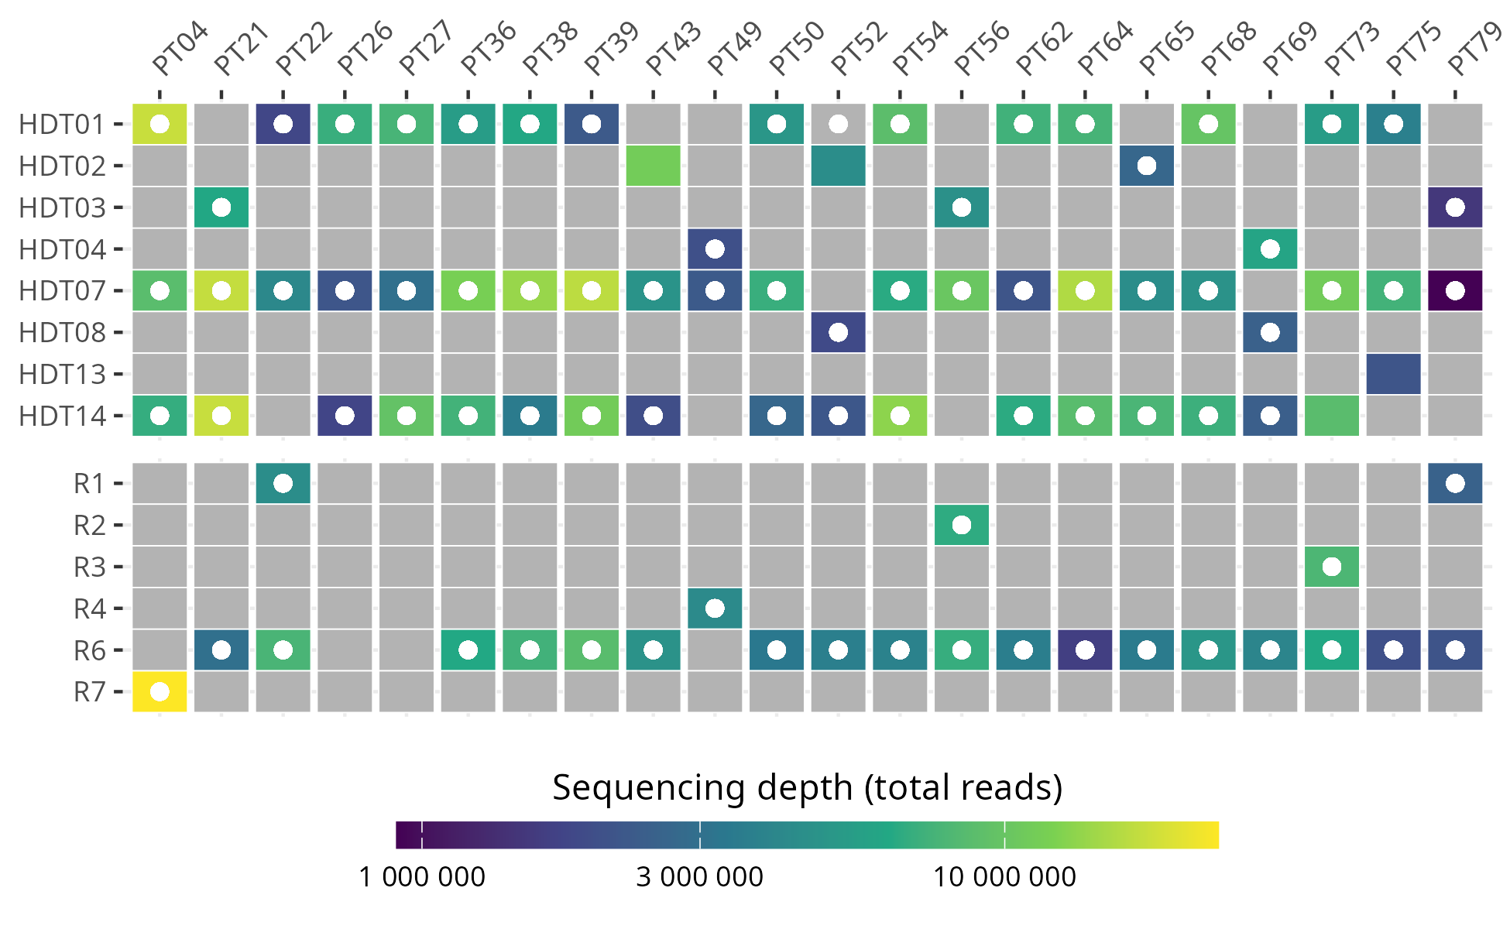
Figure S3: Availability and sequencing depth for fecal metagenomic and metabolomic samples. Sample read depth is shown for processed and decontaminated samples. White circles indicate metabolomic sample was collected. Gray values indicate sample was not collected. HDT: HDBR phase; R: recovery phase

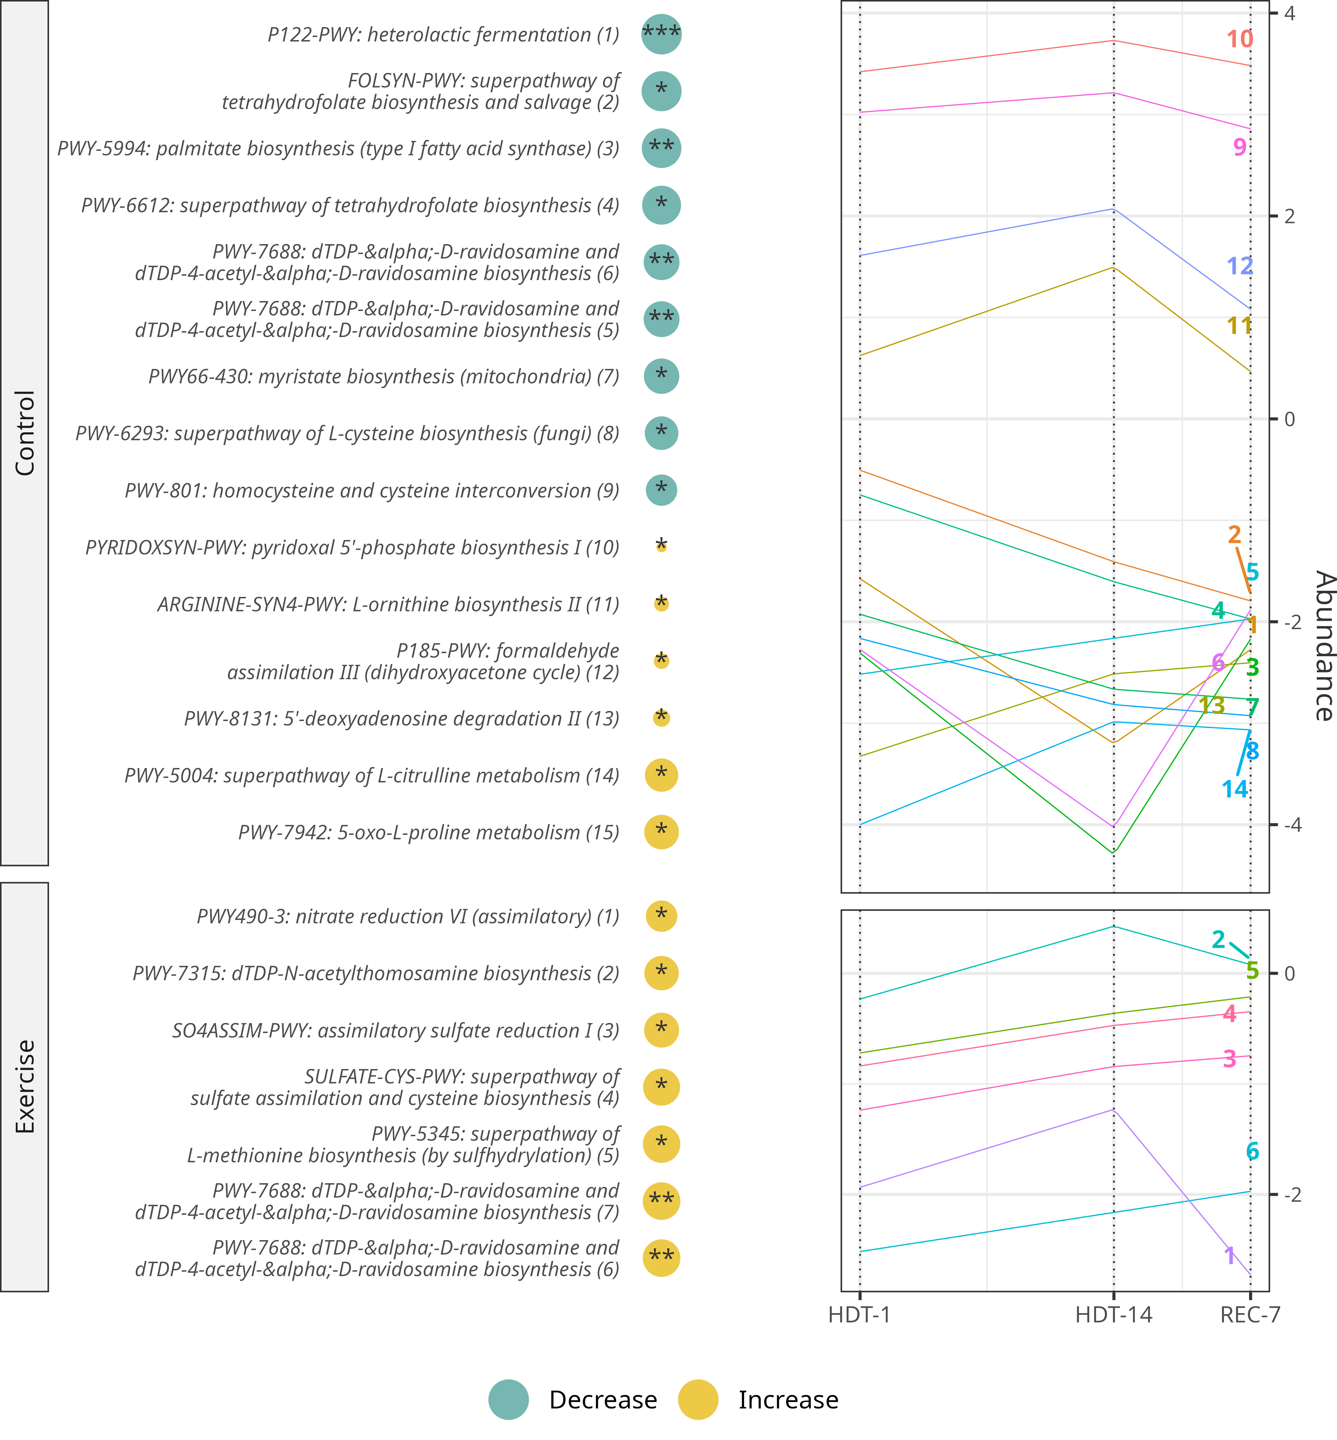
Figure S4: Longitudinal differential abundance analysis of gut metabolic pathways. Circle size represents the rate of change in CLR abundance of each taxon per day of HDBR. Adjusted p-values are represented as (p < 0.001: ***; p < 0.01: **; p < 0.05: *). The right-hand panels display linear regression lines for the abundance of each differentially abundant pathway across all participants during bedrest and recovery phases. Dotted lines indicate beginning of bedrest (HDT-1), end of bedrest (HDT-14) and end of recovery (REC). Individual features are represented by their corresponding number.
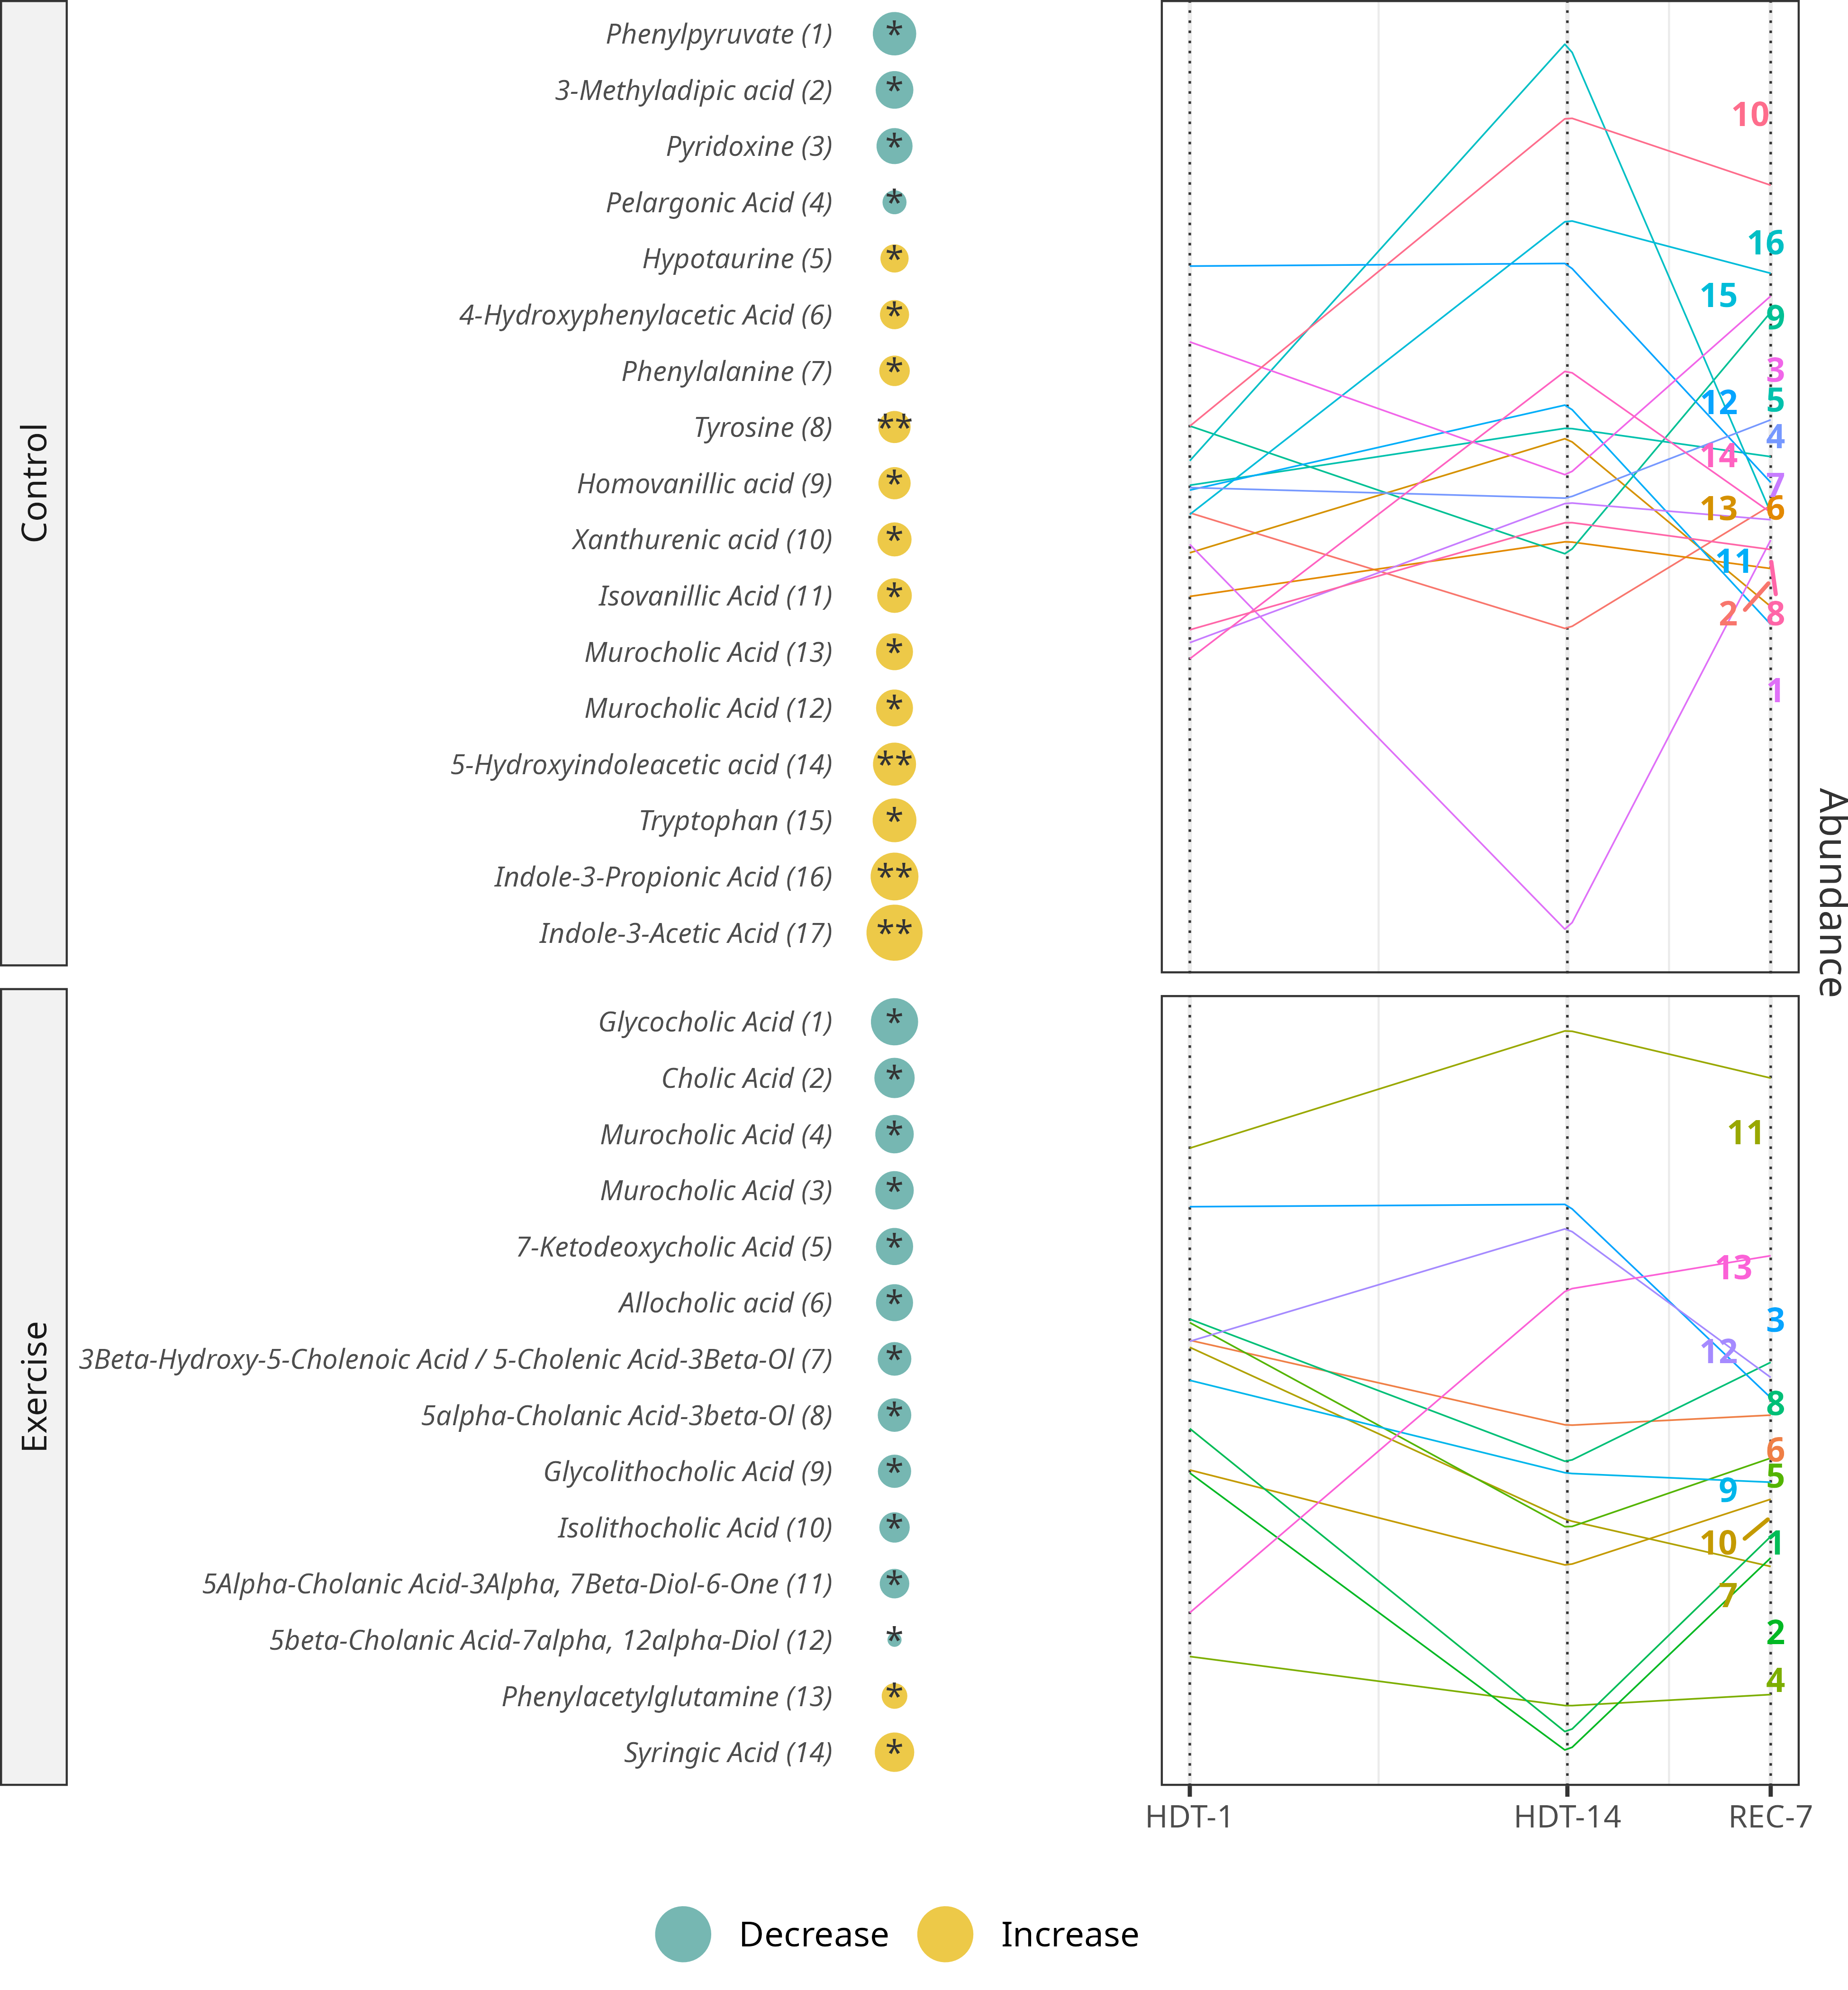
Figure S5: Longitudinal differential abundance analysis of gut metabolites. Circle size represents the rate of change in CLR abundance of each taxon per day of HDBR. Adjusted p-values are represented as (p < 0.001: ***; p < 0.01: **; p < 0.05: *). The right-hand panels display linear regression lines for the abundance of each differentially abundant metabolite across all participants during bedrest and recovery phases. Dotted lines indicate beginning of bedrest (HDT-1), end of bedrest (HDT-14) and end of recovery (REC). Individual features are represented by their corresponding number.

