MATHEMATICS PROJECT
Project Title:Designing a Simple Rectangular Water Tank Using Volume and Surface Area Concepts
Topic: Mensuration
---
Stage 1: Problem Identification
1.1 Description of the Problem
At school, there is a need to construct a water tank to collect rainwater. Students must help design a suitable rectangular tank based on available space and water needs.
1.2 Statement of Intent
To use volume and surface area formulas to design a rectangular water tank that can hold a specific amount of water and determine how much material is needed to build it.
1.3 Design Specifications
- The tank must hold at least 3 000 litres of water.
- Use simple rectangular dimensions.
- Calculate surface area for estimating construction material.
- Use scale drawing to represent dimensions.
Stage 2: Investigation of Related Ideas
2.1 Solutions (3 options)
- Cube-shaped tank (e.g. 15 × 15 × 15 dm)
- Long rectangular tank (e.g. 100 × 30 × 10 dm)
- Vertical rectangular tank (e.g. 60 × 25 × 20 dm)
2.2 Merits
- Easy to calculate and design
- Fits different spaces (horizontal/vertical)
- Allows comparisons of surface area

2.3 Demerits
- Some designs need more material
- May not fit available space
- May be unstable if too tall
Stage 3: Generation of Ideas
3.1 More Solutions
- L-shaped tank
- Cylindrical tank (extra research)
- Modular tanks joined together
3.2 Merits
- More flexibility in space
- Learn about other 3D shapes
- Easy expansion in future
3.3 Demerits
- More complex maths
- Harder to construct
- Not suitable for this level
Stage 4: Development of Idea
4.1 Solution Chosen
Rectangular tank measuring 100 cm × 30 cm × 100 cm
4.2 Justification
- Simple to calculate
- Easy to construct
- Meets water volume requirement (100×30×100 = 300 000 cm³ = 3 000 litres)

4.3 Development and Refinement
- Convert all units to cm and dm
- Calculated surface area for materials:
SA = 2(lw + lh + wh) = 2(100×30 + 100×100 + 30×100) = 26 000 cm²
Stage 5: Presentation of Solution
5.1 Presentation
- A scale drawing of the tank
- Labelled diagram
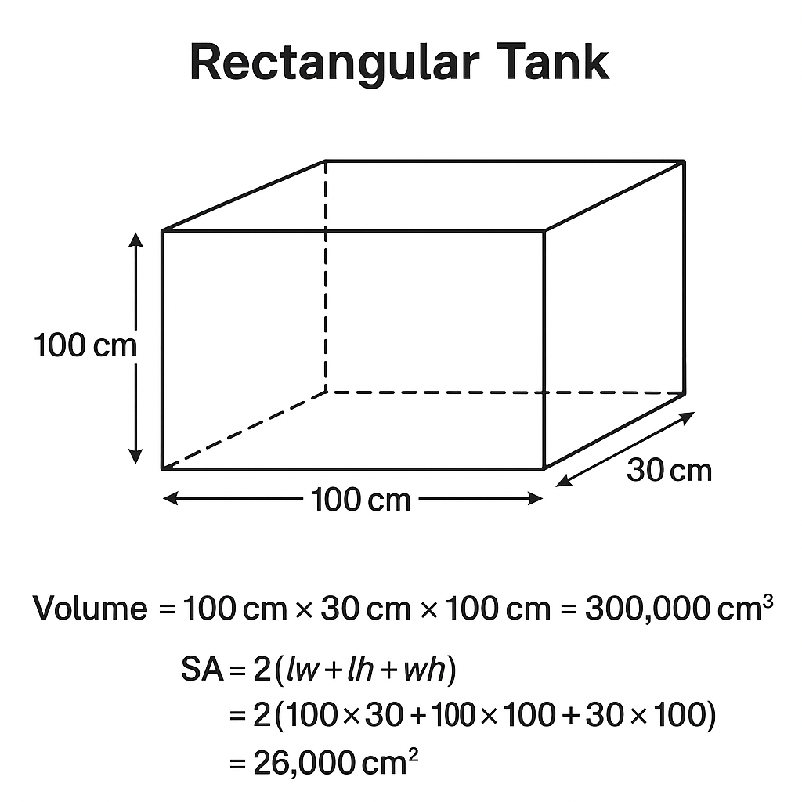
- Volume and surface area calculations shown

Stage 6: Evaluation and Recommendations
6.1 Relevance to Statement of Intent
Project achieved the goal of designing a working tank that holds required water.
6.2 Challenges Encountered
- Unit conversions were tricky
- Choosing the best dimensions required many trials
6.3 Recommendations
- Use spreadsheet for faster calculations
- Involve practical construction in future

