HOUSE PRICE PREDICTION USING MACHINE LEARNING

Yuva Intern – Week 6: Integrative Capstone Project and Evaluation

Submitted By: Malvika Sharma
Internship Organization: Yuva Intern
Project Domain: Data Science and Machine Learning
Programming Language: Python

1. ABSTRACT
House Price Prediction is a data science project that uses machine learning techniques to estimate house values based on available housing features. The main objective of this project is to analyze housing data, identify useful patterns, and develop a predictive model using Python. The project uses libraries such as Pandas, NumPy, Matplotlib, Seaborn, and Scikit-learn for data analysis, visualization, model development, and evaluation. A Linear Regression model is trained on the dataset and tested using a separate test set. The model is evaluated using Mean Absolute Error (MAE), Root Mean Squared Error (RMSE), and the R-squared score. This project demonstrates the basic workflow of a data science project, from data preparation to model evaluation.

2. INTRODUCTION
House prices depend on several factors, including location, income levels, housing characteristics, and local market conditions. Predicting house prices manually can be difficult because many variables influence property values.

Machine learning can help analyze historical housing data and identify relationships between different features and house prices. In this project, Python is used to build a Linear Regression model that predicts house values from the available input features.

The project also provides practical experience in data cleaning, exploratory data analysis, visualization, model training, and performance evaluation.

3. PROBLEM STATEMENT
The objective of this project is to develop a machine learning model that predicts house values using a housing dataset. The project aims to understand the relationship between housing features and prices, analyze the dataset through visualizations, and evaluate the performance of a regression model.

4. OBJECTIVES
The main objectives are:
To load and understand a housing dataset.
To inspect data types and identify missing values.
To perform exploratory data analysis.
To visualize the distribution of house prices and relationships between features.
To train a Linear Regression model.
To evaluate predictions using MAE, RMSE, and R-squared.
To identify limitations and suggest possible improvements.

5. TOOLS AND TECHNOLOGIES USED
Python: Used for programming and model development.
Pandas: Used for loading, organizing, and analyzing tabular data.
NumPy: Used for numerical calculations.
Matplotlib: Used to create graphs and visualizations.
Seaborn: Used for statistical visualizations and correlation analysis.
Scikit-learn: Used for splitting the dataset, training the model, and evaluating predictions.
Google Colab: Used as the online Python coding environment.

6. DATASET DESCRIPTION
The project uses a housing dataset containing numerical and, depending on the selected dataset, categorical features related to houses or housing districts. The target variable represents the house value that the model attempts to predict.

The dataset is inspected using functions such as head(), info(), describe(), and isnull().sum(). These functions help understand the dataset structure, statistical properties, data types, and missing values.

Dataset source: [Write the actual dataset source used in your Google Colab notebook.]

7. DATA PREPROCESSING
Data preprocessing is an important step because the quality of the input data affects model performance.

The following operations were performed:
The dataset was loaded into a Pandas DataFrame.
The first few records and column names were examined.
Missing values were checked.
Missing numerical feature values were filled using column medians where required.
Categorical features, if present, were converted into numerical columns.
The target column was separated from the input features.
The dataset was divided into training and testing sets using an 80:20 split.

These steps prepared the dataset for training and evaluating the machine learning model.

8. EXPLORATORY DATA ANALYSIS
Exploratory Data Analysis (EDA) was performed to understand the distribution of house prices and the relationships between variables.

A histogram was used to examine the distribution of house values. A scatter plot was used to investigate the relationship between median income and house value when those columns were available. A correlation heatmap was used to examine correlations between numerical features.

The visualizations helped identify patterns, possible relationships, and areas that could be investigated further. Correlation alone does not establish causation.

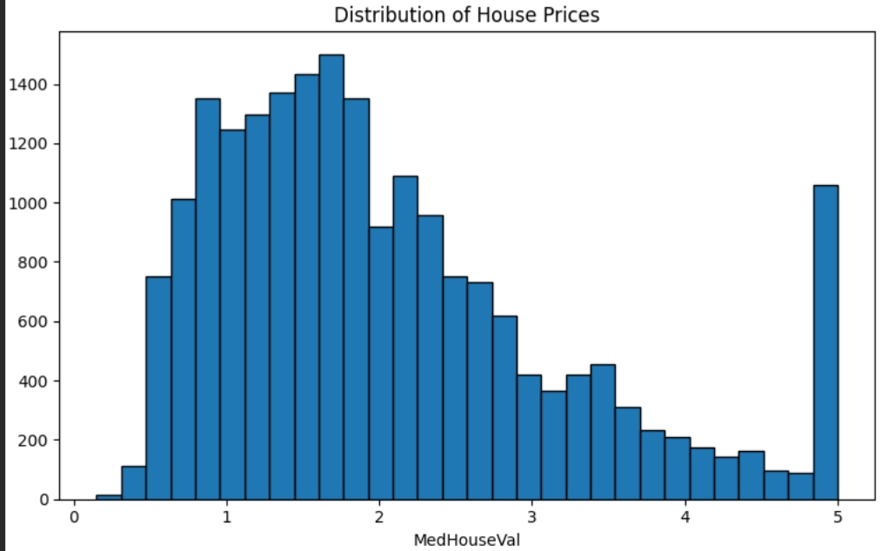

9. MODEL DEVELOPMENT
Linear Regression was selected as the baseline machine learning algorithm for this project. It is a supervised learning technique used to predict continuous numerical values.
The input features were used to train the model, while the house value column served as the target variable. The training data was used to fit the model, and the testing data was used to evaluate its performance on unseen records.

After training, predictions were generated for the test dataset. The actual and predicted values were compared to understand the model's predictive performance.

10. MODEL EVALUATION

The model was evaluated using three performance metrics.
Mean Absolute Error (MAE): 0.53
MAE measures the average absolute difference between actual and predicted values. Lower MAE generally indicates smaller prediction errors.

Root Mean Squared Error (RMSE): 0.75
RMSE measures prediction errors while assigning greater influence to larger errors. Lower RMSE generally indicates better predictive accuracy.

R-squared (R²): 0.5758
The R-squared score indicates that the model explains approximately 57.58% of the variation in the target values on the test dataset. This suggests that the model captures some useful relationships, but a considerable amount of variation remains unexplained.
The MAE and RMSE values must be interpreted in the units of the target variable. The dataset used determines whether these values represent dollars, hundreds of thousands of dollars, or another scale.

11. RESULTS AND DISCUSSION

The Linear Regression model was successfully trained and used to generate house value predictions. The actual-versus-predicted scatter plot provided a visual comparison of the model's predictions with the actual target values. A reference line was used to indicate where perfect predictions would fall.

The R-squared score of 0.5758 indicates moderate explanatory performance on the test data. The model provides a useful baseline, but it should not be assumed to predict every house value accurately.

The sample prediction table also helped compare actual values with predicted values for individual test records.
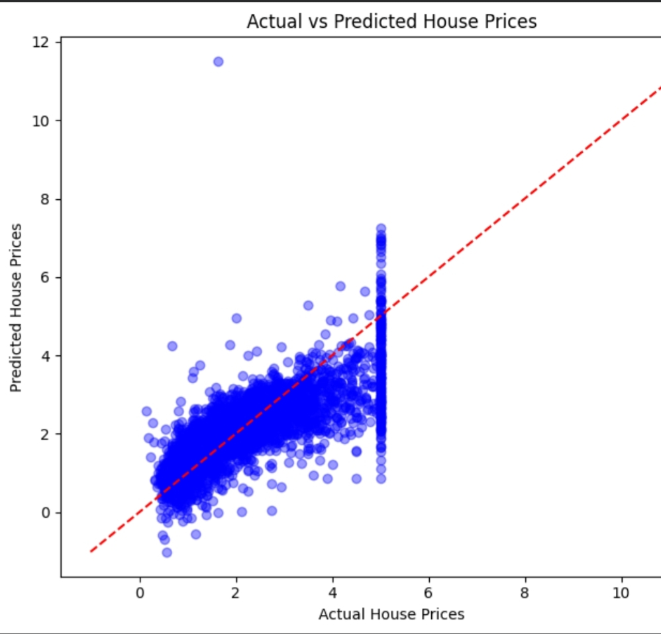

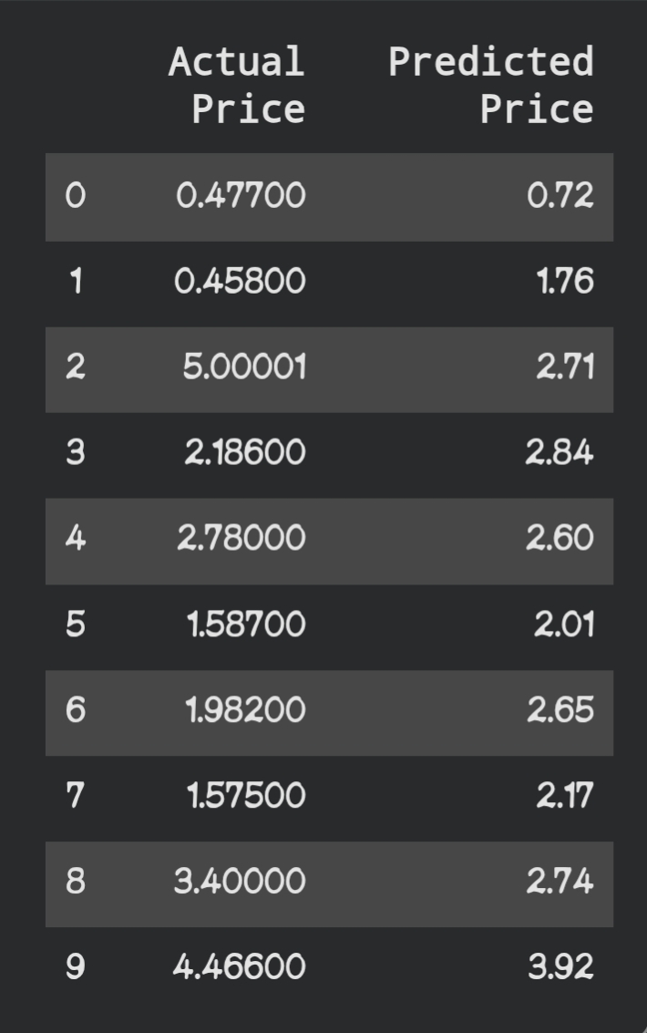
12. RECOMMENDATIONS AND FUTURE IMPROVEMENTS

The project can be improved in several ways:

Compare Linear Regression with Random Forest Regression and other suitable algorithms.
Investigate outliers and data quality issues.
Evaluate feature importance and the usefulness of different input variables.
Use cross-validation to obtain a more reliable estimate of model performance.
Tune model parameters and compare evaluation metrics.
Test the model on additional data where available.

Predictions should be treated as estimates rather than professional property valuations.

13. LIMITATIONS

The model's performance depends on the dataset's quality, feature selection, and coverage. Some factors affecting real estate prices may not be represented in the available data. Linear Regression may also fail to capture complex non-linear relationships. Therefore, the model may not generalize equally well to every location or market.

14. CONCLUSION

This House Price Prediction project demonstrates the application of Python and machine learning to a regression problem. The workflow includes dataset inspection, preprocessing, exploratory data analysis, visualization, model training, prediction, and evaluation.
The Linear Regression model achieved an MAE of 0.53, an RMSE of 0.75, and an R-squared score of 0.5758 in the recorded evaluation. These results provide a baseline for further experimentation and model improvement.

Overall, the project strengthened practical understanding of data science concepts and showed how machine learning can be used to analyze housing data and estimate property values.

15. REFERENCES
Pandas Documentation: https://pandas.pydata.org/docs/

NumPy Documentation: https://numpy.org/doc/

Matplotlib Documentation: https://matplotlib.org/stable/

Seaborn Documentation: https://seaborn.pydata.org/

Scikit-learn Documentation: https://scikit-learn.org/stable/

Google Colab: https://colab.research.google.com/

16. PROJECT LINKS
GitHub Repository: https://github.com/malvika-sharma-biotech/House-Price-Prediction.git

