Linux Assignment 1 - Manish Malviya

1. Creating and Renaming Files/Directories
Commands:
mkdir test_dir
cd test_dir
touch example.txt
mv example.txt renamed_example.txt
Explanation:
Creates directory, file, and renames it using mv.
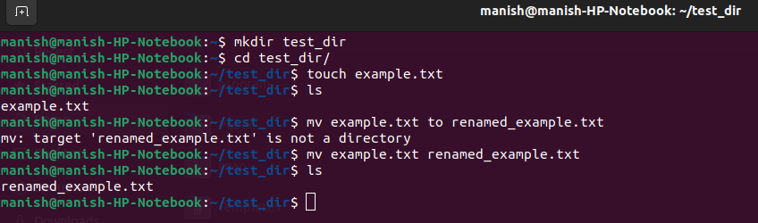

2. Viewing File Contents
Commands:
cat /etc/passwd
head -n 5 /etc/passwd
tail -n 5 /etc/passwd
Explanation:
Displays full, first 5 lines, and last 5 lines of file.

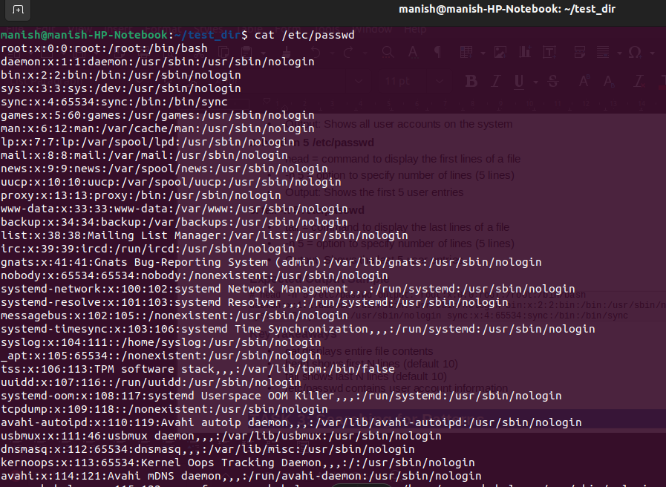

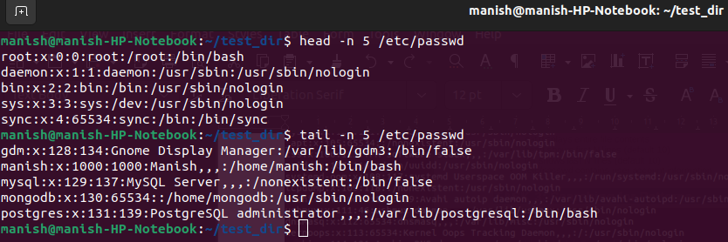

3. Searching for Patterns
Command:
grep "root" /etc/passwd
Explanation:
Searches lines containing 'root'.

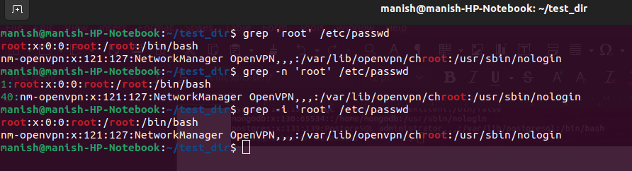

4. Zipping and Unzipping
Commands:
cd ..
zip -r test_dir.zip test_dir
unzip test_dir.zip -d unzipped_dir
Explanation:
Compress and extract directory.
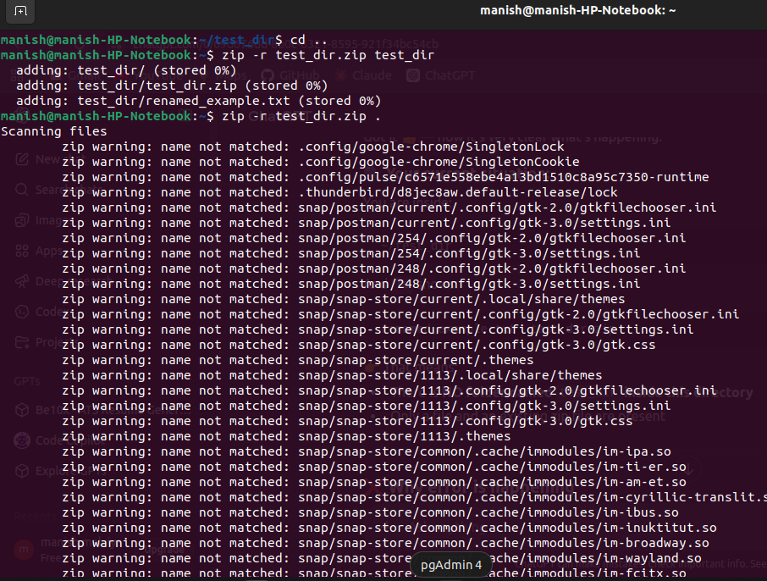
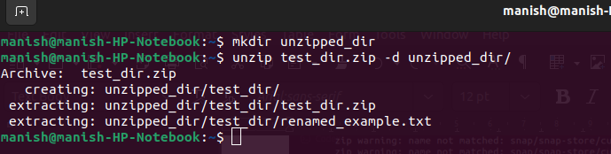

5. Downloading Files
Command:
wget https://www.w3.org/TR/PNG/iso_8859-1.txt
Explanation:
Downloads file from internet.

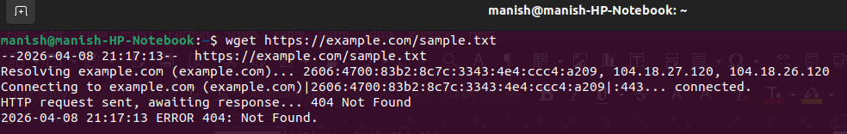

6. Changing Permissions
Commands:
touch secure.txt
chmod 444 secure.txt
Explanation:
Makes file read-only.

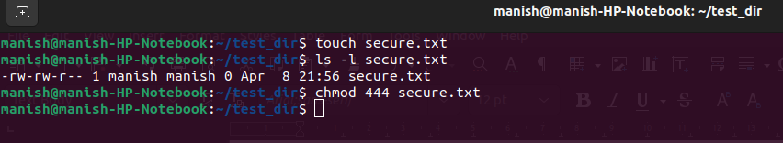

7. Environment Variables
Commands:
export MY_VAR="Hello, Linux!"
echo $MY_VAR
Explanation:
Creates and verifies environment variable.

