**Name: Mohmmad Alwakeel**

**GitHub Name: malwake-git**

**Purdue Username: malwake**

**Instructor: Prof. Inouye**

**Problem1 Writeup**

**Estimated Functions:**

Based on the Following Output ->

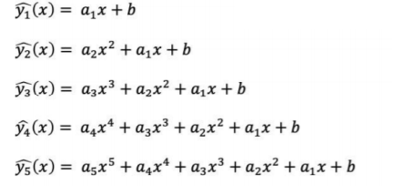

Y1: a1 = 21.99190792

, b = 92.70531403

Y2: a2 = -1.15834068

,a1 = 22.60822925

, b = 100.79905593

Y3: a3 = 1.66680649

, a2 = -1.19334469

, a1 = 0.39581103

, b = 100.43721865

Y4: a4 = -1.43365571e-02

, a3 = 1.66770942e+00

, a2 = -9.05694362e-01

, a1 = 3.39499592e-01

, b = 9.97620446e+01

Y5: a5 = -2.31737037e-02

, a4 = -1.96196620e-02

, a3 = 2.27429003e+00

, a2 = -8.64397166e-01

, a1 = -2.65996605e+00

, b = 9.94138526e+01

**Data Visualization:**

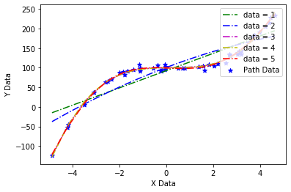

The data seems to best follow a fifth order polynomial (a two curves line) which can be seen from the low error between the estimated regression function y 5hat (x), and the data given based on the plot above.

Measuring the new data point x = 2, the predicted y value is approximately : 107.775