**Name: Mohmmad Alwakeel**

**GitHub Name: malwake-git**

**Purdue Username: malwake**

**Instructor: Prof. Inouye**

**Problem2 Writeup**

**Finding best Lambda:**

Based on the Following Output ->

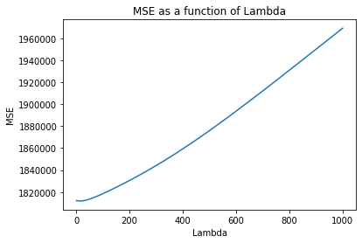

Best lambda tested is **14.563484775012437**, which yields an MSE of **1811977.1732371899**

**Equation of best fitted model:**

Y:

a9 = 5112.15519761

, a8 = -200.98248228

, a7 = -207.14794325

, a6 = -1330.75810931

, a5 = 217.69361706

, a4 = -69.0190039

, a3 = 500.94160313

, a2 = 74.33788618

,a1 = -458.97374368

, b = 3928.07687554

The predicted price y for a 0.25 carat, 3 cut, 3 color, 5 clarity, 60 depth, 55 table, 4 x, 3 y, 2 z diamond is **9721.455713041743**

, which was determined by the equation of the best fitted model. There, we plugged the given value based on their X orders (i.e., x1, x2, x3, etc.), multiplied it with the founded coefficients, and finally sum the result with the intercept. The result is the estimated price based on the best fitted equation line.