**Report**

This program work is to extract any URL from the website and text files.

* **First, we will do the extraction from website**
* **Second will do the extraction from file.txt**

**First**, we imported a library name “re”. The “re” module provides a set of powerful regular expression facilities, which allows you to quickly check whether a given string matches a given pattern (using the match function), or contains such a pattern (using the search function).

Then we imported “requests” library. The Requests library **provides a simple API for interacting with HTTP operations such as GET , POST , etc**. The methods implemented in the Requests library execute HTTP operations against a specific web server specified by its URL.

1. After that we created a variable named 'URL' in which we take input of website given by the users.

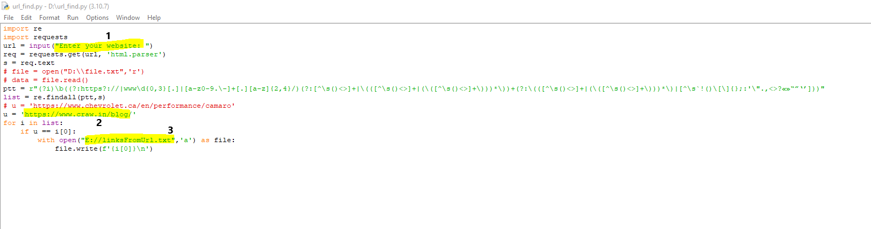

2. Then we created a variable name “u”. this is a specific URL which we have to find, if the “u” isn’t the URL which we have given then I will extract it.

3. This is a function to make a .txt file and append the URL in the .txt file.

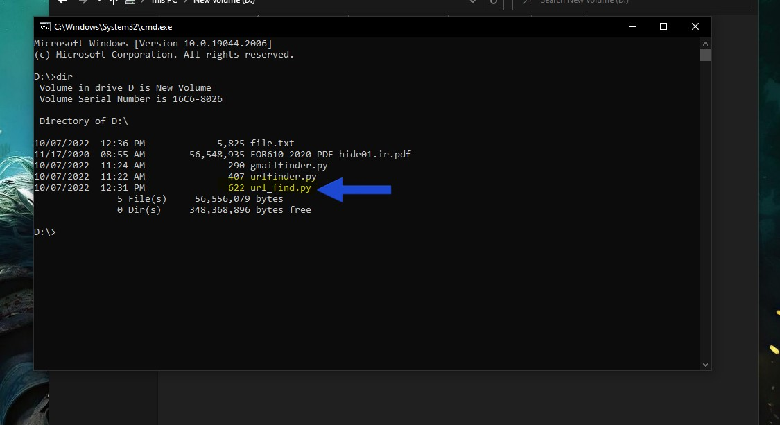

In the above image we opened cmd and goes to D drive where you find the python program name “url_find.py”.

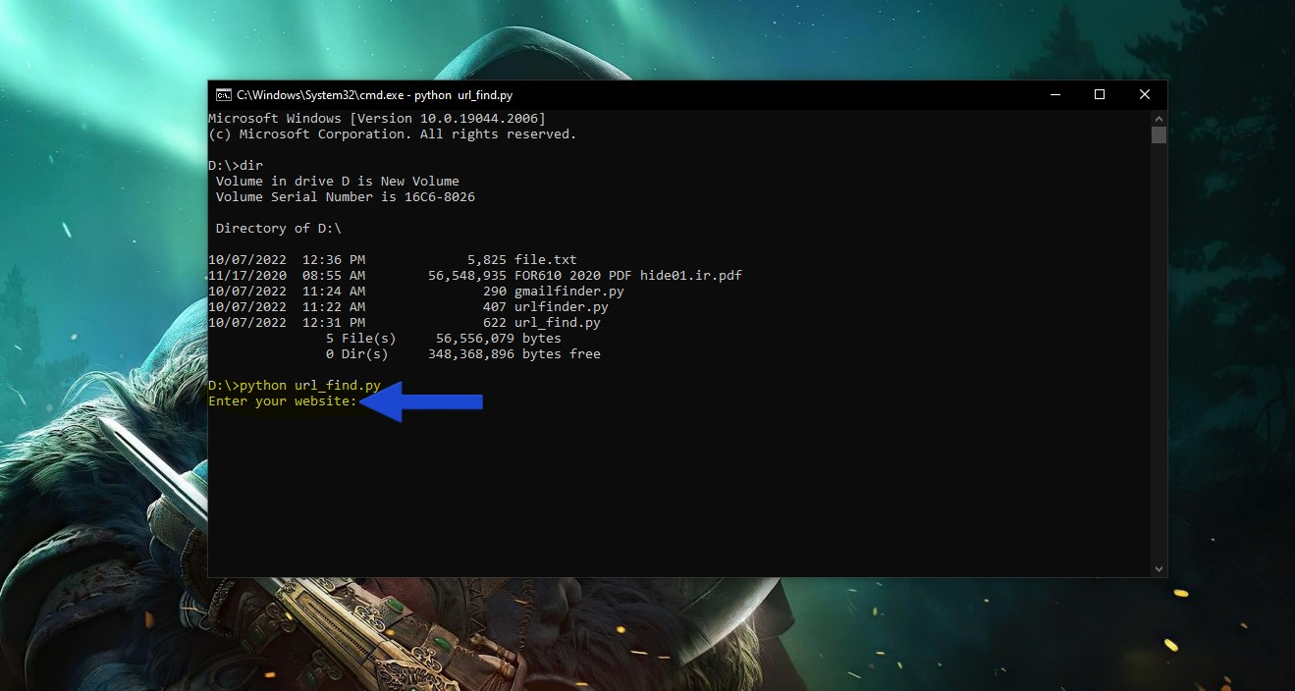

We have to enter the website name whatever you want to search.

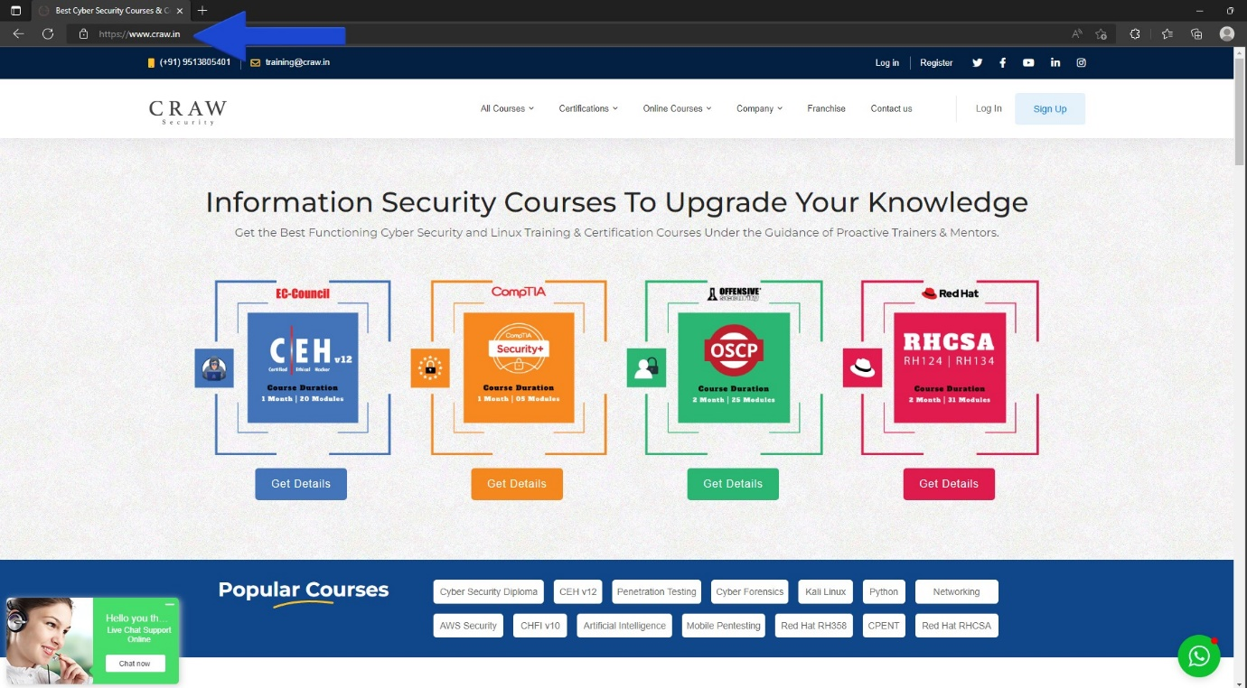

This is the sample that we doing extraction a specific URL from <https://craw.in>.

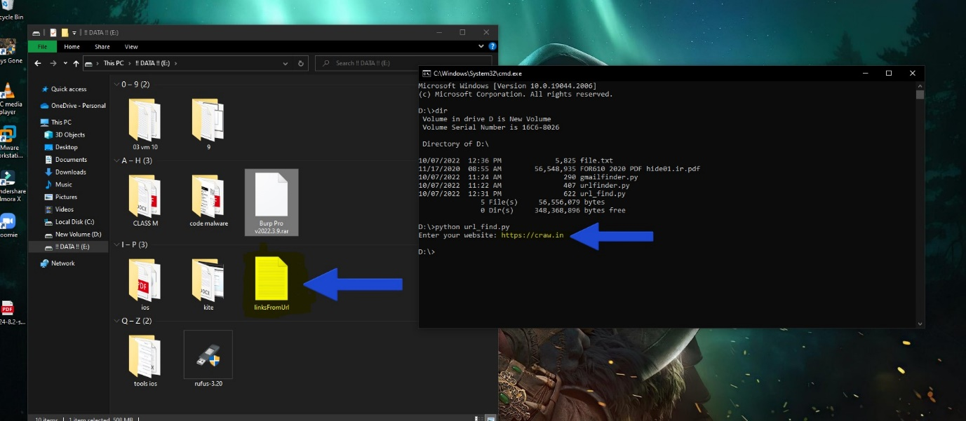

Here we enter the website name “https://craw.in” and it make a file name “linksfromurl”, this is the file where the URLs are saved or write.

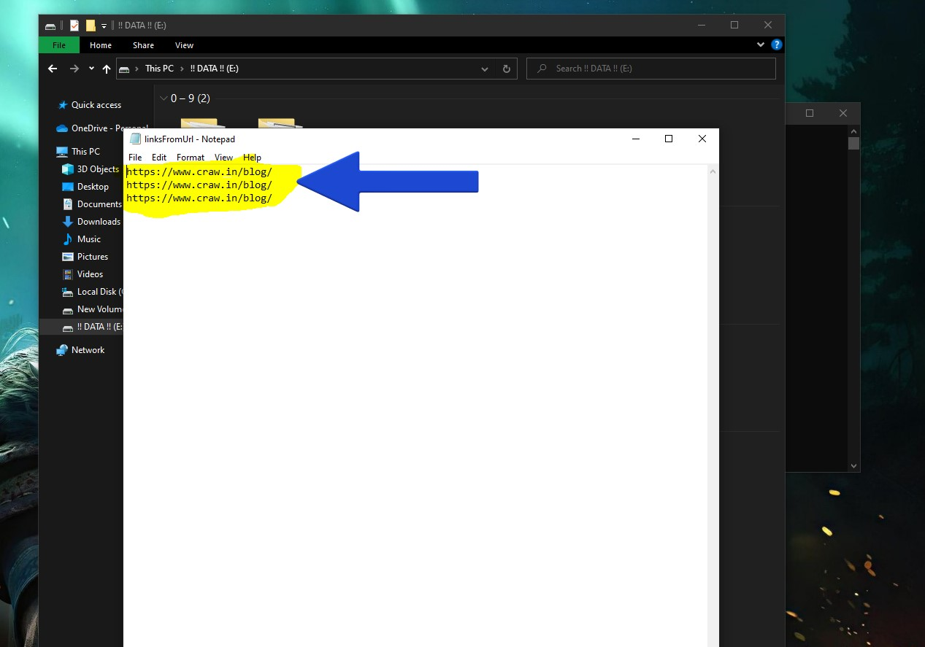

Here you see the all the URLs were extract from the website and save.

**Second operation on File.txt**

In this we will extract the URL from the files

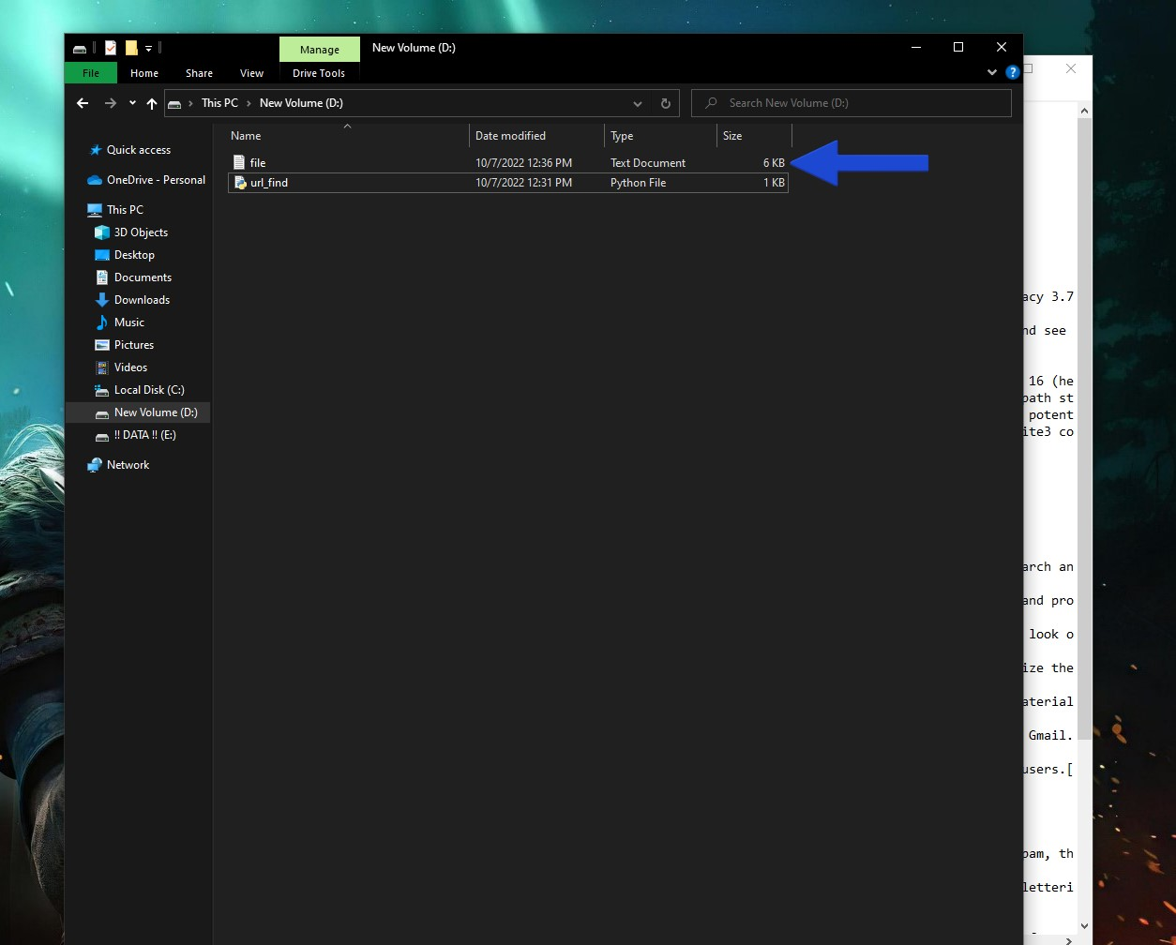zkfgh

here is a .txt file name “file.txt”.

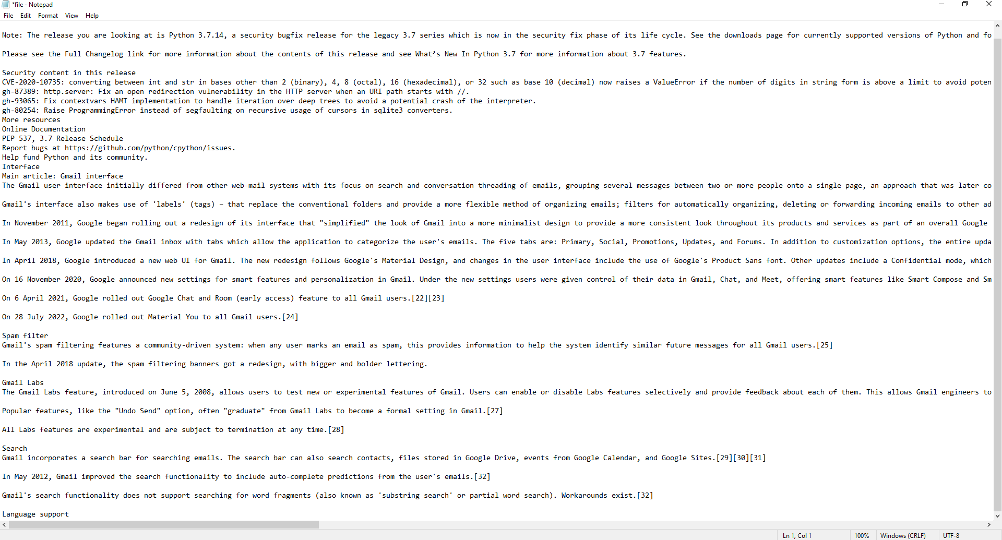

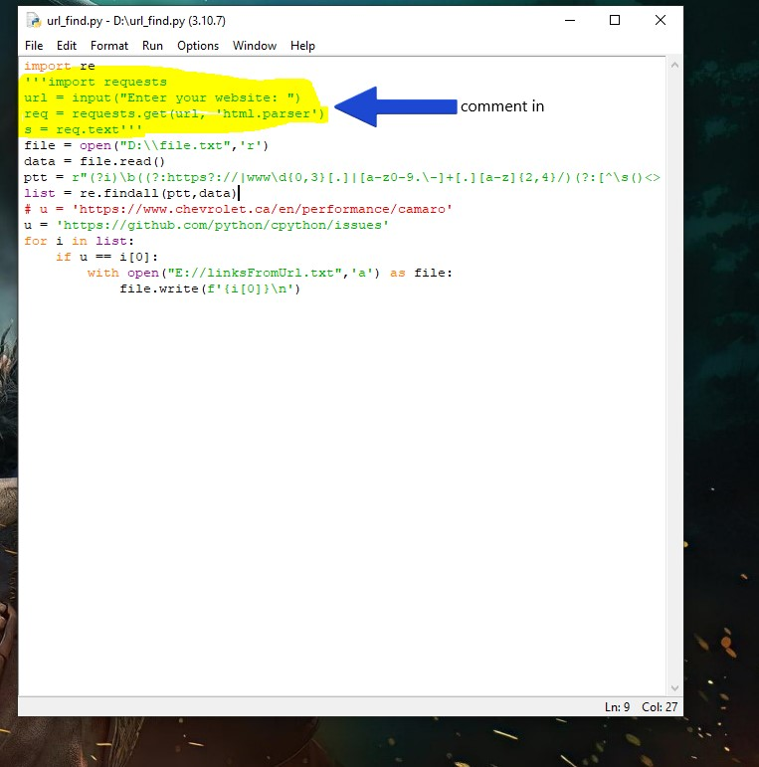this is a random .txt where we have to extract specific URL.

From the previous code we **comment in** the highlighted portion.

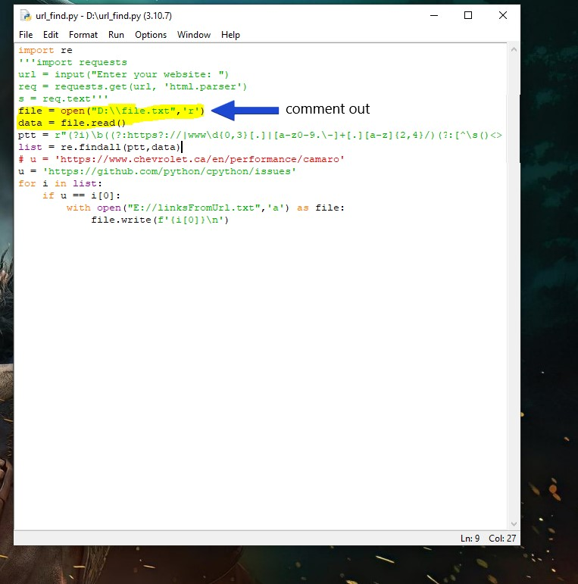

Here we **Comment out** the highlighted portion.

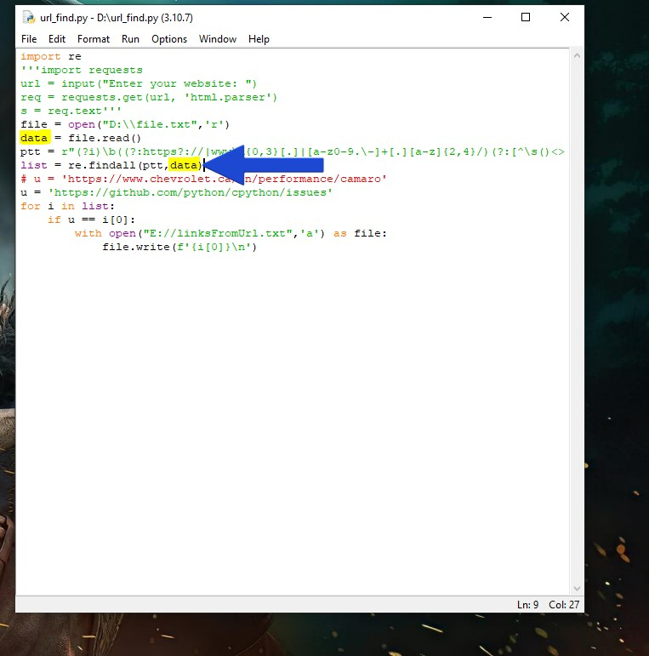

Will edit list var with data so it can only search URL from the file.txt file

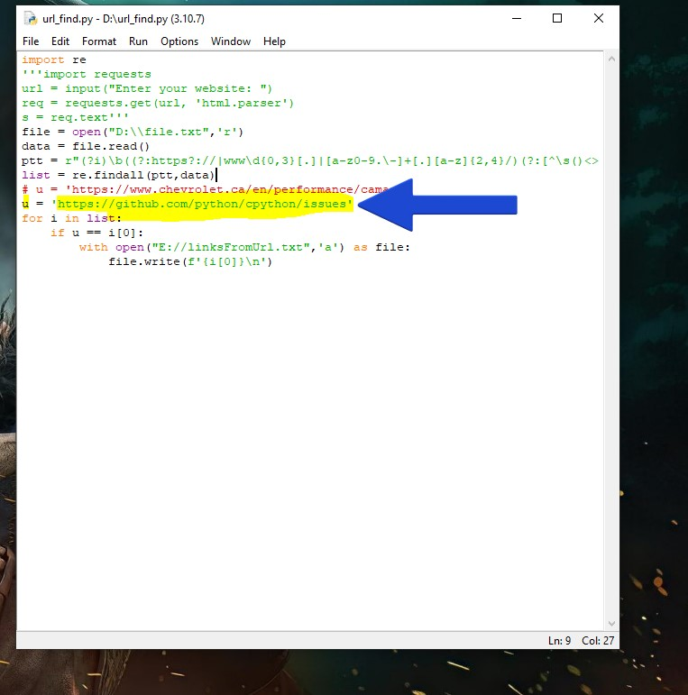

In this section will give our specific URL that we need to find out in file.txt file

It depends on our need; we can modify the URL according to our need.

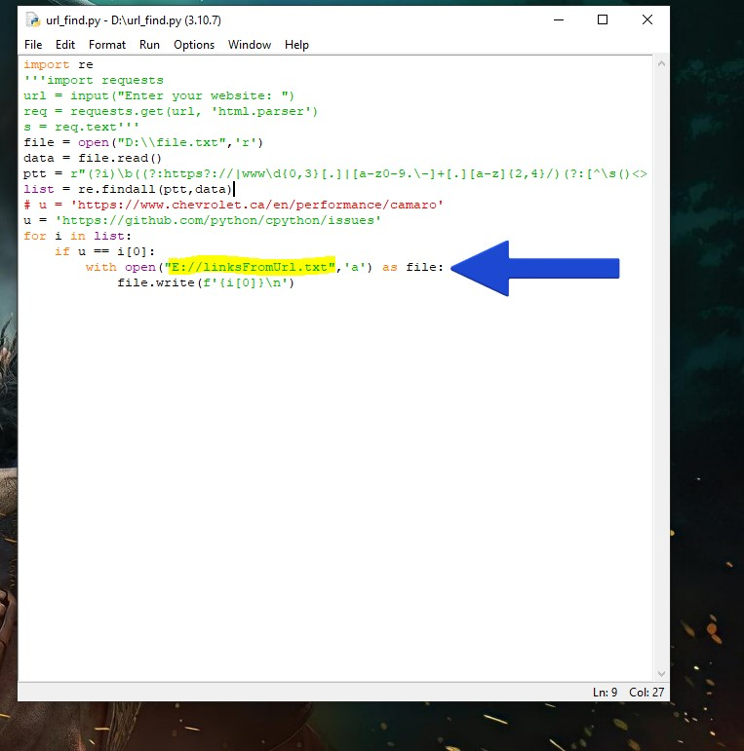

Here you see the all the URLs were extract from the file and save.