Classification of Rakuten e-commerce products
Inhaltsverzeichnis
1 Data Analysis i
1.1 Textual Data i
1.1.1 Missing values ii
1.1.2 Analysis of target data iii
1.1.3 Analysis of textual metrics iv
1.1.4 Word Frequency Analysis vii
1.1.5 Language Analysis ix
1.2 Image Data x
1.2.1 Display random Images for all groups x
1.2.2 Image Dimension xii
1.2.3 Pixel Distribution xii
2 Data Preprocessing xiii
2.1 Textual Data xiii
2.1.1 Text Outliers xiii
2.2 Image Data xiv
2.2.1 Blank Images xiv
2.2.2 Duplicated Images xiv
2.2.3 Noise Removal xiv

Data Analysis

Textual Data
To get a first overview of the content and structure of the data, the first 5 rows of the data set will be shown in the following table:
index | designation | description | productid | imageid |  | prdtypecode
0 | Olivia: Personalisiertes Notizbuch / 150 Seite... | NaN | 3804725264 | 1263597046 |  | 10
1 | Journal Des Arts (Le) N° 133 Du 28/09/2001 - L... | NaN | 436067568 | 1008141237 |  | 2280
2 | Grand Stylet Ergonomique Bleu Gamepad Nintendo... | PILOT STYLE Touch Pen de marque Speedlink est ... | 201115110 | 938777978 |  | 50
3 | Peluche Donald - Europe - Disneyland 2000 (Mar... | NaN | 50418756 | 457047496 |  | 1280
4 | La Guerre Des Tuques | Luc a des id&eacute;es de grandeur. Il veut or... | 278535884 | 1077757786 |  | 2705

Here, the target “prdtypecode” data is joined together with the input variables to represent the wo data set. Therefore, it consists of four features and one target variable.
Features:
- Designation: Title of the product.
- Description: Description text of the product.
- Productid: Unique product identifier.
- Imageid: Unique image identifier.
Target:
- Prdtypecode: Product type code.

From the text columns “designation” and “description”, we can see that the texts contain characters, numbers and special characters, as well as different languages. Also, the “description” column seems to have many missing values. In addition, we cannot directly get an overview of the lengths of the text columns. The “productid” and “imageid” columns correspond to the related image of the product. The “prdtypecode” shows some different numbers related to the product categories.

Missing values
Analyzing the data set by exploring the information, we can see that only the “description” column contains missing values. Further analysis shows that the missing values have a proportion of 35.38 percent of the whole data set.
I a next step we will analyze the proportion of missing values of the product description for each category of the target variable.
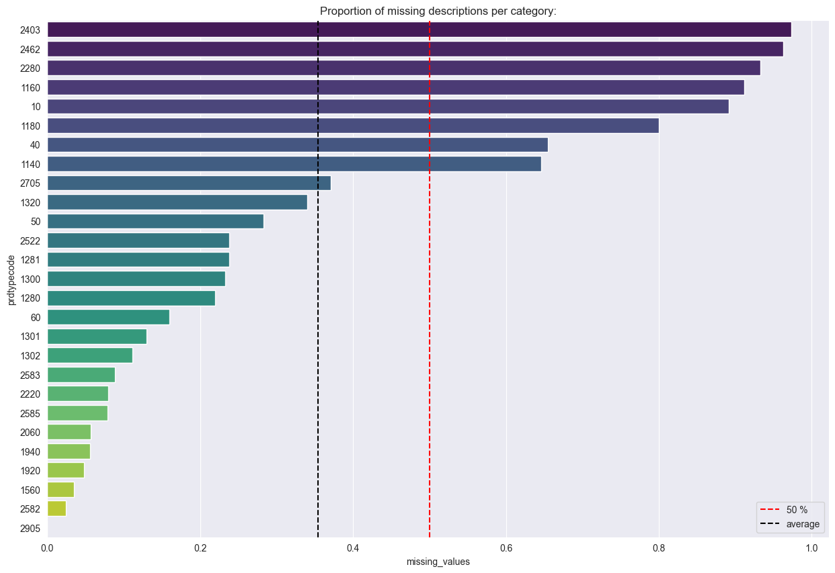
From the above graph, we see that distribution of missing values of description for each category is imbalanced. Category 2403 contains most missing values and Category 2905 contains less missing values for description. For 8 categories more than 50 percent of the descriptions are missing (2403, 2462, 2280, 1160, 10, 1180, 40, 1140).

Analysis of target data
The target variable represents the product type code for each product category of the data set. It consists of 27 different categories, with a distribution as shown below in the graph.
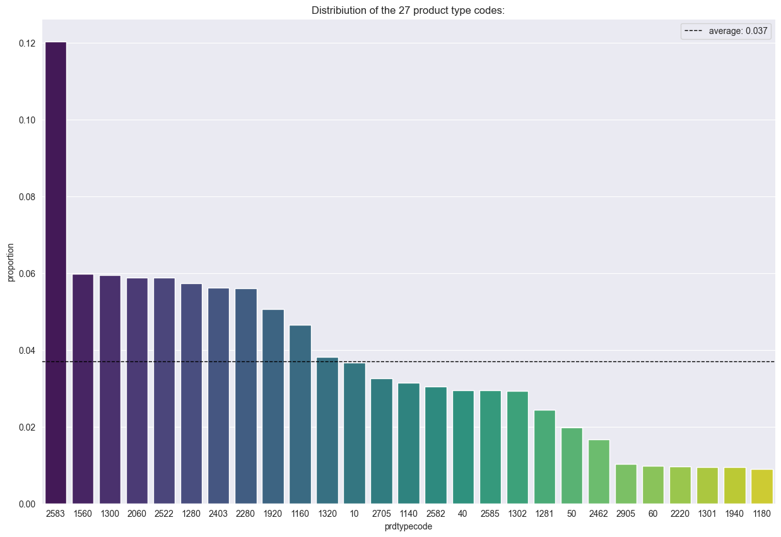
We can clearly see that the class distribution is imbalanced. The most represented category is 2583 with a proportion of 12 percent. The least represented category is 1180 with a proportion of 0.9 percent.

Analysis of textual metrics
To explore the textual structure of the data set, the length of characters, the counts of words as well as the count of sentences of each row are analyzed for textual columns of the data set.
Description:
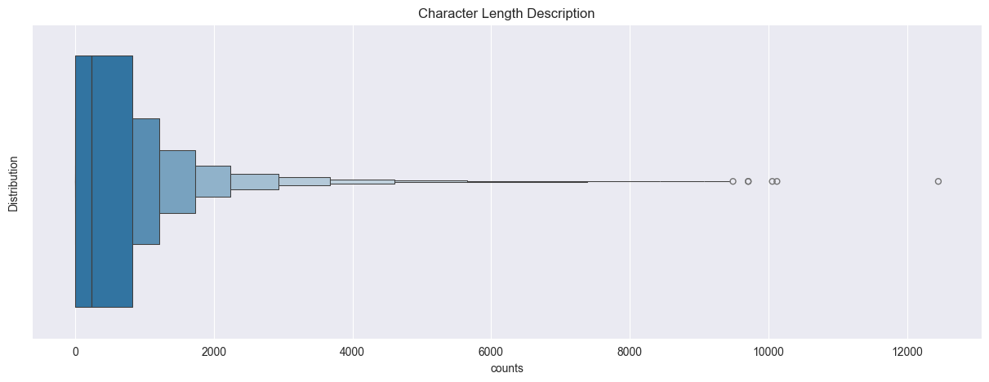
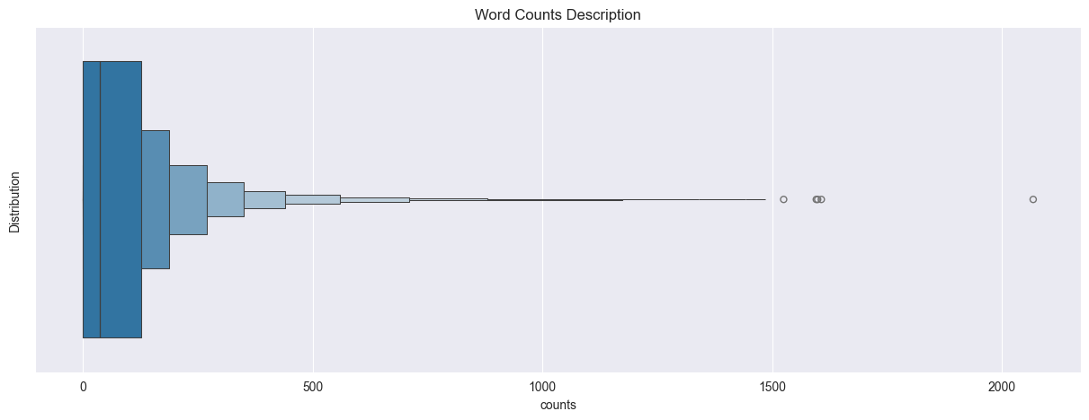
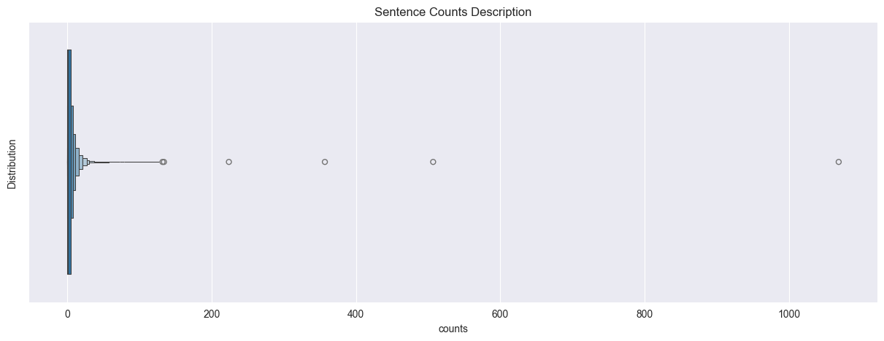
The graphs above show that for all measures several outliers exist. Looking at the highest values, it can be assumed that not all sentences contain relevant information and need to be cleaned. Also processing more than 1000 sentences per observation can cause high computational time.
Designation:
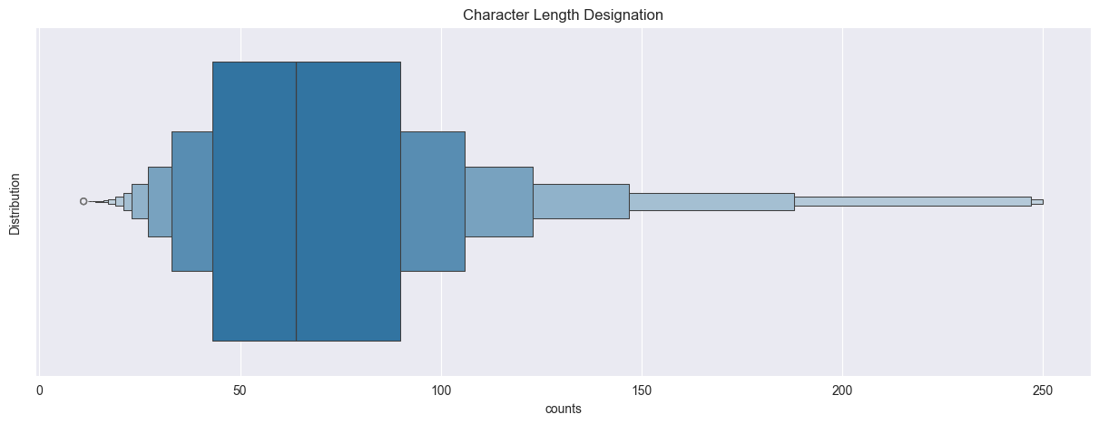
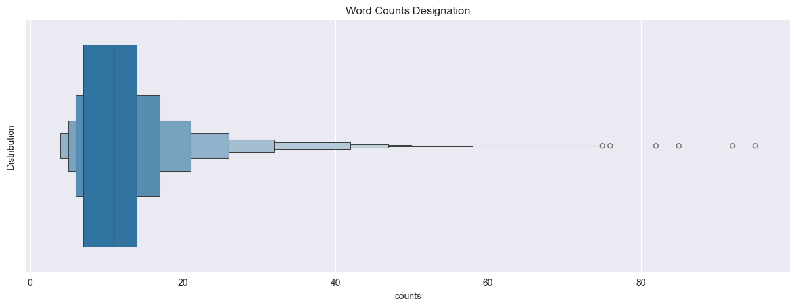
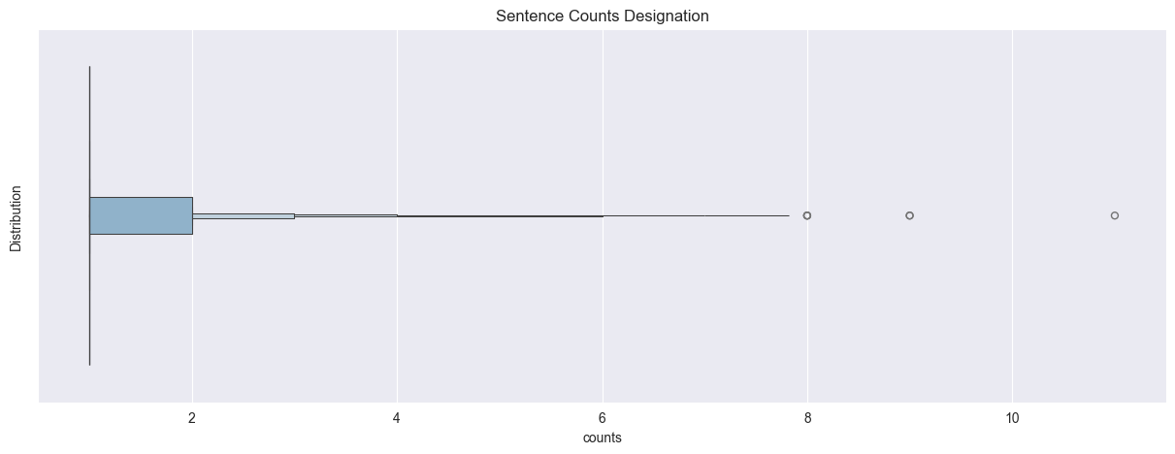
Same occurs for the designation column. Overall, the texts in these columns are shorter than the text from description column, which is indeed to be expected. The length of the description and the number of expressions vary considerably. Also 179 observations have identical designation and description texts.

The summarized textual statistics can be seen in the following table:

 | Designation |  |  | Description
Statistics | Characters | Words | Sentences | Characters | Words | Sentences
mean | 70.16 | 11.65 | 1.04 | 524.56 | 80.76 | 3.26
std | 36.79 | 6.42 | 0.27 | 754.89 | 116.66 | 6.69
min | 11.0 | 4.0 | 1.0 | 0.0 | 0.0 | 0.0
25% | 43.0 | 7.0 | 1.0 | 0.0 | 0.0 | 0.0
50% | 64.0 | 11.0 | 1.0 | 231.0 | 36.0 | 1.0
75% | 90.0 | 14.0 | 1.0 | 231.0 | 126.0 | 5.0
max | 250.0 | 95.0 | 11.0 | 12451.0 | 2068.0 | 1069.0

Word Frequency Analysis
The following graphs show the most frequent words of the textual columns.
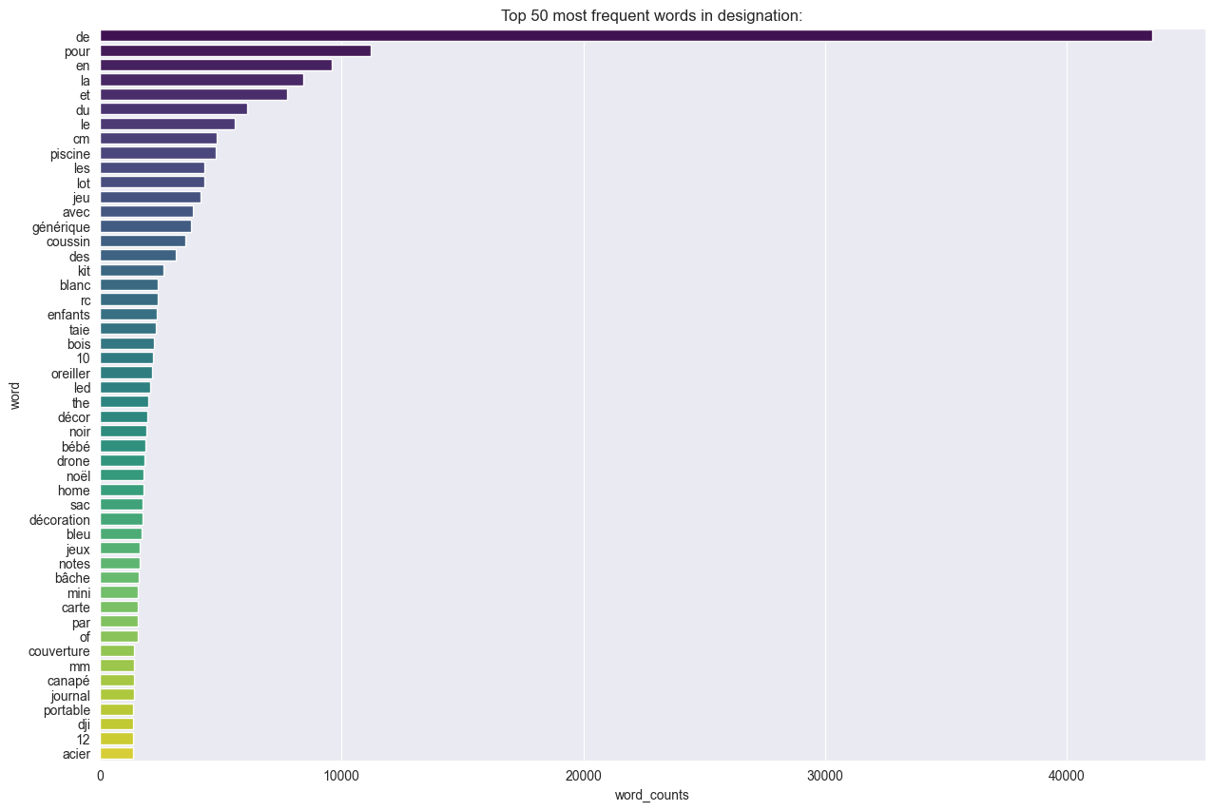
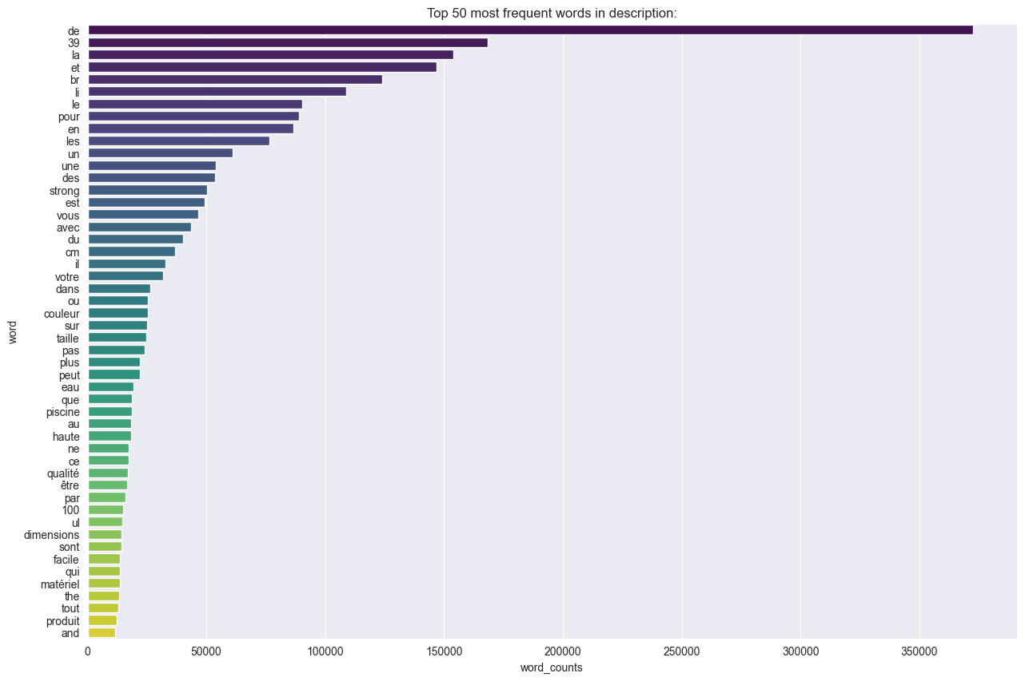
It can be clearly seen that the common language is French, and the most frequent words are so called stop words. In addition, there are some random numbers and units listed. However, there are also English words. Therefore, a word frequency analysis is executed with removed stop words, units, numbers, and some special characters.
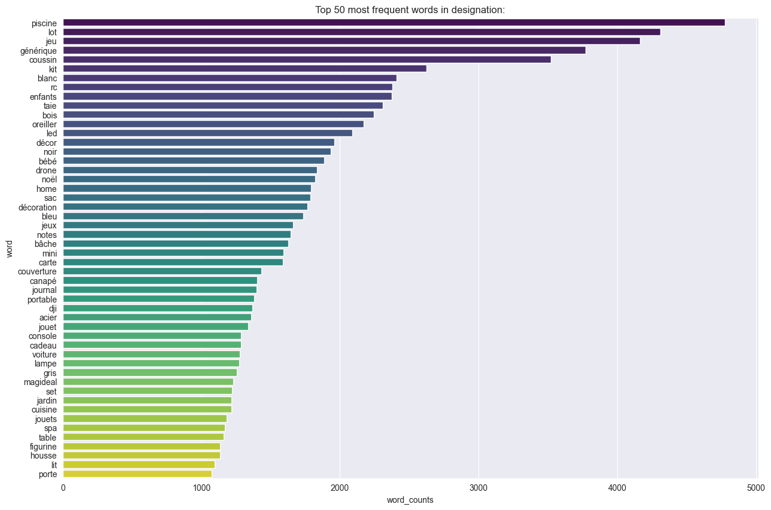
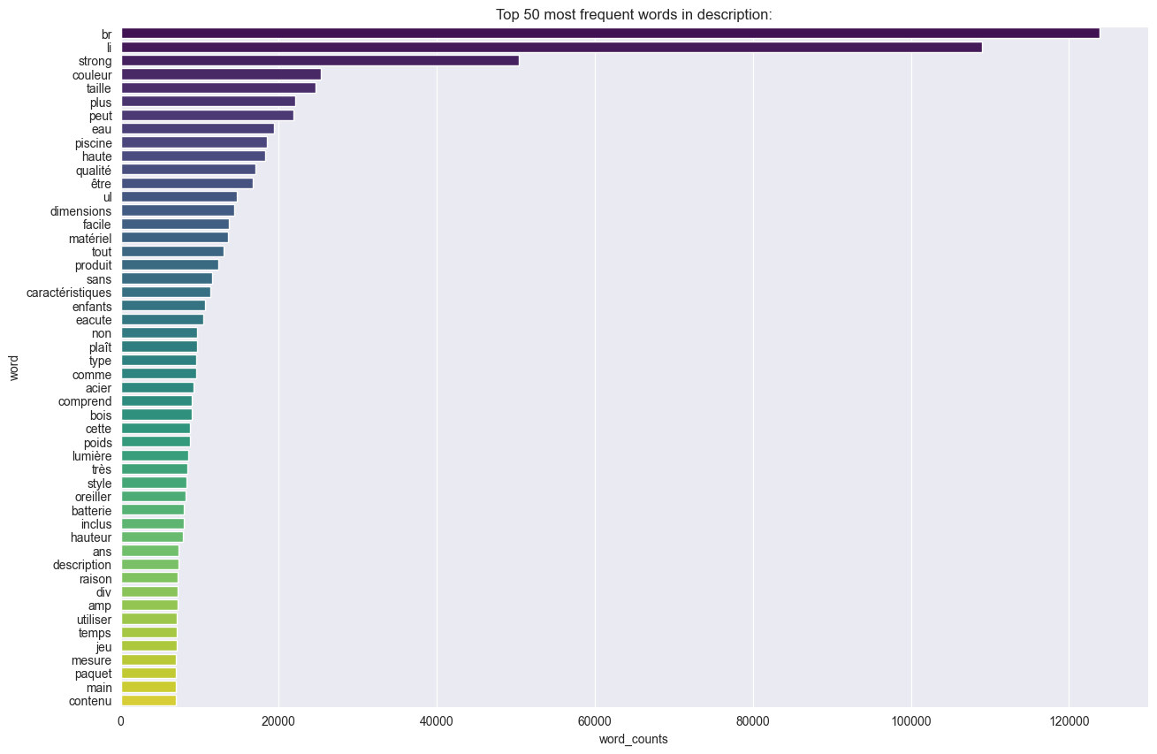

Language Analysis
The previous analysis shows that there are different languages in the textual data. To identify the different languages in the data set and analyze the proportion a language detection method is used.
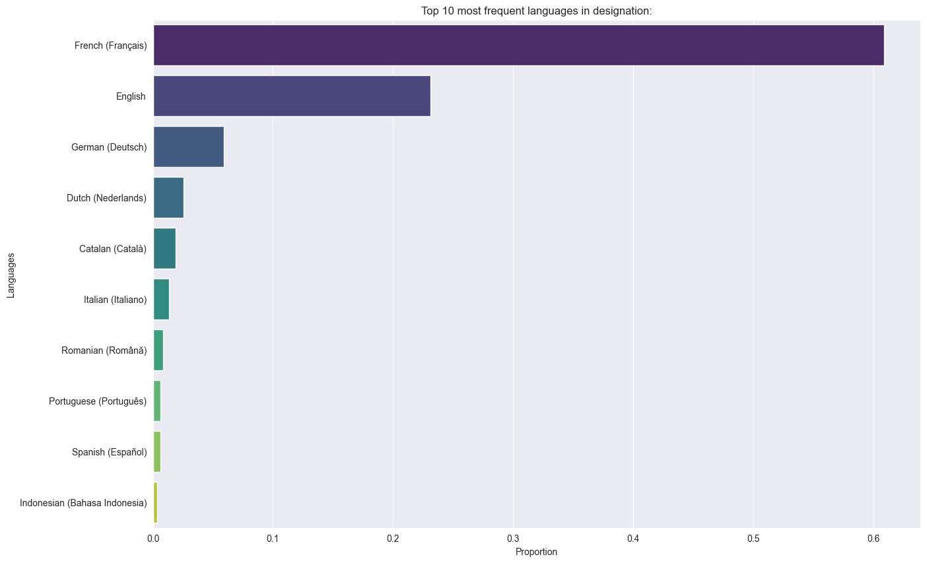
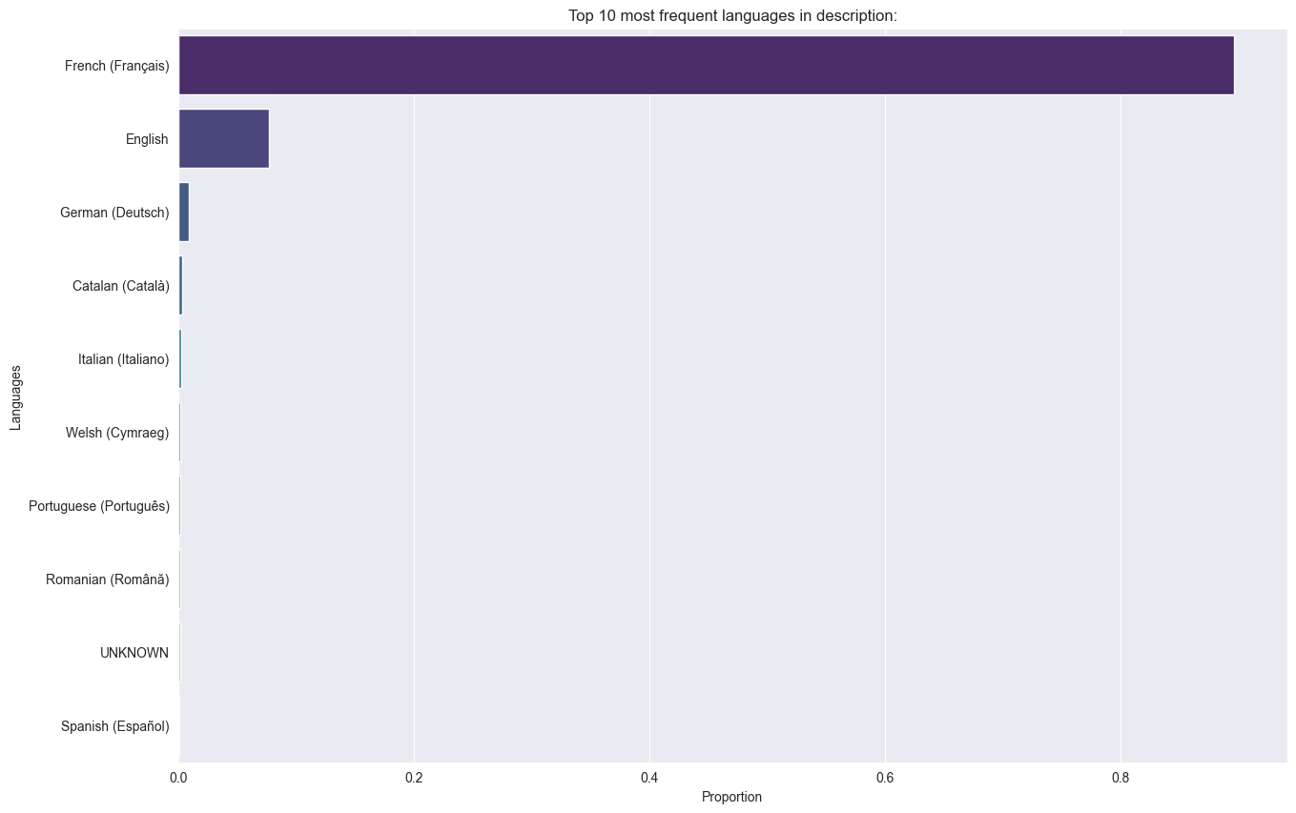

Image Data

Display random Images for all groups
To explore the large data set of images, some randomly chosen images for each target category are displayed.

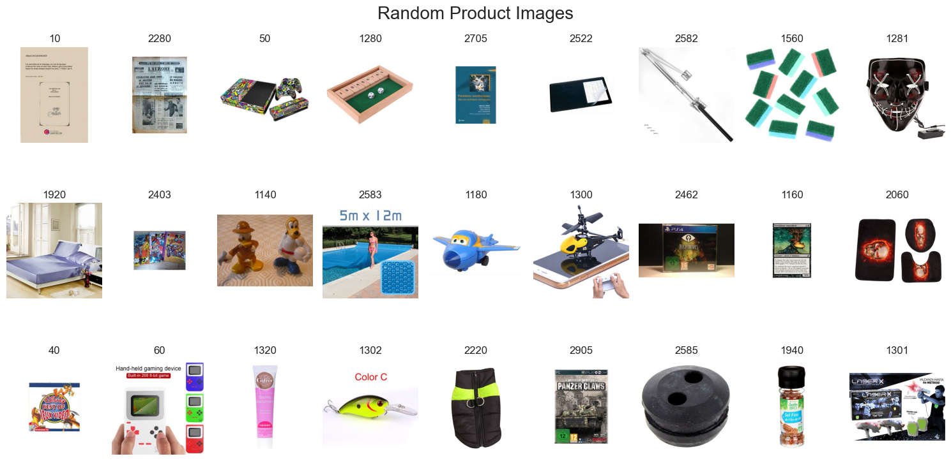

There are very different products and different representations of the products, but some deeper insights into the different products of each category need to be gathered. Therefore, seven randomly chosen images of each category are displayed. For example, the category of “prdtypecode” 10 seems to be about books or magazines.
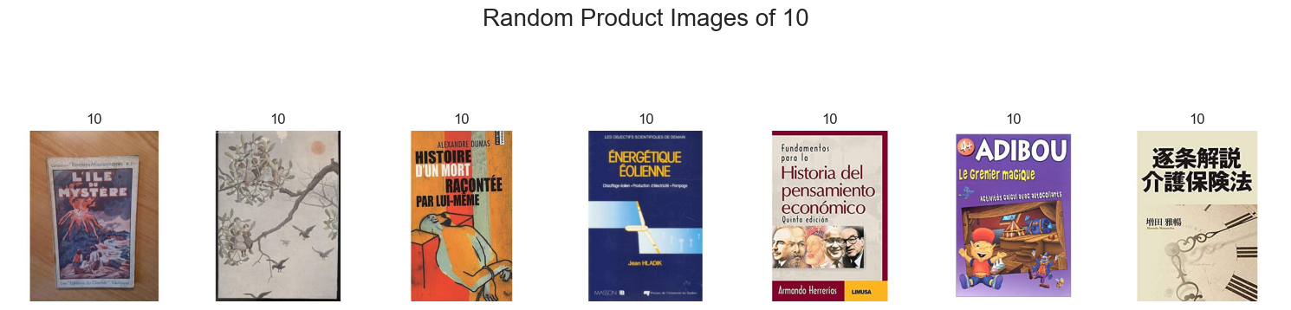
The category “prdtypecode” 60 seems to be about gaming:
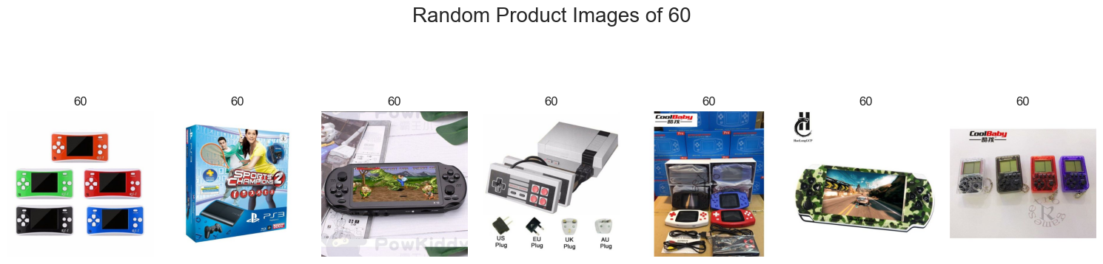

And the “prdtypecode” 2585 could reffere to water spray systems. However, the last image in the following representation shows, that there might be some misscategorized images in the data set.
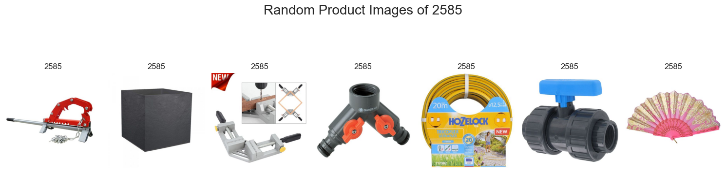

Image Dimension
The pixel dimensions of all available images are 500 x 500 with no outliers. This was validated by calculating the mean dimensions of all images.

Pixel Distribution
The analysis of pixel distribution can deliver some insights into the image variance of each category. The following graph shows that the product representation can vary a lot. The first image on the left side has a gray background, while the second image in the middle has a colored background with varying patterns. The third image on the right side is represented on a with background. The margin of the different backgrounds can introduce some bias to the model. So the influence of the background needs to be reduced.

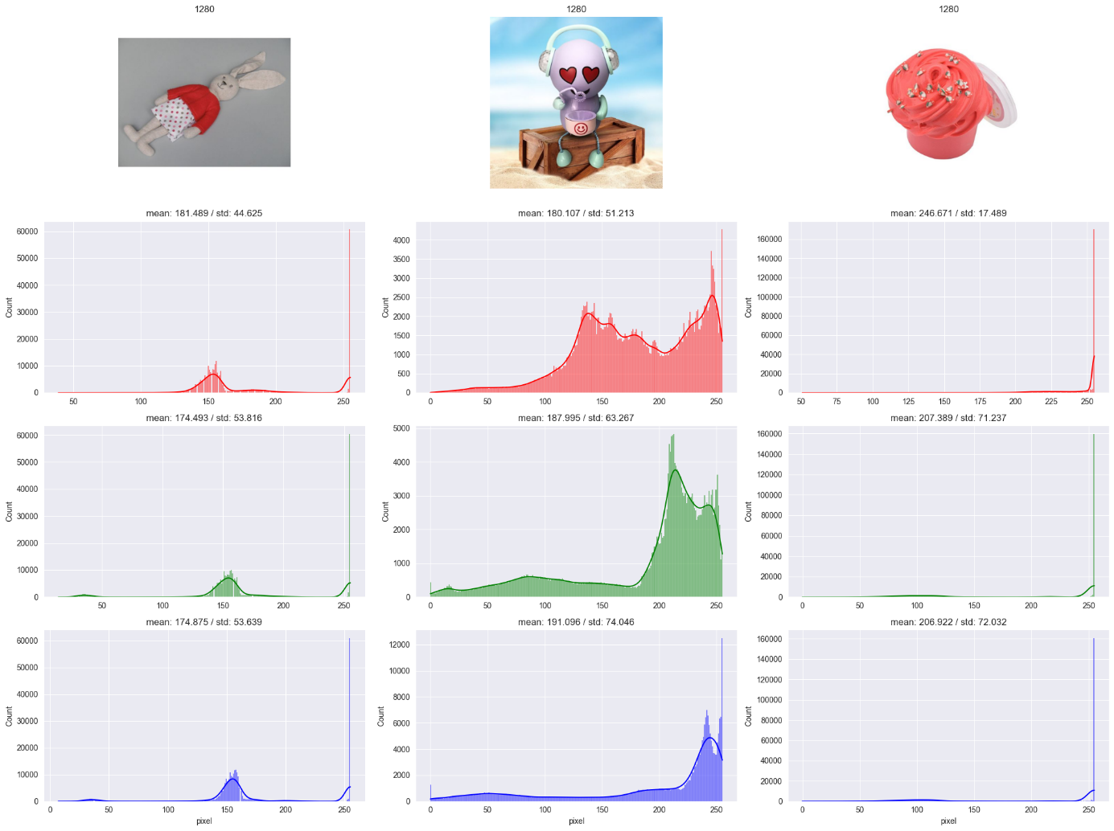

Data Preprocessing

Textual Data

Text Outliers
As shown in the textual data analysis, the text column as a combination of designation and description columns contains some outliers. A large number sentences per observation causes high computational costs during model training and prediction. In addition these observations containing irrelevant or redundant information. Same applies for a large number of words (or phrases) in each sentence.
To handle his issue, we need to identify the text observations which are too long according a defined threshold. To not lose important information of the data frame, we remove only redundant sentences and summarize the remaining sentences according the most relevant words.
In a first step the statistics (min, max, mean, std) of the text column are calculated for words and sentences. The text of each row are tokenized by a space (in assumption, that all phrases not corresponding to natural language are cleaned in advance) to determine the length of the resulting elements per row. The tokenization of the sentences are done with a custom sentence tokenization function using the library NLTK and it’s method sents_tokenize().
The threshold for the text outliers is calculated based on the length of word tokens per row. The average is summed up with it’s weigthed standard deviation. The weight factor is treated as a adjustable parameter.
To remove redundant sentences the cosine similarity between each sentence of a row is calculated based on TF-IDF vectorization. The library Scikit-Learn is used for this purpose. If the sentences are similar according to a defined similarity threshold, they are eliminated and stored in a report document for further exploration and analysis.
The cleaned text is then summarized, retaining the most important sentences based on word frequencies.
Sentences are sorted within the text according to the sum of the frequencies of tokens they contain. The three sentences with the highest scores, indicating they consist of the most frequently occurring words, are retained to form the summary.

Image Data

Blank Images
Blank images containing no relevant information for model training, so they need to be removed. If the variance of an grayscale image is zero or a least close to zero it counts as an blank image and will be eliminated from the data set.

Duplicated Images
Duplicated images increasing bias of a model due to its overrepresentation. To compare the images in the data set the structural similarity index measure (SSIM) is chosen. Since the SSIM for each combination of images needs to be calculated, this approach is not feasible for the high number of images in the data set. To reduce computational costs a pre-selection of possible duplicates indicated by the mean and variance of images is done in advance. For each combination of images referring to the pre-selection group the SSIM and the mean squared error are calculated. If the images have a SSIM higher than a defined threshold, the images are eliminated from the data set and stored in a dictionary for further exploration and analysis.

Noise Removal
Some images in the data set can have quality issues due to noise. If images have a very high variance they might be considered noisy.

