Muğla Sıtkı Koçman University

Department of Computer Engineering

Senior Design Project I

**Affield**

Analysis & Design Report

Gökhan MUTLU, Mamady III DIAKITE

Supervisor: Zeynep Filiz Eren

January 18, 2024

**Contents**

1 Introduction 3

2 Motivation 3

3 Similar Existing Applications 3

4 Proposed System 3

4.1 Overview 3

4.2 Functional Requirements 3

4.3 User Interface Design 3

4.4 Entity Relationship Diagram 3

4.5 Technologies and Tools 3

5 Future Work 3

6 References 3

Affield

# Introduction

The global trade landscape demands efficient access to company information. Businesses constantly seek relevant details of potential partners, competitors, and suppliers across diverse sectors and countries. Current methods of gathering such information can be time-consuming and fragmented, often relying on scattered websites and databases.

This project aims to address this challenge by developing Global Connect, a user-friendly platform that seamlessly integrates company information from various sources. Utilizing a well-structured database and intuitive interface, Global Connect empowers individuals involved in trade to find accurate and comprehensive information effortlessly.

# Motivation

The motivation for this project stems from the growing need for accessible and centralized business information in the ever-expanding global trade landscape. Existing methods for data collection are often inefficient and require navigating numerous resources.

Global Connect strives to alleviate these challenges by offering the following benefits:

* **Centralized Platform:** Consolidates information from various sources, offering a one-stop shop for business data.
* **Ease of Access:** Streamlined interface allows users to quickly find relevant information through intuitive search and filtering functions.
* **Comprehensive Data:** Caters to diverse user needs by providing a wide range of company details, including contact information, addresses, financial data, and sector/country classifications.
* **Time Efficiency:** Saves users valuable time by eliminating the need to search through multiple websites and databases.

# Similar Existing Applications

* **Yellow Pages:** Yellow Pages directories cover a wide range of businesses, including local services, retailers, professionals, and other commercial entities.
* **ZoomInfo:** Features contact information and business intelligence tools, but caters mainly to sales and marketing professionals.

# Proposed System

## Overview

* **Database:** A MYSQL database stores company information with well-defined tables and relationships.
* **Web Application:** Developed using FASTAPI, the web application provides a user-friendly interface for searching, filtering, and accessing company details.

Database

API

Website

## Functional Requirements

**Use Case Diagram:**

**Description:**

* **Log-In:** User provide username and password to log-in to the system.
* **View Company Details:** Users can view detailed information about a specific company, including contact information, addresses, financial data, and more.
* **Filter Results:** Users can filter search results based on specific criteria, such as sector, country, company size, etc.
* **Search Company**: Users can search for companies by name, sector, country, or other relevant criteria.

## User Interface Design

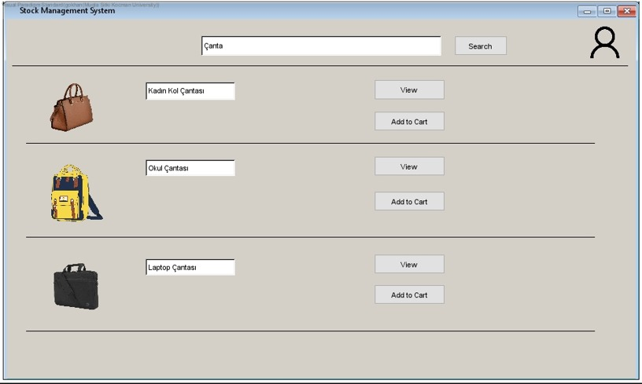

Firm

Firm

Firm

View

Details

View

View

Details

Details

Firm

## metin, ekran görüntüsü, yazı tipi, diyagram içeren bir resim Açıklama otomatik olarak oluşturulduEntity Relationship Diagram

**Description of Entity Relationship Diagram:**

**Company:** Stores information about each company, including name, sector, details.

**Address:** Stores address information for each company.

**Phone:** Stores contact information for each company.

**Link:** Stores websites information for each company

**City:** Stores city name location of company.

**Country:** Stores country of company location.

**Sector:** Stores sectors name of company.

## Technologies and Tools

* MySQL for database management
* FASTAPI for backend development
* Docker for containerization
* Python's MySQL Connector for data loading

# Future Work

1. Finalize UI Mockups and Database Schema
2. Implement Backend (FASTAPI) and Database (MySQL)
3. Integrate Website with Database
4. Implement User Authentication and Authorization
5. Perform Testing and Debugging
6. Finalize Documentation and Prepare for Deployment

# References

MySQL Documentation. Retrieved from <https://dev.mysql.com/doc/>

FASTAPI Documentation. Retrieved from <https://fastapi.tiangolo.com/>

MySQL Connector Documentation. Retrieved from <https://dev.mysql.com/doc/connector-python/en/>

Docker. Docker Documentation. Retrieved from <https://docs.docker.com/>

freeCodeCamp.org. (2021, November 1). Python API Development - Comprehensive Course for Beginners. <https://www.youtube.com/watch?v=0sOvCWFmrtA&t=8s>