A Template to Create Reproducible Document Using Rmarkdown and Knitr

Mahbubul Majumder, PhD

Jan 14, 2018

This is an R Markdown document. Markdown is a simple formatting syntax for authoring HTML, PDF, and MS Word documents. Notice the source file extension is .Rmd. You can Knit this file from RStudio and produce the output in either HTML or PDF or MS Word format. Viewing the actual markdown syntax in .Rmd file will help you understand how this file is created.

## Basic functions

We use asterisk mark to emphasize the words such as single * for *italics* and double ** for **bolds**.

We use dash mark to create a list.

* item 1
* item 2
* item 3

We can also create ordered list by numbering them as follows

1. list 1
2. list 2
3. list 3

We use back ticks to create  
a block of codes

## Embedding R codes

If we want to embed some R codes we can do it as below. This is one of the powers R package kintr brought for us. We can control the size of the figure in knitr code chunk option.

library(ggplot2)  
ggplot(mtcars, aes(hp, mpg)) +  
 geom_point()

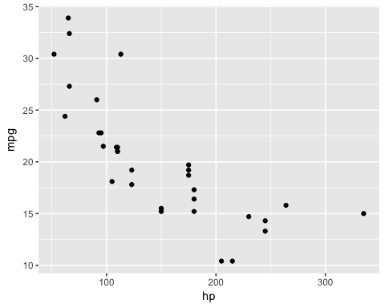

We can embed inline R codes to display results in a line. Such as the number of records in dataframe women is 15.

We use function kable() to display a table of data

knitr::kable(head(mtcars, 10))

|  |  |  |  |  |  |  |  |  |  |  |  |
| --- | --- | --- | --- | --- | --- | --- | --- | --- | --- | --- | --- |
|  | mpg | cyl | disp | hp | drat | wt | qsec | vs | am | gear | carb |
| Mazda RX4 | 21.0 | 6 | 160.0 | 110 | 3.90 | 2.620 | 16.46 | 0 | 1 | 4 | 4 |
| Mazda RX4 Wag | 21.0 | 6 | 160.0 | 110 | 3.90 | 2.875 | 17.02 | 0 | 1 | 4 | 4 |
| Datsun 710 | 22.8 | 4 | 108.0 | 93 | 3.85 | 2.320 | 18.61 | 1 | 1 | 4 | 1 |
| Hornet 4 Drive | 21.4 | 6 | 258.0 | 110 | 3.08 | 3.215 | 19.44 | 1 | 0 | 3 | 1 |
| Hornet Sportabout | 18.7 | 8 | 360.0 | 175 | 3.15 | 3.440 | 17.02 | 0 | 0 | 3 | 2 |
| Valiant | 18.1 | 6 | 225.0 | 105 | 2.76 | 3.460 | 20.22 | 1 | 0 | 3 | 1 |
| Duster 360 | 14.3 | 8 | 360.0 | 245 | 3.21 | 3.570 | 15.84 | 0 | 0 | 3 | 4 |
| Merc 240D | 24.4 | 4 | 146.7 | 62 | 3.69 | 3.190 | 20.00 | 1 | 0 | 4 | 2 |
| Merc 230 | 22.8 | 4 | 140.8 | 95 | 3.92 | 3.150 | 22.90 | 1 | 0 | 4 | 2 |
| Merc 280 | 19.2 | 6 | 167.6 | 123 | 3.92 | 3.440 | 18.30 | 1 | 0 | 4 | 4 |

## Math Equation

We can embed mathematical equations. For inline equation we use single $ sign such as $var(\overline{y})=σ^{2}/n$. For standalone equation we use double $$ as below

$$f(x)=\frac{1}{\sqrt{2πσ^{2}}}e^{−\frac{1}{2σ^{2}}(x−μ)^{2}}$$

## Adding Bibliography

We can add bibliography and cite it. For example if we want to cite knitr we just do it as this [1]. If we want to cite other references we can do it as this[2].

1. Dynamic Documents with R and knitr by Yihui Xie.
2. knitr showcase, examples from other users <http://yihui.name/knitr/demo/showcase/>