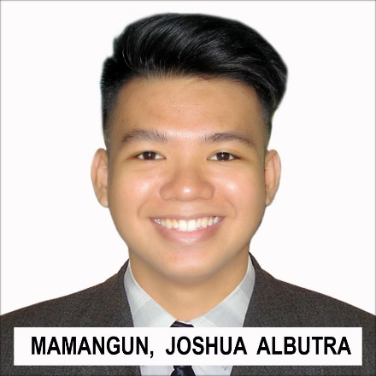

**BIODATA**

PERSONAL DATA

|  |  |  |  |  |  |
| --- | --- | --- | --- | --- | --- |
| Position Desired | : | Back-End Web Developer | Date | : | 10/15/2018 |
| Name: | : | Mamangun, Joshua A. | Sex | : | Male |
| City Address | : | 3201-D J. Trinidad St. Tondo, Manila | | | |
| Provincial Address | : |  |  |  |  |
| Telephone | : | 426-7608 | Cell phone | : | 09239201924 |
| E-mail Address | : | [mamangunjoshua@gmail.com](mailto:mamangunjoshua@gmail.com) |  |  |  |
| Date of Birth | : | July 20, 1999 | Place | : | Manila |
| Civil Status | : | Single | Citizenship | : | Filipino |
| Height | : | 5’7’’ | Weight | : |  |
| Religion | : | Born Again |  |  |  |
| Spouse | : | N/A | Occupation | : | N/A |
| Name of Children | : | N/A | Date of Birth | : | N/A |
| Father’s Name | : | Renato P. Mamangun | Occupation | : | Fishball Vendor |
| Mother’s Name | : | Almira A. Mamangun | Occupation | : | Housewife |
| Parent’s Address | : | 3201-D J. Trinidad St. Tondo, Manila | | | |
| Language/Dialect spoken &written | : | Filipino, English |  |  |  |
| Person to be contacted in case of emergency | : | Almira A. Mamangun |  |  |  |
| His/Her Address and Telephone | : | 3201-D J. Trindad St. Tondo, Manila  426-7608 | | | |

EDUCATIONAL ATTAINMENT

|  |  |  |  |  |  |
| --- | --- | --- | --- | --- | --- |
| Elementary | : | Barrio Obrero Elementary School | Year Graduated | : | 2010 |
| High School | : | Felipe G. Calderon Integrated School | Year Graduated | : | 2014 |
| College | : | Pamantasan ng Lungod ng Maynila | Year Graduated | : | N/A |
|  | : | Universidad de Manila | Year Graduated | : | Ongoing |