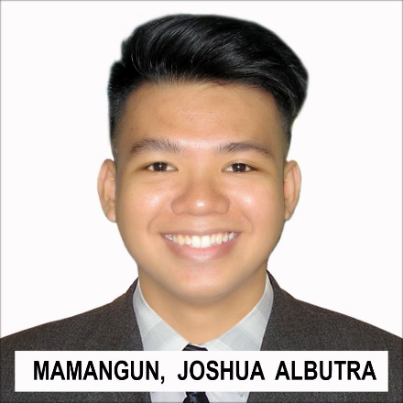

Accelerated at Grade 4, 5   
and 6

3rd Honorable Mention  
Best in Mathematics

**Barrio Obrero Elementary School**  
Narra St. Tondo Manila  
2005-2010

**Pamantasan ng Lungsod ng Maynila**  
Intramuros Manila  
2014-2017 (Not Graduated)

**Felipe G. Calderon Integrated School**  
Hermosa St. Tondo Manila  
2010-2014

Bachelor of Science in Computer Science major in Information Technology.

**Universidad de Manila**  
One Mehan Gardens, Manila Philippines 1000  
2018-Present (Ongoing)

Bachelor of Science in Information Technology.

www.facebook.com/AskMamangun

Bootstrap

jQuery

Laravel

CSS

MySQL

JavaScript

HTML

[mamangunjoshua@gmail.com](mailto:mamangunjoshua@gmail.com)

PHP

**Skills**

**Education**

I am knowledgeable IT professional seeking for an opportunity to apply skills, knowledge and experience on a company. I am best in coding the functionality of a website. I am good in supporting and helping colleague in terms of web developing.

**Summary**

**Objective**

To bring knowledge of programming that prioritizes logical back-end.  
To be an asset of a company.  
To obtain challenging position as a Back-End Web Developer.

twitter.com/mamangss

0923-920-1924  
426-7608

3201 DJ Trinidad Limay St. Tondo Manila

Joshua A. Mamangun